Demographic Summary Report
San Diego Data Science Alliance — ACS Demographic Data & Assistance Program Integration

1. Distribution of Poverty Rates Across SD Zip Codes
Poverty rates across San Diego County's 99 measured zip codes are right-skewed (skew = 4.86): the mean (11.6%) sits well above the median (9.2%), with a small number of high-poverty zips pulling the distribution's tail out to 93.5%. Half of all zips fall between 5.9% and 13.4%. Countywide, the population-weighted average declined from 12.6% (2018) to 10.3% (2024), though this masks divergence at the zip level.
Rank | Zip | City | Poverty Rate | Population
Top | 91934 | Jacumba Hot Springs | 52.5% | 1,200
Top | 91917 | Dulzura | 42.3% | 749
Top | 92066 | Ranchita | 29.7% | 290
Top | 92113 | San Diego | 21.8% | 48,215
Top | 92122 | University City | 21.2% | 45,411
Bottom | 92121 | Sorrento Valley | 3.0% | 35,503
Bottom | 92067 | Rancho Santa Fe | 3.3% | 7,938
Bottom | 91916 | Descanso | 3.8% | 1,710
Bottom | 92004 | Borrego Springs | 4.1% | 3,007
Bottom | 92127 | San Diego | 4.2% | 50,555
The extremes span under 5% in large, established communities (University City, Rancho Santa Fe) to over 50% in small rural communities (Jacumba Hot Springs, Dulzura). Caution: three of the five highest-poverty zips have populations under 1,300, where ACS estimates carry substantial statistical noise; 92113 and 92122 are the more reliable high-poverty findings given their much larger populations.
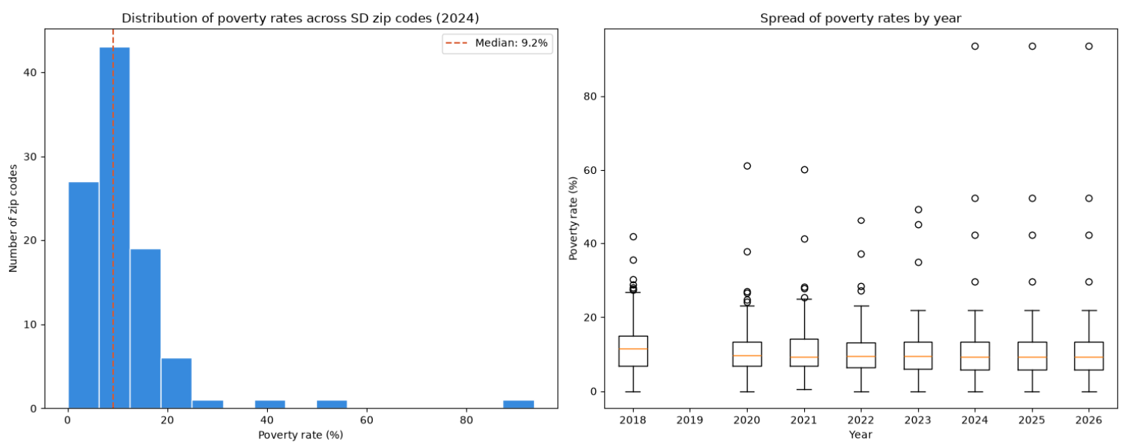

2. Range of Unemployment Rates
After removing 8 zips reporting exactly 0.0% unemployment (a small-sample artifact, not literal full employment), rates across the remaining 96 zips range from 0.3% to 21.6% (mean 6.3%, median 5.6%; skew 2.48 — right-skewed, but less extreme than poverty rate). The most reliable high-value finding is San Ysidro (92173, 12.8%, pop. 27,585); the most reliable low-value finding is Solana Beach (92075, 2.7%, pop. 11,944). Two raw extremes need caution: Pine Valley (91962, 21.6%) has a small population, and UCSD's campus zip (92093, 20.0%) reflects a mostly-student population rather than genuine economic distress.

3. Housing Cost Patterns
This section reports raw housing costs, not "cost burden" (cost as a share of income) — household income data was not part of this pull. Median gross rent across 91 zips ranges $854–$3,501 (median $2,252); median owner cost with mortgage across 95 zips ranges $1,843–$4,001 (median $3,076). Both maximums are ACS reporting ceilings, not true highs: 4 zips (91914, 92014, 92067, 92091) are top-coded on rent, and 8 zips (92007, 92009, 92014, 92067, 92075, 92091, 92118, 92130) on owner cost — so the true cost gap for San Diego's most expensive zips is understated. The top-15 most expensive zips are concentrated in San Diego, Chula Vista, Carlsbad, Rancho Santa Fe, Del Mar, Coronado, Cardiff-by-the-Sea, and Solana Beach — overwhelmingly coastal and North County communities.
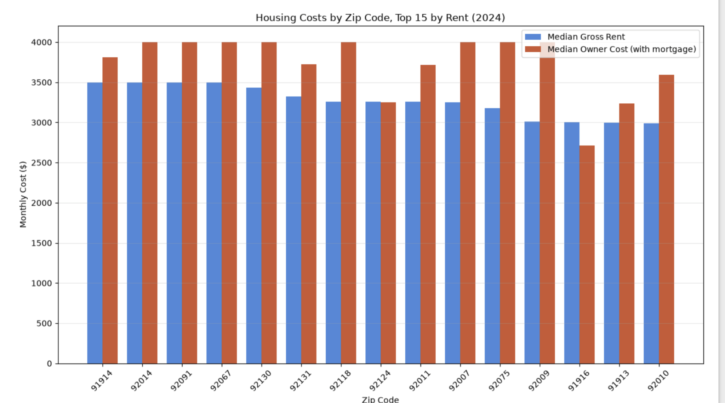

4. Demographic Indicators vs. Assistance Enrollment (Initial Observations)
Zip-level, per-capita correlations (preliminary, not causal): poverty rate vs. CalFresh $/capita, r = 0.12 (weak); vs. food pounds distributed/capita, r = 0.48 (moderate); vs. LIHEAP enrollment, r = 0.44 (moderate; n=89, Jan–Jul 2023 only, due to a known LIHEAP zip-capture gap). Food banks and LIHEAP track poverty reasonably well; CalFresh does not — the most notable finding of this analysis, suggesting enrollment gaps or eligibility mismatches worth further investigation. Poverty rate does not predict assistance uptake equally across program types.
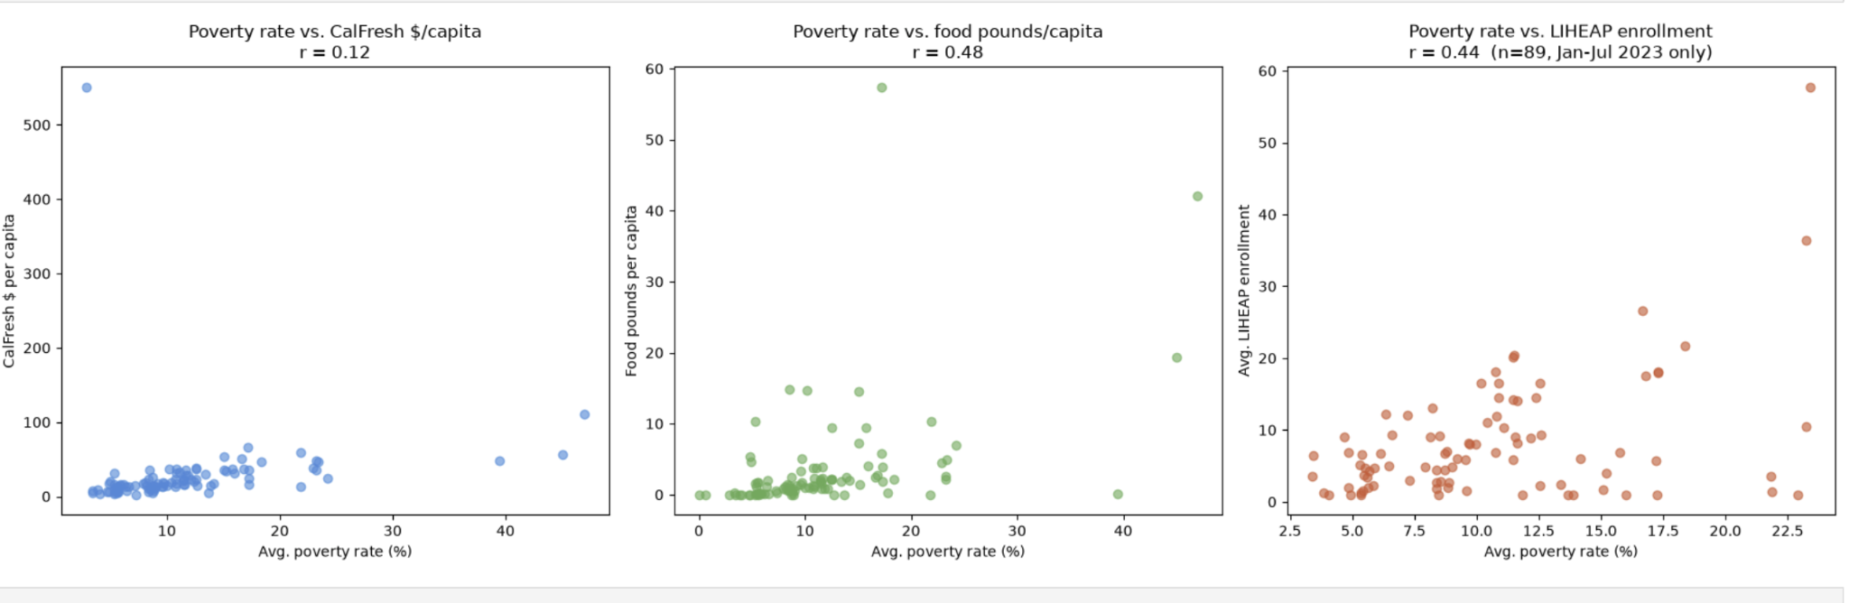

Summary of Key Caveats
- Zips under 2,000 population carry wide ACS margins of error; weight large zips more heavily in any ranking claim.
- Housing costs are top-coded at both ends and understate true costs for the most expensive zips.
- LIHEAP findings are built on a 7-month window (Jan–Jul 2023), not the full 2018–2025 study period.
- All figures reflect the 2024 ACS5 vintage (a 2020–2024 rolling 5-year estimate), not conditions in any single year.

