LIHEAP & Food Assistance Dashboard: Technical Documentation
San Diego Data Science Alliance · November 2026 · Version: Commit #12

1. Overview and code location
Item | Location
Live dashboard | https://liheapproject-vpwsxmw8wlptpcquxcczh9.streamlit.app (Streamlit Community Cloud)
Code repository | https://github.com/AHayslip23/LIHEAP_Project, branch main (public repo)
README | README.md at the repository root: findings, pipeline order, repository layout, how to run the dashboard, changelog
User guide | LIHEAP_Dashboard_UserGuide (Google Doc, Deliverables folder)
The project has two halves: a Jupyter analysis pipeline that cleans, joins and models the data and writes CSV/GeoJSON files to data/, and a Streamlit dashboard in app/ that reads those files. The dashboard never calls external APIs at run time, so it only changes when new data files or code are pushed.

Repository layout
Path | Contents
notebooks/ | 14 analysis notebooks, run in order (Section 3)
data/ | Datasets grouped by stage: LIHEAP/, CalFresh/, Food Bank/, ACS/, Integrated/, Policy_TimeLag/, Spatial/, Modeling/
app/Home.py | Entry page; overview, key findings, data sources
app/pages/1_Map.py … 8_Policy_Impact.py | One file per dashboard component; the number sets sidebar order
app/utils.py | Cached data loaders, shared sidebar filters, policy regimes, CSV download helper, chart styling, correlation statistics
app/train_models.py | Fits the CalFresh (Random Forest) and food bank (Linear Regression) models and their 90% interval widths
app/scenario.py | Loads or trains the models; scenario and sensitivity functions used by Forecast and Scenario Analysis
app/requirements.txt | Python packages installed by Streamlit Cloud
test_dashboard.py | Automated test of every page and its main controls (38 checks)
figures/, reports/, docs/images/ | Analysis charts, PDF deliverables, documentation screenshots

2. Architecture
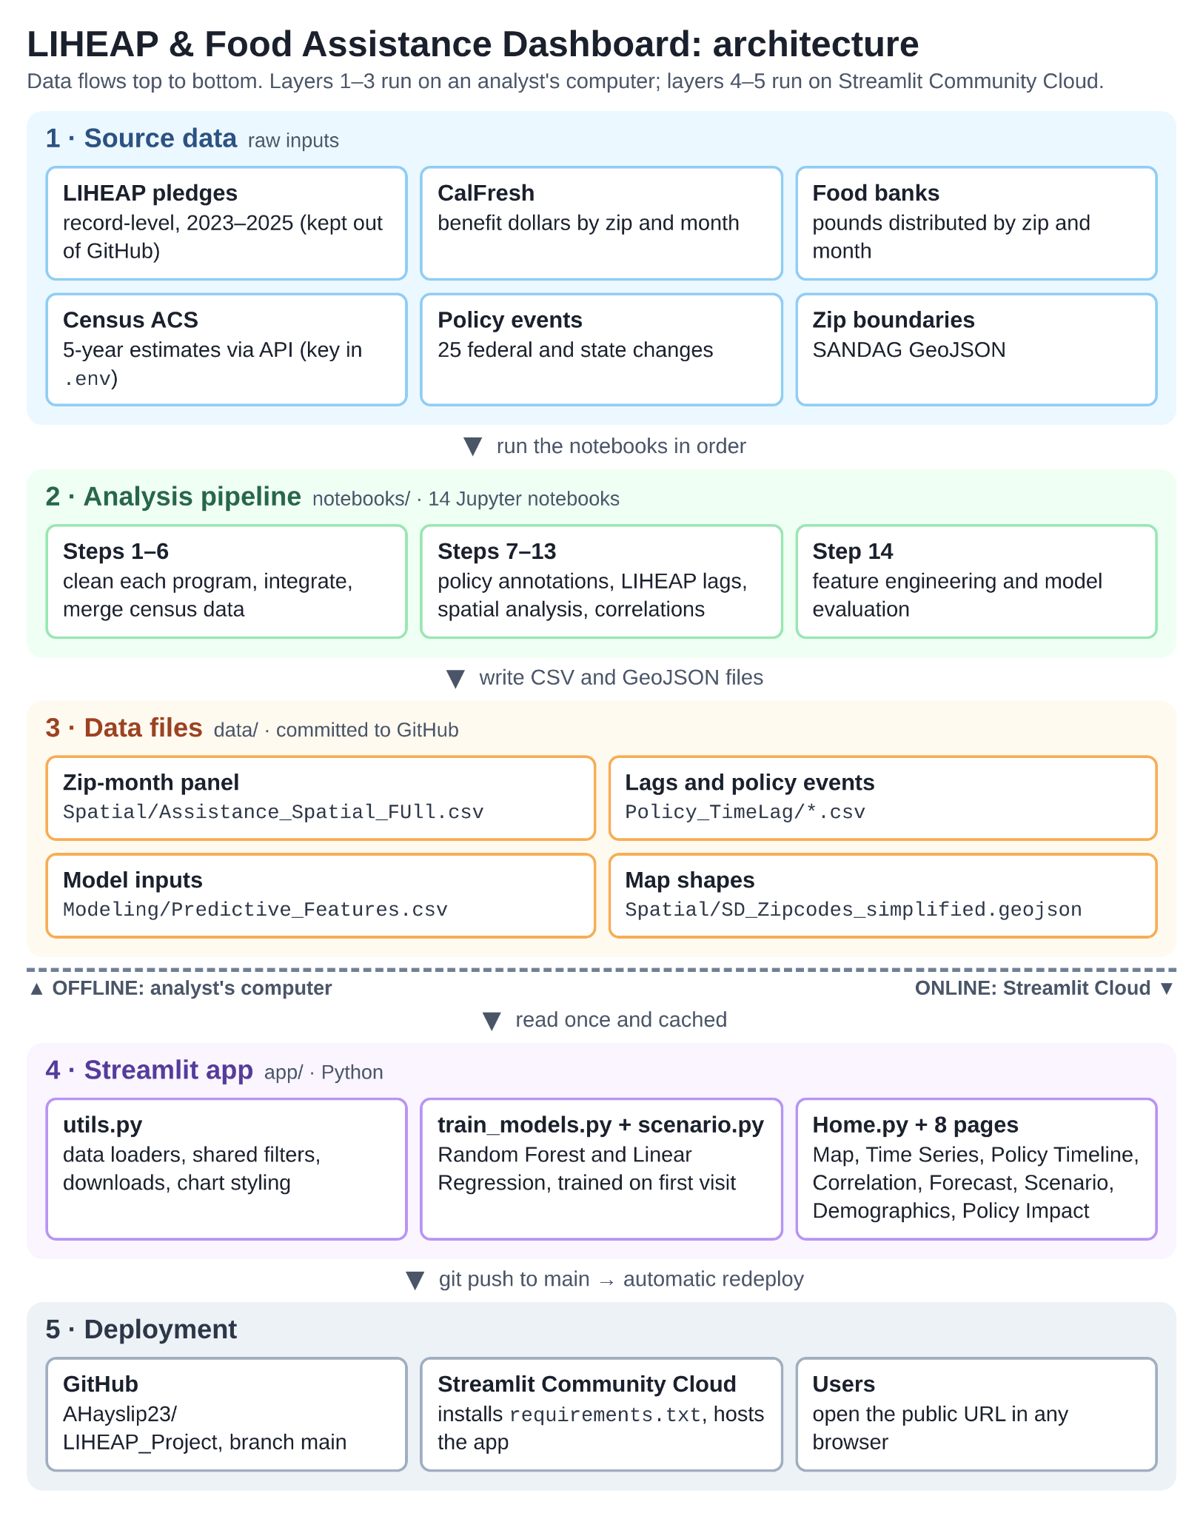
Figure 1. Architecture: source data → notebooks → data files → Streamlit app → deployment.
- Layers 1–3 (offline): analysts run the notebooks on their own computer; outputs are committed to GitHub. Record-level LIHEAP files and the Census API key stay local (git-ignored).
- Layer 4 (app): every page calls utils.sidebar_filters() and utils.apply_filters(), so filters behave the same everywhere. Loaders use @st.cache_data and the models use @st.cache_resource, so files and models load once per server process.
- Models: scenario.load_bundle() loads app/models/scenario_models.joblib; if it is missing or was saved by an incompatible scikit-learn version it runs train_models.main() (about one minute) and saves it. The file is git-ignored, so the cloud app trains on its first visit after each deploy.
- Layer 5 (deployment): Streamlit Community Cloud watches the GitHub repository and redeploys on every push to main.

3. Data pipeline
Run the notebooks in notebooks/ in this order, with notebooks/ as the working directory. Paths are relative (../data/...).
Step | Notebook | Main output (under data/)
1 | Data Cleaning LIHEAP | LIHEAP/LIHEAP_validated.csv (needs record-level file, not in repo)
2 | Calfresh Data Cleaning | CalFresh/CalFresh_cleaned.csv
3 | Food Banks Data Cleaning | Food Bank/FoodBank_cleaned.csv
4 | Coverage Matrix + Standardization of Data Sets | Integrated/Assistance_Integrated.csv
5 | Census_Demographic_Pull (Census API) | ACS/Demographics_SD_ZipCode.csv
6 | Merge of Census and Integrated Datasets | Integrated/Assistance_Demographics_Master.csv
7 | Notebook for Policy Annotations | Policy_TimeLag/Policy_Annotations.csv, Policy_Events.csv
8 | TimeLag_Generation | LIHEAP/LIHEAP_lags.csv
9 | Merge LIHEAP and Policy Annotation | Policy_TimeLag/TimeLag_PolicyAnnotated.csv
10 | TimeLag_PreliminaryCorrelations | preliminary lag correlations
11 | Spatial_Analysis | Spatial/Assistance_Spatial_FUll.csv, Zip_Segments.csv, maps
12 | Segment Analysis by Demographics | segment correlations
13 | Correlation_Analysis | Modeling/Zip_Correlation_Ranking.csv, report figures
14 | Predictive_Modeling | Modeling/Predictive_Features.csv, Feature_Dictionary.csv

Files the dashboard reads and rules applied on load
- Spatial/Assistance_Spatial_FUll.csv: zip × month panel (LIHEAP, CalFresh, food bank, ACS, city) for Map, Time Series, Demographics, Policy Impact.
- Policy_TimeLag/TimeLag_PolicyAnnotated.csv: LIHEAP lags 0–3 for the Correlation Explorer (Feb–Oct 2023).
- Policy_TimeLag/Policy_Events.csv: 25 policy events; edit this file to add or correct a policy (no code change needed).
- Modeling/Predictive_Features.csv: model inputs for Forecast and Scenario Analysis.
- Spatial/SD_Zipcodes_simplified.geojson: 121 KB simplified copy of SD_Zipcodes.geojson for the map.
- Rules: food bank months with 0 lb are treated as missing; LIHEAP is used only for Jan–Jul 2023 (later records mostly lack a zip code); 32 PO-box zip codes have no census data or map boundary and are labelled “(PO box)”.

Refresh procedure (when new data arrives)
- Add the new raw files to the matching data/ subfolder
- Re-run the notebooks in order from the first step that uses the new data through step 14 (for example, new CalFresh months: steps 2–14; new census data: steps 5–14).
- If policy information changed, edit data/Policy_TimeLag/Policy_Events.csv and re-run steps 7 and 9.
- Retrain the models: python app/train_models.py (or delete app/models/scenario_models.joblib; the app retrains on next load).
- If zip boundaries changed, regenerate the simplified map file (snippet below).
- Update hard-coded accuracy figures if the model evaluation changed: TEST_RESULTS in app/pages/5_Forecast.py.
- Test locally: python test_dashboard.py (all checks should pass), then streamlit run app/Home.py and click through.
- Commit and push; Streamlit Cloud redeploys within a few minutes. Open each page on the live URL to confirm.
# regenerate data/Spatial/SD_Zipcodes_simplified.geojson (needs: pip install shapely)
import json
from shapely.geometry import shape, mapping, MultiPolygon
from shapely.geometry.polygon import orient
g = json.load(open('data/Spatial/SD_Zipcodes.geojson'))
cw = lambda s: orient(s, -1.0) if s.geom_type == 'Polygon' else MultiPolygon([orient(p, -1.0) for p in s.geoms])
feats = [{'type': 'Feature', 'properties': {'zip': str(f['properties']['zip']).zfill(5)},
'geometry': mapping(cw(shape(f['geometry']).simplify(0.0008, preserve_topology=True)))}
for f in g['features']]
json.dump({'type': 'FeatureCollection', 'features': feats}, open('data/Spatial/SD_Zipcodes_simplified.geojson', 'w'))

4. Dependencies
Dashboard (app/requirements.txt). Versions below are the ones the full test suite passed with. requirements.txt currently lists package names without versions, so Streamlit Cloud installs the latest releases; pinning these versions (recommended) makes deployments repeatable.
Package | Tested version | Used for
Python | 3.12 (Streamlit Cloud setting) | Runtime
streamlit | 1.66.1 | Web app framework, multipage navigation, caching
pandas | 3.0.5 | Data loading and aggregation
numpy | 2.5.3 | Numerical work, log transforms, statistics
plotly | 7.1.0 | All charts and the zip-code map
scikit-learn | 1.9.1 | Random Forest and Linear Regression models
joblib | 1.6.0 | Saving and loading trained models

streamlit==1.66.1
pandas==3.0.5
numpy==2.5.3
plotly==7.1.0
scikit-learn==1.9.1
joblib==1.6.0
Analysis notebooks (not needed to run the dashboard). These are not pinned in the repository; record the exact versions on the analysis computer with pip freeze > requirements-notebooks.txt.
Package(s) | Used for
pandas, numpy, scipy | Cleaning, joins, correlations and statistical tests
matplotlib, seaborn, adjustText | Report figures
geopandas, mapclassify, libpysal, esda | Zip-code maps, spatial weights, Moran's I hot/cold spots
scikit-learn | Predictive modeling and validation
census, us, requests, python-dotenv | Census ACS API pull (key in .env)
zipcodes | Zip-code validation
openpyxl | Reading FOOD_BANKS_DATA.xlsx
pypdf, Pillow | Combining exported map PDFs and images
shapely (optional) | Regenerating the simplified map file

5. Deployment

Run locally
cd "C:\Users\alexh\Python\Data Science Alliance\LIHEAP_Project"
pip install -r app/requirements.txt
python test_dashboard.py # expect: 38 of 38 checks passed
streamlit run app/Home.py # opens http://localhost:8501 (Ctrl + C to stop)

Deploy to Streamlit Community Cloud (first time)
- Push the repository to GitHub (branch main), including the data/ files the app reads.
- Sign in at share.streamlit.io with the GitHub account that owns the repository and allow access to private repositories.
- Click Create app → deploy from a GitHub repository. Repository: AHayslip23/LIHEAP_Project; branch: main; main file path: app/Home.py.
- Under Advanced settings, choose Python 3.12. No secrets are needed (the dashboard does not call the Census API).
- Click Deploy. The first build installs the requirements (a few minutes); the first Forecast/Scenario visit trains the models (about a minute).
- Open every page on the live URL to verify, then use Share to set who can view the app.

Updating the live app
- Every push to main redeploys automatically. Run python test_dashboard.py before pushing.
- If the app does not pick up a change, open share.streamlit.io, click ⋮ next to the app and choose Reboot app.
- Build failures are shown in the app's log on share.streamlit.io; the usual causes are a missing package in requirements.txt or a moved data file.

6. Testing
test_dashboard.py uses Streamlit's built-in test harness (streamlit.testing.v1.AppTest) to open the Home page and all eight pages, change each page's main controls and shared filters, check that filters carry over between pages, print the CalFresh correlation for comparison with the report (0.68), and report any page error. It needs no browser and takes about a minute on first run (model training).

7. Known issues and limitations
Issue | Impact | Workaround / status
Zip-level LIHEAP data only for Jan–Jul 2023 | LIHEAP panels are blank outside those months; models use 7 months | Recover zip codes for later LIHEAP records
32 PO-box zip codes lack census data and map boundaries | Not on the map; excluded from Demographics; largest forecast errors | Labelled “(PO box)”; listed in tables
Unpinned requirements | A new library release could change behaviour or break model loading | Pin versions (Section 4); app retrains if a saved model will not load
Model file not stored in Git | First Forecast/Scenario visit after a deploy takes about a minute | Expected; commit the .joblib file if instant start-up matters
Free Streamlit Cloud tier | App sleeps after inactivity; limited memory | Visitors click “Yes, get this app back up!”
Map loads a drawing library from cdn.plot.ly | Map is blank without internet access or if blocked | Allow the site; other pages unaffected
utils.py changes while running locally | Pages report missing functions until restart | Restart streamlit run
Before/after and correlation views are descriptive | Seasonality and concurrent events are not controlled for | Stated on the pages; see Future enhancements
Hard-coded test accuracy on Forecast | Must be updated by hand after re-evaluation | Edit TEST_RESULTS in 5_Forecast.py

8. Future enhancements
- More LIHEAP data: recover zip codes for post-July 2023 records and add 2022 so models cover several stable periods and policy changes.
- Reproducible builds: pin app/requirements.txt and add requirements-notebooks.txt.
- Continuous integration: run test_dashboard.py automatically on every push with GitHub Actions.
- Pipeline automation: convert notebooks 1–14 into scripts (or a Makefile) so a data refresh is one command.
- Better attribution: add month fixed effects or difference-in-differences to the Policy Impact view to separate policy effects from seasonality.
- Model upkeep: re-evaluate and recalibrate intervals as new months arrive; show accuracy from the evaluation output instead of fixed numbers.
- Usability: neighborhood names for City of San Diego zip codes, saved filter links, and an accessibility review (colour contrast, screen readers).
- Hosting: move to a paid tier or another host if the app needs to stay awake or handle more visitors.

