LIHEAP & Food Assistance Dashboard: User Guide
San Diego Data Science Alliance · November 2026 · Open the live dashboard
1. Purpose and data sources
The dashboard shows how LIHEAP energy-assistance enrollment relates to CalFresh benefits and to food distributed (in pounds) by Feeding San Diego and the San Diego Food Bank across San Diego County. It also tracks how federal and state policy changes affected each program, and presents a predictive model that uses LIHEAP enrollment to estimate CalFresh benefits or food bank pounds. Open the link above in any browser; nothing needs to be installed.
- LIHEAP: validated enrollment by zip code, January–July 2023 (the only months with zip-level county data).
- CalFresh: benefit dollars by zip code and month, 2020–2025. Food banks: pounds distributed, 2018–2025.
- Census: American Community Survey 5-year estimates (poverty, unemployment, rent, age, households).
- Policy changes: 25 federal and state changes with effective dates, 2018–2025.
2. Navigating the views
Choose a page from the left sidebar (Figure 1). The Home page summarizes every page and the key findings.
Page | Use it to… | Main controls
Map | See which zip codes have the most enrollment, benefits or need over a period | Metric dropdown; tick Show only the filtered zip codes to map just the zips you filtered
Time Series | Follow monthly LIHEAP, CalFresh and food bank totals | Total / Per 1,000 households changes the y-axis; Show policy changes marks when policies took effect
Policy Timeline | See when policies were in effect and how totals moved | Program tabs list related policies; Program to plot and Highlight a policy focus the chart
Correlation Explorer | Check how closely LIHEAP tracks CalFresh or food bank | Outcome (CalFresh or food bank); LIHEAP lag (1–3 months earlier); Method (Pearson or Spearman coefficient)
Forecast | Compare model predictions with what actually happened | Program and Month (Feb–Aug 2023); enter a zip code and edit its lagged LIHEAP enrollment to test a prediction against the actual value
Scenario Analysis | Ask “what if LIHEAP enrollment were X% higher or lower?” | Program, Month, the Change in LIHEAP enrollment slider, and Focus on specific zip codes (see Section 3)
Demographics | Compare assistance by poverty, unemployment, rent and more | Split zip codes by picks the measure; Number of groups (thirds, quarters or fifths) sets the bars; Program for the scatter; Drill down into one group (see Section 4)
Policy Impact | Compare the months before and after a policy change | Policy change dropdown; Months before / after slider sets the comparison window
3. Using filters and the scenario tool
Most pages share the Filters in the sidebar (Figure 1): program type, time period, policy regime (e.g. “Emergency Allotments ended,” April–June 2023), city and zip code. Blank means “all.” The time period starts at every month with data; drag both ends, or use the quick-pick buttons All, 2023 (the year with zip-level LIHEAP data) and 1 year (the latest 12 months). The same period applies on every page, other choices also carry over, and Clear zip, city and regime filters resets them. The Correlation Explorer always uses February–October 2023; Forecast and Scenario Analysis set their month on the page.
Scenario Analysis (Figure 2): choose the program and month, then drag Change in LIHEAP enrollment (%) between −50% and +100%. The four numbers and the blue Takeaway box compare the estimate before and after your change. Below them, the left chart shows every change from −50% to +100% (your setting is the red dotted line) and the right chart lists the zip codes that move most (Figure 3). Open Focus on specific zip codes to limit results, or to change enrollment in chosen zips only.
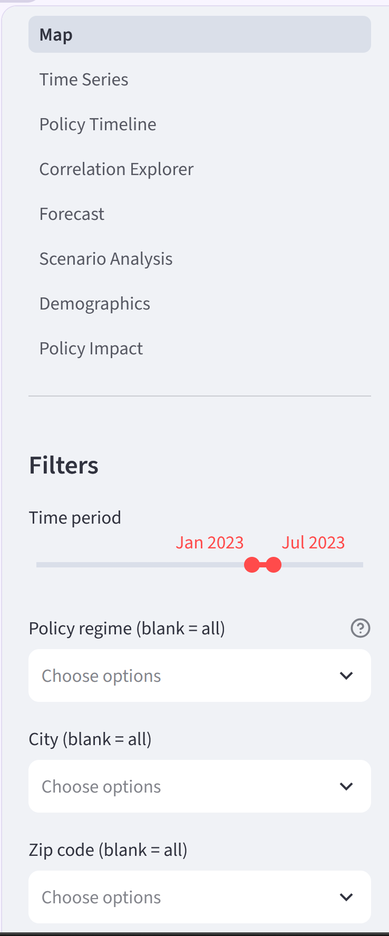  Figure 1. Page list and shared filters. | 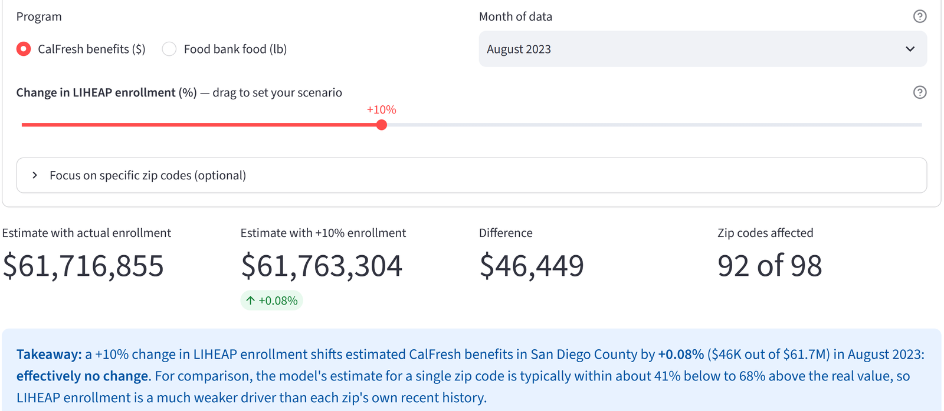  Figure 2. Scenario Analysis controls and results.
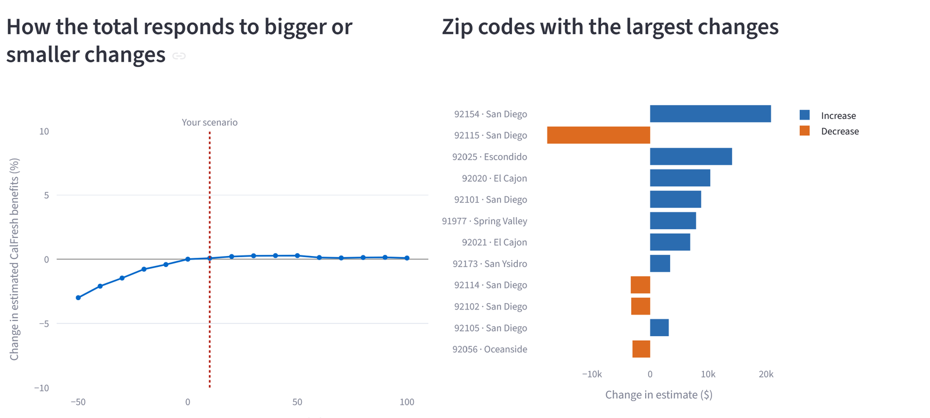
Figure 3. Scenario response curve and the zip codes that change most.
4. Interpreting model outputs and the policy timeline
- Actual vs predicted (Forecast, Figure 4): each dot is a zip code; dots on the dotted line were predicted exactly. Grey bars are 90% ranges that should contain the real value about 9 times in 10.
- Accuracy: on unseen months the model was off by about 7% per zip code for CalFresh and 21% for food bank; simply repeating last month’s value did as well or better (3% and 21%). Use forecasts as a cross-check, not a replacement for recent actuals.
- What-if results are small because last month’s value drives the model far more than LIHEAP: a 10% LIHEAP change moves CalFresh estimates by under 1%. Small bends and opposite-direction bars (Figure 3) are model noise. This describes the model, not a measured cause and effect.
- Policy Timeline: bars show when each policy was in effect (green = expected to raise the program, red = lower, grey = unclear). Numbered badges on the totals chart match the list beneath it.
- Policy Impact (Figure 5): compares average monthly levels before vs after a change, using only zip codes with data in both windows; dashed lines mark the two averages. A yellow Read with care note flags when the trend inside the window runs against the averages. Seasonal patterns and other changes in the same months can also contribute. The zip-code table gives the median change and how many zips rose, sorted from largest fall to largest rise.
- Demographic groups: zip codes are ranked by the chosen measure (e.g. poverty rate) and split into equal-sized groups. With thirds, Low holds the zips with the lowest values and High the highest; quarters and fifths run from Lowest to Highest. The drill-down table shows each group’s range, its typical zip code and how many zips it holds.
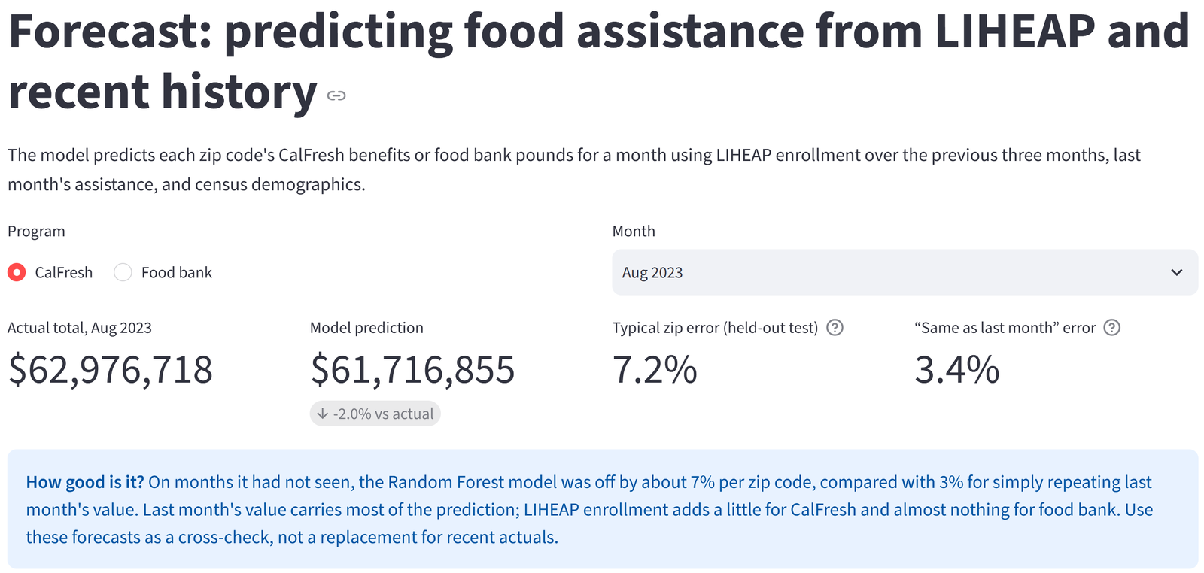
Figure 4. Forecast: actual vs predicted and model accuracy.
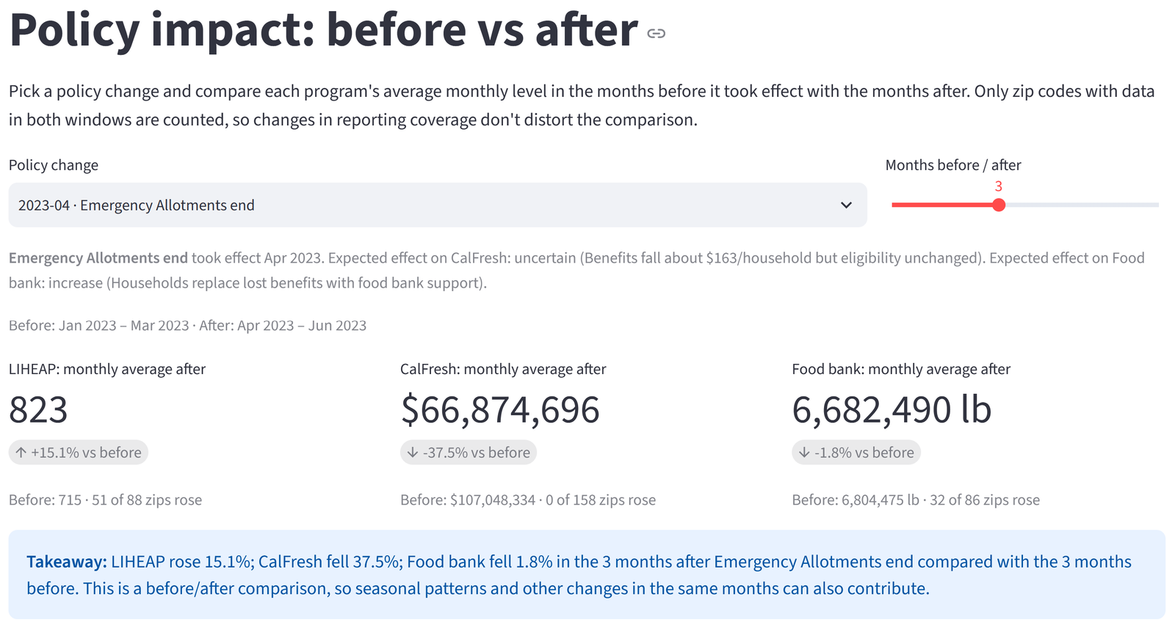
Figure 5. Policy Impact: before vs after a change.
5. Downloading data
Every page has a Download this data (CSV) button below its table, containing what the page shows with your current filters; it opens in Excel or Google Sheets. Scenario Analysis also has Download full results (CSV) with every column. To save a chart as an image, hover over it and click the camera icon in its toolbar.
6. Troubleshooting
Problem | What to do
“This app has gone to sleep” | Click Yes, get this app back up! and wait about a minute.
“Loading models…” on Forecast or Scenario | Normal on the first visit after a restart; the models train in about a minute.
LIHEAP charts are blank | Click 2023 under Time period; zip-level LIHEAP data covers January–July 2023 only.
“Too few zip codes” or “No data” | Click Clear zip, city and regime filters or widen the time period.
Map is empty | The map needs internet access to load; refresh, or allow the site in script-blocking extensions.
Numbers differ between pages | Pages count different zip codes (Policy Impact uses only zips with data before and after).
Page looks stuck | Refresh the browser tab; filters return to their defaults.

