iStnMonitor a software package for monitoring international LOFAR stations remotely
v1.2
2013-09-30
Tobia Carozzi (tobia@chalmers.se) and Simon Casey
Onsala Space Observatory, Sweden

Changes in v1.2
- The paths to standard Lofar commands have been updated to reflect changes in the MAC version 1.16 (currently latest). The paths have been placed in global variables, but users shouldn't have to change these unless they are using a MAC version prior to 1.16. (Before 1.16 the path to the environment control scripts were in /opt/stationtest/test/envcontroltest/ )

Changes in v1.1
- Cacti scripts have been updated to resolve incorrect correspondence between graphs labels and variables
- stnStatMon.py has been updated to reflect changes in isStatus.py output strings (“cab3” had been removed 21 June 2013)

Introduction
Although international LOFAR stations come equipped with numerous scripts for monitoring the status of the station, it is often useful to get the status information out of the LCU network, e.g., on a computer dedicated to centralized monitoring of observatory resources. The software package dubbed iStnMonitor provides this functionality.

Provides
The software provides a webpage with plots over time of environment control:
- Temperature (in container)
- Humidity (in container)
- 48V power supply ON/OFF status
and in addition
- swlevel
- ILT switch ON/OFF status

Prerequisites
In order to use the software, hardware-wise you need
- international LOFAR LCU
- Gateway (GW) PC (usually a computer with 2 ethernet cards: one to LCU & one to observatory network)
Software-wise you need python and cacti. It would be convenient if the GW PC had ubuntu linux.

Software contents
The iStnMonitor package consists of at least
- stnStatMon.py
  - which collates LCU status information
  - runs on LCU
- LCUcli.py
  - which reads status info and converts it for use in cacti
  - runs on GW PC or other PC on observatory network
- LOFAR_cacti_template_Fat.xml and LOFAR_cacti_templateNoFat.xml
  - which are xml descriptions of how to plot monitoring data on webpage
- mkRRD.sh
  - which creates the initial Round Robin Database files
Optionally you could use
- stnMonitorRelay.py
  - a script that relays UDP packets from LCU to cacti server via GW PC
- FatterLines.sh
  - Makes thicker lines in Cacti plots

Installation

On LCU
- copy over stnStatMon.py and monitor_crontabs.txt to LCU
- Edit stnStatMon.py to reflect the IP addresses and port number of your gateway PC (specifically: edit global variable GW_PC_UDP_IP )
- Create a crontab entry (crontab -e at prompt) and type
*/5 * * * * $HOME/iStnMonitor/stnStatMon.py >> stnStatus.log
for updates every five minutes. Note that $HOME is where you installed the iStnMonitor software. The redirect at the end is an example and can edited to suit tastes (and can even be removed), it simply provides a log file of the status data that was sent to the GW PC, so you should have this data anyways.

On GW PC (optional)
- Either copy over stnMonitorRelay.py and run this by putting into /etc/rc.local
- Or configure using iptables to reroute packets from LCU to cacti server

On cacti server

This section aims to provide the reader with a guide to install a web-based platform for viewing monitoring parameters of a LOFAR station. It is dependant on a package called Cacti which provides an easy to use interface to a database and graphing package called rrdtool.
First of all you will need to install Cacti, in Ubuntu, apt-get install cacti will install and configure Cacti and its dependencies.

Once Cacti is installed, you can create the empty Round Robin Database files which will be used for storing the logged data. Execute the mkRRD.sh script in a directory to which you have write access. This will create two files, LOFAR_status.rrd and LOFAR_environment.rrd. You will then need to move these to a suitable permanent location where the LCUcli.py script has write access to them, and the apache2 process has read access. On Ubuntu, the default location for RRD files is /var/lib/cacti/rra, so this may be a good location to choose, but remember to check the permissions, and note down the location you choose as it will be needed later on.

To enable fatter lines to be displayed in the graphs, some modifications need making to a few of the Cacti files. On Ubuntu, Cacti is installed to /usr/share/cacti/site and from within that directory, execute the FatterLines.sh script. This requires that you have sufficient permissions to modify files within this directory. If you don't, then you will need to use the LOFAR_cacti_template_NoFat.xml script in the next steps, otherwise you should use the script LOFAR_cacti_template_Fat.xml.

Assuming you are using a newly installed Cacti, open a web browser and go to http://cactiserver/cacti where you will be asked to login. The default login on Ubuntu is admin/admin, and on the following page you will be asked to choose a new password.

From the menu on the left, navigate to Import/Export -> Import Templates. Select the appropriate LOFAR template file, and choose “Use custom RRA settings from template”.
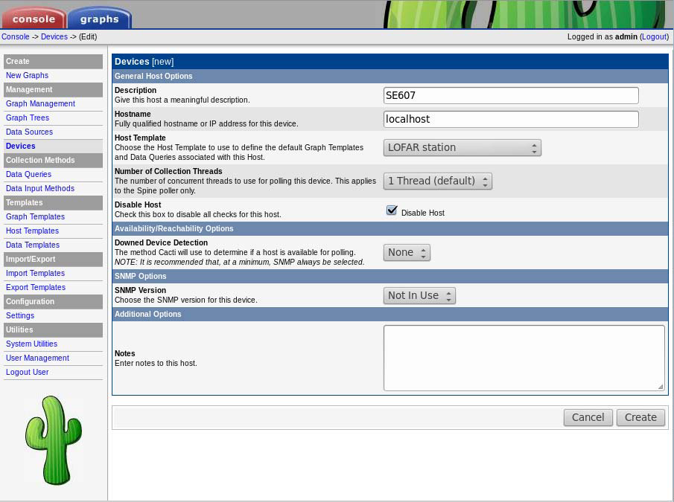Figure 1: Adding a 'LOFAR station' device

With the template imported, you now need to configure a device to use the template. Click Management -> Devices and you should have a single device listed, ‘localhost’. It’s unlikely you want to monitor the machine running cacti, so check the box to the right of this, and choose the delete action then click go to remove this. Now back in Management -> Devices, choose ‘add’. Fill in the details as in Figure 1. The description can be anything appropriate, probably your station code is a good idea. Click create.

Next, click ‘Create graphs for this host’. Check the boxes next to ‘LCU environment’ & ‘LCU status’ and click create, then create again on the next page.
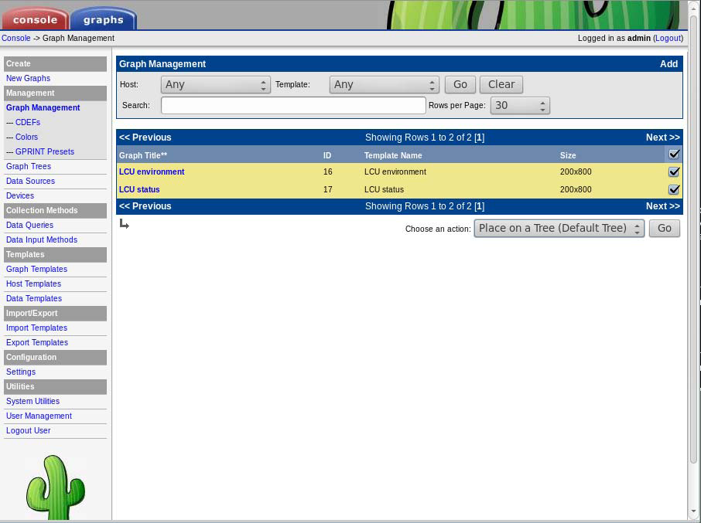Figure 2: Adding graphs to a tree

From the left menu, click Management -> Graph Management. If no rows are visible in the table, i.e. you don’t see the two LCU lines as in Figure 2, click Go in the “Graph Management” search box. Check the box beside each LCU line, then choose action “Place on a tree (Default Tree)” and click Go. On the next page, use the default Destination Branch [root] and click continue.

Finally, Cacti needs informing of where to source its data for the graphs. Click Management -> Data Sources. Again if no rows are visible, click Go in the “Data Sources” search box. For each of the two data sources, click on the name and on the next page enter the location to the appropriate RRD file that you created earlier, then click save.

With all this done, you should now be able to click on the Graphs tab, and be presented with 2 (empty) graphs.

From here on, you need to deploy the LCUcli.py on the machine hosting cacti. For this, you will need to take a note of the location of the two .rrd files you created earlier. Again, double check the permissions, they need to be readable by the httpd process, and writable by the user id that the LCUcli.py script will be running as.

