# Q1:

1. 
2. 
3. 
4. 
5. 
6. 
7. 
8. 
9. 
10. 

# Q2:

|  |  |  |
| --- | --- | --- |
| # | cat | Combine file content together and prints it out on standard output (screen / terminal) |
| 1 | more | Filter through text in files, starting from certain line or ending at specific words (vice versa) |
| 2 | cp | Copying files to specified destinations |
| 3 | mv | Moving files to specified destinations |
| 4 | rm | Removing files |
| 5 | ls | List all content in current directory, sorted alphabetically by default |
| 6 | mkdir | Make directories or folders, assume they don’t exist |
| 7 | cd | Changes directory, can give a path |
| 8 | pwd | Print the full name of the current directory or location to the screen/terminal |
| 9 | rmdir | Remove empty folders |
| 10 | whoami | Prints current user to screen/terminal |

# Q3:



# Q4:











# Q5:

1. Cal someYear -m someMonth
   1. cal 4 -m 2
   2. cal 52 -m 2
   3. cal 1752 -m 2
   4. cal 1952 -m 2
   5. cal 2004 -m 2
   6. cal 2005 -m 2

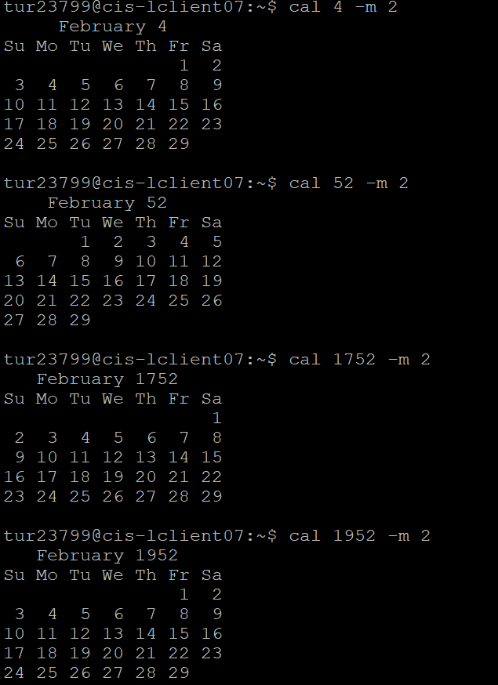

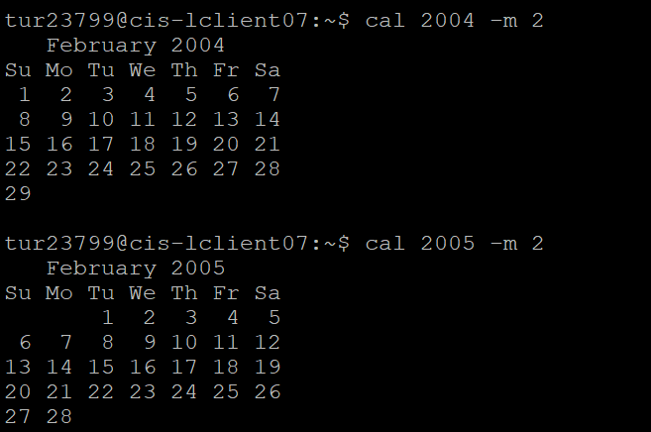

1. The commands work fine for both leap and non-leap years. Every year except for 2005 is a leap year, therefore Feb. has 29 days except for 2005. I also did more cal for 2016 - 2020. Only 2016 and 2020 had 29 days in Feb, the rest did not. Also the Julian calender showed the 355 days for normal years, and 366 for leap years.

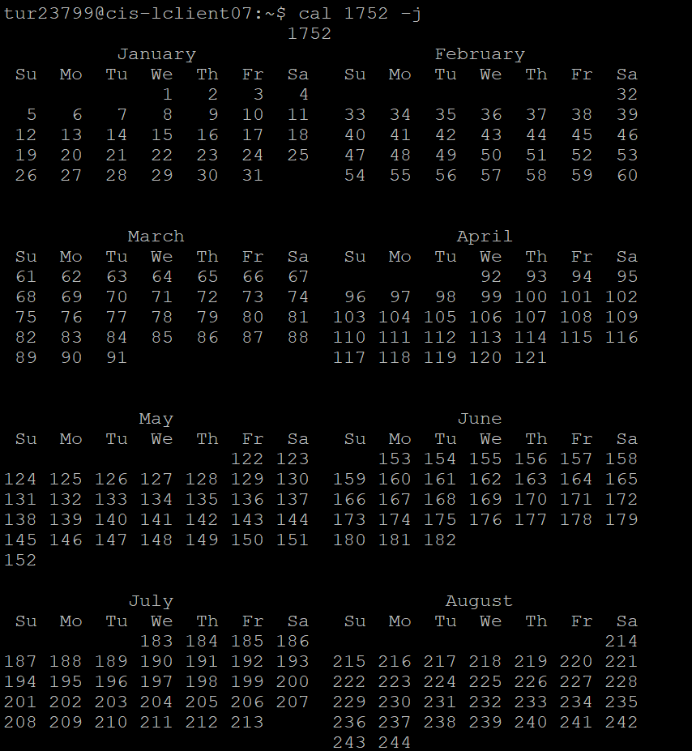

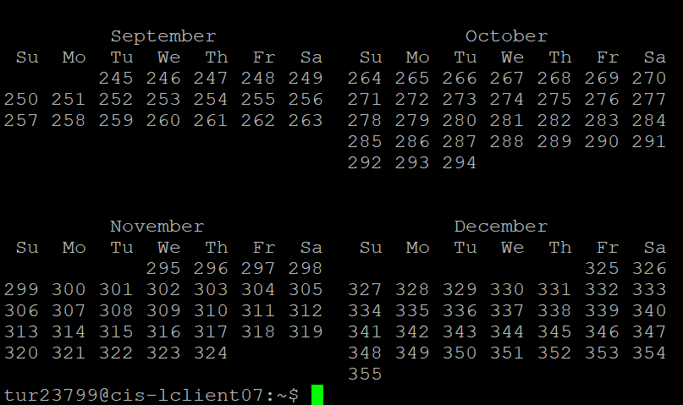

Year 1752 had 355 days instead of the typical 366 days of a leap year. Google had 15,800,000 results for the search of the Gregorian calendar. But it went down to 160,000 when I searched “Gregorian calendar 1752.” The reason for the 11 days missing from 1752 was because “the discrepancy between a solar year and the Julian Calendar had grown by an additional day, so that the calendar used in England and its colonies was 11 days out-of-sync with the Gregorian Calendar in use in most other parts of Europe.” Also the reason it’s named after Pope Gregory XIII.

([Gregorian calendar | Definition & Facts | Britannica](https://www.britannica.com/topic/Gregorian-calendar))

([1752 Calendar Change - Colonial Records & Topics - LibGuides Home at Connecticut State Library.](https://libguides.ctstatelibrary.org/hg/colonialresearch/calendar))

# Q6:

1. OS Name: Linux
2. domain name: cis-lclient07
3. Cpu: x86_64

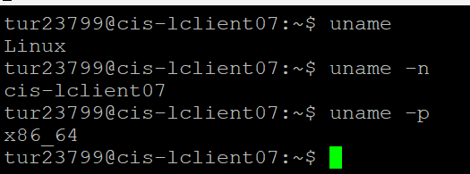

# Q7:

1. 9 users 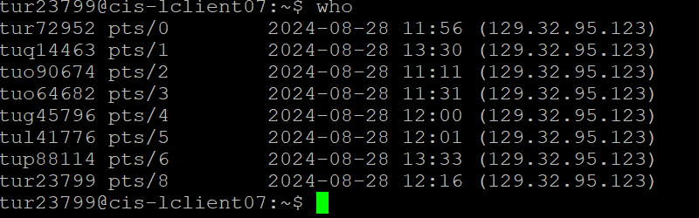

# Q8:

Bash & Tcsh

