Linux Multimedia Studio
Alexandre Hudon 9580433
Sardar Maninder Singh 6555519
Simon Symeonidis 5887887
Pavleen Kaur 9754733
Amir Hakim 4050711
Due: March 3, 11 marks

Github
As requested, the assignment code, and documents are all located here:
https://github.com/AHudon/SOEN6471_LMMS

Summary of Project
LMMS (Linux Multimedia Studio) is a DAW (Digital Audio Workstation), very similar to commercial ones, such as FL Studio. It provides facilities for you to engineer synthesizers in order to create instruments, and also piano rolls to create possible melodies. There exists a beat-bassline interface as well, to assign repetitive patterns quickly.

Class Diagram of Actual System
Below is the domain model with the corrections from the feedback of the previous milestone.

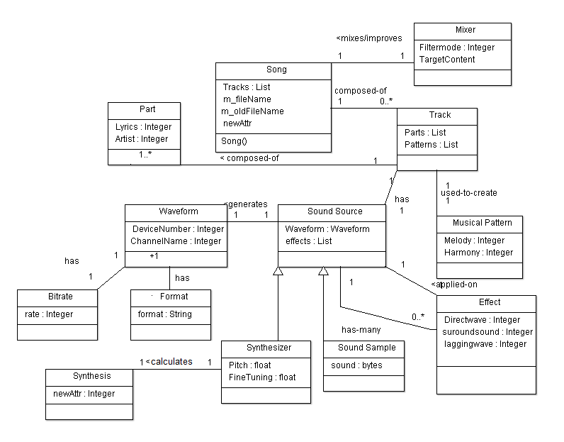
Figure1: General overview

Class Diagram

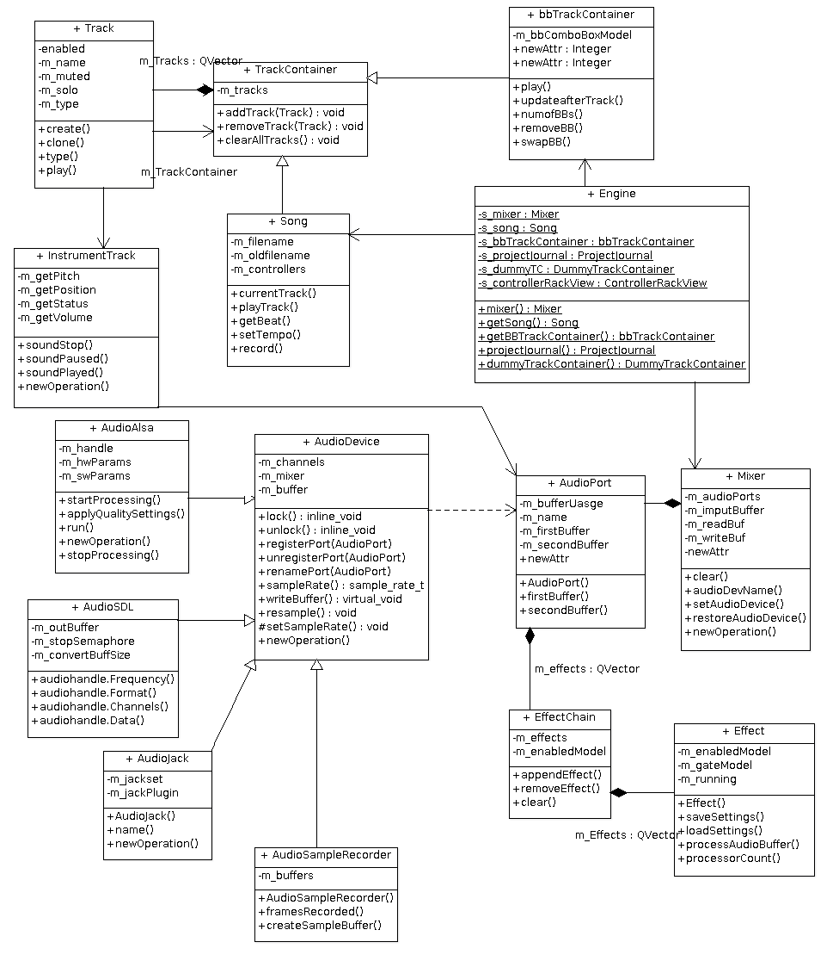
Figure 2: Focus on Track
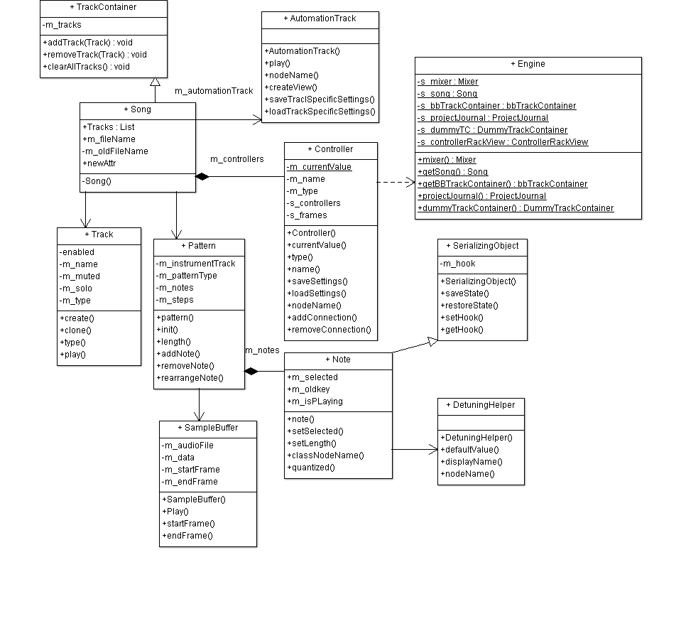
Figure 3: Focus on Song

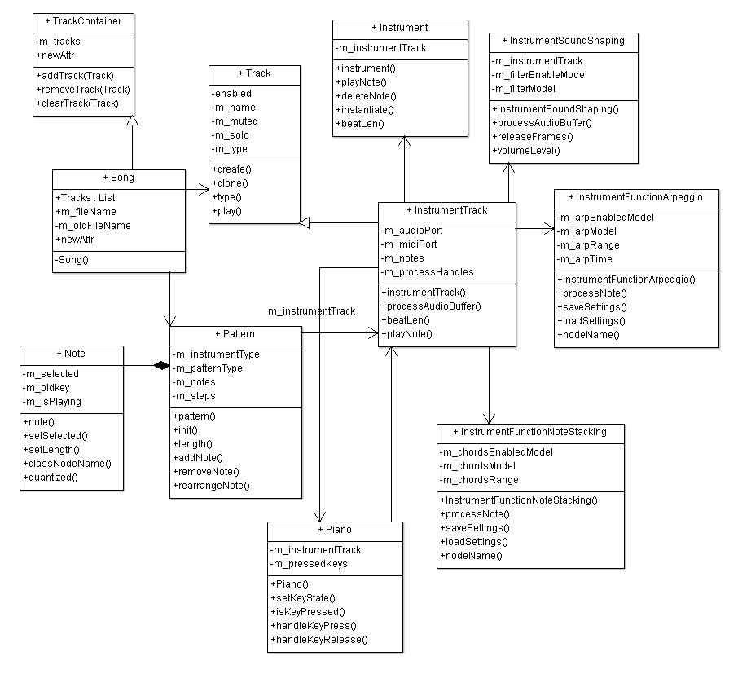
Figure 4: Focus on Instrument
In figure 1 we see the overal organisation of the software.

Conceptual Classes to Actual Classes
There is indeed a discrepancy between the concepts and the actual classes. For complex systems this will be much more obvious, because complex systems always require some auxiliary classes to 'glue' concepts together. For example aggregations might almost be similar, but mechanisms introduced (eg: Lazy Loading) are highly likely to break any possible, but highly unlikely 1-to-1 relationships from the Domain Model, to the Class Diagrams.
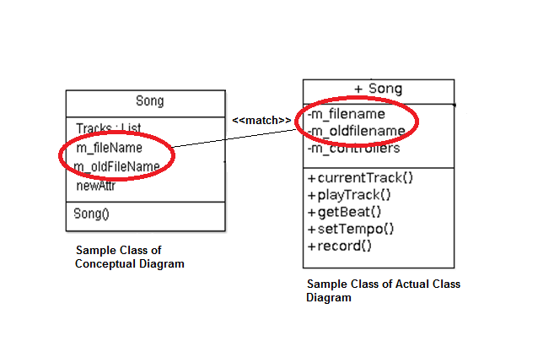
The Mixer, Song, Track and Musical Pattern map coherently, with the exception that Musical Pattern is not exactly the same as bbTrackContainer. The bbTrackContainer is a container for other tracks, and tracks aggregate notes. When we specified Musical Pattern, we meant a collection of notes that are repeated in different measures. This is implemented using some classes that are not listed in our class diagram (namely Pattern, and trackContentObject which together form a simple mechanism that makes this work), because we found that other parts of the system required much more care in terms of refactoring and quality improvement.
On the subject of Song, we spot very quickly a problem: inheritance abuse. In human thinking, it would be obvious that a song in this case is a collection of 'stacked' tracks. However in the case of the software, namely in Figure 1, we see that Song inherits from the TrackContainer. This is possibly something that we need to look into.
On the subject of Mixer, the domain entity is much different than in the class diagram. The mixer in the domain model was directly linked to the song, whereas in the practical case, there exists an Engine class that acts as a mediator between said Mixer, and Song.
The Engine almost acts as a singleton due to its global state: a collection of static fields usable from any part in the system, as observed in the source code (adding all direct relations would make the diagram very messy).
Track is much more decomposed in the software than in our domain model. In the domain model we though that a Track entity would suffice. However in the code, we found out that it requires a track container (TrackContainer) that aggregates Track instances. Also another unexpected issue we found is that Song directly inherits by this container. Track also aggregates contents using a 'TCO' object as observed in the code, less cryptically meaning "Track Content Object". This class is extended in order to provide different Track Content types inside a track. For example, a repeated pattern, versus a collection of notes that are only played once.
The Bitrate and Format were not in the class diagram. Though they make sense in a domain model (for example some person might like high quality (bitrate) mp3s (format) or some other person might like high quality Ogg Vorbis (format)), they're taken care of in a different fashion in practice - mainly delegated as fields to an exporter plugin (eg: LAME for mp3 etc).
Synthesis, Synthesizer, Sound Sample are taken care of in a much different fashion than what we had in mind. These are not included in the diagram. The reason is because they seem to have a good mechanism to deal with this already hence no refactoring need, and we foresaw that it would be too complex in this course to look into it further (on linux distributions, Wine (Windows Emulator) is used along in order to provide functionality for integration of VST/i instruments).
Overall the way that the above is achieved, is by having a Model store a generic plugin. The plugin can be anything: a synthesizer, a sample, a VST instrument, etc. The PluginView contains this information, and it is used with any other possible window (recall that models are coupled with UI in our case, so this hackery is possible). The InstrumentTrack contains a PluginView, and some other generic parts: Instrument{SoundShapingView, FunctionNoteStackingView, FunctionArpeggioView, InstrumentMidiIOView}, EffectRackView, which are present for any synthesizer.

Discrepancy between the Concepts and Classes
  - What does it mean to the architecture of the system?

Necessary Evils
Some of the domain objects in the application are coupled with the Qt (UI) library. In principle we know this is not favorable. In this specific case, it doesn't matter. There has been a lot of work done on the user interface, and it is very specific to the user base [1, 2, 3, 4].
Also, speaking from experience, Qt is probably the best option for developers to use in contrast with other technologies such as GTK+, wxWidgets, Fox Toolkit, etc. New user interface toolkits rarely appear, and regardless change is unlikely to happen. If there was a richer collection of user interface libraries to use, then this might have been a concern.

Reverse Engineering Tool (Doxygen)
We used Doxygen as a reverse engineering tool. If a system using Doxygen has the extra package 'graphviz', then apart from extracting the API of the application, we are able to extract many other diagrams of interest, namely class diagrams, and collaboration diagrams.
However in order to present the work, ArgoUML was used in order to make diagrams that are more readable. As previously stated, some classes in those diagrams were left blank or partly filled because in this project, long classes are quite common. This already raises an obvious need for refactoring.
- In maximum of one page, for two classes and the relationship between them:
For the two classes requested, we chose TrackContainer, and Track. We show how the relation exists, in this case the aggregation. We also show the similar methods and attributes that are demonstrated in the class diagram by selecting to paste specific code. The definition, and implementation of these classes is quite long, so most code is omitted.
Track Definition (header) [/include/track.h]
Track Implementation (cpp) [/src/core/track.h]

TrackContainer (header) [/include/TrackContainer.h]
TrackContainer Implementation (cpp) [/src/core/track.h]

Sample Classes:
Code to be pasted-----Related

Code Smells and System Level Refactorings

to be pasted

Figure 3: Partial class diagram of ____________ before refactoring

Code Smells :

Large Class ,

Feature Envy ,

Long Method,

Data Clumps:

Be idealistic! Restructure the system to fix some of the code smells you identified above.
- Describe the code smell(s) and how you will combine together a series of refactorings to fix the smells.
- Describe how the refactorings are interrelated and how they correct the problems you identified in the above. For example, “First, I moved the methods X and fields Y and Z, to increase cohesion and to reduce feature envy. Second I renamed the class to reflect its new limited responsibilities. Third I removed the coupling to …”
- 1 to 2 pages of text + 1 to 2 UML diagrams (diagrams should be at most 2 additional pages).

Figure 4: Proposed Partial class diagram of ______ for refactoring.

to be pasted

Specific Refactorings that you will implement in M4

Source code and Suggested Refactoring: -----to be Done

Large Class ,

Feature Envy ,

Long Method,

Data Clumps:

Be realistic, you have to implement at least two of these! Suggest two to four refactorings that you will implement in Milestone 4. In maximum of one page, for one of the refactorings you suggest: Copy-and-paste the class, method, and attributes declarations (and anything else that is necessary) directly from the source code. Do not include code that is unnecessary (be selective, you will lose marks for large dumps of source code.)
Notes:
- Algorithmic changes are not acceptable refactorings. You must deal with the logic and relationships between the classes -- ideally real world or domain entities.
- Stay away from the GUI classes as they often contain a lot of autogenerated non-domain code.
- Moving a code around without modifying it is unacceptable.
- Isolated changes that do not affect other parts of the system is unacceptable.
- Example of possible refactorings: Refactoring 1, fix some complex if statements. Refactoring 2, introduce a strategy pattern and use delegation to keep the system running. Gradually remove the delegation on some of the cases.

References

[1] | UI Gripes: http://sourceforge.net/p/lmms/mailman/message/31913561/
[2] | UI Rework: http://sourceforge.net/p/lmms/mailman/message/31853352/
[3] | New UI: http://sourceforge.net/p/lmms/mailman/message/31832076/
[4] | Song Editor Look: http://sourceforge.net/p/lmms/mailman/message/32009515/

