### Filename: GH6303829 RNA QC - 2025-08-18 - 10.36.49.RNA

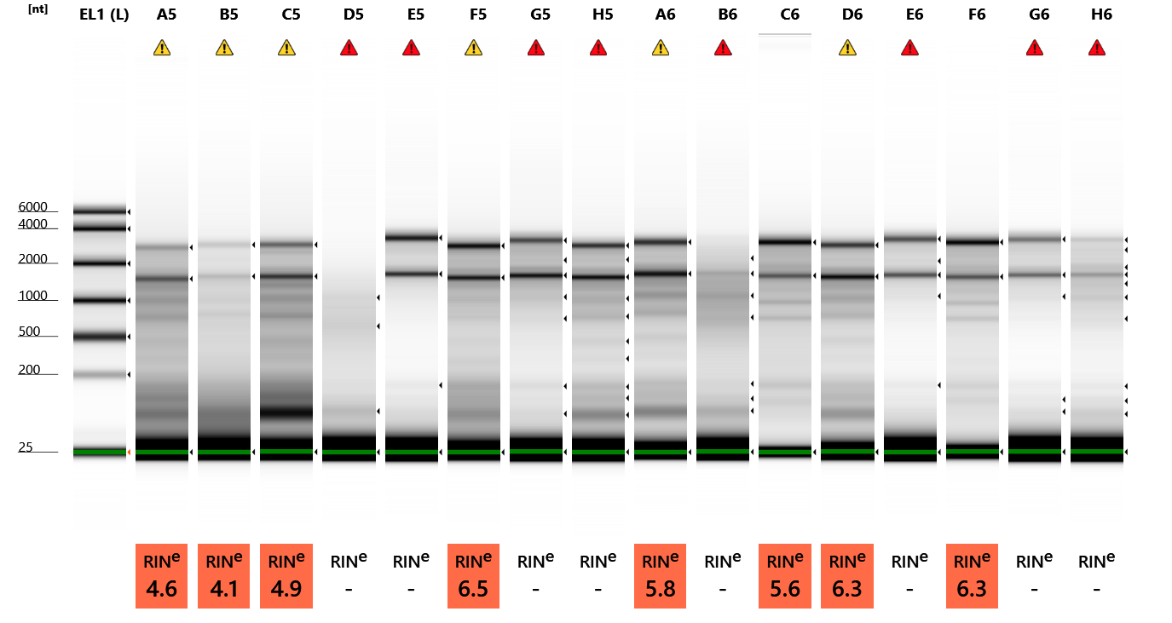

**Default image (Contrast 50%), Image is Scaled to Sample**

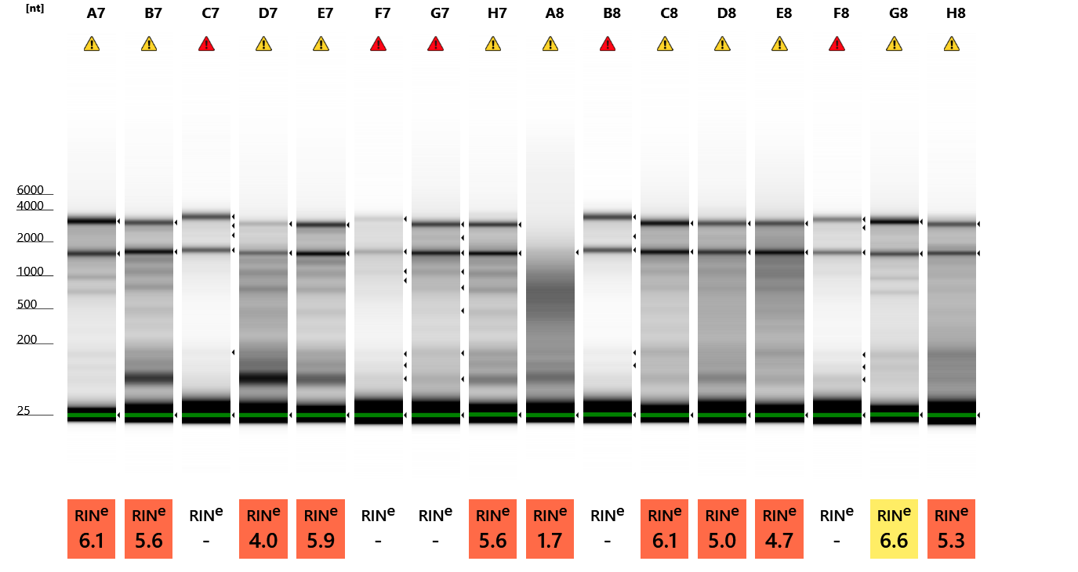

**Default image (Contrast 50%), Image is Scaled to Sample**

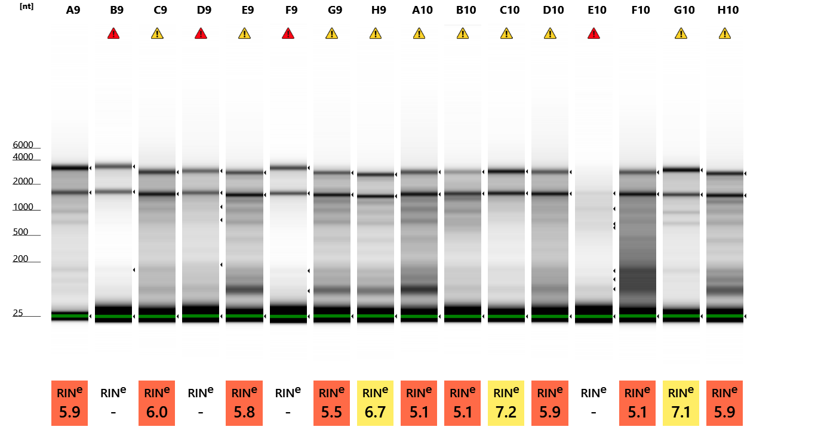

**Default image (Contrast 50%), Image is Scaled to Sample**

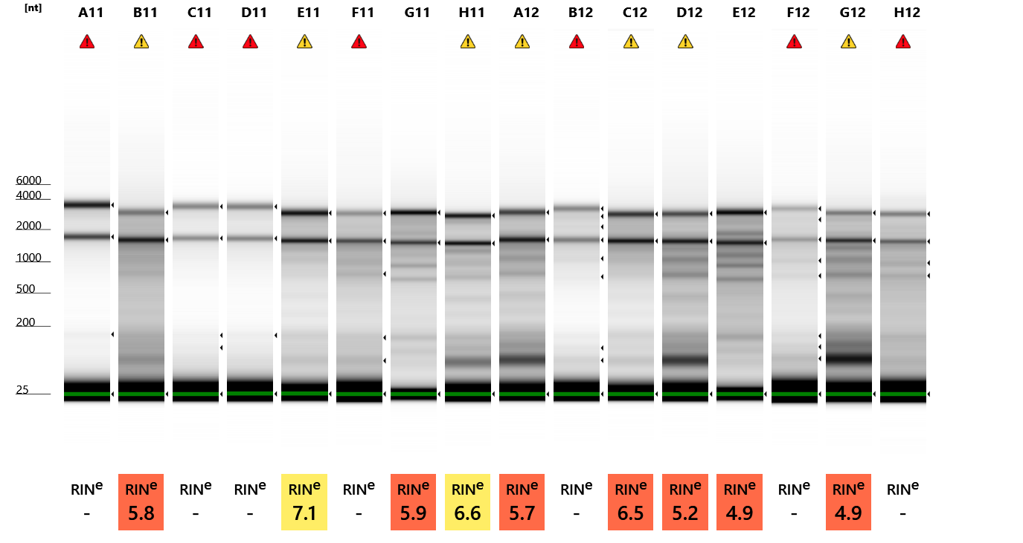

**Default image (Contrast 50%), Image is Scaled to Sample**

#### Sample Info

|  |  |  |  |  |  |  |
| --- | --- | --- | --- | --- | --- | --- |
| **Well** | **RIN**e | **28S/18S (Area)** | **Conc. [ng/µl]** | **Sample Description** | **Alert** | **Observations** |
| EL1 | - | - | 84.9 | Electronic Ladder |  | Ladder |
| A5 | 4.6 | 0.4 | 15.1 | RNA 1 | image0.png | Sample concentration outside functional range for RINe and the assay |
| B5 | 4.1 | 0.5 | 12.5 | RNA 2 | image0.png | Sample concentration outside functional range for RINe and the assay |
| C5 | 4.9 | 0.6 | 18.1 | RNA 3 | image0.png | Sample concentration outside functional range for RINe and the assay |
| D5 | - | - | 4.64 | RNA 4 | image0.png | Sample concentration outside functional range for RINe and the assay |
| E5 | - | - | 5.25 | RNA 5 | image0.png | Sample concentration outside functional range for RINe and the assay |
| F5 | 6.5 | 0.8 | 16.6 | RNA 6 | image0.png | Sample concentration outside functional range for RINe and the assay |
| G5 | - | - | 7.61 | RNA 7 | image0.png | Sample concentration outside functional range for RINe and the assay |
| H5 | - | - | 9.92 | RNA 8 | image0.png | Sample concentration outside functional range for RINe and the assay |
| A6 | 5.8 | 0.6 | 17.3 | RNA 9 | image0.png | Sample concentration outside functional range for RINe and the assay |
| B6 | - | - | 7.94 | RNA 10 | image0.png | Sample concentration outside functional range for RINe and the assay |
| C6 | 5.6 | 1.3 | 48.8 | RNA 11 |  |  |
| D6 | 6.3 | 0.6 | 17.5 | RNA 12 | image0.png | Sample concentration outside functional range for RINe and the assay |
| E6 | - | - | 4.67 | RNA 13 | image0.png | Sample concentration outside functional range for RINe and the assay |
| F6 | 6.3 | 1.3 | 26.3 | RNA 14 |  |  |
| G6 | - | - | 3.87 | RNA 15 | image0.png | Sample concentration outside functional range for RINe and the assay |
| H6 | - | - | 4.27 | RNA 16 | image0.png | Sample concentration outside functional range for RINe and the assay |
| A7 | 6.1 | 0.8 | 21.5 | RNA 17 | image0.png | Sample concentration outside functional range for RINe and the assay |
| B7 | 5.6 | 0.6 | 17.1 | RNA 18 | image0.png | Sample concentration outside functional range for RINe and the assay |
| C7 | - | - | 4.33 | RNA 19 | image0.png | Sample concentration outside functional range for RINe and the assay |
| D7 | 4.0 | 0.4 | 17.6 | RNA 20 | image0.png | Sample concentration outside functional range for RINe and the assay; The upper ribosomal fragment has degraded |
| E7 | 5.9 | 0.7 | 23.5 | RNA 21 | image0.png | Sample concentration outside functional range for RINe and the assay |
| F7 | - | - | 4.03 | RNA 22 | image0.png | Sample concentration outside functional range for RINe and the assay |
| G7 | - | - | 9.37 | RNA 23 | image0.png | Sample concentration outside functional range for RINe and the assay |
| H7 | 5.6 | 0.7 | 16.3 | RNA 24 | image0.png | Sample concentration outside functional range for RINe and the assay |
| A8 | 1.7 | - | 17.0 | RNA 25 | image0.png | Sample concentration outside functional range for RINe and the assay; The upper ribosomal fragment has degraded |
| B8 | - | - | 4.34 | RNA 26 | image0.png | Sample concentration outside functional range for RINe and the assay |
| C8 | 6.1 | 0.7 | 16.8 | RNA 27 | image0.png | Sample concentration outside functional range for RINe and the assay |
| D8 | 5.0 | 0.6 | 13.6 | RNA 28 | image0.png | Sample concentration outside functional range for RINe and the assay |
| E8 | 4.7 | 0.5 | 22.6 | RNA 29 | image0.png | Sample concentration outside functional range for RINe and the assay |
| F8 | - | - | 4.27 | RNA 30 | image0.png | Sample concentration outside functional range for RINe and the assay |
| G8 | 6.6 | 1.5 | 16.4 | RNA 31 | image0.png | Sample concentration outside functional range for RINe and the assay |
| H8 | 5.3 | 0.9 | 11.4 | RNA 32 | image0.png | Sample concentration outside functional range for RINe and the assay |
| A9 | 5.9 | 1.2 | 36.0 | RNA 33 |  |  |
| B9 | - | - | 4.36 | RNA 34 | image0.png | Sample concentration outside functional range for RINe and the assay |
| C9 | 6.0 | 0.7 | 14.5 | RNA 35 | image0.png | Sample concentration outside functional range for RINe and the assay |
| D9 | - | - | 8.47 | RNA 36 | image0.png | Sample concentration outside functional range for RINe and the assay |
| E9 | 5.8 | 0.6 | 19.8 | RNA 37 | image0.png | Sample concentration outside functional range for RINe and the assay |
| F9 | - | - | 4.09 | RNA 38 | image0.png | Sample concentration outside functional range for RINe and the assay |
| G9 | 5.5 | 0.6 | 13.0 | RNA 39 | image0.png | Sample concentration outside functional range for RINe and the assay |
| H9 | 6.7 | 1.0 | 12.3 | RNA 40 | image0.png | Sample concentration outside functional range for RINe and the assay |
| A10 | 5.1 | 0.7 | 21.3 | RNA 41 | image0.png | Sample concentration outside functional range for RINe and the assay |
| B10 | 5.1 | 0.6 | 10.3 | RNA 42 | image0.png | Sample concentration outside functional range for RINe and the assay |
| C10 | 7.2 | 0.9 | 11.3 | RNA 43 | image0.png | Sample concentration outside functional range for RINe and the assay |
| D10 | 5.9 | 0.6 | 16.4 | RNA 44 | image0.png | Sample concentration outside functional range for RINe and the assay |
| E10 | - | - | 4.04 | RNA 45 | image0.png | Sample concentration outside functional range for RINe and the assay |
| F10 | 5.1 | 0.6 | 28.4 | RNA 46 |  |  |
| G10 | 7.1 | 1.2 | 14.6 | RNA 47 | image0.png | Sample concentration outside functional range for RINe and the assay |
| H10 | 5.9 | 0.8 | 18.6 | RNA 48 | image0.png | Sample concentration outside functional range for RINe and the assay |
| A11 | - | - | 5.35 | RNA 49 | image0.png | Sample concentration outside functional range for RINe and the assay |
| B11 | 5.8 | 0.5 | 13.6 | RNA 50 | image0.png | Sample concentration outside functional range for RINe and the assay |
| C11 | - | - | 3.86 | RNA 51 | image0.png | Sample concentration outside functional range for RINe and the assay |
| D11 | - | - | 4.11 | RNA 52 | image0.png | Sample concentration outside functional range for RINe and the assay |
| E11 | 7.1 | 0.9 | 12.3 | RNA 53 | image0.png | Sample concentration outside functional range for RINe and the assay |
| F11 | - | - | 8.33 | RNA 54 | image0.png | Sample concentration outside functional range for RINe and the assay |
| G11 | 5.9 | 1.4 | 36.0 | RNA 55 |  |  |
| H11 | 6.6 | 0.9 | 12.8 | RNA 56 | image0.png | Sample concentration outside functional range for RINe and the assay |
| A12 | 5.7 | 0.6 | 16.2 | RNA 57 | image0.png | Sample concentration outside functional range for RINe and the assay |
| B12 | - | - | 5.11 | RNA 58 | image0.png | Sample concentration outside functional range for RINe and the assay |
| C12 | 6.5 | 0.7 | 12.9 | RNA 59 | image0.png | Sample concentration outside functional range for RINe and the assay |
| D12 | 5.2 | 0.6 | 15.7 | RNA 60 | image0.png | Sample concentration outside functional range for RINe and the assay |
| E12 | 4.9 | 1.0 | 33.4 | RNA 61 |  |  |
| F12 | - | - | 5.56 | RNA 62 | image0.png | Sample concentration outside functional range for RINe and the assay |
| G12 | 4.9 | 0.5 | 19.1 | RNA 63 | image0.png | Sample concentration outside functional range for RINe and the assay |
| H12 | - | - | 9.10 | RNA 64 | image0.png | Sample concentration outside functional range for RINe and the assay |

#### EL1: Electronic Ladder

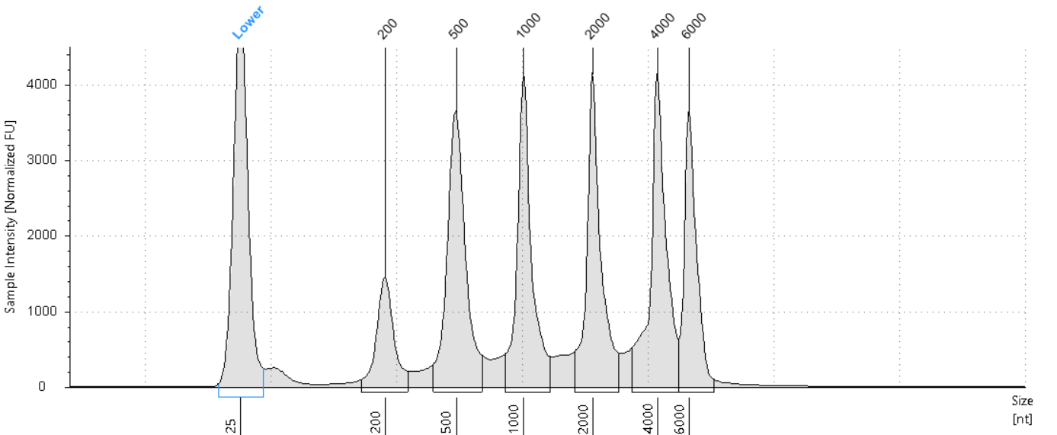

##### Sample Table

|  |  |  |  |  |  |  |
| --- | --- | --- | --- | --- | --- | --- |
| **Well** | **RIN**e | **28S/18S (Area)** | **Conc. [ng/µl]** | **Sample Description** | **Alert** | **Observations** |
| EL1 | - | - | 84.9 | Electronic Ladder |  | Ladder |

##### Peak Table

|  |  |  |  |  |  |  |
| --- | --- | --- | --- | --- | --- | --- |
| **Size [nt]** | **Calibrated Conc. [ng/µl]** | **Assigned Conc. [ng/µl]** | **Peak Molarity [nmol/l]** | **% Integrated Area** | **Peak Comment** | **Observations** |
| 25 | 40.0 | 40.0 | 4710 | - |  | Lower Marker |
| 200 | 5.94 | - | 87.4 | 7.80 |  |  |
| 500 | 15.9 | - | 93.6 | 20.88 |  |  |
| 1000 | 14.2 | - | 41.8 | 18.62 |  |  |
| 2000 | 13.8 | - | 20.3 | 18.11 |  |  |
| 4000 | 15.5 | - | 11.4 | 20.38 |  |  |
| 6000 | 10.8 | - | 5.31 | 14.22 |  |  |

#### A5: RNA 1

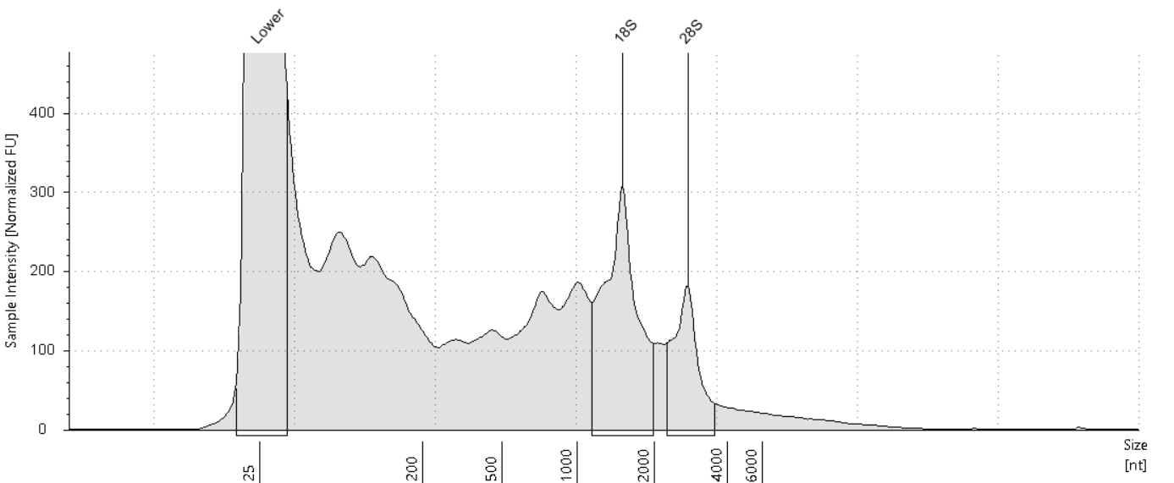

##### Sample Table

|  |  |  |  |  |  |  |
| --- | --- | --- | --- | --- | --- | --- |
| **Well** | **RIN**e | **28S/18S (Area)** | **Conc. [ng/µl]** | **Sample Description** | **Alert** | **Observations** |
| A5 | 4.6 | 0.4 | 15.1 | RNA 1 | image0.png | Sample concentration outside functional range for RINe and the assay |

##### Peak Table

|  |  |  |  |  |  |  |
| --- | --- | --- | --- | --- | --- | --- |
| **Size [nt]** | **Calibrated Conc. [ng/µl]** | **Assigned Conc. [ng/µl]** | **Peak Molarity [nmol/l]** | **% Integrated Area** | **Peak Comment** | **Observations** |
| 25 | 40.0 | 40.0 | 4710 | - |  | Lower Marker |
| 1501 | 2.39 | - | 4.69 | 69.10 |  | 18S |
| 2754 | 1.07 | - | 1.14 | 30.90 |  | 28S |

#### B5: RNA 2

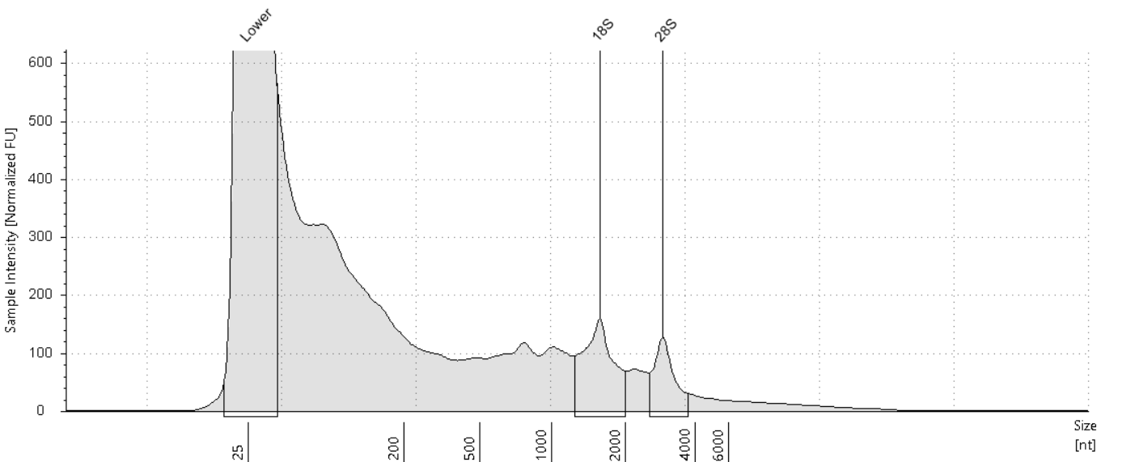

##### Sample Table

|  |  |  |  |  |  |  |
| --- | --- | --- | --- | --- | --- | --- |
| **Well** | **RIN**e | **28S/18S (Area)** | **Conc. [ng/µl]** | **Sample Description** | **Alert** | **Observations** |
| B5 | 4.1 | 0.5 | 12.5 | RNA 2 | image0.png | Sample concentration outside functional range for RINe and the assay |

##### Peak Table

|  |  |  |  |  |  |  |
| --- | --- | --- | --- | --- | --- | --- |
| **Size [nt]** | **Calibrated Conc. [ng/µl]** | **Assigned Conc. [ng/µl]** | **Peak Molarity [nmol/l]** | **% Integrated Area** | **Peak Comment** | **Observations** |
| 25 | 40.0 | 40.0 | 4710 | - |  | Lower Marker |
| 1571 | 1.07 | - | 2.01 | 65.46 |  | 18S |
| 2904 | 0.566 | - | 0.574 | 34.54 |  | 28S |

#### C5: RNA 3

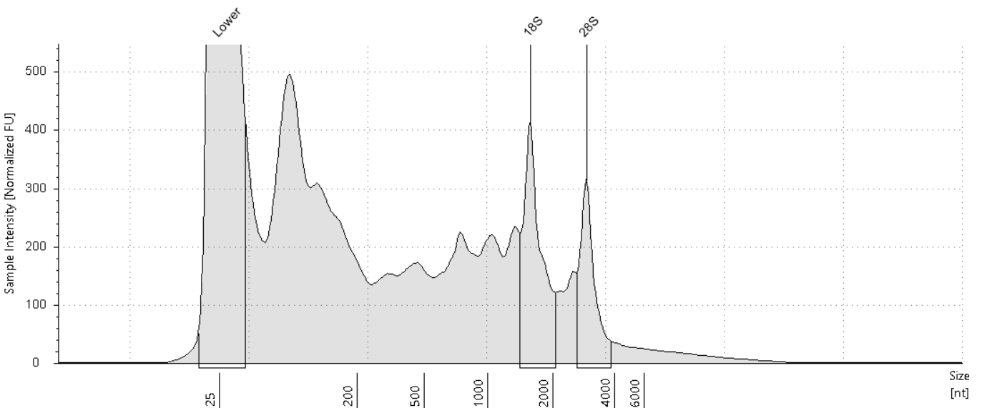

##### Sample Table

|  |  |  |  |  |  |  |
| --- | --- | --- | --- | --- | --- | --- |
| **Well** | **RIN**e | **28S/18S (Area)** | **Conc. [ng/µl]** | **Sample Description** | **Alert** | **Observations** |
| C5 | 4.9 | 0.6 | 18.1 | RNA 3 | image0.png | Sample concentration outside functional range for RINe and the assay |

##### Peak Table

|  |  |  |  |  |  |  |
| --- | --- | --- | --- | --- | --- | --- |
| **Size [nt]** | **Calibrated Conc. [ng/µl]** | **Assigned Conc. [ng/µl]** | **Peak Molarity [nmol/l]** | **% Integrated Area** | **Peak Comment** | **Observations** |
| 25 | 40.0 | 40.0 | 4710 | - |  | Lower Marker |
| 1568 | 1.88 | - | 3.53 | 61.43 |  | 18S |
| 2902 | 1.18 | - | 1.20 | 38.57 |  | 28S |

#### D5: RNA 4

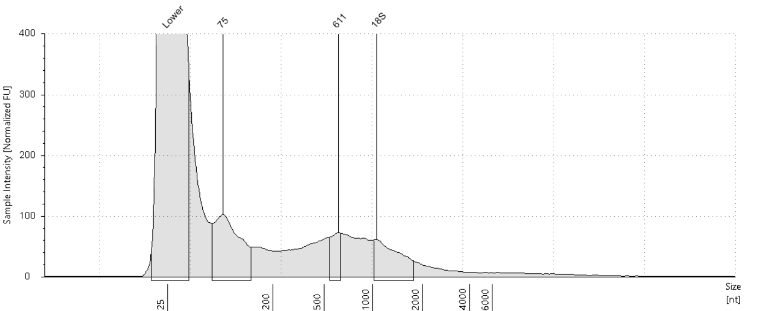

##### Sample Table

|  |  |  |  |  |  |  |
| --- | --- | --- | --- | --- | --- | --- |
| **Well** | **RIN**e | **28S/18S (Area)** | **Conc. [ng/µl]** | **Sample Description** | **Alert** | **Observations** |
| D5 | - | - | 4.64 | RNA 4 | image0.png | Sample concentration outside functional range for RINe and the assay |

##### Peak Table

|  |  |  |  |  |  |  |
| --- | --- | --- | --- | --- | --- | --- |
| **Size [nt]** | **Calibrated Conc. [ng/µl]** | **Assigned Conc. [ng/µl]** | **Peak Molarity [nmol/l]** | **% Integrated Area** | **Peak Comment** | **Observations** |
| 25 | 40.0 | 40.0 | 4710 | - |  | Lower Marker |
| 75 | 0.865 | - | 34.0 | 54.51 |  |  |
| 611 | 0.225 | - | 1.08 | 14.17 |  |  |
| 1059 | 0.497 | - | 1.38 | 31.32 |  | 18S |

#### E5: RNA 5

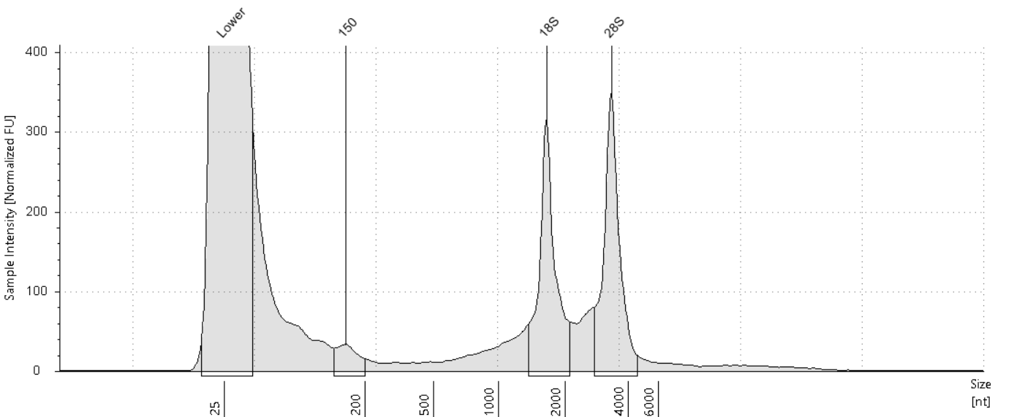

##### Sample Table

|  |  |  |  |  |  |  |
| --- | --- | --- | --- | --- | --- | --- |
| **Well** | **RIN**e | **28S/18S (Area)** | **Conc. [ng/µl]** | **Sample Description** | **Alert** | **Observations** |
| E5 | - | - | 5.25 | RNA 5 | image0.png | Sample concentration outside functional range for RINe and the assay |

##### Peak Table

|  |  |  |  |  |  |  |
| --- | --- | --- | --- | --- | --- | --- |
| **Size [nt]** | **Calibrated Conc. [ng/µl]** | **Assigned Conc. [ng/µl]** | **Peak Molarity [nmol/l]** | **% Integrated Area** | **Peak Comment** | **Observations** |
| 25 | 40.0 | 40.0 | 4710 | - |  | Lower Marker |
| 150 | 0.173 | - | 3.39 | 6.63 |  |  |
| 1644 | 1.15 | - | 2.06 | 44.22 |  | 18S |
| 3343 | 1.28 | - | 1.13 | 49.14 |  | 28S |

#### F5: RNA 6

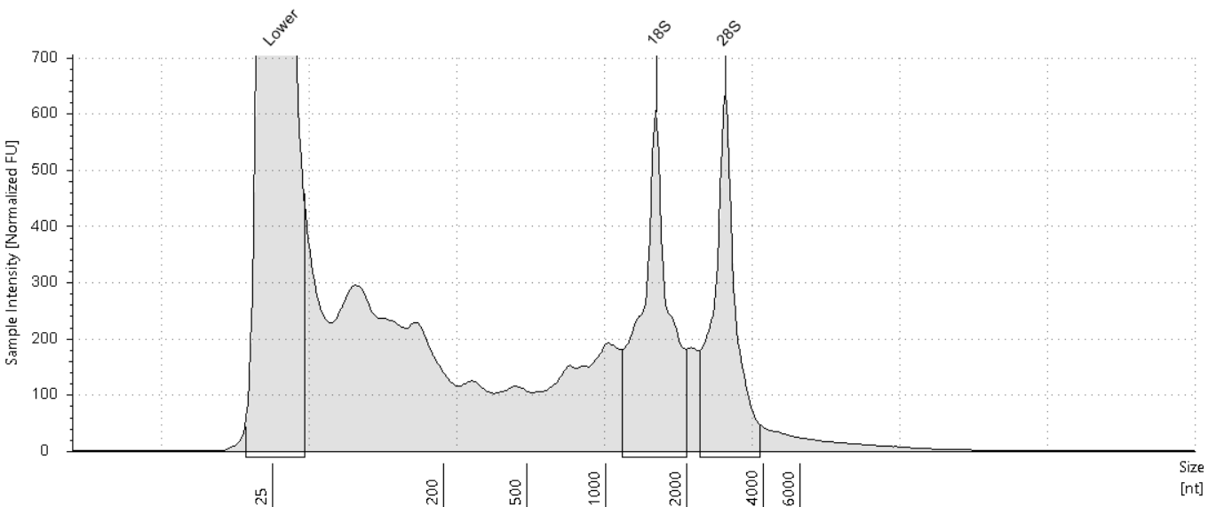

##### Sample Table

|  |  |  |  |  |  |  |
| --- | --- | --- | --- | --- | --- | --- |
| **Well** | **RIN**e | **28S/18S (Area)** | **Conc. [ng/µl]** | **Sample Description** | **Alert** | **Observations** |
| F5 | 6.5 | 0.8 | 16.6 | RNA 6 | image0.png | Sample concentration outside functional range for RINe and the assay |

##### Peak Table

|  |  |  |  |  |  |  |
| --- | --- | --- | --- | --- | --- | --- |
| **Size [nt]** | **Calibrated Conc. [ng/µl]** | **Assigned Conc. [ng/µl]** | **Peak Molarity [nmol/l]** | **% Integrated Area** | **Peak Comment** | **Observations** |
| 25 | 40.0 | 40.0 | 4710 | - |  | Lower Marker |
| 1540 | 3.15 | - | 6.02 | 54.20 |  | 18S |
| 2856 | 2.66 | - | 2.74 | 45.80 |  | 28S |

#### G5: RNA 7

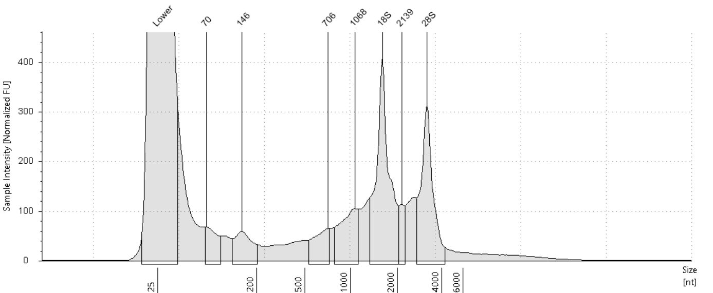

##### Sample Table

|  |  |  |  |  |  |  |
| --- | --- | --- | --- | --- | --- | --- |
| **Well** | **RIN**e | **28S/18S (Area)** | **Conc. [ng/µl]** | **Sample Description** | **Alert** | **Observations** |
| G5 | - | - | 7.61 | RNA 7 | image0.png | Sample concentration outside functional range for RINe and the assay |

##### Peak Table

|  |  |  |  |  |  |  |
| --- | --- | --- | --- | --- | --- | --- |
| **Size [nt]** | **Calibrated Conc. [ng/µl]** | **Assigned Conc. [ng/µl]** | **Peak Molarity [nmol/l]** | **% Integrated Area** | **Peak Comment** | **Observations** |
| 25 | 40.0 | 40.0 | 4710 | - |  | Lower Marker |
| 70 | 0.280 | - | 11.8 | 5.92 |  |  |
| 146 | 0.343 | - | 6.92 | 7.25 |  |  |
| 706 | 0.324 | - | 1.35 | 6.85 |  |  |
| 1068 | 0.618 | - | 1.70 | 13.04 |  |  |
| 1602 | 1.72 | - | 3.15 | 36.24 |  | 18S |
| 2139 | 0.209 | - | 0.288 | 4.42 |  |  |
| 3176 | 1.24 | - | 1.15 | 26.28 |  | 28S |

#### H5: RNA 8

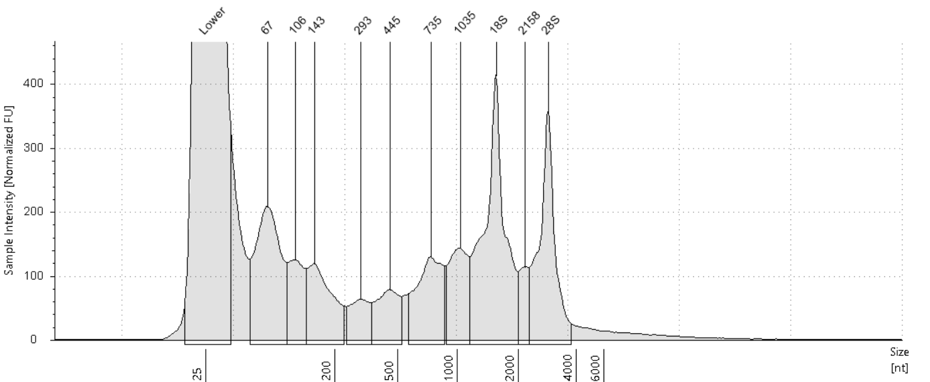

##### Sample Table

|  |  |  |  |  |  |  |
| --- | --- | --- | --- | --- | --- | --- |
| **Well** | **RIN**e | **28S/18S (Area)** | **Conc. [ng/µl]** | **Sample Description** | **Alert** | **Observations** |
| H5 | - | - | 9.92 | RNA 8 | image0.png | Sample concentration outside functional range for RINe and the assay |

##### Peak Table

|  |  |  |  |  |  |  |
| --- | --- | --- | --- | --- | --- | --- |
| **Size [nt]** | **Calibrated Conc. [ng/µl]** | **Assigned Conc. [ng/µl]** | **Peak Molarity [nmol/l]** | **% Integrated Area** | **Peak Comment** | **Observations** |
| 25 | 40.0 | 40.0 | 4710 | - |  | Lower Marker |
| 67 | 1.38 | - | 59.9 | 15.67 |  |  |
| 106 | 0.514 | - | 14.3 | 5.86 |  |  |
| 143 | 0.761 | - | 15.6 | 8.66 |  |  |
| 293 | 0.340 | - | 3.42 | 3.87 |  |  |
| 445 | 0.463 | - | 3.06 | 5.27 |  |  |
| 735 | 0.840 | - | 3.36 | 9.57 |  |  |
| 1035 | 0.728 | - | 2.07 | 8.30 |  |  |
| 1551 | 2.08 | - | 3.94 | 23.66 |  | 18S |
| 2158 | 0.286 | - | 0.390 | 3.26 |  |  |
| 2859 | 1.39 | - | 1.43 | 15.88 |  | 28S |

#### A6: RNA 9

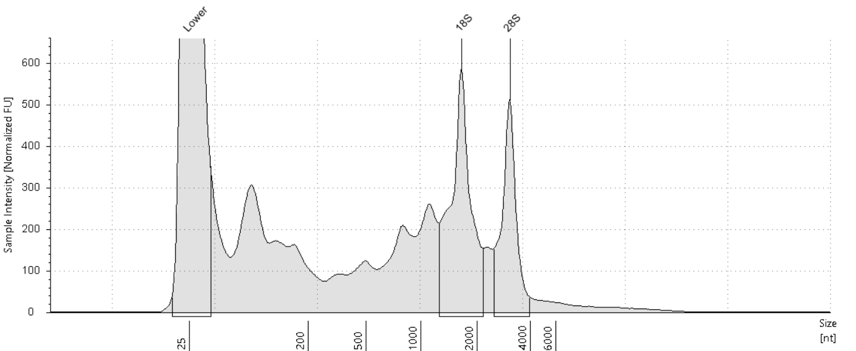

##### Sample Table

|  |  |  |  |  |  |  |
| --- | --- | --- | --- | --- | --- | --- |
| **Well** | **RIN**e | **28S/18S (Area)** | **Conc. [ng/µl]** | **Sample Description** | **Alert** | **Observations** |
| A6 | 5.8 | 0.6 | 17.3 | RNA 9 | image0.png | Sample concentration outside functional range for RINe and the assay |

##### Peak Table

|  |  |  |  |  |  |  |
| --- | --- | --- | --- | --- | --- | --- |
| **Size [nt]** | **Calibrated Conc. [ng/µl]** | **Assigned Conc. [ng/µl]** | **Peak Molarity [nmol/l]** | **% Integrated Area** | **Peak Comment** | **Observations** |
| 25 | 40.0 | 40.0 | 4710 | - |  | Lower Marker |
| 1652 | 3.70 | - | 6.59 | 61.41 |  | 18S |
| 3070 | 2.33 | - | 2.23 | 38.59 |  | 28S |

#### B6: RNA 10

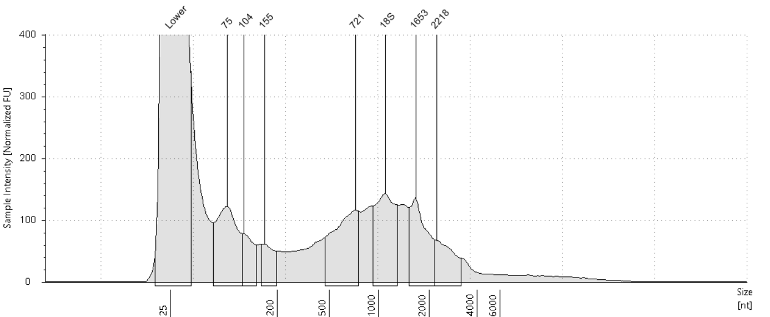

##### Sample Table

|  |  |  |  |  |  |  |
| --- | --- | --- | --- | --- | --- | --- |
| **Well** | **RIN**e | **28S/18S (Area)** | **Conc. [ng/µl]** | **Sample Description** | **Alert** | **Observations** |
| B6 | - | - | 7.94 | RNA 10 | image0.png | Sample concentration outside functional range for RINe and the assay |

##### Peak Table

|  |  |  |  |  |  |  |
| --- | --- | --- | --- | --- | --- | --- |
| **Size [nt]** | **Calibrated Conc. [ng/µl]** | **Assigned Conc. [ng/µl]** | **Peak Molarity [nmol/l]** | **% Integrated Area** | **Peak Comment** | **Observations** |
| 25 | 40.0 | 40.0 | 4710 | - |  | Lower Marker |
| 75 | 0.913 | - | 35.7 | 19.62 |  |  |
| 104 | 0.309 | - | 8.71 | 6.63 |  |  |
| 155 | 0.258 | - | 4.89 | 5.55 |  |  |
| 721 | 0.970 | - | 3.96 | 20.84 |  |  |
| 1092 | 0.969 | - | 2.61 | 20.81 |  | 18S |
| 1653 | 0.803 | - | 1.43 | 17.26 |  |  |
| 2218 | 0.432 | - | 0.572 | 9.27 |  |  |

#### C6: RNA 11

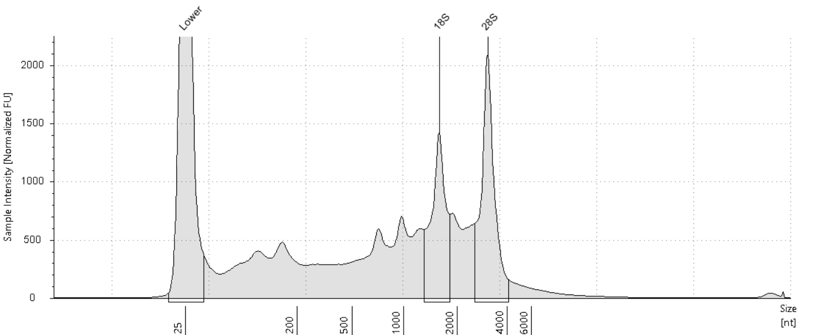

##### Sample Table

|  |  |  |  |  |  |  |
| --- | --- | --- | --- | --- | --- | --- |
| **Well** | **RIN**e | **28S/18S (Area)** | **Conc. [ng/µl]** | **Sample Description** | **Alert** | **Observations** |
| C6 | 5.6 | 1.3 | 48.8 | RNA 11 |  |  |

##### Peak Table

|  |  |  |  |  |  |  |
| --- | --- | --- | --- | --- | --- | --- |
| **Size [nt]** | **Calibrated Conc. [ng/µl]** | **Assigned Conc. [ng/µl]** | **Peak Molarity [nmol/l]** | **% Integrated Area** | **Peak Comment** | **Observations** |
| 25 | 40.0 | 40.0 | 4710 | - |  | Lower Marker |
| 1596 | 7.30 | - | 13.5 | 43.28 |  | 18S |
| 3059 | 9.57 | - | 9.20 | 56.72 |  | 28S |

#### D6: RNA 12

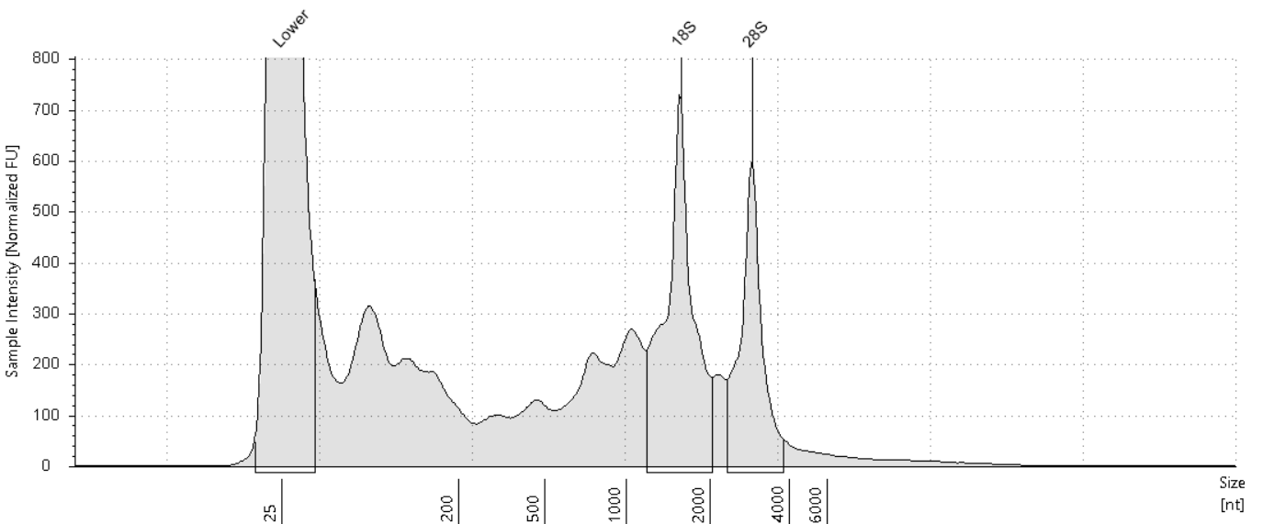

##### Sample Table

|  |  |  |  |  |  |  |
| --- | --- | --- | --- | --- | --- | --- |
| **Well** | **RIN**e | **28S/18S (Area)** | **Conc. [ng/µl]** | **Sample Description** | **Alert** | **Observations** |
| D6 | 6.3 | 0.6 | 17.5 | RNA 12 | image0.png | Sample concentration outside functional range for RINe and the assay |

##### Peak Table

|  |  |  |  |  |  |  |
| --- | --- | --- | --- | --- | --- | --- |
| **Size [nt]** | **Calibrated Conc. [ng/µl]** | **Assigned Conc. [ng/µl]** | **Peak Molarity [nmol/l]** | **% Integrated Area** | **Peak Comment** | **Observations** |
| 25 | 40.0 | 40.0 | 4710 | - |  | Lower Marker |
| 1564 | 3.91 | - | 7.36 | 60.82 |  | 18S |
| 2883 | 2.52 | - | 2.57 | 39.18 |  | 28S |

#### E6: RNA 13

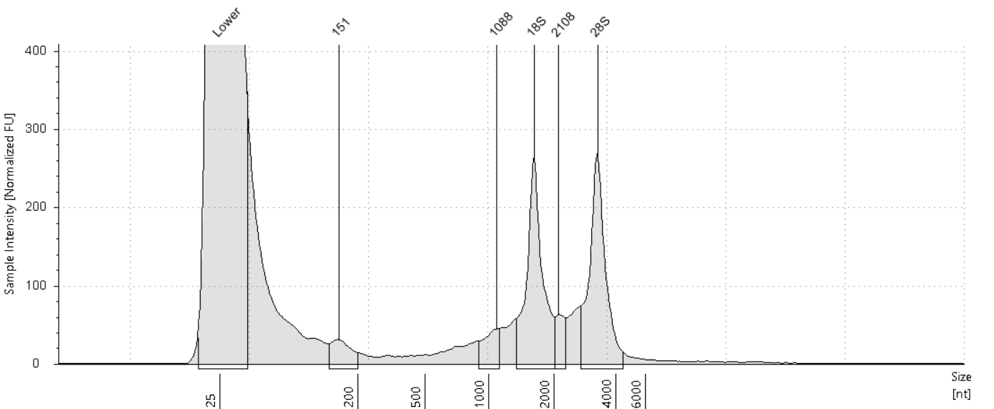

##### Sample Table

|  |  |  |  |  |  |  |
| --- | --- | --- | --- | --- | --- | --- |
| **Well** | **RIN**e | **28S/18S (Area)** | **Conc. [ng/µl]** | **Sample Description** | **Alert** | **Observations** |
| E6 | - | - | 4.67 | RNA 13 | image0.png | Sample concentration outside functional range for RINe and the assay |

##### Peak Table

|  |  |  |  |  |  |  |
| --- | --- | --- | --- | --- | --- | --- |
| **Size [nt]** | **Calibrated Conc. [ng/µl]** | **Assigned Conc. [ng/µl]** | **Peak Molarity [nmol/l]** | **% Integrated Area** | **Peak Comment** | **Observations** |
| 25 | 40.0 | 40.0 | 4710 | - |  | Lower Marker |
| 151 | 0.148 | - | 2.89 | 6.06 |  |  |
| 1088 | 0.159 | - | 0.429 | 6.50 |  |  |
| 1618 | 0.976 | - | 1.77 | 39.95 |  | 18S |
| 2108 | 0.151 | - | 0.211 | 6.20 |  |  |
| 3273 | 1.01 | - | 0.906 | 41.29 |  | 28S |

#### F6: RNA 14

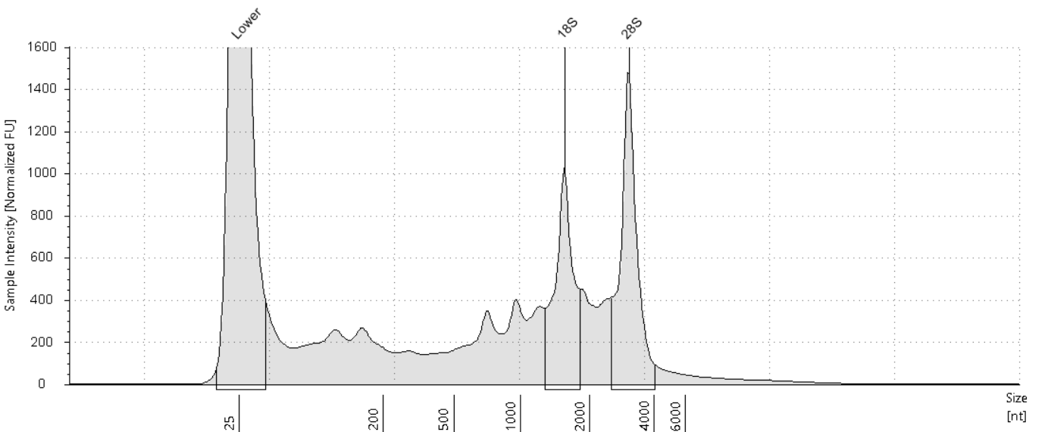

##### Sample Table

|  |  |  |  |  |  |  |
| --- | --- | --- | --- | --- | --- | --- |
| **Well** | **RIN**e | **28S/18S (Area)** | **Conc. [ng/µl]** | **Sample Description** | **Alert** | **Observations** |
| F6 | 6.3 | 1.3 | 26.3 | RNA 14 |  |  |

##### Peak Table

|  |  |  |  |  |  |  |
| --- | --- | --- | --- | --- | --- | --- |
| **Size [nt]** | **Calibrated Conc. [ng/µl]** | **Assigned Conc. [ng/µl]** | **Peak Molarity [nmol/l]** | **% Integrated Area** | **Peak Comment** | **Observations** |
| 25 | 40.0 | 40.0 | 4710 | - |  | Lower Marker |
| 1554 | 4.36 | - | 8.25 | 43.82 |  | 18S |
| 3049 | 5.59 | - | 5.39 | 56.18 |  | 28S |

#### G6: RNA 15

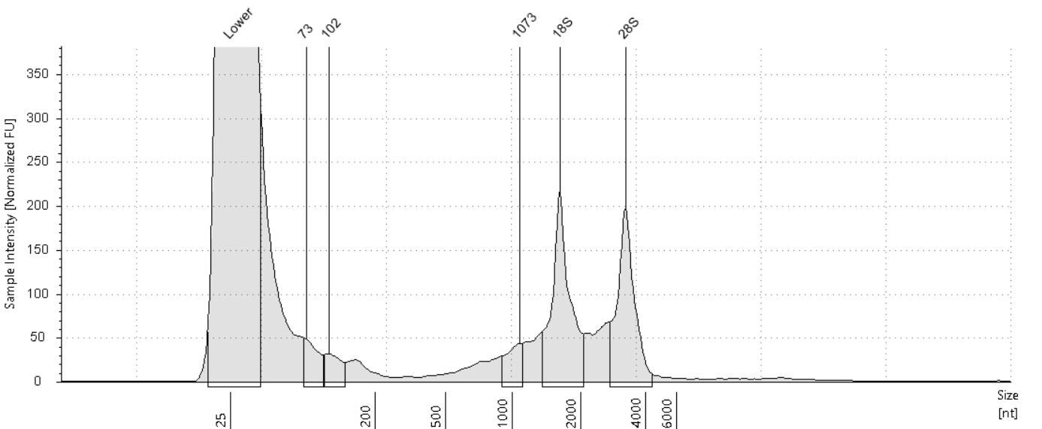

##### Sample Table

|  |  |  |  |  |  |  |
| --- | --- | --- | --- | --- | --- | --- |
| **Well** | **RIN**e | **28S/18S (Area)** | **Conc. [ng/µl]** | **Sample Description** | **Alert** | **Observations** |
| G6 | - | - | 3.87 | RNA 15 | image0.png | Sample concentration outside functional range for RINe and the assay |

##### Peak Table

|  |  |  |  |  |  |  |
| --- | --- | --- | --- | --- | --- | --- |
| **Size [nt]** | **Calibrated Conc. [ng/µl]** | **Assigned Conc. [ng/µl]** | **Peak Molarity [nmol/l]** | **% Integrated Area** | **Peak Comment** | **Observations** |
| 25 | 40.0 | 40.0 | 4710 | - |  | Lower Marker |
| 73 | 0.161 | - | 6.44 | 8.03 |  |  |
| 102 | 0.115 | - | 3.32 | 5.73 |  |  |
| 1073 | 0.147 | - | 0.403 | 7.33 |  |  |
| 1611 | 0.832 | - | 1.52 | 41.54 |  | 18S |
| 3240 | 0.749 | - | 0.680 | 37.37 |  | 28S |

#### H6: RNA 16

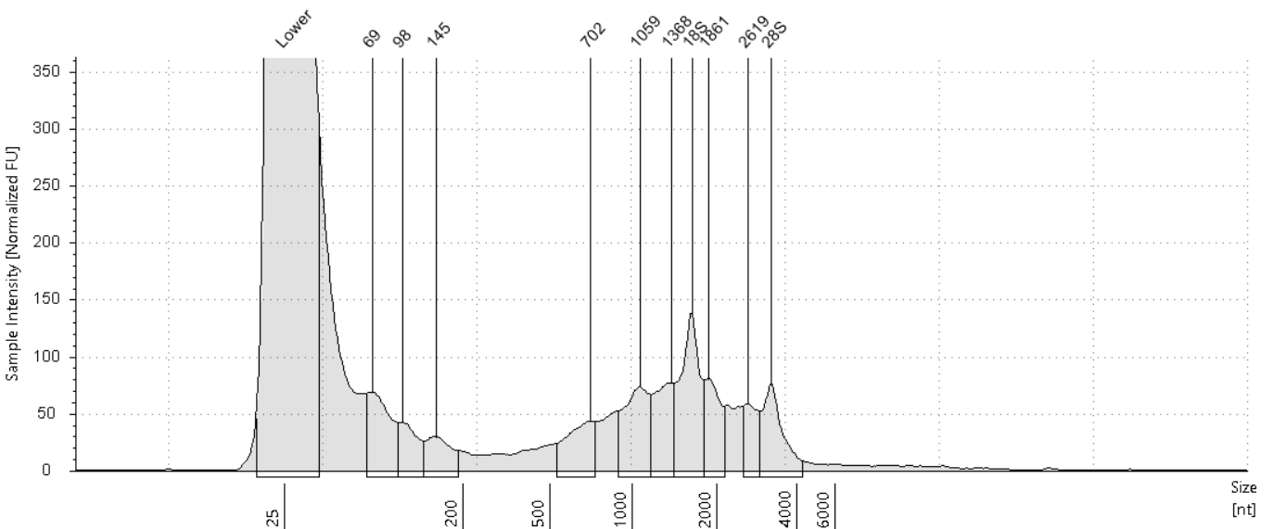

##### Sample Table

|  |  |  |  |  |  |  |
| --- | --- | --- | --- | --- | --- | --- |
| **Well** | **RIN**e | **28S/18S (Area)** | **Conc. [ng/µl]** | **Sample Description** | **Alert** | **Observations** |
| H6 | - | - | 4.27 | RNA 16 | image0.png | Sample concentration outside functional range for RINe and the assay |

##### Peak Table

|  |  |  |  |  |  |  |
| --- | --- | --- | --- | --- | --- | --- |
| **Size [nt]** | **Calibrated Conc. [ng/µl]** | **Assigned Conc. [ng/µl]** | **Peak Molarity [nmol/l]** | **% Integrated Area** | **Peak Comment** | **Observations** |
| 25 | 40.0 | 40.0 | 4710 | - |  | Lower Marker |
| 69 | 0.303 | - | 12.9 | 11.40 |  |  |
| 98 | 0.150 | - | 4.50 | 5.67 |  |  |
| 145 | 0.142 | - | 2.88 | 5.37 |  |  |
| 702 | 0.221 | - | 0.926 | 8.33 |  |  |
| 1059 | 0.359 | - | 0.997 | 13.52 |  |  |
| 1368 | 0.284 | - | 0.611 | 10.71 |  |  |
| 1623 | 0.505 | - | 0.916 | 19.04 |  | 18S |
| 1861 | 0.242 | - | 0.382 | 9.12 |  |  |
| 2619 | 0.161 | - | 0.181 | 6.07 |  |  |
| 3200 | 0.286 | - | 0.263 | 10.77 |  | 28S |

#### A7: RNA 17

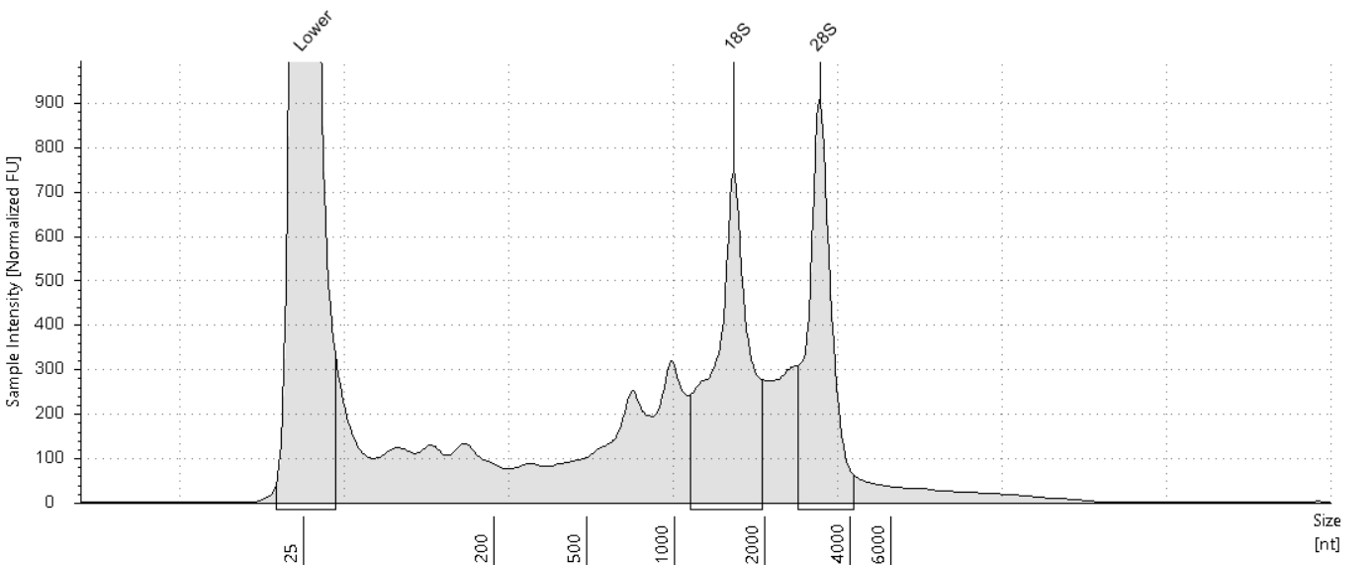

##### Sample Table

|  |  |  |  |  |  |  |
| --- | --- | --- | --- | --- | --- | --- |
| **Well** | **RIN**e | **28S/18S (Area)** | **Conc. [ng/µl]** | **Sample Description** | **Alert** | **Observations** |
| A7 | 6.1 | 0.8 | 21.5 | RNA 17 | image0.png | Sample concentration outside functional range for RINe and the assay |

##### Peak Table

|  |  |  |  |  |  |  |
| --- | --- | --- | --- | --- | --- | --- |
| **Size [nt]** | **Calibrated Conc. [ng/µl]** | **Assigned Conc. [ng/µl]** | **Peak Molarity [nmol/l]** | **% Integrated Area** | **Peak Comment** | **Observations** |
| 25 | 40.0 | 40.0 | 4710 | - |  | Lower Marker |
| 1573 | 5.19 | - | 9.70 | 54.06 |  | 18S |
| 3137 | 4.41 | - | 4.14 | 45.94 |  | 28S |

#### B7: RNA 18

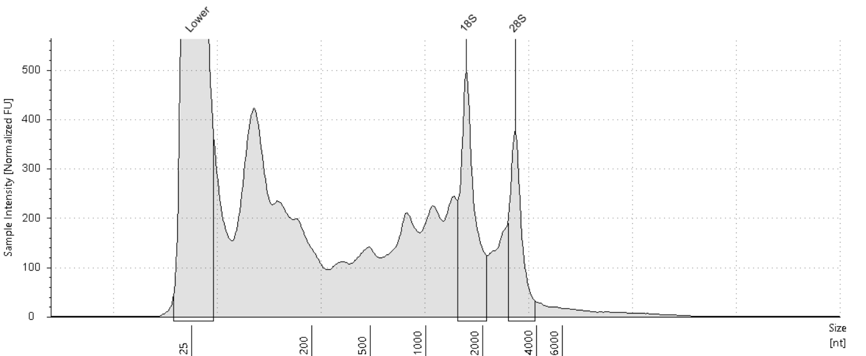

##### Sample Table

|  |  |  |  |  |  |  |
| --- | --- | --- | --- | --- | --- | --- |
| **Well** | **RIN**e | **28S/18S (Area)** | **Conc. [ng/µl]** | **Sample Description** | **Alert** | **Observations** |
| B7 | 5.6 | 0.6 | 17.1 | RNA 18 | image0.png | Sample concentration outside functional range for RINe and the assay |

##### Peak Table

|  |  |  |  |  |  |  |
| --- | --- | --- | --- | --- | --- | --- |
| **Size [nt]** | **Calibrated Conc. [ng/µl]** | **Assigned Conc. [ng/µl]** | **Peak Molarity [nmol/l]** | **% Integrated Area** | **Peak Comment** | **Observations** |
| 25 | 40.0 | 40.0 | 4710 | - |  | Lower Marker |
| 1637 | 2.11 | - | 3.80 | 60.75 |  | 18S |
| 3059 | 1.36 | - | 1.31 | 39.25 |  | 28S |

#### C7: RNA 19

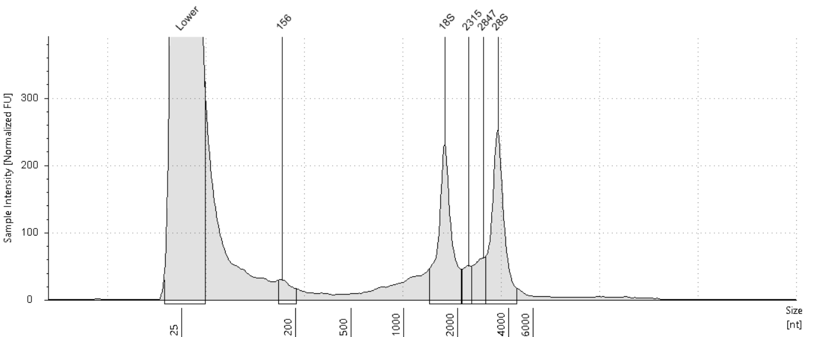

##### Sample Table

|  |  |  |  |  |  |  |
| --- | --- | --- | --- | --- | --- | --- |
| **Well** | **RIN**e | **28S/18S (Area)** | **Conc. [ng/µl]** | **Sample Description** | **Alert** | **Observations** |
| C7 | - | - | 4.33 | RNA 19 | image0.png | Sample concentration outside functional range for RINe and the assay |

##### Peak Table

|  |  |  |  |  |  |  |
| --- | --- | --- | --- | --- | --- | --- |
| **Size [nt]** | **Calibrated Conc. [ng/µl]** | **Assigned Conc. [ng/µl]** | **Peak Molarity [nmol/l]** | **% Integrated Area** | **Peak Comment** | **Observations** |
| 25 | 40.0 | 40.0 | 4710 | - |  | Lower Marker |
| 156 | 0.110 | - | 2.07 | 4.89 |  |  |
| 1693 | 0.872 | - | 1.52 | 38.75 |  | 18S |
| 2315 | 0.133 | - | 0.169 | 5.92 |  |  |
| 2847 | 0.216 | - | 0.223 | 9.58 |  |  |
| 3469 | 0.920 | - | 0.780 | 40.85 |  | 28S |

#### D7: RNA 20

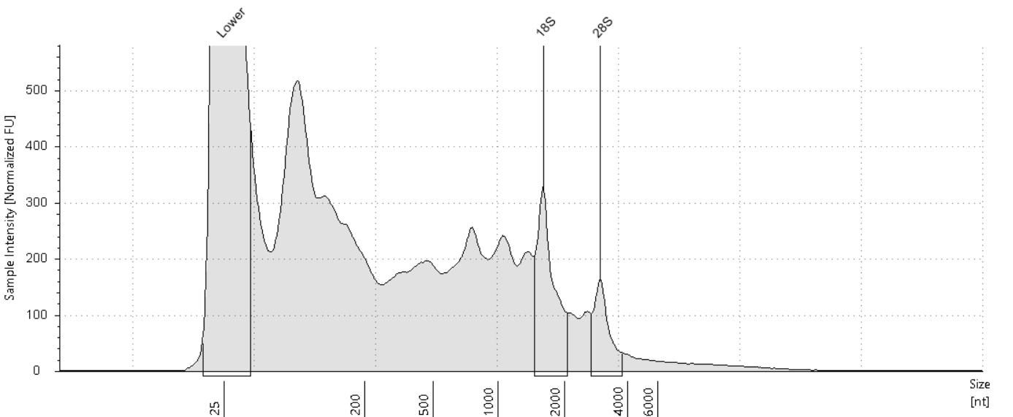

##### Sample Table

|  |  |  |  |  |  |  |
| --- | --- | --- | --- | --- | --- | --- |
| **Well** | **RIN**e | **28S/18S (Area)** | **Conc. [ng/µl]** | **Sample Description** | **Alert** | **Observations** |
| D7 | 4.0 | 0.4 | 17.6 | RNA 20 | image0.png | Sample concentration outside functional range for RINe and the assay; The upper ribosomal fragment has degraded |

##### Peak Table

|  |  |  |  |  |  |  |
| --- | --- | --- | --- | --- | --- | --- |
| **Size [nt]** | **Calibrated Conc. [ng/µl]** | **Assigned Conc. [ng/µl]** | **Peak Molarity [nmol/l]** | **% Integrated Area** | **Peak Comment** | **Observations** |
| 25 | 40.0 | 40.0 | 4710 | - |  | Lower Marker |
| 1595 | 1.39 | - | 2.56 | 69.28 |  | 18S |
| 2958 | 0.616 | - | 0.612 | 30.72 |  | 28S |

#### E7: RNA 21

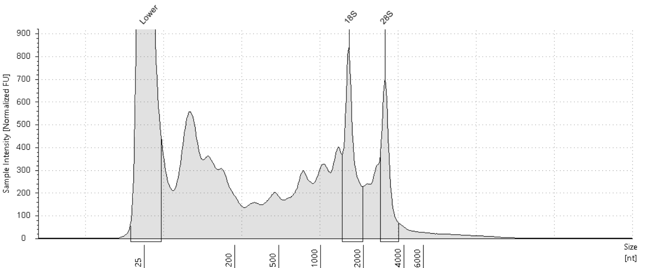

##### Sample Table

|  |  |  |  |  |  |  |
| --- | --- | --- | --- | --- | --- | --- |
| **Well** | **RIN**e | **28S/18S (Area)** | **Conc. [ng/µl]** | **Sample Description** | **Alert** | **Observations** |
| E7 | 5.9 | 0.7 | 23.5 | RNA 21 | image0.png | Sample concentration outside functional range for RINe and the assay |

##### Peak Table

|  |  |  |  |  |  |  |
| --- | --- | --- | --- | --- | --- | --- |
| **Size [nt]** | **Calibrated Conc. [ng/µl]** | **Assigned Conc. [ng/µl]** | **Peak Molarity [nmol/l]** | **% Integrated Area** | **Peak Comment** | **Observations** |
| 25 | 40.0 | 40.0 | 4710 | - |  | Lower Marker |
| 1582 | 3.08 | - | 5.72 | 59.37 |  | 18S |
| 2898 | 2.10 | - | 2.14 | 40.63 |  | 28S |

#### F7: RNA 22

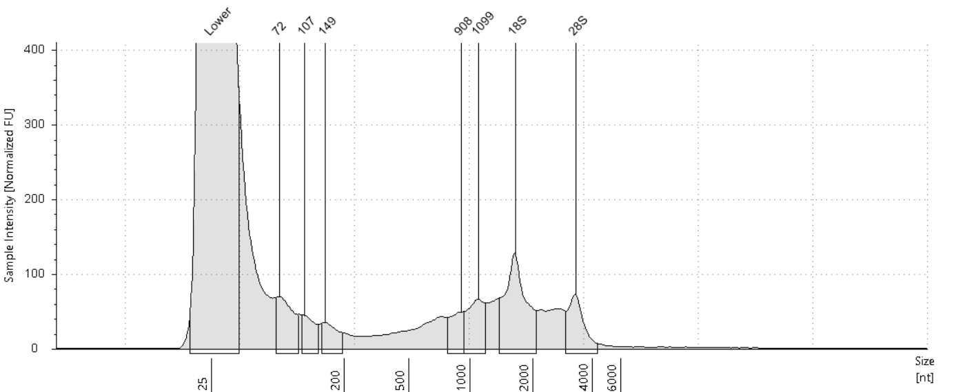

##### Sample Table

|  |  |  |  |  |  |  |
| --- | --- | --- | --- | --- | --- | --- |
| **Well** | **RIN**e | **28S/18S (Area)** | **Conc. [ng/µl]** | **Sample Description** | **Alert** | **Observations** |
| F7 | - | - | 4.03 | RNA 22 | image0.png | Sample concentration outside functional range for RINe and the assay |

##### Peak Table

|  |  |  |  |  |  |  |
| --- | --- | --- | --- | --- | --- | --- |
| **Size [nt]** | **Calibrated Conc. [ng/µl]** | **Assigned Conc. [ng/µl]** | **Peak Molarity [nmol/l]** | **% Integrated Area** | **Peak Comment** | **Observations** |
| 25 | 40.0 | 40.0 | 4710 | - |  | Lower Marker |
| 72 | 0.289 | - | 11.7 | 15.19 |  |  |
| 107 | 0.140 | - | 3.84 | 7.35 |  |  |
| 149 | 0.131 | - | 2.59 | 6.89 |  |  |
| 908 | 0.163 | - | 0.528 | 8.57 |  |  |
| 1099 | 0.278 | - | 0.744 | 14.61 |  |  |
| 1643 | 0.627 | - | 1.12 | 32.94 |  | 18S |
| 3303 | 0.275 | - | 0.245 | 14.46 |  | 28S |

#### G7: RNA 23

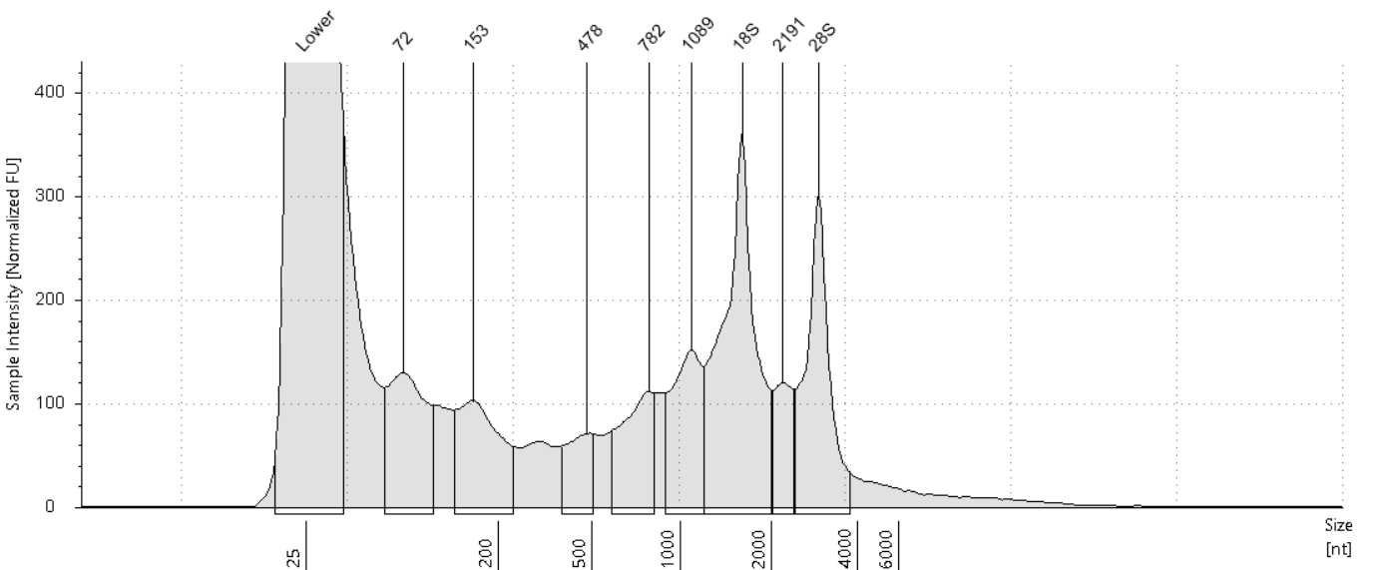

##### Sample Table

|  |  |  |  |  |  |  |
| --- | --- | --- | --- | --- | --- | --- |
| **Well** | **RIN**e | **28S/18S (Area)** | **Conc. [ng/µl]** | **Sample Description** | **Alert** | **Observations** |
| G7 | - | - | 9.37 | RNA 23 | image0.png | Sample concentration outside functional range for RINe and the assay |

##### Peak Table

|  |  |  |  |  |  |  |
| --- | --- | --- | --- | --- | --- | --- |
| **Size [nt]** | **Calibrated Conc. [ng/µl]** | **Assigned Conc. [ng/µl]** | **Peak Molarity [nmol/l]** | **% Integrated Area** | **Peak Comment** | **Observations** |
| 25 | 40.0 | 40.0 | 4710 | - |  | Lower Marker |
| 72 | 0.856 | - | 35.2 | 12.55 |  |  |
| 153 | 0.756 | - | 14.5 | 11.08 |  |  |
| 478 | 0.308 | - | 1.89 | 4.51 |  |  |
| 782 | 0.604 | - | 2.27 | 8.85 |  |  |
| 1089 | 0.794 | - | 2.14 | 11.64 |  |  |
| 1601 | 1.95 | - | 3.58 | 28.53 |  | 18S |
| 2191 | 0.389 | - | 0.522 | 5.70 |  |  |
| 2934 | 1.17 | - | 1.17 | 17.14 |  | 28S |

#### H7: RNA 24

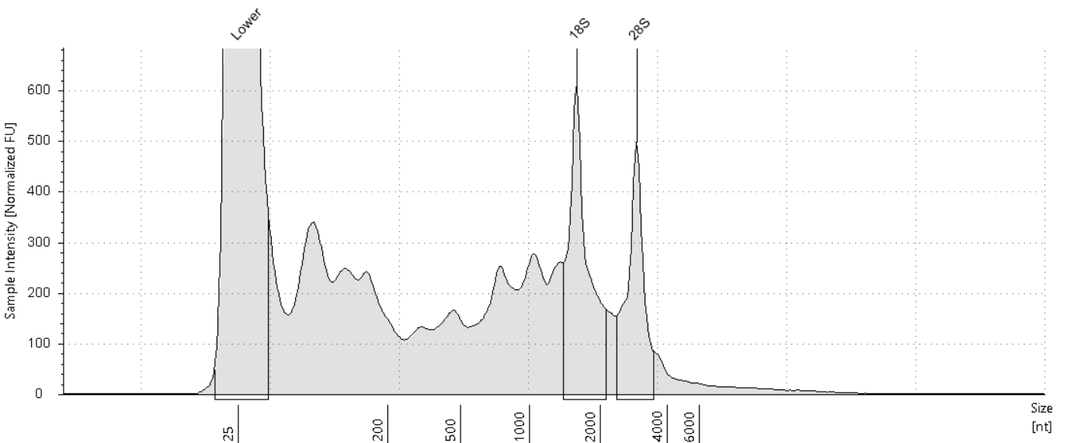

##### Sample Table

|  |  |  |  |  |  |  |
| --- | --- | --- | --- | --- | --- | --- |
| **Well** | **RIN**e | **28S/18S (Area)** | **Conc. [ng/µl]** | **Sample Description** | **Alert** | **Observations** |
| H7 | 5.6 | 0.7 | 16.3 | RNA 24 | image0.png | Sample concentration outside functional range for RINe and the assay |

##### Peak Table

|  |  |  |  |  |  |  |
| --- | --- | --- | --- | --- | --- | --- |
| **Size [nt]** | **Calibrated Conc. [ng/µl]** | **Assigned Conc. [ng/µl]** | **Peak Molarity [nmol/l]** | **% Integrated Area** | **Peak Comment** | **Observations** |
| 25 | 40.0 | 40.0 | 4710 | - |  | Lower Marker |
| 1581 | 2.55 | - | 4.74 | 59.60 |  | 18S |
| 2902 | 1.73 | - | 1.75 | 40.40 |  | 28S |

#### A8: RNA 25

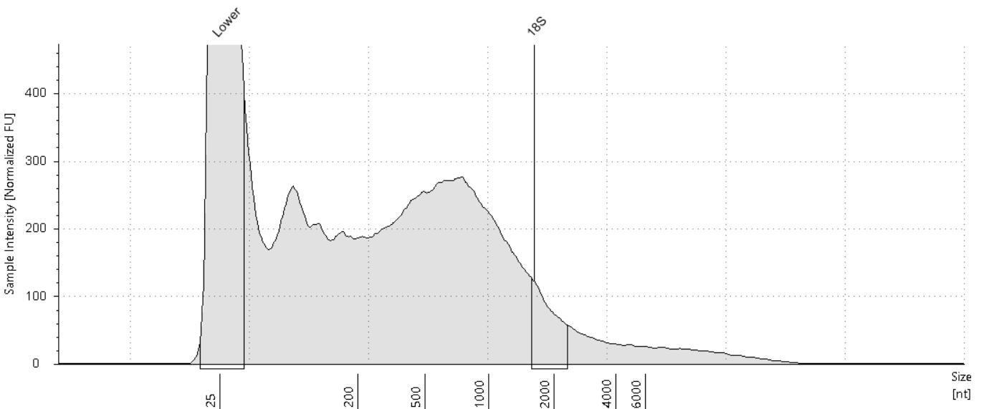

##### Sample Table

|  |  |  |  |  |  |  |
| --- | --- | --- | --- | --- | --- | --- |
| **Well** | **RIN**e | **28S/18S (Area)** | **Conc. [ng/µl]** | **Sample Description** | **Alert** | **Observations** |
| A8 | 1.7 | - | 17.0 | RNA 25 | image0.png | Sample concentration outside functional range for RINe and the assay; The upper ribosomal fragment has degraded |

##### Peak Table

|  |  |  |  |  |  |  |
| --- | --- | --- | --- | --- | --- | --- |
| **Size [nt]** | **Calibrated Conc. [ng/µl]** | **Assigned Conc. [ng/µl]** | **Peak Molarity [nmol/l]** | **% Integrated Area** | **Peak Comment** | **Observations** |
| 25 | 40.0 | 40.0 | 4710 | - |  | Lower Marker |
| 1622 | 0.759 | - | 1.38 | 100.00 |  | 18S |

#### B8: RNA 26

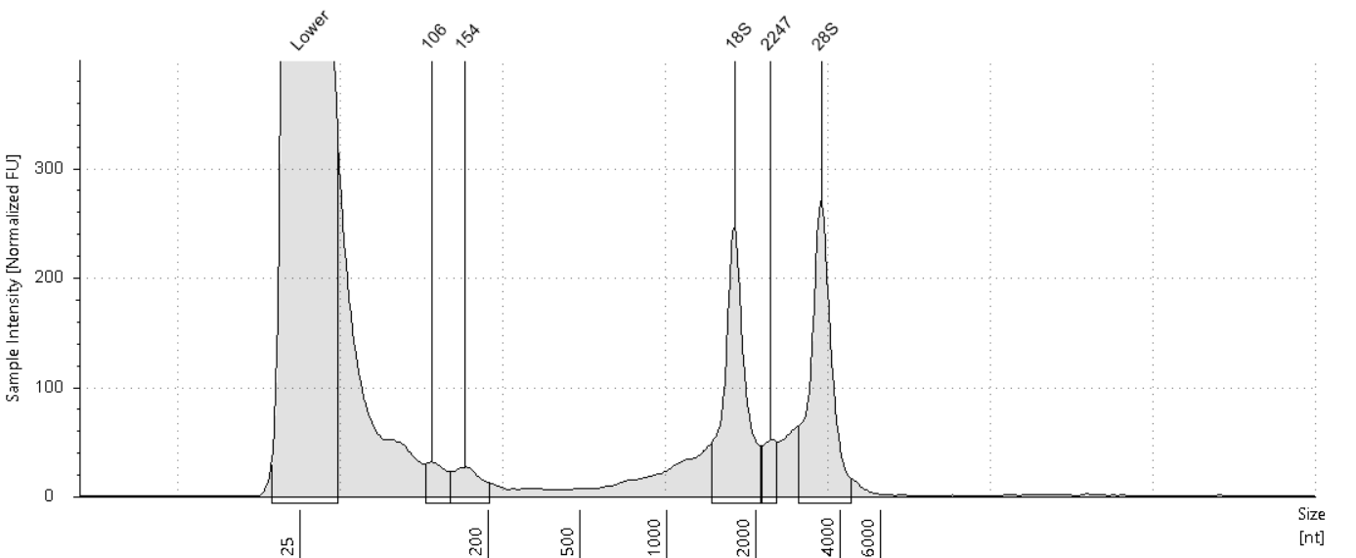

##### Sample Table

|  |  |  |  |  |  |  |
| --- | --- | --- | --- | --- | --- | --- |
| **Well** | **RIN**e | **28S/18S (Area)** | **Conc. [ng/µl]** | **Sample Description** | **Alert** | **Observations** |
| B8 | - | - | 4.34 | RNA 26 | image0.png | Sample concentration outside functional range for RINe and the assay |

##### Peak Table

|  |  |  |  |  |  |  |
| --- | --- | --- | --- | --- | --- | --- |
| **Size [nt]** | **Calibrated Conc. [ng/µl]** | **Assigned Conc. [ng/µl]** | **Peak Molarity [nmol/l]** | **% Integrated Area** | **Peak Comment** | **Observations** |
| 25 | 40.0 | 40.0 | 4710 | - |  | Lower Marker |
| 106 | 0.112 | - | 3.11 | 4.85 |  |  |
| 154 | 0.141 | - | 2.70 | 6.10 |  |  |
| 1690 | 0.923 | - | 1.61 | 39.91 |  | 18S |
| 2247 | 0.122 | - | 0.160 | 5.27 |  |  |
| 3426 | 1.01 | - | 0.871 | 43.87 |  | 28S |

#### C8: RNA 27

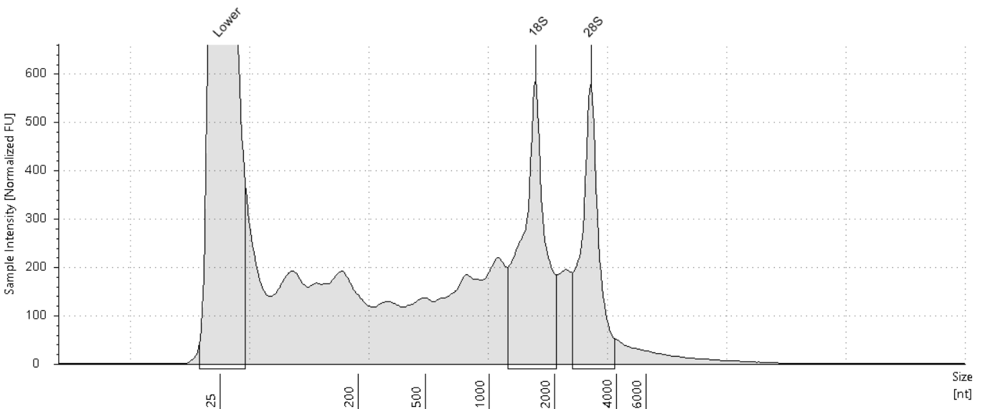

##### Sample Table

|  |  |  |  |  |  |  |
| --- | --- | --- | --- | --- | --- | --- |
| **Well** | **RIN**e | **28S/18S (Area)** | **Conc. [ng/µl]** | **Sample Description** | **Alert** | **Observations** |
| C8 | 6.1 | 0.7 | 16.8 | RNA 27 | image0.png | Sample concentration outside functional range for RINe and the assay |

##### Peak Table

|  |  |  |  |  |  |  |
| --- | --- | --- | --- | --- | --- | --- |
| **Size [nt]** | **Calibrated Conc. [ng/µl]** | **Assigned Conc. [ng/µl]** | **Peak Molarity [nmol/l]** | **% Integrated Area** | **Peak Comment** | **Observations** |
| 25 | 40.0 | 40.0 | 4710 | - |  | Lower Marker |
| 1637 | 3.39 | - | 6.09 | 57.16 |  | 18S |
| 3004 | 2.54 | - | 2.49 | 42.84 |  | 28S |

#### D8: RNA 28

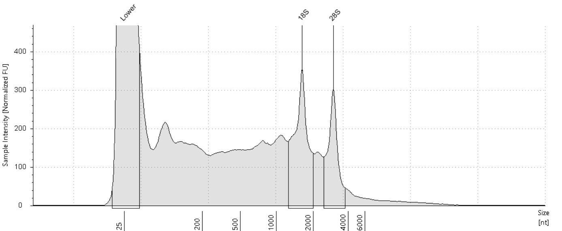

##### Sample Table

|  |  |  |  |  |  |  |
| --- | --- | --- | --- | --- | --- | --- |
| **Well** | **RIN**e | **28S/18S (Area)** | **Conc. [ng/µl]** | **Sample Description** | **Alert** | **Observations** |
| D8 | 5.0 | 0.6 | 13.6 | RNA 28 | image0.png | Sample concentration outside functional range for RINe and the assay |

##### Peak Table

|  |  |  |  |  |  |  |
| --- | --- | --- | --- | --- | --- | --- |
| **Size [nt]** | **Calibrated Conc. [ng/µl]** | **Assigned Conc. [ng/µl]** | **Peak Molarity [nmol/l]** | **% Integrated Area** | **Peak Comment** | **Observations** |
| 25 | 40.0 | 40.0 | 4710 | - |  | Lower Marker |
| 1616 | 2.00 | - | 3.64 | 61.17 |  | 18S |
| 2980 | 1.27 | - | 1.25 | 38.83 |  | 28S |

#### E8: RNA 29

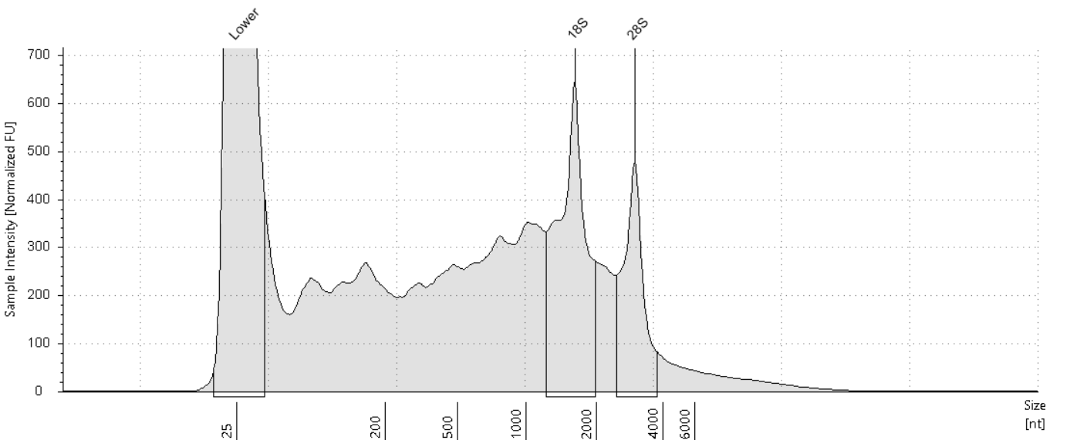

##### Sample Table

|  |  |  |  |  |  |  |
| --- | --- | --- | --- | --- | --- | --- |
| **Well** | **RIN**e | **28S/18S (Area)** | **Conc. [ng/µl]** | **Sample Description** | **Alert** | **Observations** |
| E8 | 4.7 | 0.5 | 22.6 | RNA 29 | image0.png | Sample concentration outside functional range for RINe and the assay |

##### Peak Table

|  |  |  |  |  |  |  |
| --- | --- | --- | --- | --- | --- | --- |
| **Size [nt]** | **Calibrated Conc. [ng/µl]** | **Assigned Conc. [ng/µl]** | **Peak Molarity [nmol/l]** | **% Integrated Area** | **Peak Comment** | **Observations** |
| 25 | 40.0 | 40.0 | 4710 | - |  | Lower Marker |
| 1616 | 4.03 | - | 7.34 | 64.68 |  | 18S |
| 2980 | 2.20 | - | 2.17 | 35.32 |  | 28S |

#### F8: RNA 30

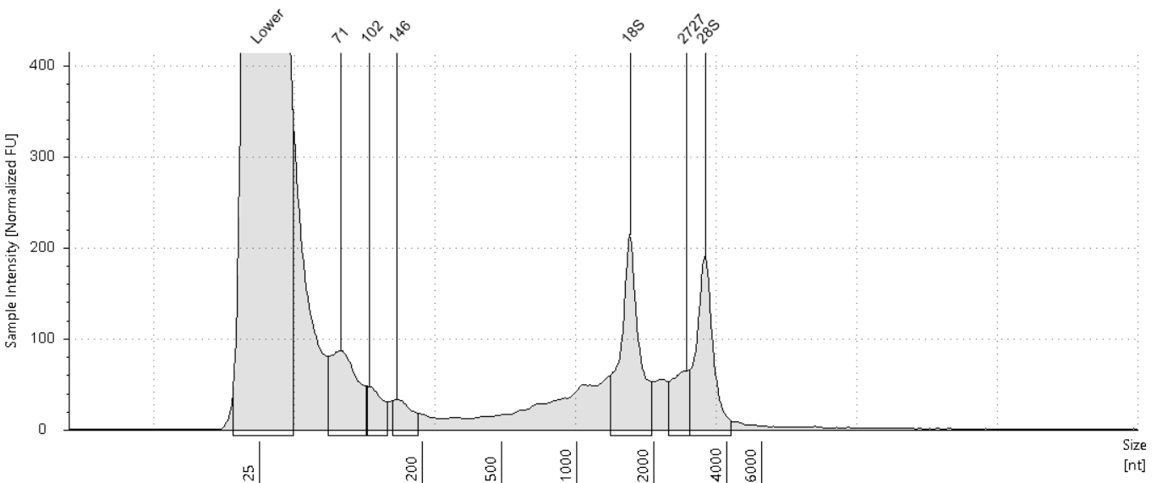

##### Sample Table

|  |  |  |  |  |  |  |
| --- | --- | --- | --- | --- | --- | --- |
| **Well** | **RIN**e | **28S/18S (Area)** | **Conc. [ng/µl]** | **Sample Description** | **Alert** | **Observations** |
| F8 | - | - | 4.27 | RNA 30 | image0.png | Sample concentration outside functional range for RINe and the assay |

##### Peak Table

|  |  |  |  |  |  |  |
| --- | --- | --- | --- | --- | --- | --- |
| **Size [nt]** | **Calibrated Conc. [ng/µl]** | **Assigned Conc. [ng/µl]** | **Peak Molarity [nmol/l]** | **% Integrated Area** | **Peak Comment** | **Observations** |
| 25 | 40.0 | 40.0 | 4710 | - |  | Lower Marker |
| 71 | 0.465 | - | 19.4 | 20.11 |  |  |
| 102 | 0.147 | - | 4.24 | 6.36 |  |  |
| 146 | 0.121 | - | 2.44 | 5.23 |  |  |
| 1615 | 0.739 | - | 1.35 | 31.95 |  | 18S |
| 2727 | 0.223 | - | 0.240 | 9.63 |  |  |
| 3273 | 0.619 | - | 0.556 | 26.73 |  | 28S |

#### G8: RNA 31

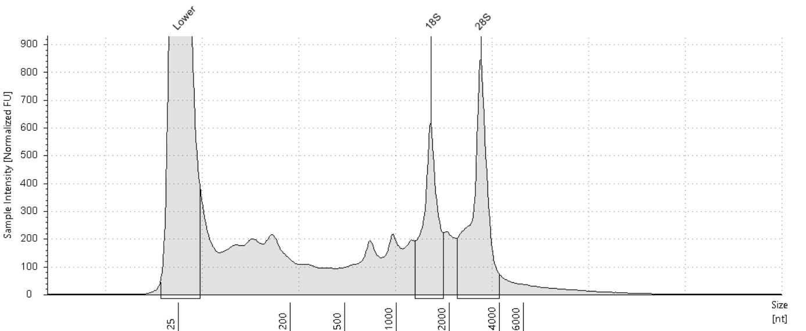

##### Sample Table

|  |  |  |  |  |  |  |
| --- | --- | --- | --- | --- | --- | --- |
| **Well** | **RIN**e | **28S/18S (Area)** | **Conc. [ng/µl]** | **Sample Description** | **Alert** | **Observations** |
| G8 | 6.6 | 1.5 | 16.4 | RNA 31 | image0.png | Sample concentration outside functional range for RINe and the assay |

##### Peak Table

|  |  |  |  |  |  |  |
| --- | --- | --- | --- | --- | --- | --- |
| **Size [nt]** | **Calibrated Conc. [ng/µl]** | **Assigned Conc. [ng/µl]** | **Peak Molarity [nmol/l]** | **% Integrated Area** | **Peak Comment** | **Observations** |
| 25 | 40.0 | 40.0 | 4710 | - |  | Lower Marker |
| 1568 | 2.52 | - | 4.74 | 40.32 |  | 18S |
| 3094 | 3.74 | - | 3.55 | 59.68 |  | 28S |

#### H8: RNA 32

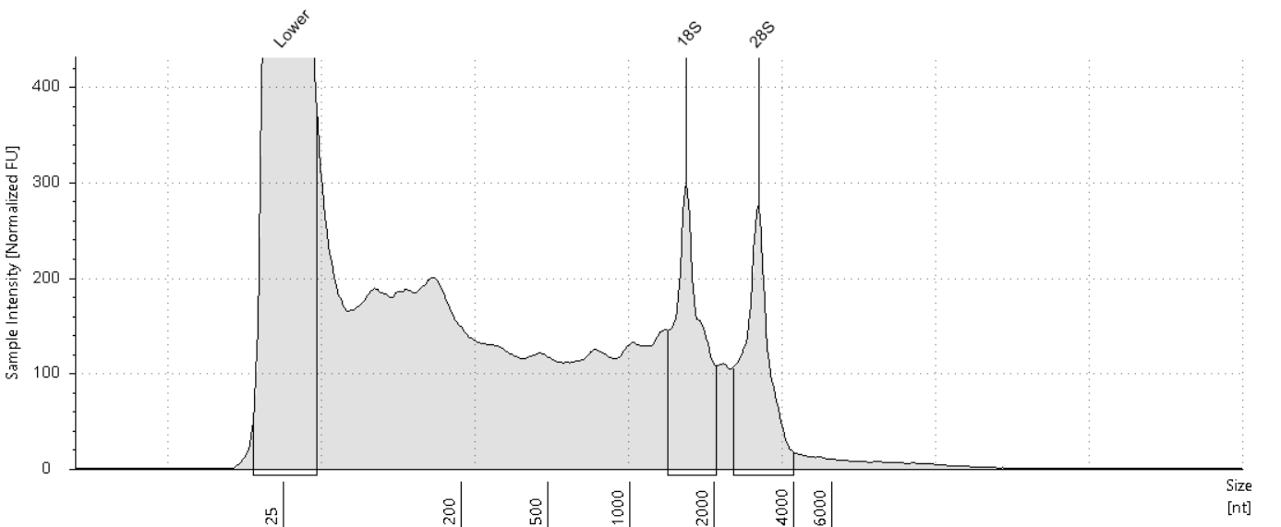

##### Sample Table

|  |  |  |  |  |  |  |
| --- | --- | --- | --- | --- | --- | --- |
| **Well** | **RIN**e | **28S/18S (Area)** | **Conc. [ng/µl]** | **Sample Description** | **Alert** | **Observations** |
| H8 | 5.3 | 0.9 | 11.4 | RNA 32 | image0.png | Sample concentration outside functional range for RINe and the assay |

##### Peak Table

|  |  |  |  |  |  |  |
| --- | --- | --- | --- | --- | --- | --- |
| **Size [nt]** | **Calibrated Conc. [ng/µl]** | **Assigned Conc. [ng/µl]** | **Peak Molarity [nmol/l]** | **% Integrated Area** | **Peak Comment** | **Observations** |
| 25 | 40.0 | 40.0 | 4710 | - |  | Lower Marker |
| 1587 | 1.39 | - | 2.57 | 53.87 |  | 18S |
| 2960 | 1.19 | - | 1.18 | 46.13 |  | 28S |

#### A9: RNA 33

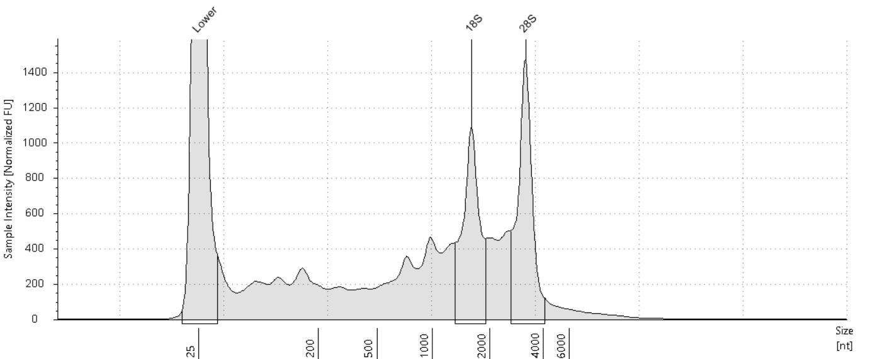

##### Sample Table

|  |  |  |  |  |  |  |
| --- | --- | --- | --- | --- | --- | --- |
| **Well** | **RIN**e | **28S/18S (Area)** | **Conc. [ng/µl]** | **Sample Description** | **Alert** | **Observations** |
| A9 | 5.9 | 1.2 | 36.0 | RNA 33 |  |  |

##### Peak Table

|  |  |  |  |  |  |  |
| --- | --- | --- | --- | --- | --- | --- |
| **Size [nt]** | **Calibrated Conc. [ng/µl]** | **Assigned Conc. [ng/µl]** | **Peak Molarity [nmol/l]** | **% Integrated Area** | **Peak Comment** | **Observations** |
| 25 | 40.0 | 40.0 | 4710 | - |  | Lower Marker |
| 1602 | 6.39 | - | 11.7 | 46.32 |  | 18S |
| 3175 | 7.41 | - | 6.86 | 53.68 |  | 28S |

#### B9: RNA 34

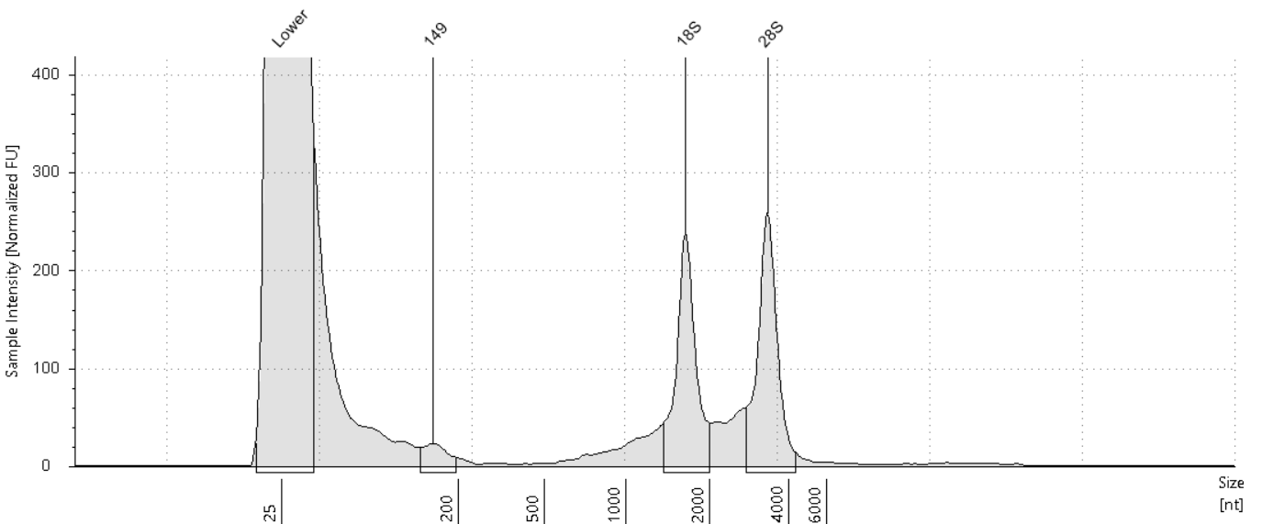

##### Sample Table

|  |  |  |  |  |  |  |
| --- | --- | --- | --- | --- | --- | --- |
| **Well** | **RIN**e | **28S/18S (Area)** | **Conc. [ng/µl]** | **Sample Description** | **Alert** | **Observations** |
| B9 | - | - | 4.36 | RNA 34 | image0.png | Sample concentration outside functional range for RINe and the assay |

##### Peak Table

|  |  |  |  |  |  |  |
| --- | --- | --- | --- | --- | --- | --- |
| **Size [nt]** | **Calibrated Conc. [ng/µl]** | **Assigned Conc. [ng/µl]** | **Peak Molarity [nmol/l]** | **% Integrated Area** | **Peak Comment** | **Observations** |
| 25 | 40.0 | 40.0 | 4710 | - |  | Lower Marker |
| 149 | 0.121 | - | 2.39 | 5.54 |  |  |
| 1643 | 0.974 | - | 1.74 | 44.66 |  | 18S |
| 3338 | 1.09 | - | 0.957 | 49.81 |  | 28S |

#### C9: RNA 35

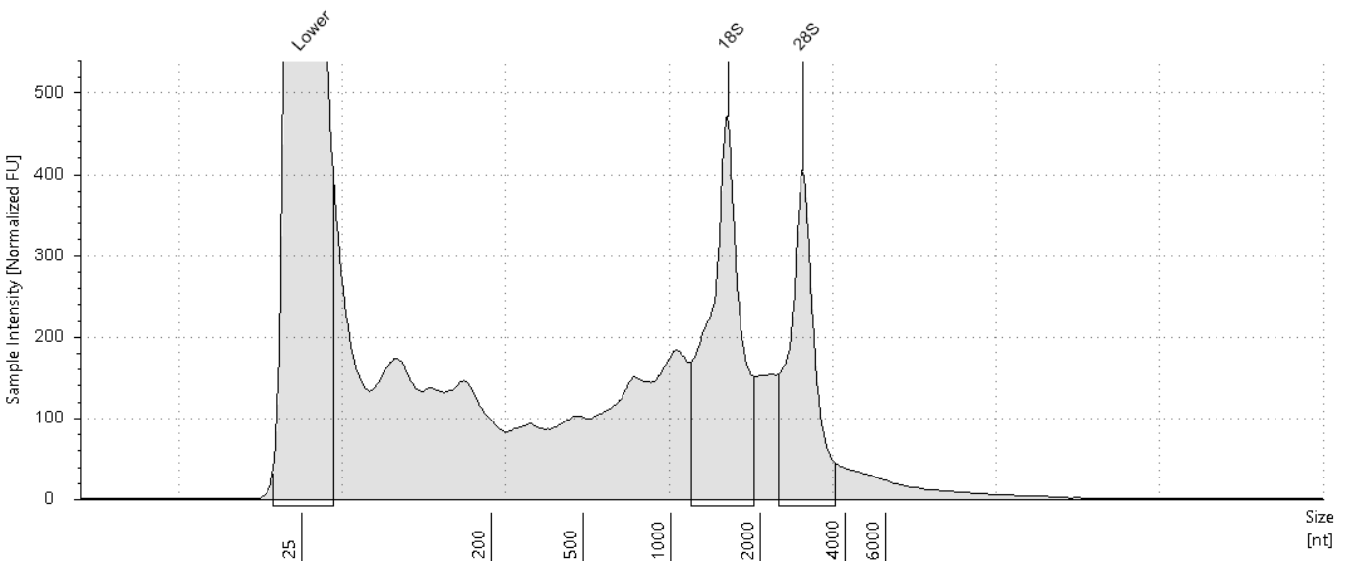

##### Sample Table

|  |  |  |  |  |  |  |
| --- | --- | --- | --- | --- | --- | --- |
| **Well** | **RIN**e | **28S/18S (Area)** | **Conc. [ng/µl]** | **Sample Description** | **Alert** | **Observations** |
| C9 | 6.0 | 0.7 | 14.5 | RNA 35 | image0.png | Sample concentration outside functional range for RINe and the assay |

##### Peak Table

|  |  |  |  |  |  |  |
| --- | --- | --- | --- | --- | --- | --- |
| **Size [nt]** | **Calibrated Conc. [ng/µl]** | **Assigned Conc. [ng/µl]** | **Peak Molarity [nmol/l]** | **% Integrated Area** | **Peak Comment** | **Observations** |
| 25 | 40.0 | 40.0 | 4710 | - |  | Lower Marker |
| 1551 | 2.91 | - | 5.52 | 58.98 |  | 18S |
| 2839 | 2.03 | - | 2.10 | 41.02 |  | 28S |

#### D9: RNA 36

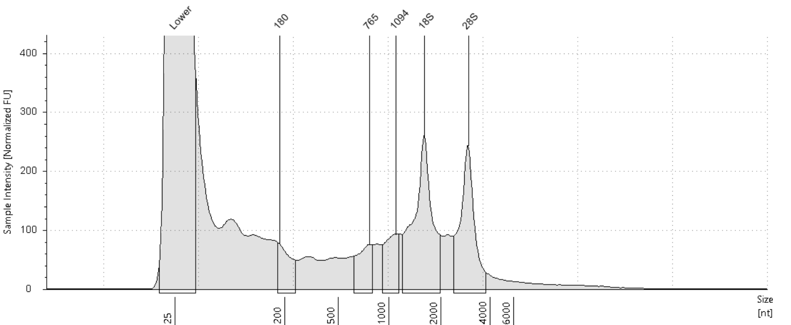

##### Sample Table

|  |  |  |  |  |  |  |
| --- | --- | --- | --- | --- | --- | --- |
| **Well** | **RIN**e | **28S/18S (Area)** | **Conc. [ng/µl]** | **Sample Description** | **Alert** | **Observations** |
| D9 | - | - | 8.47 | RNA 36 | image0.png | Sample concentration outside functional range for RINe and the assay |

##### Peak Table

|  |  |  |  |  |  |  |
| --- | --- | --- | --- | --- | --- | --- |
| **Size [nt]** | **Calibrated Conc. [ng/µl]** | **Assigned Conc. [ng/µl]** | **Peak Molarity [nmol/l]** | **% Integrated Area** | **Peak Comment** | **Observations** |
| 25 | 40.0 | 40.0 | 4710 | - |  | Lower Marker |
| 180 | 0.331 | - | 5.41 | 8.66 |  |  |
| 765 | 0.373 | - | 1.44 | 9.75 |  |  |
| 1094 | 0.440 | - | 1.18 | 11.49 |  |  |
| 1595 | 1.56 | - | 2.87 | 40.66 |  | 18S |
| 2934 | 1.13 | - | 1.13 | 29.45 |  | 28S |

#### E9: RNA 37

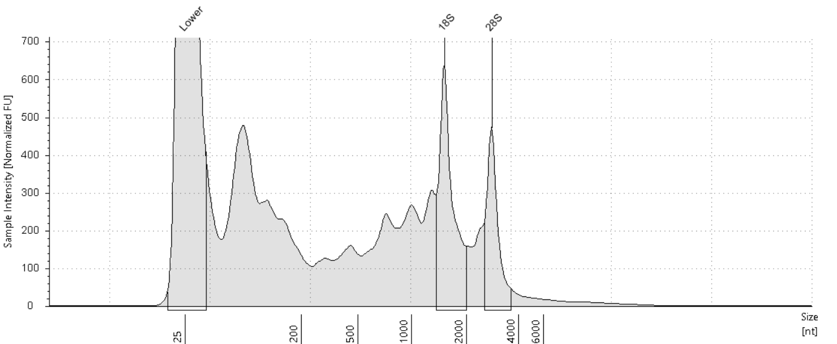

##### Sample Table

|  |  |  |  |  |  |  |
| --- | --- | --- | --- | --- | --- | --- |
| **Well** | **RIN**e | **28S/18S (Area)** | **Conc. [ng/µl]** | **Sample Description** | **Alert** | **Observations** |
| E9 | 5.8 | 0.6 | 19.8 | RNA 37 | image0.png | Sample concentration outside functional range for RINe and the assay |

##### Peak Table

|  |  |  |  |  |  |  |
| --- | --- | --- | --- | --- | --- | --- |
| **Size [nt]** | **Calibrated Conc. [ng/µl]** | **Assigned Conc. [ng/µl]** | **Peak Molarity [nmol/l]** | **% Integrated Area** | **Peak Comment** | **Observations** |
| 25 | 40.0 | 40.0 | 4710 | - |  | Lower Marker |
| 1507 | 2.81 | - | 5.48 | 62.52 |  | 18S |
| 2798 | 1.68 | - | 1.77 | 37.48 |  | 28S |

#### F9: RNA 38

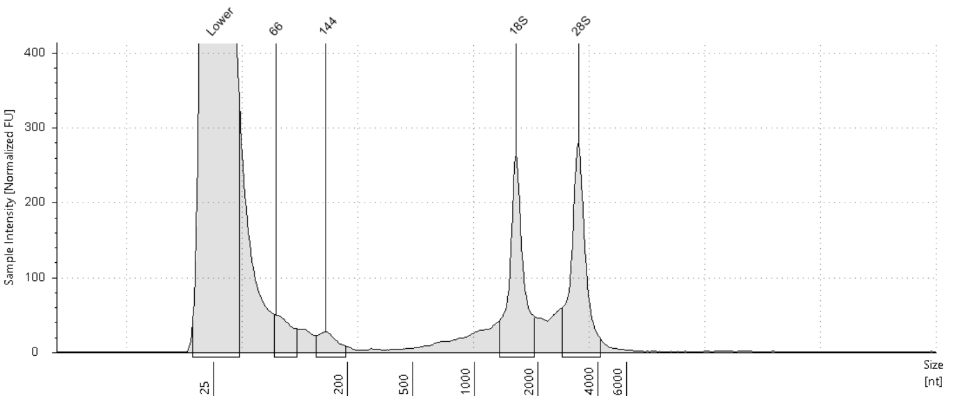

##### Sample Table

|  |  |  |  |  |  |  |
| --- | --- | --- | --- | --- | --- | --- |
| **Well** | **RIN**e | **28S/18S (Area)** | **Conc. [ng/µl]** | **Sample Description** | **Alert** | **Observations** |
| F9 | - | - | 4.09 | RNA 38 | image0.png | Sample concentration outside functional range for RINe and the assay |

##### Peak Table

|  |  |  |  |  |  |  |
| --- | --- | --- | --- | --- | --- | --- |
| **Size [nt]** | **Calibrated Conc. [ng/µl]** | **Assigned Conc. [ng/µl]** | **Peak Molarity [nmol/l]** | **% Integrated Area** | **Peak Comment** | **Observations** |
| 25 | 40.0 | 40.0 | 4710 | - |  | Lower Marker |
| 66 | 0.215 | - | 9.55 | 9.59 |  |  |
| 144 | 0.132 | - | 2.71 | 5.88 |  |  |
| 1577 | 0.896 | - | 1.67 | 39.90 |  | 18S |
| 3215 | 1.00 | - | 0.917 | 44.63 |  | 28S |

#### G9: RNA 39

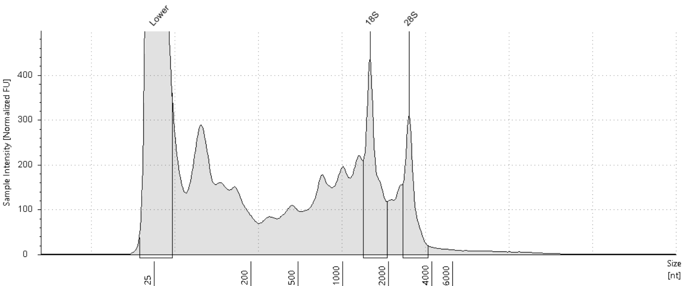

##### Sample Table

|  |  |  |  |  |  |  |
| --- | --- | --- | --- | --- | --- | --- |
| **Well** | **RIN**e | **28S/18S (Area)** | **Conc. [ng/µl]** | **Sample Description** | **Alert** | **Observations** |
| G9 | 5.5 | 0.6 | 13.0 | RNA 39 | image0.png | Sample concentration outside functional range for RINe and the assay |

##### Peak Table

|  |  |  |  |  |  |  |
| --- | --- | --- | --- | --- | --- | --- |
| **Size [nt]** | **Calibrated Conc. [ng/µl]** | **Assigned Conc. [ng/µl]** | **Peak Molarity [nmol/l]** | **% Integrated Area** | **Peak Comment** | **Observations** |
| 25 | 40.0 | 40.0 | 4710 | - |  | Lower Marker |
| 1512 | 1.86 | - | 3.61 | 62.68 |  | 18S |
| 2774 | 1.11 | - | 1.17 | 37.32 |  | 28S |

#### H9: RNA 40

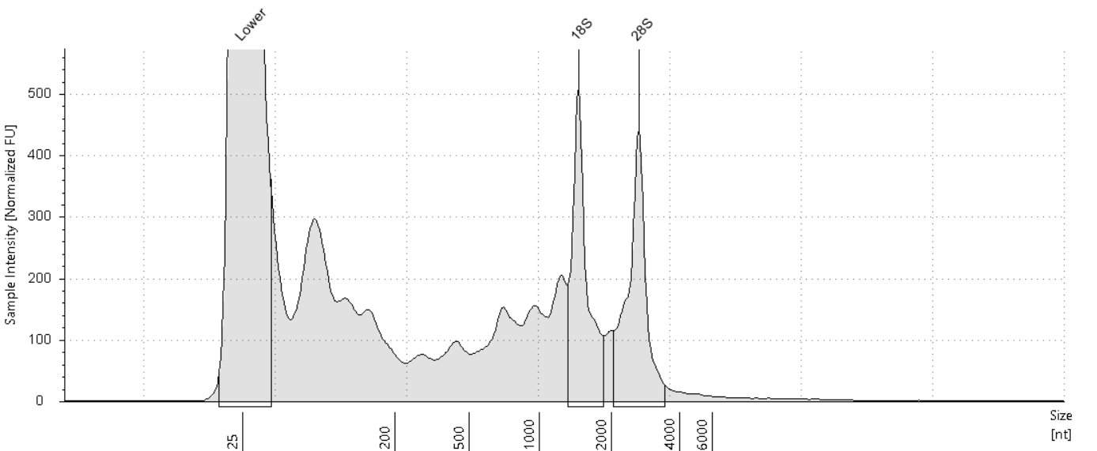

##### Sample Table

|  |  |  |  |  |  |  |
| --- | --- | --- | --- | --- | --- | --- |
| **Well** | **RIN**e | **28S/18S (Area)** | **Conc. [ng/µl]** | **Sample Description** | **Alert** | **Observations** |
| H9 | 6.7 | 1.0 | 12.3 | RNA 40 | image0.png | Sample concentration outside functional range for RINe and the assay |

##### Peak Table

|  |  |  |  |  |  |  |
| --- | --- | --- | --- | --- | --- | --- |
| **Size [nt]** | **Calibrated Conc. [ng/µl]** | **Assigned Conc. [ng/µl]** | **Peak Molarity [nmol/l]** | **% Integrated Area** | **Peak Comment** | **Observations** |
| 25 | 40.0 | 40.0 | 4710 | - |  | Lower Marker |
| 1457 | 1.77 | - | 3.57 | 49.12 |  | 18S |
| 2652 | 1.83 | - | 2.03 | 50.88 |  | 28S |

#### A10: RNA 41

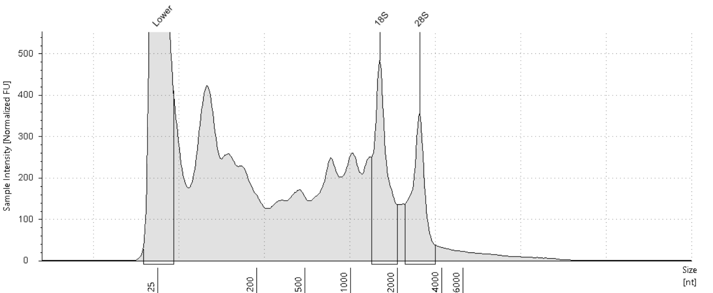

##### Sample Table

|  |  |  |  |  |  |  |
| --- | --- | --- | --- | --- | --- | --- |
| **Well** | **RIN**e | **28S/18S (Area)** | **Conc. [ng/µl]** | **Sample Description** | **Alert** | **Observations** |
| A10 | 5.1 | 0.7 | 21.3 | RNA 41 | image0.png | Sample concentration outside functional range for RINe and the assay |

##### Peak Table

|  |  |  |  |  |  |  |
| --- | --- | --- | --- | --- | --- | --- |
| **Size [nt]** | **Calibrated Conc. [ng/µl]** | **Assigned Conc. [ng/µl]** | **Peak Molarity [nmol/l]** | **% Integrated Area** | **Peak Comment** | **Observations** |
| 25 | 40.0 | 40.0 | 4710 | - |  | Lower Marker |
| 1538 | 2.65 | - | 5.07 | 57.52 |  | 18S |
| 2849 | 1.96 | - | 2.02 | 42.48 |  | 28S |

#### B10: RNA 42

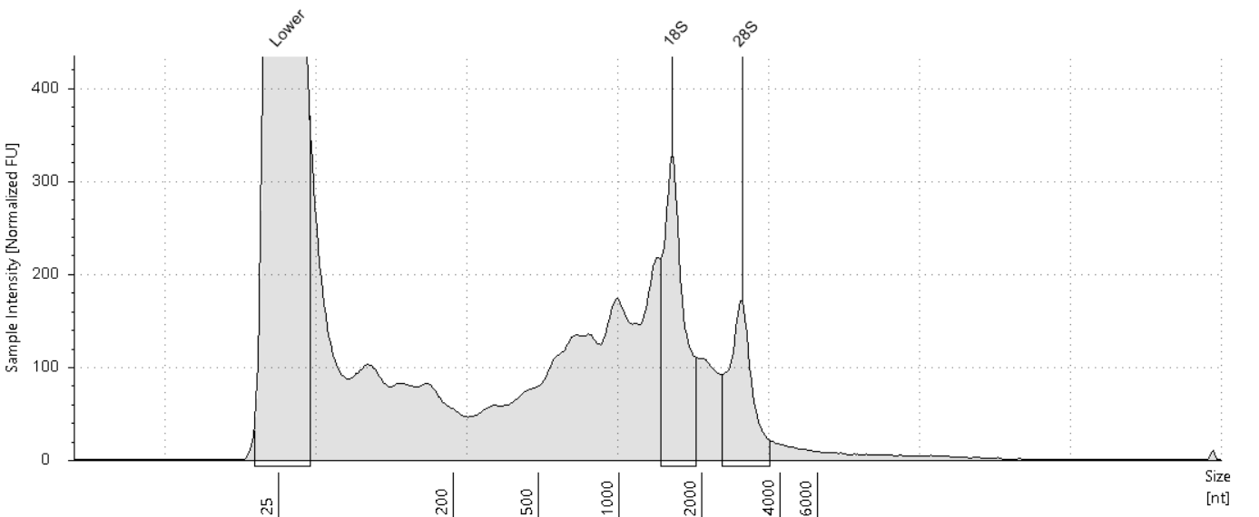

##### Sample Table

|  |  |  |  |  |  |  |
| --- | --- | --- | --- | --- | --- | --- |
| **Well** | **RIN**e | **28S/18S (Area)** | **Conc. [ng/µl]** | **Sample Description** | **Alert** | **Observations** |
| B10 | 5.1 | 0.6 | 10.3 | RNA 42 | image0.png | Sample concentration outside functional range for RINe and the assay |

##### Peak Table

|  |  |  |  |  |  |  |
| --- | --- | --- | --- | --- | --- | --- |
| **Size [nt]** | **Calibrated Conc. [ng/µl]** | **Assigned Conc. [ng/µl]** | **Peak Molarity [nmol/l]** | **% Integrated Area** | **Peak Comment** | **Observations** |
| 25 | 40.0 | 40.0 | 4710 | - |  | Lower Marker |
| 1564 | 1.49 | - | 2.80 | 63.10 |  | 18S |
| 2864 | 0.871 | - | 0.894 | 36.90 |  | 28S |

#### C10: RNA 43

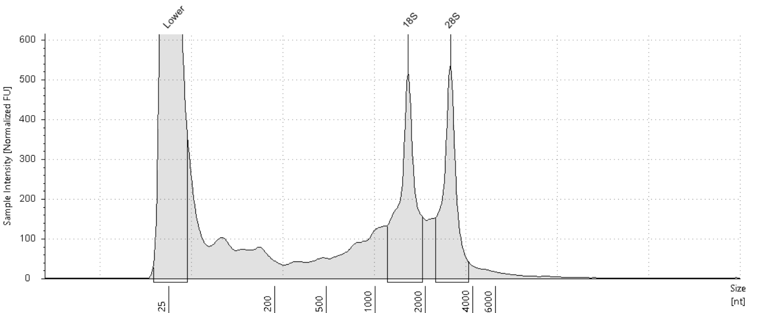

##### Sample Table

|  |  |  |  |  |  |  |
| --- | --- | --- | --- | --- | --- | --- |
| **Well** | **RIN**e | **28S/18S (Area)** | **Conc. [ng/µl]** | **Sample Description** | **Alert** | **Observations** |
| C10 | 7.2 | 0.9 | 11.3 | RNA 43 | image0.png | Sample concentration outside functional range for RINe and the assay |

##### Peak Table

|  |  |  |  |  |  |  |
| --- | --- | --- | --- | --- | --- | --- |
| **Size [nt]** | **Calibrated Conc. [ng/µl]** | **Assigned Conc. [ng/µl]** | **Peak Molarity [nmol/l]** | **% Integrated Area** | **Peak Comment** | **Observations** |
| 25 | 40.0 | 40.0 | 4710 | - |  | Lower Marker |
| 1579 | 2.82 | - | 5.25 | 53.39 |  | 18S |
| 2899 | 2.46 | - | 2.50 | 46.61 |  | 28S |

#### D10: RNA 44

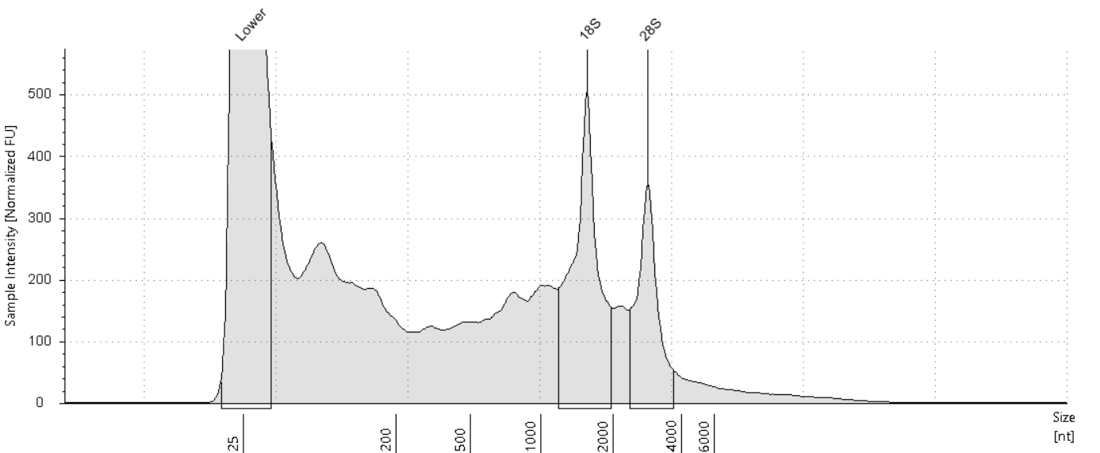

##### Sample Table

|  |  |  |  |  |  |  |
| --- | --- | --- | --- | --- | --- | --- |
| **Well** | **RIN**e | **28S/18S (Area)** | **Conc. [ng/µl]** | **Sample Description** | **Alert** | **Observations** |
| D10 | 5.9 | 0.6 | 16.4 | RNA 44 | image0.png | Sample concentration outside functional range for RINe and the assay |

##### Peak Table

|  |  |  |  |  |  |  |
| --- | --- | --- | --- | --- | --- | --- |
| **Size [nt]** | **Calibrated Conc. [ng/µl]** | **Assigned Conc. [ng/µl]** | **Peak Molarity [nmol/l]** | **% Integrated Area** | **Peak Comment** | **Observations** |
| 25 | 40.0 | 40.0 | 4710 | - |  | Lower Marker |
| 1557 | 2.93 | - | 5.53 | 63.07 |  | 18S |
| 2840 | 1.71 | - | 1.77 | 36.93 |  | 28S |

#### E10: RNA 45

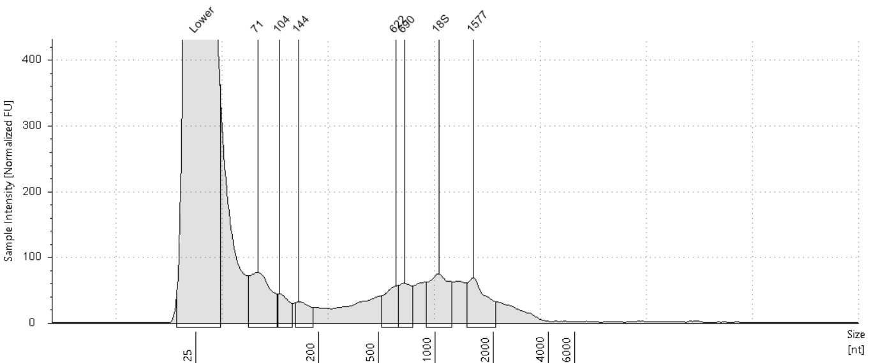

##### Sample Table

|  |  |  |  |  |  |  |
| --- | --- | --- | --- | --- | --- | --- |
| **Well** | **RIN**e | **28S/18S (Area)** | **Conc. [ng/µl]** | **Sample Description** | **Alert** | **Observations** |
| E10 | - | - | 4.04 | RNA 45 | image0.png | Sample concentration outside functional range for RINe and the assay |

##### Peak Table

|  |  |  |  |  |  |  |
| --- | --- | --- | --- | --- | --- | --- |
| **Size [nt]** | **Calibrated Conc. [ng/µl]** | **Assigned Conc. [ng/µl]** | **Peak Molarity [nmol/l]** | **% Integrated Area** | **Peak Comment** | **Observations** |
| 25 | 40.0 | 40.0 | 4710 | - |  | Lower Marker |
| 71 | 0.454 | - | 18.7 | 23.82 |  |  |
| 104 | 0.143 | - | 4.05 | 7.50 |  |  |
| 144 | 0.126 | - | 2.59 | 6.63 |  |  |
| 622 | 0.210 | - | 0.991 | 11.01 |  |  |
| 690 | 0.209 | - | 0.891 | 10.97 |  |  |
| 1043 | 0.413 | - | 1.16 | 21.68 |  | 18S |
| 1577 | 0.350 | - | 0.653 | 18.40 |  |  |

#### F10: RNA 46

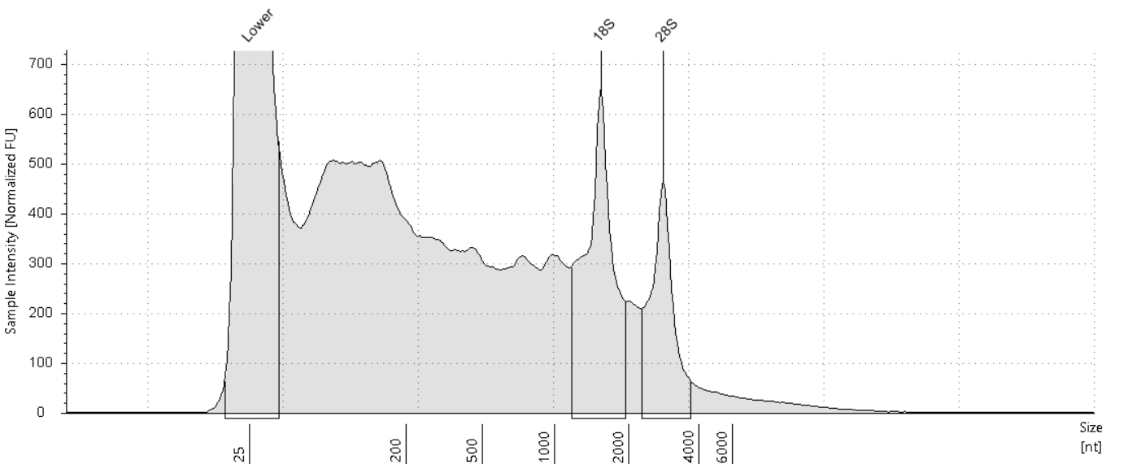

##### Sample Table

|  |  |  |  |  |  |  |
| --- | --- | --- | --- | --- | --- | --- |
| **Well** | **RIN**e | **28S/18S (Area)** | **Conc. [ng/µl]** | **Sample Description** | **Alert** | **Observations** |
| F10 | 5.1 | 0.6 | 28.4 | RNA 46 |  |  |

##### Peak Table

|  |  |  |  |  |  |  |
| --- | --- | --- | --- | --- | --- | --- |
| **Size [nt]** | **Calibrated Conc. [ng/µl]** | **Assigned Conc. [ng/µl]** | **Peak Molarity [nmol/l]** | **% Integrated Area** | **Peak Comment** | **Observations** |
| 25 | 40.0 | 40.0 | 4710 | - |  | Lower Marker |
| 1540 | 3.80 | - | 7.25 | 63.00 |  | 18S |
| 2818 | 2.23 | - | 2.33 | 37.00 |  | 28S |

#### G10: RNA 47

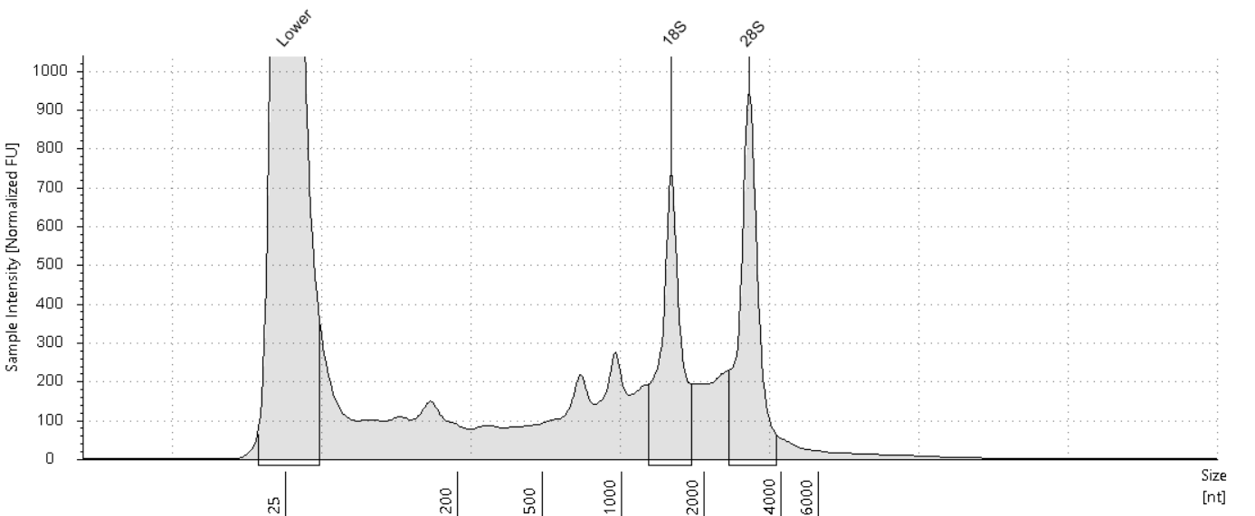

##### Sample Table

|  |  |  |  |  |  |  |
| --- | --- | --- | --- | --- | --- | --- |
| **Well** | **RIN**e | **28S/18S (Area)** | **Conc. [ng/µl]** | **Sample Description** | **Alert** | **Observations** |
| G10 | 7.1 | 1.2 | 14.6 | RNA 47 | image0.png | Sample concentration outside functional range for RINe and the assay |

##### Peak Table

|  |  |  |  |  |  |  |
| --- | --- | --- | --- | --- | --- | --- |
| **Size [nt]** | **Calibrated Conc. [ng/µl]** | **Assigned Conc. [ng/µl]** | **Peak Molarity [nmol/l]** | **% Integrated Area** | **Peak Comment** | **Observations** |
| 25 | 40.0 | 40.0 | 4710 | - |  | Lower Marker |
| 1516 | 2.64 | - | 5.12 | 45.04 |  | 18S |
| 3002 | 3.22 | - | 3.16 | 54.96 |  | 28S |

#### H10: RNA 48

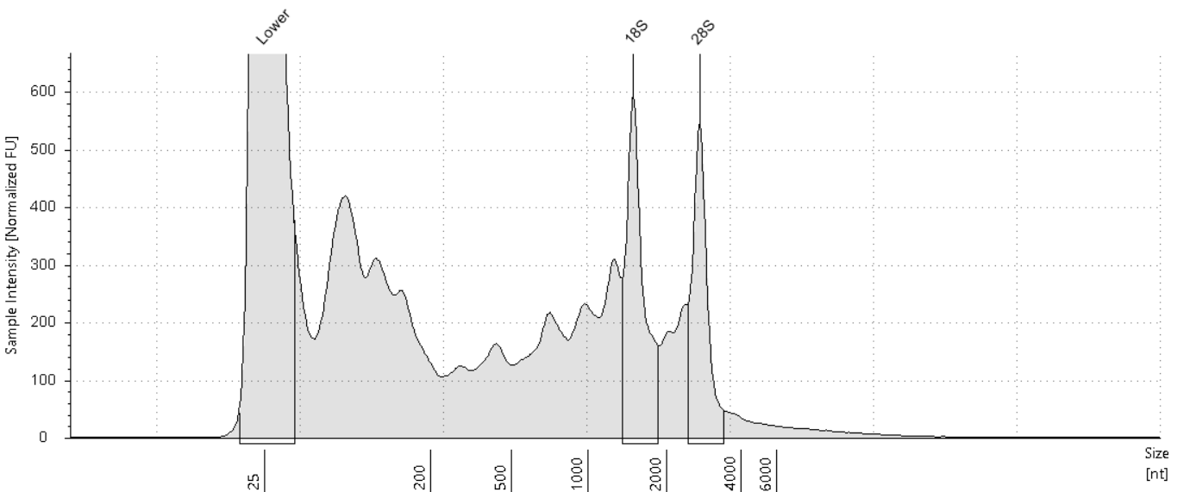

##### Sample Table

|  |  |  |  |  |  |  |
| --- | --- | --- | --- | --- | --- | --- |
| **Well** | **RIN**e | **28S/18S (Area)** | **Conc. [ng/µl]** | **Sample Description** | **Alert** | **Observations** |
| H10 | 5.9 | 0.8 | 18.6 | RNA 48 | image0.png | Sample concentration outside functional range for RINe and the assay |

##### Peak Table

|  |  |  |  |  |  |  |
| --- | --- | --- | --- | --- | --- | --- |
| **Size [nt]** | **Calibrated Conc. [ng/µl]** | **Assigned Conc. [ng/µl]** | **Peak Molarity [nmol/l]** | **% Integrated Area** | **Peak Comment** | **Observations** |
| 25 | 40.0 | 40.0 | 4710 | - |  | Lower Marker |
| 1485 | 2.21 | - | 4.38 | 55.72 |  | 18S |
| 2730 | 1.76 | - | 1.89 | 44.28 |  | 28S |

#### A11: RNA 49

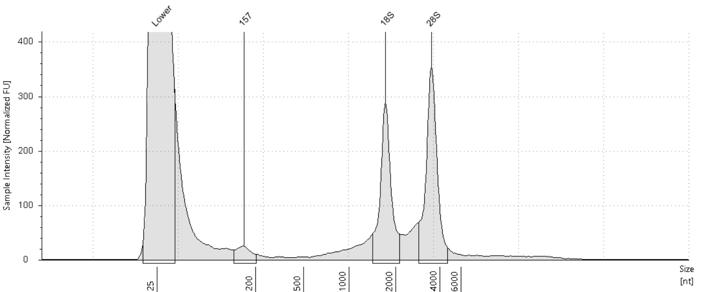

##### Sample Table

|  |  |  |  |  |  |  |
| --- | --- | --- | --- | --- | --- | --- |
| **Well** | **RIN**e | **28S/18S (Area)** | **Conc. [ng/µl]** | **Sample Description** | **Alert** | **Observations** |
| A11 | - | - | 5.35 | RNA 49 | image0.png | Sample concentration outside functional range for RINe and the assay |

##### Peak Table

|  |  |  |  |  |  |  |
| --- | --- | --- | --- | --- | --- | --- |
| **Size [nt]** | **Calibrated Conc. [ng/µl]** | **Assigned Conc. [ng/µl]** | **Peak Molarity [nmol/l]** | **% Integrated Area** | **Peak Comment** | **Observations** |
| 25 | 40.0 | 40.0 | 4710 | - |  | Lower Marker |
| 157 | 0.147 | - | 2.75 | 4.93 |  |  |
| 1717 | 1.25 | - | 2.14 | 41.94 |  | 18S |
| 3526 | 1.58 | - | 1.32 | 53.13 |  | 28S |

#### B11: RNA 50

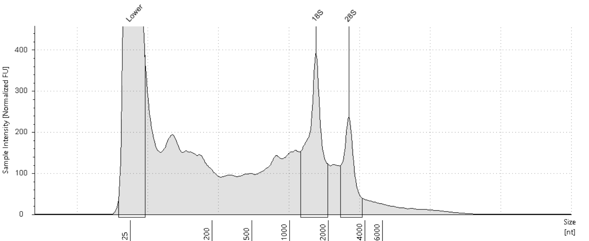

##### Sample Table

|  |  |  |  |  |  |  |
| --- | --- | --- | --- | --- | --- | --- |
| **Well** | **RIN**e | **28S/18S (Area)** | **Conc. [ng/µl]** | **Sample Description** | **Alert** | **Observations** |
| B11 | 5.8 | 0.5 | 13.6 | RNA 50 | image0.png | Sample concentration outside functional range for RINe and the assay |

##### Peak Table

|  |  |  |  |  |  |  |
| --- | --- | --- | --- | --- | --- | --- |
| **Size [nt]** | **Calibrated Conc. [ng/µl]** | **Assigned Conc. [ng/µl]** | **Peak Molarity [nmol/l]** | **% Integrated Area** | **Peak Comment** | **Observations** |
| 25 | 40.0 | 40.0 | 4710 | - |  | Lower Marker |
| 1604 | 2.43 | - | 4.46 | 66.82 |  | 18S |
| 2968 | 1.21 | - | 1.20 | 33.18 |  | 28S |

#### C11: RNA 51

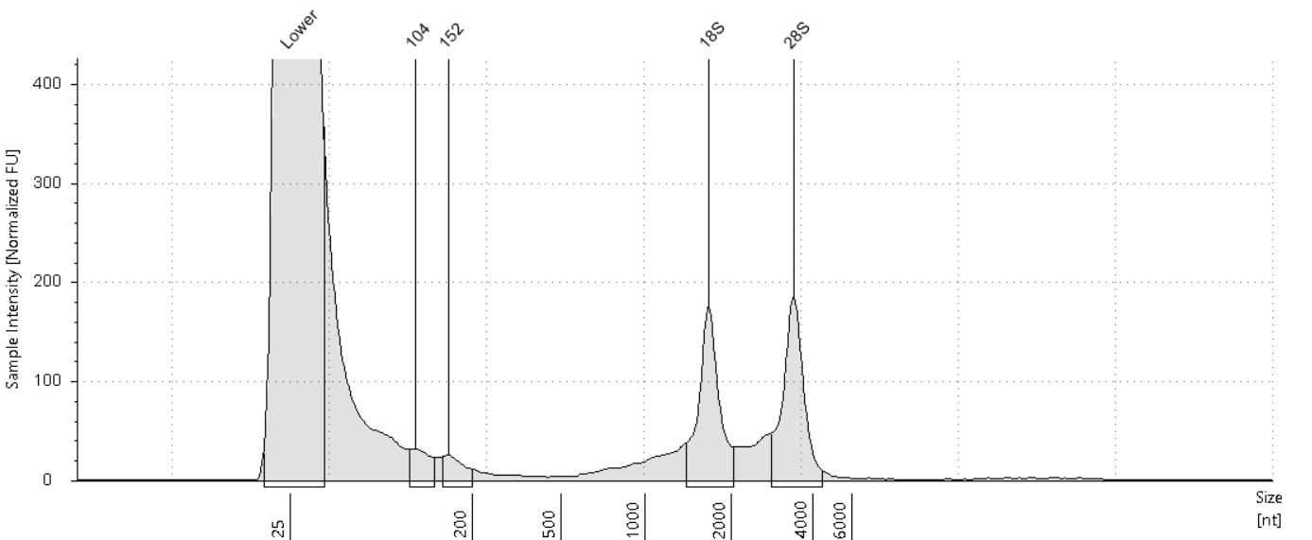

##### Sample Table

|  |  |  |  |  |  |  |
| --- | --- | --- | --- | --- | --- | --- |
| **Well** | **RIN**e | **28S/18S (Area)** | **Conc. [ng/µl]** | **Sample Description** | **Alert** | **Observations** |
| C11 | - | - | 3.86 | RNA 51 | image0.png | Sample concentration outside functional range for RINe and the assay |

##### Peak Table

|  |  |  |  |  |  |  |
| --- | --- | --- | --- | --- | --- | --- |
| **Size [nt]** | **Calibrated Conc. [ng/µl]** | **Assigned Conc. [ng/µl]** | **Peak Molarity [nmol/l]** | **% Integrated Area** | **Peak Comment** | **Observations** |
| 25 | 40.0 | 40.0 | 4710 | - |  | Lower Marker |
| 104 | 0.129 | - | 3.66 | 7.43 |  |  |
| 152 | 0.101 | - | 1.95 | 5.78 |  |  |
| 1661 | 0.721 | - | 1.28 | 41.48 |  | 18S |
| 3392 | 0.788 | - | 0.683 | 45.31 |  | 28S |

#### D11: RNA 52

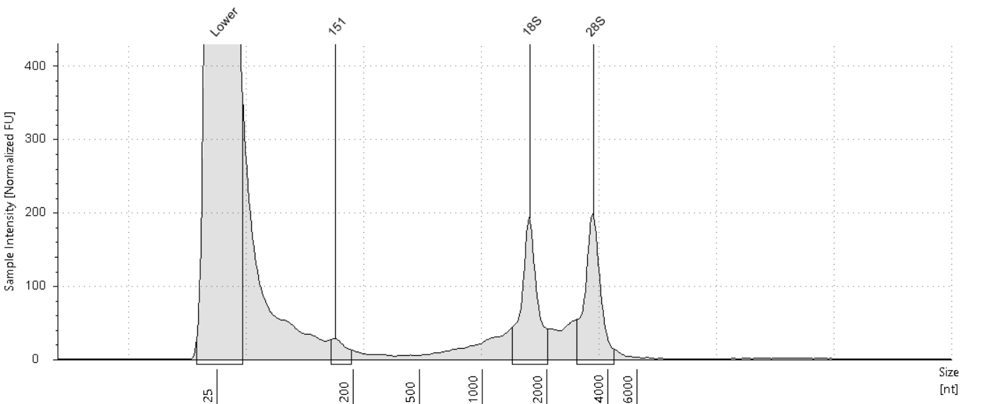

##### Sample Table

|  |  |  |  |  |  |  |
| --- | --- | --- | --- | --- | --- | --- |
| **Well** | **RIN**e | **28S/18S (Area)** | **Conc. [ng/µl]** | **Sample Description** | **Alert** | **Observations** |
| D11 | - | - | 4.11 | RNA 52 | image0.png | Sample concentration outside functional range for RINe and the assay |

##### Peak Table

|  |  |  |  |  |  |  |
| --- | --- | --- | --- | --- | --- | --- |
| **Size [nt]** | **Calibrated Conc. [ng/µl]** | **Assigned Conc. [ng/µl]** | **Peak Molarity [nmol/l]** | **% Integrated Area** | **Peak Comment** | **Observations** |
| 25 | 40.0 | 40.0 | 4710 | - |  | Lower Marker |
| 151 | 0.104 | - | 2.02 | 6.13 |  |  |
| 1655 | 0.774 | - | 1.38 | 45.72 |  | 18S |
| 3388 | 0.815 | - | 0.707 | 48.14 |  | 28S |

#### E11: RNA 53

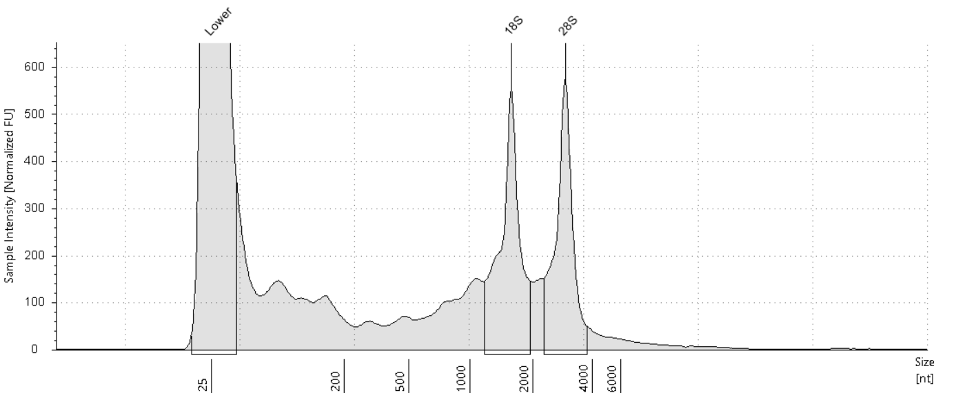

##### Sample Table

|  |  |  |  |  |  |  |
| --- | --- | --- | --- | --- | --- | --- |
| **Well** | **RIN**e | **28S/18S (Area)** | **Conc. [ng/µl]** | **Sample Description** | **Alert** | **Observations** |
| E11 | 7.1 | 0.9 | 12.3 | RNA 53 | image0.png | Sample concentration outside functional range for RINe and the assay |

##### Peak Table

|  |  |  |  |  |  |  |
| --- | --- | --- | --- | --- | --- | --- |
| **Size [nt]** | **Calibrated Conc. [ng/µl]** | **Assigned Conc. [ng/µl]** | **Peak Molarity [nmol/l]** | **% Integrated Area** | **Peak Comment** | **Observations** |
| 25 | 40.0 | 40.0 | 4710 | - |  | Lower Marker |
| 1572 | 2.83 | - | 5.29 | 52.35 |  | 18S |
| 2927 | 2.57 | - | 2.58 | 47.65 |  | 28S |

#### F11: RNA 54

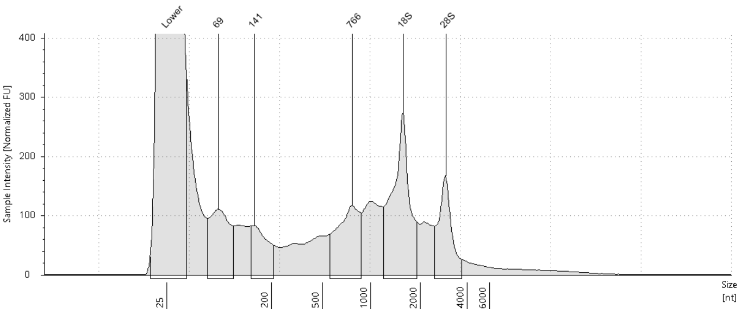

##### Sample Table

|  |  |  |  |  |  |  |
| --- | --- | --- | --- | --- | --- | --- |
| **Well** | **RIN**e | **28S/18S (Area)** | **Conc. [ng/µl]** | **Sample Description** | **Alert** | **Observations** |
| F11 | - | - | 8.33 | RNA 54 | image0.png | Sample concentration outside functional range for RINe and the assay |

##### Peak Table

|  |  |  |  |  |  |  |
| --- | --- | --- | --- | --- | --- | --- |
| **Size [nt]** | **Calibrated Conc. [ng/µl]** | **Assigned Conc. [ng/µl]** | **Peak Molarity [nmol/l]** | **% Integrated Area** | **Peak Comment** | **Observations** |
| 25 | 40.0 | 40.0 | 4710 | - |  | Lower Marker |
| 69 | 0.778 | - | 33.0 | 17.58 |  |  |
| 141 | 0.464 | - | 9.67 | 10.48 |  |  |
| 766 | 0.897 | - | 3.45 | 20.28 |  |  |
| 1562 | 1.55 | - | 2.92 | 35.01 |  | 18S |
| 2903 | 0.737 | - | 0.747 | 16.65 |  | 28S |

#### G11: RNA 55

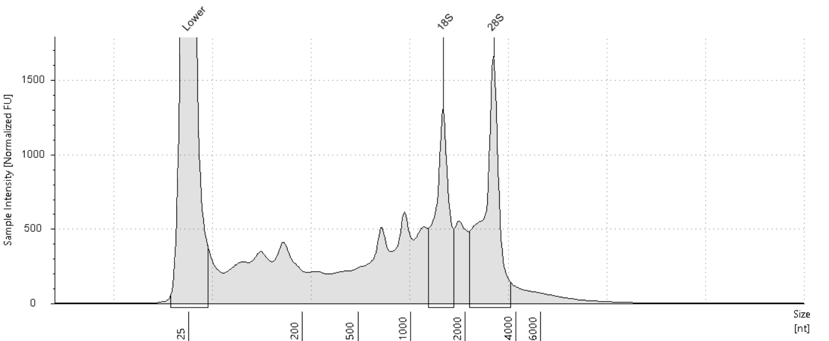

##### Sample Table

|  |  |  |  |  |  |  |
| --- | --- | --- | --- | --- | --- | --- |
| **Well** | **RIN**e | **28S/18S (Area)** | **Conc. [ng/µl]** | **Sample Description** | **Alert** | **Observations** |
| G11 | 5.9 | 1.4 | 36.0 | RNA 55 |  |  |

##### Peak Table

|  |  |  |  |  |  |  |
| --- | --- | --- | --- | --- | --- | --- |
| **Size [nt]** | **Calibrated Conc. [ng/µl]** | **Assigned Conc. [ng/µl]** | **Peak Molarity [nmol/l]** | **% Integrated Area** | **Peak Comment** | **Observations** |
| 25 | 40.0 | 40.0 | 4710 | - |  | Lower Marker |
| 1509 | 5.58 | - | 10.9 | 41.71 |  | 18S |
| 2953 | 7.80 | - | 7.76 | 58.29 |  | 28S |

#### H11: RNA 56

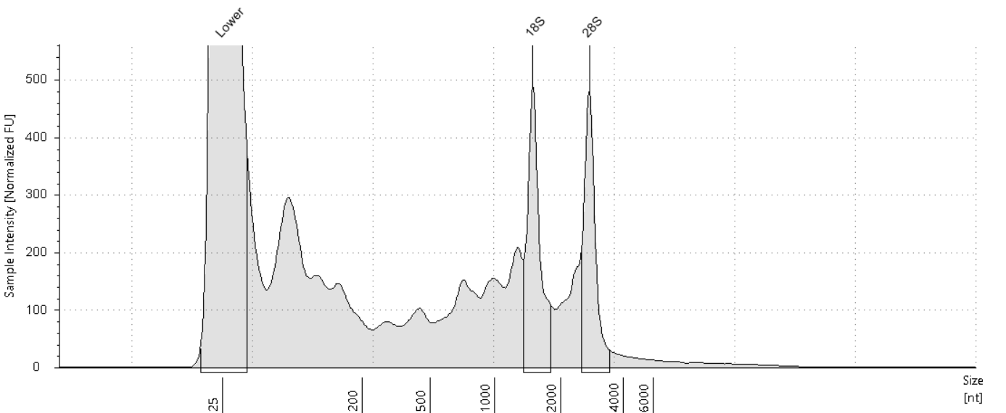

##### Sample Table

|  |  |  |  |  |  |  |
| --- | --- | --- | --- | --- | --- | --- |
| **Well** | **RIN**e | **28S/18S (Area)** | **Conc. [ng/µl]** | **Sample Description** | **Alert** | **Observations** |
| H11 | 6.6 | 0.9 | 12.8 | RNA 56 | image0.png | Sample concentration outside functional range for RINe and the assay |

##### Peak Table

|  |  |  |  |  |  |  |
| --- | --- | --- | --- | --- | --- | --- |
| **Size [nt]** | **Calibrated Conc. [ng/µl]** | **Assigned Conc. [ng/µl]** | **Peak Molarity [nmol/l]** | **% Integrated Area** | **Peak Comment** | **Observations** |
| 25 | 40.0 | 40.0 | 4710 | - |  | Lower Marker |
| 1485 | 1.61 | - | 3.18 | 53.53 |  | 18S |
| 2751 | 1.40 | - | 1.49 | 46.47 |  | 28S |

#### A12: RNA 57

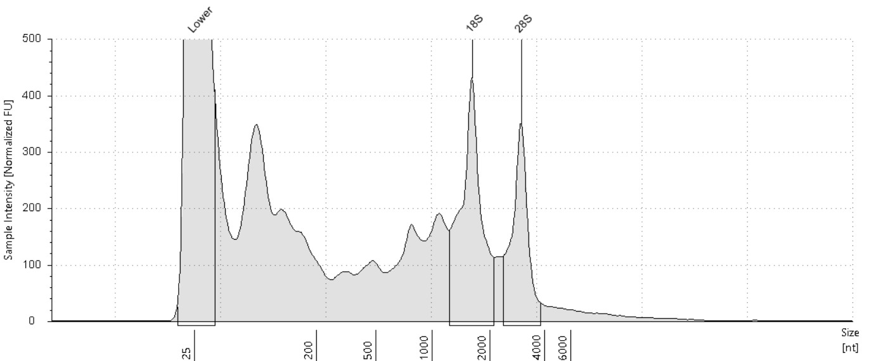

##### Sample Table

|  |  |  |  |  |  |  |
| --- | --- | --- | --- | --- | --- | --- |
| **Well** | **RIN**e | **28S/18S (Area)** | **Conc. [ng/µl]** | **Sample Description** | **Alert** | **Observations** |
| A12 | 5.7 | 0.6 | 16.2 | RNA 57 | image0.png | Sample concentration outside functional range for RINe and the assay |

##### Peak Table

|  |  |  |  |  |  |  |
| --- | --- | --- | --- | --- | --- | --- |
| **Size [nt]** | **Calibrated Conc. [ng/µl]** | **Assigned Conc. [ng/µl]** | **Peak Molarity [nmol/l]** | **% Integrated Area** | **Peak Comment** | **Observations** |
| 25 | 40.0 | 40.0 | 4710 | - |  | Lower Marker |
| 1616 | 2.92 | - | 5.31 | 61.37 |  | 18S |
| 2977 | 1.84 | - | 1.81 | 38.63 |  | 28S |

#### B12: RNA 58

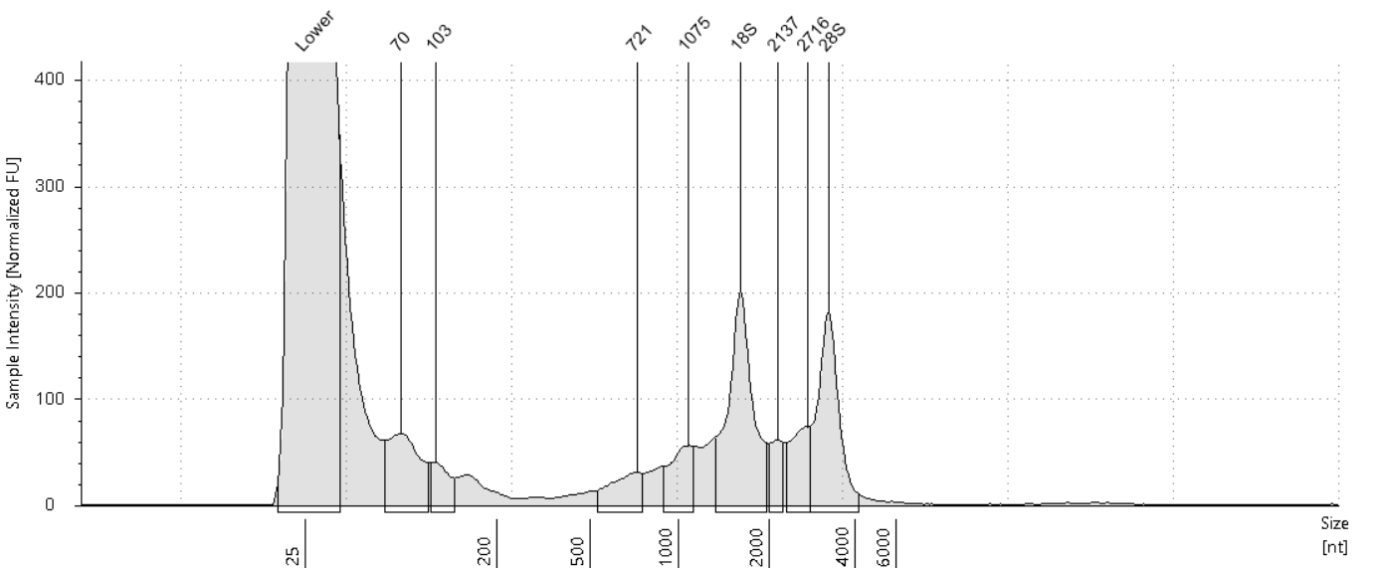

##### Sample Table

|  |  |  |  |  |  |  |
| --- | --- | --- | --- | --- | --- | --- |
| **Well** | **RIN**e | **28S/18S (Area)** | **Conc. [ng/µl]** | **Sample Description** | **Alert** | **Observations** |
| B12 | - | - | 5.11 | RNA 58 | image0.png | Sample concentration outside functional range for RINe and the assay |

##### Peak Table

|  |  |  |  |  |  |  |
| --- | --- | --- | --- | --- | --- | --- |
| **Size [nt]** | **Calibrated Conc. [ng/µl]** | **Assigned Conc. [ng/µl]** | **Peak Molarity [nmol/l]** | **% Integrated Area** | **Peak Comment** | **Observations** |
| 25 | 40.0 | 40.0 | 4710 | - |  | Lower Marker |
| 70 | 0.455 | - | 19.0 | 13.68 |  |  |
| 103 | 0.154 | - | 4.40 | 4.63 |  |  |
| 721 | 0.192 | - | 0.782 | 5.77 |  |  |
| 1075 | 0.266 | - | 0.727 | 8.00 |  |  |
| 1604 | 1.01 | - | 1.85 | 30.34 |  | 18S |
| 2137 | 0.163 | - | 0.224 | 4.90 |  |  |
| 2716 | 0.299 | - | 0.324 | 9.01 |  |  |
| 3243 | 0.786 | - | 0.713 | 23.66 |  | 28S |

#### C12: RNA 59

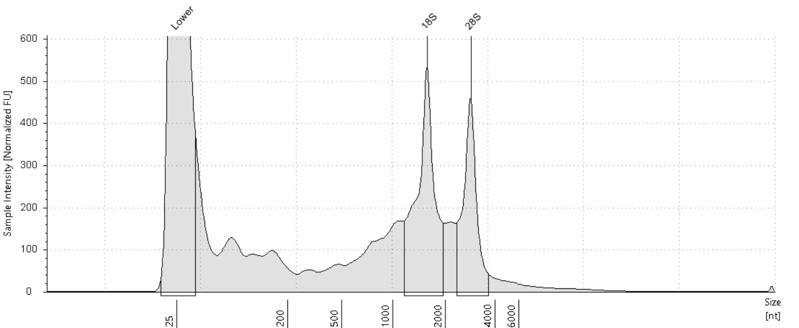

##### Sample Table

|  |  |  |  |  |  |  |
| --- | --- | --- | --- | --- | --- | --- |
| **Well** | **RIN**e | **28S/18S (Area)** | **Conc. [ng/µl]** | **Sample Description** | **Alert** | **Observations** |
| C12 | 6.5 | 0.7 | 12.9 | RNA 59 | image0.png | Sample concentration outside functional range for RINe and the assay |

##### Peak Table

|  |  |  |  |  |  |  |
| --- | --- | --- | --- | --- | --- | --- |
| **Size [nt]** | **Calibrated Conc. [ng/µl]** | **Assigned Conc. [ng/µl]** | **Peak Molarity [nmol/l]** | **% Integrated Area** | **Peak Comment** | **Observations** |
| 25 | 40.0 | 40.0 | 4710 | - |  | Lower Marker |
| 1565 | 3.29 | - | 6.18 | 59.96 |  | 18S |
| 2858 | 2.19 | - | 2.26 | 40.04 |  | 28S |

#### D12: RNA 60

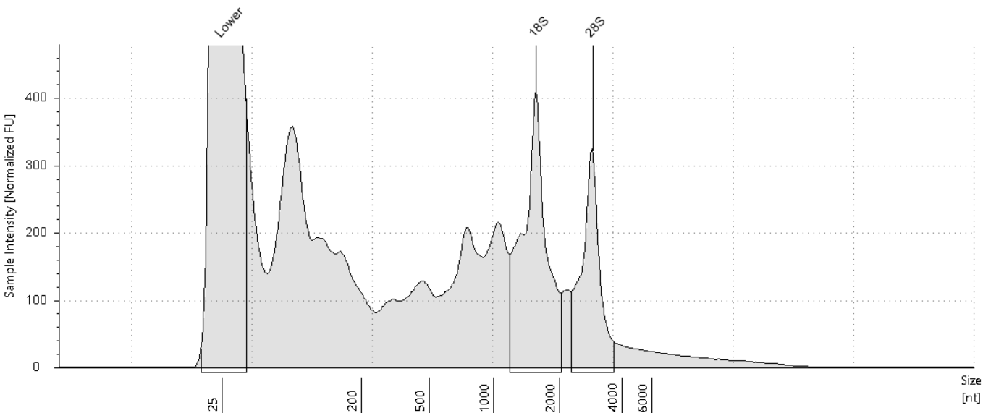

##### Sample Table

|  |  |  |  |  |  |  |
| --- | --- | --- | --- | --- | --- | --- |
| **Well** | **RIN**e | **28S/18S (Area)** | **Conc. [ng/µl]** | **Sample Description** | **Alert** | **Observations** |
| D12 | 5.2 | 0.6 | 15.7 | RNA 60 | image0.png | Sample concentration outside functional range for RINe and the assay |

##### Peak Table

|  |  |  |  |  |  |  |
| --- | --- | --- | --- | --- | --- | --- |
| **Size [nt]** | **Calibrated Conc. [ng/µl]** | **Assigned Conc. [ng/µl]** | **Peak Molarity [nmol/l]** | **% Integrated Area** | **Peak Comment** | **Observations** |
| 25 | 40.0 | 40.0 | 4710 | - |  | Lower Marker |
| 1562 | 2.67 | - | 5.02 | 62.64 |  | 18S |
| 2891 | 1.59 | - | 1.62 | 37.36 |  | 28S |

#### E12: RNA 61

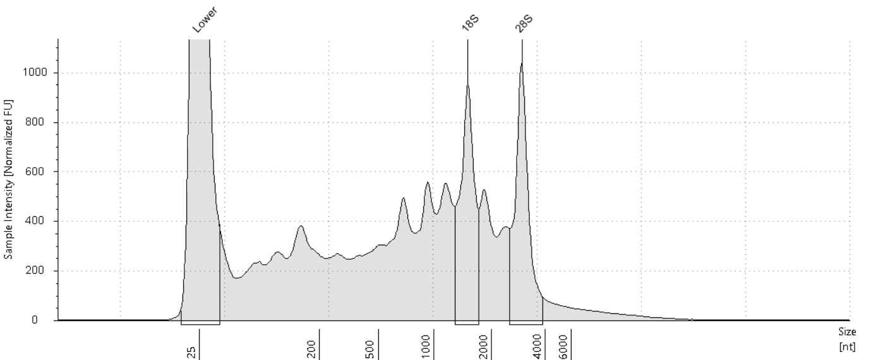

##### Sample Table

|  |  |  |  |  |  |  |
| --- | --- | --- | --- | --- | --- | --- |
| **Well** | **RIN**e | **28S/18S (Area)** | **Conc. [ng/µl]** | **Sample Description** | **Alert** | **Observations** |
| E12 | 4.9 | 1.0 | 33.4 | RNA 61 |  |  |

##### Peak Table

|  |  |  |  |  |  |  |
| --- | --- | --- | --- | --- | --- | --- |
| **Size [nt]** | **Calibrated Conc. [ng/µl]** | **Assigned Conc. [ng/µl]** | **Peak Molarity [nmol/l]** | **% Integrated Area** | **Peak Comment** | **Observations** |
| 25 | 40.0 | 40.0 | 4710 | - |  | Lower Marker |
| 1507 | 4.36 | - | 8.51 | 49.87 |  | 18S |
| 2963 | 4.38 | - | 4.35 | 50.13 |  | 28S |

#### F12: RNA 62

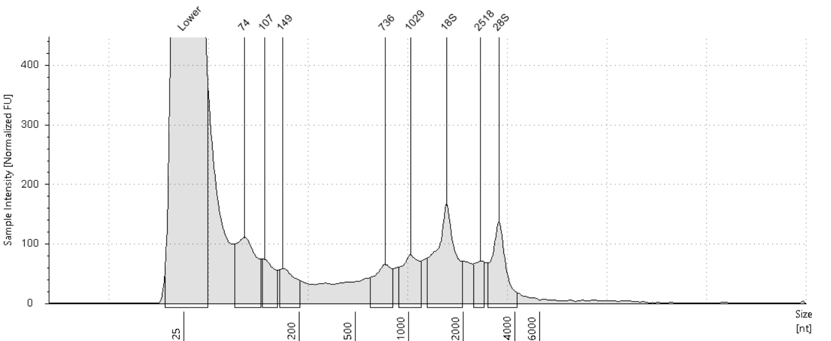

##### Sample Table

|  |  |  |  |  |  |  |
| --- | --- | --- | --- | --- | --- | --- |
| **Well** | **RIN**e | **28S/18S (Area)** | **Conc. [ng/µl]** | **Sample Description** | **Alert** | **Observations** |
| F12 | - | - | 5.56 | RNA 62 | image0.png | Sample concentration outside functional range for RINe and the assay |

##### Peak Table

|  |  |  |  |  |  |  |
| --- | --- | --- | --- | --- | --- | --- |
| **Size [nt]** | **Calibrated Conc. [ng/µl]** | **Assigned Conc. [ng/µl]** | **Peak Molarity [nmol/l]** | **% Integrated Area** | **Peak Comment** | **Observations** |
| 25 | 40.0 | 40.0 | 4710 | - |  | Lower Marker |
| 74 | 0.616 | - | 24.3 | 18.51 |  |  |
| 107 | 0.245 | - | 6.76 | 7.36 |  |  |
| 149 | 0.241 | - | 4.75 | 7.25 |  |  |
| 736 | 0.304 | - | 1.21 | 9.12 |  |  |
| 1029 | 0.381 | - | 1.09 | 11.44 |  |  |
| 1618 | 0.847 | - | 1.54 | 25.44 |  | 18S |
| 2518 | 0.183 | - | 0.214 | 5.50 |  |  |
| 3235 | 0.512 | - | 0.466 | 15.38 |  | 28S |

#### G12: RNA 63

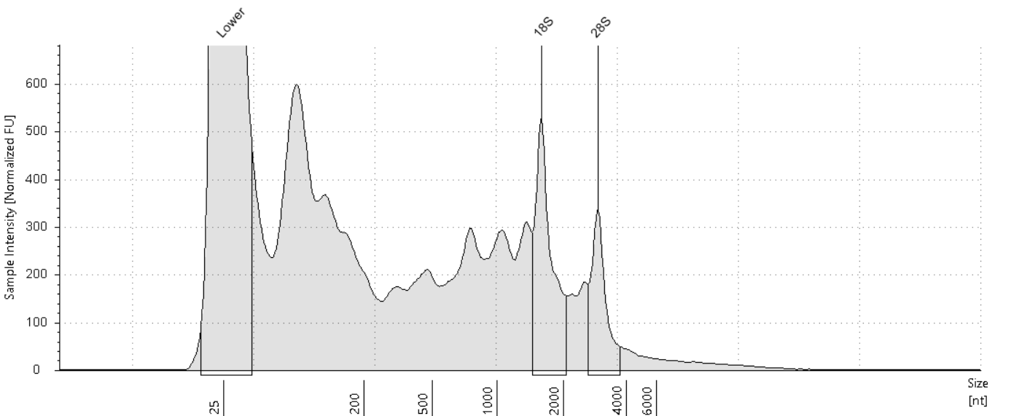

##### Sample Table

|  |  |  |  |  |  |  |
| --- | --- | --- | --- | --- | --- | --- |
| **Well** | **RIN**e | **28S/18S (Area)** | **Conc. [ng/µl]** | **Sample Description** | **Alert** | **Observations** |
| G12 | 4.9 | 0.5 | 19.1 | RNA 63 | image0.png | Sample concentration outside functional range for RINe and the assay |

##### Peak Table

|  |  |  |  |  |  |  |
| --- | --- | --- | --- | --- | --- | --- |
| **Size [nt]** | **Calibrated Conc. [ng/µl]** | **Assigned Conc. [ng/µl]** | **Peak Molarity [nmol/l]** | **% Integrated Area** | **Peak Comment** | **Observations** |
| 25 | 40.0 | 40.0 | 4710 | - |  | Lower Marker |
| 1575 | 1.99 | - | 3.71 | 64.52 |  | 18S |
| 2929 | 1.09 | - | 1.10 | 35.48 |  | 28S |

#### H12: RNA 64

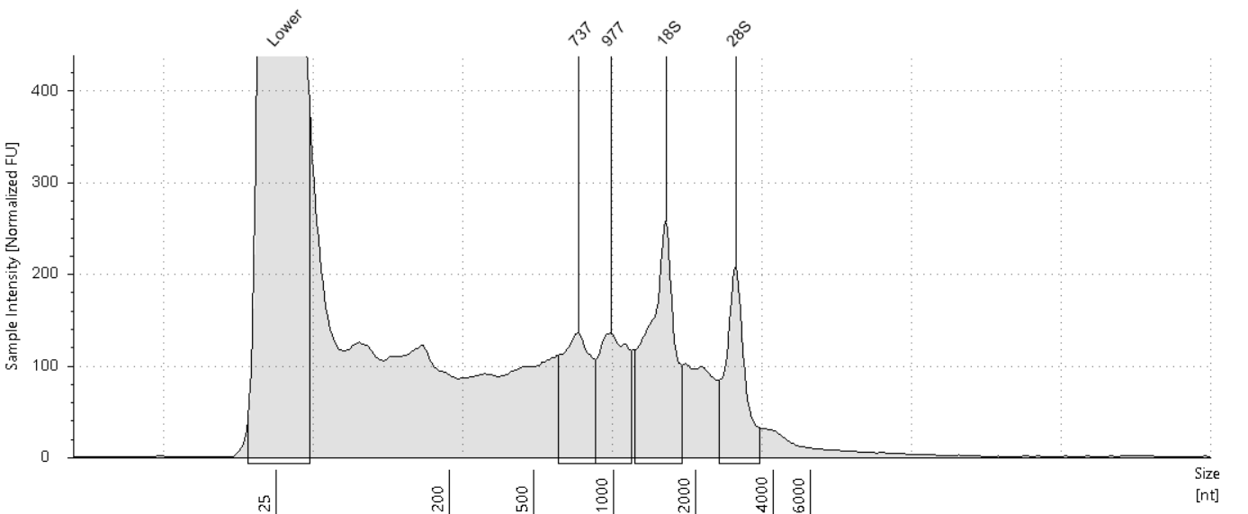

##### Sample Table

|  |  |  |  |  |  |  |
| --- | --- | --- | --- | --- | --- | --- |
| **Well** | **RIN**e | **28S/18S (Area)** | **Conc. [ng/µl]** | **Sample Description** | **Alert** | **Observations** |
| H12 | - | - | 9.10 | RNA 64 | image0.png | Sample concentration outside functional range for RINe and the assay |

##### Peak Table

|  |  |  |  |  |  |  |
| --- | --- | --- | --- | --- | --- | --- |
| **Size [nt]** | **Calibrated Conc. [ng/µl]** | **Assigned Conc. [ng/µl]** | **Peak Molarity [nmol/l]** | **% Integrated Area** | **Peak Comment** | **Observations** |
| 25 | 40.0 | 40.0 | 4710 | - |  | Lower Marker |
| 737 | 0.770 | - | 3.07 | 21.82 |  |  |
| 977 | 0.753 | - | 2.27 | 21.34 |  |  |
| 1552 | 1.27 | - | 2.40 | 35.91 |  | 18S |
| 2866 | 0.738 | - | 0.758 | 20.93 |  | 28S |