ITEC 621 - Predictive Project - Airbnb
Antal
February 21, 2019
knitr::opts_chunk$set(echo=T, warning=F, message=F)
## Cleaning data for training for log_price predictions.
train <-read.csv("train.csv", header = T, sep = ",", na.strings=c("","NA"))
library(tidyverse)
library(ggplot2)
library(corrplot)
library(perturb)
library(car)
library(lmtest)
library(ISLR)
library(boot)
library(tree)
library(stats)
train <- train[, c(
'log_price',
'property_type',
'room_type',
'accommodates',
'bathrooms',
'bed_type',
'cancellation_policy',
'cleaning_fee',
'city',
'first_review',
'host_has_profile_pic',
'host_identity_verified',
'host_response_rate',
'host_since',
'instant_bookable',
'last_review',
'number_of_reviews',
'review_scores_rating',
'bedrooms',
'beds'
)]
##Data Cleaning!
train$first_review <- as.Date(train$first_review, format = '%Y-%m-%d')
train$host_since <- as.Date(train$host_since, format = '%Y-%m-%d')
train$last_review <- as.Date(train$last_review, format = '%Y-%m-%d')
which(colnames(train)=="host_response_rate" )
## [1] 13
colnames(train)[13] <- "host_response_rate_percent"
percent_num <- as.numeric(sub("%", "", train$host_response_rate_percent))
head(percent_num)
## [1] NA 100 100 NA 100 100
train$host_response_rate_percent <- percent_num
# Creating a correlation matrix
trainNo <- train[complete.cases(train), ]
numVar <- which(sapply(trainNo, is.numeric))
dataset_num <- trainNo[, numVar]
data_cor <- cor(dataset_num, use = 'complete.obs')
corrplot(data_cor)
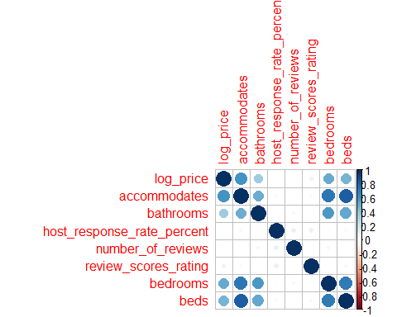
# OLS model of the complete dataset for log_price.
lm.model <- lm(log_price ~. , data = trainNo)
summary(lm.model)
##
## Call:
## lm(formula = log_price ~ ., data = trainNo)
##
## Residuals:
## Min 1Q Median 3Q Max
## -3.7490 -0.2682 -0.0140 0.2516 2.8472
##
## Coefficients:
## Estimate Std. Error t value Pr(>|t|)
## (Intercept) 8.860e+00 2.286e-01 38.760 < 2e-16
## property_typeBed & Breakfast 1.056e-01 2.295e-02 4.603 4.18e-06
## property_typeBoat 2.147e-01 6.150e-02 3.491 0.000482
## property_typeBoutique hotel 1.193e-01 6.797e-02 1.756 0.079126
## property_typeBungalow -2.554e-02 2.499e-02 -1.022 0.306805
## property_typeCabin -1.229e-01 5.386e-02 -2.282 0.022472
## property_typeCamper/RV -2.461e-01 5.125e-02 -4.802 1.57e-06
## property_typeCastle 4.107e-01 1.143e-01 3.594 0.000326
## property_typeCave 3.039e-01 2.912e-01 1.044 0.296619
## property_typeChalet 5.722e-02 1.843e-01 0.310 0.756185
## property_typeCondominium 1.072e-01 1.030e-02 10.408 < 2e-16
## property_typeDorm -4.258e-01 4.153e-02 -10.253 < 2e-16
## property_typeEarth House 6.383e-02 2.377e-01 0.269 0.788300
## property_typeGuest suite -9.055e-02 4.154e-02 -2.180 0.029262
## property_typeGuesthouse -5.205e-02 2.105e-02 -2.472 0.013435
## property_typeHostel -5.328e-01 5.678e-02 -9.383 < 2e-16
## property_typeHouse -5.380e-02 5.119e-03 -10.508 < 2e-16
## property_typeHut -3.637e-01 1.557e-01 -2.336 0.019499
## property_typeIn-law -2.095e-01 5.219e-02 -4.014 5.97e-05
## property_typeIsland 8.313e-01 4.117e-01 2.019 0.043491
## property_typeLoft 1.633e-01 1.423e-02 11.477 < 2e-16
## property_typeOther 1.922e-02 2.105e-02 0.913 0.361201
## property_typeServiced apartment 2.033e-01 1.064e-01 1.911 0.055959
## property_typeTent -3.717e-01 1.103e-01 -3.370 0.000752
## property_typeTimeshare 5.107e-01 7.530e-02 6.782 1.20e-11
## property_typeTipi 6.096e-01 2.379e-01 2.563 0.010390
## property_typeTownhouse -1.569e-02 1.233e-02 -1.273 0.203190
## property_typeTrain 6.426e-01 2.912e-01 2.207 0.027333
## property_typeTreehouse 3.843e-01 2.060e-01 1.866 0.062066
## property_typeVacation home 3.875e-01 1.681e-01 2.305 0.021174
## property_typeVilla 4.007e-02 3.723e-02 1.076 0.281815
## property_typeYurt 9.651e-02 1.682e-01 0.574 0.566069
## room_typePrivate room -6.158e-01 4.758e-03 -129.402 < 2e-16
## room_typeShared room -1.106e+00 1.301e-02 -85.045 < 2e-16
## accommodates 7.628e-02 1.762e-03 43.278 < 2e-16
## bathrooms 1.484e-01 4.162e-03 35.662 < 2e-16
## bed_typeCouch 6.159e-02 4.452e-02 1.384 0.166517
## bed_typeFuton -1.116e-02 3.189e-02 -0.350 0.726326
## bed_typePull-out Sofa 6.997e-02 3.297e-02 2.123 0.033799
## bed_typeReal Bed 8.278e-02 2.616e-02 3.164 0.001558
## cancellation_policymoderate 8.614e-03 5.727e-03 1.504 0.132566
## cancellation_policystrict 4.039e-02 5.395e-03 7.485 7.25e-14
## cancellation_policysuper_strict_30 2.253e-01 4.734e-02 4.760 1.94e-06
## cancellation_policysuper_strict_60 7.315e-01 1.306e-01 5.600 2.16e-08
## cleaning_feeTrue -4.971e-03 5.235e-03 -0.950 0.342316
## cityChicago -3.620e-01 1.137e-02 -31.854 < 2e-16
## cityDC -1.560e-01 1.107e-02 -14.099 < 2e-16
## cityLA -1.965e-01 9.355e-03 -21.006 < 2e-16
## cityNYC -2.657e-02 8.936e-03 -2.973 0.002949
## citySF 2.545e-01 1.066e-02 23.865 < 2e-16
## first_review -4.776e-05 5.482e-06 -8.711 < 2e-16
## host_has_profile_pict -1.410e-01 4.834e-02 -2.916 0.003545
## host_identity_verifiedt -5.659e-05 4.559e-03 -0.012 0.990096
## host_response_rate_percent -5.928e-04 1.472e-04 -4.027 5.65e-05
## host_since -2.604e-05 3.523e-06 -7.390 1.49e-13
## instant_bookablet -1.970e-02 4.384e-03 -4.493 7.04e-06
## last_review -2.084e-04 1.378e-05 -15.129 < 2e-16
## number_of_reviews -4.255e-04 5.617e-05 -7.576 3.62e-14
## review_scores_rating 6.972e-03 2.679e-04 26.025 < 2e-16
## bedrooms 1.433e-01 3.598e-03 39.821 < 2e-16
## beds -3.870e-02 2.717e-03 -14.245 < 2e-16
##
## (Intercept) ***
## property_typeBed & Breakfast ***
## property_typeBoat ***
## property_typeBoutique hotel .
## property_typeBungalow
## property_typeCabin *
## property_typeCamper/RV ***
## property_typeCastle ***
## property_typeCave
## property_typeChalet
## property_typeCondominium ***
## property_typeDorm ***
## property_typeEarth House
## property_typeGuest suite *
## property_typeGuesthouse *
## property_typeHostel ***
## property_typeHouse ***
## property_typeHut *
## property_typeIn-law ***
## property_typeIsland *
## property_typeLoft ***
## property_typeOther
## property_typeServiced apartment .
## property_typeTent ***
## property_typeTimeshare ***
## property_typeTipi *
## property_typeTownhouse
## property_typeTrain *
## property_typeTreehouse .
## property_typeVacation home *
## property_typeVilla
## property_typeYurt
## room_typePrivate room ***
## room_typeShared room ***
## accommodates ***
## bathrooms ***
## bed_typeCouch
## bed_typeFuton
## bed_typePull-out Sofa *
## bed_typeReal Bed **
## cancellation_policymoderate
## cancellation_policystrict ***
## cancellation_policysuper_strict_30 ***
## cancellation_policysuper_strict_60 ***
## cleaning_feeTrue
## cityChicago ***
## cityDC ***
## cityLA ***
## cityNYC **
## citySF ***
## first_review ***
## host_has_profile_pict **
## host_identity_verifiedt
## host_response_rate_percent ***
## host_since ***
## instant_bookablet ***
## last_review ***
## number_of_reviews ***
## review_scores_rating ***
## bedrooms ***
## beds ***
## ---
## Signif. codes: 0 '***' 0.001 '**' 0.01 '*' 0.05 '.' 0.1 ' ' 1
##
## Residual standard error: 0.4116 on 47725 degrees of freedom
## Multiple R-squared: 0.6293, Adjusted R-squared: 0.6289
## F-statistic: 1351 on 60 and 47725 DF, p-value: < 2.2e-16
## Checking if cities are significant with predictor log_price
zip.cost <-glm(city ~ log_price, family=binomial(link="logit"), data=trainNo)
summary(zip.cost)
##
## Call:
## glm(formula = city ~ log_price, family = binomial(link = "logit"),
## data = trainNo)
##
## Deviance Residuals:
## Min 1Q Median 3Q Max
## -2.6375 0.3007 0.3171 0.3402 0.4693
##
## Coefficients:
## Estimate Std. Error z value Pr(>|z|)
## (Intercept) 4.2173 0.1460 28.893 <2e-16 ***
## log_price -0.2719 0.0297 -9.156 <2e-16 ***
## ---
## Signif. codes: 0 '***' 0.001 '**' 0.01 '*' 0.05 '.' 0.1 ' ' 1
##
## (Dispersion parameter for binomial family taken to be 1)
##
## Null deviance: 19439 on 47785 degrees of freedom
## Residual deviance: 19357 on 47784 degrees of freedom
## AIC: 19361
##
## Number of Fisher Scoring iterations: 5
# Confirms that city has a significant effect on price
## Creating models for San Francisco
SF <- train %>%
filter(city == "SF")
# Removing rows with NA and city column
SFNo <- SF[complete.cases(SF), ] %>%
select(-city)
## OLS Assumptions
## Assumption 1. Y is continuous
hist(SFNo$log_price)
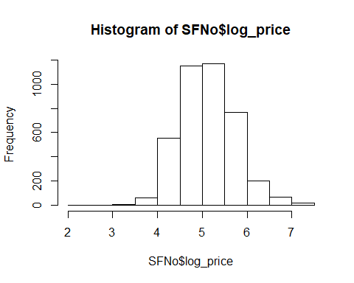
# The bar plot seems to be normally distributed.
## Assumption 2. Errors (ɛ) are normally distributed
# Since Y is normally distributed, residual would also be normally distributed.
qqnorm(SFNo$log_price, main=" Price SF")
qqline(SFNo$log_price)
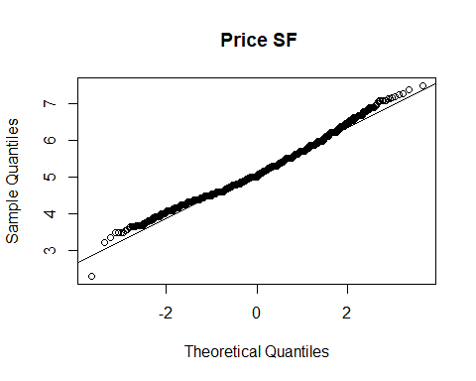
# A large majority of residuals lie on the qqline implying that the residuals are normally distributed.
## Assumption 3. X’s are independent
#Log-Linear model for each city
SFLogLinearModel <- lm(log_price ~ ., data = SFNo)
summary(SFLogLinearModel)
##
## Call:
## lm(formula = log_price ~ ., data = SFNo)
##
## Residuals:
## Min 1Q Median 3Q Max
## -3.3386 -0.2188 -0.0026 0.2141 1.8616
##
## Coefficients:
## Estimate Std. Error t value Pr(>|t|)
## (Intercept) 7.744e+00 6.205e-01 12.481 < 2e-16
## property_typeBed & Breakfast 1.105e-02 6.208e-02 0.178 0.858746
## property_typeBoat -1.828e-01 1.829e-01 -0.999 0.317796
## property_typeBoutique hotel -8.057e-03 7.859e-02 -0.103 0.918347
## property_typeBungalow 7.219e-03 1.391e-01 0.052 0.958622
## property_typeCabin 7.460e-02 1.504e-01 0.496 0.619848
## property_typeCamper/RV -1.668e-01 1.505e-01 -1.109 0.267657
## property_typeCastle 1.818e-01 2.120e-01 0.858 0.391057
## property_typeCave 2.974e-01 3.658e-01 0.813 0.416280
## property_typeCondominium 1.723e-01 2.222e-02 7.756 1.11e-14
## property_typeDorm -3.004e-01 1.302e-01 -2.308 0.021066
## property_typeGuest suite -1.286e-01 5.931e-02 -2.168 0.030200
## property_typeGuesthouse 3.463e-02 7.851e-02 0.441 0.659123
## property_typeHostel -2.586e-01 1.431e-01 -1.807 0.070847
## property_typeHouse -5.923e-02 1.392e-02 -4.254 2.15e-05
## property_typeIn-law -1.227e-01 5.322e-02 -2.305 0.021191
## property_typeLoft 1.461e-01 4.904e-02 2.979 0.002910
## property_typeOther -1.627e-02 5.879e-02 -0.277 0.781999
## property_typeServiced apartment 1.604e+00 3.660e-01 4.382 1.21e-05
## property_typeTent -5.012e-01 3.664e-01 -1.368 0.171382
## property_typeTimeshare 1.956e-01 1.022e-01 1.914 0.055728
## property_typeTownhouse -2.555e-02 7.101e-02 -0.360 0.719035
## property_typeTreehouse 2.040e-01 3.657e-01 0.558 0.577016
## property_typeVilla -7.427e-02 2.590e-01 -0.287 0.774297
## room_typePrivate room -4.516e-01 1.473e-02 -30.666 < 2e-16
## room_typeShared room -1.004e+00 6.104e-02 -16.446 < 2e-16
## accommodates 9.368e-02 5.767e-03 16.243 < 2e-16
## bathrooms 1.175e-01 1.297e-02 9.062 < 2e-16
## bed_typeCouch 7.619e-02 1.503e-01 0.507 0.612228
## bed_typeFuton -1.144e-01 1.206e-01 -0.948 0.342951
## bed_typePull-out Sofa -1.093e-01 1.184e-01 -0.923 0.356113
## bed_typeReal Bed -1.076e-01 1.027e-01 -1.048 0.294802
## cancellation_policymoderate -4.490e-02 1.871e-02 -2.400 0.016445
## cancellation_policystrict -2.182e-02 1.827e-02 -1.194 0.232524
## cancellation_policysuper_strict_30 -5.005e-01 1.186e-01 -4.219 2.51e-05
## cancellation_policysuper_strict_60 1.101e+00 3.739e-01 2.946 0.003238
## cleaning_feeTrue -1.078e-02 1.809e-02 -0.596 0.551327
## first_review -4.931e-05 1.452e-05 -3.397 0.000689
## host_has_profile_pict -7.475e-02 1.108e-01 -0.675 0.499938
## host_identity_verifiedt 2.989e-02 1.480e-02 2.019 0.043519
## host_response_rate_percent 3.567e-05 5.554e-04 0.064 0.948793
## host_since -5.296e-06 1.027e-05 -0.516 0.606187
## instant_bookablet -4.030e-03 1.385e-02 -0.291 0.771140
## last_review -1.713e-04 3.650e-05 -4.694 2.77e-06
## number_of_reviews -7.156e-04 1.281e-04 -5.585 2.50e-08
## review_scores_rating 1.122e-02 9.743e-04 11.514 < 2e-16
## bedrooms 1.554e-01 1.164e-02 13.343 < 2e-16
## beds -2.885e-02 1.031e-02 -2.798 0.005169
##
## (Intercept) ***
## property_typeBed & Breakfast
## property_typeBoat
## property_typeBoutique hotel
## property_typeBungalow
## property_typeCabin
## property_typeCamper/RV
## property_typeCastle
## property_typeCave
## property_typeCondominium ***
## property_typeDorm *
## property_typeGuest suite *
## property_typeGuesthouse
## property_typeHostel .
## property_typeHouse ***
## property_typeIn-law *
## property_typeLoft **
## property_typeOther
## property_typeServiced apartment ***
## property_typeTent
## property_typeTimeshare .
## property_typeTownhouse
## property_typeTreehouse
## property_typeVilla
## room_typePrivate room ***
## room_typeShared room ***
## accommodates ***
## bathrooms ***
## bed_typeCouch
## bed_typeFuton
## bed_typePull-out Sofa
## bed_typeReal Bed
## cancellation_policymoderate *
## cancellation_policystrict
## cancellation_policysuper_strict_30 ***
## cancellation_policysuper_strict_60 **
## cleaning_feeTrue
## first_review ***
## host_has_profile_pict
## host_identity_verifiedt *
## host_response_rate_percent
## host_since
## instant_bookablet
## last_review ***
## number_of_reviews ***
## review_scores_rating ***
## bedrooms ***
## beds **
## ---
## Signif. codes: 0 '***' 0.001 '**' 0.01 '*' 0.05 '.' 0.1 ' ' 1
##
## Residual standard error: 0.365 on 3944 degrees of freedom
## Multiple R-squared: 0.6393, Adjusted R-squared: 0.635
## F-statistic: 148.7 on 47 and 3944 DF, p-value: < 2.2e-16
# Checking for correlation in X variables
# Condition Index and Variance Inflation factor
vif(SFLogLinearModel)
## GVIF Df GVIF^(1/(2*Df))
## property_type 1.762348 23 1.012395
## room_type 1.731785 2 1.147159
## accommodates 3.764351 1 1.940194
## bathrooms 1.538577 1 1.240394
## bed_type 1.113817 4 1.013565
## cancellation_policy 1.277912 4 1.031128
## cleaning_fee 1.130537 1 1.063267
## first_review 2.189616 1 1.479735
## host_has_profile_pic 1.010999 1 1.005484
## host_identity_verified 1.217478 1 1.103394
## host_response_rate_percent 1.075120 1 1.036880
## host_since 1.584554 1 1.258791
## instant_bookable 1.152157 1 1.073386
## last_review 1.237542 1 1.112449
## number_of_reviews 1.749767 1 1.322788
## review_scores_rating 1.117706 1 1.057216
## bedrooms 2.992160 1 1.729786
## beds 3.821367 1 1.954832
# All the vif coefficients are below 10. Therefore there is no significant correlation between the variables.
## Assumption 4. Y and X’s have linear relationship
#Plots
# the_plot <- ggpairs(data.frame(SFNo), cardinality_threshold = 35, showStrips = TRUE)
plot(SFLogLinearModel)
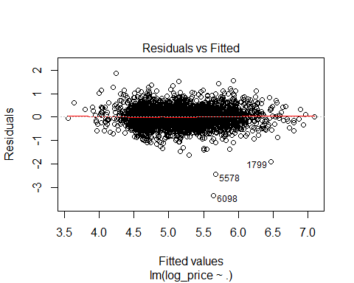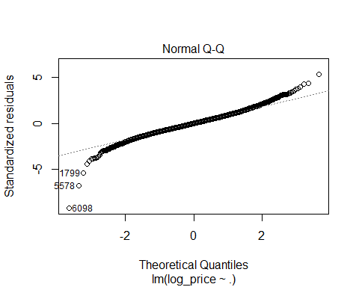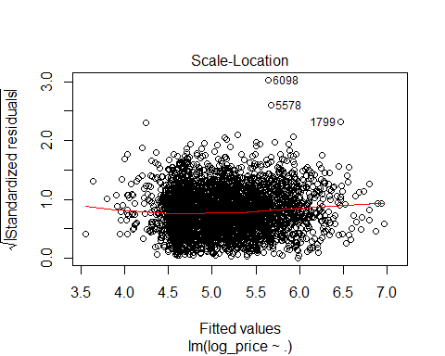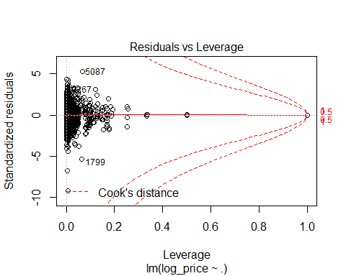
## Assumption 5 & 6. Observations are independent & Errors are independent
# Durbin-Watson Test for Serial Correlation
dwtest(SFLogLinearModel)
##
## Durbin-Watson test
##
## data: SFLogLinearModel
## DW = 2.0418, p-value = 0.9072
## alternative hypothesis: true autocorrelation is greater than 0
# DW test shows there is acceptable level of level of correlation as the value is 2.0418.
## Assumptions 7 & 8. The error average is 0 & The error variance is constant.
# Breusch-Pagan Test
bptest(SFNo$log_price ~ ., data = SFNo)
##
## studentized Breusch-Pagan test
##
## data: SFNo$log_price ~ .
## BP = 125.28, df = 47, p-value = 4.824e-09
# BP test is significant; therefore there is hetroscedasticity in the residuals. Need to run WLS to fix the issue.
plot(SFLogLinearModel, which = 1)
# However, the plot shows there is not much visual hetroscedasticity.
# Drop unused factors
SFNo$property_type <- droplevels(SFNo)$property_type
SFNo$room_type <- droplevels(SFNo)$room_type
SFNo$bed_type <- droplevels(SFNo)$bed_type
SFNo$host_has_profile_pic <- droplevels(SFNo)$host_has_profile_pic
SFNo$host_identity_verified <- droplevels(SFNo)$host_identity_verified
SFNo$instant_bookable <- droplevels(SFNo)$instant_bookable
table(SFNo$property_type)
##
## Apartment Bed & Breakfast Boat
## 1985 38 4
## Boutique hotel Bungalow Cabin
## 23 7 6
## Camper/RV Castle Cave
## 6 3 1
## Condominium Dorm Guest suite
## 321 8 39
## Guesthouse Hostel House
## 22 7 1329
## In-law Loft Other
## 49 59 40
## Serviced apartment Tent Timeshare
## 1 1 13
## Townhouse Treehouse Villa
## 27 1 2
# Combining all the factor that have degree of freedom less than 10
levels(SFNo$property_type)[levels(SFNo$property_type)=="Tent"] <- "Other"
levels(SFNo$property_type)[levels(SFNo$property_type)=="Boat"] <- "Other"
levels(SFNo$property_type)[levels(SFNo$property_type)=="Bungalow"] <- "Other"
levels(SFNo$property_type)[levels(SFNo$property_type)=="Cabin"] <- "Other"
levels(SFNo$property_type)[levels(SFNo$property_type)=="Camper/RV"] <- "Other"
levels(SFNo$property_type)[levels(SFNo$property_type)=="Castle"] <- "Other"
levels(SFNo$property_type)[levels(SFNo$property_type)=="Cave"] <- "Other"
levels(SFNo$property_type)[levels(SFNo$property_type)=="Dorm"] <- "Other"
levels(SFNo$property_type)[levels(SFNo$property_type)=="Hostel"] <- "Other"
levels(SFNo$property_type)[levels(SFNo$property_type)=="Serviced apartment"] <- "Other"
levels(SFNo$property_type)[levels(SFNo$property_type)=="Treehouse"] <- "Other"
levels(SFNo$property_type)[levels(SFNo$property_type)=="Villa"] <- "Other"
levels(SFNo$cancellation_policy)[levels(SFNo$cancellation_policy)=="super_strict_60"] <- "super_strict_30"
## OLS model for all cities.
set.seed(1)
SF.train <- sample(nrow(SFNo), 0.7*nrow(SFNo))
SFLogLinearModel <- lm(log_price ~ ., data = SFNo[SF.train,])
summary(SFLogLinearModel)
##
## Call:
## lm(formula = log_price ~ ., data = SFNo[SF.train, ])
##
## Residuals:
## Min 1Q Median 3Q Max
## -3.3328 -0.2210 -0.0038 0.2292 1.8098
##
## Coefficients:
## Estimate Std. Error t value Pr(>|t|)
## (Intercept) 7.557e+00 7.395e-01 10.220 < 2e-16
## property_typeBed & Breakfast 3.925e-02 7.469e-02 0.525 0.599287
## property_typeOther -3.782e-02 4.927e-02 -0.768 0.442749
## property_typeBoutique hotel 8.673e-03 9.310e-02 0.093 0.925787
## property_typeCondominium 1.687e-01 2.725e-02 6.191 6.86e-10
## property_typeGuest suite -2.423e-01 7.549e-02 -3.210 0.001342
## property_typeGuesthouse 7.138e-02 9.385e-02 0.761 0.447003
## property_typeHouse -5.514e-02 1.680e-02 -3.281 0.001046
## property_typeIn-law -1.169e-01 6.828e-02 -1.712 0.087080
## property_typeLoft 7.723e-02 6.109e-02 1.264 0.206283
## property_typeTimeshare 1.070e-01 1.251e-01 0.855 0.392447
## property_typeTownhouse -4.578e-03 8.020e-02 -0.057 0.954480
## room_typePrivate room -4.705e-01 1.809e-02 -26.004 < 2e-16
## room_typeShared room -1.074e+00 8.268e-02 -12.994 < 2e-16
## accommodates 9.526e-02 7.015e-03 13.580 < 2e-16
## bathrooms 9.288e-02 1.563e-02 5.942 3.18e-09
## bed_typeCouch 2.766e-01 1.899e-01 1.456 0.145467
## bed_typeFuton -9.755e-02 1.365e-01 -0.715 0.474937
## bed_typePull-out Sofa -7.037e-02 1.361e-01 -0.517 0.605124
## bed_typeReal Bed -7.617e-02 1.151e-01 -0.662 0.508274
## cancellation_policymoderate -3.685e-02 2.274e-02 -1.620 0.105289
## cancellation_policystrict -1.256e-02 2.226e-02 -0.564 0.572619
## cancellation_policysuper_strict_30 -2.683e-01 1.290e-01 -2.080 0.037598
## cleaning_feeTrue -1.957e-02 2.180e-02 -0.898 0.369487
## first_review -3.669e-05 1.804e-05 -2.033 0.042108
## host_has_profile_pict -1.090e-01 1.326e-01 -0.822 0.411099
## host_identity_verifiedt 4.780e-02 1.814e-02 2.636 0.008443
## host_response_rate_percent -3.782e-04 6.643e-04 -0.569 0.569191
## host_since -3.490e-06 1.247e-05 -0.280 0.779624
## instant_bookablet -6.969e-03 1.699e-02 -0.410 0.681799
## last_review -1.673e-04 4.400e-05 -3.802 0.000147
## number_of_reviews -6.274e-04 1.591e-04 -3.945 8.19e-05
## review_scores_rating 1.045e-02 1.145e-03 9.129 < 2e-16
## bedrooms 1.671e-01 1.422e-02 11.749 < 2e-16
## beds -3.649e-02 1.247e-02 -2.926 0.003460
##
## (Intercept) ***
## property_typeBed & Breakfast
## property_typeOther
## property_typeBoutique hotel
## property_typeCondominium ***
## property_typeGuest suite **
## property_typeGuesthouse
## property_typeHouse **
## property_typeIn-law .
## property_typeLoft
## property_typeTimeshare
## property_typeTownhouse
## room_typePrivate room ***
## room_typeShared room ***
## accommodates ***
## bathrooms ***
## bed_typeCouch
## bed_typeFuton
## bed_typePull-out Sofa
## bed_typeReal Bed
## cancellation_policymoderate
## cancellation_policystrict
## cancellation_policysuper_strict_30 *
## cleaning_feeTrue
## first_review *
## host_has_profile_pict
## host_identity_verifiedt **
## host_response_rate_percent
## host_since
## instant_bookablet
## last_review ***
## number_of_reviews ***
## review_scores_rating ***
## bedrooms ***
## beds **
## ---
## Signif. codes: 0 '***' 0.001 '**' 0.01 '*' 0.05 '.' 0.1 ' ' 1
##
## Residual standard error: 0.3717 on 2759 degrees of freedom
## Multiple R-squared: 0.6305, Adjusted R-squared: 0.626
## F-statistic: 138.5 on 34 and 2759 DF, p-value: < 2.2e-16
# Stepwise for OLS Model
SF.null <- lm(log_price ~ 1, data = SFNo[SF.train,])
SF.full <- lm(log_price ~ ., data = SFNo[SF.train,])
SF.stepwise <- step(SF.full, scope = list(lower = SF.full, upper = SF.full), direction = 'both', test = 'F')
## Start: AIC=-5495.03
## log_price ~ property_type + room_type + accommodates + bathrooms +
## bed_type + cancellation_policy + cleaning_fee + first_review +
## host_has_profile_pic + host_identity_verified + host_response_rate_percent +
## host_since + instant_bookable + last_review + number_of_reviews +
## review_scores_rating + bedrooms + beds
summary(SF.stepwise)
##
## Call:
## lm(formula = log_price ~ property_type + room_type + accommodates +
## bathrooms + bed_type + cancellation_policy + cleaning_fee +
## first_review + host_has_profile_pic + host_identity_verified +
## host_response_rate_percent + host_since + instant_bookable +
## last_review + number_of_reviews + review_scores_rating +
## bedrooms + beds, data = SFNo[SF.train, ])
##
## Residuals:
## Min 1Q Median 3Q Max
## -3.3328 -0.2210 -0.0038 0.2292 1.8098
##
## Coefficients:
## Estimate Std. Error t value Pr(>|t|)
## (Intercept) 7.557e+00 7.395e-01 10.220 < 2e-16
## property_typeBed & Breakfast 3.925e-02 7.469e-02 0.525 0.599287
## property_typeOther -3.782e-02 4.927e-02 -0.768 0.442749
## property_typeBoutique hotel 8.673e-03 9.310e-02 0.093 0.925787
## property_typeCondominium 1.687e-01 2.725e-02 6.191 6.86e-10
## property_typeGuest suite -2.423e-01 7.549e-02 -3.210 0.001342
## property_typeGuesthouse 7.138e-02 9.385e-02 0.761 0.447003
## property_typeHouse -5.514e-02 1.680e-02 -3.281 0.001046
## property_typeIn-law -1.169e-01 6.828e-02 -1.712 0.087080
## property_typeLoft 7.723e-02 6.109e-02 1.264 0.206283
## property_typeTimeshare 1.070e-01 1.251e-01 0.855 0.392447
## property_typeTownhouse -4.578e-03 8.020e-02 -0.057 0.954480
## room_typePrivate room -4.705e-01 1.809e-02 -26.004 < 2e-16
## room_typeShared room -1.074e+00 8.268e-02 -12.994 < 2e-16
## accommodates 9.526e-02 7.015e-03 13.580 < 2e-16
## bathrooms 9.288e-02 1.563e-02 5.942 3.18e-09
## bed_typeCouch 2.766e-01 1.899e-01 1.456 0.145467
## bed_typeFuton -9.755e-02 1.365e-01 -0.715 0.474937
## bed_typePull-out Sofa -7.037e-02 1.361e-01 -0.517 0.605124
## bed_typeReal Bed -7.617e-02 1.151e-01 -0.662 0.508274
## cancellation_policymoderate -3.685e-02 2.274e-02 -1.620 0.105289
## cancellation_policystrict -1.256e-02 2.226e-02 -0.564 0.572619
## cancellation_policysuper_strict_30 -2.683e-01 1.290e-01 -2.080 0.037598
## cleaning_feeTrue -1.957e-02 2.180e-02 -0.898 0.369487
## first_review -3.669e-05 1.804e-05 -2.033 0.042108
## host_has_profile_pict -1.090e-01 1.326e-01 -0.822 0.411099
## host_identity_verifiedt 4.780e-02 1.814e-02 2.636 0.008443
## host_response_rate_percent -3.782e-04 6.643e-04 -0.569 0.569191
## host_since -3.490e-06 1.247e-05 -0.280 0.779624
## instant_bookablet -6.969e-03 1.699e-02 -0.410 0.681799
## last_review -1.673e-04 4.400e-05 -3.802 0.000147
## number_of_reviews -6.274e-04 1.591e-04 -3.945 8.19e-05
## review_scores_rating 1.045e-02 1.145e-03 9.129 < 2e-16
## bedrooms 1.671e-01 1.422e-02 11.749 < 2e-16
## beds -3.649e-02 1.247e-02 -2.926 0.003460
##
## (Intercept) ***
## property_typeBed & Breakfast
## property_typeOther
## property_typeBoutique hotel
## property_typeCondominium ***
## property_typeGuest suite **
## property_typeGuesthouse
## property_typeHouse **
## property_typeIn-law .
## property_typeLoft
## property_typeTimeshare
## property_typeTownhouse
## room_typePrivate room ***
## room_typeShared room ***
## accommodates ***
## bathrooms ***
## bed_typeCouch
## bed_typeFuton
## bed_typePull-out Sofa
## bed_typeReal Bed
## cancellation_policymoderate
## cancellation_policystrict
## cancellation_policysuper_strict_30 *
## cleaning_feeTrue
## first_review *
## host_has_profile_pict
## host_identity_verifiedt **
## host_response_rate_percent
## host_since
## instant_bookablet
## last_review ***
## number_of_reviews ***
## review_scores_rating ***
## bedrooms ***
## beds **
## ---
## Signif. codes: 0 '***' 0.001 '**' 0.01 '*' 0.05 '.' 0.1 ' ' 1
##
## Residual standard error: 0.3717 on 2759 degrees of freedom
## Multiple R-squared: 0.6305, Adjusted R-squared: 0.626
## F-statistic: 138.5 on 34 and 2759 DF, p-value: < 2.2e-16
SF.reduced <- SFNo[, c(
'log_price',
'property_type',
'room_type',
'accommodates',
'bathrooms',
'cancellation_policy',
'first_review',
'host_identity_verified',
'last_review',
'number_of_reviews',
'review_scores_rating',
'bedrooms',
'beds'
)]
# Running OLS with the reduced model with only significant predictors.
SF.reduced.model <- lm(log_price ~., data = SF.reduced[SF.train,])
summary(SF.reduced.model)
##
## Call:
## lm(formula = log_price ~ ., data = SF.reduced[SF.train, ])
##
## Residuals:
## Min 1Q Median 3Q Max
## -3.3454 -0.2195 -0.0050 0.2284 1.8336
##
## Coefficients:
## Estimate Std. Error t value Pr(>|t|)
## (Intercept) 7.483e+00 7.035e-01 10.637 < 2e-16
## property_typeBed & Breakfast 4.108e-02 7.371e-02 0.557 0.577422
## property_typeOther -3.296e-02 4.904e-02 -0.672 0.501620
## property_typeBoutique hotel -1.325e-03 9.255e-02 -0.014 0.988576
## property_typeCondominium 1.737e-01 2.712e-02 6.406 1.75e-10
## property_typeGuest suite -2.465e-01 7.537e-02 -3.271 0.001085
## property_typeGuesthouse 6.756e-02 9.379e-02 0.720 0.471338
## property_typeHouse -5.625e-02 1.677e-02 -3.355 0.000806
## property_typeIn-law -1.169e-01 6.822e-02 -1.714 0.086662
## property_typeLoft 8.628e-02 6.076e-02 1.420 0.155682
## property_typeTimeshare 1.117e-01 1.249e-01 0.895 0.370967
## property_typeTownhouse -6.529e-03 8.016e-02 -0.081 0.935090
## room_typePrivate room -4.708e-01 1.787e-02 -26.354 < 2e-16
## room_typeShared room -1.043e+00 8.034e-02 -12.988 < 2e-16
## accommodates 9.500e-02 6.980e-03 13.612 < 2e-16
## bathrooms 9.567e-02 1.558e-02 6.140 9.45e-10
## cancellation_policymoderate -3.994e-02 2.235e-02 -1.787 0.074041
## cancellation_policystrict -1.661e-02 2.182e-02 -0.761 0.446687
## cancellation_policysuper_strict_30 -2.754e-01 1.285e-01 -2.144 0.032154
## first_review -4.068e-05 1.612e-05 -2.524 0.011649
## host_identity_verifiedt 4.603e-02 1.722e-02 2.673 0.007555
## last_review -1.759e-04 4.332e-05 -4.061 5.02e-05
## number_of_reviews -6.469e-04 1.567e-04 -4.128 3.77e-05
## review_scores_rating 1.045e-02 1.137e-03 9.191 < 2e-16
## bedrooms 1.663e-01 1.416e-02 11.746 < 2e-16
## beds -3.756e-02 1.244e-02 -3.019 0.002557
##
## (Intercept) ***
## property_typeBed & Breakfast
## property_typeOther
## property_typeBoutique hotel
## property_typeCondominium ***
## property_typeGuest suite **
## property_typeGuesthouse
## property_typeHouse ***
## property_typeIn-law .
## property_typeLoft
## property_typeTimeshare
## property_typeTownhouse
## room_typePrivate room ***
## room_typeShared room ***
## accommodates ***
## bathrooms ***
## cancellation_policymoderate .
## cancellation_policystrict
## cancellation_policysuper_strict_30 *
## first_review *
## host_identity_verifiedt **
## last_review ***
## number_of_reviews ***
## review_scores_rating ***
## bedrooms ***
## beds **
## ---
## Signif. codes: 0 '***' 0.001 '**' 0.01 '*' 0.05 '.' 0.1 ' ' 1
##
## Residual standard error: 0.3717 on 2768 degrees of freedom
## Multiple R-squared: 0.6295, Adjusted R-squared: 0.6261
## F-statistic: 188.1 on 25 and 2768 DF, p-value: < 2.2e-16
SF.reduced.mse <- mean((SF.reduced$log_price-predict(SF.reduced.model, SF.reduced))[-SF.train]^2)
print(paste("MSE Reduced OLS = ", SF.reduced.mse), digits=5)
## [1] "MSE Reduced OLS = 0.127344976439721"
# Talk about which variables are significant variables and what does the sign of the coefficient represents!!
## k-Fold Cross-Validation (KFCV)
# Cross-Validation of OLS
glm.fit <- glm(log_price ~ ., data = SF.reduced)
cv.10K <- cv.glm(SF.reduced, glm.fit, K=10)
print(paste("10FCV MSE OLS = ", cv.10K$delta[1]), digits=5)
## [1] "10FCV MSE OLS = 0.136049429532059"
# WLS Model
wts <- 1/fitted(lm(abs(residuals(SFLogLinearModel))~fitted(SFLogLinearModel)))^2
SF.wls <- lm(log_price ~ ., data = SFNo[SF.train,], weights=1/wts)
summary(SF.wls)
##
## Call:
## lm(formula = log_price ~ ., data = SFNo[SF.train, ], weights = 1/wts)
##
## Weighted Residuals:
## Min 1Q Median 3Q Max
## -0.98345 -0.06064 -0.00041 0.06372 0.48009
##
## Coefficients:
## Estimate Std. Error t value Pr(>|t|)
## (Intercept) 7.627e+00 7.236e-01 10.540 < 2e-16
## property_typeBed & Breakfast 3.431e-02 7.743e-02 0.443 0.65778
## property_typeOther -2.808e-02 5.005e-02 -0.561 0.57487
## property_typeBoutique hotel -5.058e-03 9.593e-02 -0.053 0.95796
## property_typeCondominium 1.620e-01 2.683e-02 6.039 1.76e-09
## property_typeGuest suite -2.485e-01 7.828e-02 -3.175 0.00152
## property_typeGuesthouse 7.166e-02 9.553e-02 0.750 0.45326
## property_typeHouse -5.265e-02 1.697e-02 -3.103 0.00194
## property_typeIn-law -1.195e-01 6.969e-02 -1.715 0.08641
## property_typeLoft 6.210e-02 6.068e-02 1.023 0.30622
## property_typeTimeshare 1.128e-01 1.231e-01 0.917 0.35941
## property_typeTownhouse -2.982e-03 8.136e-02 -0.037 0.97076
## room_typePrivate room -4.745e-01 1.840e-02 -25.793 < 2e-16
## room_typeShared room -1.084e+00 9.236e-02 -11.732 < 2e-16
## accommodates 9.215e-02 6.648e-03 13.862 < 2e-16
## bathrooms 1.080e-01 1.545e-02 6.993 3.37e-12
## bed_typeCouch 2.898e-01 1.912e-01 1.516 0.12975
## bed_typeFuton -1.054e-01 1.405e-01 -0.750 0.45342
## bed_typePull-out Sofa -7.560e-02 1.400e-01 -0.540 0.58922
## bed_typeReal Bed -8.460e-02 1.177e-01 -0.718 0.47252
## cancellation_policymoderate -3.714e-02 2.319e-02 -1.601 0.10941
## cancellation_policystrict -9.663e-03 2.265e-02 -0.427 0.66966
## cancellation_policysuper_strict_30 -2.936e-01 1.312e-01 -2.238 0.02532
## cleaning_feeTrue -2.067e-02 2.221e-02 -0.931 0.35215
## first_review -4.189e-05 1.806e-05 -2.320 0.02044
## host_has_profile_pict -1.100e-01 1.322e-01 -0.832 0.40530
## host_identity_verifiedt 4.972e-02 1.827e-02 2.721 0.00654
## host_response_rate_percent -3.825e-04 6.684e-04 -0.572 0.56721
## host_since -1.965e-06 1.257e-05 -0.156 0.87576
## instant_bookablet -7.025e-03 1.720e-02 -0.409 0.68293
## last_review -1.717e-04 4.305e-05 -3.989 6.82e-05
## number_of_reviews -6.816e-04 1.626e-04 -4.192 2.85e-05
## review_scores_rating 1.121e-02 1.198e-03 9.355 < 2e-16
## bedrooms 1.667e-01 1.399e-02 11.916 < 2e-16
## beds -3.621e-02 1.209e-02 -2.995 0.00277
##
## (Intercept) ***
## property_typeBed & Breakfast
## property_typeOther
## property_typeBoutique hotel
## property_typeCondominium ***
## property_typeGuest suite **
## property_typeGuesthouse
## property_typeHouse **
## property_typeIn-law .
## property_typeLoft
## property_typeTimeshare
## property_typeTownhouse
## room_typePrivate room ***
## room_typeShared room ***
## accommodates ***
## bathrooms ***
## bed_typeCouch
## bed_typeFuton
## bed_typePull-out Sofa
## bed_typeReal Bed
## cancellation_policymoderate
## cancellation_policystrict
## cancellation_policysuper_strict_30 *
## cleaning_feeTrue
## first_review *
## host_has_profile_pict
## host_identity_verifiedt **
## host_response_rate_percent
## host_since
## instant_bookablet
## last_review ***
## number_of_reviews ***
## review_scores_rating ***
## bedrooms ***
## beds **
## ---
## Signif. codes: 0 '***' 0.001 '**' 0.01 '*' 0.05 '.' 0.1 ' ' 1
##
## Residual standard error: 0.1049 on 2759 degrees of freedom
## Multiple R-squared: 0.64, Adjusted R-squared: 0.6355
## F-statistic: 144.2 on 34 and 2759 DF, p-value: < 2.2e-16
MSE.wls <- mean((SFNo$log_price-predict(SF.wls, SFNo))[-SF.train]^2)
print(paste("MSE WLS = ", MSE.wls))
## [1] "MSE WLS = 0.127793172432053"
# Regression Tree
tree.SF <- tree(log_price ~ ., data = SFNo[SF.train,])
tree.SF
## node), split, n, deviance, yval
## * denotes terminal node
##
## 1) root 2794 1032.000 5.106
## 2) bedrooms < 1.5 1979 419.000 4.864
## 4) room_type: Private room,Shared room 1100 152.600 4.639 *
## 5) room_type: Entire home/apt 879 140.800 5.146 *
## 3) bedrooms > 1.5 815 215.500 5.694
## 6) bedrooms < 2.5 508 106.000 5.517 *
## 7) bedrooms > 2.5 307 67.450 5.986
## 14) bathrooms < 2.75 262 48.420 5.908 *
## 15) bathrooms > 2.75 45 8.118 6.441 *
summary(tree.SF)
##
## Regression tree:
## tree(formula = log_price ~ ., data = SFNo[SF.train, ])
## Variables actually used in tree construction:
## [1] "bedrooms" "room_type" "bathrooms"
## Number of terminal nodes: 5
## Residual mean deviance: 0.1635 = 455.9 / 2789
## Distribution of residuals:
## Min. 1st Qu. Median Mean 3rd Qu. Max.
## -3.21500 -0.24430 -0.01604 0.00000 0.24750 2.13300
plot(tree.SF)
text(tree.SF, pretty = 0)
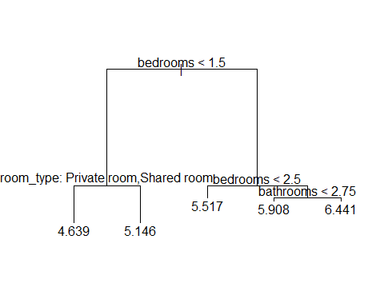
# Regression Tree splits the tree based on bedrooms and room_type!!
tree.SF.pred <- predict(tree.SF, newdata = SFNo[-SF.train,])
print(paste("MSE Regression Tree = ", mean((tree.SF.pred - SF.reduced$log_price[-SF.train])^2)))
## [1] "MSE Regression Tree = 0.161539803651961"
## Creating models for District of Columbia
DC <- train %>%
filter(city == "DC")
# Removing rows with NA and city column
DCNo <- DC[complete.cases(DC), ] %>%
select(-city)
### OLS Assumptions
## Assumption 1. Y is continuous
hist(DCNo$log_price)
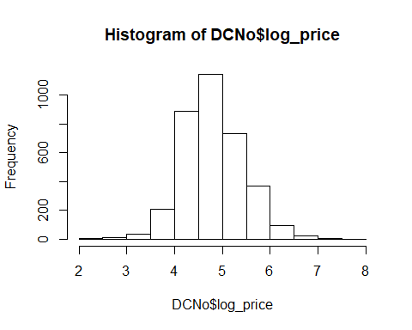
# The bar plot seems to be normally distributed.
## Assumption 2. Errors (ɛ) are normally distributed
# Since Y is normally distributed, residual would also be normally distributed.
qqnorm(DCNo$log_price, main=" Price DC")
qqline(DCNo$log_price)
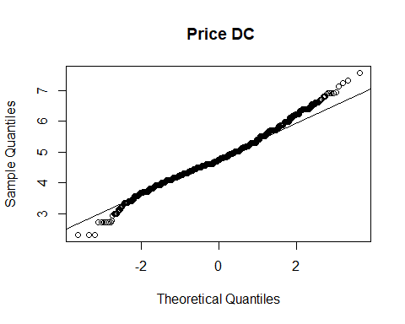
# A large majority of residuals lie on the qqline implying that the residuals are normally distributed.
## Assumption 3. X’s are independent
#Log-Linear model for each city
DCLogLinearModel <- lm(log_price ~ ., data = DCNo)
summary(DCLogLinearModel)
##
## Call:
## lm(formula = log_price ~ ., data = DCNo)
##
## Residuals:
## Min 1Q Median 3Q Max
## -2.53960 -0.25284 -0.01011 0.22607 1.75548
##
## Coefficients:
## Estimate Std. Error t value Pr(>|t|)
## (Intercept) 8.958e+00 9.547e-01 9.384 < 2e-16
## property_typeBed & Breakfast 2.878e-01 6.465e-02 4.451 8.80e-06
## property_typeBoat -5.516e-01 2.864e-01 -1.926 0.05420
## property_typeBungalow -1.365e-01 2.861e-01 -0.477 0.63333
## property_typeCabin 8.175e-02 4.092e-01 0.200 0.84168
## property_typeCastle -6.788e-01 4.070e-01 -1.668 0.09544
## property_typeCondominium 3.816e-02 3.242e-02 1.177 0.23921
## property_typeDorm -4.633e-01 1.159e-01 -3.998 6.51e-05
## property_typeGuest suite -3.023e-01 2.027e-01 -1.491 0.13603
## property_typeGuesthouse -6.594e-02 1.537e-01 -0.429 0.66784
## property_typeHostel -8.566e-01 2.985e-01 -2.870 0.00414
## property_typeHouse -5.207e-02 1.864e-02 -2.793 0.00525
## property_typeIn-law -1.227e-01 1.813e-01 -0.677 0.49869
## property_typeLoft 1.631e-01 9.589e-02 1.701 0.08907
## property_typeOther -8.117e-02 9.328e-02 -0.870 0.38429
## property_typeServiced apartment 2.852e-01 4.098e-01 0.696 0.48659
## property_typeTownhouse 3.096e-03 3.053e-02 0.101 0.91924
## property_typeTrain 6.321e-01 4.059e-01 1.557 0.11952
## room_typePrivate room -4.841e-01 1.994e-02 -24.271 < 2e-16
## room_typeShared room -1.098e+00 5.402e-02 -20.326 < 2e-16
## accommodates 4.262e-02 6.889e-03 6.186 6.90e-10
## bathrooms 1.362e-01 1.451e-02 9.390 < 2e-16
## bed_typeCouch 3.771e-01 1.564e-01 2.410 0.01598
## bed_typeFuton 2.061e-01 1.341e-01 1.537 0.12438
## bed_typePull-out Sofa 2.643e-01 1.253e-01 2.109 0.03500
## bed_typeReal Bed 2.966e-01 1.094e-01 2.711 0.00675
## cancellation_policymoderate 2.230e-03 1.892e-02 0.118 0.90619
## cancellation_policystrict 5.105e-02 1.875e-02 2.723 0.00650
## cancellation_policysuper_strict_30 5.288e-01 8.327e-02 6.351 2.42e-10
## cleaning_feeTrue -4.834e-02 1.782e-02 -2.712 0.00672
## first_review -6.472e-05 2.098e-05 -3.085 0.00205
## host_has_profile_pict -5.856e-01 2.344e-01 -2.498 0.01255
## host_identity_verifiedt 1.190e-02 1.759e-02 0.677 0.49858
## host_response_rate_percent 1.540e-03 6.020e-04 2.559 0.01055
## host_since -3.917e-06 1.262e-05 -0.310 0.75622
## instant_bookablet 1.519e-02 1.581e-02 0.961 0.33669
## last_review -2.265e-04 5.753e-05 -3.936 8.44e-05
## number_of_reviews -8.922e-04 2.015e-04 -4.429 9.77e-06
## review_scores_rating 7.268e-03 1.060e-03 6.855 8.38e-12
## bedrooms 1.724e-01 1.480e-02 11.642 < 2e-16
## beds -3.127e-03 1.052e-02 -0.297 0.76641
##
## (Intercept) ***
## property_typeBed & Breakfast ***
## property_typeBoat .
## property_typeBungalow
## property_typeCabin
## property_typeCastle .
## property_typeCondominium
## property_typeDorm ***
## property_typeGuest suite
## property_typeGuesthouse
## property_typeHostel **
## property_typeHouse **
## property_typeIn-law
## property_typeLoft .
## property_typeOther
## property_typeServiced apartment
## property_typeTownhouse
## property_typeTrain
## room_typePrivate room ***
## room_typeShared room ***
## accommodates ***
## bathrooms ***
## bed_typeCouch *
## bed_typeFuton
## bed_typePull-out Sofa *
## bed_typeReal Bed **
## cancellation_policymoderate
## cancellation_policystrict **
## cancellation_policysuper_strict_30 ***
## cleaning_feeTrue **
## first_review **
## host_has_profile_pict *
## host_identity_verifiedt
## host_response_rate_percent *
## host_since
## instant_bookablet
## last_review ***
## number_of_reviews ***
## review_scores_rating ***
## bedrooms ***
## beds
## ---
## Signif. codes: 0 '***' 0.001 '**' 0.01 '*' 0.05 '.' 0.1 ' ' 1
##
## Residual standard error: 0.4041 on 3474 degrees of freedom
## Multiple R-squared: 0.5857, Adjusted R-squared: 0.5809
## F-statistic: 122.8 on 40 and 3474 DF, p-value: < 2.2e-16
# Checking for correlation in X variables
# Condition Index and Variance Inflation factor
vif(DCLogLinearModel)
## GVIF Df GVIF^(1/(2*Df))
## property_type 3.029385 17 1.033136
## room_type 2.649695 2 1.275848
## accommodates 5.276673 1 2.297101
## bathrooms 2.259426 1 1.503139
## bed_type 1.224967 4 1.025689
## cancellation_policy 1.472226 3 1.066586
## cleaning_fee 1.152222 1 1.073416
## first_review 2.142374 1 1.463685
## host_has_profile_pic 1.008865 1 1.004423
## host_identity_verified 1.154728 1 1.074583
## host_response_rate_percent 1.128343 1 1.062235
## host_since 1.540925 1 1.241340
## instant_bookable 1.106374 1 1.051843
## last_review 1.436543 1 1.198559
## number_of_reviews 1.682469 1 1.297100
## review_scores_rating 1.109285 1 1.053226
## bedrooms 4.042179 1 2.010517
## beds 4.317204 1 2.077788
# All the vif coefficients are below 10. Therefore there is no significant correlation between the variables.
## Assumption 4. Y and X’s have linear relationship
#Plots
plot(DCLogLinearModel)
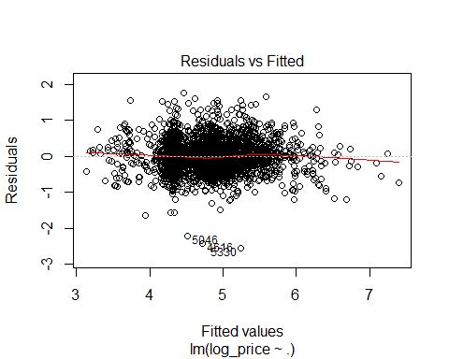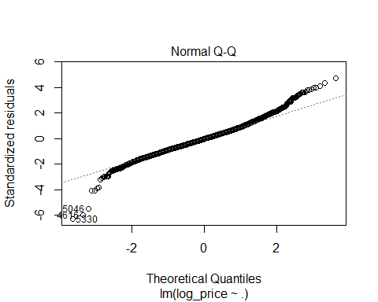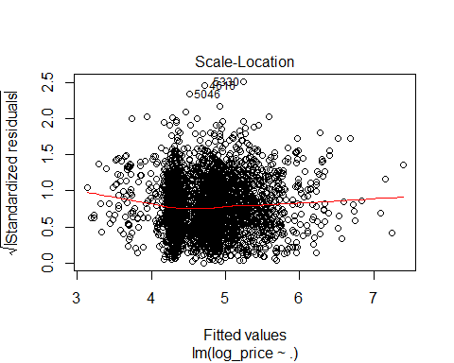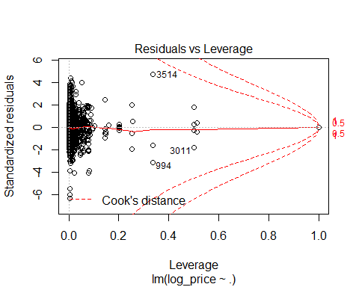
## Assumption 5 & 6. Observations are independent & Errors are independent
# Durbin-Watson Test for Serial Correlation
dwtest(DCLogLinearModel)
##
## Durbin-Watson test
##
## data: DCLogLinearModel
## DW = 1.9809, p-value = 0.2844
## alternative hypothesis: true autocorrelation is greater than 0
# DW test shows there is acceptable level of level of correlation as the value is 1.9772
## Assumptions 7 & 8. The error average is 0 & The error variance is constant.
# Breusch-Pagan Test
bptest(DCNo$log_price ~ ., data = DCNo)
##
## studentized Breusch-Pagan test
##
## data: DCNo$log_price ~ .
## BP = 163.87, df = 40, p-value < 2.2e-16
# BP test is significant; therefore there is hetroscedasticity in the residuals. Need to run WLS to fix the issue.
plot(DCLogLinearModel, which = 1)
# However, the plot shows there is not much visual hetroscedasticity.
# Drop unused factors
DCNo$property_type <- droplevels(DCNo)$property_type
DCNo$room_type <- droplevels(DCNo)$room_type
DCNo$bed_type <- droplevels(DCNo)$bed_type
DCNo$host_has_profile_pic <- droplevels(DCNo)$host_has_profile_pic
DCNo$host_identity_verified <- droplevels(DCNo)$host_identity_verified
DCNo$instant_bookable <- droplevels(DCNo)$instant_bookable
table(DCNo$property_type)
##
## Apartment Bed & Breakfast Boat
## 1836 43 2
## Bungalow Cabin Castle
## 2 1 1
## Condominium Dorm Guest suite
## 178 19 4
## Guesthouse Hostel House
## 7 2 1155
## In-law Loft Other
## 5 18 19
## Serviced apartment Townhouse Train
## 1 221 1
# Combining all the factor that have degree of freedom less than 10
levels(DCNo$property_type)[levels(DCNo$property_type)=="Boat"] <- "Other"
levels(DCNo$property_type)[levels(DCNo$property_type)=="Bungalow"] <- "Other"
levels(DCNo$property_type)[levels(DCNo$property_type)=="Cabin"] <- "Other"
levels(DCNo$property_type)[levels(DCNo$property_type)=="Castle"] <- "Other"
levels(DCNo$property_type)[levels(DCNo$property_type)=="Guest suite"] <- "Other"
levels(DCNo$property_type)[levels(DCNo$property_type)=="Guesthouse"] <- "Other"
levels(DCNo$property_type)[levels(DCNo$property_type)=="Hostel"] <- "Other"
levels(DCNo$property_type)[levels(DCNo$property_type)=="In-law"] <- "Other"
levels(DCNo$property_type)[levels(DCNo$property_type)=="Train"] <- "Other"
levels(DCNo$property_type)[levels(DCNo$property_type)=="Serviced apartment"] <- "Other"
## OLS model for all cities.
set.seed(1)
DC.train <- sample(nrow(DCNo), 0.7*nrow(DCNo))
DCLogLinearModel <- lm(log_price ~ ., data = DCNo[DC.train,])
summary(DCLogLinearModel)
##
## Call:
## lm(formula = log_price ~ ., data = DCNo[DC.train, ])
##
## Residuals:
## Min 1Q Median 3Q Max
## -2.55864 -0.25497 -0.01115 0.22151 1.78450
##
## Coefficients:
## Estimate Std. Error t value Pr(>|t|)
## (Intercept) 8.649e+00 1.231e+00 7.027 2.74e-12
## property_typeBed & Breakfast 3.222e-01 7.557e-02 4.264 2.09e-05
## property_typeOther -1.603e-01 7.862e-02 -2.039 0.041565
## property_typeCondominium 3.341e-02 3.936e-02 0.849 0.396134
## property_typeDorm -2.928e-01 1.270e-01 -2.306 0.021218
## property_typeHouse -4.035e-02 2.246e-02 -1.797 0.072511
## property_typeLoft 1.146e-01 1.233e-01 0.930 0.352566
## property_typeTownhouse 8.333e-05 3.698e-02 0.002 0.998202
## room_typePrivate room -4.994e-01 2.401e-02 -20.797 < 2e-16
## room_typeShared room -1.122e+00 6.509e-02 -17.233 < 2e-16
## accommodates 4.158e-02 7.961e-03 5.223 1.91e-07
## bathrooms 1.061e-01 1.656e-02 6.407 1.77e-10
## bed_typeCouch 5.555e-01 1.871e-01 2.970 0.003010
## bed_typeFuton 3.917e-01 1.698e-01 2.307 0.021122
## bed_typePull-out Sofa 3.118e-01 1.643e-01 1.897 0.057901
## bed_typeReal Bed 4.577e-01 1.447e-01 3.163 0.001578
## cancellation_policymoderate 1.788e-02 2.301e-02 0.777 0.437114
## cancellation_policystrict 5.168e-02 2.277e-02 2.270 0.023317
## cancellation_policysuper_strict_30 5.073e-01 1.007e-01 5.039 5.01e-07
## cleaning_feeTrue -5.982e-02 2.178e-02 -2.747 0.006065
## first_review -6.452e-05 2.500e-05 -2.581 0.009921
## host_has_profile_pict 1.397e-01 2.889e-01 0.483 0.628793
## host_identity_verifiedt 1.548e-02 2.138e-02 0.724 0.469114
## host_response_rate_percent 2.080e-03 7.433e-04 2.798 0.005179
## host_since -3.479e-06 1.522e-05 -0.229 0.819252
## instant_bookablet 6.004e-03 1.903e-02 0.316 0.752376
## last_review -2.575e-04 7.255e-05 -3.549 0.000394
## number_of_reviews -9.311e-04 2.377e-04 -3.917 9.20e-05
## review_scores_rating 6.501e-03 1.253e-03 5.190 2.28e-07
## bedrooms 2.121e-01 1.776e-02 11.946 < 2e-16
## beds -1.908e-02 1.224e-02 -1.559 0.119145
##
## (Intercept) ***
## property_typeBed & Breakfast ***
## property_typeOther *
## property_typeCondominium
## property_typeDorm *
## property_typeHouse .
## property_typeLoft
## property_typeTownhouse
## room_typePrivate room ***
## room_typeShared room ***
## accommodates ***
## bathrooms ***
## bed_typeCouch **
## bed_typeFuton *
## bed_typePull-out Sofa .
## bed_typeReal Bed **
## cancellation_policymoderate
## cancellation_policystrict *
## cancellation_policysuper_strict_30 ***
## cleaning_feeTrue **
## first_review **
## host_has_profile_pict
## host_identity_verifiedt
## host_response_rate_percent **
## host_since
## instant_bookablet
## last_review ***
## number_of_reviews ***
## review_scores_rating ***
## bedrooms ***
## beds
## ---
## Signif. codes: 0 '***' 0.001 '**' 0.01 '*' 0.05 '.' 0.1 ' ' 1
##
## Residual standard error: 0.4063 on 2429 degrees of freedom
## Multiple R-squared: 0.5849, Adjusted R-squared: 0.5798
## F-statistic: 114.1 on 30 and 2429 DF, p-value: < 2.2e-16
# Stepwise for OLS Model
DC.null <- lm(log_price ~ 1, data = DCNo[DC.train,])
DC.full <- lm(log_price ~ ., data = DCNo[DC.train,])
DC.stepwise <- step(DC.full, scope = list(lower = DC.full, upper = DC.full), direction = 'both', test = 'F')
## Start: AIC=-4400.09
## log_price ~ property_type + room_type + accommodates + bathrooms +
## bed_type + cancellation_policy + cleaning_fee + first_review +
## host_has_profile_pic + host_identity_verified + host_response_rate_percent +
## host_since + instant_bookable + last_review + number_of_reviews +
## review_scores_rating + bedrooms + beds
summary(DC.stepwise)
##
## Call:
## lm(formula = log_price ~ property_type + room_type + accommodates +
## bathrooms + bed_type + cancellation_policy + cleaning_fee +
## first_review + host_has_profile_pic + host_identity_verified +
## host_response_rate_percent + host_since + instant_bookable +
## last_review + number_of_reviews + review_scores_rating +
## bedrooms + beds, data = DCNo[DC.train, ])
##
## Residuals:
## Min 1Q Median 3Q Max
## -2.55864 -0.25497 -0.01115 0.22151 1.78450
##
## Coefficients:
## Estimate Std. Error t value Pr(>|t|)
## (Intercept) 8.649e+00 1.231e+00 7.027 2.74e-12
## property_typeBed & Breakfast 3.222e-01 7.557e-02 4.264 2.09e-05
## property_typeOther -1.603e-01 7.862e-02 -2.039 0.041565
## property_typeCondominium 3.341e-02 3.936e-02 0.849 0.396134
## property_typeDorm -2.928e-01 1.270e-01 -2.306 0.021218
## property_typeHouse -4.035e-02 2.246e-02 -1.797 0.072511
## property_typeLoft 1.146e-01 1.233e-01 0.930 0.352566
## property_typeTownhouse 8.333e-05 3.698e-02 0.002 0.998202
## room_typePrivate room -4.994e-01 2.401e-02 -20.797 < 2e-16
## room_typeShared room -1.122e+00 6.509e-02 -17.233 < 2e-16
## accommodates 4.158e-02 7.961e-03 5.223 1.91e-07
## bathrooms 1.061e-01 1.656e-02 6.407 1.77e-10
## bed_typeCouch 5.555e-01 1.871e-01 2.970 0.003010
## bed_typeFuton 3.917e-01 1.698e-01 2.307 0.021122
## bed_typePull-out Sofa 3.118e-01 1.643e-01 1.897 0.057901
## bed_typeReal Bed 4.577e-01 1.447e-01 3.163 0.001578
## cancellation_policymoderate 1.788e-02 2.301e-02 0.777 0.437114
## cancellation_policystrict 5.168e-02 2.277e-02 2.270 0.023317
## cancellation_policysuper_strict_30 5.073e-01 1.007e-01 5.039 5.01e-07
## cleaning_feeTrue -5.982e-02 2.178e-02 -2.747 0.006065
## first_review -6.452e-05 2.500e-05 -2.581 0.009921
## host_has_profile_pict 1.397e-01 2.889e-01 0.483 0.628793
## host_identity_verifiedt 1.548e-02 2.138e-02 0.724 0.469114
## host_response_rate_percent 2.080e-03 7.433e-04 2.798 0.005179
## host_since -3.479e-06 1.522e-05 -0.229 0.819252
## instant_bookablet 6.004e-03 1.903e-02 0.316 0.752376
## last_review -2.575e-04 7.255e-05 -3.549 0.000394
## number_of_reviews -9.311e-04 2.377e-04 -3.917 9.20e-05
## review_scores_rating 6.501e-03 1.253e-03 5.190 2.28e-07
## bedrooms 2.121e-01 1.776e-02 11.946 < 2e-16
## beds -1.908e-02 1.224e-02 -1.559 0.119145
##
## (Intercept) ***
## property_typeBed & Breakfast ***
## property_typeOther *
## property_typeCondominium
## property_typeDorm *
## property_typeHouse .
## property_typeLoft
## property_typeTownhouse
## room_typePrivate room ***
## room_typeShared room ***
## accommodates ***
## bathrooms ***
## bed_typeCouch **
## bed_typeFuton *
## bed_typePull-out Sofa .
## bed_typeReal Bed **
## cancellation_policymoderate
## cancellation_policystrict *
## cancellation_policysuper_strict_30 ***
## cleaning_feeTrue **
## first_review **
## host_has_profile_pict
## host_identity_verifiedt
## host_response_rate_percent **
## host_since
## instant_bookablet
## last_review ***
## number_of_reviews ***
## review_scores_rating ***
## bedrooms ***
## beds
## ---
## Signif. codes: 0 '***' 0.001 '**' 0.01 '*' 0.05 '.' 0.1 ' ' 1
##
## Residual standard error: 0.4063 on 2429 degrees of freedom
## Multiple R-squared: 0.5849, Adjusted R-squared: 0.5798
## F-statistic: 114.1 on 30 and 2429 DF, p-value: < 2.2e-16
DC.reduced <- DCNo[, c(
'log_price',
'property_type',
'room_type',
'accommodates',
'bathrooms',
'bed_type',
'cancellation_policy',
'cleaning_fee',
'first_review',
'host_response_rate_percent',
'last_review',
'number_of_reviews',
'review_scores_rating',
'bedrooms'
)]
# Running OLS with the reduced model with only significant predictors.
DC.reduced.model <- lm(log_price ~., data = DC.reduced[DC.train,])
summary(DC.reduced.model)
##
## Call:
## lm(formula = log_price ~ ., data = DC.reduced[DC.train, ])
##
## Residuals:
## Min 1Q Median 3Q Max
## -2.55372 -0.25059 -0.01037 0.22154 1.80932
##
## Coefficients:
## Estimate Std. Error t value Pr(>|t|)
## (Intercept) 8.828e+00 1.175e+00 7.514 7.98e-14
## property_typeBed & Breakfast 3.200e-01 7.547e-02 4.240 2.32e-05
## property_typeOther -1.620e-01 7.834e-02 -2.068 0.038731
## property_typeCondominium 3.581e-02 3.929e-02 0.911 0.362175
## property_typeDorm -3.440e-01 1.232e-01 -2.793 0.005267
## property_typeHouse -3.941e-02 2.242e-02 -1.757 0.078979
## property_typeLoft 1.195e-01 1.232e-01 0.970 0.331954
## property_typeTownhouse 5.402e-03 3.683e-02 0.147 0.883404
## room_typePrivate room -5.004e-01 2.397e-02 -20.872 < 2e-16
## room_typeShared room -1.128e+00 6.491e-02 -17.384 < 2e-16
## accommodates 3.475e-02 6.494e-03 5.351 9.55e-08
## bathrooms 1.060e-01 1.654e-02 6.410 1.74e-10
## bed_typeCouch 5.509e-01 1.869e-01 2.948 0.003228
## bed_typeFuton 3.866e-01 1.696e-01 2.280 0.022710
## bed_typePull-out Sofa 3.091e-01 1.642e-01 1.882 0.059907
## bed_typeReal Bed 4.535e-01 1.445e-01 3.138 0.001723
## cancellation_policymoderate 1.846e-02 2.285e-02 0.808 0.419348
## cancellation_policystrict 5.245e-02 2.254e-02 2.327 0.020036
## cancellation_policysuper_strict_30 5.183e-01 9.885e-02 5.243 1.72e-07
## cleaning_feeTrue -5.822e-02 2.158e-02 -2.697 0.007038
## first_review -6.978e-05 2.252e-05 -3.098 0.001970
## host_response_rate_percent 2.089e-03 7.377e-04 2.831 0.004674
## last_review -2.570e-04 7.215e-05 -3.563 0.000374
## number_of_reviews -9.386e-04 2.351e-04 -3.993 6.73e-05
## review_scores_rating 6.506e-03 1.247e-03 5.217 1.97e-07
## bedrooms 2.037e-01 1.696e-02 12.007 < 2e-16
##
## (Intercept) ***
## property_typeBed & Breakfast ***
## property_typeOther *
## property_typeCondominium
## property_typeDorm **
## property_typeHouse .
## property_typeLoft
## property_typeTownhouse
## room_typePrivate room ***
## room_typeShared room ***
## accommodates ***
## bathrooms ***
## bed_typeCouch **
## bed_typeFuton *
## bed_typePull-out Sofa .
## bed_typeReal Bed **
## cancellation_policymoderate
## cancellation_policystrict *
## cancellation_policysuper_strict_30 ***
## cleaning_feeTrue **
## first_review **
## host_response_rate_percent **
## last_review ***
## number_of_reviews ***
## review_scores_rating ***
## bedrooms ***
## ---
## Signif. codes: 0 '***' 0.001 '**' 0.01 '*' 0.05 '.' 0.1 ' ' 1
##
## Residual standard error: 0.4062 on 2434 degrees of freedom
## Multiple R-squared: 0.5843, Adjusted R-squared: 0.58
## F-statistic: 136.9 on 25 and 2434 DF, p-value: < 2.2e-16
DC.reduced.mse <- mean((DC.reduced$log_price-predict(DC.reduced.model, DC.reduced))[-DC.train]^2)
DC.reduced.mse
## [1] 0.1633929
print(paste("MSE Reduced OLS = ", DC.reduced.mse), digits=5)
## [1] "MSE Reduced OLS = 0.163392864246798"
## k-Fold Cross-Validation (KFCV)
# Cross-Validation of OLS
glm.fit <- glm(log_price ~ ., data = DC.reduced)
cv.10K <- cv.glm(DC.reduced, glm.fit, K=10)
print(paste("10FCV MSE OLS = ", cv.10K$delta[1]), digits=5)
## [1] "10FCV MSE OLS = 0.165904442141652"
# WLS Model
wts <- 1/fitted(lm(abs(residuals(DCLogLinearModel))~fitted(DCLogLinearModel)))^2
DC.wls <- lm(log_price ~ ., data = DCNo[DC.train,], weights=1/wts)
summary(DC.wls)
##
## Call:
## lm(formula = log_price ~ ., data = DCNo[DC.train, ], weights = 1/wts)
##
## Weighted Residuals:
## Min 1Q Median 3Q Max
## -0.79464 -0.07774 -0.00384 0.06705 0.53105
##
## Coefficients:
## Estimate Std. Error t value Pr(>|t|)
## (Intercept) 8.508e+00 1.219e+00 6.979 3.83e-12
## property_typeBed & Breakfast 3.252e-01 7.581e-02 4.290 1.86e-05
## property_typeOther -1.620e-01 7.975e-02 -2.031 0.042375
## property_typeCondominium 3.424e-02 3.935e-02 0.870 0.384311
## property_typeDorm -3.026e-01 1.333e-01 -2.270 0.023284
## property_typeHouse -3.659e-02 2.254e-02 -1.623 0.104645
## property_typeLoft 1.210e-01 1.229e-01 0.984 0.325010
## property_typeTownhouse 4.681e-03 3.694e-02 0.127 0.899170
## room_typePrivate room -5.046e-01 2.423e-02 -20.825 < 2e-16
## room_typeShared room -1.128e+00 6.871e-02 -16.420 < 2e-16
## accommodates 4.064e-02 7.875e-03 5.162 2.65e-07
## bathrooms 1.103e-01 1.663e-02 6.634 4.00e-11
## bed_typeCouch 5.449e-01 1.956e-01 2.786 0.005378
## bed_typeFuton 3.877e-01 1.768e-01 2.193 0.028394
## bed_typePull-out Sofa 3.143e-01 1.712e-01 1.835 0.066573
## bed_typeReal Bed 4.623e-01 1.514e-01 3.053 0.002289
## cancellation_policymoderate 1.700e-02 2.319e-02 0.733 0.463652
## cancellation_policystrict 5.226e-02 2.293e-02 2.279 0.022772
## cancellation_policysuper_strict_30 5.042e-01 9.767e-02 5.162 2.64e-07
## cleaning_feeTrue -6.418e-02 2.197e-02 -2.922 0.003512
## first_review -6.198e-05 2.489e-05 -2.490 0.012841
## host_has_profile_pict 1.438e-01 2.960e-01 0.486 0.627117
## host_identity_verifiedt 1.584e-02 2.146e-02 0.738 0.460429
## host_response_rate_percent 2.124e-03 7.523e-04 2.823 0.004794
## host_since -4.906e-06 1.524e-05 -0.322 0.747621
## instant_bookablet 5.340e-03 1.905e-02 0.280 0.779209
## last_review -2.500e-04 7.162e-05 -3.490 0.000491
## number_of_reviews -9.507e-04 2.399e-04 -3.962 7.64e-05
## review_scores_rating 6.348e-03 1.267e-03 5.011 5.81e-07
## bedrooms 2.087e-01 1.767e-02 11.813 < 2e-16
## beds -1.916e-02 1.209e-02 -1.585 0.113104
##
## (Intercept) ***
## property_typeBed & Breakfast ***
## property_typeOther *
## property_typeCondominium
## property_typeDorm *
## property_typeHouse
## property_typeLoft
## property_typeTownhouse
## room_typePrivate room ***
## room_typeShared room ***
## accommodates ***
## bathrooms ***
## bed_typeCouch **
## bed_typeFuton *
## bed_typePull-out Sofa .
## bed_typeReal Bed **
## cancellation_policymoderate
## cancellation_policystrict *
## cancellation_policysuper_strict_30 ***
## cleaning_feeTrue **
## first_review *
## host_has_profile_pict
## host_identity_verifiedt
## host_response_rate_percent **
## host_since
## instant_bookablet
## last_review ***
## number_of_reviews ***
## review_scores_rating ***
## bedrooms ***
## beds
## ---
## Signif. codes: 0 '***' 0.001 '**' 0.01 '*' 0.05 '.' 0.1 ' ' 1
##
## Residual standard error: 0.1236 on 2429 degrees of freedom
## Multiple R-squared: 0.5894, Adjusted R-squared: 0.5843
## F-statistic: 116.2 on 30 and 2429 DF, p-value: < 2.2e-16
MSE.wls <- mean((DCNo$log_price-predict(DC.wls, DCNo))[-DC.train]^2)
print(paste("MSE WLS = ", MSE.wls))
## [1] "MSE WLS = 0.164662385015175"
# Regression Tree
tree.DC <- tree(log_price ~ ., data = DCNo[DC.train,])
tree.DC
## node), split, n, deviance, yval
## * denotes terminal node
##
## 1) root 2460 966.2000 4.796
## 2) bedrooms < 1.5 1808 451.3000 4.580
## 4) room_type: Private room,Shared room 782 166.0000 4.286
## 8) room_type: Private room 717 125.2000 4.338 *
## 9) room_type: Shared room 65 17.9100 3.718 *
## 5) room_type: Entire home/apt 1026 166.3000 4.804 *
## 3) bedrooms > 1.5 652 195.3000 5.397
## 6) bathrooms < 1.25 201 36.0000 5.031 *
## 7) bathrooms > 1.25 451 120.4000 5.560
## 14) bathrooms < 2.75 369 81.7400 5.466
## 28) room_type: Entire home/apt 360 69.8700 5.494 *
## 29) room_type: Private room 9 0.6708 4.365 *
## 15) bathrooms > 2.75 82 20.8200 5.981 *
summary(tree.DC)
##
## Regression tree:
## tree(formula = log_price ~ ., data = DCNo[DC.train, ])
## Variables actually used in tree construction:
## [1] "bedrooms" "room_type" "bathrooms"
## Number of terminal nodes: 7
## Residual mean deviance: 0.1781 = 436.8 / 2453
## Distribution of residuals:
## Min. 1st Qu. Median Mean 3rd Qu. Max.
## -2.50100 -0.25010 -0.02016 0.00000 0.23320 1.87700
plot(tree.DC)
text(tree.DC, pretty = 0)
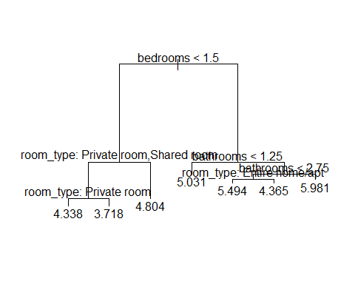
# Regression Tree splits the tree based on bedrooms and room_type!!
tree.DC.pred <- predict(tree.DC, newdata = DCNo[-DC.train,])
mean((tree.DC.pred - DC.reduced$log_price[-DC.train])^2)
## [1] 0.1765671
print(paste("MSE Regression Tree = ", mean(tree.SF.pred - mean(tree.DC.pred - DC.reduced$log_price[-DC.train])^2)))
## [1] "MSE Regression Tree = 5.10423875872797"
## Creating models for New York City
NYC <- train %>%
filter(city == "NYC")
# Removing rows with NA and city column
NYCNo <- NYC[complete.cases(NYC), ] %>%
select(-city)
### OLS Assumptions
## Assumption 1. Y is continuous
hist(NYCNo$log_price)
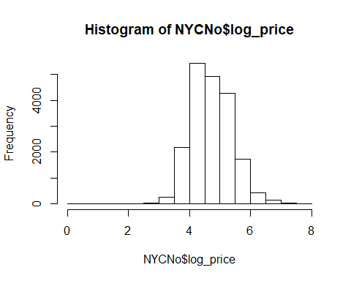
# The bar plot seems to be normally distributed.
## Assumption 2. Errors (ɛ) are normally distributed
# Since Y is normally distributed, residual would also be normally distributed.
qqnorm(NYCNo$log_price, main=" Price NYC")
qqline(NYCNo$log_price)
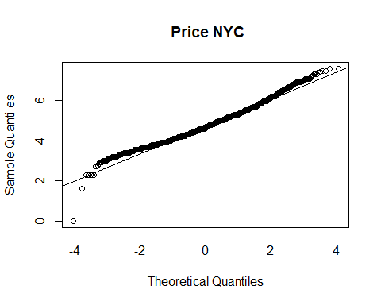
# A large majority of residuals lie on the qqline implying that the residuals are normally distributed.
## Assumption 3. X’s are independent
#Log-Linear model for each city
NYCLogLinearModel <- lm(log_price ~ ., data = NYCNo)
summary(NYCLogLinearModel)
##
## Call:
## lm(formula = log_price ~ ., data = NYCNo)
##
## Residuals:
## Min 1Q Median 3Q Max
## -4.0235 -0.2773 -0.0129 0.2620 2.5645
##
## Coefficients:
## Estimate Std. Error t value Pr(>|t|)
## (Intercept) 7.585e+00 3.438e-01 22.059 < 2e-16
## property_typeBed & Breakfast 1.694e-01 5.039e-02 3.362 0.000777
## property_typeBoat -1.785e-01 2.406e-01 -0.742 0.458277
## property_typeBoutique hotel 1.989e-01 1.576e-01 1.262 0.206862
## property_typeBungalow -1.144e-01 1.389e-01 -0.823 0.410327
## property_typeCabin -4.316e-02 2.950e-01 -0.146 0.883678
## property_typeCastle 8.534e-01 4.166e-01 2.049 0.040523
## property_typeChalet 2.242e-01 2.411e-01 0.930 0.352526
## property_typeCondominium 2.183e-01 2.517e-02 8.672 < 2e-16
## property_typeDorm -1.126e-01 1.115e-01 -1.010 0.312650
## property_typeEarth House 4.276e-01 4.166e-01 1.026 0.304671
## property_typeGuest suite -6.391e-02 7.265e-02 -0.880 0.379024
## property_typeGuesthouse -2.169e-01 8.374e-02 -2.590 0.009599
## property_typeHostel -6.141e-02 1.260e-01 -0.487 0.626019
## property_typeHouse -2.329e-01 1.023e-02 -22.773 < 2e-16
## property_typeIn-law -1.355e-01 2.405e-01 -0.563 0.573297
## property_typeLoft 1.632e-01 2.084e-02 7.833 4.99e-15
## property_typeOther 4.329e-04 3.747e-02 0.012 0.990784
## property_typeServiced apartment 1.596e-01 2.084e-01 0.766 0.443692
## property_typeTimeshare 7.272e-01 1.043e-01 6.975 3.17e-12
## property_typeTownhouse -6.115e-02 2.000e-02 -3.058 0.002230
## property_typeVacation home 2.483e-01 1.865e-01 1.332 0.182947
## property_typeVilla 8.721e-03 1.257e-01 0.069 0.944684
## property_typeYurt -5.883e-01 4.166e-01 -1.412 0.157886
## room_typePrivate room -6.444e-01 7.414e-03 -86.908 < 2e-16
## room_typeShared room -9.959e-01 2.056e-02 -48.452 < 2e-16
## accommodates 8.832e-02 3.104e-03 28.458 < 2e-16
## bathrooms 1.417e-01 8.260e-03 17.156 < 2e-16
## bed_typeCouch -5.719e-02 7.697e-02 -0.743 0.457499
## bed_typeFuton -3.425e-02 5.214e-02 -0.657 0.511238
## bed_typePull-out Sofa 3.848e-02 5.335e-02 0.721 0.470748
## bed_typeReal Bed 6.285e-02 4.475e-02 1.404 0.160237
## cancellation_policymoderate -2.999e-03 9.341e-03 -0.321 0.748163
## cancellation_policystrict 4.486e-02 8.604e-03 5.213 1.87e-07
## cancellation_policysuper_strict_30 5.511e-01 2.408e-01 2.288 0.022133
## cancellation_policysuper_strict_60 1.560e+00 4.174e-01 3.737 0.000187
## cleaning_feeTrue 1.169e-02 7.947e-03 1.471 0.141213
## first_review -2.991e-05 8.151e-06 -3.670 0.000243
## host_has_profile_pict -1.858e-01 7.169e-02 -2.592 0.009555
## host_identity_verifiedt -3.974e-03 6.940e-03 -0.573 0.566941
## host_response_rate_percent -2.839e-04 2.099e-04 -1.353 0.176162
## host_since -3.192e-05 5.389e-06 -5.924 3.20e-09
## instant_bookablet -6.730e-03 7.031e-03 -0.957 0.338449
## last_review -1.329e-04 2.074e-05 -6.410 1.49e-10
## number_of_reviews -3.766e-04 1.009e-04 -3.733 0.000189
## review_scores_rating 4.736e-03 4.133e-04 11.458 < 2e-16
## bedrooms 1.022e-01 5.920e-03 17.269 < 2e-16
## beds -3.216e-02 4.986e-03 -6.450 1.14e-10
##
## (Intercept) ***
## property_typeBed & Breakfast ***
## property_typeBoat
## property_typeBoutique hotel
## property_typeBungalow
## property_typeCabin
## property_typeCastle *
## property_typeChalet
## property_typeCondominium ***
## property_typeDorm
## property_typeEarth House
## property_typeGuest suite
## property_typeGuesthouse **
## property_typeHostel
## property_typeHouse ***
## property_typeIn-law
## property_typeLoft ***
## property_typeOther
## property_typeServiced apartment
## property_typeTimeshare ***
## property_typeTownhouse **
## property_typeVacation home
## property_typeVilla
## property_typeYurt
## room_typePrivate room ***
## room_typeShared room ***
## accommodates ***
## bathrooms ***
## bed_typeCouch
## bed_typeFuton
## bed_typePull-out Sofa
## bed_typeReal Bed
## cancellation_policymoderate
## cancellation_policystrict ***
## cancellation_policysuper_strict_30 *
## cancellation_policysuper_strict_60 ***
## cleaning_feeTrue
## first_review ***
## host_has_profile_pict **
## host_identity_verifiedt
## host_response_rate_percent
## host_since ***
## instant_bookablet
## last_review ***
## number_of_reviews ***
## review_scores_rating ***
## bedrooms ***
## beds ***
## ---
## Signif. codes: 0 '***' 0.001 '**' 0.01 '*' 0.05 '.' 0.1 ' ' 1
##
## Residual standard error: 0.4165 on 19353 degrees of freedom
## Multiple R-squared: 0.5907, Adjusted R-squared: 0.5898
## F-statistic: 594.4 on 47 and 19353 DF, p-value: < 2.2e-16
# Checking for correlation in X variables
# Condition Index and Variance Inflation factor
vif(NYCLogLinearModel)
## GVIF Df GVIF^(1/(2*Df))
## property_type 1.188543 23 1.003762
## room_type 1.643339 2 1.132223
## accommodates 4.276937 1 2.068076
## bathrooms 1.329254 1 1.152933
## bed_type 1.084298 4 1.010168
## cancellation_policy 1.175461 4 1.020413
## cleaning_fee 1.116097 1 1.056455
## first_review 2.258868 1 1.502953
## host_has_profile_pic 1.005761 1 1.002876
## host_identity_verified 1.160637 1 1.077329
## host_response_rate_percent 1.081417 1 1.039912
## host_since 1.640146 1 1.280682
## instant_bookable 1.128832 1 1.062465
## last_review 1.273144 1 1.128337
## number_of_reviews 1.688297 1 1.299345
## review_scores_rating 1.049560 1 1.024480
## bedrooms 2.259649 1 1.503213
## beds 3.807730 1 1.951341
# All the vif coefficients are below 10. Therefore there is no significant correlation between the variables.
## Assumption 4. Y and X’s have linear relationship
#Plots
plot(NYCLogLinearModel)
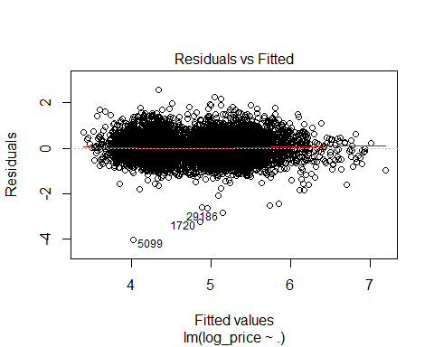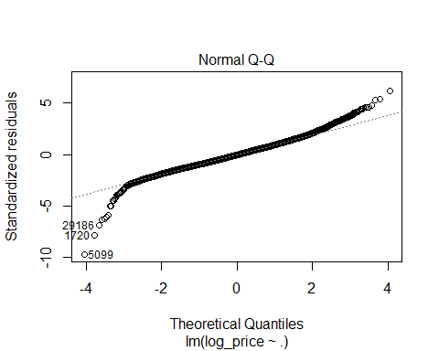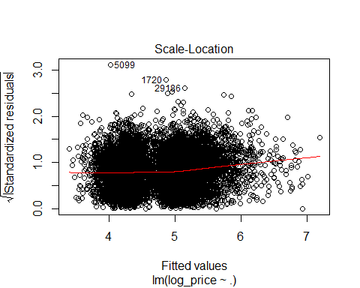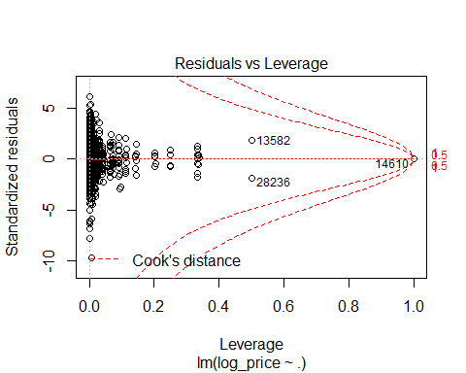
## Assumption 5 & 6. Observations are independent & Errors are independent
# Durbin-Watson Test for Serial Correlation
dwtest(NYCLogLinearModel)
##
## Durbin-Watson test
##
## data: NYCLogLinearModel
## DW = 2.0252, p-value = 0.9602
## alternative hypothesis: true autocorrelation is greater than 0
# DW test shows there is acceptable level of level of correlation as the value is 2.0249
## Assumptions 7 & 8. The error average is 0 & The error variance is constant.
# Breusch-Pagan Test
bptest(NYCNo$log_price ~ ., data = NYCNo)
##
## studentized Breusch-Pagan test
##
## data: NYCNo$log_price ~ .
## BP = 613.76, df = 47, p-value < 2.2e-16
# BP test is significant; therefore there is hetroscedasticity in the residuals. Need to run WLS to fix the issue.
plot(NYCLogLinearModel, which = 1)
# However, the plot shows there is not much visual hetroscedasticity.
# Drop unused factors
NYCNo$property_type <- droplevels(NYCNo)$property_type
NYCNo$host_has_profile_pic <- droplevels(NYCNo)$host_has_profile_pic
NYCNo$host_identity_verified <- droplevels(NYCNo)$host_identity_verified
NYCNo$cancellation_policy <- droplevels(NYCNo)$cancellation_policy
table(NYCNo$property_type)
##
## Apartment Bed & Breakfast Boat
## 15887 69 3
## Boutique hotel Bungalow Cabin
## 7 9 2
## Castle Chalet Condominium
## 1 3 282
## Dorm Earth House Guest suite
## 14 1 33
## Guesthouse Hostel House
## 25 11 2014
## In-law Loft Other
## 3 414 125
## Serviced apartment Timeshare Townhouse
## 4 16 461
## Vacation home Villa Yurt
## 5 11 1
# Combining all the factor that have degree of freedom less than 10
levels(NYCNo$property_type)[levels(NYCNo$property_type)=="Boat"] <- "Other"
levels(NYCNo$property_type)[levels(NYCNo$property_type)=="Boutique hotel"] <- "Other"
levels(NYCNo$property_type)[levels(NYCNo$property_type)=="Bungalow"] <- "Other"
levels(NYCNo$property_type)[levels(NYCNo$property_type)=="Cabin"] <- "Other"
levels(NYCNo$property_type)[levels(NYCNo$property_type)=="Chalet"] <- "Other"
levels(NYCNo$property_type)[levels(NYCNo$property_type)=="Castle"] <- "Other"
levels(NYCNo$property_type)[levels(NYCNo$property_type)=="Earth House"] <- "Other"
levels(NYCNo$property_type)[levels(NYCNo$property_type)=="In-law"] <- "Other"
levels(NYCNo$property_type)[levels(NYCNo$property_type)=="Serviced apartment"] <- "Other"
levels(NYCNo$property_type)[levels(NYCNo$property_type)=="Vacation home"] <- "Other"
levels(NYCNo$property_type)[levels(NYCNo$property_type)=="Yurt"] <- "Other"
levels(NYCNo$cancellation_policy)[levels(NYCNo$cancellation_policy)=="super_strict_60"] <- "super_strict_30"
## OLS model for all cities.
set.seed(1)
NYC.train <- sample(nrow(NYCNo), 0.7*nrow(NYCNo))
NYCLogLinearModel <- lm(log_price ~ ., data = NYCNo[NYC.train,])
summary(NYCLogLinearModel)
##
## Call:
## lm(formula = log_price ~ ., data = NYCNo[NYC.train, ])
##
## Residuals:
## Min 1Q Median 3Q Max
## -3.2384 -0.2754 -0.0119 0.2580 2.5666
##
## Coefficients:
## Estimate Std. Error t value Pr(>|t|)
## (Intercept) 7.726e+00 4.127e-01 18.719 < 2e-16
## property_typeBed & Breakfast 2.046e-01 6.336e-02 3.229 0.00125
## property_typeOther 4.098e-02 3.869e-02 1.059 0.28953
## property_typeCondominium 2.643e-01 2.996e-02 8.823 < 2e-16
## property_typeDorm -1.164e-01 1.249e-01 -0.932 0.35158
## property_typeGuest suite -1.339e-01 8.648e-02 -1.549 0.12152
## property_typeGuesthouse -2.207e-01 9.812e-02 -2.249 0.02450
## property_typeHostel -9.064e-02 1.314e-01 -0.690 0.49042
## property_typeHouse -2.354e-01 1.218e-02 -19.336 < 2e-16
## property_typeLoft 1.373e-01 2.438e-02 5.631 1.82e-08
## property_typeTimeshare 7.868e-01 1.311e-01 6.001 2.01e-09
## property_typeTownhouse -6.567e-02 2.441e-02 -2.691 0.00714
## property_typeVilla -6.818e-02 1.464e-01 -0.466 0.64143
## room_typePrivate room -6.496e-01 8.778e-03 -74.000 < 2e-16
## room_typeShared room -9.761e-01 2.434e-02 -40.096 < 2e-16
## accommodates 8.757e-02 3.582e-03 24.446 < 2e-16
## bathrooms 1.434e-01 9.922e-03 14.448 < 2e-16
## bed_typeCouch -1.430e-01 9.283e-02 -1.541 0.12338
## bed_typeFuton -8.906e-02 5.945e-02 -1.498 0.13418
## bed_typePull-out Sofa -1.226e-03 6.182e-02 -0.020 0.98418
## bed_typeReal Bed 1.700e-02 5.046e-02 0.337 0.73628
## cancellation_policymoderate -6.694e-03 1.113e-02 -0.602 0.54745
## cancellation_policystrict 4.651e-02 1.023e-02 4.546 5.52e-06
## cancellation_policysuper_strict_30 1.018e+00 2.398e-01 4.243 2.22e-05
## cleaning_feeTrue 1.280e-02 9.484e-03 1.349 0.17724
## first_review -2.821e-05 9.657e-06 -2.921 0.00350
## host_has_profile_pict -1.752e-01 8.475e-02 -2.067 0.03874
## host_identity_verifiedt -3.146e-03 8.243e-03 -0.382 0.70273
## host_response_rate_percent -2.027e-04 2.489e-04 -0.814 0.41556
## host_since -2.855e-05 6.377e-06 -4.477 7.62e-06
## instant_bookablet -3.486e-03 8.337e-03 -0.418 0.67583
## last_review -1.429e-04 2.500e-05 -5.718 1.10e-08
## number_of_reviews -3.615e-04 1.201e-04 -3.009 0.00262
## review_scores_rating 4.436e-03 4.878e-04 9.092 < 2e-16
## bedrooms 1.144e-01 7.007e-03 16.333 < 2e-16
## beds -3.844e-02 5.848e-03 -6.573 5.10e-11
##
## (Intercept) ***
## property_typeBed & Breakfast **
## property_typeOther
## property_typeCondominium ***
## property_typeDorm
## property_typeGuest suite
## property_typeGuesthouse *
## property_typeHostel
## property_typeHouse ***
## property_typeLoft ***
## property_typeTimeshare ***
## property_typeTownhouse **
## property_typeVilla
## room_typePrivate room ***
## room_typeShared room ***
## accommodates ***
## bathrooms ***
## bed_typeCouch
## bed_typeFuton
## bed_typePull-out Sofa
## bed_typeReal Bed
## cancellation_policymoderate
## cancellation_policystrict ***
## cancellation_policysuper_strict_30 ***
## cleaning_feeTrue
## first_review **
## host_has_profile_pict *
## host_identity_verifiedt
## host_response_rate_percent
## host_since ***
## instant_bookablet
## last_review ***
## number_of_reviews **
## review_scores_rating ***
## bedrooms ***
## beds ***
## ---
## Signif. codes: 0 '***' 0.001 '**' 0.01 '*' 0.05 '.' 0.1 ' ' 1
##
## Residual standard error: 0.4136 on 13544 degrees of freedom
## Multiple R-squared: 0.5976, Adjusted R-squared: 0.5966
## F-statistic: 574.7 on 35 and 13544 DF, p-value: < 2.2e-16
# Stepwise for OLS Model
NYC.null <- lm(log_price ~ 1, data = NYCNo[NYC.train,])
NYC.full <- lm(log_price ~ ., data = NYCNo[NYC.train,])
NYC.stepwise <- step(NYC.full, scope = list(lower = NYC.full, upper = NYC.full), direction = 'both', test = 'F')
## Start: AIC=-23944.38
## log_price ~ property_type + room_type + accommodates + bathrooms +
## bed_type + cancellation_policy + cleaning_fee + first_review +
## host_has_profile_pic + host_identity_verified + host_response_rate_percent +
## host_since + instant_bookable + last_review + number_of_reviews +
## review_scores_rating + bedrooms + beds
summary(NYC.stepwise)
##
## Call:
## lm(formula = log_price ~ property_type + room_type + accommodates +
## bathrooms + bed_type + cancellation_policy + cleaning_fee +
## first_review + host_has_profile_pic + host_identity_verified +
## host_response_rate_percent + host_since + instant_bookable +
## last_review + number_of_reviews + review_scores_rating +
## bedrooms + beds, data = NYCNo[NYC.train, ])
##
## Residuals:
## Min 1Q Median 3Q Max
## -3.2384 -0.2754 -0.0119 0.2580 2.5666
##
## Coefficients:
## Estimate Std. Error t value Pr(>|t|)
## (Intercept) 7.726e+00 4.127e-01 18.719 < 2e-16
## property_typeBed & Breakfast 2.046e-01 6.336e-02 3.229 0.00125
## property_typeOther 4.098e-02 3.869e-02 1.059 0.28953
## property_typeCondominium 2.643e-01 2.996e-02 8.823 < 2e-16
## property_typeDorm -1.164e-01 1.249e-01 -0.932 0.35158
## property_typeGuest suite -1.339e-01 8.648e-02 -1.549 0.12152
## property_typeGuesthouse -2.207e-01 9.812e-02 -2.249 0.02450
## property_typeHostel -9.064e-02 1.314e-01 -0.690 0.49042
## property_typeHouse -2.354e-01 1.218e-02 -19.336 < 2e-16
## property_typeLoft 1.373e-01 2.438e-02 5.631 1.82e-08
## property_typeTimeshare 7.868e-01 1.311e-01 6.001 2.01e-09
## property_typeTownhouse -6.567e-02 2.441e-02 -2.691 0.00714
## property_typeVilla -6.818e-02 1.464e-01 -0.466 0.64143
## room_typePrivate room -6.496e-01 8.778e-03 -74.000 < 2e-16
## room_typeShared room -9.761e-01 2.434e-02 -40.096 < 2e-16
## accommodates 8.757e-02 3.582e-03 24.446 < 2e-16
## bathrooms 1.434e-01 9.922e-03 14.448 < 2e-16
## bed_typeCouch -1.430e-01 9.283e-02 -1.541 0.12338
## bed_typeFuton -8.906e-02 5.945e-02 -1.498 0.13418
## bed_typePull-out Sofa -1.226e-03 6.182e-02 -0.020 0.98418
## bed_typeReal Bed 1.700e-02 5.046e-02 0.337 0.73628
## cancellation_policymoderate -6.694e-03 1.113e-02 -0.602 0.54745
## cancellation_policystrict 4.651e-02 1.023e-02 4.546 5.52e-06
## cancellation_policysuper_strict_30 1.018e+00 2.398e-01 4.243 2.22e-05
## cleaning_feeTrue 1.280e-02 9.484e-03 1.349 0.17724
## first_review -2.821e-05 9.657e-06 -2.921 0.00350
## host_has_profile_pict -1.752e-01 8.475e-02 -2.067 0.03874
## host_identity_verifiedt -3.146e-03 8.243e-03 -0.382 0.70273
## host_response_rate_percent -2.027e-04 2.489e-04 -0.814 0.41556
## host_since -2.855e-05 6.377e-06 -4.477 7.62e-06
## instant_bookablet -3.486e-03 8.337e-03 -0.418 0.67583
## last_review -1.429e-04 2.500e-05 -5.718 1.10e-08
## number_of_reviews -3.615e-04 1.201e-04 -3.009 0.00262
## review_scores_rating 4.436e-03 4.878e-04 9.092 < 2e-16
## bedrooms 1.144e-01 7.007e-03 16.333 < 2e-16
## beds -3.844e-02 5.848e-03 -6.573 5.10e-11
##
## (Intercept) ***
## property_typeBed & Breakfast **
## property_typeOther
## property_typeCondominium ***
## property_typeDorm
## property_typeGuest suite
## property_typeGuesthouse *
## property_typeHostel
## property_typeHouse ***
## property_typeLoft ***
## property_typeTimeshare ***
## property_typeTownhouse **
## property_typeVilla
## room_typePrivate room ***
## room_typeShared room ***
## accommodates ***
## bathrooms ***
## bed_typeCouch
## bed_typeFuton
## bed_typePull-out Sofa
## bed_typeReal Bed
## cancellation_policymoderate
## cancellation_policystrict ***
## cancellation_policysuper_strict_30 ***
## cleaning_feeTrue
## first_review **
## host_has_profile_pict *
## host_identity_verifiedt
## host_response_rate_percent
## host_since ***
## instant_bookablet
## last_review ***
## number_of_reviews **
## review_scores_rating ***
## bedrooms ***
## beds ***
## ---
## Signif. codes: 0 '***' 0.001 '**' 0.01 '*' 0.05 '.' 0.1 ' ' 1
##
## Residual standard error: 0.4136 on 13544 degrees of freedom
## Multiple R-squared: 0.5976, Adjusted R-squared: 0.5966
## F-statistic: 574.7 on 35 and 13544 DF, p-value: < 2.2e-16
NYC.reduced <- NYCNo[, c(
'log_price',
'property_type',
'room_type',
'accommodates',
'bathrooms',
'bed_type',
'cancellation_policy',
'first_review',
'host_has_profile_pic',
'host_since',
'last_review',
'number_of_reviews',
'review_scores_rating',
'bedrooms',
'beds'
)]
# Running OLS with the reduced model with only significant predictors.
NYC.reduced.model <- lm(log_price ~., data = NYC.reduced[NYC.train,])
summary(NYC.reduced.model)
##
## Call:
## lm(formula = log_price ~ ., data = NYC.reduced[NYC.train, ])
##
## Residuals:
## Min 1Q Median 3Q Max
## -3.2363 -0.2763 -0.0127 0.2597 2.5729
##
## Coefficients:
## Estimate Std. Error t value Pr(>|t|)
## (Intercept) 7.774e+00 4.038e-01 19.253 < 2e-16
## property_typeBed & Breakfast 2.031e-01 6.333e-02 3.206 0.00135
## property_typeOther 3.929e-02 3.866e-02 1.016 0.30952
## property_typeCondominium 2.643e-01 2.995e-02 8.824 < 2e-16
## property_typeDorm -1.189e-01 1.249e-01 -0.951 0.34142
## property_typeGuest suite -1.341e-01 8.647e-02 -1.551 0.12104
## property_typeGuesthouse -2.182e-01 9.808e-02 -2.225 0.02611
## property_typeHostel -8.885e-02 1.313e-01 -0.677 0.49863
## property_typeHouse -2.359e-01 1.216e-02 -19.392 < 2e-16
## property_typeLoft 1.369e-01 2.437e-02 5.615 2.00e-08
## property_typeTimeshare 7.839e-01 1.310e-01 5.983 2.25e-09
## property_typeTownhouse -6.556e-02 2.440e-02 -2.687 0.00722
## property_typeVilla -6.921e-02 1.464e-01 -0.473 0.63629
## room_typePrivate room -6.510e-01 8.722e-03 -74.640 < 2e-16
## room_typeShared room -9.781e-01 2.430e-02 -40.247 < 2e-16
## accommodates 8.778e-02 3.574e-03 24.562 < 2e-16
## bathrooms 1.434e-01 9.921e-03 14.450 < 2e-16
## bed_typeCouch -1.450e-01 9.281e-02 -1.563 0.11813
## bed_typeFuton -8.911e-02 5.944e-02 -1.499 0.13387
## bed_typePull-out Sofa -1.948e-03 6.181e-02 -0.032 0.97485
## bed_typeReal Bed 1.660e-02 5.045e-02 0.329 0.74208
## cancellation_policymoderate -4.851e-03 1.095e-02 -0.443 0.65762
## cancellation_policystrict 4.886e-02 9.965e-03 4.903 9.54e-07
## cancellation_policysuper_strict_30 1.014e+00 2.398e-01 4.227 2.38e-05
## first_review -2.904e-05 9.573e-06 -3.033 0.00242
## host_has_profile_pict -1.759e-01 8.462e-02 -2.079 0.03760
## host_since -2.863e-05 6.124e-06 -4.675 2.96e-06
## last_review -1.454e-04 2.453e-05 -5.925 3.19e-09
## number_of_reviews -3.837e-04 1.187e-04 -3.232 0.00123
## review_scores_rating 4.420e-03 4.849e-04 9.117 < 2e-16
## bedrooms 1.144e-01 7.005e-03 16.336 < 2e-16
## beds -3.866e-02 5.846e-03 -6.613 3.91e-11
##
## (Intercept) ***
## property_typeBed & Breakfast **
## property_typeOther
## property_typeCondominium ***
## property_typeDorm
## property_typeGuest suite
## property_typeGuesthouse *
## property_typeHostel
## property_typeHouse ***
## property_typeLoft ***
## property_typeTimeshare ***
## property_typeTownhouse **
## property_typeVilla
## room_typePrivate room ***
## room_typeShared room ***
## accommodates ***
## bathrooms ***
## bed_typeCouch
## bed_typeFuton
## bed_typePull-out Sofa
## bed_typeReal Bed
## cancellation_policymoderate
## cancellation_policystrict ***
## cancellation_policysuper_strict_30 ***
## first_review **
## host_has_profile_pict *
## host_since ***
## last_review ***
## number_of_reviews **
## review_scores_rating ***
## bedrooms ***
## beds ***
## ---
## Signif. codes: 0 '***' 0.001 '**' 0.01 '*' 0.05 '.' 0.1 ' ' 1
##
## Residual standard error: 0.4136 on 13548 degrees of freedom
## Multiple R-squared: 0.5975, Adjusted R-squared: 0.5966
## F-statistic: 648.9 on 31 and 13548 DF, p-value: < 2.2e-16
NYC.reduced.mse <- mean((NYC.reduced$log_price-predict(NYC.reduced.model, NYC.reduced))[-NYC.train]^2)
print(paste("MSE Reduced OLS = ", NYC.reduced.mse), digits = 5)
## [1] "MSE Reduced OLS = 0.179872203027293"
## k-Fold Cross-Validation (KFCV)
# Cross-Validation of OLS
glm.fit <- glm(log_price ~ ., data = NYC.reduced)
cv.10K <- cv.glm(NYC.reduced, glm.fit, K=10)
print(paste("CV MSE OLS = ", cv.10K$delta[1]), digits=5)
## [1] "CV MSE OLS = 0.173990095092131"
# WLS Model
wts <- 1/fitted(lm(abs(residuals(NYCLogLinearModel))~fitted(NYCLogLinearModel)))^2
NYC.wls <- lm(log_price ~ ., data = NYCNo[NYC.train,], weights=1/wts)
summary(NYC.wls)
##
## Call:
## lm(formula = log_price ~ ., data = NYCNo[NYC.train, ], weights = 1/wts)
##
## Weighted Residuals:
## Min 1Q Median 3Q Max
## -1.06074 -0.08784 -0.00377 0.08351 0.77816
##
## Coefficients:
## Estimate Std. Error t value Pr(>|t|)
## (Intercept) 7.593e+00 4.116e-01 18.450 < 2e-16
## property_typeBed & Breakfast 1.962e-01 6.314e-02 3.108 0.001890
## property_typeOther 2.946e-02 3.868e-02 0.762 0.446227
## property_typeCondominium 2.645e-01 2.873e-02 9.205 < 2e-16
## property_typeDorm -1.129e-01 1.392e-01 -0.811 0.417453
## property_typeGuest suite -1.495e-01 8.858e-02 -1.688 0.091417
## property_typeGuesthouse -2.327e-01 1.103e-01 -2.111 0.034827
## property_typeHostel -9.882e-02 1.434e-01 -0.689 0.490697
## property_typeHouse -2.379e-01 1.279e-02 -18.601 < 2e-16
## property_typeLoft 1.547e-01 2.367e-02 6.535 6.59e-11
## property_typeTimeshare 7.793e-01 1.144e-01 6.809 1.02e-11
## property_typeTownhouse -6.837e-02 2.418e-02 -2.827 0.004705
## property_typeVilla -4.936e-02 1.537e-01 -0.321 0.748102
## room_typePrivate room -6.585e-01 8.872e-03 -74.228 < 2e-16
## room_typeShared room -9.866e-01 2.748e-02 -35.908 < 2e-16
## accommodates 8.370e-02 3.336e-03 25.086 < 2e-16
## bathrooms 1.669e-01 9.582e-03 17.416 < 2e-16
## bed_typeCouch -1.367e-01 1.016e-01 -1.346 0.178274
## bed_typeFuton -9.637e-02 6.424e-02 -1.500 0.133569
## bed_typePull-out Sofa -1.635e-02 6.634e-02 -0.246 0.805316
## bed_typeReal Bed 1.758e-02 5.436e-02 0.323 0.746423
## cancellation_policymoderate -2.297e-04 1.148e-02 -0.020 0.984044
## cancellation_policystrict 6.055e-02 1.053e-02 5.749 9.15e-09
## cancellation_policysuper_strict_30 1.025e+00 1.967e-01 5.209 1.93e-07
## cleaning_feeTrue 1.103e-02 9.842e-03 1.120 0.262633
## first_review -2.748e-05 9.709e-06 -2.830 0.004661
## host_has_profile_pict -1.717e-01 8.340e-02 -2.058 0.039595
## host_identity_verifiedt -2.220e-03 8.357e-03 -0.266 0.790484
## host_response_rate_percent -2.085e-04 2.518e-04 -0.828 0.407698
## host_since -2.348e-05 6.431e-06 -3.652 0.000261
## instant_bookablet -1.528e-03 8.461e-03 -0.181 0.856681
## last_review -1.432e-04 2.492e-05 -5.748 9.22e-09
## number_of_reviews -3.950e-04 1.222e-04 -3.232 0.001234
## review_scores_rating 4.668e-03 5.054e-04 9.236 < 2e-16
## bedrooms 1.179e-01 6.746e-03 17.475 < 2e-16
## beds -4.092e-02 5.516e-03 -7.418 1.26e-13
##
## (Intercept) ***
## property_typeBed & Breakfast **
## property_typeOther
## property_typeCondominium ***
## property_typeDorm
## property_typeGuest suite .
## property_typeGuesthouse *
## property_typeHostel
## property_typeHouse ***
## property_typeLoft ***
## property_typeTimeshare ***
## property_typeTownhouse **
## property_typeVilla
## room_typePrivate room ***
## room_typeShared room ***
## accommodates ***
## bathrooms ***
## bed_typeCouch
## bed_typeFuton
## bed_typePull-out Sofa
## bed_typeReal Bed
## cancellation_policymoderate
## cancellation_policystrict ***
## cancellation_policysuper_strict_30 ***
## cleaning_feeTrue
## first_review **
## host_has_profile_pict *
## host_identity_verifiedt
## host_response_rate_percent
## host_since ***
## instant_bookablet
## last_review ***
## number_of_reviews **
## review_scores_rating ***
## bedrooms ***
## beds ***
## ---
## Signif. codes: 0 '***' 0.001 '**' 0.01 '*' 0.05 '.' 0.1 ' ' 1
##
## Residual standard error: 0.1351 on 13544 degrees of freedom
## Multiple R-squared: 0.6063, Adjusted R-squared: 0.6052
## F-statistic: 595.8 on 35 and 13544 DF, p-value: < 2.2e-16
MSE.wls <- mean((NYCNo$log_price-predict(NYC.wls, NYCNo))[-NYC.train]^2)
print(paste("MSE WLS = ", MSE.wls), digits=5)
## [1] "MSE WLS = 0.180127315845003"
# Regression Tree
tree.NYC <- tree(log_price ~ ., data = NYCNo[NYC.train,])
tree.NYC
## node), split, n, deviance, yval
## * denotes terminal node
##
## 1) root 13580 5757.0 4.720
## 2) room_type: Private room,Shared room 6652 1205.0 4.269 *
## 3) room_type: Entire home/apt 6928 1902.0 5.153
## 6) bathrooms < 1.25 5963 1166.0 5.056
## 12) bedrooms < 1.5 4311 718.7 4.979 *
## 13) bedrooms > 1.5 1652 357.3 5.254 *
## 7) bathrooms > 1.25 965 333.2 5.752 *
summary(tree.NYC)
##
## Regression tree:
## tree(formula = log_price ~ ., data = NYCNo[NYC.train, ])
## Variables actually used in tree construction:
## [1] "room_type" "bathrooms" "bedrooms"
## Number of terminal nodes: 4
## Residual mean deviance: 0.1925 = 2614 / 13580
## Distribution of residuals:
## Min. 1st Qu. Median Mean 3rd Qu. Max.
## -3.37000 -0.28530 -0.02036 0.00000 0.28500 3.01700
plot(tree.NYC)
text(tree.NYC, pretty = 0)
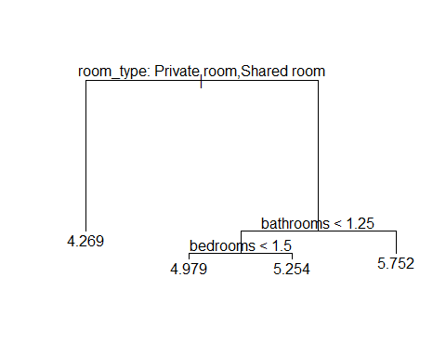
# Regression Tree splits the tree based on room_type and bedrooms!!
tree.NYC.pred <- predict(tree.NYC, newdata = NYCNo[-NYC.train,])
print(paste("MSE Regression Tree = ", mean((tree.NYC.pred - NYC.reduced$log_price[-NYC.train])^2)), digits=5)
## [1] "MSE Regression Tree = 0.198458399173624"
## Creating models for Boston
Boston <- train %>%
filter(city == "Boston")
# Removing rows with NA and city column
BostonNo <- Boston[complete.cases(Boston), ] %>%
select(-city)
### OLS Assumptions
## Assumption 1. Y is continuous
hist(BostonNo$log_price)
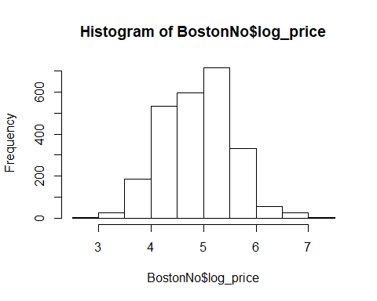
## Assumption 2. Errors (ɛ) are normally distributed
# Since Y is normally distributed, residual would also be normally distributed.
qqnorm(BostonNo$log_price, main=" Price Boston")
qqline(BostonNo$log_price)
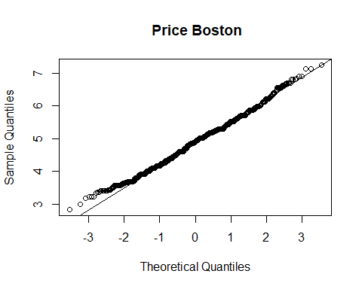
# A large majority of residuals lie on the qqline implying that the residuals are normally distributed.
## Assumption 3. X’s are independent
#Log-Linear model for each city
BostonLogLinearModel <- lm(log_price ~ ., data = BostonNo)
summary(BostonLogLinearModel)
##
## Call:
## lm(formula = log_price ~ ., data = BostonNo)
##
## Residuals:
## Min 1Q Median 3Q Max
## -1.74579 -0.25297 -0.00358 0.25242 1.95545
##
## Coefficients:
## Estimate Std. Error t value Pr(>|t|)
## (Intercept) 7.930e+00 1.014e+00 7.821 7.74e-15
## property_typeBed & Breakfast 1.904e-01 1.099e-01 1.732 0.083376
## property_typeBoat 4.860e-01 1.372e-01 3.542 0.000405
## property_typeBoutique hotel 6.608e-02 4.066e-01 0.163 0.870907
## property_typeCondominium 5.924e-02 2.821e-02 2.100 0.035845
## property_typeDorm -1.009e-01 2.872e-01 -0.351 0.725385
## property_typeGuest suite -2.497e-02 1.540e-01 -0.162 0.871232
## property_typeGuesthouse 4.204e-01 2.043e-01 2.058 0.039713
## property_typeHostel -1.400e-01 2.236e-01 -0.626 0.531305
## property_typeHouse -9.617e-02 2.452e-02 -3.921 9.05e-05
## property_typeIn-law -5.816e-01 2.031e-01 -2.864 0.004220
## property_typeLoft 1.583e-01 1.131e-01 1.400 0.161735
## property_typeOther 1.617e-01 8.590e-02 1.883 0.059871
## property_typeServiced apartment -2.834e-01 4.058e-01 -0.698 0.484983
## property_typeTimeshare 8.606e-01 4.069e-01 2.115 0.034520
## property_typeTownhouse 1.281e-01 6.285e-02 2.039 0.041594
## property_typeVilla -5.740e-01 2.875e-01 -1.997 0.045978
## room_typePrivate room -7.243e-01 2.269e-02 -31.916 < 2e-16
## room_typeShared room -5.956e-01 9.079e-02 -6.560 6.57e-11
## accommodates 7.095e-02 9.126e-03 7.774 1.11e-14
## bathrooms 1.252e-01 1.984e-02 6.309 3.33e-10
## bed_typeCouch 4.361e-01 3.096e-01 1.408 0.159158
## bed_typeFuton 3.256e-01 1.272e-01 2.559 0.010568
## bed_typePull-out Sofa 1.687e-01 1.398e-01 1.206 0.227794
## bed_typeReal Bed 4.110e-01 8.721e-02 4.713 2.58e-06
## cancellation_policymoderate 7.327e-02 2.665e-02 2.749 0.006025
## cancellation_policystrict 4.098e-02 2.470e-02 1.659 0.097230
## cancellation_policysuper_strict_30 2.976e-01 8.044e-02 3.699 0.000221
## cancellation_policysuper_strict_60 6.262e-01 2.892e-01 2.165 0.030450
## cleaning_feeTrue -8.776e-02 2.371e-02 -3.702 0.000219
## first_review -6.263e-05 2.484e-05 -2.521 0.011765
## host_has_profile_pict -1.631e-02 2.353e-01 -0.069 0.944735
## host_identity_verifiedt -1.112e-02 1.842e-02 -0.604 0.545948
## host_response_rate_percent -2.148e-03 8.646e-04 -2.485 0.013026
## host_since -3.585e-05 1.615e-05 -2.219 0.026571
## instant_bookablet -3.292e-02 1.820e-02 -1.809 0.070508
## last_review -1.264e-04 5.937e-05 -2.129 0.033348
## number_of_reviews -2.748e-04 2.104e-04 -1.306 0.191561
## review_scores_rating 5.387e-03 1.131e-03 4.763 2.02e-06
## bedrooms 8.052e-02 1.506e-02 5.345 9.90e-08
## beds -3.894e-02 1.284e-02 -3.033 0.002445
##
## (Intercept) ***
## property_typeBed & Breakfast .
## property_typeBoat ***
## property_typeBoutique hotel
## property_typeCondominium *
## property_typeDorm
## property_typeGuest suite
## property_typeGuesthouse *
## property_typeHostel
## property_typeHouse ***
## property_typeIn-law **
## property_typeLoft
## property_typeOther .
## property_typeServiced apartment
## property_typeTimeshare *
## property_typeTownhouse *
## property_typeVilla *
## room_typePrivate room ***
## room_typeShared room ***
## accommodates ***
## bathrooms ***
## bed_typeCouch
## bed_typeFuton *
## bed_typePull-out Sofa
## bed_typeReal Bed ***
## cancellation_policymoderate **
## cancellation_policystrict .
## cancellation_policysuper_strict_30 ***
## cancellation_policysuper_strict_60 *
## cleaning_feeTrue ***
## first_review *
## host_has_profile_pict
## host_identity_verifiedt
## host_response_rate_percent *
## host_since *
## instant_bookablet .
## last_review *
## number_of_reviews
## review_scores_rating ***
## bedrooms ***
## beds **
## ---
## Signif. codes: 0 '***' 0.001 '**' 0.01 '*' 0.05 '.' 0.1 ' ' 1
##
## Residual standard error: 0.4049 on 2428 degrees of freedom
## Multiple R-squared: 0.6123, Adjusted R-squared: 0.6059
## F-statistic: 95.85 on 40 and 2428 DF, p-value: < 2.2e-16
# Checking for correlation in X variables
# Condition Index and Variance Inflation factor
vif(BostonLogLinearModel)
## GVIF Df GVIF^(1/(2*Df))
## property_type 1.876642 16 1.019866
## room_type 2.167213 2 1.213320
## accommodates 6.525516 1 2.554509
## bathrooms 1.653215 1 1.285774
## bed_type 1.281741 4 1.031514
## cancellation_policy 1.357232 4 1.038919
## cleaning_fee 1.165153 1 1.079423
## first_review 2.326477 1 1.525279
## host_has_profile_pic 1.011520 1 1.005743
## host_identity_verified 1.167652 1 1.080580
## host_response_rate_percent 1.085558 1 1.041901
## host_since 1.646716 1 1.283244
## instant_bookable 1.178732 1 1.085694
## last_review 1.303897 1 1.141883
## number_of_reviews 1.644448 1 1.282360
## review_scores_rating 1.089438 1 1.043761
## bedrooms 2.849272 1 1.687979
## beds 4.762084 1 2.182220
# All the vif coefficients are below 10. Therefore there is no significant correlation between the variables.
## Assumption 4. Y and X’s have linear relationship
#Plots
plot(BostonLogLinearModel)
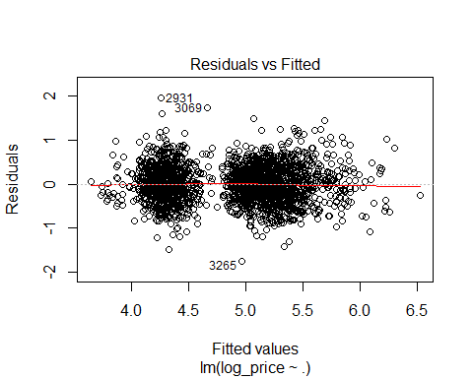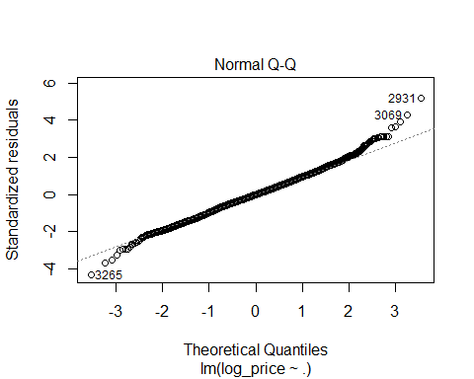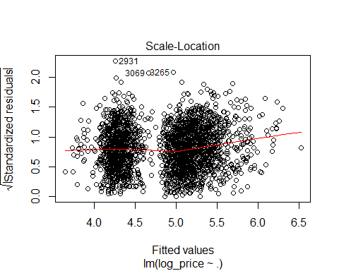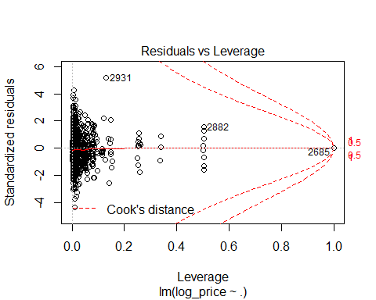
## Assumption 5 & 6. Observations are independent & Errors are independent
# Durbin-Watson Test for Serial Correlation
dwtest(BostonLogLinearModel)
##
## Durbin-Watson test
##
## data: BostonLogLinearModel
## DW = 2.0414, p-value = 0.8487
## alternative hypothesis: true autocorrelation is greater than 0
# DW test shows there is acceptable level of level of correlation as the value is 2.0513
## Assumptions 7 & 8. The error average is 0 & The error variance is constant.
# Breusch-Pagan Test
bptest(BostonNo$log_price ~ ., data = BostonNo)
##
## studentized Breusch-Pagan test
##
## data: BostonNo$log_price ~ .
## BP = 165.47, df = 40, p-value < 2.2e-16
# BP test is significant; therefore there is hetroscedasticity in the residuals. Need to run WLS to fix the issue.
plot(BostonLogLinearModel, which = 1)
# The plot shows there is some hetroscedasticity.
# Drop unused factors
BostonNo$property_type <- droplevels(BostonNo)$property_type
BostonNo$host_has_profile_pic <- droplevels(BostonNo)$host_has_profile_pic
BostonNo$host_identity_verified <- droplevels(BostonNo)$host_identity_verified
BostonChicancellation_policy <- droplevels(BostonNo)$cancellation_policy
table(BostonNo$property_type)
##
## Apartment Bed & Breakfast Boat
## 1637 14 9
## Boutique hotel Condominium Dorm
## 1 242 2
## Guest suite Guesthouse Hostel
## 7 4 4
## House In-law Loft
## 461 4 13
## Other Serviced apartment Timeshare
## 23 1 1
## Townhouse Villa
## 44 2
# Combining all the factor that have degree of freedom less than 10
levels(BostonNo$property_type)[levels(BostonNo$property_type)=="Boat"] <- "Other"
levels(BostonNo$property_type)[levels(BostonNo$property_type)=="Boutique hotel"] <- "Other"
levels(BostonNo$property_type)[levels(BostonNo$property_type)=="Serviced apartment"] <- "Other"
levels(BostonNo$property_type)[levels(BostonNo$property_type)=="Dorm"] <- "Other"
levels(BostonNo$property_type)[levels(BostonNo$property_type)=="Guest suite"] <- "Other"
levels(BostonNo$property_type)[levels(BostonNo$property_type)=="Guesthouse"] <- "Other"
levels(BostonNo$property_type)[levels(BostonNo$property_type)=="Hostel"] <- "Other"
levels(BostonNo$property_type)[levels(BostonNo$property_type)=="In-law"] <- "Other"
levels(BostonNo$property_type)[levels(BostonNo$property_type)=="Timeshare"] <- "Other"
levels(BostonNo$property_type)[levels(BostonNo$property_type)=="Villa"] <- "Other"
levels(BostonNo$cancellation_policy)[levels(BostonNo$cancellation_policy)=="super_strict_60"] <- "super_strict_30"
## OLS model for all cities.
set.seed(1)
Boston.train <- sample(nrow(BostonNo), 0.7*nrow(BostonNo))
BostonLogLinearModel <- lm(log_price ~ ., data = BostonNo[Boston.train,])
summary(BostonLogLinearModel)
##
## Call:
## lm(formula = log_price ~ ., data = BostonNo[Boston.train, ])
##
## Residuals:
## Min 1Q Median 3Q Max
## -1.69760 -0.26111 -0.00029 0.26636 1.76132
##
## Coefficients:
## Estimate Std. Error t value Pr(>|t|)
## (Intercept) 7.390e+00 1.212e+00 6.098 1.33e-09
## property_typeBed & Breakfast 2.229e-01 1.392e-01 1.601 0.109499
## property_typeOther 1.047e-01 7.094e-02 1.476 0.140129
## property_typeCondominium 5.165e-02 3.376e-02 1.530 0.126196
## property_typeHouse -9.006e-02 2.934e-02 -3.069 0.002180
## property_typeLoft 9.632e-02 1.684e-01 0.572 0.567346
## property_typeTownhouse 9.724e-02 7.370e-02 1.319 0.187223
## room_typePrivate room -7.306e-01 2.750e-02 -26.565 < 2e-16
## room_typeShared room -6.587e-01 1.224e-01 -5.382 8.40e-08
## accommodates 7.952e-02 1.105e-02 7.197 9.19e-13
## bathrooms 1.321e-01 2.246e-02 5.880 4.94e-09
## bed_typeCouch 6.371e-01 3.274e-01 1.946 0.051844
## bed_typeFuton 4.358e-01 1.403e-01 3.107 0.001919
## bed_typePull-out Sofa 2.871e-01 1.580e-01 1.818 0.069298
## bed_typeReal Bed 5.369e-01 9.987e-02 5.376 8.67e-08
## cancellation_policymoderate 1.015e-01 3.217e-02 3.155 0.001635
## cancellation_policystrict 6.218e-02 2.991e-02 2.079 0.037784
## cancellation_policysuper_strict_30 4.024e-01 9.719e-02 4.140 3.64e-05
## cleaning_feeTrue -9.961e-02 2.863e-02 -3.480 0.000514
## first_review -5.395e-05 2.955e-05 -1.826 0.068021
## host_has_profile_pict -2.840e-02 2.384e-01 -0.119 0.905200
## host_identity_verifiedt -1.257e-02 2.216e-02 -0.567 0.570506
## host_response_rate_percent -1.804e-03 1.015e-03 -1.779 0.075499
## host_since -2.475e-05 1.955e-05 -1.266 0.205526
## instant_bookablet -4.422e-02 2.195e-02 -2.015 0.044066
## last_review -1.228e-04 7.146e-05 -1.718 0.086042
## number_of_reviews -2.718e-04 2.576e-04 -1.055 0.291526
## review_scores_rating 5.376e-03 1.303e-03 4.126 3.87e-05
## bedrooms 6.877e-02 1.749e-02 3.932 8.76e-05
## beds -5.289e-02 1.550e-02 -3.411 0.000661
##
## (Intercept) ***
## property_typeBed & Breakfast
## property_typeOther
## property_typeCondominium
## property_typeHouse **
## property_typeLoft
## property_typeTownhouse
## room_typePrivate room ***
## room_typeShared room ***
## accommodates ***
## bathrooms ***
## bed_typeCouch .
## bed_typeFuton **
## bed_typePull-out Sofa .
## bed_typeReal Bed ***
## cancellation_policymoderate **
## cancellation_policystrict *
## cancellation_policysuper_strict_30 ***
## cleaning_feeTrue ***
## first_review .
## host_has_profile_pict
## host_identity_verifiedt
## host_response_rate_percent .
## host_since
## instant_bookablet *
## last_review .
## number_of_reviews
## review_scores_rating ***
## bedrooms ***
## beds ***
## ---
## Signif. codes: 0 '***' 0.001 '**' 0.01 '*' 0.05 '.' 0.1 ' ' 1
##
## Residual standard error: 0.4093 on 1698 degrees of freedom
## Multiple R-squared: 0.6125, Adjusted R-squared: 0.6058
## F-statistic: 92.53 on 29 and 1698 DF, p-value: < 2.2e-16
# Stepwise for OLS Model
Boston.null <- lm(log_price ~ 1, data = BostonNo[Boston.train,])
Boston.full <- lm(log_price ~ ., data = BostonNo[Boston.train,])
Boston.stepwise <- step(Boston.full, scope = list(lower = Boston.full, upper = Boston.full), direction = 'both', test = 'F')
## Start: AIC=-3057.19
## log_price ~ property_type + room_type + accommodates + bathrooms +
## bed_type + cancellation_policy + cleaning_fee + first_review +
## host_has_profile_pic + host_identity_verified + host_response_rate_percent +
## host_since + instant_bookable + last_review + number_of_reviews +
## review_scores_rating + bedrooms + beds
summary(Boston.stepwise)
##
## Call:
## lm(formula = log_price ~ property_type + room_type + accommodates +
## bathrooms + bed_type + cancellation_policy + cleaning_fee +
## first_review + host_has_profile_pic + host_identity_verified +
## host_response_rate_percent + host_since + instant_bookable +
## last_review + number_of_reviews + review_scores_rating +
## bedrooms + beds, data = BostonNo[Boston.train, ])
##
## Residuals:
## Min 1Q Median 3Q Max
## -1.69760 -0.26111 -0.00029 0.26636 1.76132
##
## Coefficients:
## Estimate Std. Error t value Pr(>|t|)
## (Intercept) 7.390e+00 1.212e+00 6.098 1.33e-09
## property_typeBed & Breakfast 2.229e-01 1.392e-01 1.601 0.109499
## property_typeOther 1.047e-01 7.094e-02 1.476 0.140129
## property_typeCondominium 5.165e-02 3.376e-02 1.530 0.126196
## property_typeHouse -9.006e-02 2.934e-02 -3.069 0.002180
## property_typeLoft 9.632e-02 1.684e-01 0.572 0.567346
## property_typeTownhouse 9.724e-02 7.370e-02 1.319 0.187223
## room_typePrivate room -7.306e-01 2.750e-02 -26.565 < 2e-16
## room_typeShared room -6.587e-01 1.224e-01 -5.382 8.40e-08
## accommodates 7.952e-02 1.105e-02 7.197 9.19e-13
## bathrooms 1.321e-01 2.246e-02 5.880 4.94e-09
## bed_typeCouch 6.371e-01 3.274e-01 1.946 0.051844
## bed_typeFuton 4.358e-01 1.403e-01 3.107 0.001919
## bed_typePull-out Sofa 2.871e-01 1.580e-01 1.818 0.069298
## bed_typeReal Bed 5.369e-01 9.987e-02 5.376 8.67e-08
## cancellation_policymoderate 1.015e-01 3.217e-02 3.155 0.001635
## cancellation_policystrict 6.218e-02 2.991e-02 2.079 0.037784
## cancellation_policysuper_strict_30 4.024e-01 9.719e-02 4.140 3.64e-05
## cleaning_feeTrue -9.961e-02 2.863e-02 -3.480 0.000514
## first_review -5.395e-05 2.955e-05 -1.826 0.068021
## host_has_profile_pict -2.840e-02 2.384e-01 -0.119 0.905200
## host_identity_verifiedt -1.257e-02 2.216e-02 -0.567 0.570506
## host_response_rate_percent -1.804e-03 1.015e-03 -1.779 0.075499
## host_since -2.475e-05 1.955e-05 -1.266 0.205526
## instant_bookablet -4.422e-02 2.195e-02 -2.015 0.044066
## last_review -1.228e-04 7.146e-05 -1.718 0.086042
## number_of_reviews -2.718e-04 2.576e-04 -1.055 0.291526
## review_scores_rating 5.376e-03 1.303e-03 4.126 3.87e-05
## bedrooms 6.877e-02 1.749e-02 3.932 8.76e-05
## beds -5.289e-02 1.550e-02 -3.411 0.000661
##
## (Intercept) ***
## property_typeBed & Breakfast
## property_typeOther
## property_typeCondominium
## property_typeHouse **
## property_typeLoft
## property_typeTownhouse
## room_typePrivate room ***
## room_typeShared room ***
## accommodates ***
## bathrooms ***
## bed_typeCouch .
## bed_typeFuton **
## bed_typePull-out Sofa .
## bed_typeReal Bed ***
## cancellation_policymoderate **
## cancellation_policystrict *
## cancellation_policysuper_strict_30 ***
## cleaning_feeTrue ***
## first_review .
## host_has_profile_pict
## host_identity_verifiedt
## host_response_rate_percent .
## host_since
## instant_bookablet *
## last_review .
## number_of_reviews
## review_scores_rating ***
## bedrooms ***
## beds ***
## ---
## Signif. codes: 0 '***' 0.001 '**' 0.01 '*' 0.05 '.' 0.1 ' ' 1
##
## Residual standard error: 0.4093 on 1698 degrees of freedom
## Multiple R-squared: 0.6125, Adjusted R-squared: 0.6058
## F-statistic: 92.53 on 29 and 1698 DF, p-value: < 2.2e-16
Boston.reduced <- BostonNo[, c(
'log_price',
'property_type',
'room_type',
'accommodates',
'bathrooms',
'bed_type',
'cancellation_policy',
'cleaning_fee',
'instant_bookable',
'review_scores_rating',
'bedrooms',
'beds'
)]
# Running OLS with the reduced model with only significant predictors.
Boston.reduced.model <- lm(log_price ~., data = Boston.reduced[Boston.train,])
summary(Boston.reduced.model)
##
## Call:
## lm(formula = log_price ~ ., data = Boston.reduced[Boston.train,
## ])
##
## Residuals:
## Min 1Q Median 3Q Max
## -1.67663 -0.26281 0.01297 0.26227 1.83519
##
## Coefficients:
## Estimate Std. Error t value Pr(>|t|)
## (Intercept) 3.821965 0.161907 23.606 < 2e-16
## property_typeBed & Breakfast 0.262093 0.138914 1.887 0.059366
## property_typeOther 0.105926 0.070580 1.501 0.133594
## property_typeCondominium 0.043487 0.033759 1.288 0.197865
## property_typeHouse -0.088677 0.029161 -3.041 0.002394
## property_typeLoft 0.079053 0.168770 0.468 0.639555
## property_typeTownhouse 0.085648 0.073731 1.162 0.245549
## room_typePrivate room -0.739532 0.027439 -26.952 < 2e-16
## room_typeShared room -0.644798 0.122769 -5.252 1.69e-07
## accommodates 0.076824 0.011003 6.982 4.15e-12
## bathrooms 0.134581 0.022426 6.001 2.39e-09
## bed_typeCouch 0.650863 0.327752 1.986 0.047211
## bed_typeFuton 0.421175 0.140265 3.003 0.002715
## bed_typePull-out Sofa 0.265885 0.158040 1.682 0.092675
## bed_typeReal Bed 0.524905 0.099666 5.267 1.57e-07
## cancellation_policymoderate 0.105520 0.031852 3.313 0.000943
## cancellation_policystrict 0.074230 0.029421 2.523 0.011724
## cancellation_policysuper_strict_30 0.497270 0.094602 5.256 1.65e-07
## cleaning_feeTrue -0.113827 0.028333 -4.017 6.14e-05
## instant_bookablet -0.074052 0.020734 -3.572 0.000365
## review_scores_rating 0.004628 0.001290 3.588 0.000342
## bedrooms 0.073534 0.017414 4.223 2.54e-05
## beds -0.054690 0.015507 -3.527 0.000432
##
## (Intercept) ***
## property_typeBed & Breakfast .
## property_typeOther
## property_typeCondominium
## property_typeHouse **
## property_typeLoft
## property_typeTownhouse
## room_typePrivate room ***
## room_typeShared room ***
## accommodates ***
## bathrooms ***
## bed_typeCouch *
## bed_typeFuton **
## bed_typePull-out Sofa .
## bed_typeReal Bed ***
## cancellation_policymoderate ***
## cancellation_policystrict *
## cancellation_policysuper_strict_30 ***
## cleaning_feeTrue ***
## instant_bookablet ***
## review_scores_rating ***
## bedrooms ***
## beds ***
## ---
## Signif. codes: 0 '***' 0.001 '**' 0.01 '*' 0.05 '.' 0.1 ' ' 1
##
## Residual standard error: 0.411 on 1705 degrees of freedom
## Multiple R-squared: 0.6076, Adjusted R-squared: 0.6026
## F-statistic: 120 on 22 and 1705 DF, p-value: < 2.2e-16
Boston.reduced.mse <- mean((Boston.reduced$log_price-predict(Boston.reduced.model, Boston.reduced))[-Boston.train]^2)
print(paste("MSE Reduced OLS = ", Boston.reduced.mse), digits=5)
## [1] "MSE Reduced OLS = 0.16833606730453"
## k-Fold Cross-Validation (KFCV)
# Cross-Validation of OLS
glm.fit <- glm(log_price ~ ., data = Boston.reduced)
cv.10K <- cv.glm(Boston.reduced, glm.fit, K=10)
print(paste("CV MSE OLS = ", cv.10K$delta[1]), digits=5)
## [1] "CV MSE OLS = 0.170953211998498"
# WLS Model
wts <- 1/fitted(lm(abs(residuals(BostonLogLinearModel))~fitted(BostonLogLinearModel)))^2
Boston.wls <- lm(log_price ~ ., data = BostonNo[Boston.train,], weights=1/wts)
summary(Boston.wls)
##
## Call:
## lm(formula = log_price ~ ., data = BostonNo[Boston.train, ],
## weights = 1/wts)
##
## Weighted Residuals:
## Min 1Q Median 3Q Max
## -0.54551 -0.08276 0.00065 0.08280 0.54281
##
## Coefficients:
## Estimate Std. Error t value Pr(>|t|)
## (Intercept) 7.270e+00 1.180e+00 6.160 9.08e-10
## property_typeBed & Breakfast 2.385e-01 1.454e-01 1.640 0.101110
## property_typeOther 9.796e-02 7.111e-02 1.377 0.168545
## property_typeCondominium 4.181e-02 3.353e-02 1.247 0.212587
## property_typeHouse -8.643e-02 3.024e-02 -2.859 0.004307
## property_typeLoft 8.692e-02 1.626e-01 0.535 0.592921
## property_typeTownhouse 7.496e-02 7.438e-02 1.008 0.313700
## room_typePrivate room -7.453e-01 2.825e-02 -26.382 < 2e-16
## room_typeShared room -6.762e-01 1.331e-01 -5.080 4.20e-07
## accommodates 7.241e-02 1.071e-02 6.763 1.85e-11
## bathrooms 1.579e-01 2.213e-02 7.138 1.39e-12
## bed_typeCouch 6.210e-01 3.515e-01 1.767 0.077470
## bed_typeFuton 4.240e-01 1.564e-01 2.710 0.006790
## bed_typePull-out Sofa 2.893e-01 1.747e-01 1.656 0.097925
## bed_typeReal Bed 5.213e-01 1.158e-01 4.500 7.26e-06
## cancellation_policymoderate 9.811e-02 3.316e-02 2.959 0.003129
## cancellation_policystrict 5.987e-02 3.085e-02 1.940 0.052504
## cancellation_policysuper_strict_30 3.948e-01 9.074e-02 4.352 1.43e-05
## cleaning_feeTrue -1.029e-01 2.933e-02 -3.509 0.000462
## first_review -5.517e-05 2.951e-05 -1.870 0.061711
## host_has_profile_pict -3.105e-02 2.366e-01 -0.131 0.895617
## host_identity_verifiedt -1.860e-02 2.228e-02 -0.835 0.403934
## host_response_rate_percent -1.722e-03 1.015e-03 -1.697 0.089892
## host_since -2.098e-05 1.961e-05 -1.070 0.284839
## instant_bookablet -4.707e-02 2.210e-02 -2.130 0.033353
## last_review -1.192e-04 6.956e-05 -1.714 0.086741
## number_of_reviews -3.644e-04 2.628e-04 -1.387 0.165685
## review_scores_rating 5.704e-03 1.351e-03 4.221 2.57e-05
## bedrooms 7.120e-02 1.690e-02 4.213 2.65e-05
## beds -5.022e-02 1.494e-02 -3.362 0.000792
##
## (Intercept) ***
## property_typeBed & Breakfast
## property_typeOther
## property_typeCondominium
## property_typeHouse **
## property_typeLoft
## property_typeTownhouse
## room_typePrivate room ***
## room_typeShared room ***
## accommodates ***
## bathrooms ***
## bed_typeCouch .
## bed_typeFuton **
## bed_typePull-out Sofa .
## bed_typeReal Bed ***
## cancellation_policymoderate **
## cancellation_policystrict .
## cancellation_policysuper_strict_30 ***
## cleaning_feeTrue ***
## first_review .
## host_has_profile_pict
## host_identity_verifiedt
## host_response_rate_percent .
## host_since
## instant_bookablet *
## last_review .
## number_of_reviews
## review_scores_rating ***
## bedrooms ***
## beds ***
## ---
## Signif. codes: 0 '***' 0.001 '**' 0.01 '*' 0.05 '.' 0.1 ' ' 1
##
## Residual standard error: 0.1316 on 1698 degrees of freedom
## Multiple R-squared: 0.6033, Adjusted R-squared: 0.5965
## F-statistic: 89.04 on 29 and 1698 DF, p-value: < 2.2e-16
MSE.wls <- mean((BostonNo$log_price-predict(Boston.wls, BostonNo))[-Boston.train]^2)
print(paste("MSE WLS = ", MSE.wls), digits=5)
## [1] "MSE WLS = 0.164475330263763"
# Regression Tree
tree.Boston <- tree(log_price ~ ., data = BostonNo[Boston.train,])
tree.Boston
## node), split, n, deviance, yval
## * denotes terminal node
##
## 1) root 1728 734.20 4.872
## 2) room_type: Private room,Shared room 647 121.80 4.279
## 4) accommodates < 1.5 172 30.78 4.027 *
## 5) accommodates > 1.5 475 76.20 4.371 *
## 3) room_type: Entire home/apt 1081 249.10 5.227
## 6) bathrooms < 1.25 811 118.80 5.102 *
## 7) bathrooms > 1.25 270 80.00 5.600
## 14) bathrooms < 2.25 226 56.04 5.515 *
## 15) bathrooms > 2.25 44 13.76 6.041 *
summary(tree.Boston)
##
## Regression tree:
## tree(formula = log_price ~ ., data = BostonNo[Boston.train, ])
## Variables actually used in tree construction:
## [1] "room_type" "accommodates" "bathrooms"
## Number of terminal nodes: 5
## Residual mean deviance: 0.1715 = 295.6 / 1723
## Distribution of residuals:
## Min. 1st Qu. Median Mean 3rd Qu. Max.
## -1.883000 -0.273900 -0.001117 0.000000 0.240100 2.021000
plot(tree.Boston)
text(tree.Boston, pretty = 0)
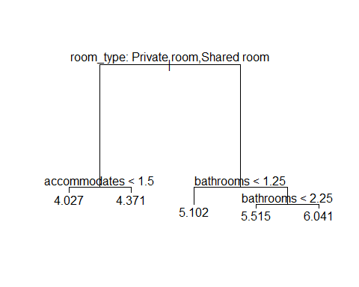
# Regression Tree splits the tree based on room_type and bedrooms!!
tree.Boston.pred <- predict(tree.Boston, newdata = BostonNo[-Boston.train,])
print(paste("MSE Regression Tree = ", mean((tree.Boston.pred - Boston.reduced$log_price[-Boston.train])^2)), digits=5)
## [1] "MSE Regression Tree = 0.165961535885672"
## Creating models for Chicago
Chi <- train %>%
filter(city == "Chicago")
# Removing rows with NA and city column
ChiNo <- Chi[complete.cases(Chi), ] %>%
select(-city)
### OLS Assumptions
## Assumption 1. Y is continuous
hist(ChiNo$log_price)
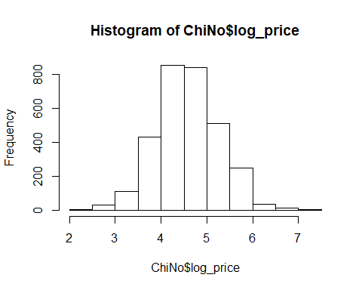
# The bar plot seems to be normally distributed.
## Assumption 2. Errors (ɛ) are normally distributed
# Since Y is normally distributed, residual would also be normally distributed.
qqnorm(ChiNo$log_price, main=" Price Chi")
qqline(ChiNo$log_price)
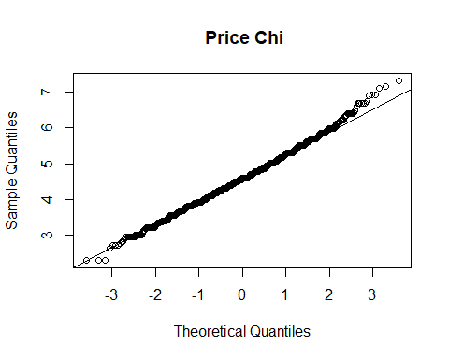
# A large majority of residuals lie on the qqline implying that the residuals are normally distributed.
## Assumption 3. X’s are independent
#Log-Linear model for each city
ChiLogLinearModel <- lm(log_price ~ ., data = ChiNo)
summary(ChiLogLinearModel)
##
## Call:
## lm(formula = log_price ~ ., data = ChiNo)
##
## Residuals:
## Min 1Q Median 3Q Max
## -2.4581 -0.2647 -0.0026 0.2549 1.8665
##
## Coefficients:
## Estimate Std. Error t value Pr(>|t|)
## (Intercept) 1.345e+01 1.103e+00 12.189 < 2e-16
## property_typeBed & Breakfast 2.494e-01 1.228e-01 2.031 0.042354
## property_typeBoat 3.416e-01 1.599e-01 2.136 0.032749
## property_typeBoutique hotel 5.267e-01 2.974e-01 1.771 0.076656
## property_typeBungalow -4.681e-01 2.433e-01 -1.924 0.054424
## property_typeCondominium 1.194e-01 2.573e-02 4.639 3.65e-06
## property_typeDorm -3.880e-01 1.530e-01 -2.535 0.011279
## property_typeGuest suite -9.379e-02 2.105e-01 -0.446 0.655925
## property_typeGuesthouse 2.117e-01 1.406e-01 1.506 0.132282
## property_typeHostel 9.020e-01 4.241e-01 2.127 0.033536
## property_typeHouse -3.732e-03 2.333e-02 -0.160 0.872889
## property_typeIn-law -9.119e-01 4.205e-01 -2.168 0.030209
## property_typeLoft 2.051e-01 5.414e-02 3.789 0.000154
## property_typeOther 1.733e-01 9.516e-02 1.821 0.068714
## property_typeTownhouse 2.491e-01 6.245e-02 3.989 6.80e-05
## property_typeVacation home 7.597e-01 4.206e-01 1.806 0.070996
## property_typeVilla -6.099e-01 2.980e-01 -2.047 0.040765
## room_typePrivate room -5.940e-01 1.967e-02 -30.204 < 2e-16
## room_typeShared room -1.176e+00 5.277e-02 -22.276 < 2e-16
## accommodates 6.837e-02 6.150e-03 11.117 < 2e-16
## bathrooms 1.606e-01 1.705e-02 9.422 < 2e-16
## bed_typeCouch -1.193e-02 1.470e-01 -0.081 0.935311
## bed_typeFuton -8.025e-02 9.975e-02 -0.804 0.421190
## bed_typePull-out Sofa 4.526e-02 1.291e-01 0.351 0.725859
## bed_typeReal Bed 2.582e-02 7.047e-02 0.366 0.714051
## cancellation_policymoderate 5.702e-02 2.157e-02 2.644 0.008236
## cancellation_policystrict 3.526e-02 2.112e-02 1.670 0.095109
## cancellation_policysuper_strict_30 1.471e-01 1.906e-01 0.772 0.440176
## cancellation_policysuper_strict_60 -2.148e-01 4.212e-01 -0.510 0.610076
## cleaning_feeTrue -6.385e-02 1.922e-02 -3.323 0.000902
## first_review -1.341e-04 2.844e-05 -4.714 2.54e-06
## host_has_profile_pict -1.262e-02 2.109e-01 -0.060 0.952281
## host_identity_verifiedt -2.150e-02 2.111e-02 -1.018 0.308626
## host_response_rate_percent -2.032e-03 7.743e-04 -2.625 0.008715
## host_since -8.221e-06 1.505e-05 -0.546 0.585029
## instant_bookablet -6.577e-02 1.770e-02 -3.717 0.000205
## last_review -4.444e-04 6.970e-05 -6.377 2.09e-10
## number_of_reviews -1.604e-03 2.583e-04 -6.208 6.10e-10
## review_scores_rating 1.204e-02 1.316e-03 9.142 < 2e-16
## bedrooms 7.934e-02 1.442e-02 5.500 4.11e-08
## beds -1.322e-02 1.086e-02 -1.217 0.223620
##
## (Intercept) ***
## property_typeBed & Breakfast *
## property_typeBoat *
## property_typeBoutique hotel .
## property_typeBungalow .
## property_typeCondominium ***
## property_typeDorm *
## property_typeGuest suite
## property_typeGuesthouse
## property_typeHostel *
## property_typeHouse
## property_typeIn-law *
## property_typeLoft ***
## property_typeOther .
## property_typeTownhouse ***
## property_typeVacation home .
## property_typeVilla *
## room_typePrivate room ***
## room_typeShared room ***
## accommodates ***
## bathrooms ***
## bed_typeCouch
## bed_typeFuton
## bed_typePull-out Sofa
## bed_typeReal Bed
## cancellation_policymoderate **
## cancellation_policystrict .
## cancellation_policysuper_strict_30
## cancellation_policysuper_strict_60
## cleaning_feeTrue ***
## first_review ***
## host_has_profile_pict
## host_identity_verifiedt
## host_response_rate_percent **
## host_since
## instant_bookablet ***
## last_review ***
## number_of_reviews ***
## review_scores_rating ***
## bedrooms ***
## beds
## ---
## Signif. codes: 0 '***' 0.001 '**' 0.01 '*' 0.05 '.' 0.1 ' ' 1
##
## Residual standard error: 0.4199 on 3028 degrees of freedom
## Multiple R-squared: 0.6084, Adjusted R-squared: 0.6033
## F-statistic: 117.6 on 40 and 3028 DF, p-value: < 2.2e-16
# Checking for correlation in X variables
# Condition Index and Variance Inflation factor
vif(ChiLogLinearModel)
## GVIF Df GVIF^(1/(2*Df))
## property_type 1.458179 16 1.011857
## room_type 1.807210 2 1.159450
## accommodates 4.208342 1 2.051424
## bathrooms 1.588266 1 1.260264
## bed_type 1.157326 4 1.018432
## cancellation_policy 1.224880 4 1.025680
## cleaning_fee 1.112229 1 1.054623
## first_review 2.419394 1 1.555440
## host_has_profile_pic 1.007850 1 1.003917
## host_identity_verified 1.160779 1 1.077394
## host_response_rate_percent 1.085070 1 1.041667
## host_since 1.482259 1 1.217480
## instant_bookable 1.118681 1 1.057677
## last_review 1.377264 1 1.173569
## number_of_reviews 1.928071 1 1.388550
## review_scores_rating 1.073873 1 1.036279
## bedrooms 2.984430 1 1.727550
## beds 3.900554 1 1.974982
# All the vif coefficients are below 10. Therefore there is no significant correlation between the variables.
## Assumption 4. Y and X’s have linear relationship
#Plots
plot(ChiLogLinearModel)
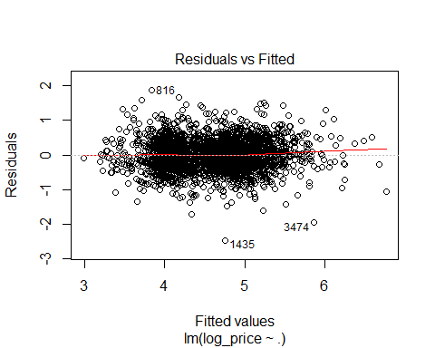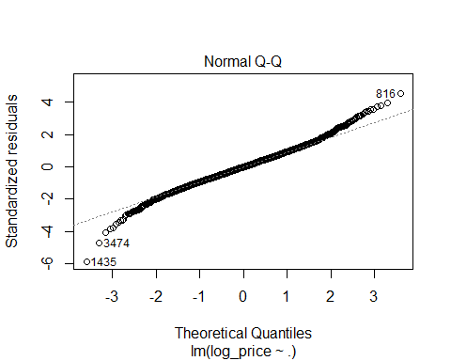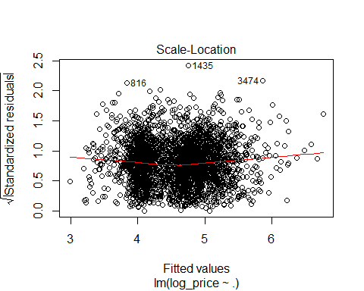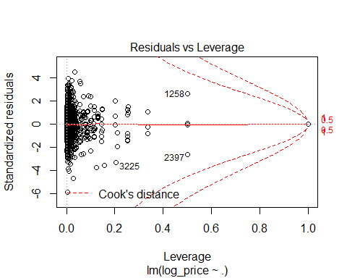
## Assumption 5 & 6. Observations are independent & Errors are independent
# Durbin-Watson Test for Serial Correlation
dwtest(ChiLogLinearModel)
##
## Durbin-Watson test
##
## data: ChiLogLinearModel
## DW = 2.0201, p-value = 0.7108
## alternative hypothesis: true autocorrelation is greater than 0
# DW test shows there is acceptable level of level of correlation as the value is 2.0201
## Assumptions 7 & 8. The error average is 0 & The error variance is constant.
# Breusch-Pagan Test
bptest(ChiNo$log_price ~ ., data = ChiNo)
##
## studentized Breusch-Pagan test
##
## data: ChiNo$log_price ~ .
## BP = 137.17, df = 40, p-value = 1.427e-12
# BP test is significant; therefore there is hetroscedasticity in the residuals. Need to run WLS to fix the issue.
plot(ChiLogLinearModel, which = 1)
# However, the plot shows there is not much visual hetroscedasticity.
# Drop unused factors
ChiNo$property_type <- droplevels(ChiNo)$property_type
ChiNo$host_has_profile_pic <- droplevels(ChiNo)$host_has_profile_pic
ChiNo$host_identity_verified <- droplevels(ChiNo)$host_identity_verified
ChiNo$cancellation_policy <- droplevels(ChiNo)$cancellation_policy
table(ChiNo$property_type)
##
## Apartment Bed & Breakfast Boat Boutique hotel
## 2103 12 7 2
## Bungalow Condominium Dorm Guest suite
## 3 322 8 4
## Guesthouse Hostel House In-law
## 9 1 463 1
## Loft Other Townhouse Vacation home
## 63 20 48 1
## Villa
## 2
# Combining all the factor that have degree of freedom less than 10
levels(ChiNo$property_type)[levels(ChiNo$property_type)=="Boat"] <- "Other"
levels(ChiNo$property_type)[levels(ChiNo$property_type)=="Boutique hotel"] <- "Other"
levels(ChiNo$property_type)[levels(ChiNo$property_type)=="Bungalow"] <- "Other"
levels(ChiNo$property_type)[levels(ChiNo$property_type)=="Dorm"] <- "Other"
levels(ChiNo$property_type)[levels(ChiNo$property_type)=="Guest suite"] <- "Other"
levels(ChiNo$property_type)[levels(ChiNo$property_type)=="Guesthouse"] <- "Other"
levels(ChiNo$property_type)[levels(ChiNo$property_type)=="Hostel"] <- "Other"
levels(ChiNo$property_type)[levels(ChiNo$property_type)=="In-law"] <- "Other"
levels(ChiNo$property_type)[levels(ChiNo$property_type)=="Vacation home"] <- "Other"
levels(ChiNo$property_type)[levels(ChiNo$property_type)=="Villa"] <- "Other"
levels(ChiNo$cancellation_policy)[levels(ChiNo$cancellation_policy)=="super_strict_60"] <- "super_strict_30"
## OLS model for all cities.
set.seed(1)
Chi.train <- sample(nrow(ChiNo), 0.7*nrow(ChiNo))
ChiLogLinearModel <- lm(log_price ~ ., data = ChiNo[Chi.train,])
summary(ChiLogLinearModel)
##
## Call:
## lm(formula = log_price ~ ., data = ChiNo[Chi.train, ])
##
## Residuals:
## Min 1Q Median 3Q Max
## -1.92115 -0.27231 0.00031 0.25713 1.60828
##
## Coefficients:
## Estimate Std. Error t value Pr(>|t|)
## (Intercept) 1.318e+01 1.318e+00 10.001 < 2e-16
## property_typeBed & Breakfast 2.635e-01 1.233e-01 2.137 0.032730
## property_typeOther 8.822e-02 6.339e-02 1.392 0.164154
## property_typeCondominium 1.261e-01 3.092e-02 4.079 4.68e-05
## property_typeHouse -2.108e-02 2.808e-02 -0.751 0.452972
## property_typeLoft 1.913e-01 6.459e-02 2.962 0.003094
## property_typeTownhouse 2.791e-01 7.139e-02 3.910 9.53e-05
## room_typePrivate room -6.104e-01 2.345e-02 -26.034 < 2e-16
## room_typeShared room -1.110e+00 6.096e-02 -18.216 < 2e-16
## accommodates 7.553e-02 7.410e-03 10.193 < 2e-16
## bathrooms 1.802e-01 2.066e-02 8.724 < 2e-16
## bed_typeCouch -1.313e-01 1.628e-01 -0.806 0.420063
## bed_typeFuton -6.640e-02 1.184e-01 -0.561 0.575019
## bed_typePull-out Sofa -7.211e-02 1.589e-01 -0.454 0.650069
## bed_typeReal Bed 1.967e-02 8.722e-02 0.226 0.821575
## cancellation_policymoderate 6.470e-02 2.589e-02 2.499 0.012539
## cancellation_policystrict 4.070e-02 2.539e-02 1.603 0.109049
## cancellation_policysuper_strict_30 2.602e-01 2.139e-01 1.217 0.223895
## cleaning_feeTrue -7.202e-02 2.303e-02 -3.128 0.001785
## first_review -1.167e-04 3.414e-05 -3.419 0.000641
## host_has_profile_pict -1.765e-02 2.112e-01 -0.084 0.933391
## host_identity_verifiedt -1.937e-02 2.519e-02 -0.769 0.441913
## host_response_rate_percent -2.029e-03 8.908e-04 -2.278 0.022811
## host_since -5.581e-06 1.806e-05 -0.309 0.757375
## instant_bookablet -6.149e-02 2.136e-02 -2.879 0.004031
## last_review -4.502e-04 8.380e-05 -5.372 8.64e-08
## number_of_reviews -1.623e-03 3.045e-04 -5.329 1.09e-07
## review_scores_rating 1.246e-02 1.516e-03 8.215 3.65e-16
## bedrooms 6.536e-02 1.725e-02 3.789 0.000155
## beds -2.902e-02 1.280e-02 -2.268 0.023418
##
## (Intercept) ***
## property_typeBed & Breakfast *
## property_typeOther
## property_typeCondominium ***
## property_typeHouse
## property_typeLoft **
## property_typeTownhouse ***
## room_typePrivate room ***
## room_typeShared room ***
## accommodates ***
## bathrooms ***
## bed_typeCouch
## bed_typeFuton
## bed_typePull-out Sofa
## bed_typeReal Bed
## cancellation_policymoderate *
## cancellation_policystrict
## cancellation_policysuper_strict_30
## cleaning_feeTrue **
## first_review ***
## host_has_profile_pict
## host_identity_verifiedt
## host_response_rate_percent *
## host_since
## instant_bookablet **
## last_review ***
## number_of_reviews ***
## review_scores_rating ***
## bedrooms ***
## beds *
## ---
## Signif. codes: 0 '***' 0.001 '**' 0.01 '*' 0.05 '.' 0.1 ' ' 1
##
## Residual standard error: 0.4196 on 2118 degrees of freedom
## Multiple R-squared: 0.6058, Adjusted R-squared: 0.6004
## F-statistic: 112.2 on 29 and 2118 DF, p-value: < 2.2e-16
# Stepwise for OLS Model
Chi.null <- lm(log_price ~ 1, data = ChiNo[Chi.train,])
Chi.full <- lm(log_price ~ ., data = ChiNo[Chi.train,])
Chi.stepwise <- step(Chi.full, scope = list(lower = Chi.full, upper = Chi.full), direction = 'both', test = 'F')
## Start: AIC=-3700.97
## log_price ~ property_type + room_type + accommodates + bathrooms +
## bed_type + cancellation_policy + cleaning_fee + first_review +
## host_has_profile_pic + host_identity_verified + host_response_rate_percent +
## host_since + instant_bookable + last_review + number_of_reviews +
## review_scores_rating + bedrooms + beds
summary(Chi.stepwise)
##
## Call:
## lm(formula = log_price ~ property_type + room_type + accommodates +
## bathrooms + bed_type + cancellation_policy + cleaning_fee +
## first_review + host_has_profile_pic + host_identity_verified +
## host_response_rate_percent + host_since + instant_bookable +
## last_review + number_of_reviews + review_scores_rating +
## bedrooms + beds, data = ChiNo[Chi.train, ])
##
## Residuals:
## Min 1Q Median 3Q Max
## -1.92115 -0.27231 0.00031 0.25713 1.60828
##
## Coefficients:
## Estimate Std. Error t value Pr(>|t|)
## (Intercept) 1.318e+01 1.318e+00 10.001 < 2e-16
## property_typeBed & Breakfast 2.635e-01 1.233e-01 2.137 0.032730
## property_typeOther 8.822e-02 6.339e-02 1.392 0.164154
## property_typeCondominium 1.261e-01 3.092e-02 4.079 4.68e-05
## property_typeHouse -2.108e-02 2.808e-02 -0.751 0.452972
## property_typeLoft 1.913e-01 6.459e-02 2.962 0.003094
## property_typeTownhouse 2.791e-01 7.139e-02 3.910 9.53e-05
## room_typePrivate room -6.104e-01 2.345e-02 -26.034 < 2e-16
## room_typeShared room -1.110e+00 6.096e-02 -18.216 < 2e-16
## accommodates 7.553e-02 7.410e-03 10.193 < 2e-16
## bathrooms 1.802e-01 2.066e-02 8.724 < 2e-16
## bed_typeCouch -1.313e-01 1.628e-01 -0.806 0.420063
## bed_typeFuton -6.640e-02 1.184e-01 -0.561 0.575019
## bed_typePull-out Sofa -7.211e-02 1.589e-01 -0.454 0.650069
## bed_typeReal Bed 1.967e-02 8.722e-02 0.226 0.821575
## cancellation_policymoderate 6.470e-02 2.589e-02 2.499 0.012539
## cancellation_policystrict 4.070e-02 2.539e-02 1.603 0.109049
## cancellation_policysuper_strict_30 2.602e-01 2.139e-01 1.217 0.223895
## cleaning_feeTrue -7.202e-02 2.303e-02 -3.128 0.001785
## first_review -1.167e-04 3.414e-05 -3.419 0.000641
## host_has_profile_pict -1.765e-02 2.112e-01 -0.084 0.933391
## host_identity_verifiedt -1.937e-02 2.519e-02 -0.769 0.441913
## host_response_rate_percent -2.029e-03 8.908e-04 -2.278 0.022811
## host_since -5.581e-06 1.806e-05 -0.309 0.757375
## instant_bookablet -6.149e-02 2.136e-02 -2.879 0.004031
## last_review -4.502e-04 8.380e-05 -5.372 8.64e-08
## number_of_reviews -1.623e-03 3.045e-04 -5.329 1.09e-07
## review_scores_rating 1.246e-02 1.516e-03 8.215 3.65e-16
## bedrooms 6.536e-02 1.725e-02 3.789 0.000155
## beds -2.902e-02 1.280e-02 -2.268 0.023418
##
## (Intercept) ***
## property_typeBed & Breakfast *
## property_typeOther
## property_typeCondominium ***
## property_typeHouse
## property_typeLoft **
## property_typeTownhouse ***
## room_typePrivate room ***
## room_typeShared room ***
## accommodates ***
## bathrooms ***
## bed_typeCouch
## bed_typeFuton
## bed_typePull-out Sofa
## bed_typeReal Bed
## cancellation_policymoderate *
## cancellation_policystrict
## cancellation_policysuper_strict_30
## cleaning_feeTrue **
## first_review ***
## host_has_profile_pict
## host_identity_verifiedt
## host_response_rate_percent *
## host_since
## instant_bookablet **
## last_review ***
## number_of_reviews ***
## review_scores_rating ***
## bedrooms ***
## beds *
## ---
## Signif. codes: 0 '***' 0.001 '**' 0.01 '*' 0.05 '.' 0.1 ' ' 1
##
## Residual standard error: 0.4196 on 2118 degrees of freedom
## Multiple R-squared: 0.6058, Adjusted R-squared: 0.6004
## F-statistic: 112.2 on 29 and 2118 DF, p-value: < 2.2e-16
Chi.reduced <- ChiNo[, c(
'log_price',
'property_type',
'room_type',
'accommodates',
'bathrooms',
'bed_type',
'cancellation_policy',
'cleaning_fee',
'first_review',
'host_response_rate_percent',
'instant_bookable',
'last_review',
'number_of_reviews',
'review_scores_rating',
'bedrooms',
'beds'
)]
# Running OLS with the reduced model with only significant predictors.
Chi.reduced.model <- lm(log_price ~., data = Chi.reduced[Chi.train,])
summary(Chi.reduced.model)
##
## Call:
## lm(formula = log_price ~ ., data = Chi.reduced[Chi.train, ])
##
## Residuals:
## Min 1Q Median 3Q Max
## -1.92172 -0.27312 0.00033 0.25731 1.59953
##
## Coefficients:
## Estimate Std. Error t value Pr(>|t|)
## (Intercept) 1.311e+01 1.303e+00 10.060 < 2e-16
## property_typeBed & Breakfast 2.593e-01 1.231e-01 2.107 0.035252
## property_typeOther 8.940e-02 6.323e-02 1.414 0.157514
## property_typeCondominium 1.261e-01 3.085e-02 4.089 4.49e-05
## property_typeHouse -2.054e-02 2.803e-02 -0.733 0.463657
## property_typeLoft 1.921e-01 6.454e-02 2.976 0.002950
## property_typeTownhouse 2.799e-01 7.134e-02 3.924 8.99e-05
## room_typePrivate room -6.105e-01 2.343e-02 -26.057 < 2e-16
## room_typeShared room -1.107e+00 6.075e-02 -18.225 < 2e-16
## accommodates 7.541e-02 7.403e-03 10.187 < 2e-16
## bathrooms 1.800e-01 2.063e-02 8.726 < 2e-16
## bed_typeCouch -1.343e-01 1.626e-01 -0.826 0.408868
## bed_typeFuton -6.682e-02 1.183e-01 -0.565 0.572138
## bed_typePull-out Sofa -7.305e-02 1.588e-01 -0.460 0.645449
## bed_typeReal Bed 1.881e-02 8.701e-02 0.216 0.828895
## cancellation_policymoderate 6.443e-02 2.588e-02 2.490 0.012845
## cancellation_policystrict 3.972e-02 2.527e-02 1.571 0.116242
## cancellation_policysuper_strict_30 2.544e-01 2.135e-01 1.192 0.233571
## cleaning_feeTrue -7.337e-02 2.292e-02 -3.202 0.001387
## first_review -1.195e-04 3.101e-05 -3.853 0.000120
## host_response_rate_percent -2.071e-03 8.884e-04 -2.331 0.019858
## instant_bookablet -6.060e-02 2.129e-02 -2.847 0.004454
## last_review -4.495e-04 8.370e-05 -5.370 8.75e-08
## number_of_reviews -1.648e-03 3.021e-04 -5.455 5.47e-08
## review_scores_rating 1.241e-02 1.512e-03 8.207 3.88e-16
## bedrooms 6.572e-02 1.722e-02 3.816 0.000139
## beds -2.913e-02 1.278e-02 -2.280 0.022689
##
## (Intercept) ***
## property_typeBed & Breakfast *
## property_typeOther
## property_typeCondominium ***
## property_typeHouse
## property_typeLoft **
## property_typeTownhouse ***
## room_typePrivate room ***
## room_typeShared room ***
## accommodates ***
## bathrooms ***
## bed_typeCouch
## bed_typeFuton
## bed_typePull-out Sofa
## bed_typeReal Bed
## cancellation_policymoderate *
## cancellation_policystrict
## cancellation_policysuper_strict_30
## cleaning_feeTrue **
## first_review ***
## host_response_rate_percent *
## instant_bookablet **
## last_review ***
## number_of_reviews ***
## review_scores_rating ***
## bedrooms ***
## beds *
## ---
## Signif. codes: 0 '***' 0.001 '**' 0.01 '*' 0.05 '.' 0.1 ' ' 1
##
## Residual standard error: 0.4194 on 2121 degrees of freedom
## Multiple R-squared: 0.6057, Adjusted R-squared: 0.6008
## F-statistic: 125.3 on 26 and 2121 DF, p-value: < 2.2e-16
Chi.reduced.mse <- mean((Chi.reduced$log_price-predict(Chi.reduced.model, Chi.reduced))[-Chi.train]^2)
print(paste("MSE Reduced OLS = ", Chi.reduced.mse), digits=5)
## [1] "MSE Reduced OLS = 0.184829432332047"
## k-Fold Cross-Validation (KFCV)
# Cross-Validation of OLS
glm.fit <- glm(log_price ~ ., data = Chi.reduced)
cv.10K <- cv.glm(Chi.reduced, glm.fit, K=10)
print(paste("CV MSE OLS = ", cv.10K$delta[1]), digits=5)
## [1] "CV MSE OLS = 0.181453817777"
# WLS Model
wts <- 1/fitted(lm(abs(residuals(ChiLogLinearModel))~fitted(ChiLogLinearModel)))^2
Chi.wls <- lm(log_price ~ ., data = ChiNo[Chi.train,], weights=1/wts)
summary(Chi.wls)
##
## Call:
## lm(formula = log_price ~ ., data = ChiNo[Chi.train, ], weights = 1/wts)
##
## Weighted Residuals:
## Min 1Q Median 3Q Max
## -0.62163 -0.08777 0.00009 0.08279 0.51942
##
## Coefficients:
## Estimate Std. Error t value Pr(>|t|)
## (Intercept) 1.318e+01 1.317e+00 10.008 < 2e-16
## property_typeBed & Breakfast 2.638e-01 1.234e-01 2.137 0.032687
## property_typeOther 8.826e-02 6.339e-02 1.392 0.163951
## property_typeCondominium 1.257e-01 3.091e-02 4.067 4.93e-05
## property_typeHouse -2.104e-02 2.809e-02 -0.749 0.453994
## property_typeLoft 1.910e-01 6.453e-02 2.960 0.003112
## property_typeTownhouse 2.783e-01 7.133e-02 3.902 9.85e-05
## room_typePrivate room -6.106e-01 2.345e-02 -26.034 < 2e-16
## room_typeShared room -1.111e+00 6.114e-02 -18.172 < 2e-16
## accommodates 7.543e-02 7.399e-03 10.194 < 2e-16
## bathrooms 1.807e-01 2.064e-02 8.756 < 2e-16
## bed_typeCouch -1.311e-01 1.632e-01 -0.803 0.421952
## bed_typeFuton -6.655e-02 1.186e-01 -0.561 0.574759
## bed_typePull-out Sofa -7.255e-02 1.591e-01 -0.456 0.648540
## bed_typeReal Bed 1.970e-02 8.736e-02 0.225 0.821630
## cancellation_policymoderate 6.474e-02 2.591e-02 2.499 0.012529
## cancellation_policystrict 4.087e-02 2.540e-02 1.609 0.107757
## cancellation_policysuper_strict_30 2.591e-01 2.131e-01 1.216 0.223999
## cleaning_feeTrue -7.217e-02 2.304e-02 -3.133 0.001753
## first_review -1.166e-04 3.414e-05 -3.416 0.000647
## host_has_profile_pict -1.700e-02 2.112e-01 -0.080 0.935867
## host_identity_verifiedt -1.934e-02 2.520e-02 -0.768 0.442865
## host_response_rate_percent -2.032e-03 8.908e-04 -2.282 0.022602
## host_since -5.659e-06 1.806e-05 -0.313 0.754097
## instant_bookablet -6.132e-02 2.136e-02 -2.870 0.004143
## last_review -4.502e-04 8.374e-05 -5.376 8.44e-08
## number_of_reviews -1.624e-03 3.047e-04 -5.331 1.08e-07
## review_scores_rating 1.246e-02 1.518e-03 8.211 3.78e-16
## bedrooms 6.549e-02 1.723e-02 3.801 0.000148
## beds -2.907e-02 1.278e-02 -2.275 0.022980
##
## (Intercept) ***
## property_typeBed & Breakfast *
## property_typeOther
## property_typeCondominium ***
## property_typeHouse
## property_typeLoft **
## property_typeTownhouse ***
## room_typePrivate room ***
## room_typeShared room ***
## accommodates ***
## bathrooms ***
## bed_typeCouch
## bed_typeFuton
## bed_typePull-out Sofa
## bed_typeReal Bed
## cancellation_policymoderate *
## cancellation_policystrict
## cancellation_policysuper_strict_30
## cleaning_feeTrue **
## first_review ***
## host_has_profile_pict
## host_identity_verifiedt
## host_response_rate_percent *
## host_since
## instant_bookablet **
## last_review ***
## number_of_reviews ***
## review_scores_rating ***
## bedrooms ***
## beds *
## ---
## Signif. codes: 0 '***' 0.001 '**' 0.01 '*' 0.05 '.' 0.1 ' ' 1
##
## Residual standard error: 0.1353 on 2118 degrees of freedom
## Multiple R-squared: 0.6059, Adjusted R-squared: 0.6005
## F-statistic: 112.3 on 29 and 2118 DF, p-value: < 2.2e-16
MSE.wls <- mean((ChiNo$log_price-predict(Chi.wls, ChiNo))[-Chi.train]^2)
print(paste("MSE WLS = ", MSE.wls), digits=5)
## [1] "MSE WLS = 0.184804490069853"
# Regression Tree
tree.Chi <- tree(log_price ~ ., data = ChiNo[Chi.train,])
tree.Chi
## node), split, n, deviance, yval
## * denotes terminal node
##
## 1) root 2148 946.00 4.584
## 2) room_type: Private room,Shared room 859 211.00 4.067
## 4) room_type: Private room 800 172.40 4.101 *
## 5) room_type: Shared room 59 24.89 3.602 *
## 3) room_type: Entire home/apt 1289 353.20 4.928
## 6) bathrooms < 1.75 946 160.60 4.760 *
## 7) bathrooms > 1.75 343 92.72 5.390
## 14) bathrooms < 2.75 298 65.91 5.309 *
## 15) bathrooms > 2.75 45 12.02 5.925 *
summary(tree.Chi)
##
## Regression tree:
## tree(formula = log_price ~ ., data = ChiNo[Chi.train, ])
## Variables actually used in tree construction:
## [1] "room_type" "bathrooms"
## Number of terminal nodes: 5
## Residual mean deviance: 0.2034 = 435.8 / 2143
## Distribution of residuals:
## Min. 1st Qu. Median Mean 3rd Qu. Max.
## -1.799000 -0.285400 -0.007035 0.000000 0.250500 1.924000
plot(tree.Chi)
text(tree.Chi, pretty = 0)
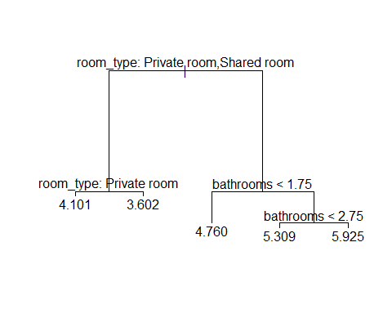
# Regression Tree splits the tree based on room_type and bedrooms!!
tree.Chi.pred <- predict(tree.Chi, newdata = ChiNo[-Chi.train,])
print(paste("MSE Regression Tree = ", mean((tree.Chi.pred - Chi.reduced$log_price[-Chi.train])^2)), digits=5)
## [1] "MSE Regression Tree = 0.218029041531808"
## Creating models for Los Angeles
LA <- train %>%
filter(city == "LA")
# Removing rows with NA and city column
LANo <- LA[complete.cases(LA), ] %>%
select(-city)
### OLS Assumptions
## Assumption 1. Y is continuous
hist(LANo$log_price)
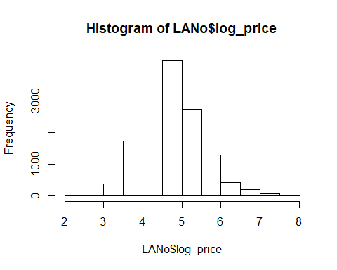
## Assumption 2. Errors (ɛ) are normally distributed
# Since Y is normally distributed, residual would also be normally distributed.
qqnorm(LANo$log_price, main=" Price LA")
qqline(LANo$log_price)
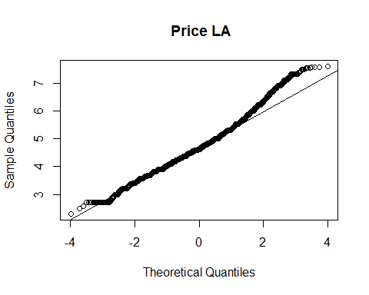
# A large majority of residuals lie on the qqline implying that the residuals are normally distributed except at one end of the tail.
## Assumption 3. X’s are independent
#Log-Linear model for each city
LALogLinearModel <- lm(log_price ~ ., data = LANo)
summary(LALogLinearModel)
##
## Call:
## lm(formula = log_price ~ ., data = LANo)
##
## Residuals:
## Min 1Q Median 3Q Max
## -2.94430 -0.25433 -0.01679 0.22855 2.84398
##
## Coefficients:
## Estimate Std. Error t value Pr(>|t|)
## (Intercept) 1.006e+01 4.097e-01 24.548 < 2e-16
## property_typeBed & Breakfast 1.743e-02 3.235e-02 0.539 0.590034
## property_typeBoat 2.339e-01 8.812e-02 2.655 0.007944
## property_typeBoutique hotel 2.675e-01 1.966e-01 1.361 0.173565
## property_typeBungalow 1.196e-02 2.505e-02 0.478 0.632890
## property_typeCabin -1.199e-01 5.607e-02 -2.139 0.032486
## property_typeCamper/RV -2.014e-01 5.147e-02 -3.913 9.16e-05
## property_typeCastle 5.994e-01 1.391e-01 4.311 1.64e-05
## property_typeCave 3.010e-01 3.929e-01 0.766 0.443707
## property_typeChalet -2.836e-01 2.783e-01 -1.019 0.308236
## property_typeCondominium 3.651e-02 1.997e-02 1.829 0.067478
## property_typeDorm -4.556e-01 5.654e-02 -8.058 8.30e-16
## property_typeEarth House -1.190e-01 2.778e-01 -0.428 0.668358
## property_typeGuest suite 1.070e-02 1.135e-01 0.094 0.924953
## property_typeGuesthouse -1.167e-02 2.244e-02 -0.520 0.603141
## property_typeHostel -6.935e-01 7.568e-02 -9.164 < 2e-16
## property_typeHouse -1.697e-03 7.584e-03 -0.224 0.822943
## property_typeHut -3.222e-01 1.487e-01 -2.167 0.030274
## property_typeIn-law -3.028e-01 3.929e-01 -0.771 0.440878
## property_typeIsland 8.474e-01 3.929e-01 2.157 0.031037
## property_typeLoft 1.726e-01 2.323e-02 7.427 1.17e-13
## property_typeOther 1.554e-02 3.129e-02 0.497 0.619482
## property_typeServiced apartment 1.371e-01 1.390e-01 0.986 0.324167
## property_typeTent -3.441e-01 1.097e-01 -3.137 0.001708
## property_typeTipi 6.829e-01 2.273e-01 3.005 0.002660
## property_typeTownhouse -3.735e-02 2.059e-02 -1.814 0.069682
## property_typeTrain 4.463e-01 3.933e-01 1.135 0.256513
## property_typeTreehouse 4.369e-01 2.271e-01 1.924 0.054375
## property_typeVilla 6.959e-02 3.866e-02 1.800 0.071903
## property_typeYurt 2.577e-01 1.761e-01 1.464 0.143267
## room_typePrivate room -6.130e-01 8.251e-03 -74.294 < 2e-16
## room_typeShared room -1.210e+00 2.013e-02 -60.107 < 2e-16
## accommodates 6.438e-02 2.688e-03 23.953 < 2e-16
## bathrooms 1.521e-01 6.346e-03 23.972 < 2e-16
## bed_typeCouch 4.093e-02 7.214e-02 0.567 0.570408
## bed_typeFuton -5.500e-02 5.527e-02 -0.995 0.319723
## bed_typePull-out Sofa 3.695e-02 5.930e-02 0.623 0.533249
## bed_typeReal Bed 7.031e-02 4.522e-02 1.555 0.120015
## cancellation_policymoderate 1.527e-02 9.579e-03 1.594 0.110920
## cancellation_policystrict 5.185e-02 9.067e-03 5.719 1.09e-08
## cancellation_policysuper_strict_60 8.594e-01 1.768e-01 4.860 1.18e-06
## cleaning_feeTrue 1.292e-02 9.624e-03 1.343 0.179381
## first_review -6.284e-05 1.052e-05 -5.973 2.38e-09
## host_has_profile_pict -9.110e-02 9.324e-02 -0.977 0.328583
## host_identity_verifiedt 5.939e-03 7.950e-03 0.747 0.455037
## host_response_rate_percent -1.256e-03 2.523e-04 -4.980 6.42e-07
## host_since -2.449e-05 6.441e-06 -3.802 0.000144
## instant_bookablet -1.942e-02 7.462e-03 -2.603 0.009257
## last_review -2.854e-04 2.511e-05 -11.368 < 2e-16
## number_of_reviews -1.053e-04 9.681e-05 -1.088 0.276692
## review_scores_rating 8.053e-03 4.402e-04 18.293 < 2e-16
## bedrooms 1.933e-01 5.972e-03 32.359 < 2e-16
## beds -3.928e-02 3.909e-03 -10.047 < 2e-16
##
## (Intercept) ***
## property_typeBed & Breakfast
## property_typeBoat **
## property_typeBoutique hotel
## property_typeBungalow
## property_typeCabin *
## property_typeCamper/RV ***
## property_typeCastle ***
## property_typeCave
## property_typeChalet
## property_typeCondominium .
## property_typeDorm ***
## property_typeEarth House
## property_typeGuest suite
## property_typeGuesthouse
## property_typeHostel ***
## property_typeHouse
## property_typeHut *
## property_typeIn-law
## property_typeIsland *
## property_typeLoft ***
## property_typeOther
## property_typeServiced apartment
## property_typeTent **
## property_typeTipi **
## property_typeTownhouse .
## property_typeTrain
## property_typeTreehouse .
## property_typeVilla .
## property_typeYurt
## room_typePrivate room ***
## room_typeShared room ***
## accommodates ***
## bathrooms ***
## bed_typeCouch
## bed_typeFuton
## bed_typePull-out Sofa
## bed_typeReal Bed
## cancellation_policymoderate
## cancellation_policystrict ***
## cancellation_policysuper_strict_60 ***
## cleaning_feeTrue
## first_review ***
## host_has_profile_pict
## host_identity_verifiedt
## host_response_rate_percent ***
## host_since ***
## instant_bookablet **
## last_review ***
## number_of_reviews
## review_scores_rating ***
## bedrooms ***
## beds ***
## ---
## Signif. codes: 0 '***' 0.001 '**' 0.01 '*' 0.05 '.' 0.1 ' ' 1
##
## Residual standard error: 0.3927 on 15287 degrees of freedom
## Multiple R-squared: 0.6935, Adjusted R-squared: 0.6925
## F-statistic: 665.3 on 52 and 15287 DF, p-value: < 2.2e-16
# Checking for correlation in X variables
# Condition Index and Variance Inflation factor
vif(LALogLinearModel)
## GVIF Df GVIF^(1/(2*Df))
## property_type 1.770579 29 1.009899
## room_type 1.894417 2 1.173191
## accommodates 4.331268 1 2.081170
## bathrooms 2.046017 1 1.430391
## bed_type 1.098403 4 1.011801
## cancellation_policy 1.213254 3 1.032742
## cleaning_fee 1.178807 1 1.085729
## first_review 2.178740 1 1.476056
## host_has_profile_pic 1.013506 1 1.006731
## host_identity_verified 1.119715 1 1.058166
## host_response_rate_percent 1.081711 1 1.040053
## host_since 1.565524 1 1.251209
## instant_bookable 1.149608 1 1.072198
## last_review 1.320043 1 1.148931
## number_of_reviews 1.708166 1 1.306968
## review_scores_rating 1.058497 1 1.028833
## bedrooms 3.182142 1 1.783856
## beds 3.436803 1 1.853862
# All the vif coefficients are below 10. Therefore there is no significant correlation between the variables.
## Assumption 4. Y and X’s have linear relationship
#Plots
plot(LALogLinearModel)
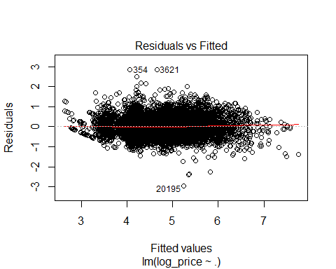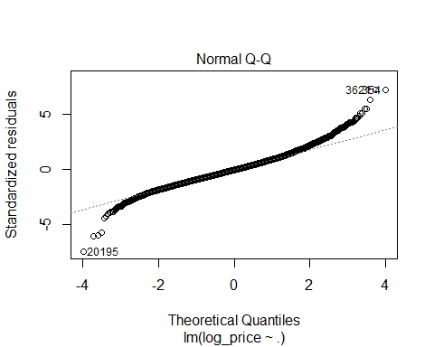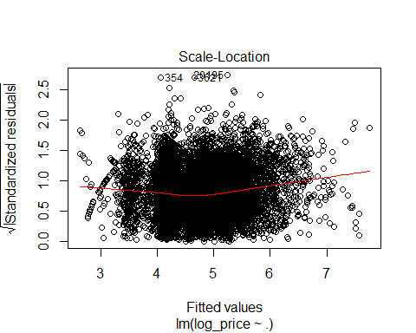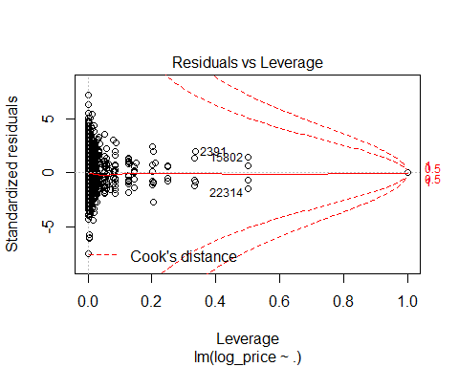
## Assumption 5 & 6. Observations are independent & Errors are independent
# Durbin-Watson Test for Serial Correlation
dwtest(LALogLinearModel)
##
## Durbin-Watson test
##
## data: LALogLinearModel
## DW = 1.9876, p-value = 0.221
## alternative hypothesis: true autocorrelation is greater than 0
# DW test shows there is acceptable level of level of correlation as the value is 1.9876
## Assumptions 7 & 8. The error average is 0 & The error variance is constant.
# Breusch-Pagan Test
bptest(LANo$log_price ~ ., data = LANo)
##
## studentized Breusch-Pagan test
##
## data: LANo$log_price ~ .
## BP = 709.48, df = 52, p-value < 2.2e-16
# BP test is significant; therefore there is hetroscedasticity in the residuals. Need to run WLS to fix the issue.
plot(LALogLinearModel, which = 1)
# However, the plot shows there is not much visual hetroscedasticity.
# Drop unused factors
LANo$property_type <- droplevels(LANo)$property_type
LANo$host_has_profile_pic <- droplevels(LANo)$host_has_profile_pic
LANo$host_identity_verified <- droplevels(LANo)$host_identity_verified
LANo$cancellation_policy <- droplevels(LANo)$cancellation_policy
table(LANo$property_type)
##
## Apartment Bed & Breakfast Boat
## 6570 156 20
## Boutique hotel Bungalow Cabin
## 4 258 50
## Camper/RV Castle Cave
## 59 8 1
## Chalet Condominium Dorm
## 2 419 53
## Earth House Guest suite Guesthouse
## 2 12 330
## Hostel House Hut
## 30 6354 7
## In-law Island Loft
## 1 1 302
## Other Serviced apartment Tent
## 162 8 13
## Tipi Townhouse Train
## 3 398 1
## Treehouse Villa Yurt
## 3 108 5
# Combining all the factor that have degree of freedom less than 10
levels(LANo$property_type)[levels(LANo$property_type)=="Castle"] <- "Other"
levels(LANo$property_type)[levels(LANo$property_type)=="Boutique hotel"] <- "Other"
levels(LANo$property_type)[levels(LANo$property_type)=="Cave"] <- "Other"
levels(LANo$property_type)[levels(LANo$property_type)=="Chalet"] <- "Other"
levels(LANo$property_type)[levels(LANo$property_type)=="Earth House"] <- "Other"
levels(LANo$property_type)[levels(LANo$property_type)=="Hut"] <- "Other"
levels(LANo$property_type)[levels(LANo$property_type)=="Serviced apartment"] <- "Other"
levels(LANo$property_type)[levels(LANo$property_type)=="In-law"] <- "Other"
levels(LANo$property_type)[levels(LANo$property_type)=="Island"] <- "Other"
levels(LANo$property_type)[levels(LANo$property_type)=="Tipi"] <- "Other"
levels(LANo$property_type)[levels(LANo$property_type)=="Train"] <- "Other"
levels(LANo$property_type)[levels(LANo$property_type)=="Treehouse"] <- "Other"
levels(LANo$property_type)[levels(LANo$property_type)=="Yurt"] <- "Other"
# levels(LANo$cancellation_policy)[levels(LANo$cancellation_policy)=="super_strict_60"] <- "super_strict_30"
## OLS model for all cities.
set.seed(1)
LA.train <- sample(nrow(LANo), 0.7*nrow(LANo))
LALogLinearModel <- lm(log_price ~ ., data = LANo[LA.train,])
summary(LALogLinearModel)
##
## Call:
## lm(formula = log_price ~ ., data = LANo[LA.train, ])
##
## Residuals:
## Min 1Q Median 3Q Max
## -2.93419 -0.25244 -0.01686 0.22842 2.84282
##
## Coefficients:
## Estimate Std. Error t value Pr(>|t|)
## (Intercept) 1.013e+01 4.871e-01 20.803 < 2e-16
## property_typeBed & Breakfast 3.741e-03 3.837e-02 0.097 0.922338
## property_typeBoat 2.217e-01 1.013e-01 2.189 0.028652
## property_typeOther 8.873e-02 3.360e-02 2.641 0.008285
## property_typeBungalow -7.536e-03 2.937e-02 -0.257 0.797479
## property_typeCabin -1.487e-01 6.171e-02 -2.410 0.015963
## property_typeCamper/RV -2.370e-01 5.874e-02 -4.034 5.51e-05
## property_typeCondominium 3.774e-02 2.396e-02 1.575 0.115363
## property_typeDorm -4.738e-01 6.851e-02 -6.916 4.92e-12
## property_typeGuest suite -6.090e-02 1.305e-01 -0.467 0.640842
## property_typeGuesthouse -2.026e-02 2.640e-02 -0.768 0.442763
## property_typeHostel -6.857e-01 9.203e-02 -7.450 1.00e-13
## property_typeHouse 8.438e-03 9.026e-03 0.935 0.349892
## property_typeLoft 1.612e-01 2.743e-02 5.877 4.29e-09
## property_typeTent -4.997e-01 1.392e-01 -3.590 0.000332
## property_typeTownhouse -3.109e-02 2.470e-02 -1.258 0.208265
## property_typeVilla 2.158e-02 4.609e-02 0.468 0.639557
## room_typePrivate room -5.994e-01 9.808e-03 -61.117 < 2e-16
## room_typeShared room -1.189e+00 2.410e-02 -49.343 < 2e-16
## accommodates 6.801e-02 3.283e-03 20.720 < 2e-16
## bathrooms 1.481e-01 7.551e-03 19.618 < 2e-16
## bed_typeCouch -2.840e-02 8.131e-02 -0.349 0.726926
## bed_typeFuton -5.053e-02 6.602e-02 -0.765 0.444056
## bed_typePull-out Sofa 1.437e-02 7.040e-02 0.204 0.838206
## bed_typeReal Bed 4.971e-02 5.354e-02 0.928 0.353205
## cancellation_policymoderate 1.366e-02 1.127e-02 1.212 0.225657
## cancellation_policystrict 5.080e-02 1.068e-02 4.758 1.98e-06
## cancellation_policysuper_strict_60 8.670e-01 1.766e-01 4.910 9.23e-07
## cleaning_feeTrue 1.438e-02 1.130e-02 1.272 0.203371
## first_review -5.748e-05 1.250e-05 -4.596 4.35e-06
## host_has_profile_pict -2.818e-02 1.137e-01 -0.248 0.804182
## host_identity_verifiedt 7.528e-04 9.470e-03 0.079 0.936644
## host_response_rate_percent -1.086e-03 3.013e-04 -3.606 0.000313
## host_since -2.931e-05 7.722e-06 -3.796 0.000148
## instant_bookablet -1.815e-02 8.898e-03 -2.040 0.041410
## last_review -2.935e-04 2.976e-05 -9.863 < 2e-16
## number_of_reviews -2.485e-05 1.139e-04 -0.218 0.827319
## review_scores_rating 7.865e-03 5.238e-04 15.015 < 2e-16
## bedrooms 1.904e-01 7.101e-03 26.811 < 2e-16
## beds -3.747e-02 4.763e-03 -7.866 4.00e-15
##
## (Intercept) ***
## property_typeBed & Breakfast
## property_typeBoat *
## property_typeOther **
## property_typeBungalow
## property_typeCabin *
## property_typeCamper/RV ***
## property_typeCondominium
## property_typeDorm ***
## property_typeGuest suite
## property_typeGuesthouse
## property_typeHostel ***
## property_typeHouse
## property_typeLoft ***
## property_typeTent ***
## property_typeTownhouse
## property_typeVilla
## room_typePrivate room ***
## room_typeShared room ***
## accommodates ***
## bathrooms ***
## bed_typeCouch
## bed_typeFuton
## bed_typePull-out Sofa
## bed_typeReal Bed
## cancellation_policymoderate
## cancellation_policystrict ***
## cancellation_policysuper_strict_60 ***
## cleaning_feeTrue
## first_review ***
## host_has_profile_pict
## host_identity_verifiedt
## host_response_rate_percent ***
## host_since ***
## instant_bookablet *
## last_review ***
## number_of_reviews
## review_scores_rating ***
## bedrooms ***
## beds ***
## ---
## Signif. codes: 0 '***' 0.001 '**' 0.01 '*' 0.05 '.' 0.1 ' ' 1
##
## Residual standard error: 0.391 on 10698 degrees of freedom
## Multiple R-squared: 0.6946, Adjusted R-squared: 0.6935
## F-statistic: 623.9 on 39 and 10698 DF, p-value: < 2.2e-16
# Stepwise for OLS Model
LA.null <- lm(log_price ~ 1, data = LANo[LA.train,])
LA.full <- lm(log_price ~ ., data = LANo[LA.train,])
LA.stepwise <- step(LA.full, scope = list(lower = LA.full, upper = LA.full), direction = 'both', test = 'F')
## Start: AIC=-20128.25
## log_price ~ property_type + room_type + accommodates + bathrooms +
## bed_type + cancellation_policy + cleaning_fee + first_review +
## host_has_profile_pic + host_identity_verified + host_response_rate_percent +
## host_since + instant_bookable + last_review + number_of_reviews +
## review_scores_rating + bedrooms + beds
summary(LA.stepwise)
##
## Call:
## lm(formula = log_price ~ property_type + room_type + accommodates +
## bathrooms + bed_type + cancellation_policy + cleaning_fee +
## first_review + host_has_profile_pic + host_identity_verified +
## host_response_rate_percent + host_since + instant_bookable +
## last_review + number_of_reviews + review_scores_rating +
## bedrooms + beds, data = LANo[LA.train, ])
##
## Residuals:
## Min 1Q Median 3Q Max
## -2.93419 -0.25244 -0.01686 0.22842 2.84282
##
## Coefficients:
## Estimate Std. Error t value Pr(>|t|)
## (Intercept) 1.013e+01 4.871e-01 20.803 < 2e-16
## property_typeBed & Breakfast 3.741e-03 3.837e-02 0.097 0.922338
## property_typeBoat 2.217e-01 1.013e-01 2.189 0.028652
## property_typeOther 8.873e-02 3.360e-02 2.641 0.008285
## property_typeBungalow -7.536e-03 2.937e-02 -0.257 0.797479
## property_typeCabin -1.487e-01 6.171e-02 -2.410 0.015963
## property_typeCamper/RV -2.370e-01 5.874e-02 -4.034 5.51e-05
## property_typeCondominium 3.774e-02 2.396e-02 1.575 0.115363
## property_typeDorm -4.738e-01 6.851e-02 -6.916 4.92e-12
## property_typeGuest suite -6.090e-02 1.305e-01 -0.467 0.640842
## property_typeGuesthouse -2.026e-02 2.640e-02 -0.768 0.442763
## property_typeHostel -6.857e-01 9.203e-02 -7.450 1.00e-13
## property_typeHouse 8.438e-03 9.026e-03 0.935 0.349892
## property_typeLoft 1.612e-01 2.743e-02 5.877 4.29e-09
## property_typeTent -4.997e-01 1.392e-01 -3.590 0.000332
## property_typeTownhouse -3.109e-02 2.470e-02 -1.258 0.208265
## property_typeVilla 2.158e-02 4.609e-02 0.468 0.639557
## room_typePrivate room -5.994e-01 9.808e-03 -61.117 < 2e-16
## room_typeShared room -1.189e+00 2.410e-02 -49.343 < 2e-16
## accommodates 6.801e-02 3.283e-03 20.720 < 2e-16
## bathrooms 1.481e-01 7.551e-03 19.618 < 2e-16
## bed_typeCouch -2.840e-02 8.131e-02 -0.349 0.726926
## bed_typeFuton -5.053e-02 6.602e-02 -0.765 0.444056
## bed_typePull-out Sofa 1.437e-02 7.040e-02 0.204 0.838206
## bed_typeReal Bed 4.971e-02 5.354e-02 0.928 0.353205
## cancellation_policymoderate 1.366e-02 1.127e-02 1.212 0.225657
## cancellation_policystrict 5.080e-02 1.068e-02 4.758 1.98e-06
## cancellation_policysuper_strict_60 8.670e-01 1.766e-01 4.910 9.23e-07
## cleaning_feeTrue 1.438e-02 1.130e-02 1.272 0.203371
## first_review -5.748e-05 1.250e-05 -4.596 4.35e-06
## host_has_profile_pict -2.818e-02 1.137e-01 -0.248 0.804182
## host_identity_verifiedt 7.528e-04 9.470e-03 0.079 0.936644
## host_response_rate_percent -1.086e-03 3.013e-04 -3.606 0.000313
## host_since -2.931e-05 7.722e-06 -3.796 0.000148
## instant_bookablet -1.815e-02 8.898e-03 -2.040 0.041410
## last_review -2.935e-04 2.976e-05 -9.863 < 2e-16
## number_of_reviews -2.485e-05 1.139e-04 -0.218 0.827319
## review_scores_rating 7.865e-03 5.238e-04 15.015 < 2e-16
## bedrooms 1.904e-01 7.101e-03 26.811 < 2e-16
## beds -3.747e-02 4.763e-03 -7.866 4.00e-15
##
## (Intercept) ***
## property_typeBed & Breakfast
## property_typeBoat *
## property_typeOther **
## property_typeBungalow
## property_typeCabin *
## property_typeCamper/RV ***
## property_typeCondominium
## property_typeDorm ***
## property_typeGuest suite
## property_typeGuesthouse
## property_typeHostel ***
## property_typeHouse
## property_typeLoft ***
## property_typeTent ***
## property_typeTownhouse
## property_typeVilla
## room_typePrivate room ***
## room_typeShared room ***
## accommodates ***
## bathrooms ***
## bed_typeCouch
## bed_typeFuton
## bed_typePull-out Sofa
## bed_typeReal Bed
## cancellation_policymoderate
## cancellation_policystrict ***
## cancellation_policysuper_strict_60 ***
## cleaning_feeTrue
## first_review ***
## host_has_profile_pict
## host_identity_verifiedt
## host_response_rate_percent ***
## host_since ***
## instant_bookablet *
## last_review ***
## number_of_reviews
## review_scores_rating ***
## bedrooms ***
## beds ***
## ---
## Signif. codes: 0 '***' 0.001 '**' 0.01 '*' 0.05 '.' 0.1 ' ' 1
##
## Residual standard error: 0.391 on 10698 degrees of freedom
## Multiple R-squared: 0.6946, Adjusted R-squared: 0.6935
## F-statistic: 623.9 on 39 and 10698 DF, p-value: < 2.2e-16
LA.reduced <- LANo[, c(
'log_price',
'property_type',
'room_type',
'accommodates',
'bathrooms',
'cancellation_policy',
'first_review',
'host_response_rate_percent',
'host_since',
'instant_bookable',
'last_review',
'number_of_reviews',
'bedrooms',
'beds'
)]
# Running OLS with the reduced model with only significant predictors.
LA.reduced.model <- lm(log_price ~., data = LA.reduced[LA.train,])
summary(LA.reduced.model)
##
## Call:
## lm(formula = log_price ~ ., data = LA.reduced[LA.train, ])
##
## Residuals:
## Min 1Q Median 3Q Max
## -2.88686 -0.25354 -0.01162 0.23228 2.73617
##
## Coefficients:
## Estimate Std. Error t value Pr(>|t|)
## (Intercept) 1.039e+01 4.770e-01 21.775 < 2e-16
## property_typeBed & Breakfast 4.736e-03 3.873e-02 0.122 0.902682
## property_typeBoat 2.337e-01 1.023e-01 2.284 0.022384
## property_typeOther 8.723e-02 3.395e-02 2.570 0.010194
## property_typeBungalow 6.934e-03 2.964e-02 0.234 0.815043
## property_typeCabin -1.447e-01 6.228e-02 -2.323 0.020181
## property_typeCamper/RV -2.340e-01 5.929e-02 -3.947 7.97e-05
## property_typeCondominium 4.998e-02 2.419e-02 2.066 0.038846
## property_typeDorm -5.073e-01 6.897e-02 -7.355 2.04e-13
## property_typeGuest suite -3.431e-02 1.319e-01 -0.260 0.794774
## property_typeGuesthouse 3.792e-03 2.663e-02 0.142 0.886758
## property_typeHostel -6.731e-01 9.259e-02 -7.270 3.85e-13
## property_typeHouse 1.845e-02 9.091e-03 2.029 0.042476
## property_typeLoft 1.746e-01 2.769e-02 6.307 2.97e-10
## property_typeTent -5.315e-01 1.399e-01 -3.798 0.000146
## property_typeTownhouse -1.995e-02 2.494e-02 -0.800 0.423668
## property_typeVilla 2.445e-02 4.655e-02 0.525 0.599403
## room_typePrivate room -6.055e-01 9.776e-03 -61.939 < 2e-16
## room_typeShared room -1.223e+00 2.343e-02 -52.175 < 2e-16
## accommodates 6.622e-02 3.300e-03 20.068 < 2e-16
## bathrooms 1.501e-01 7.625e-03 19.680 < 2e-16
## cancellation_policymoderate 1.715e-02 1.123e-02 1.527 0.126796
## cancellation_policystrict 4.726e-02 1.055e-02 4.481 7.52e-06
## cancellation_policysuper_strict_60 8.703e-01 1.784e-01 4.878 1.09e-06
## first_review -5.130e-05 1.262e-05 -4.067 4.80e-05
## host_response_rate_percent -5.961e-04 3.020e-04 -1.973 0.048478
## host_since -3.293e-05 7.583e-06 -4.343 1.42e-05
## instant_bookablet -3.056e-02 8.943e-03 -3.417 0.000634
## last_review -2.684e-04 3.002e-05 -8.940 < 2e-16
## number_of_reviews -4.751e-06 1.147e-04 -0.041 0.966965
## bedrooms 1.941e-01 7.165e-03 27.090 < 2e-16
## beds -3.910e-02 4.798e-03 -8.148 4.12e-16
##
## (Intercept) ***
## property_typeBed & Breakfast
## property_typeBoat *
## property_typeOther *
## property_typeBungalow
## property_typeCabin *
## property_typeCamper/RV ***
## property_typeCondominium *
## property_typeDorm ***
## property_typeGuest suite
## property_typeGuesthouse
## property_typeHostel ***
## property_typeHouse *
## property_typeLoft ***
## property_typeTent ***
## property_typeTownhouse
## property_typeVilla
## room_typePrivate room ***
## room_typeShared room ***
## accommodates ***
## bathrooms ***
## cancellation_policymoderate
## cancellation_policystrict ***
## cancellation_policysuper_strict_60 ***
## first_review ***
## host_response_rate_percent *
## host_since ***
## instant_bookablet ***
## last_review ***
## number_of_reviews
## bedrooms ***
## beds ***
## ---
## Signif. codes: 0 '***' 0.001 '**' 0.01 '*' 0.05 '.' 0.1 ' ' 1
##
## Residual standard error: 0.3951 on 10706 degrees of freedom
## Multiple R-squared: 0.6879, Adjusted R-squared: 0.687
## F-statistic: 761.1 on 31 and 10706 DF, p-value: < 2.2e-16
LA.reduced.mse <- mean((LA.reduced$log_price-predict(LA.reduced.model, LA.reduced))[-LA.train]^2)
print(paste("MSE Reduced OLS = ", LA.reduced.mse), digits=5)
## [1] "MSE Reduced OLS = 0.163376169362981"
## k-Fold Cross-Validation (KFCV)
# Cross-Validation of OLS
glm.fit <- glm(log_price ~ ., data = LA.reduced)
cv.10K <- cv.glm(LA.reduced, glm.fit, K=10)
print(paste("CV MSE OLS = ", cv.10K$delta[1]), digits=5)
## [1] "CV MSE OLS = 0.158682781807338"
# WLS Model
wts <- 1/fitted(lm(abs(residuals(LALogLinearModel))~fitted(LALogLinearModel)))^2
LA.wls <- lm(log_price ~ ., data = LANo[LA.train,], weights=1/wts)
summary(LA.wls)
##
## Call:
## lm(formula = log_price ~ ., data = LANo[LA.train, ], weights = 1/wts)
##
## Weighted Residuals:
## Min 1Q Median 3Q Max
## -0.92810 -0.07511 -0.00471 0.06837 0.84089
##
## Coefficients:
## Estimate Std. Error t value Pr(>|t|)
## (Intercept) 9.998e+00 4.791e-01 20.869 < 2e-16
## property_typeBed & Breakfast 4.384e-03 4.058e-02 0.108 0.913960
## property_typeBoat 2.231e-01 9.963e-02 2.240 0.025128
## property_typeOther 9.800e-02 3.371e-02 2.908 0.003650
## property_typeBungalow -9.436e-03 2.953e-02 -0.320 0.749337
## property_typeCabin -1.466e-01 6.345e-02 -2.311 0.020864
## property_typeCamper/RV -2.398e-01 6.141e-02 -3.905 9.47e-05
## property_typeCondominium 3.399e-02 2.416e-02 1.407 0.159472
## property_typeDorm -4.998e-01 7.886e-02 -6.338 2.43e-10
## property_typeGuest suite -6.614e-02 1.333e-01 -0.496 0.619827
## property_typeGuesthouse -2.433e-02 2.667e-02 -0.912 0.361585
## property_typeHostel -7.207e-01 1.124e-01 -6.412 1.50e-10
## property_typeHouse 2.357e-02 9.152e-03 2.576 0.010012
## property_typeLoft 1.665e-01 2.716e-02 6.130 9.09e-10
## property_typeTent -5.075e-01 1.557e-01 -3.260 0.001118
## property_typeTownhouse -2.954e-02 2.513e-02 -1.176 0.239794
## property_typeVilla 5.383e-02 4.450e-02 1.210 0.226429
## room_typePrivate room -6.114e-01 1.005e-02 -60.838 < 2e-16
## room_typeShared room -1.212e+00 2.699e-02 -44.906 < 2e-16
## accommodates 6.243e-02 3.138e-03 19.895 < 2e-16
## bathrooms 1.674e-01 7.301e-03 22.930 < 2e-16
## bed_typeCouch -3.094e-02 8.843e-02 -0.350 0.726471
## bed_typeFuton -5.365e-02 7.097e-02 -0.756 0.449711
## bed_typePull-out Sofa 1.027e-02 7.493e-02 0.137 0.890993
## bed_typeReal Bed 5.248e-02 5.772e-02 0.909 0.363218
## cancellation_policymoderate 1.527e-02 1.158e-02 1.318 0.187430
## cancellation_policystrict 5.551e-02 1.094e-02 5.074 3.96e-07
## cancellation_policysuper_strict_60 8.529e-01 1.472e-01 5.795 7.02e-09
## cleaning_feeTrue 1.976e-02 1.174e-02 1.683 0.092389
## first_review -6.023e-05 1.253e-05 -4.808 1.55e-06
## host_has_profile_pict -4.721e-02 1.107e-01 -0.426 0.669791
## host_identity_verifiedt 1.867e-03 9.622e-03 0.194 0.846185
## host_response_rate_percent -1.076e-03 3.051e-04 -3.528 0.000421
## host_since -2.679e-05 7.766e-06 -3.450 0.000562
## instant_bookablet -1.643e-02 9.002e-03 -1.825 0.068034
## last_review -2.870e-04 2.930e-05 -9.794 < 2e-16
## number_of_reviews -1.082e-04 1.153e-04 -0.938 0.348114
## review_scores_rating 8.224e-03 5.413e-04 15.194 < 2e-16
## bedrooms 1.813e-01 6.988e-03 25.949 < 2e-16
## beds -3.417e-02 4.650e-03 -7.347 2.17e-13
##
## (Intercept) ***
## property_typeBed & Breakfast
## property_typeBoat *
## property_typeOther **
## property_typeBungalow
## property_typeCabin *
## property_typeCamper/RV ***
## property_typeCondominium
## property_typeDorm ***
## property_typeGuest suite
## property_typeGuesthouse
## property_typeHostel ***
## property_typeHouse *
## property_typeLoft ***
## property_typeTent **
## property_typeTownhouse
## property_typeVilla
## room_typePrivate room ***
## room_typeShared room ***
## accommodates ***
## bathrooms ***
## bed_typeCouch
## bed_typeFuton
## bed_typePull-out Sofa
## bed_typeReal Bed
## cancellation_policymoderate
## cancellation_policystrict ***
## cancellation_policysuper_strict_60 ***
## cleaning_feeTrue .
## first_review ***
## host_has_profile_pict
## host_identity_verifiedt
## host_response_rate_percent ***
## host_since ***
## instant_bookablet .
## last_review ***
## number_of_reviews
## review_scores_rating ***
## bedrooms ***
## beds ***
## ---
## Signif. codes: 0 '***' 0.001 '**' 0.01 '*' 0.05 '.' 0.1 ' ' 1
##
## Residual standard error: 0.118 on 10698 degrees of freedom
## Multiple R-squared: 0.706, Adjusted R-squared: 0.7049
## F-statistic: 658.6 on 39 and 10698 DF, p-value: < 2.2e-16
MSE.wls <- mean((LANo$log_price-predict(LA.wls, LANo))[-LA.train]^2)
print(paste("MSE WLS = ", MSE.wls), digits=5)
## [1] "MSE WLS = 0.159163681058095"
# Regression Tree
tree.LA <- tree(log_price ~ ., data = LANo[LA.train,])
tree.LA
## node), split, n, deviance, yval
## * denotes terminal node
##
## 1) root 10738 5355.00 4.699
## 2) room_type: Private room,Shared room 4197 852.40 4.140
## 4) room_type: Private room 3839 619.90 4.198 *
## 5) room_type: Shared room 358 84.57 3.525 *
## 3) room_type: Entire home/apt 6541 2355.00 5.057
## 6) bathrooms < 1.75 4664 785.30 4.825
## 12) bedrooms < 1.5 3685 513.00 4.746 *
## 13) bedrooms > 1.5 979 163.90 5.121 *
## 7) bathrooms > 1.75 1877 694.70 5.633
## 14) bathrooms < 2.75 1437 333.90 5.453 *
## 15) bathrooms > 2.75 440 160.90 6.223 *
summary(tree.LA)
##
## Regression tree:
## tree(formula = log_price ~ ., data = LANo[LA.train, ])
## Variables actually used in tree construction:
## [1] "room_type" "bathrooms" "bedrooms"
## Number of terminal nodes: 6
## Residual mean deviance: 0.1748 = 1876 / 10730
## Distribution of residuals:
## Min. 1st Qu. Median Mean 3rd Qu. Max.
## -3.15000 -0.26960 -0.02319 0.00000 0.24510 3.02600
plot(tree.LA)
text(tree.LA, pretty = 0)
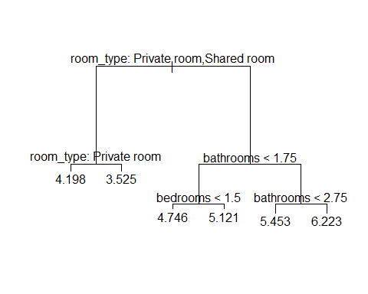
# Regression Tree splits the tree based on bedrooms and room_type!!
tree.LA.pred <- predict(tree.LA, newdata = LANo[-LA.train,])
mean((tree.LA.pred - LA.reduced$log_price[-LA.train])^2)
## [1] 0.1710504
print(paste("MSE Regression Tree = ", mean((tree.LA.pred - LA.reduced$log_price[-LA.train])^2)), digits=5)
## [1] "MSE Regression Tree = 0.171050370864367"

