Prerequisite Forms Module
Project Name: GateGenius
Module: AI Chat History & Collection Module

What has been done (One-page summary):
I have enhanced the GATE CSE AI Mentor chatbot by implementing a complete CRUD (Create, Read, Update, Delete) and Search system. This allows for a more persistent and manageable study history.
Here is the summary of exactly what has been built:
1. Unified History Management (CRUD)
- Create: Every message you send is automatically saved to MongoDB with a timestamp and the AI's response.
- Read: The sidebar now automatically fetches and displays your most recent chat sessions when you log in.
- Update (Edit): You can now edit your past questions. Hovering over a history item in the sidebar reveals an "Edit" button that lets you modify the text directly.
- Delete: You can remove specific messages from your history using the "Delete" button, keeping your sidebar clean.
2. Powerful Search Interface
- Case-Insensitive Search: I added a search bar at the top of the sidebar. You can type keywords (e.g., "TCP", "OS", "DBMS") to instantly filter your past conversations across both your questions and the AI's answers.
3. Backend API Enhancements (main.py)
- Added five specialized endpoints to the FastAPI backend:
  - PUT /api/chat/{id} (Update)
  - DELETE /api/chat/{id} (Delete)
  - GET /api/search (Search)
  - Optimized GET /api/history and POST /api/chat for better performance.

CRUD + Search operations implemented:
Insert:
The user sends a GATE CSE query and receive an expert AI-generated response. The full session is automatically saved to MongoDB.

Edit:
The user can update previous questions/queries from the history sidebar. The backend updates the record while preserving the chronological order.

Delete:
The user can delete specific chat sessions directly from the history sidebar. Manual deletion from the MongoDB collection is also fully supported.

Search:
Search past conversations by keyword, concept, or specific query content. The history sidebar filters and updates live as you type.

Additional points:
- Modern UI with Material-UI DataGrid.
- Action buttons for Insert, Edit, Delete next to each booking.
- Notes field for extra instruction

Operation-wise Notes + Screenshot Placeholders
1) INSERT
Inserts the history immediately after the user chats with the bot.
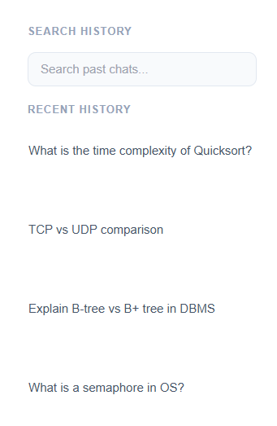

2) DELETE
Can Delete the history/chat with the bot, if not needed

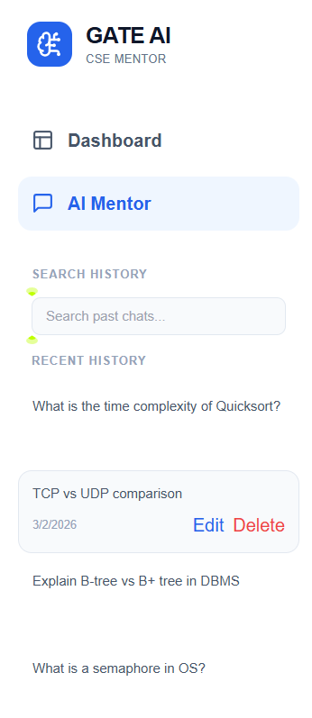

3) UPDATE
User can edit and update the title of the chat in the history on the sidebar

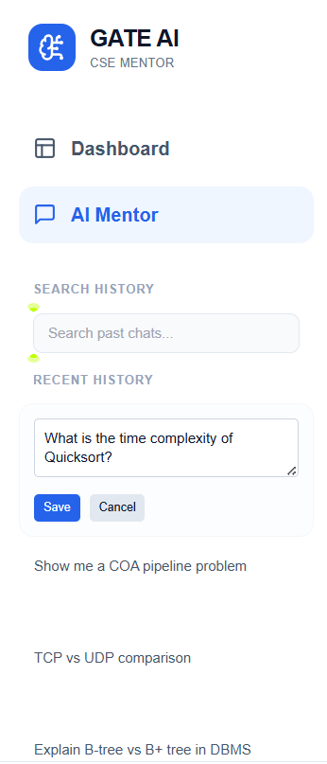

4) SEARCH
Search the history based on the keywords and it shows up.

