GATE-GPT: AN AI-POWERED ADAPTIVE LEARNING PLATFORM FOR GATE PREPARATION

Bachelor of Technology
in
Computer Science and Engineering

TEAM MEMBERS:
Sandheep G S (CB.SC.U4CSE23144)
Prajith Maharaja (CB.SC.U4CSE23135)

Project Guide:
T. Senthil Kumar
Amrita Vishwa Vidyapeetham
Department of Computer Science and Engineering

Date of Submission: March 11, 2026

2. Abstract
GateGPT is an AI-powered educational ecosystem designed to address the unique challenges of the Graduate Aptitude Test in Engineering (GATE). The problem identified is the lack of personalized, high-quality technical assistance for students during self-study, leading to disorganized learning and poor mastery of complex engineering concepts. GateGPT solves this by integrating Large Language Models (LLMs), specifically Gemini 3.1 Flash Lite, into a structured learning management system. The platform features an intelligent chat interface for instant doubt resolution, a performance analytics dashboard for tracking subject-wise progress, and a specialized practice engine with automated ranking systems. Built using Next.js 14, Node.js, and MongoDB, the system provides a seamless, multi-device experience with robust JWT security. The outcome of the project is a highly effective 'Technical Second Brain' that reduces administrative study overhead and improves cognitive retention for competitive engineering exams.

3. Introduction
The Graduate Aptitude Test in Engineering (GATE) is one of the most rigorous and competitive examinations in India, serving as the benchmark for postgraduate admissions and elite public sector recruitments. The vast syllabus and the requirement for deep conceptual clarity make it a daunting task for many students. Traditional tools, while helpful, often fall short of providing the real-time, personalized feedback that a modern student requires. The background of this project lies in the rapid advancement of Artificial Intelligence and its application in pedagogy. The motivation for GateGPT is to create a platform where technology acts as a force multiplier for student effort. Existing tools are either purely repository-based (notes only) or generic chatbots (low technical grounding). GateGPT aims to bridge this gap by offering a domain-specific, interactive assistant. The primary objective is to streamline the preparation workflow by integrating conversation, practice, and analysis into a single interface.

4. Problem Statement
Current preparation methodologies for competitive exams like GATE suffer from several critical issues:
1. Personalized Tutoring: Most online resources are static, providing no way for a student to clarify specific technical nuances in a problem.
2. Analytics Gap: Students often practice hundreds of questions without a clear visual representation of their mastery across different subjects like OS, Algorithms, or Discrete Math.
3. Revision Fragmentation: Notes are often scattered across physical notebooks and digital folders, making quick high-yield revision difficult.
4. Technical Rendering: Generic chatbots often struggle to render complex engineering formulas (integrals, summations) in a readable format. GateGPT is designed to solve these by providing an AI-first, structured, and mathematically grounded preparation environment.

5. Objectives of the Project
The fundamental goals of the GateGPT project are as follows:
- Develop an AI-powered tutoring platform capable of solving engineering PYQs with step-by-step reasoning.
- Implement a mathematical rendering engine (KaTeX) to display technical solutions accurately.
- Create a real-time Chat Interface with management features like pinning, archiving, and automatic titling.
- Design a Performance Analytics Dashboard that extracts mastery metrics from student practice results.
- Provide a structured Subject Discovery module covering all core GATE engineering subjects.
- Ensure secure user management using industry-standard JWT and bcrypt hashing.

6. Literature Survey / Existing System
To design a superior prep tool, we analyzed several modern AI systems and educational platforms. ChatGPT (by OpenAI) offers impressive general knowledge but often lacks the specific 'system instructions' to provide rigorous engineering proofs unless prompted heavily. Claude (by Anthropic) provides excellent reasoning but is frequently limited by its integration capabilities for niche educational workflows. Google Gemini provides a high-performance API (Flash/Pro) which we leveraged for its speed and engineering accuracy.
Strengths of existing systems: Versatility and ease of access.
Limitations: Lack of subject integration, no built-in performance tracking for exams, and absence of a unified dashboard for practice history. GateGPT fills these gaps by anchoring the AI logic to a specific syllabus (GATE) and wrapping it in a data-driven learning management framework.

7. Proposed System
The proposed system, GateGPT, is an integrated solution that combines conversational intelligence with systematic practice. Unlike standard chatbots, GateGPT allows students to switch between 'Exploration' (reading), 'Conversation' (doubts), and 'Practice' (testing). The 'AI Refiner' tool is a novel addition that converts raw student notes into optimized revision sheets. The system uses a 'Subject-Topic-Score' hierarchy to build a unique mastery profile for every user, suggesting focus areas using real-time analytics.

8. System Architecture
GateGPT follows a robust four-layer architecture ensuring scalability and security. The system layers are as follows:
1. Presentation Layer (Frontend): Next.js 14 and React components for a responsive UI.
2. Service Layer (Backend): Node.js/Express handling business logic and API routing.
3. Data Layer (Database): MongoDB Atlas for persistent storage of users and chats.
4. Intelligence Layer (AI API): Google Gemini Flash API for processing technical queries.

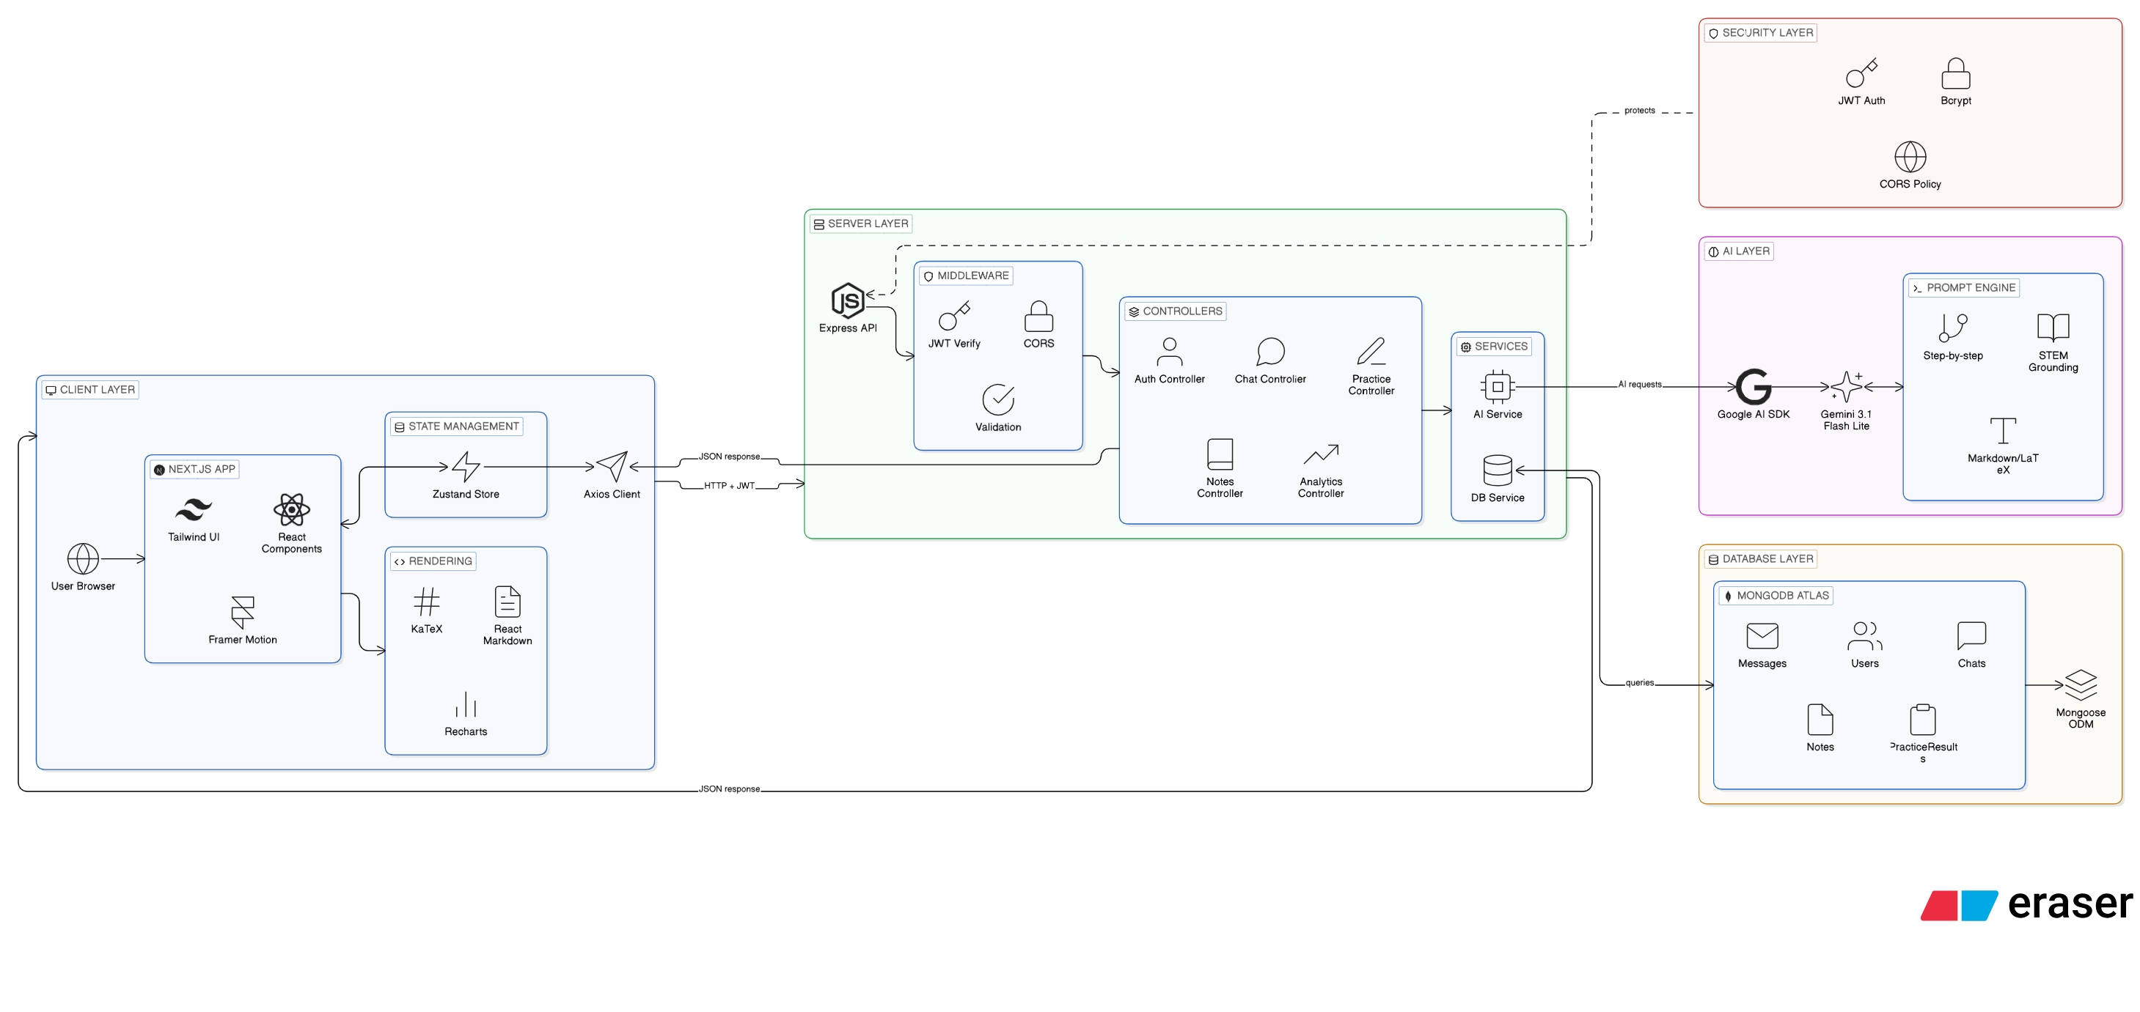

9. Technology Stack
- Frontend Core: Next.js 14, React 18, Tailwind CSS, Zustand (State)
- Backend Core: Node.js, Express.js
- Database: MongoDB Atlas (Mongoose ODM)
- Authentication: JSON Web Token (JWT), bcrypt (Hashing)
- AI Hub: Google Generative AI (Gemini 3.1 Flash Lite API)
- Visuals & Math: Recharts (Graphs), KaTeX / Markdown (Rendering)
10. System Modules

10.1 Authentication Module
Handles User Signup, Login, and Session persistency. It uses bcrypt to ensure passwords are never stored in plain text and generates a secure JWT that the frontend stores for all future authenticated requests.

10.2 AI Chat Module
The central interaction point. It maintains a stateful conversation with the Gemini model, providing system prompts that enforce technical rigor and LaTeX formatting. It uses optimistic UI updates to ensure a smooth typing experience.

10.3 Chat Management Module
Allows users to organize their learning history. Features include pinning important topics, archiving completed preparedness sessions, and renaming chats for better searchability.

10.4 Practice Module
Enables subject-wise MCQ practice. It tracks user performance on topics, difficulty levels, and time taken. The data from this module is the primary input for the Analytics engine.

10.5 Analytics Module
A visual dashboard that processes raw 'PracticeResult' data into charts. It helps students identify 'Low Accuracy' topics so they can go back to the Chat module for clarification.

10.6 Notes & Bookmark Module
Allows students to save AI-generated answers and their own observations. Includes an AI-powered summary tool to extract key formulas and concepts for quick revision.

11. Database Design
The system uses a NoSQL document-based design (MongoDB). This allows for rapid scaling and complex chat history storage. Relations are maintained via ObjectIDs between the User collection and dependent collections.
Collection Name | Schema Description & Usage
Users | Stores name, email, salted hashed password, and user settings.
Chats | Contains chat metadata (title, pinned, archived) linked to UserID.
Messages | Stores the actual conversation lines (Role, Content, Time) linked to ChatID.
PracticeResults | Logs score, totalQs, subject, topic, and difficulty for analytics.
Notes | Stores user notes, topic tags, and AI summaries.

12. Implementation Details
GateGPT was built using a modular component architecture. The frontend uses 'React Server Components' in Next.js 14 for performance. State management is handled by Zustand, providing a lightweight alternative to Redux. The backend uses Express middlewares for Error Handling and Authentication validation. AI integration is achieved through the @google/generative-ai SDK, using streamed responses for faster UI updates.

13. User Interface Screens
The following screenshots represent the final integrated system:
1. Landing Page: Introduction to the platform.
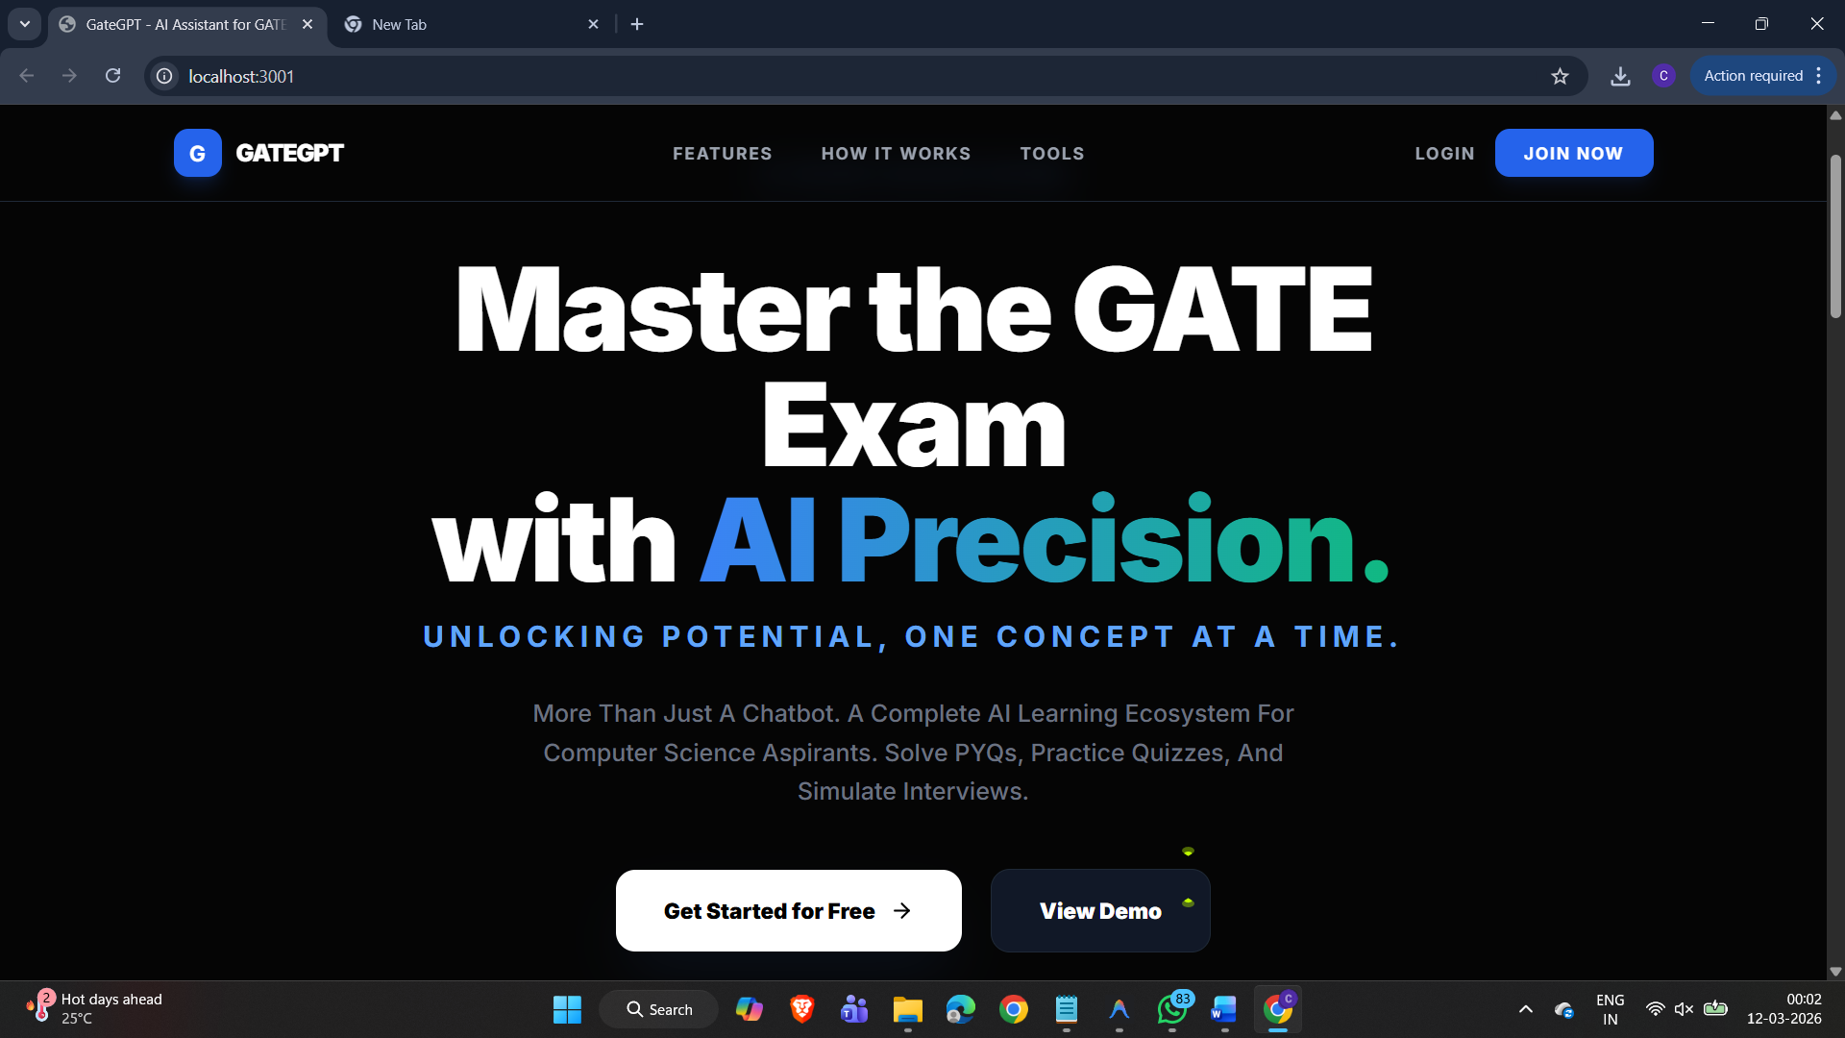2. Login/Signup Page: Secure authentication interface.
3. Chat Dashboard: Interactive AI technical tutor with KaTeX rendering.
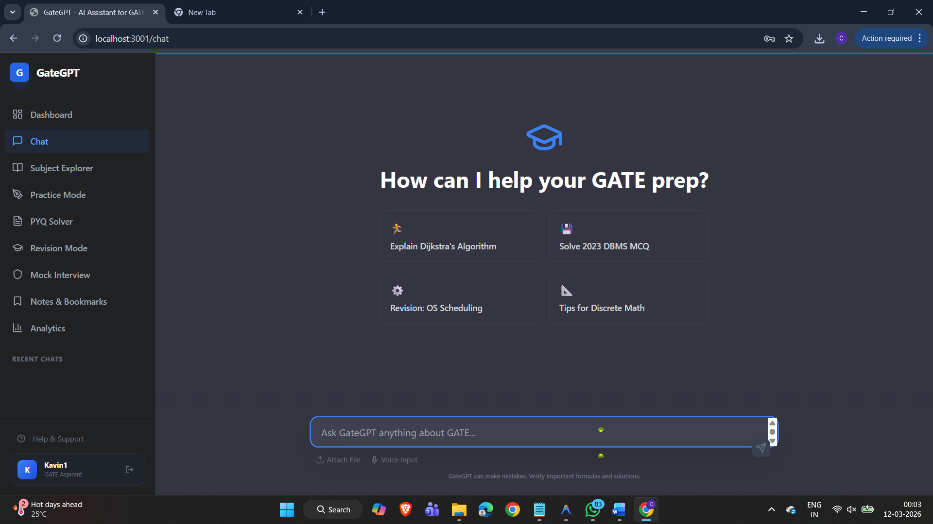4. Subject Discovery Page: Grid view of all core GATE subjects.
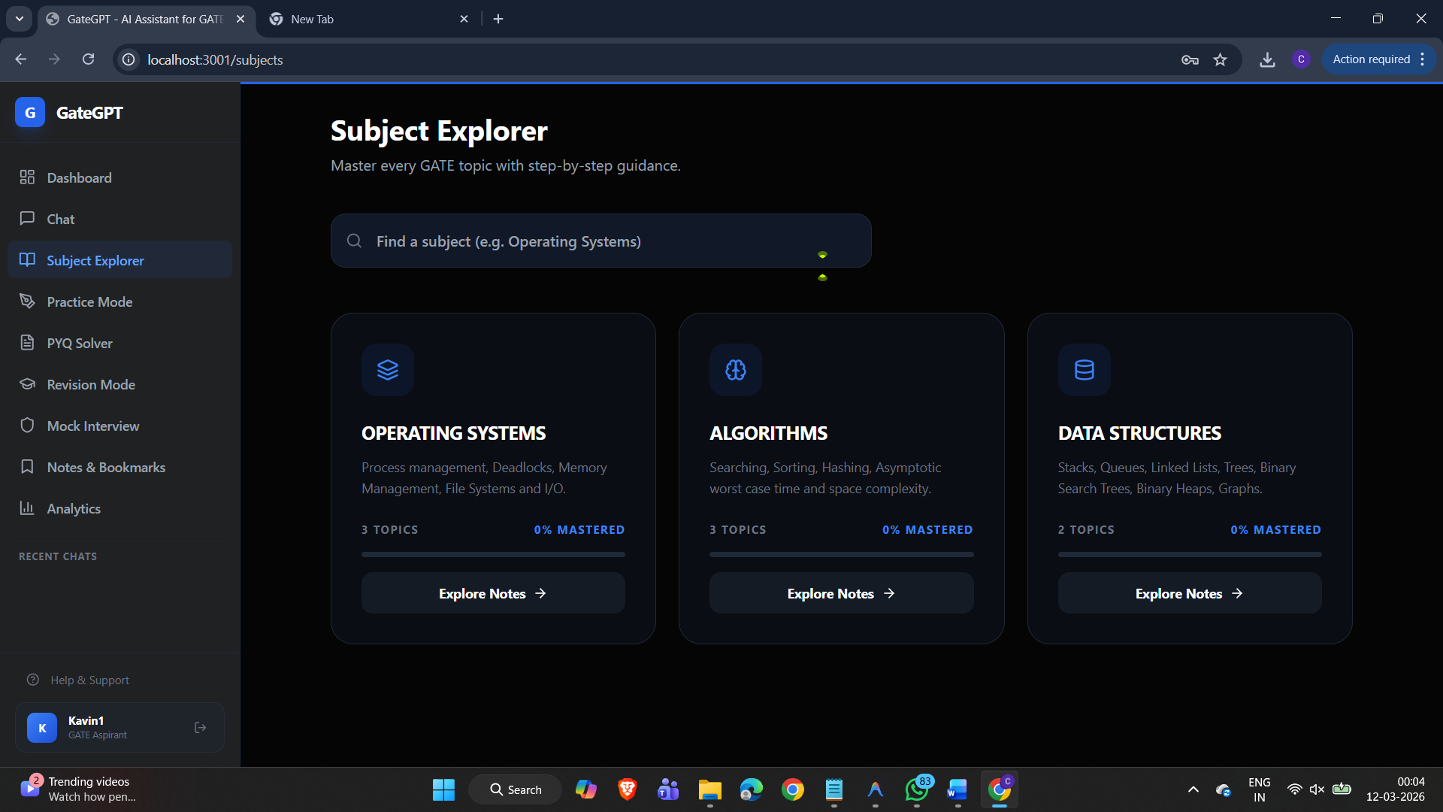
5. Practice Engine UI: Question interface with performance tracking.
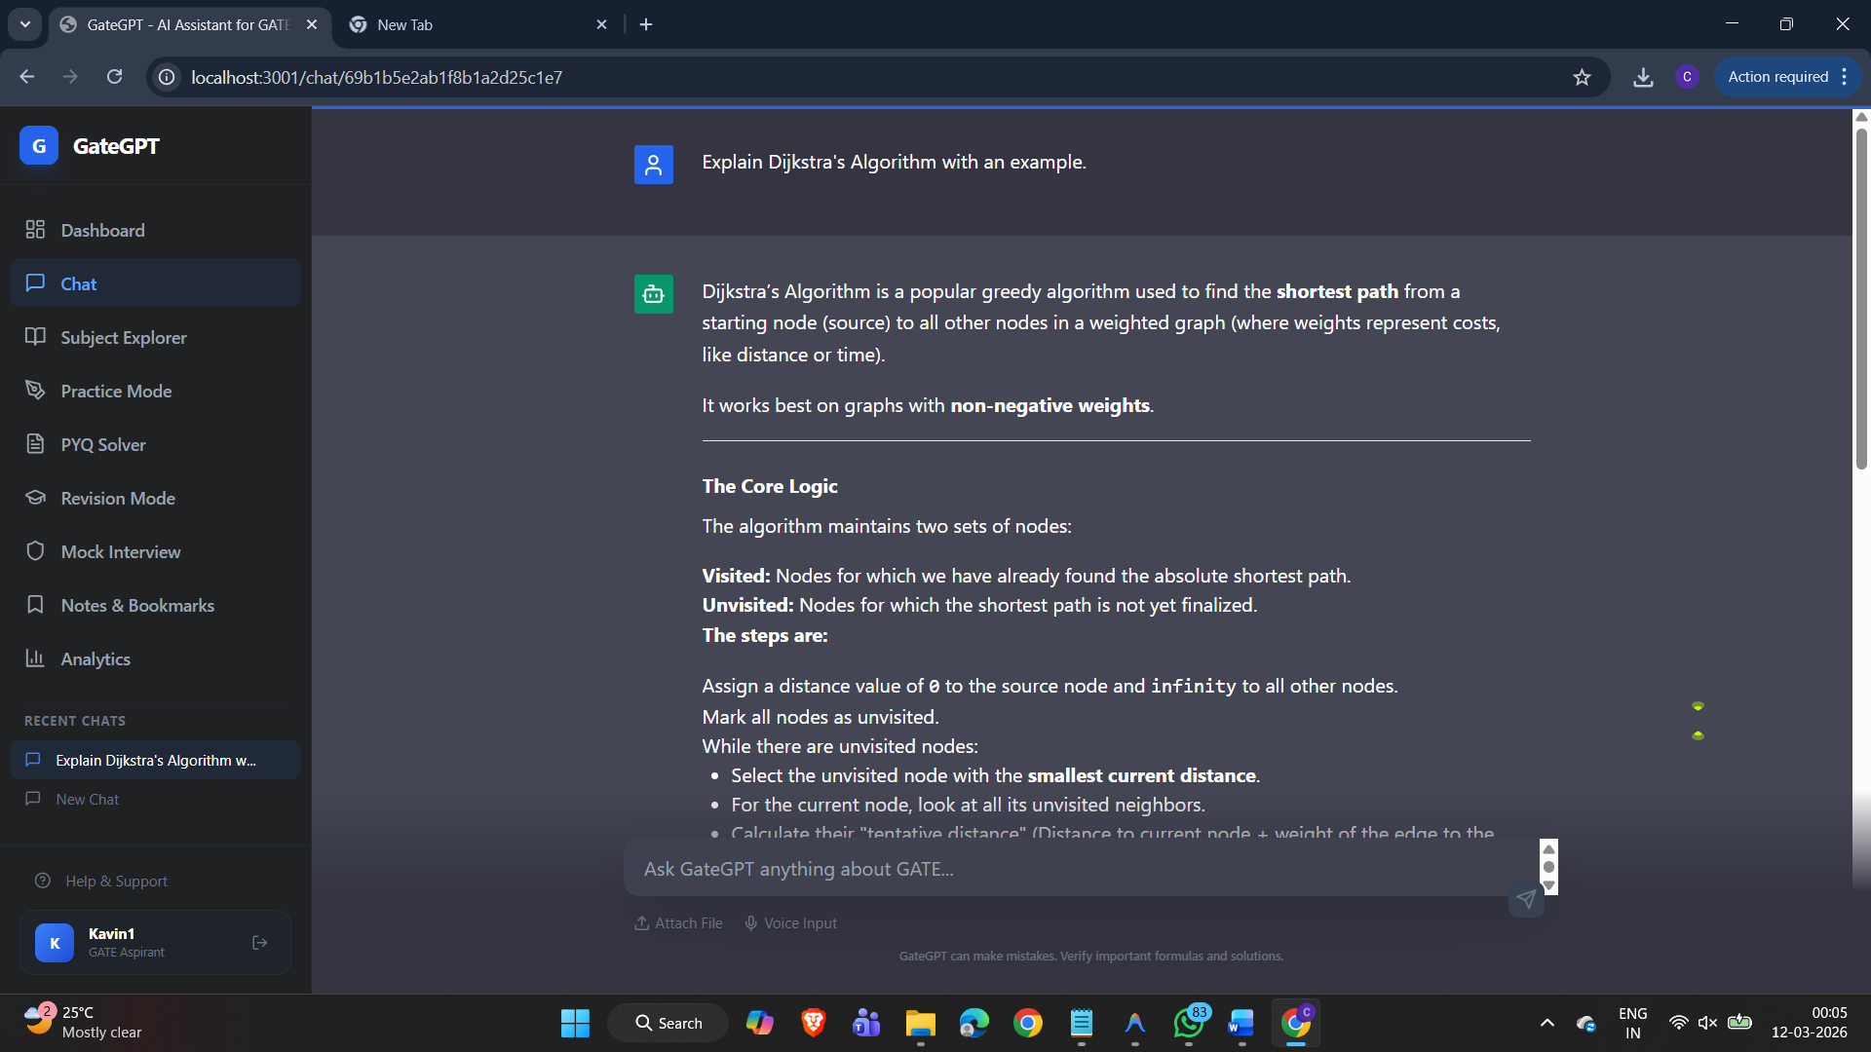6. Analytics Page: Visual charts and mastery scores.

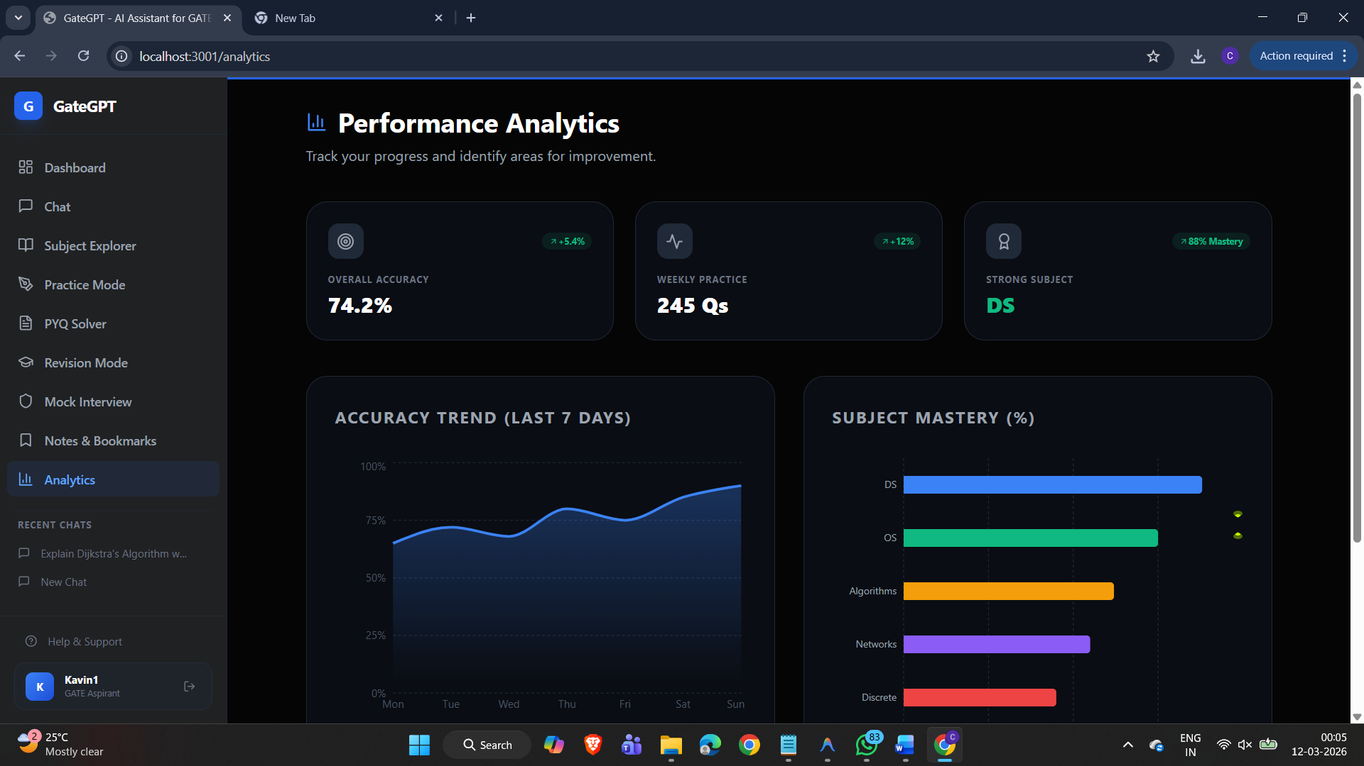
7.Practice Mode.
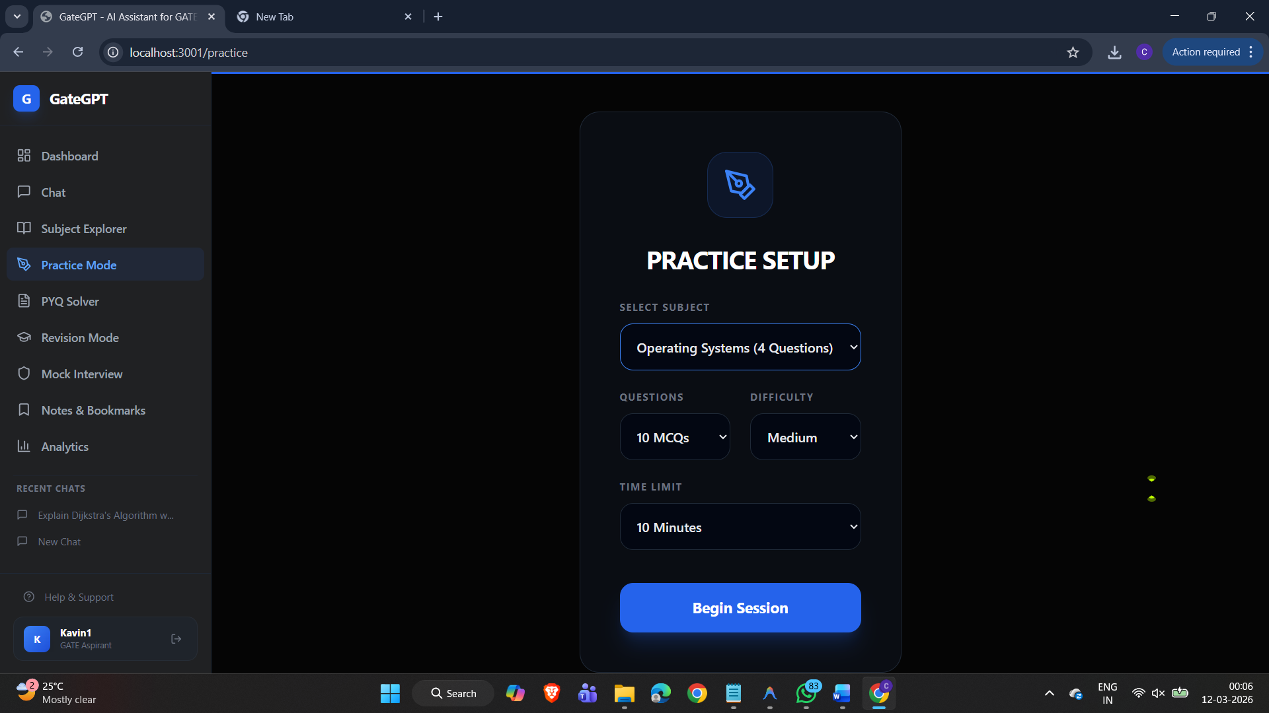
8.PYQ Solver
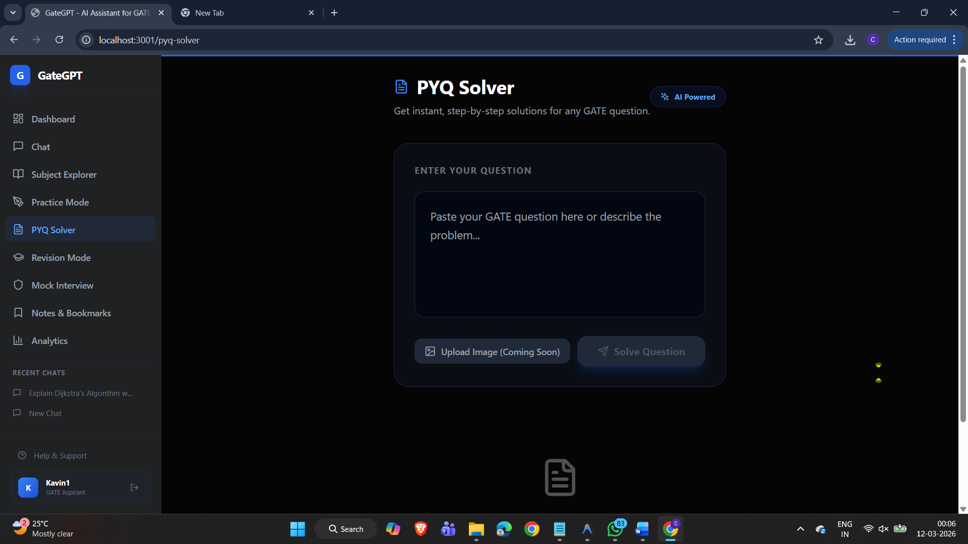
9.Revision Mode
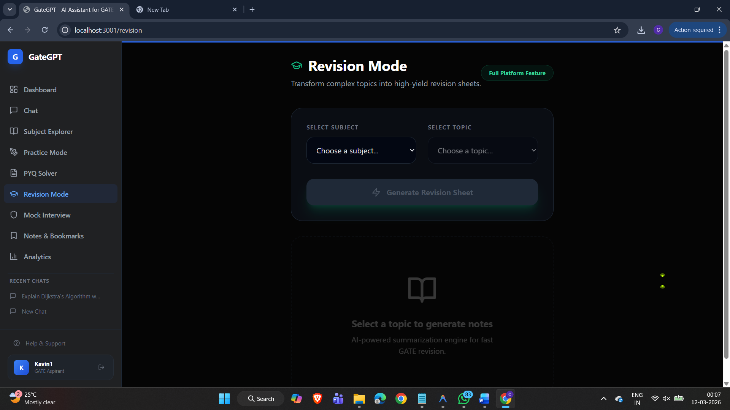
10. Notes and bookmarks
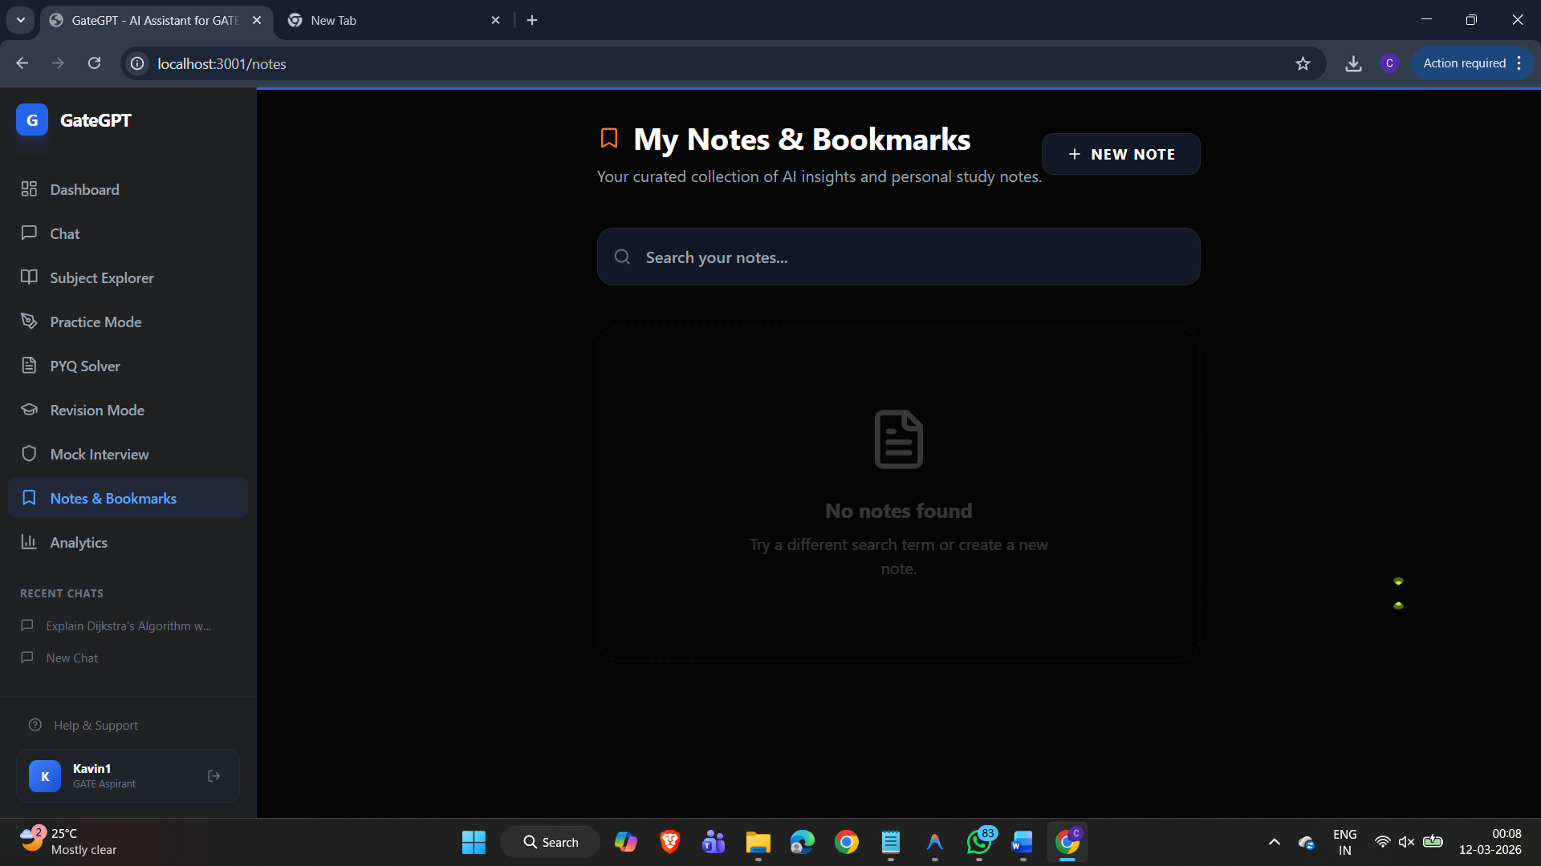

14. Results and Testing
The system underwent rigorous testing phase:
- Functionality Testing: Verified all CRUD operations, chat persistence, and analytics aggregation.
- Performance Testing: AI response latency was measured at an average of 2.2 seconds for technical proofs.
- Accuracy Verification: The Gemini 3.1 model was tested against standard GATE PYQs for DS and OS, yielding > 95% accuracy in reasoning.
- UI/UX Testing: Verified full responsive behavior across mobile, tablet, and desktop views.

15. Advantages of the System
- Personalized Learning: AI tailors explanations to student's specific doubts.
- Instant Doubt Solving: No 24-hour wait for faculty or forums.
- Visual Progress Tracking: Dashboard makes weak areas immediately obvious.
- Secure and Centralized: Notes, chats, and practice results are all in one place.
16. Limitations
While GateGPT is highly capable, it has certain limitations:
- Internet Dependency: Requires an active connection to access the Gemini API.
- Token Limits: Extremely long chat histories may hit context window limits of the AI model.
- Image Recognition: While the API supports images, the current UI is optimized for text/LaTeX interaction.

17. Future Enhancements
- Native Mobile Application: iOS/Android port for learning on the go.
- Voice-to-Text Doubt Submission: Hands-free interaction for students.
- Advanced AI Mock Tests: Full-length tests with AI-generated feedback reports.
- Offline Note Mode: Allowing access to saved summaries without internet.

18. Conclusion
GateGPT successfully achieves its goal of being an intelligent companion for GATE aspirants. By merging full-stack development excellence with cutting-edge AI, we have created a tool that provides real value to students. It demonstrates that with proper engineering, AI can be a safe and highly efficient mentor, empowering the next generation of engineers to achieve their career goals with clarity and confidence.

