**WiMaX**

***“One whose ideal is mortal dies when his ideal is achieved.But one whose ideal is immortal must become immortal himself to attain it”***

**ABOUT:**

This is WiMaX, a club initiated by the **STUDENTS** of artificial intelligence and data science department of Easwari Engineering college. WiMaX is not just a club but also a **COMMUNITY** for our students to sharpen their skills in their interested domain and to explore new domains***. Our ideology is focused on COLLECTIVE GROWTH.*** We help among ourselves **by GAINING KNOWLEDGE** from others and **TEACHING** their **KNOWLEDGE** to others. We try to bring our **IDEAS** to real life to make an **IMPACT** in our society and the world and an **INSPIRATION** to our younger generation.

**DOMAIN:**

**Game development**

The art of creating games and describes the design, development and release of a game.

Involves concept generation

* Design
* Build
* Test
* release.

**Web development**

The art of building, creating, and maintaining websites. Divided into two categories Front End and Back end. Involves aspects such as

* **FRONT END**
  + UI/UX design
  + web publishing
  + web programming
* **BACK END**
  + database management
  + Deployment

**Devops**

the combination of cultural philosophies, practices, and tools that increases an organization’s ability to deliver applications and services at high velocity. DevOps is divided into 8 phases

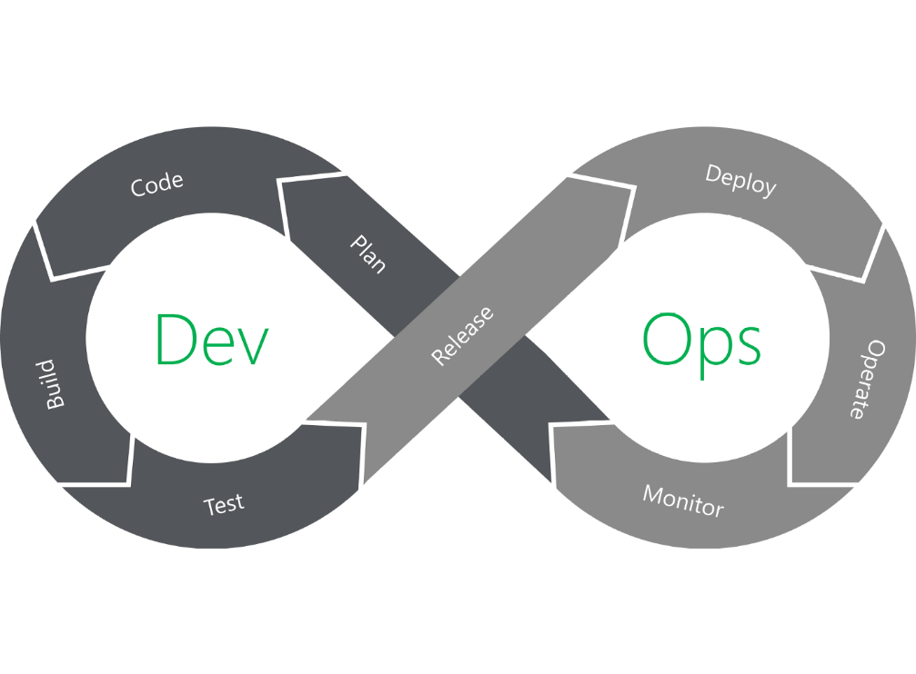

**Cloud Computing**

cloud computing is the delivery of computing services—including servers, storage, databases, networking, software, analytics, and intelligence—over the Internet to offer faster innovation

**ARTIFICIAL INTELLIGENCE**

The concept of developing machines to mimic human nature and behavior. Make machines to think like us, to take decisions like us, to understand and express the human emotions like us.

**Data analysis/Data Science**

The art of extracting knowledge and insights from a set of data respective to its type. Plays a major role in the ongoing information era and in Artificial Intelligence.

**Machine Learning**

the use and development of computer systems that are able to learn and adapt without following explicit instructions, by using algorithms and statistical models to analyse and draw inferences from patterns in data.

**App development**

Covers both Mobile app and system app development. Application software addresses the end user and provides features to perform specific tasks and activities

**Documentation**

Documentation is any communicable material that is used to describe, explain or instruct regarding some attributes of an object, system or procedure, such as its parts, assembly, installation, maintenance and use. Every project need its own documentation.

**Blockchain**

**Blockchain = Decentralization**. The goal of blockchain is to allow digital information to be recorded and distributed, but not edited. Provides enhanced security, transparency, traceability, automation and efficiency.

**Web3**

Web3 is an idea for a new iteration of the World Wide Web which incorporates concepts such as decentralization, blockchain technologies, and token-based economics

**3D design/modelling**

3D modeling is the art of developing a mathematical coordinate-based representation of any surface of an object in three dimensions via specialized software by manipulating edges, vertices, and polygons in a simulated 3D space

**Testing**

the process of evaluating and verifying that a software product or application does what it is supposed to do. The benefits of testing include preventing bugs, reducing development costs and improving performance

**IoT**

The Internet of things describes physical objects with sensors, processing ability, software, and other technologies that connect and exchange data with other devices and systems over the Internet or other communications networks

**Cybersecurity**

Cybersecurity is the practice of protecting systems, networks, and programs from digital attacks. These cyberattacks are usually aimed at accessing, changing, or destroying sensitive information; extorting money from users; or interrupting normal business processes