TECHNICAL CASE STUDY
PII Airlock
A local privacy gateway for cloud AI requests
Author | AI-Danil
Date | 20 July 2026
Status | Reproducible public demonstrator

Outcome first
A working two-contour gateway now turns a document and task into a pseudonymized cloud payload, blocks unsafe cases, and restores only exact operation-scoped tokens. Cloud use is optional; the default is an inspectable dry-run. The project does not claim perfect anonymization.

1. Problem and design decision
A personal AI assistant can benefit from a cloud model while its local context contains names, contacts, addresses, IDs, and credentials. A local LLM alone is not a security boundary: it can miss an entity, invent a substring, return invalid JSON, or follow an instruction embedded in the document. The design therefore combines a semantic detector with deterministic checks.

2. Two-contour flow
- LM Studio receives the task and document only through 127.0.0.1 and returns schema-constrained entity candidates.
- Code accepts exact source substrings, resolves overlap longest-first, and emits __PII_<nonce>_<TYPE>_<N>__ tokens.
- A residual gate checks the exact outgoing fields. Any model/schema error or known residual secret stops the request.
- OpenAI is optional. Without a key the exact payload is shown; with a key the Responses API is called with store: false.
- The cloud response is untrusted. Unknown, altered, or forged tokens block restoration; the in-memory map is destroyed.
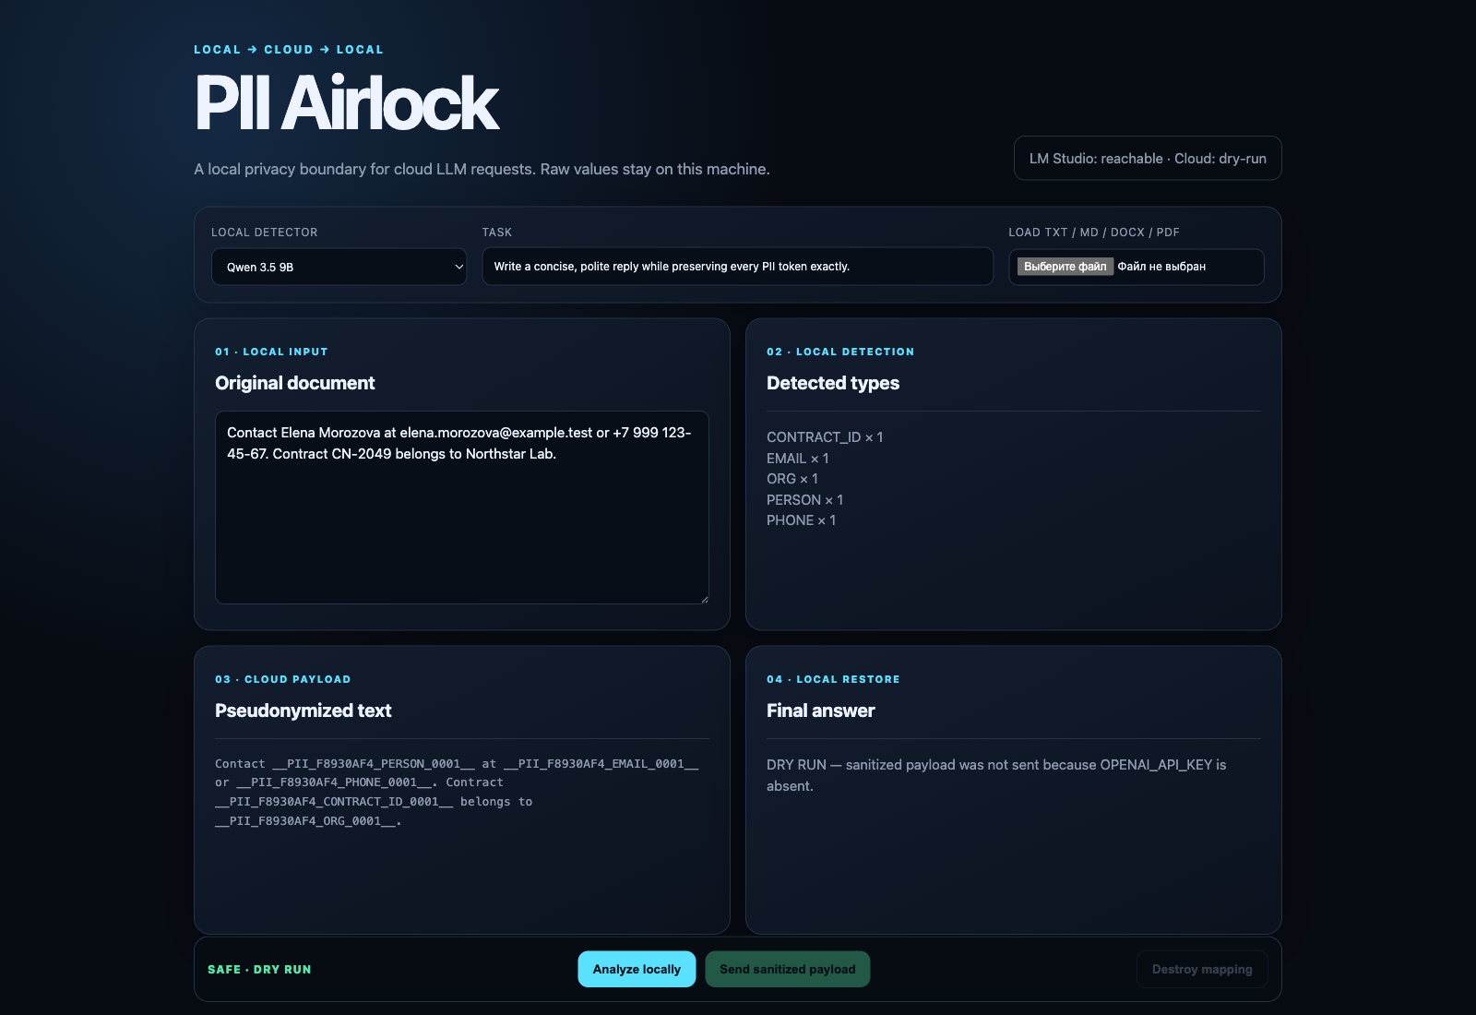
Real local Qwen dry-run · synthetic values only

3. Evidence, not promises
All figures below come from the new reproducible run on 30 synthetic documents (15 Russian, 15 English).
Metric | Qwen 3.5 9B | Gemma 4 E4B
Approved payloads / 30 | 25 | 25
Control leaks in approved payloads | 0 | 0
Entity-level recall | 0.6667 | 0.7593
Extra replacement values | 5 | 4
Schema / exact-substring failures | 4 | 0
Dataset release blocks | 1 | 5
Round-trip fidelity cases | 26 | 30
Median / maximum | 2.556 / 6.182 s | 1.567 / 4.116 s
Interpretation: both models remain experimental. The dataset-only oracle withheld any payload still containing a known control value. Zero approved-payload leaks is bounded evidence for these fixtures—not proof for unseen documents.

4. Delivered artifacts
- Python 3.11 Web UI, CLI, and local API with a 10-minute in-memory mapping TTL.
- TXT, Markdown, DOCX, and text-layer PDF parsing; OCR/images/archives and >20,000 characters blocked in V1.
- 25 offline tests with stubs: span validation, overlap, tokens, TTL, formats, timeout, prompt-injection framing, logs, and round trip.
- Full English/Russian README, threat model, SECURITY.md, synthetic fixtures, per-case JSON, screenshot, and GitHub Actions.
- A local, disabled Gosha adapter with fail-closed behavior; 27/27 current Gosha tests passed and no service was restarted.

5. Risks and next experiment
Semantic PII can still be missed; rules are not universal DLP. Process memory, LM Studio internals, OS swap, and provider policy are outside the guarantee. High-risk use requires dry-run review. The next useful experiment is a larger adversarial fixture set plus improved semantic detection without weakening exact-substring validation.

