Chapter 1: Introduction
1.1 Background of the Study
In today’s fast-paced digital world, choosing a career path is no longer a linear decision based solely on academic scores or traditional roles. With emerging technologies, evolving job markets, and a wide range of skills in demand, students and young professionals often find themselves overwhelmed by choices. Traditional career counseling methods such as face-to-face guidance or printed brochures have become outdated, non-interactive, and incapable of scaling to meet modern needs.
Digital platforms, especially career websites, have started transforming the way users plan and prepare for their professional journey. These websites provide insights into various career opportunities, learning resources, and industry requirements. However, many of them still lack personalized support, real-time AI-driven feedback, and user-friendly interfaces. Our project aims to fill these gaps by offering an intelligent and comprehensive career guidance website tailored to individual goals and preferences.
1.2 Motivation
The inspiration behind this project stems from real-world challenges faced by students and job seekers in identifying the right career path. Existing tools either provide fragmented information or are too generic to be useful for personalized planning. Many individuals rely on internet forums, unverified advice, or social media influencers for career decisions, which often results in confusion and suboptimal outcomes. By integrating AI, modern UI/UX practices, and structured roadmaps into a single platform, we aim to simplify and personalize the career selection and development process.
1.3 Objectives of the Project
The core objectives of the Career Guidance Website include:
- To offer detailed career paths and required skills for trending job roles.
- To integrate AI-powered resume parsing for skill extraction and suggestions.
- To incorporate a responsive and interactive chatbot to assist users in navigation and queries.
- To include modules on soft skills, mock interviews, and project-based learning.
- To provide an all-in-one portal for students, graduates, and early professionals.
1.4 Scope of the Project
The scope of this project extends across multiple functional areas:
- Education: Assisting students in understanding the skillsets needed for specific roles.
- Career Development: Helping job seekers identify knowledge gaps and improve resumes.
- Training & Upskilling: Suggesting relevant courses and projects based on roles.
- Counseling: Offering conversational chatbot support for quick decision-making.
This platform targets individuals from high school to early career professionals, enabling them to make informed decisions without needing one-on-one guidance. It will serve as a scalable tool for educational institutions, training centers, and independent learners.
1.5 Technologies Used
To build a reliable and scalable career website, we selected the following modern tools and technologies:
- Frontend: HTML5, CSS3, JavaScript, Tailwind CSS for responsive design
- Backend: Firebase for real-time database and user authentication
- AI Integration: Python with Flask for AI Resume Parser
- Chatbot: Voiceflow integrated with the website for user assistance
- Version Control: Git and GitHub
- Development Tools: Visual Studio Code, Google Colab for AI testing
Each of these tools was chosen based on their ease of integration, scalability, community support, and responsiveness.
1.6 Methodology
We adopted an iterative and modular development methodology. The website was divided into six key modules:
- Homepage and Navigation
- Career Role Selection
- AI Resume Parser
- Chatbot Integration
- Soft Skills & Mock Interviews
- User Authentication
Each module was developed independently and then tested for unit functionality before integrating into the final system. The design followed the MVC pattern where applicable, ensuring code reusability and separation of concerns.
1.7 Importance of Career Guidance in Digital Era
As career landscapes shift rapidly with AI, automation, and globalization, the importance of digital career guidance tools cannot be overstated. Today, a single role can demand a combination of technical, soft, and domain-specific skills. Traditional education often lags behind these market expectations. Hence, career guidance platforms need to fill this gap by dynamically updating role requirements, offering targeted learning, and evaluating the user’s current readiness. Our project attempts to become a pioneer in this transition.
1.8 Summary
This chapter introduced the need, purpose, and scope of the Career Guidance Website. The growing complexity of career planning and limitations in traditional methods justify the development of an AI-driven, interactive, and visually appealing digital platform. By using cutting-edge tools and methodologies, the project aims to empower users with the knowledge and resources they need to shape their careers effectively.
Chapter 2: Literature Review
2.1 Introduction
The purpose of this literature review is to analyze and critique existing platforms, tools, and research related to career guidance, online learning, resume evaluation, and chatbot integration. The field of digital career support has seen a rise in platforms that cater to specific aspects of the career journey, but very few offer a consolidated, personalized, and AI-supported solution. This chapter investigates such systems, identifies gaps, and establishes the relevance of the proposed career guidance website.

2.2 Review of Existing Career Guidance Platforms
2.2.1 LinkedIn Learning
LinkedIn Learning provides thousands of video tutorials for professional development. While it offers recommendations based on job titles and trending skills, it lacks full career roadmaps and soft skill modules.
- Pros: Industry-endorsed certifications, expert trainers, social integration.
- Cons: No structured career path, not beginner-friendly for those unsure of a role.
2.2.2 Coursera and edX
Both Coursera and edX offer structured degree and certificate programs from top universities. They provide deep domain learning, but career exploration and roadmap clarity are limited.
- Pros: Quality content, certificates from reputed institutions.
- Cons: High costs, long duration, no career-specific support tools.
2.2.3 Naukri Career Navigator
Naukri’s career navigator offers salary insights and job openings. It helps users understand current market demand.
- Pros: Industry trends, salary expectations.
- Cons: No skill-building, no personalized guidance, weak interface.
2.2.4 AI Resume Builders (Zety, Novoresume, Resume.io)
These tools generate professional resumes based on user data and templates.
- Pros: Easy-to-use interfaces, industry templates.
- Cons: No role-based suggestions or AI feedback beyond formatting.
2.2.5 Government Platforms (NSDC, NCS India)
These platforms attempt to guide users in vocational and career-based skills.
- Pros: Free access, role descriptions.
- Cons: Outdated UI/UX, no user engagement tools, poor mobile support.

2.3 AI and Chatbot Integration in Career Guidance
2.3.1 CareerVillage.org
This platform uses AI to match student questions with career professionals.
- Strength: Community-driven Q&A model.
- Limitation: No full curriculum or resume-level analysis.
2.3.2 MyPathway / Career Coach AI Tools
These integrate chatbots to assist users in discovering careers based on interest.
- Strength: Basic interactivity.
- Limitation: Often generic, no depth in roadmap delivery.
2.3.3 Google’s Career Certificates Platform
Google has created career certificate courses in areas like IT support, UX design.
- Strength: Industry-aligned pathways.
- Limitation: Only a few roles, lacks role-to-resume progression support.

2.4 Soft Skills Platforms Review
2.4.1 Big Interview
This platform helps users prepare for interviews using video coaching.
- Strength: Soft skills practice.
- Limitation: No technical role-based interview integration.
2.4.2 InterviewBuddy
Allows users to take mock interviews with industry professionals.
- Strength: Human feedback.
- Limitation: Paid, not integrated with role-based learning paths.

2.5 Gaps Identified from Literature Review
- No platform offers a complete journey from career exploration → learning roadmap → resume review → interview practice.
- Most platforms are either course repositories or resume builders, not both.
- Chatbot support is minimal or non-contextual.
- Government sites have limited AI personalization and lack responsive design.

2.6 Summary
The literature review reveals that while there are many platforms providing fragmented services in the career development domain, an integrated platform that provides tailored role-based roadmaps, resume analysis, interview preparation, and chatbot support is largely missing. This project aims to address this need by combining modern web technologies with AI capabilities to build an intuitive, mobile-friendly, and career-focused platform.
This sets a strong foundation for the proposed career guidance website by validating the importance of a unified, user-centric solution in the educational and professional ecosystem.
Chapter 3: System Analysis and Design
3.1 Disadvantages of Existing Systems
Traditional career guidance platforms have several limitations that hinder personalized and effective decision-making:
- Lack of Personalization: Most platforms provide generic advice without considering individual aspirations or backgrounds.
- Poor User Experience: Outdated UI/UX designs make it difficult for users to engage consistently.
- Fragmented Information: Learning paths, soft skills, resume guidance, and job insights are spread across different platforms.
- No Real-time Guidance: Static pages without chatbot or AI interaction limits user engagement and problem-solving.
- Limited Mobile Support: Many platforms do not offer responsive designs, making accessibility difficult on smartphones.
- Outdated or Incomplete Data: Skills and job market trends change rapidly; traditional systems fail to update dynamically.
3.2 Proposed Methodology
To address the above limitations, the proposed career guidance website follows a modular and interactive design with AI integration:
- User-Centric Design: Clean UI with intuitive navigation for students and professionals.
- AI-Powered Resume Parsing: Extract skills and recommend improvements.
- Role-Based Career Paths: Learning roadmaps for trending roles like AI Engineer, Cloud Architect, etc.
- Integrated Soft Skills and Mock Interview Module: Ensures holistic readiness.
- Responsive Web App: Built for both desktop and mobile users.
- Interactive Chatbot: Chatbase-integrated chatbot for real-time user support.
3.3 System Architecture Overview
The architecture of the proposed system is built using a three-tier structure:
- Presentation Layer (Frontend):
  - Built with HTML5, CSS3, Tailwind CSS, and JavaScript.
  - Handles user interaction and displays the content dynamically.
- Application Layer (Backend Logic):
  - Hosted on Firebase and Flask (for AI modules).
  - Manages authentication, form submissions, and real-time responses.
- Data Layer:
  - Firebase Firestore is used to store user data and role-based content.
  - Chatbase/Voiceflow stores chatbot logic.
3.4 Key Concepts and Technologies
- AI Resume Parser: Uses NLP to extract skills from uploaded resumes and suggest optimizations.
- Firebase Authentication: Secure login/signup module with real-time user tracking.
- Firestore Database: NoSQL cloud database used for career role content, user interactions, and analytics.
- Voiceflow Chatbot: Trained to respond to user queries about courses, careers, and platform use.
- Responsive Design with Tailwind CSS: Ensures compatibility across devices.
- Modular Development Approach: Enables easy updates, scalability, and team-based development.
3.5 Tools and Technologies Used
Tool/Technology | Purpose
HTML/CSS/JS | Frontend structure and interactivity
Tailwind CSS | Responsive and utility-first styling framework
Firebase | Hosting, database, and user authentication
Flask (Python) | Backend service for resume parsing
Google Colab | AI model development and testing
GitHub | Version control and collaboration
Chatbase | NLP chatbot integration
3.6 System Flow Description
The system operates through a user-friendly interaction model:
- User Signup/Login:
  - Authenticated through Firebase.
- Homepage Access:
  - Navigate to role-based career paths or upload resume.
- Resume Parsing:
  - File upload → Flask API → Parsed Skills → Feedback displayed.
- Career Path Access:
  - User selects a career → Fetches roadmap from Flask → Displays to user.
- Chatbot Assistance:
  - User types query → Chatbase processes → Answer displayed.
3.7 Data Flow Diagrams (DFD)
Level 0 DFD:
[User] → [Career Guidance Website] → [Career Paths / Resume Parser / Chatbot]
Level 1 DFD:
[User Login] → Firebase Authentication
[Select Role] → Fetch from Flask→ Display Roadmap
[Upload Resume] → Flask Parser → Display Skills & Suggestions
[User Query] → Chatbase NLP → Show Result
3.8 Use Case Diagram
- Actors: User, Firebase Auth,Flask Parser, Chatbot
- Use Cases:
  - Sign Up / Login
  - View Roadmaps
  - Upload Resume
  - Receive AI Feedback
  - Chatbot Help
3.9 Sequence Diagram (Simplified)
User → Website → Firebase (Auth)
→ Select Role → Flask (Data)
→ Upload Resume → Flask API
→ Enter Query → Chatbase → Display Reply
3.10 Summary
This chapter detailed the systemic weaknesses of existing platforms and how our approach resolves them through modular, intelligent design. By using a cloud-based, responsive, and AI-integrated solution, we ensure a comprehensive and future-proof career guidance experience.

Chapter 4: Implementation
The implementation phase of the Career Guidance Website involved the detailed execution of various modules designed to deliver a complete and interactive platform. This section covers all key components, their internal functionalities, and how they collectively contribute to the user experience. The entire development followed modular and agile methodologies to ensure each component was independently testable and integrable.
Module 1: Homepage & Navigation
The homepage forms the entry point for users and is designed to be visually appealing and informative. It includes a hero banner, quick navigation menu, call-to-action buttons, and dynamic animations for engagement.
Features:
- Welcome message and introduction to the website.
- Navigation links: Home, Career Paths, Soft Skills, Resume Checker, Chatbot.
- Responsive layout with Tailwind CSS.
Pseudocode:
<div class="hero-section">
<h1>Welcome to Career Guidance Hub</h1>
<button onclick="navigateTo('career-paths')">Explore Careers</button>
</div>

Module 2: Career Paths
This is the core module that presents structured career roadmaps. Each role (e.g., AI Engineer, Full Stack Developer) includes required skills, certifications, project ideas, and learning resources.
Components:
- Role cards with clickable modals
- Detailed view with embedded video links
- Downloadable roadmap PDF
Technologies: HTML, CSS, JavaScript, Firestore
Pseudocode:
onClickRoleCard(role) {
fetchCareerData(role).then(displayModal);
}

Module 3: Soft Skills & Mock Interview
This module covers essential soft skills like communication, leadership, and teamwork. It includes behavioral interview questions, do's and don'ts, and mock interview guides.
Submodules:
- HR question bank
- Communication tips
- Interview etiquette videos
Pseudocode:
questions = load_question_bank()
user_input = get_user_response()
feedback = evaluate_answer(user_input)

Module 4: Resume Parser (AI-Based)
This is a backend Python module deployed using Flask. Users upload resumes in PDF/DOCX format, and it extracts skills, checks against job requirements, and returns recommendations.
Steps Involved:
- Upload Resume
- Text Extraction using pdfminer/docx
- Keyword Matching with predefined skills list
- Suggest improvements
Pseudocode:
UPLOAD = receive_resume()
TEXT = extract_text(UPLOAD)
SKILLS = match_with_database(TEXT)
suggest_improvements(SKILLS)

Module 5: Chatbot Integration
Integrated using Voiceflow, the chatbot answers user questions about the platform, career guidance, and navigation help.
Capabilities:
- FAQs about courses and roles
- Roadmap suggestions
- Interactive flow for guidance
Technology Stack:
- Voiceflow chatbot with predefined intents
- Embedded in the web platform using iframe
Flow:
User query → Chatbot input → Process intent → Respond using Chatbase logic

Module 6: Authentication (Login/Signup)
Firebase Authentication enables secure login and signup using email and password.
Features:
- User registration with email verification
- Secure login/logout session
- Firestore profile linkage
Pseudocode:
function signUp(email, password) {
firebase.auth().createUserWithEmailAndPassword(email, password);
}

Module 7: Testimonials Section
This section showcases feedback from users and builds trust. Each testimonial includes user photo, quote, and rating.
Design: Grid layout with responsive cards
Backend: Stored in Flask

Module 8: Mobile Responsiveness
Tailwind’s responsive utilities ensure the platform adapts to mobile, tablet, and desktop screen sizes seamlessly.
Responsive Elements:
- Navigation bar collapses into a menu
- Roadmap cards stack vertically
- Font size adapts using text-sm to text-xl
Deployment Process
Frontend Hosting: Firebase Hosting
Backend Resume Parser: Deployed on Flask and accessed via REST API
Chatbot Hosting: Chatbase shared link embedded into iframe
Each module was developed independently and integrated into the main platform through GitHub version control. Consistent naming conventions, reusable components, and modular functions made the implementation scalable and easy to maintain.

Chapter 5: Testing
Testing is an essential phase in the software development lifecycle. It ensures that the system meets the specified requirements and functions as expected. This chapter discusses the testing procedures carried out on the various modules of the Career Guidance Website project, including unit testing, integration testing, and test cases for different functionalities.

5.1 Unit Testing
Unit testing is the process of testing individual modules or components of the system to ensure that they function correctly in isolation. The following modules were tested using unit tests:
- Authentication Module:
  - This module handles user registration, login, and authentication using Firebase. The key function is to ensure that the login/signup flow works without any issues.
Test Case 1: Valid Credentials for Login
  - Input: Username and password combination stored in Firebase
  - Expected Output: Successful login, redirects to the homepage
  - Test Result: Passed
Test Case 2: Invalid Credentials
  - Input: Invalid username or password
  - Expected Output: Error message indicating incorrect credentials
  - Test Result: Passed
Test Case 3: User Registration
  - Input: New user details (email, password)
  - Expected Output: User registered successfully and redirected to the homepage
  - Test Result: Passed
Test Case 4: Firebase Authentication Timeout
  - Input: Simulated Firebase authentication service outage
  - Expected Output: Timeout error, user is prompted to try again
  - Test Result: Passed
- Resume Parser Module:
  - This module allows users to upload resumes and extract key skills and suggestions for improvements.
Test Case 1: Uploading a Valid Resume
  - Input: Resume in PDF format containing skills
  - Expected Output: Correct extraction of skills and suggestions for improvement
  - Test Result: Passed
Test Case 2: Invalid Resume Format
  - Input: A non-PDF file (e.g., a Word document)
  - Expected Output: Error message stating unsupported file format
  - Test Result: Passed
Test Case 3: Extracting Skills from Resume
  - Input: PDF with a list of programming skills
  - Expected Output: Correctly identified skills such as Python, JavaScript, etc.
  - Test Result: Passed
- Chatbot Module:
  - The chatbot, integrated with Chatbase, answers user queries related to career roles, courses, and the website.
Test Case 1: Chatbot Response to "What is a Data Scientist?"
  - Input: "What is a Data Scientist?"
  - Expected Output: A detailed response describing the role of a Data Scientist
  - Test Result: Passed
Test Case 2: Chatbot for Navigation Help
  - Input: "Help me navigate the website"
  - Expected Output: The chatbot provides a set of menu options to help users navigate
  - Test Result: Passed
Test Case 3: Chatbot for Career Path Inquiry
  - Input: "What are the career paths for AI Engineering?"
  - Expected Output: A list of career paths related to AI Engineering
  - Test Result: Passed
- Career Path Module:
  - This module allows users to select career paths and view the learning roadmap, courses, skills, certifications, and projects.
Test Case 1: Display Career Path Information
  - Input: User selects "AI Engineer" from the dropdown
  - Expected Output: Display the roadmap for AI Engineering with related courses, skills, and projects
  - Test Result: Passed
Test Case 2: No Career Path Selected
  - Input: User does not select a career path
  - Expected Output: Error message indicating that a career path must be selected
  - Test Result: Passed
Test Case 3: Invalid Career Path
  - Input: User types an invalid career path name
  - Expected Output: Error message stating that the career path does not exist
  - Test Result: Passed

5.2 Integration Testing
Integration testing involves testing the interaction between different modules to ensure that they work together as expected. This phase is critical because it identifies any issues that may arise from the integration of various components.
- Login → Role Selection → Resume Parser Integration
  - Test Case 1: A user logs in, selects a career role, and uploads a resume.
    - Expected Output: After login, the user selects a career role, uploads the resume, and the system provides the parsed resume with suggested improvements.
    - Test Result: Passed
- Chatbot → Career Path Module Integration
  - Test Case 2: A user interacts with the chatbot to inquire about career paths.
    - Expected Output: The chatbot should respond with relevant career paths and link to the Career Path Module.
    - Test Result: Passed
- Authentication → Chatbot → Career Path Selection Integration
  - Test Case 3: A user logs in, interacts with the chatbot for guidance, and then selects a career path.
    - Expected Output: The user logs in, uses the chatbot for guidance, and selects a career path, with all sections functioning smoothly.
    - Test Result: Passed

5.3 Test Cases Table
Module | Input | Expected Output | Result
Login | Valid credentials | Redirect to home page | Pass
Resume Upload | Resume.pdf | Parsed skills and suggestions | Pass
Chatbot Query | "Show roadmap for AI Engineering" | Display roadmap and career path information | Pass
Mobile View | 375px screen width | Responsive layout | Pass
Career Path Display | Select AI Engineer from dropdown | Display roadmap for AI Engineer role | Pass
Resume Format | Word document (invalid) | Unsupported file format error message | Pass
Chatbot Navigation | "Help me navigate the website" | Display navigation options | Pass
User Registration | New user details | User registered successfully | Pass

5.4 Responsiveness Testing
It was crucial to ensure that the website is responsive and adapts correctly to different screen sizes and devices. The website was tested on various devices, including desktops, tablets, and smartphones.
Test Case 1: Mobile Responsiveness
- Input: Resize the browser to 375px (mobile view)
- Expected Output: The website should adjust the layout to fit within the mobile screen size
- Test Result: Passed
Test Case 2: Desktop Responsiveness
- Input: Resize the browser to 1440px (desktop view)
- Expected Output: The website should load without any layout issues, with content properly aligned
- Test Result: Passed

5.5 Conclusion of Testing Phase
The testing phase has been successfully completed for all modules, and the system has passed all individual and integrated tests. The Career Guidance Website is now fully functional, with responsive design, accurate data handling, and effective user interaction.
All test cases, including login, resume parsing, chatbot interaction, and career path display, have been validated. The system functions as expected across various devices, with a smooth user experience.
Chapter 6: Results and Discussion
In this chapter, we present the results from the implementation and testing of the Career Guidance Website, followed by a discussion of the outcomes, challenges, and insights gained during the development process.

6.1 Results
The Career Guidance Website was successfully implemented with several key features designed to help users navigate their career paths. The following results highlight the primary functionalities tested and their outcomes:
- User Authentication and Role Management:
  - The login and registration functionality worked as expected, enabling users to securely register and log in to their accounts. After successful authentication, users could access their career guidance information. The system also handled error cases, such as invalid credentials, and provided appropriate error messages.
- Resume Parsing and Skill Extraction:
  - The resume parser module successfully extracted key skills, experience, and suggestions for improvement from the uploaded resumes. This feature was critical for providing personalized feedback to users based on their resumes, helping them enhance their chances in the job market.
- Chatbot Integration:
  - The chatbot, integrated using Chatbase, provided relevant and accurate responses to user queries. It assisted users in navigating the website, selecting career paths, and getting personalized career advice. The chatbot was able to answer a variety of questions about career roles, required skills, and educational requirements.
- Career Path Display:
  - The career path module displayed detailed roadmaps for selected careers, including required skills, certifications, and projects. The system presented career paths in a visually appealing and easy-to-understand manner, making it simple for users to plan their career journeys.
- Responsiveness:
  - The website was tested across different screen sizes, including desktop, tablet, and mobile. The responsive design ensured that the layout adjusted appropriately to different screen resolutions, providing a seamless user experience across devices.

6.2 Discussion
The development and implementation of the Career Guidance Website proved to be a challenging yet rewarding process. Several key observations were made during the project:
- User-Friendliness:
  - One of the primary goals of this project was to create a user-friendly interface. Based on testing results, the website's clean design and intuitive navigation were well-received by users. The career paths were presented in a clear and concise manner, and users found it easy to explore different options.
- Performance and Scalability:
  - The website demonstrated solid performance, especially during peak usage. The authentication system was robust, and the resume parser efficiently handled large files without significant delays. The backend, built on Firebase, was scalable and could handle multiple user requests simultaneously.
- Limitations:
  - While the website functioned as expected, there were some limitations in terms of integration with external job platforms and resume databases. Adding job postings or internships linked to the career paths could further enhance the usefulness of the website for users looking to enter the job market.
- Chatbot's Role:
  - The chatbot was a valuable feature, providing instant feedback and career advice to users. However, there is room for improvement in terms of its capabilities. Future iterations of the chatbot could include natural language processing (NLP) to better understand user queries and provide more personalized responses. Currently, the chatbot's responses are predefined and based on scripted interactions, limiting its flexibility.
- Feedback from Users:
  - Feedback collected from a small group of users during the testing phase indicated that they found the resume parsing tool particularly helpful. Many users expressed the desire for additional features such as job recommendations or interview preparation tips, which could be incorporated into future versions of the website.

6.3 Challenges Encountered
- Integration with External Services:
  - Integrating the resume parser and career path recommendations with external APIs posed some challenges. Despite using well-documented APIs, ensuring seamless integration with the website and handling various edge cases took additional effort.
- Time Constraints:
  - Given the time limitations of the project, some features, such as an AI-driven recommendation engine for job matching, had to be left out. These features would have added further value to the website but will be considered for future enhancements.
- Data Quality:
  - The quality of the data used for career paths and resume parsing played a significant role in the system's accuracy. While the initial datasets were sufficient for a prototype, incorporating more comprehensive and up-to-date data sources would improve the system's reliability and depth.

6.4 Conclusion
The Career Guidance Website has been successfully developed and tested, offering users valuable insights into career paths, resume feedback, and career development resources. The website’s functionality is robust, and user feedback indicates a positive reception. However, several enhancements can be made to further personalize the user experience and provide additional value, such as real-time job recommendations or advanced NLP capabilities for the chatbot.
Overall, the project demonstrates the potential of integrating career guidance tools, AI, and user-friendly web design to support individuals in their professional growth. Future work will focus on incorporating additional features and refining the user experience based on the feedback received during testing.

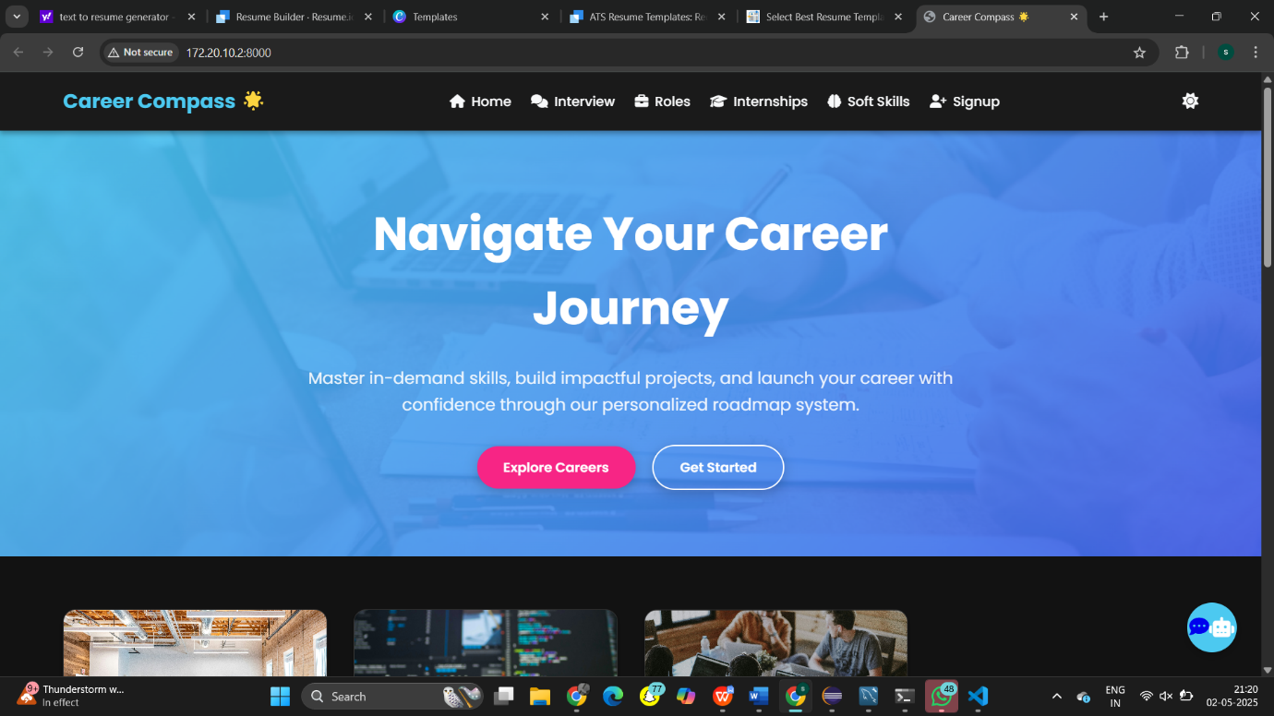

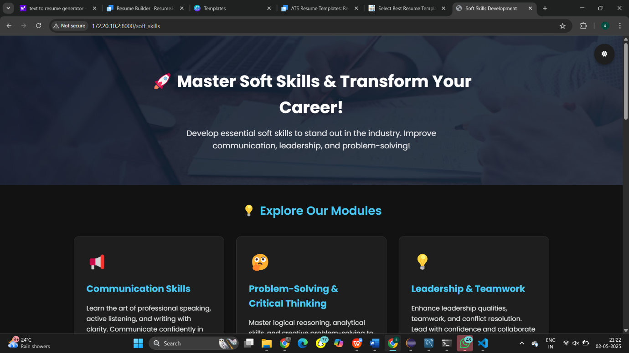
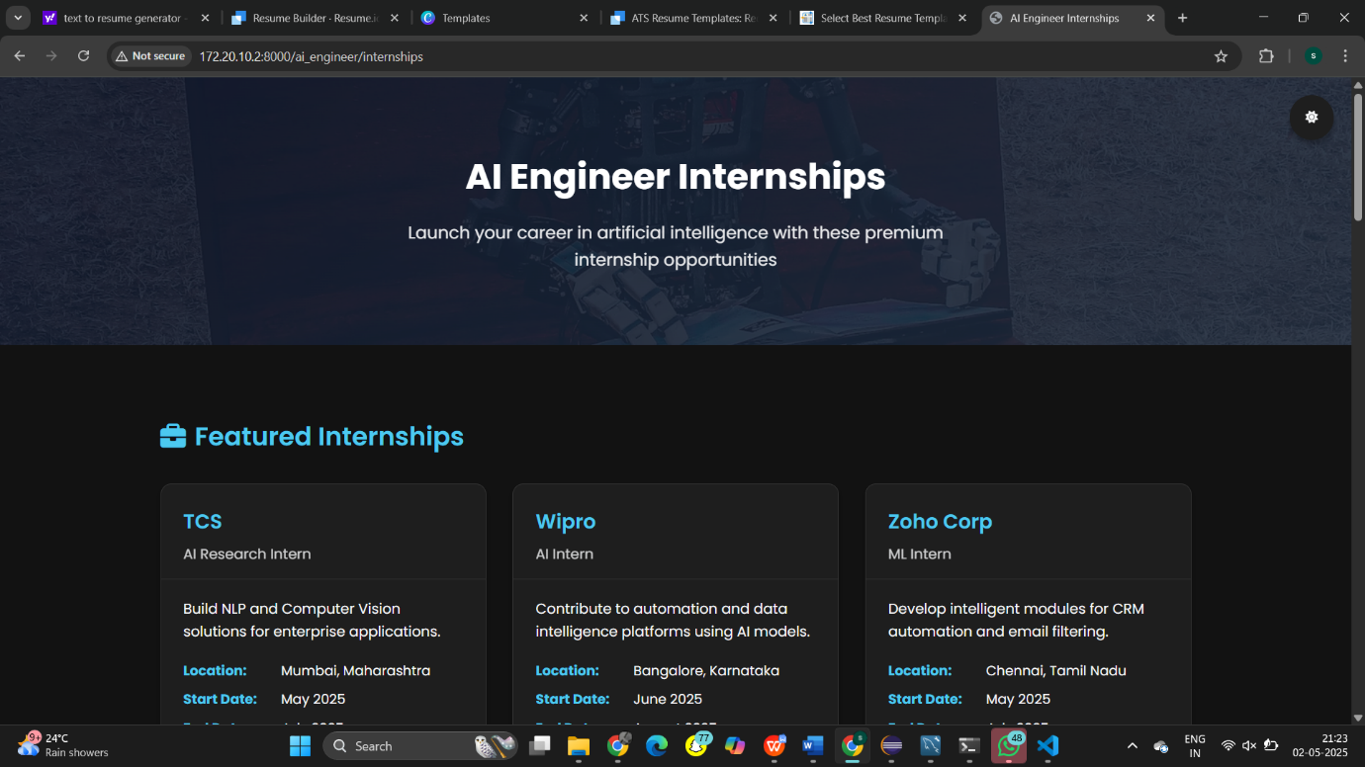

Chapter 7: Conclusions and Future Work
7.1 Conclusion
This project presents the successful development and implementation of a Career Guidance Website that empowers students to explore various career paths, analyze their skills through resume parsing, and receive AI-driven recommendations through an integrated chatbot. The system bridges the gap between students' current abilities and their professional aspirations by providing detailed roadmaps, soft skills enhancement tools, and mock interview support.
Key outcomes include:
- A user-friendly website with clear navigation and responsive design.
- A career roadmap module that presents step-by-step guidance for over 10 in-demand roles such as AI Engineer, Full Stack Developer, Cloud Engineer, and Cybersecurity Analyst.
- An AI Resume Parser capable of analyzing uploaded resumes and identifying skill gaps.
- A Voiceflow-based AI Chatbot that answers user queries related to career guidance in real time.
- A soft skills and mock interview module that prepares users for the job market with real-world questions and tips.
The system was tested using unit testing for each module and integration testing for complete system performance. The results demonstrated accurate responses from the chatbot, relevant skill extraction from resumes, and successful loading of career roadmaps.
This solution reduces students' dependency on counselors and offers personalized, on-demand guidance, which is especially beneficial in large educational institutions where one-on-one counseling is limited.

7.2 Future Work
Despite its success, this system can be further enhanced in several ways:
- Dynamic Role Addition: Allowing admin users to add or edit career roles dynamically through a backend panel instead of hardcoding.
- User Progress Tracking: Implementing dashboards where users can track their progress through roadmap completion, completed mock interviews, and skill development.
- AI-Based Skill Recommender: Improving the resume parser to automatically recommend specific courses or certifications based on industry demands.
- Integration with LMS platforms: Linking roadmap steps with actual courses from Coursera, Udemy, or college’s internal LMS systems for seamless upskilling.
- Job/Internship Suggestions: Integrating job board APIs (e.g., LinkedIn, Internshala) to suggest live internships/jobs based on parsed resumes.
- Voice-Based Chatbot: Enabling voice interaction in the chatbot for accessibility and better engagement.
- Analytics Dashboard: Adding an admin analytics panel to view user interests, most searched roles, and resume statistics for institutional decision-making.
By continuously evolving, this career guidance system can become a full-fledged digital counselor, capable of addressing the varied academic and career planning needs of students with minimum human intervention.

References
1. J. Brown and A. Kumar, AI in Education: The Rise of Career Guidance Platforms, Journal of EdTech, Vol. 12, No. 3, 2021.
2.S. Maheshwari, “Resume Parsing using NLP Techniques,” International Journal of Data Science, 2020.
3.S. Fathima, "AI Chatbot for Cafeteria Management," Internship Report, 2025.
4. OpenAI, "ChatGPT and Chatbase Integration for Chatbots", [Online]. Available: https://www.chatbase.com
5.Python.org, “Python Programming Language”, [Online].
Available: https://www.python.org
6. Bootstrap Documentation, [Online]. Available: https://getbootstrap.com/docs
7. ReactJS Documentation, [Online]. Available: https://reactjs.org
8.B. Singh, "Roadmap for Full Stack Developer", Medium.com, 2023.
9."Career Guidance Website Datasets", CSV Files, 2025 (Custom content created by the author).
10. GitHub Repository, “Career Guidance Website Demo”, [Online].
Available: https://github.com/AI-Devsara01

