MACRO PROJECT – I

Milestone 3 – Implementation & Functional Exercise Assessment

Submitted By: -
Aakanksha Vidushi Pandey (BTAI25O1001)
Dhruv Urmaliya (BTAI25O1052)

Under the Guidance of: -
Dr. Neelam Arya



CENTRE FOR ARTIFICIAL INTELLIGENCE
Madhav Institute of Technology & Science
Gwalior – 474005 (MP)
July – December 2026

1. Milestone 2 Overview
Milestone 1 established the technical foundation of this project: a live webcam-to-pose pipeline using YOLO26-Pose to detect 17 body key points and an initial joint-angle calculation, with the elbow angle validated. Milestone 2 extends this foundation towards functional assessment analysis by implementing assessment-specific movement interpretation for the Phase 1 tests: Sit-Ups, Sit & Reach, and Vertical Jump.
Milestone 1 = Technical Foundation → Milestone 2 = Assessment-Specific Movement Analysis

2. Milestone 1 Baseline
Component | Milestone 1 | Milestone 2
Webcam/OpenCV | Working | Continue
YOLO26-Pose | Working | Continue
Key points | 17 detected | Exercise analysis
Joint Angle | Initial (elbow validated) | Extend to hip, knee
Sit-ups | Pending | Movement/state analysis
Sit & reach | Pending | Posture and reach movement analysis
Vertical Jump | Pending | Movement phase analysis
Repetition Counting | Pending | Sit-up Implement
Database | Design stage | Future milestone

3. Objectives
- Implement Sit-Up movement/state detection using relevant body key points and joint-angle analysis.
- Implement transition-based repetition counting for Sit-Ups.
- Extend the pose-analysis pipeline for Sit & Reach using relevant posture, joint-angle, and wrist-position features.
- Explore movement phases relevant to Vertical Jump using body key points and joint-angle changes.
- Continue confidence filtering at threshold 0.5.
- Validate assessment-specific thresholds and movement features experimentally rather than assuming fixed values.

4. System Architecture
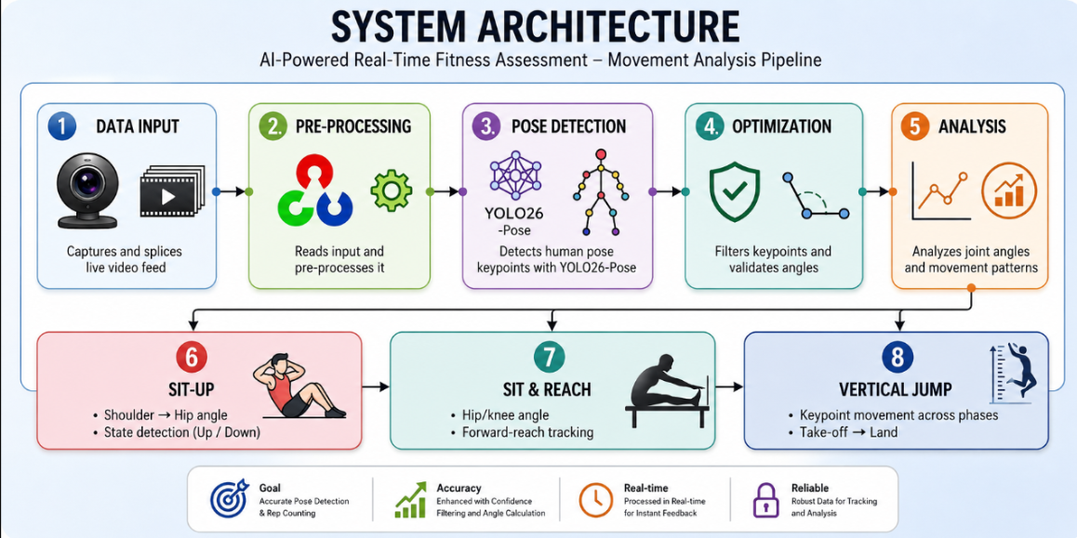
5. Webcam and OpenCV Implementation
cap = cv2.VideoCapture(0)
ret, frame = cap.read()
cv2.imshow('Live Feed', frame)
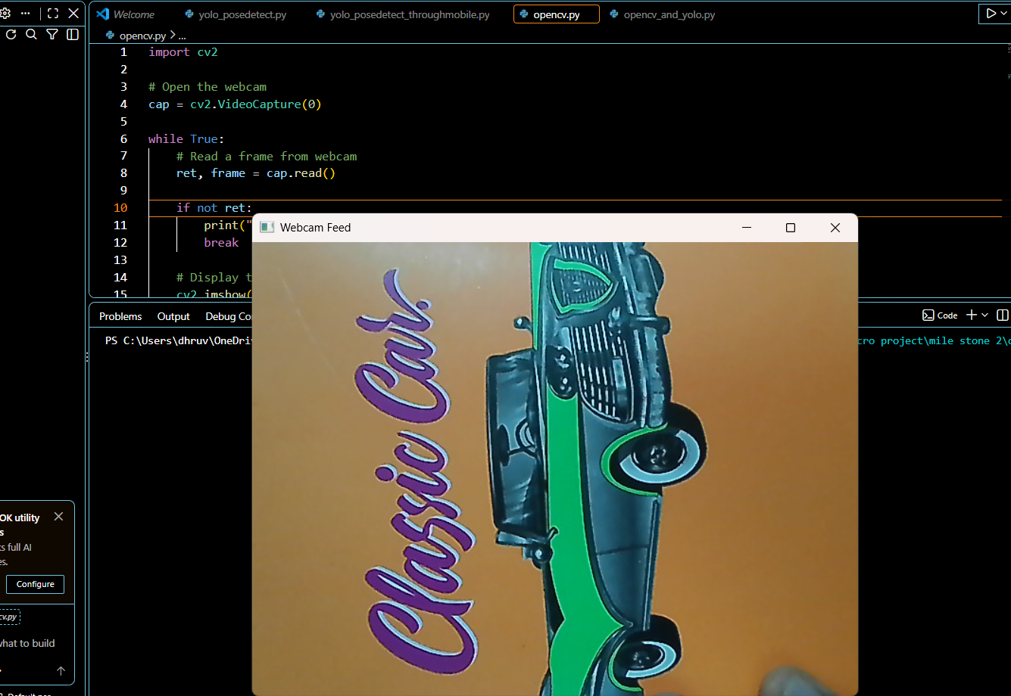
Figure 1: Live webcam feed captured using OpenCV
Confirms the video capture stage (carried over from Milestone 1) is active and feeding frames into the pipeline.

6. YOLO26-Pose Integration
model = YOLO("yolo26n-pose.pt")
results = model(frame)
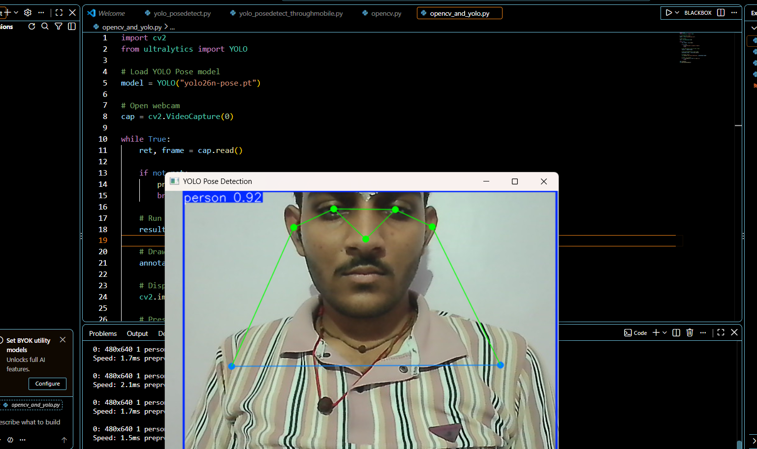
Figure 2: Real-time human pose detection using YOLO26-Pose.
Shows the model detecting the 17-keypoint skeleton on a live frame in real time.

7. Key point Extraction
YOLO26-Pose returns 17 body key points per person, each as (x-coordinate, y-coordinate, confidence). Key points with confidence below 0.5 are discarded before use, as established in Milestone 1.

8. Joint-Angle Calculation
θ = arccos( (BA · BC) / (|BA| × |BC|) )
This angle is required because YOLO26-Pose returns coordinate only; the angle at a joint is what allows the system to classify a body position as UP or DOWN. The elbow-angle case was validated in Milestone 1 and the same mathematical approach is now extended to assessment-specific joints, including hip and knee angles, depending on the movement being analysed.

9. Sit-up State Detection
Shoulder → Hip → Knee → Hip Angle → UP/DOWN. The angle thresholds separating UP from DOWN are not fixed values; they are determined and validated experimentally, since the working range varies by individual and camera angle.
Figure 5: Sit-up state detection using torso-angle analysis.
Shows the system labelling frames as UP or DOWN based on the shoulder-hip-knee angle.

10. Repetition Counting
Repetition counting uses a simple state-machine approach to avoid false counts caused by small frame-to-frame movements.
DOWN → UP → DOWN = 1 Repetition
A repetition is counted only when a complete movement cycle is detected.

11. Sit & reach Assessment
Sit & Reach is analysed using relevant pose key points: Shoulder, Wrist, Hip, Knee and Ankle.
The system calculates knee and hip/torso angles and tracks wrist position during the forward-reaching movement.
Initial flow:
YOLO26-Pose → Key points → Angles → Wrist Tracking → Movement Analysis
Final reach measurement and calibration will be added after validating the movement analysis.

12. Vertical Jump Assessment
Vertical Jump requires movement-phase analysis rather than repetition counting.
The system will observe body-key point and joint-angle changes during:
Standing → Preparation → Take-off → Airborne/Landing
Hip and knee angles, along with key point movement across frames, will be used to analyse the jump phases.

13. Database Integration
Core entities: Athlete, Session, Assessment, Score. Milestone 2 stores the first real session record only — the full dashboard remains a later milestone.
Field | Purpose
Athlete | Participant
Session | Assessment session
Exercise | Exercise type
Repetitions | Completed reps
Result | Basic assessment
Date/Time | Session tracking
Shows a real session record — athlete, exercise, repetitions, timestamp — stored in PostgreSQL.

14. Testing
Test | Expected Result | Status
Webcam | Live feed | Working
YOLO Pose | Key points | Working
Confidence Filter | Low-confidence points rejected | Working
Joint-Angle Calculation | Angles calculated | Working
Sit-up State | UP/DOWN detection | To be tested
Rep Counting | Correct repetitions | To be tested
Sit & reach | Movement tracking | To be tested
Vertical Jump | Movement analysis | To be tested

15. Challenges
- Lighting: poor lighting reduces key point confidence below the 0.5 threshold.
- Occlusion: hidden joints produce unreliable coordinates and are filtered out.
- Camera angle: affects angle and movement analysis
- Threshold selection: requires practical testing
- False repetition counting: jitter near a threshold can cause spurious transitions; the state machine aims to reduce this.
- Calibration: Real-world distance measurement requires further calibration

16. Milestone 2 Deliverables
- Sit-up state detection
- Sit-up repetition counting
- Sit & Reach movement analysis
- Joint-angle and wrist-position tracking
- Vertical Jump movement-phase analysis
- First database session record

17. Milestone 3 Target
- Improve repetition stability
- Reduce false detections
- Improve form analysis
- Refine scoring
- Improve database/session history
- Begin results/dashboard interface

18. Conclusion
Milestone 1 established the pose-detection foundation using webcam, YOLO26-Pose and joint-angle calculation. Milestone 2 extends this foundation towards Sit-ups, Sit & Reach and Vertical Jump through movement analysis, state detection and repetition counting.
The remaining measurements, scoring and additional assessments will be developed in the upcoming milestones.

