1. Milestone Overview

Milestone 1 established the pose-detection foundation using YOLO26-Pose. Milestone 2 extended this to movement analysis for Sit-ups, Sit & Reach, and Vertical Jump. Milestone 3 added scoring, calibration, and results display.

Milestone 4 transforms this technical foundation into a full multi-user assessment platform. This milestone covers PostgreSQL database integration, trainer authentication (both username/password and Google OAuth), multi-user architecture for managing multiple athletes, five exercise commands with database persistence, a complete web dashboard, mobile camera support via Droid Cam, and Sprint form-analysis features.
Scope of Milestone 5:
- PostgreSQL database integration with proper relationships
- Trainer authentication using username/password and Google OAuth
- Multi-user architecture where one trainer manages multiple athletes
- Five exercise commands with database save
- Complete web dashboard with dynamic data
- Mobile camera integration using Droid Cam
- Form analysis features for Sprint exercise

Milestone 3 = Single-Athlete System → Milestone 4 = Multi-User Platform

2. Milestone 5 Baseline
Component | Milestone 3 | Milestone 4
Webcam / OpenCV | Working | Working
YOLO26-Pose | Working | Working
Joint-Angle Calculation | Hip, Knee validated | All joints working
Sit-up Assessment | Movement analysis | Full database integration
Sit & Reach | Movement analysis | Full database integration
Vertical Jump | Movement analysis | Full database integration
Broad Jump | Not implemented | Complete
Sprint | Not implemented | Complete
Calibration | Basic | Complete (pixel-to-cm)
Scoring | Basic | Standardized (0–100)
Database | Design stage | Fully working (PostgreSQL)
Trainer Authentication | Not present | Implemented (Password + Google)
Multi-User Support | Not present | Implemented
Web Dashboard | Basic | Complete with 5 pages
Mobile Camera | Not present | DroidCam integrated
Form Analysis | Not present | Sprint features

3. Objectives

Implement PostgreSQL database with proper relationships between Trainer, Athlete, and Assessment.

Build trainer authentication system with username/password and Google OAuth login.

Develop multi-user architecture where each trainer manages multiple athletes.

Create Django management commands for five exercises with database integration.

Build a complete web dashboard with athlete overview, exercise selection, and history.

Integrate DroidCam for mobile camera support.

Implement form analysis features including knee shape, ankle path, and fatigue-related movement indicators.

Ensure trainer-level data access is restricted to the trainer's own athletes.

4. System Architecture

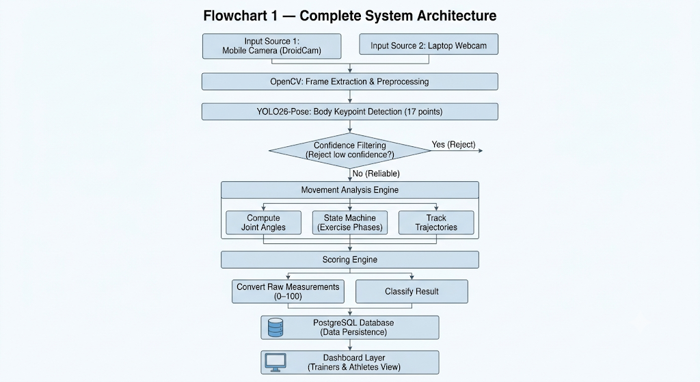

5. Trainer & Athlete Relationship

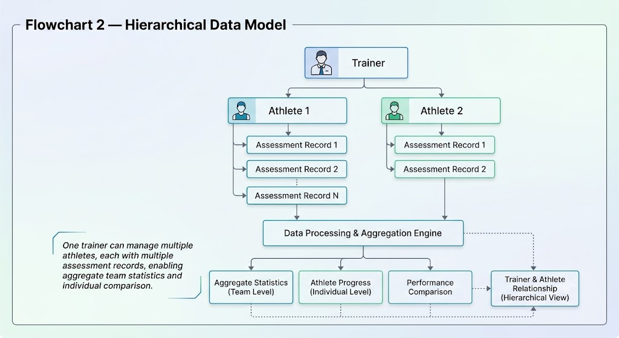

6. Database Design

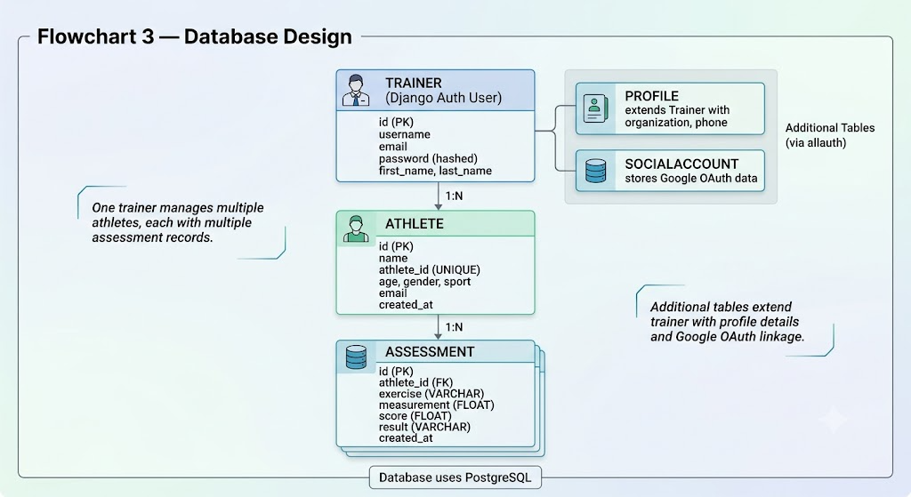

7. Authentication

Trainer authentication supports two methods: username/password and Google OAuth.

For username/password, Django's built-in authentication verifies credentials against the stored hashed password. For Google OAuth, the trainer clicks "Sign in with Google", a popup opens with Google's official login screen, the trainer selects an account and grants permission, and the OAuth callback handler processes the response. Django signals auto-create the Trainer profile if it does not exist, ensuring a seamless onboarding experience.

After successful authentication, the trainer is redirected to the trainer dashboard. Session management is handled by Django's built-in session framework.

8. Exercise Assessment Pipeline

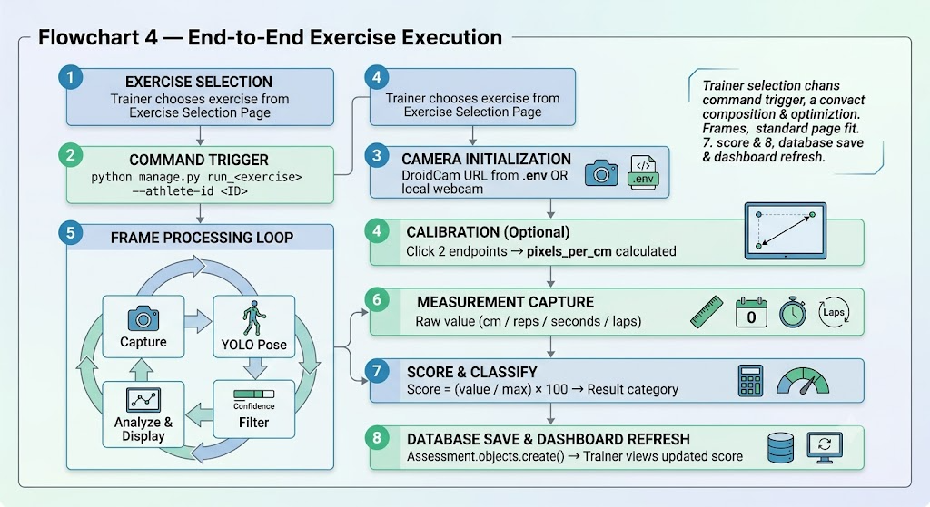

9. Sprint Form Analysis

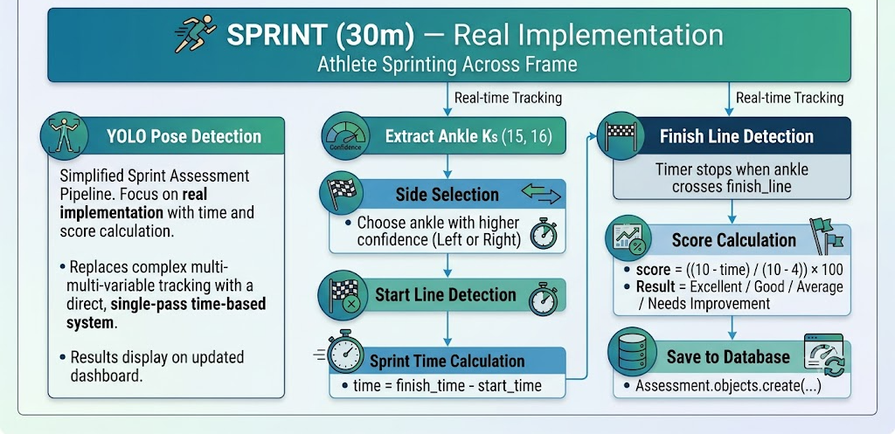

12. Progress: Milestone 3 to Milestone 4
Component | Milestone 3 | Milestone 4
Webcam | Working | Working
YOLO Pose | Working | Working
Joint Angles | Hip, Knee | All joints
Sit-up | Movement | Full DB
Sit & Reach | Movement | Full DB
Vertical Jump | Movement | Full DB
Broad Jump | Not implemented | Complete
Sprint | Not implemented | Complete
Calibration | Basic | Complete (px → cm)
Scoring | Basic | Standardized
Database | Design only | PostgreSQL working
Trainer Auth | Not implemented | Complete
Google OAuth | Not implemented | Complete
Multi-User | Not implemented | Implemented
Web Dashboard | Basic | 5 pages
DroidCam | Not implemented | Integrated
Form Analysis | Not implemented | Sprint

13. Testing
Test | Expected Result | Status
Trainer signup | Account created | Working
Trainer login | Session started | Working
Google OAuth login | One-click sign in | Working
Trainer dashboard loads | Athlete list visible | Working
Exercise selection page | All exercises shown | Working
Vertical Jump command | Database save | Working
Sit-ups command | Database save | Working
Sit & Reach command | Database save | Working
Broad Jump command | Database save | Working
Sprint command | Database save + form analysis | Working
History page | Assessments shown | Working
Django admin | Models manageable | Working
DroidCam integration | Mobile camera stream | Working
Auto-create Trainer | Signal on signup | Working

14. Screenshots

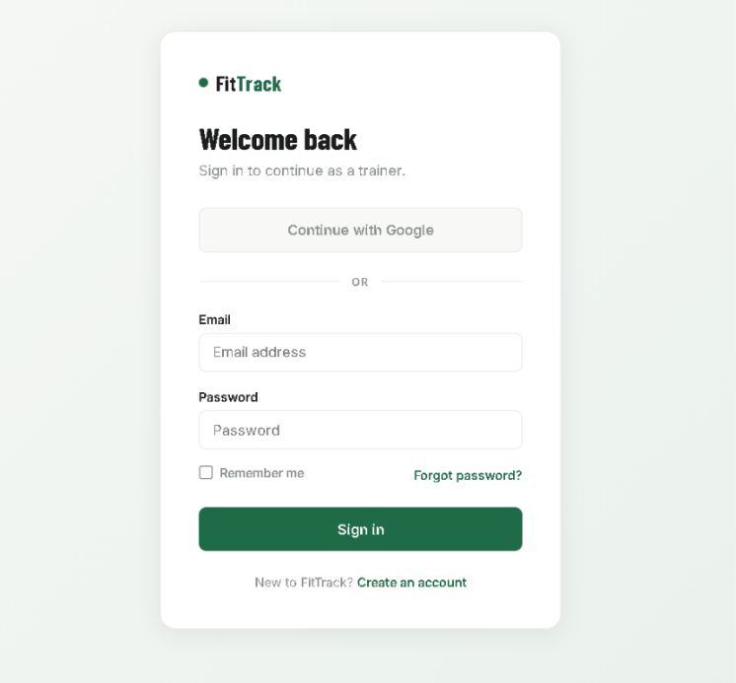
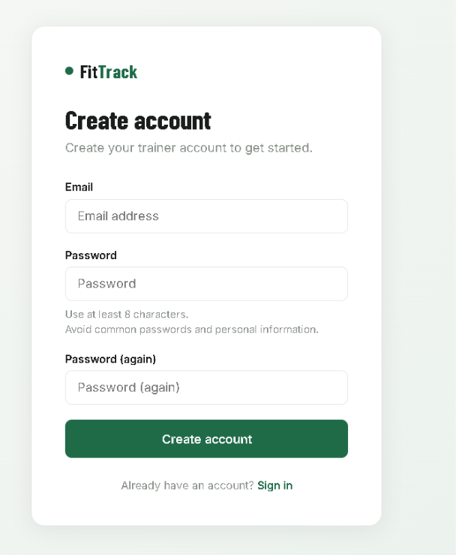
Figure 2: Trainer login Page
Figure 1: Trainer Signup Page

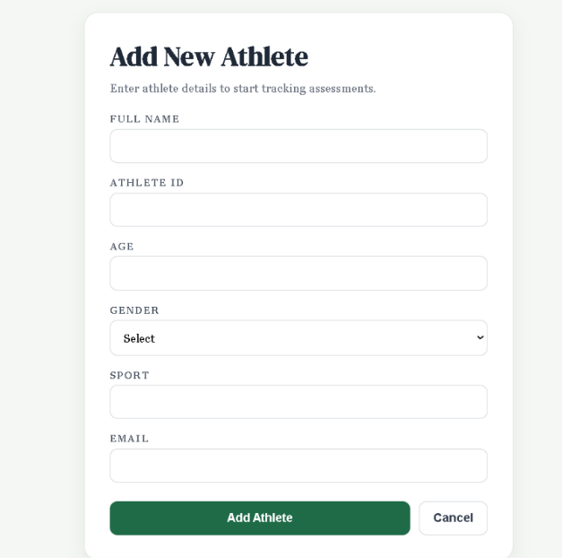
[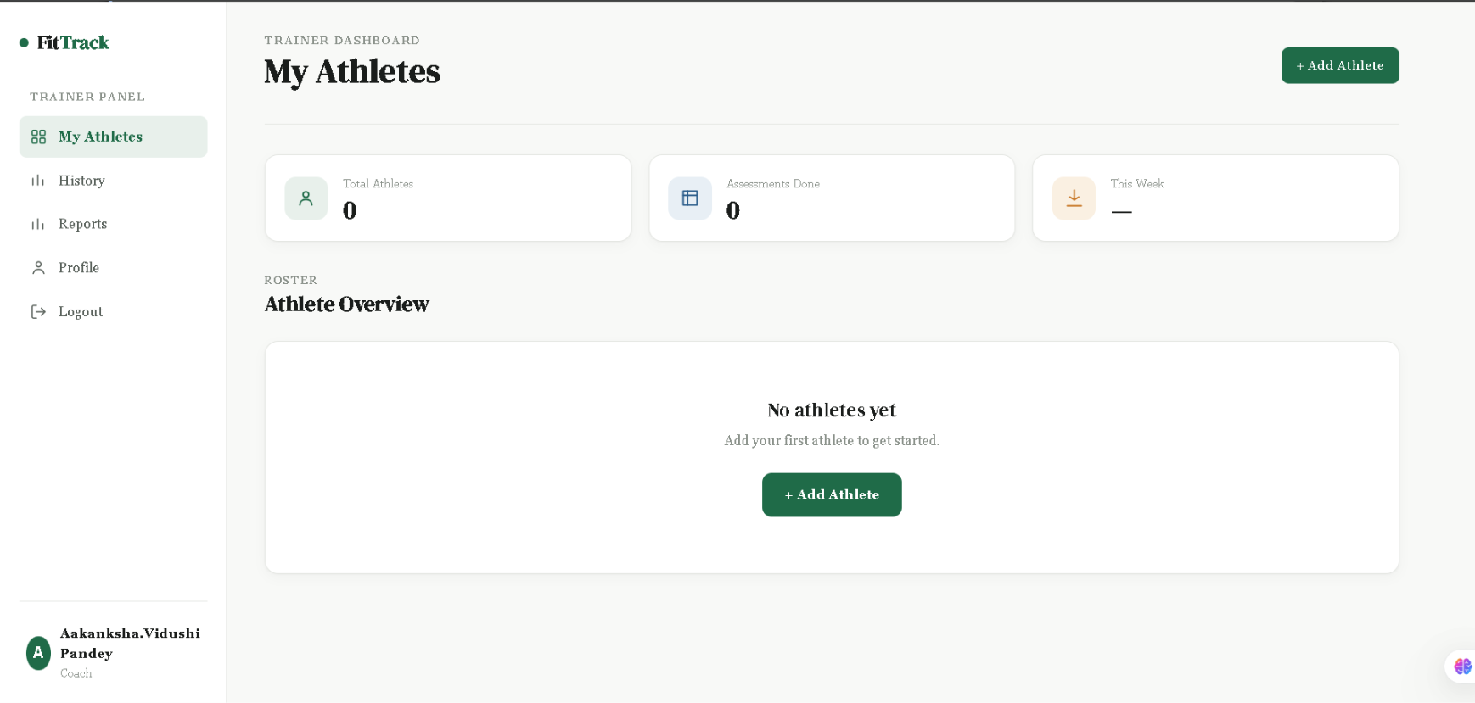
Figure 5: Add Athlete Form
Figure 4: Trainer Dashboard

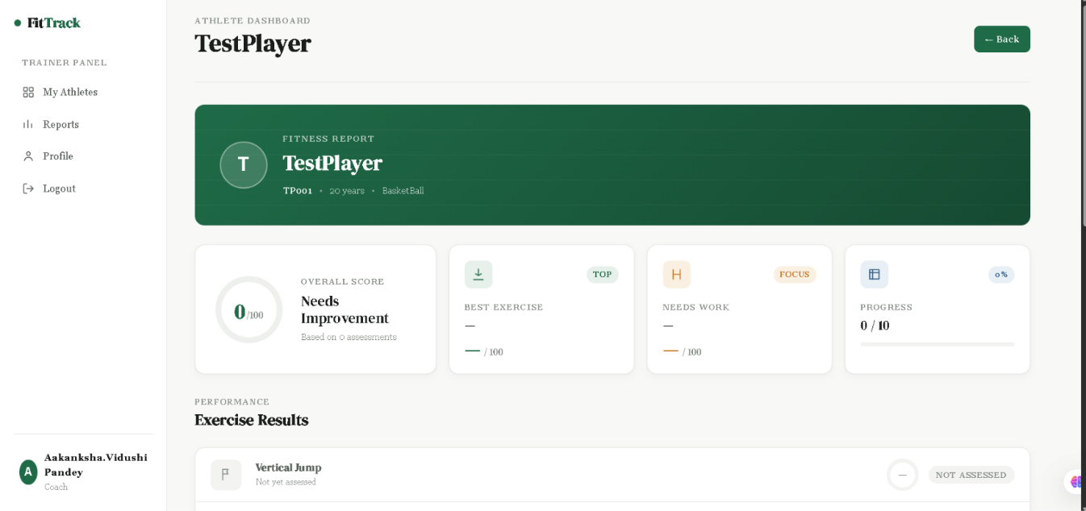
Figure 6: Athlete Dashboard

15. Challenges

CPU Processing Speed — Intel UHD graphics is used without CUDA support, making YOLO inference CPU-bound. The processing pipeline was optimized while maintaining reliable detection for slower movements.

Keypoints Miss on Resize — Frame resizing could change the aspect ratio and reduce reliable keypoint detection. The processing approach was adjusted to retain the original resolution where required.

Duplicate SocialApp Error — Google credentials configured in more than one location caused a MultipleObjectsReturned error. The duplicate admin configuration was removed so that the intended configuration remains in use.

allauth Default Template — The default Google login page was plain HTML. Custom templates were added under templates/account/ to provide a consistent interface.

DroidCam Watermark — The free version displays a watermark. The watermark was accepted because it does not affect assessment functionality.

IP Change on DroidCam — The hotspot IP can change. The current setup uses an environment configuration that can be updated when the IP changes.

16. Milestone 4 Deliverables

PostgreSQL database with Trainer, Athlete, and Assessment models

Trainer authentication using username/password

Google OAuth integration

Auto-create Trainer profile using Django signals

Five exercise commands with database save

Calibration system (pixel-to-cm)

Standardized scoring system

Trainer dashboard with athlete overview

Athlete dashboard with dynamic data

Exercise selection page

History page with filtering

Custom authentication templates

DroidCam mobile camera integration

Sprint form-analysis features

Responsive UI with consistent styling

17. Milestone 5 Target

Athlete CRUD (Add/Edit/Delete from trainer dashboard)

Athlete-specific dashboard routing

Trainer dashboard polish with proper statistics

Implement and validate trainer-level access control

Full end-to-end flow testing

Additional form-analysis features for other exercises

Session comparison charts

Report export functionality

18. Conclusion

Milestone 1 established the pose-detection foundation. Milestone 2 added movement analysis. Milestone 3 implemented scoring and calibration.

Milestone 4 extends this technical foundation into a multi-user assessment platform with PostgreSQL database integration, trainer authentication, multiple exercise commands, dashboard interfaces, DroidCam support, and Sprint form-analysis features.

Key achievements of this milestone:

PostgreSQL database with Trainer, Athlete, and Assessment relationships

Trainer authentication using username/password and Google OAuth

Multi-user architecture for managing multiple athletes

Five exercise commands with database integration

Web dashboard and assessment history

DroidCam integration for mobile camera input

Sprint form analysis using knee-angle, ankle-path, and movement indicators

The remaining athlete CRUD, routing, access-control validation, comparison features, and reporting enhancements will be addressed in Milestone 5.

