ZIMBABWE REPUBLIC POLICE
NATIONAL POLICE HEADQUARTERS (PGHQ) • ICT DIRECTORATE

ENTERPRISE SYSTEM ARCHITECTURE DOCUMENT
ZRP Records Intelligence & Facilities Tracking System (RIFTS-X)
Comprehensive Architectural Blueprint, Command Hierarchy, Multi-Tier Topology, & Subsystem Models

System Designation | ZRP RIFTS-X Master Platform & Governance Strategy Engine
Document Version | Version 2.4 (Enterprise Production Baseline)
Authoring Directorate | ZRP ICT Directorate, Systems & Comms Architecture Section
Executive Overseer | Chief Director (National Police Headquarters - PGHQ)
Security Classification | CONFIDENTIAL / LAW ENFORCEMENT RESTRICTED
Release Date | September 2026

1. Executive Summary & Architectural Scope
The Zimbabwe Republic Police (ZRP) Records Intelligence & Facilities Tracking System (RIFTS-X) is an enterprise-grade digital command platform designed to centralize, secure, and streamline law enforcement physical records management, institutional asset lifecycles, multi-echelon procurement reconciliations, electronic leave approvals, and digital twin document custodial tracking across all ten (10) provinces and National Police Headquarters (PGHQ).
Historically, station and provincial operations relied upon decentralized manual logbooks (ZRP Form 27, Form 216, Ledger registers, and physical paper dockets), creating vulnerabilities such as misplaced records, delayed procurement authorizations, lack of chain-of-custody accountability, and opaque inventory tracking. RIFTS-X resolves these operational bottlenecks through a deterministic, role-governed web application architecture built upon Django 5.2.7 and Python 3.13, delivering tamper-evident auditability and end-to-end transparency.
■ PRIMARY ARCHITECTURAL DIRECTIVE: COMMAND REALIGNMENT
RIFTS-X is strictly architected around the official ZRP Command and Staff structure. Under no circumstances does the system employ corporate designations (such as 'CEO'). Executive oversight is vested exclusively in the Chief Director, flanked by Deputy Directors (ICT, Communications, and IT), and operationalized through the Management Tier (Systems Manager, Superintendent ICT, Chief Technician, Department Managers) down to Field Officers.

2. Organizational Command Architecture & Role Topology
The application security perimeter and authorization state machine mirror the four-tier operational command hierarchy established by the ZRP Commissioner General and PGHQ Executive Command.
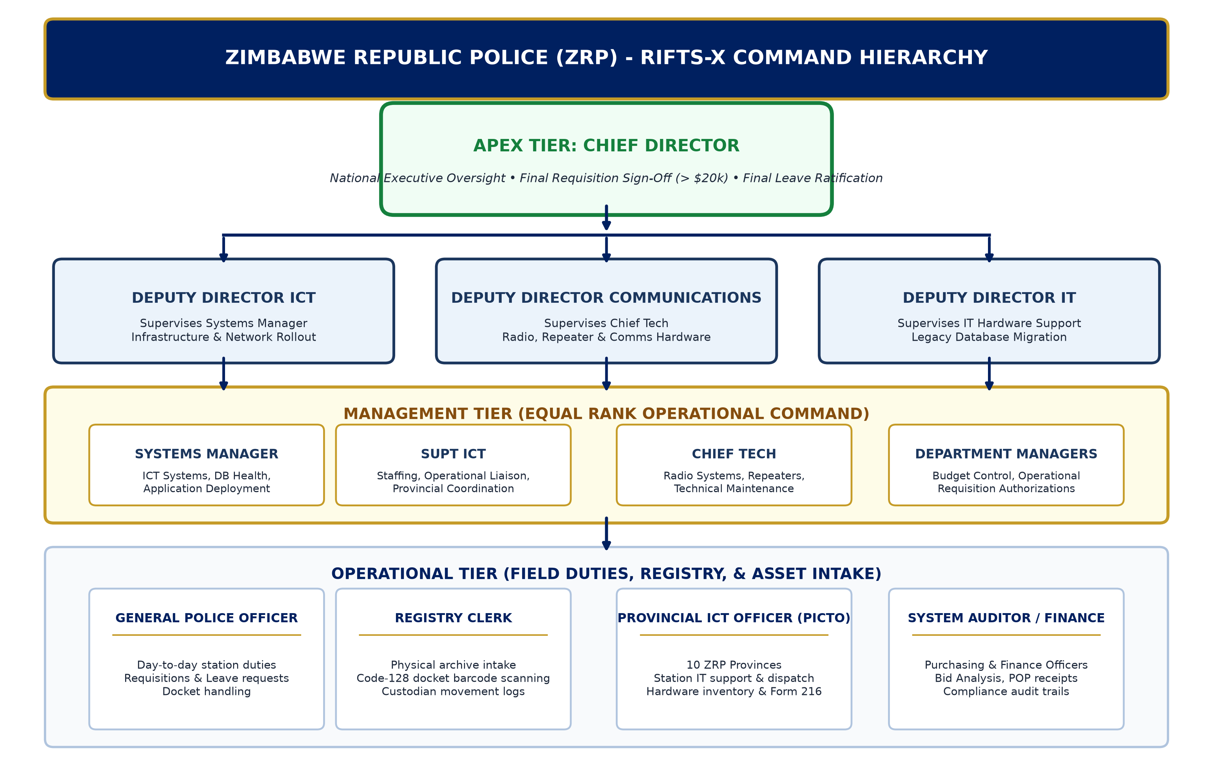
Figure 1: Official ZRP Command Hierarchy & Operational Escalation Tree
Tier Level | Designation | System Responsibilities & Authority Scope
Apex Tier  (Executive Command) | Chief Director | National oversight over all platforms, modules, and national assets. Final statutory signature for supply requisitions exceeding $20,000. Final escalation authority for leave approvals. Executive Strategic Dashboard viewer.
Directorate Tier  (Supervisory Directors) | Deputy Director ICT  Deputy Director Communications  Deputy Director IT | Supervise respective operational managers. Deputy Director ICT oversees Systems Managers, software rollouts, and infrastructure. Deputy Director Communications oversees Chief Technician, radio comms, repeaters, and field antennas. Review and recommend departmental requisitions and leave.
Management Tier  (Operational Command) | Systems Manager  Supt ICT  Chief Technician  Department Managers  Registry Supervisors | Equal operational management tier. Systems Manager governs database, software modules, and system health. Supt ICT governs staff deployments, hardware, and provincial liaison. Chief Tech oversees comms hardware and tactical communications. Review initial leave and procurement.
Operational Tier  (Field & Duty Officers) | General Police Officers  Registry Clerks  Provincial ICT Officers (PICTO)  System Auditors | Daily operational task execution: docket creation, asset barcode scanning, goods received intake (Form 27/216), service ticket dispatch, physical archive tracking, and compliance audit verification.

3. Multi-Tier Enterprise Application Topology
RIFTS-X is deployed using a robust, horizontally extensible 3-Tier Architecture designed for high availability, strict data separation, and secure access across low-bandwidth WAN connections linking provincial headquarters and remote stations.
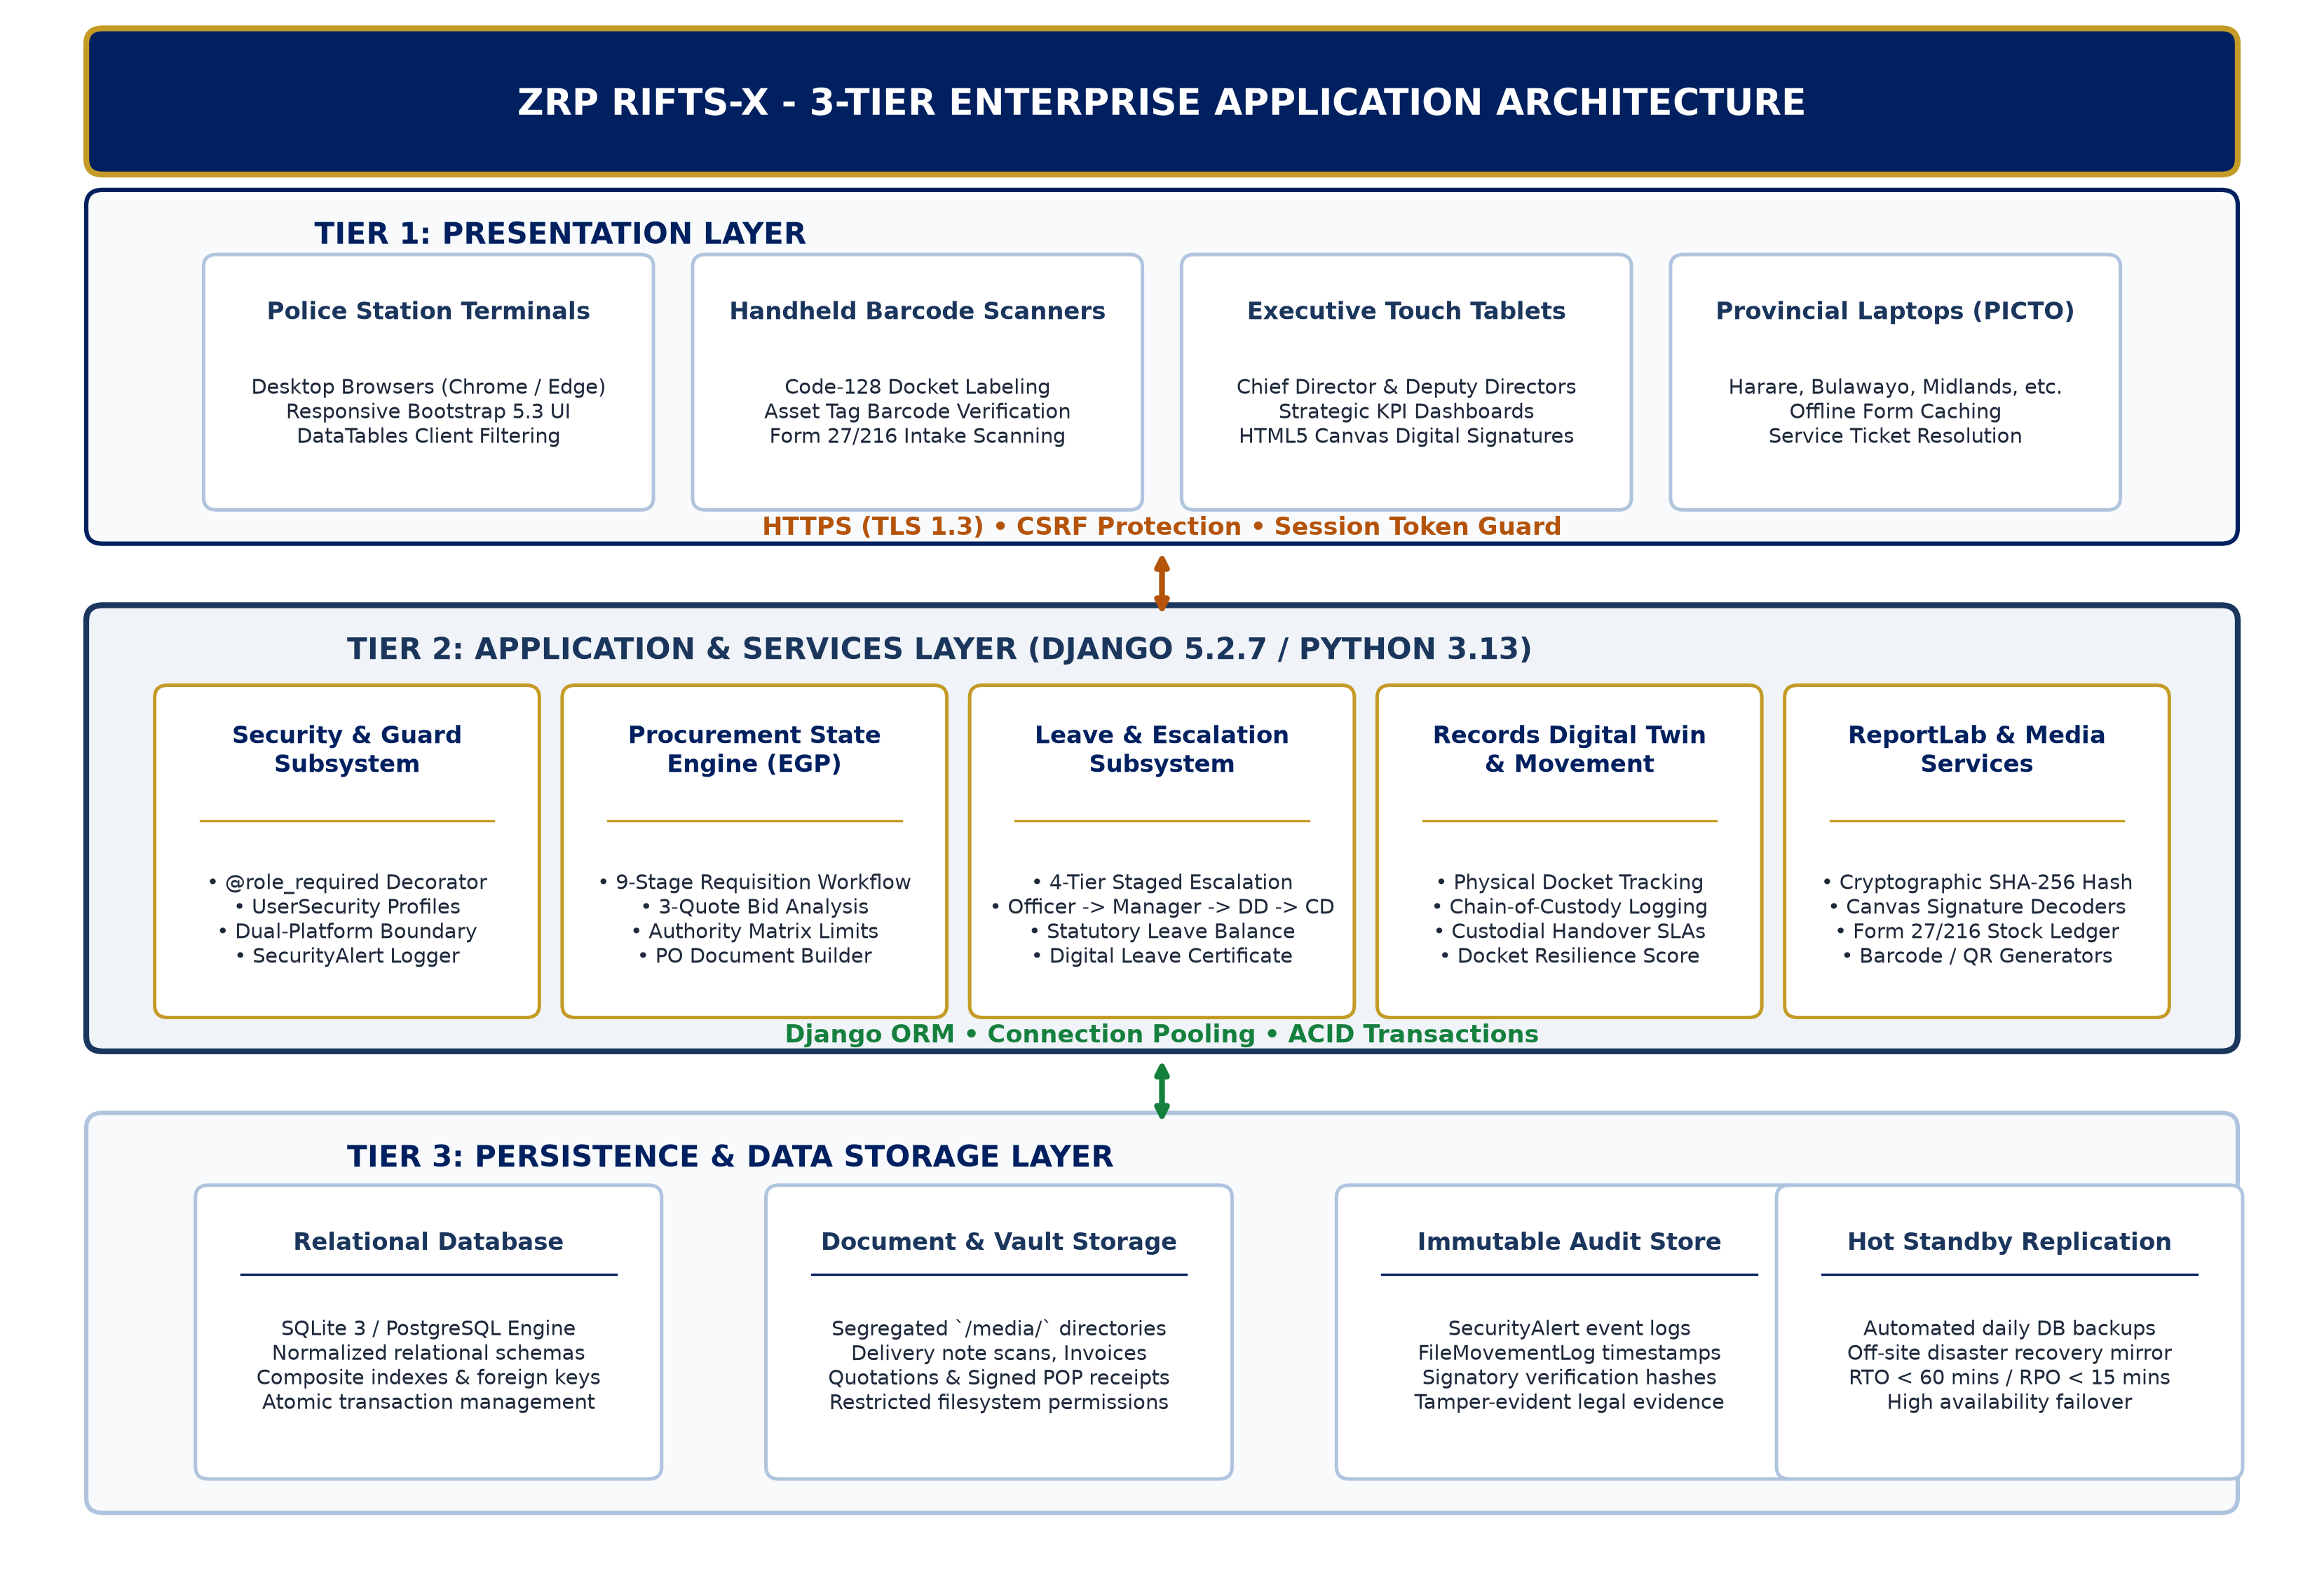
Figure 2: ZRP RIFTS-X 3-Tier Enterprise Application & Network Topology
3.1. Presentation Layer (Client Tier)
• Technology: Responsive HTML5, Bootstrap 5.3, Custom Glassmorphism UI, Vanilla JavaScript, jQuery, and DataTables.
• Capabilities: Adaptive desktop/tablet interfaces, client-side cryptographic signature capture (HTML5 Canvas), instant barcode scanning, and asynchronous AJAX interactions via CSRF-protected endpoints.
• Dual Platform Separation: Distinct UI themes for RIFTS-X Master Platform (Police Operations) and Project Governance Platform.
3.2. Business Logic Layer (Application Tier)
• Engine: Django 5.2.7 WSGI/ASGI application powered by Python 3.13.
• Services Architecture: Modular separation into dedicated domain services: `egp_service` (procurement state machine), `notification_service` (email and websocket dispatch), `barcode_service` (Code-128 and QR generation), and `pdf_generator` (ReportLab cryptographic signing engine with embedded SHA-256 verification stamps).
• Access Guards: Enforced by custom view decorators `@login_required`, `@role_required(...)`, and `@user_is_not_borrower`.
3.3. Data & Persistence Layer (Storage Tier)
• Relational Database: High-concurrency SQL database with strict foreign key constraints, composite indexation, and normalized tables maintaining complete audit histories.
• Media & File Store: Segregated file storage directories for digital docket scans, supplier bids, proof of payments, and goods received inspection dossiers, stored outside the web root with access mediated via Django authenticated handlers.

4. Subsystem Functional Architecture

4.1. Supply Requisition & Procurement Workflow Engine
The supply procurement engine enforces a strict 9-stage deterministic state machine with multi-signatory validation. At each stage, the system verifies role eligibility, checks financial delegation thresholds, records a timestamped signature, and advances the state to the subsequent authority.
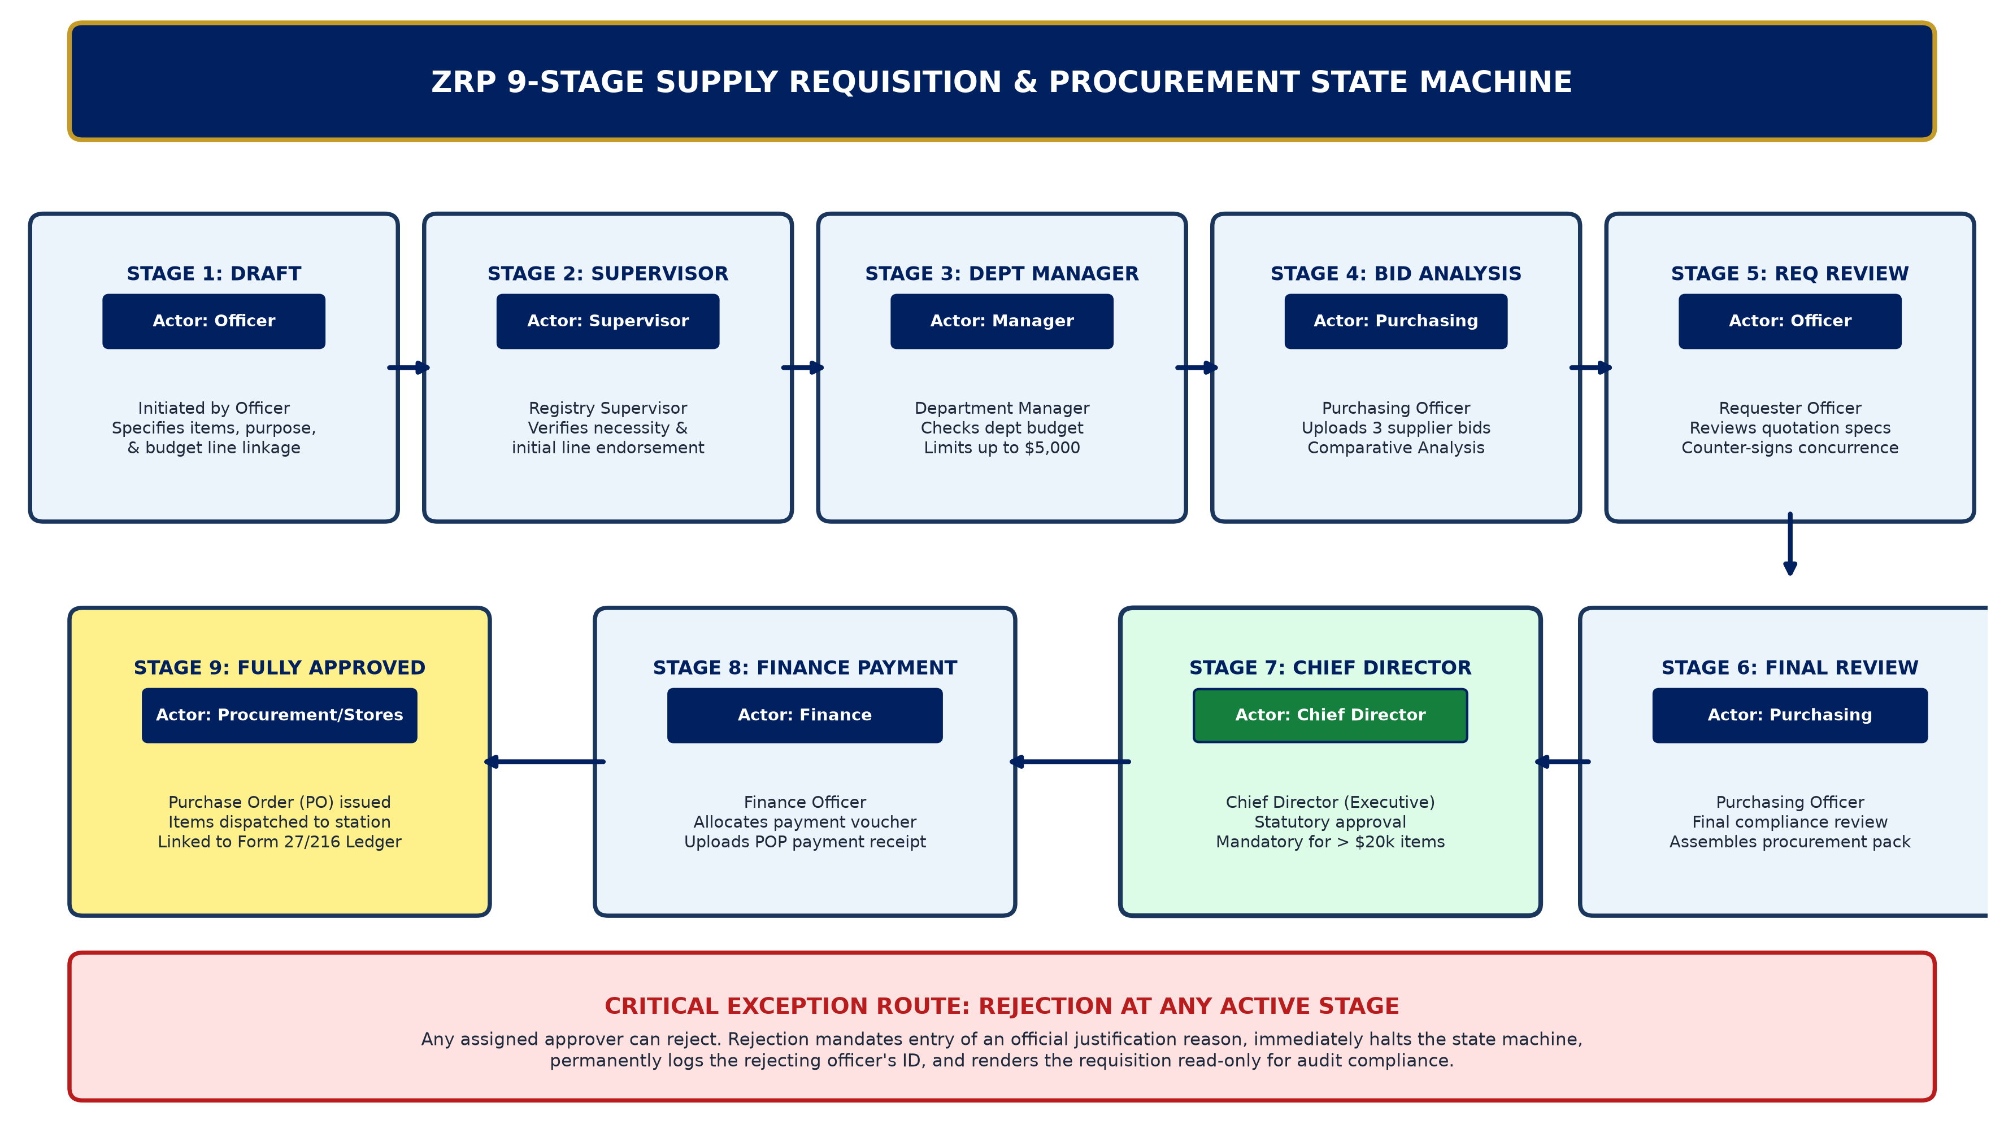
Figure 3: End-to-End 9-Stage Supply Requisition & Procurement State Machine
Stage # | State Descriptor | Action Authority | System Artifacts Produced
1 | Draft / Requisition Initiated | Requester (Duty Officer) | Item specifications, justification, budget line linkage
2 | Pending Supervisor | Registry Supervisor | Stage verification, supervisor signature
3 | Pending Dept Manager | Department Manager | Departmental budget verification & authorization
4 | Pending Purchasing (Bid Analysis) | Purchasing Officer | 3 Supplier Quotations upload, comparative bid analysis
5 | Pending Requester Review | Requester (Officer) | Requester concurrence & counter-signature on bids
6 | Pending Purchasing Final | Purchasing Officer | Final compliance certification & procurement package assembly
7 | Pending Chief Director | Chief Director | Executive statutory authorization & cryptographic approval stamp
8 | Pending Finance | Finance Officer | Payment voucher, bank allocation, proof-of-payment (POP) upload
9 | Fully Approved & Issued | Stores / Procurement Officer | Official Purchase Order (PO) document & Form 27/216 link

4.2. Leave Request & Electronic Approval Engine
The ZRP Leave Subsystem enables electronic submission and staged escalation for all statutory leave categories (Annual, Sick, Maternity, Special Duty, Compassionate). Applications route dynamically from the Officer to their designated Management Tier supervisor (Systems Manager, Supt ICT, or Chief Tech), through the supervising Deputy Director, up to the Chief Director for final ratification.

4.3. Records Digital Twin & Physical Archive Registry
Physical dockets and institutional files are assigned unique alpha-numeric identifiers (e.g., `ZRP-CR-2026-0041`) and physical Code-128 barcodes. The 'Digital Twin' engine logs every physical custody handover, borrower dispatch, temporary shelf location, and return audit. The system computes a real-time 'Resilience Score' reflecting docket completeness, condition, and inspection history.

4.4. Fixed Assets, Comms Hardware, & Goods Received Ledger
Asset tracking covers IT hardware, tactical comms (VHF radios, repeaters, base antennas), motor vehicles, and office machinery. Assets link directly to Goods Received Vouchers (Form 27 / Form 216). Automated depreciation routines support Straight-Line and Reducing-Balance models, while Board of Survey inspection modules govern statutory asset write-off and board condemnation.

5. Security Perimeter, Audit Trails, & Business Continuity
5.1. Authentication & Integrity Assurance
• Passwords stored using PBKDF2 with SHA-256 password hashing.
• Mandatory email token verification for newly created personnel accounts.
• Session expiry and brute-force lockouts with automated high-severity `SecurityAlert` event generation.
• Complete immutable movement logs capturing IP address, username, previous state, and timestamp.
5.2. Backup Strategy & High Availability Architecture
• Primary / Standby Datacenter Architecture: Daily hot database snapshot mirroring from PGHQ Central Servers to disaster recovery standby environments.
• Recovery Objectives: Recovery Time Objective (RTO) < 60 minutes; Recovery Point Objective (RPO) < 15 minutes.
• Local Station Caching: Client-side local data caching for critical form entries during intermittent WAN disruptions.

