ZIMBABWE REPUBLIC POLICE
NATIONAL POLICE HEADQUARTERS • ICT DIRECTORATE

TECHNICAL DESIGN DOCUMENT (TDD)
RIFTS-X Low-Level Technical Specifications, Database Schemas,
State Machine Determinism, Cryptographic Verification, & API Design

Document Classification | CONFIDENTIAL / LAW ENFORCEMENT SENSITIVE
System Release Baseline | RIFTS-X Master v2.4 (Django 5.2.7 / Python 3.13)
Target Audience | Systems Architects, Senior Developers, Database Administrators, Security Engineers
Engineering Overseer | Systems Manager (ICT Systems) & Deputy Director ICT
Executive Ratifier | Chief Director (PGHQ)
Publication Date | September 2026

1. Architectural Principles & Technology Specifications
This Technical Design Document defines the low-level implementation mechanics of RIFTS-X. The system adheres strictly to the following fundamental design paradigms:
1. Deterministic State Machines: Workflows such as Supply Requisitions and Leave Requests cannot skip stages, revert without reason, or accept unauthorized bypasses.
2. Zero-Trust Access Decorators: Every Django view is secured by strict role guards (`@role_required(...)`) and session boundary enforcers.
3. Cryptographic Signature Binding: Digital signatures are captured as vector paths or Base64 PNGs and bound to an SHA-256 verification hash recorded in the permanent audit trail.
4. Law Enforcement Audit Traceability: No critical record (asset, file docket, voucher, requisition) is physically deleted; all deletions employ logical soft-delete flags (`delete_flag = 1`) to preserve evidentiary integrity.
Component Layer | Technology / Library | Role & Engineering Responsibility
Core Backend Engine | Python 3.13.7 (64-bit) | Asynchronous runtime execution, cryptography, and process management.
Web Framework | Django 5.2.7 (MTV) | Object-Relational Mapping (ORM), session auth, template parsing, routing.
Document Generation | ReportLab 4.x + PyMuPDF | Cryptographic PDF generation, vector seals, signature embedding.
Frontend UI Framework | Bootstrap 5.3 + DataTables | Responsive interface, client-side pagination, sorting, search.
Barcode & Label Engine | python-barcode + qrcode | Code-128 physical docket and asset tag rendering.
Persistence Layer | SQLite 3 / PostgreSQL | Transactional relational datastore with strict foreign keys and indexation.

2. Access Control Architecture & RBAC Implementation
Role-Based Access Control is enforced by model-level profiles (`UserSecurity`), custom view decorators, and granular template context guards.
■ SECURITY COMPLIANCE: ROLE NOMENCLATURE PURITY
The system has been purged of corporate roles (such as 'CEO'). The official roles stored in UserSecurity.ROLES strictly match the ZRP hierarchy: Chief Director, Deputy Director ICT, Deputy Director Communications, Deputy Director IT, Systems Manager, Supt ICT, Chief Tech, Department Manager, Supervisor, General Police, Clerk, Provincial ICT Officer, and Auditor.

2.1. The `@role_required` Guard Mechanics
Implemented in `registry/views.py`: intercepts all requests prior to view execution. Superusers automatically bypass checks for administration. Non-superusers have their active `UserSecurity.role` evaluated against `allowed_roles`. If unauthorized, a high-severity `SecurityAlert` event is permanently recorded in the database before redirecting with an HTTP 403 / Access Denied notification.

3. Workflow State Machines & Business Logic Engines

3.1. 9-Stage Supply Requisition State Machine
Procurement requisitions (`SupplyRequisition`) transition deterministically across 9 states. Transitions are triggered exclusively via `supply_requisition_sign(request, pk, stage)` in `registry/views.py`.
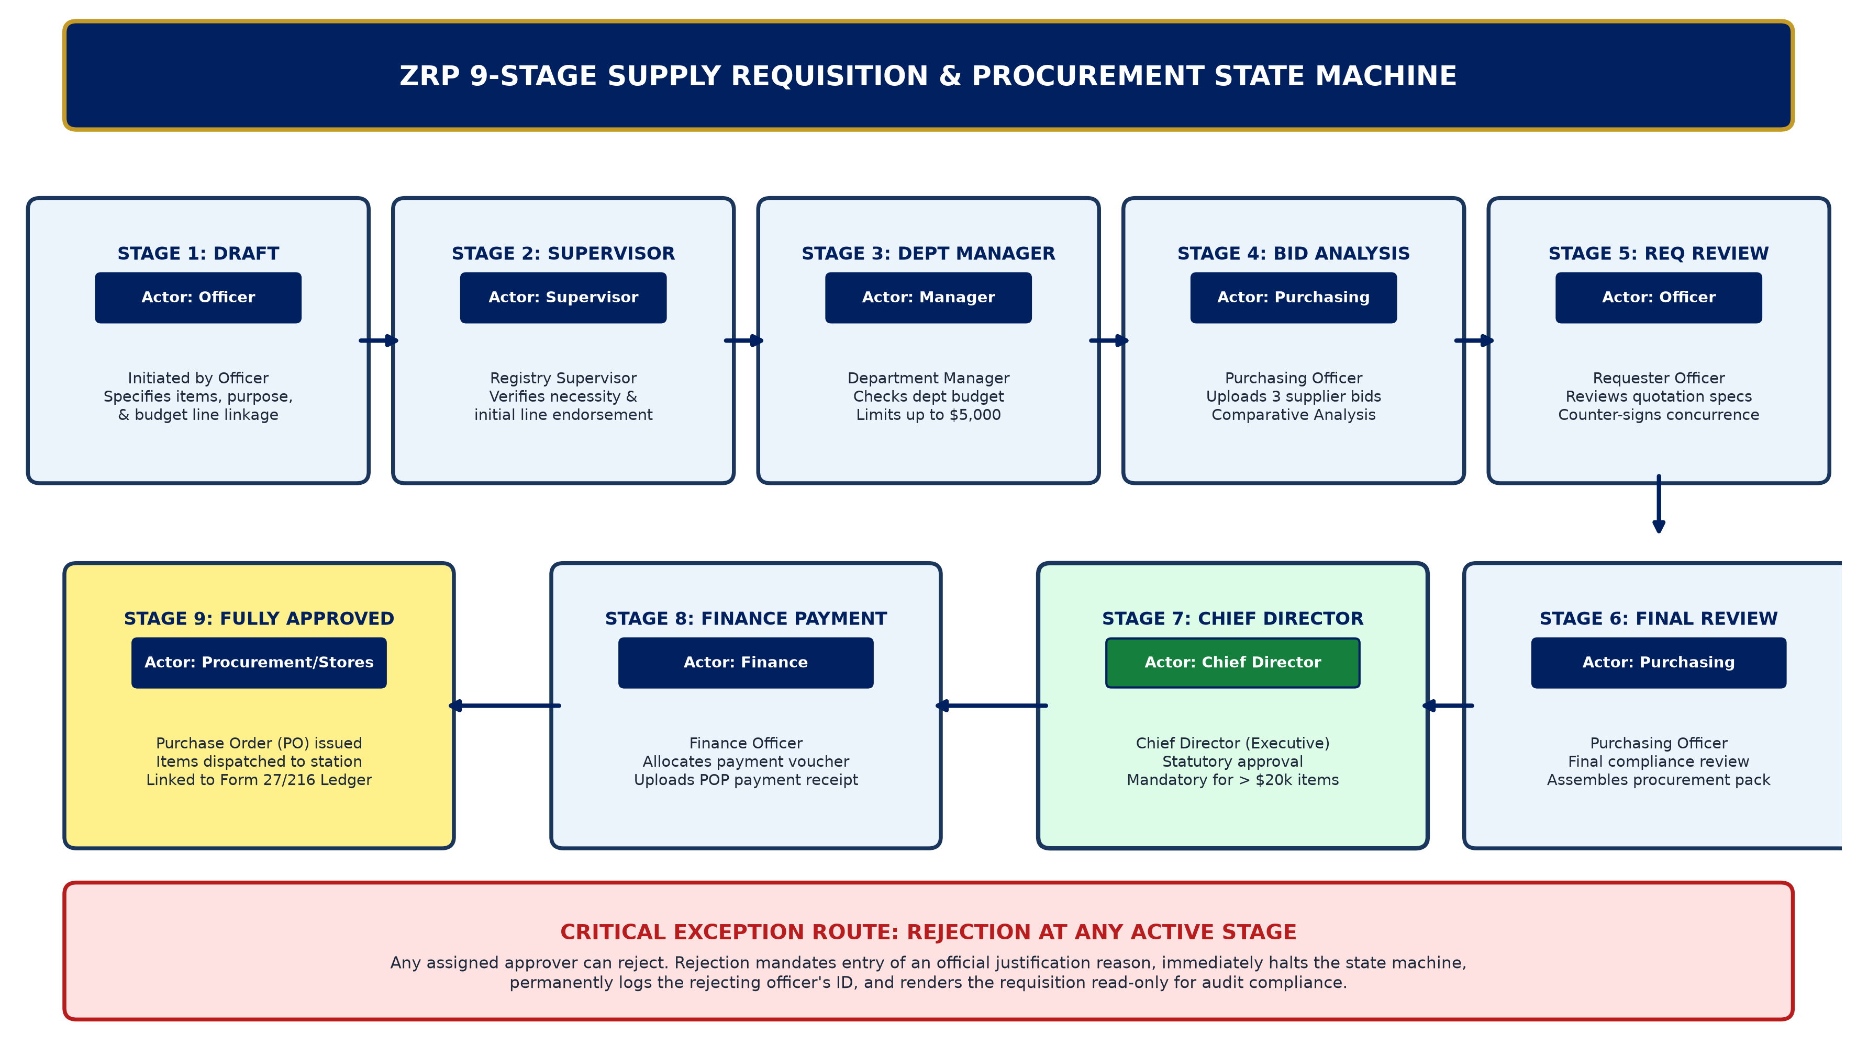
Figure 1: ZRP 9-Stage Deterministic Supply Requisition State Machine
Current State | Allowed Actor | Next State | Delegated Limit
Draft | Requester (Officer) | Pending Supervisor | No limit
Pending Supervisor | Registry Supervisor | Pending Dept Manager | No limit
Pending Dept Manager | Department Manager | Pending Purchasing | Up to $5,000
Pending Purchasing | Purchasing Officer | Pending Requester Review | Bid Comparative
Pending Requester Review | Requester | Pending Purchasing Final | Quote Concurrence
Pending Purchasing Final | Purchasing Officer | Pending Chief Director | Compliance Review
Pending Chief Director | Chief Director | Pending Finance | Above $20,000
Pending Finance | Finance Officer | Approved / Paid | Financial Voucher
Any Active State | Designated Stage Approver | Rejected | Audit Reason Mandated

3.2. Leave Escalation Engine (`LeaveRequest`)
Leave approval logic (`registry/models.py:LeaveRequest`) features dynamic supervisory routing:
• Stage 1 (Operational Submission): Officer submits request specifying category, date span, and handover contact.
• Stage 2 (Management Recommendation): Systems Manager (for systems personnel), Supt ICT (for hardware/station staff), or Chief Tech (for communications/radio technicians) reviews roster and operational availability.
• Stage 3 (Directorate Endorsement): Deputy Director ICT or Deputy Director Communications reviews recommendation.
• Stage 4 (Chief Director Ratification): Chief Director executes statutory electronic signature for national records.

4. Database Schema & ORM Model Architecture
Below is the comprehensive Entity Relationship Diagram (ERD) mapping the relational models, primary keys, foreign keys, and cardinalities in `registry/models.py`:
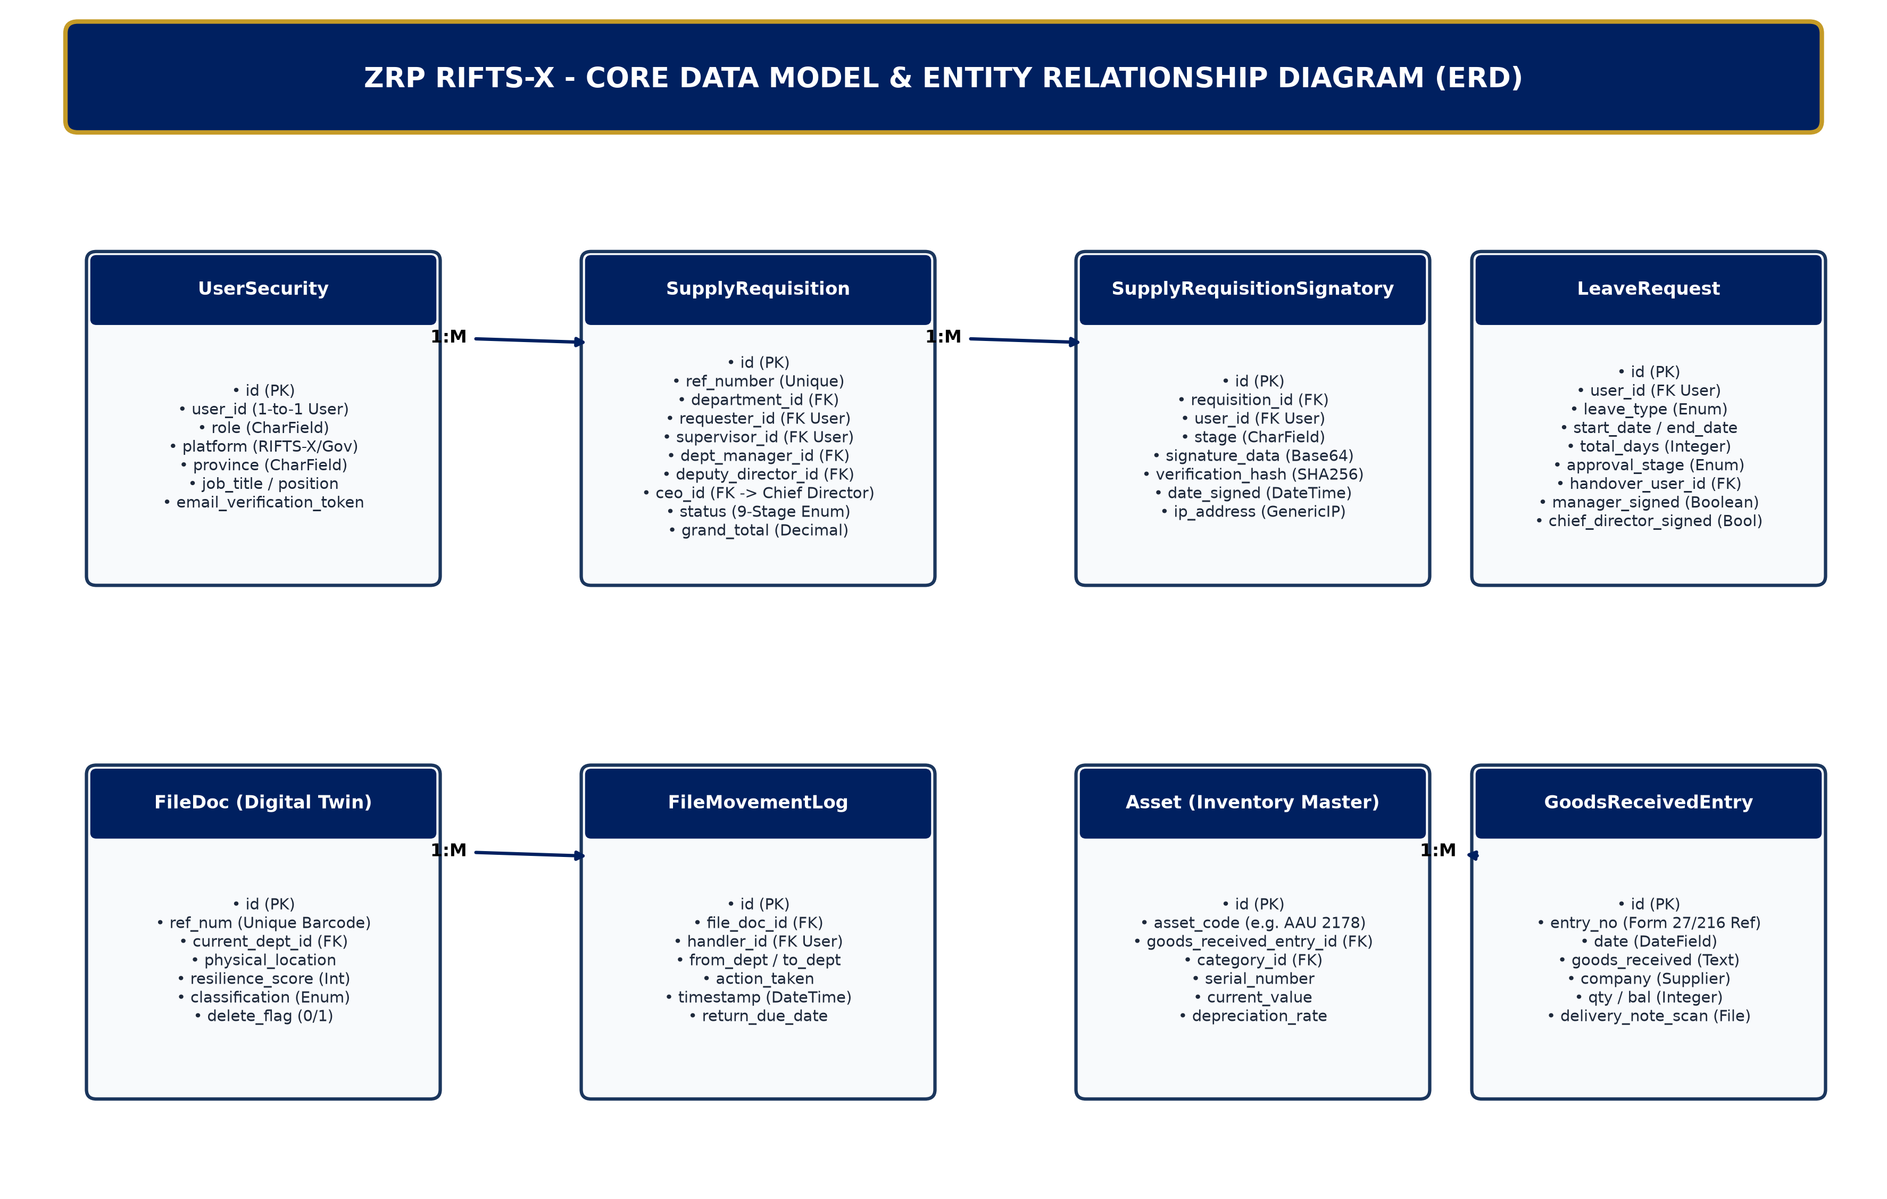
Figure 2: ZRP RIFTS-X Core Relational Entity Relationship Diagram (ERD)
4.1. `UserSecurity` (Profile & Command Extension)
• `user`: OneToOneField(User, on_delete=CASCADE, related_name='security_profile')
• `role`: CharField(max_length=50, choices=ROLES, default='Clerk')
• `platform`: CharField(choices=['RIFTS-X', 'Governance'], default='RIFTS-X')
• `province`: CharField(choices=PROVINCE_CHOICES, null=True, blank=True) - Assigned ZRP Province
• `job_title` / `position`: Personnel grade and official rank
• `email_verification_token`: UUID4 token for secure onboarding activation
4.2. `SupplyRequisition` & `SupplyRequisitionSignatory`
• `ref_number`: Unique sequential identifier formatted `ZRP-PR-YYYY-NNNN`
• Approver Foreign Keys: `supervisor`, `dept_manager`, `deputy_director`, `ceo` (verbose_name='Chief Director'), `purchasing_officer`, `finance_officer`
• `status`: CharField representing the 9-stage state machine
• `signatories`: Reverse FK to `SupplyRequisitionSignatory` recording `signature_data` (Base64 canvas string), `date_signed`, `verification_hash` (SHA-256), and `ip_address`
4.3. `Asset` & `GoodsReceivedEntry` (ZRP Form 27/216 Ledger)
• `asset_code`: Unique serial / asset tag (e.g. `AAU 2178`, `STK-0042`)
• `goods_received_entry`: FK to `GoodsReceivedEntry` capturing delivery note scan, supplier company, and invoice ref
• `depreciation_method`: Straight-Line or Reducing Balance with `depreciation_rate` and `current_value`
• `inspection_dossier`: Generated ReportLab dossier recording board survey inspections and disposal state

5. Cryptographic Signatures & PDF Output Engine
5.1. Electronic Signature Capture Pipeline
1. Client Canvas Interaction: User applies digital signature on responsive HTML5 Canvas.
2. Serialization: Canvas encodes to PNG Base64 string submitted via POST with CSRF header token.
3. Verification Hash: Server constructs payload string: `{user.username}|{stage}|{timestamp}|{requisition.ref_number}` and executes `hashlib.sha256(payload.encode()).hexdigest()`.
4. Storage: Persisted in `SupplyRequisitionSignatory.verification_hash` for immutable third-party audit verification.
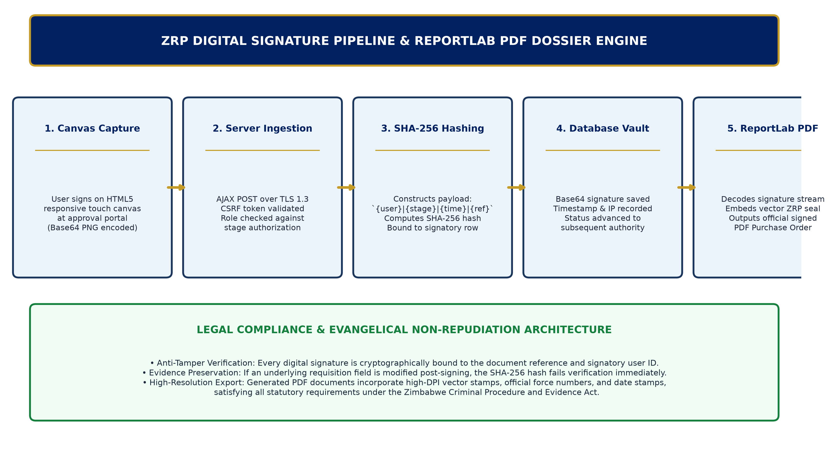
Figure 3: Digital Signature Cryptographic Pipeline & ReportLab PDF Dossier Engine
5.2. ReportLab PDF Generation Architecture
Implemented in `registry/views.py:print_supply_requisition_dossier`: renders high-resolution, vector-crisp PDF documents. Embeds official ZRP crest, multi-column line-item tables, financial summaries, and dynamically rendered signature images retrieved from Base64 decoded image streams with exact bounding box scaling.

6. RESTful API Blueprint & System Resilience
RIFTS-X provides RESTful endpoints mediated by Django REST Framework (`registry/api_views.py` and `serializers.py`):
• `/api/requisitions/`: Query requisition statuses and signatory timelines.
• `/api/assets/`: Barcode lookup and status inquiry for mobile scanner terminals.
• `/registry/collaboration/notifications/`: Lightweight polling endpoint delivering real-time task notifications.
All API endpoints mandate Token Authentication or active Django session cookies with CSRF validation.

