ZIMBABWE REPUBLIC POLICE
NATIONAL POLICE HEADQUARTERS • ICT QUALITY ASSURANCE WING

USER ACCEPTANCE TESTING (UAT)
TEST CASES & VERIFICATION MATRIX
Comprehensive Operational Acceptance Scenarios for RIFTS-X Master
Hierarchy Verification, Procurement Workflows, Leave Routing, & Ledger Auditing

Test Document Ref | ZRP-UAT-RIFTSX-2026-V1
Software Baseline | RIFTS-X Master Production Release v2.4
Lead QA Evaluator | Systems Manager (ICT Systems) & Supt ICT
Directorate Overseer | Deputy Director ICT & Deputy Director Communications
Final Acceptance Authority | Chief Director (PGHQ)
Testing Cycle | National Final Acceptance Testing (FAT/UAT) - September 2026

1. UAT Governance, Methodology & Acceptance Criteria
This User Acceptance Testing (UAT) document provides the definitive verification matrix for certifying the RIFTS-X system prior to full national deployment across Zimbabwe Republic Police stations and directorates.
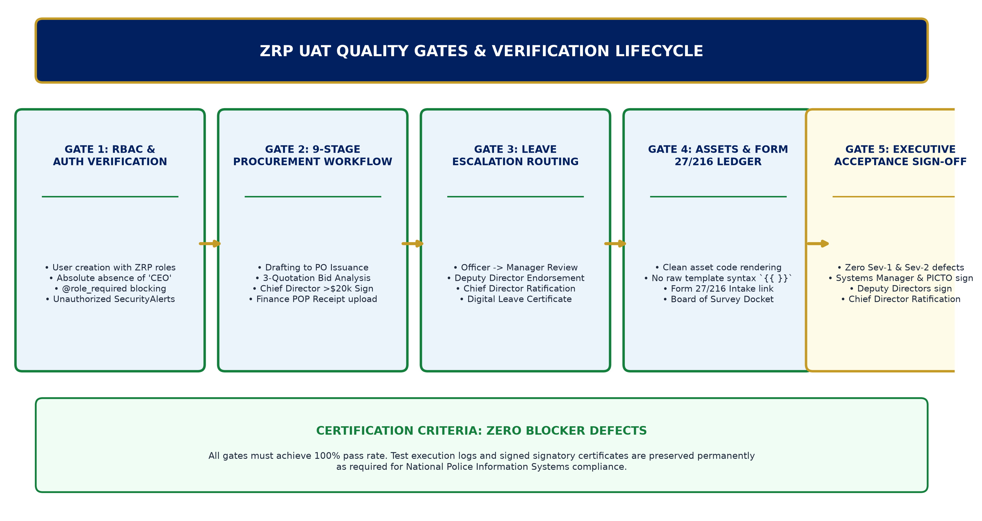
Figure 1: ZRP UAT Quality Gates & Verification Lifecycle
1.1. Defect Severity Classifications:
• Severity 1 (Blocker/Critical): Prevents statutory escalation, halts procurement or leave approvals, corrupts data, or exposes security bypass.
• Severity 2 (Major): Core feature impaired without administrative workaround.
• Severity 3 (Moderate): Operational inconvenience with established workaround; workflow proceeds.
• Severity 4 (Minor/Cosmetic): UI alignment, typography, or styling discrepancy.
■ CERTIFICATION THRESHOLD
System sign-off requires 100% execution of all Critical and Major test cases with Zero (0) open Severity 1 or 2 defects. In particular, all test cases validating the absence of corporate terms (CEO) and strict adherence to the ZRP command hierarchy (Chief Director, Deputy Directors, Systems Manager, Supt ICT, Chief Tech) must pass unconditionally.

2. Test Suite 1: Authentication & Command Hierarchy RBAC
Test Case ID | Test Scenario | Execution Steps & Input Data | Expected Result
TC-AUTH-01 | Add User with Official ZRP Hierarchy Role | 1. Login as authorized Admin / Supervisor  2. Navigate to System Users -> Add New User  3. Select 'Chief Director', 'Deputy Director ICT', or 'Systems Manager'  4. Fill form & submit. | User account is created successfully. Verification token generated. System Role reflects chosen ZRP command rank. 'CEO' is not selectable in the dropdown.
TC-AUTH-02 | Enforce @role_required View Guards | 1. Login as General Police Officer  2. Attempt direct browser URL navigation to `/users` and `/manage_user`. | Access is denied immediately. User is redirected to home dashboard. High-severity SecurityAlert logged in audit log.
TC-AUTH-03 | Chief Director Strategic Dashboard Access | 1. Login as Chief Director  2. Access `/registry/dashboard/ceo/`. | Dashboard loads successfully with title 'Chief Director Strategic Dashboard'. Shows pending national requisitions and spend metrics.
TC-AUTH-04 | Elimination of 'CEO' Terminology | 1. Inspect Add User modal, Registration form, and Requisition Movement Tracker. | Zero occurrences of 'CEO'. Role appears as 'Chief Director (Executive Oversight - All)' across all screens.

3. Test Suite 2: Supply Requisition & Multi-Stage Procurement Engine
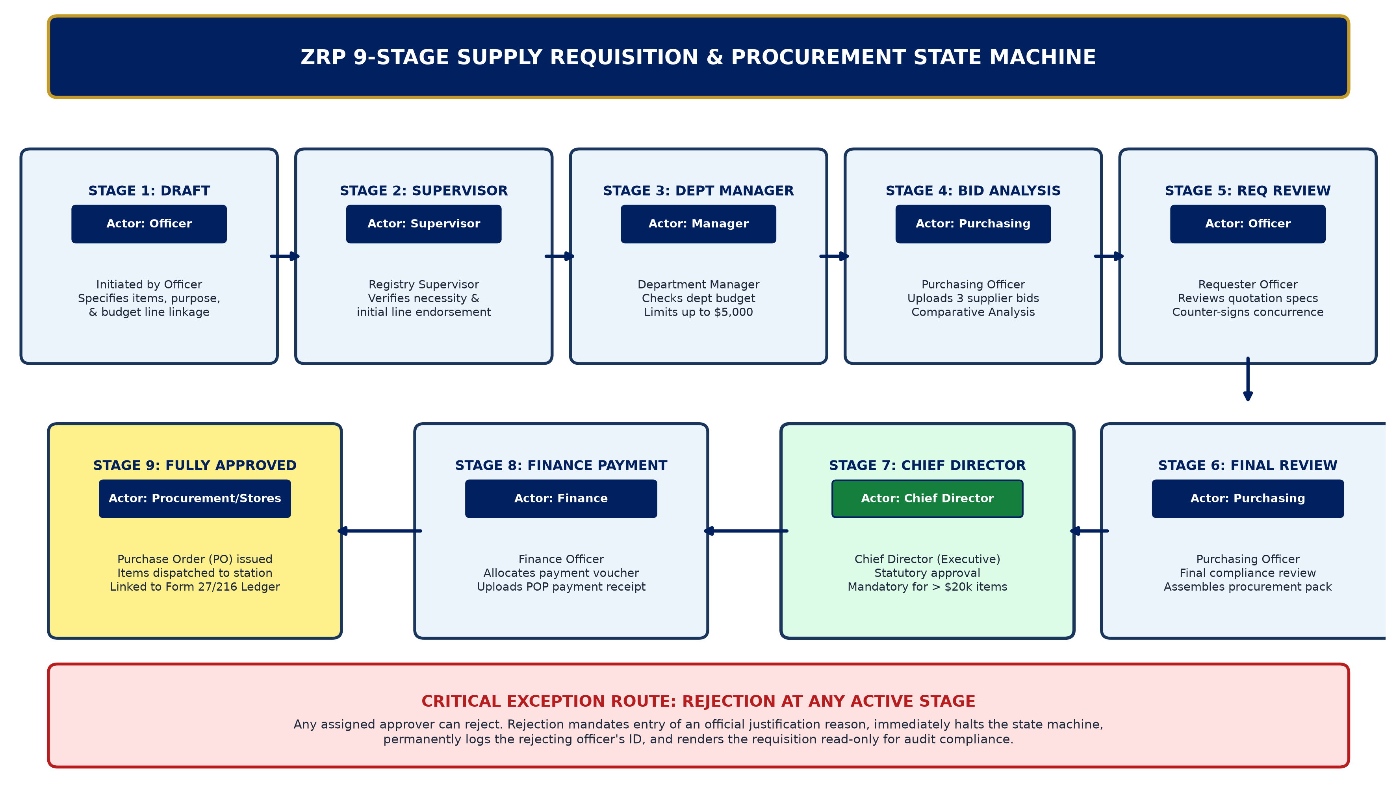
Figure 2: ZRP 9-Stage Supply Requisition & Procurement Workflow Test Coverage Map
Test Case ID | Test Scenario | Execution Steps & Input Data | Expected Result
TC-PROC-01 | Requisition Initiation by Duty Officer | 1. Login as General Police Officer  2. Create Supply Requisition for computer equipment ($25,000.00)  3. Submit with purpose and budget line. | Requisition created with ref `ZRP-PR-YYYY-NNNN`. Initial status transitions to 'Pending Supervisor'.
TC-PROC-02 | Stage 2: Supervisor Approval | 1. Login as assigned Registry Supervisor  2. Open requisition view  3. Click 'Approve & Sign (Supervisor)'  4. Apply signature on canvas & submit. | Signature saved. Status transitions to 'Pending Dept Manager'. Signatory audit entry recorded with SHA-256 hash.
TC-PROC-03 | Stage 3: Department Manager Approval | 1. Login as Department Manager  2. Verify departmental allocation  3. Click 'Approve & Sign (Dept Manager)'. | Department Manager approval committed. Status transitions to 'Pending Purchasing'.
TC-PROC-04 | Stage 4: PO Bid Analysis & 3 Quotes Upload | 1. Login as Purchasing Officer  2. Upload 3 separate supplier quotation documents  3. Fill Bid Analysis recommendation  4. Sign & submit. | Quotations attached. Comparative bid analysis saved. Status transitions to 'Pending Requester Review'.
TC-PROC-05 | Stage 5: Requester Review & Concurrence | 1. Login as original Requester  2. Review selected supplier bid  3. Sign concurrence. | Requester signature captured. Status transitions to 'Pending Purchasing Final'.
TC-PROC-06 | Stage 6: PO Final Compliance Package | 1. Login as Purchasing Officer  2. Perform final compliance audit  3. Execute Stage 6 sign-off. | Procurement package finalized. Status transitions to 'Pending CEO' (routed to Chief Director).
TC-PROC-07 | Stage 7: Chief Director Statutory Approval | 1. Login as Chief Director  2. Open Requisition awaiting executive signature  3. Verify total > $20,000  4. Click 'Approve & Sign (Chief Director)'. | Chief Director electronic signature captured. Status advances to 'Pending Finance'. Executive authorization badge displayed.
TC-PROC-08 | Stage 8: Finance Payment & Proof of Payment | 1. Login as Finance Officer  2. Verify Chief Director signature  3. Upload Proof of Payment (POP) receipt  4. Sign payment authorization. | Payment status updated to 'Paid'. Requisition status transitions to 'Approved'. Purchase Order number generated.
TC-PROC-09 | Rejection Handling with Audit Reason | 1. At any active stage (e.g. Dept Manager), click 'Reject Requisition'  2. Attempt submit without reason  3. Provide valid reason 'Budget Depleted'. | Form enforces mandatory reason. Status becomes 'Rejected'. Rejection reason permanently displayed on banner with rejected_by user tag.
TC-PROC-10 | ReportLab Cryptographic Dossier Printing | 1. Open fully approved requisition  2. Click 'Print Dossier / Purchase Order'. | Crisp vector PDF generates with official ZRP Crest, full line items, and all embedded digital signatures with audit timestamps.

4. Test Suite 3: Leave Requests & Electronic Approval Workflow
Test Case ID | Test Scenario | Execution Steps & Input Data | Expected Result
TC-LEAV-01 | Officer Leave Application Submission | 1. Login as Duty Officer  2. Submit Leave Request: Annual Leave, 14 days  3. Specify handover officer. | Request saved. Status set to 'Pending Management Review'. System validates that requested days do not exceed leave balance.
TC-LEAV-02 | Management Tier Review (Systems Manager / Supt ICT / Chief Tech) | 1. Login as Systems Manager (or Supt ICT / Chief Tech)  2. Review duty roster  3. Endorse application with electronic signature. | Management endorsement recorded. Application routes to supervising Deputy Director.
TC-LEAV-03 | Deputy Director Recommendation | 1. Login as Deputy Director ICT (or Communications)  2. Review application and operational impact  3. Sign approval recommendation. | Directorate recommendation recorded. Request escalates to Chief Director.
TC-LEAV-04 | Chief Director Final Leave Ratification | 1. Login as Chief Director  2. Review complete supervisory chain  3. Execute final executive approval. | Status transitions to 'Approved'. Officer notified. Official Leave Certificate available for printing.

5. Test Suite 4: Fixed Assets & Goods Received Ledger (Form 27/216)
Test Case ID | Test Scenario | Execution Steps & Input Data | Expected Result
TC-ASST-01 | Asset Registration & Code Rendering | 1. Login as Stores / Asset Officer  2. Register new asset 'Lenovo ThinkCentre M70'  3. Set code `AAU 2178`  4. View asset list. | Asset code renders properly as clean badge `AAU 2178`. No raw template syntax `{{ asset.asset_code }}` displayed.
TC-ASST-02 | ZRP Form 27/216 Goods Received Linkage | 1. Navigate to Goods Received Ledger  2. Create entry: 10x VHF Handheld Radios from Supplier  3. Link new Asset to this entry. | Intake voucher reference `REC-STK-XXXX` created. Supplier invoice and delivery note scan attached to asset master.
TC-ASST-03 | Depreciation Schedule Execution | 1. Open Asset Depreciation Ledger  2. Run Straight-Line depreciation calculation. | Monthly depreciation values computed accurately. Book value adjusted in ledger table.
TC-ASST-04 | Board of Survey Condemnation Workflow | 1. Select unserviceable tactical equipment  2. Initiate Board of Survey inspection docket  3. Record Board recommendations. | Board of Survey docket generated. Official Condemnation Certificate rendered with Board member signatory fields.

6. Official UAT Acceptance & Operational Sign-off Certificate
By signing below, the evaluation authorities certify that the RIFTS-X Master Platform has been thoroughly tested against the specified operational requirements, the ZRP command hierarchy has been strictly validated, and the system is certified ready for national operational commissioning across Zimbabwe Republic Police formations.
Evaluation Authority | Officer Name & Force # | Signature | Date
Lead Systems Architect | Systems Manager (ICT Systems) | ________________ | ____/____/2026
Provincial ICT Representative | Provincial ICT Officer (PICTO) | ________________ | ____/____/2026
Directorate Authority (Comms) | Deputy Director Communications | ________________ | ____/____/2026
Directorate Authority (ICT) | Deputy Director ICT | ________________ | ____/____/2026
Executive Command Authority | Chief Director (PGHQ) | ________________ | ____/____/2026

