AI GRAND CHALLENGE 2026

Track 3 – Development

COGNIFY

An AI-Powered Cognitive Operating System for Future Skills Development, Workforce Reskilling and Lifelong Learning

Official Proposal
Submitted To:
Artificial Intelligence Grand Challenge 2026 Evaluation Committee
Track:
Track 3 – Development
Prepared By:
Takudzwa Emmanuel Kuwenyi
Project Name:
Cognify
Project Category:
Artificial Intelligence for Future Skills, Education and Workforce Development
Lead Institution:
Artificial Intelligence Institute Africa (AIIA)
Country:
Zimbabwe
Submission Date:
July 2026

Section 1: Problem Definition and Strategic Alignment

Problem Definition

1. One-Size-Fits-All Education
Zimbabwe's education system largely follows a standardized teaching model that assumes all learners acquire knowledge in the same way and at the same pace. In reality, learners have different abilities, learning styles, languages, interests, cognitive strengths, and career aspirations. This approach reduces learner engagement, limits knowledge retention, and fails to develop each individual's full potential.

2. Traditional E-Learning is dead
Conventional e-learning platforms have become static repositories of digital content rather than intelligent learning environments. They do not learn from user interactions, adapt to changing learner needs, or develop purpose, reasoning, and judgment. These systems assume that intelligence exists only in humans while machines simply execute predefined tasks. As a result, they fail to deliver personalized learning experiences or prepare learners for an AI-driven world.As Zimbabwe embraces Artificial Intelligence under its National AI Strategy, there is a need to move beyond conventional e-learning towards cognitive learning systems that continuously learn and evolve.

3. Unequal Access to Quality Education
Access to high-quality education remains unequal due to geographic location, shortages of qualified educators, infrastructure limitations, language barriers, and socioeconomic challenges. Millions of learners are unable to receive the same quality of education as those in well-resourced institutions, limiting opportunities for lifelong learning and workforce development.

4. Rising Cost of Education
The rising cost of education continues to exclude many learners and places significant financial pressure on families, institutions, and governments. Traditional education models require substantial investments in physical infrastructure, teaching resources, and human capital, making it difficult to scale quality education. There is a need for an intelligent platform capable of delivering personalized cognitive growth at near-zero marginal cost while maintaining high educational quality.

Target Users and Beneficiaries
Cognify is designed for learners, educators, schools, universities, TVET institutions, government ministries, corporate organisations, researchers, and workforce development agencies. By serving both formal education and professional training, the platform supports lifelong learning, digital skills development, and national human capital growth.

Proposed Solution
With Cognify, we are not using content to teach, but we are reorganizing intelligence so we use to develop the learner cognitive abilities. Cognify is a self-adaptive cognitive intelligence platform that delivers personalized learning for every individual, anytime and anywhere. Unlike traditional e-learning systems, it continuously learns from every interaction to develop cognitive intelligence rather than simply delivering digital content.
The platform is powered by IntelliNexus, which transforms learner interactions into structured datasets that enable continuous AI learning, institutional intelligence, and adaptive personalization. NeuroWorks provides intelligent digital workers and agentic AI that automate tutoring, mentoring, research, assessments, career guidance, and institutional workflows through intelligent process orchestration. Together, these platforms create a continuously evolving cognitive ecosystem capable of simultaneously developing human and machine intelligence.

Strategic Alignment
Cognify directly supports Zimbabwe's National Artificial Intelligence Strategy and Vision 2030 by advancing AI-powered education, digital transformation, workforce development, research and innovation, and the commercialization of locally developed AI technologies. By providing personalized cognitive learning, intelligent workforce reskilling, and universal access to quality education at near-zero marginal cost, Cognify contributes to building a highly skilled, AI-ready workforce capable of driving Zimbabwe's transition to a knowledge-based digital economy.

Expected Impact
Cognify transforms education from static content delivery into continuous cognitive development. Through personalized AI tutoring, intelligent digital workers, adaptive learning, and data-driven decision-making, it improves learning outcomes, expands access to quality education, reduces educational costs, strengthens workforce readiness, and creates a sustainable national AI-powered learning ecosystem for Zimbabwe. Its vision is personalized cognitive growth for every learner, delivered at near-zero marginal cost.

Section 2: Technical Design and Product Logic

2.1 Technical Design and System Architecture
Cognify is a cloud-native, multi-tenant cognitive intelligence platform designed to deliver personalised education, workforce development, research, and lifelong learning at national scale. The platform adopts a modular architecture comprising a React web application, FastAPI backend services, MongoDB data layer, AI services, and external intelligent service integrations. This architecture enables independent scaling, maintainability, and secure interoperability through RESTful APIs.
The platform is organised into four core intelligent platforms. Cognify provides the learner-facing cognitive environment, IntelliNexus continuously transforms learner interactions, institutional activities, assessments, and educational content into structured datasets for analytics and continuous AI learning, while NeuroWorks orchestrates intelligent digital workers that automate tutoring, mentoring, research assistance, content generation, and institutional workflows. These components operate together as a unified cognitive ecosystem rather than isolated AI services.
The backend is implemented using FastAPI, asynchronous services, modular routers, middleware, and service layers, while the frontend is developed using React, Tailwind CSS, React Router, Context API, and Axios. MongoDB provides a flexible document database supporting learner profiles, knowledge graphs, AI memory, mentor conversations, courses, institutional records, research repositories, and analytics.

2.2 Artificial Intelligence Architecture and Model Justification
Artificial intelligence is embedded throughout Cognify rather than implemented as a single chatbot. The platform combines Large Language Models (GPT-5.2), Retrieval-Augmented Generation (RAG), Knowledge Graphs, recommendation systems, multilingual AI, speech synthesis, avatar technologies, predictive analytics, and generative AI to create an adaptive cognitive learning environment.
NeuroWorks functions as the AI orchestration layer, intelligently selecting and coordinating AI services for tutoring, mentoring, career guidance, research, translation, content generation, and workflow automation. Instead of relying on one model, NeuroWorks dynamically routes requests to the most appropriate AI capability, improving performance, cost efficiency, and scalability.
IntelliNexus continuously generates structured datasets from learner behaviour, assessments, institutional operations, and educational resources. These datasets support continuous model improvement, adaptive learning, predictive analytics, workforce intelligence, and institutional decision-making.
AI Memory preserves learner history, preferences, competencies, language settings, and career interests, while Knowledge Graphs model relationships between concepts, skills, and learning pathways. Combined with RAG, these technologies produce explainable, context-aware responses grounded in trusted educational resources while reducing hallucinations.

2.3 Technology Stack and Data Architecture
Cognify is developed using React 19, FastAPI, Python 3.11, MongoDB, Motor, JWT, OAuth 2.0, REST APIs, Docker, and Kubernetes. The platform integrates with GPT-5.2 through Emergent Integrations, Gemini Nano for image generation, ElevenLabs for voice synthesis, HeyGen for avatar generation, Zoom, Stripe, Paynow, AWS S3, LinkedIn APIs, and multilingual AI services.
The data architecture is managed by IntelliNexus and consists of learner profiles, courses, assessments, AI Memory, Knowledge Graphs, mentor conversations, institutional records, analytics datasets, research repositories, multilingual content, and cloud object storage. This continuously evolving intelligence layer enables personalised learning, institutional analytics, and future AI model training.

2.4 API Integration and Intelligent Services
Cognify follows an API-first architecture that enables seamless integration with Student Information Systems, Learning Management Systems, Human Resource platforms, digital libraries, payment gateways, video conferencing platforms, cloud storage, and government digital services.
External AI services are exposed through modular service layers, allowing institutions to integrate AI tutoring, avatar teachers, multilingual translation, voice synthesis, research intelligence, certification services, and intelligent workflow automation into existing educational environments. IntelliNexus APIs provide analytics and dataset services, while NeuroWorks APIs expose digital workers and AI process orchestration capabilities.

2.5 Security, Deployment and Scalability
Security is implemented using a defence-in-depth architecture incorporating Role-Based Access Control (RBAC), JWT authentication, OAuth 2.0, HTTPS encryption, secure file validation, audit logging, automated backups, disaster recovery, and continuous monitoring. Multi-tenant isolation ensures institutional data remains securely separated while enabling shared cloud infrastructure.
The platform is containerised using Docker and designed for Kubernetes orchestration, enabling horizontal scaling, load balancing, distributed storage, Redis caching, CDN integration, and GPU-enabled AI inference. Deployment within the Zimbabwe Centre for High Performance Computing (ZCHPC) supports high-performance AI workloads while maintaining national data sovereignty through private cloud infrastructure.

2.6 AI Justification
Artificial intelligence is fundamental to Cognify because conventional software cannot continuously learn from user interactions, personalise education, reason across knowledge domains, generate adaptive educational content, or orchestrate intelligent workflows.
Cognify combines three complementary AI platforms: Cognify delivers personalised cognitive learning, IntelliNexus continuously generates datasets and institutional intelligence for AI improvement, and NeuroWorks deploys intelligent digital workers that automate educational and administrative processes. Together, they create a self-improving cognitive ecosystem capable of simultaneously developing human intelligence and machine intelligence. This architecture supports personalised cognitive growth, workforce transformation, and universal access to quality education at near-zero marginal cost, directly aligning with Zimbabwe's National AI Strategy and the objectives of the AI Grand Challenge.
Below is a rewritten Section 3 that aligns with your new Cognify Enterprise Architecture (Experience Layer, AI Cognitive Core, IntelliNexus, NeuroWorks, Integration Layer, Infrastructure & Security Layer, Continuous Intelligence Improvement Loop). Each deliverable is presented as a subheading with explanatory paragraphs, making it consistent with the rest of your proposal.

Section 3: Deliverables and CCE Implementation Roadmap

3.1 AI-Powered Cognitive Learning Platform
The primary deliverable is the development of the Cognify Learning & Intelligence Platform, a cloud-native AI-powered cognitive learning environment accessible through a web portal, mobile application, AI chatbot, voice interface, avatar teacher, live classes, and APIs. The platform provides learners, educators, researchers, employers, institutions, government agencies, and developers with a unified digital ecosystem for learning, teaching, research, and workforce development.
Core learning services include the AI Tutor, AI Mentor, Learning Paths, Courses, Assessments, Live Classes, Certifications, and a Digital Resource Library. These services deliver personalised learning experiences tailored to each learner's knowledge level, learning behaviour, language preference, and career goals.

3.2 AI Cognitive Core
A major deliverable is the implementation of the AI Cognitive Core, which serves as the intelligence engine of Cognify. Rather than relying on a single Large Language Model, the platform combines multiple AI technologies including Prompt Processing, Retrieval-Augmented Generation (RAG), Knowledge Graphs, Natural Language Processing (NLP), Memory Management, and Reasoning Engines.
The AI Cognitive Core continuously analyses learner interactions to generate personalised recommendations, predictive analytics, adaptive learning pathways, and contextual responses. By combining AI Memory with Knowledge Graphs and RAG, Cognify produces explainable, context-aware, and reliable outputs while significantly reducing hallucinations.

3.3 NeuroWorks Agentic AI Engine
Another key deliverable is the deployment of NeuroWorks, the platform's Agentic AI Engine responsible for intelligent automation and workflow orchestration. NeuroWorks coordinates specialised AI agents, including the AI Tutor Agent, Curriculum Agent, Assessment Agent, Research Agent, Skills Agent, Recommendation Agent, Quality Assurance Agent, Administrator Agent, Marketplace Agent, and Dataset Agent.
An intelligent Agent Orchestrator determines which AI agent or combination of agents should execute each task. This enables Cognify to automate tutoring, curriculum generation, assessment creation, research assistance, skills mapping, recommendations, administrative workflows, and institutional operations while keeping humans in control of critical decisions.

3.4 IntelliNexus Data Intelligence and Dataset Factory
Cognify delivers IntelliNexus, a dedicated Data Intelligence and Dataset Factory that transforms operational platform data into strategic intelligence. IntelliNexus manages the complete data lifecycle through data collection, cleaning, validation, processing, anonymisation, enrichment, storage, and feature engineering.
The platform maintains a Data Lake, Data Warehouse, and Feature Store, enabling continuous generation of structured datasets from learner interactions, institutional activities, assessments, skills development, career progression, and educational content.
Generated datasets support adaptive learning, institutional analytics, predictive intelligence, workforce planning, AI model improvement, and future research. IntelliNexus also includes a secure Dataset Marketplace for dataset cataloguing, licensing, API access, usage analytics, and revenue tracking.

3.5 Intelligence Modules
Cognify provides a suite of intelligence modules that extend learning beyond traditional education. These include Skills Intelligence, Career Intelligence, Learning Analytics, Recommendation Engine, Personalisation Engine, Research Intelligence, and Knowledge Graph Services.
Together, these modules analyse learner performance, identify knowledge gaps, recommend learning pathways, predict future skills demand, support career planning, and provide institutions with real-time educational intelligence for evidence-based decision-making.

3.6 AI Content Studio
The platform includes an integrated AI Content Studio that enables educators and institutions to automatically create and transform educational content. AI services generate presentations, quizzes, assessments, videos, audio lessons, multilingual translations, research summaries, and personalised learning materials.
This significantly reduces educator workload while improving content quality, accessibility, and consistency across institutions.

3.7 Administration and Institutional Management
Cognify delivers a comprehensive administration environment supporting User Management, Institution Management, Roles and Permissions, Reports and Dashboards, Notifications, Audit Logs, and System Configuration.
These capabilities enable schools, universities, TVET institutions, enterprises, and government agencies to manage users, monitor learning performance, generate reports, and administer the platform securely within a multi-tenant environment.

3.8 API Integration and External Connectivity
Cognify follows an API-first architecture through an Integration Layer consisting of an API Gateway, REST APIs, GraphQL Services, authentication services, notification services, and external AI APIs.
This enables seamless integration with Learning Management Systems (LMS), Enterprise Resource Planning (ERP) platforms, government systems, Student Information Systems, research repositories, third-party educational platforms, and future digital services without replacing existing institutional infrastructure.

3.9 Infrastructure, Security and Deployment
The platform is deployed on a cloud-native infrastructure using Docker containers, Kubernetes orchestration, CI/CD pipelines, PostgreSQL databases, Redis caching, object storage, monitoring services, and automated backup systems.
Security is implemented through encrypted communication, Role-Based Access Control (RBAC), JWT authentication, audit logging, secure APIs, continuous monitoring, disaster recovery, and compliance with Zimbabwe's Data Protection Act. The modular architecture supports horizontal scaling and high availability for national deployment.

3.10 Continuous Intelligence Improvement Loop
Unlike conventional e-learning platforms, Cognify continuously improves itself through a Continuous Intelligence Improvement Loop. Every learner interaction generates behavioural data that IntelliNexus converts into structured datasets and Knowledge Graphs.
These datasets are used to retrain AI models, improve recommendations, strengthen reasoning capabilities, enhance personalisation, and deliver increasingly intelligent learning experiences. As more users interact with the platform, both human intelligence and machine intelligence improve simultaneously, creating a self-learning cognitive ecosystem.

3.11 Development Roadmap and ZCHPC CCE Implementation
Implementation follows a phased roadmap beginning with platform optimisation, AI model integration, and infrastructure preparation. The second phase focuses on pilot deployments in selected schools and universities to validate functionality, AI performance, and user adoption. Subsequent phases expand deployment across educational institutions, enterprises, and government agencies before positioning Cognify as Zimbabwe's national AI-powered learning infrastructure.
Deployment within the Zimbabwe Centre for High Performance Computing (ZCHPC) Cloud Computing Environment (CCE) will utilise GPU-enabled computing for AI inference, containerised microservices, secure databases, and scalable cloud infrastructure. Testing will include functional validation, AI accuracy, RAG performance, API integration, security assessment, scalability testing, and disaster recovery to ensure production readiness for national deployment.

Section 4: Compliance and Risk Mitigation

4.1 Ethical Safeguards and Responsible AI Framework
Cognify is designed around Responsible AI principles to ensure that artificial intelligence is transparent, fair, secure, and beneficial to society. The platform is built to augment human capability rather than replace educators or institutional decision-makers. Teachers remain responsible for teaching, assessment, and learner support, while AI provides recommendations, personalised learning, and analytical assistance.
The platform applies Human Oversight, Transparency, Fairness, and Privacy by Design. AI-generated recommendations are supported by explainable processes and trusted educational resources through Retrieval-Augmented Generation (RAG), reducing inaccurate outputs and improving reliability.
Cognify promotes inclusive education through multilingual AI support, adaptive learning, and personalised instruction for learners across different geographic and socioeconomic backgrounds. Data collection is limited to what is required for educational personalisation, analytics, and institutional improvement.
AI is implemented only where it provides measurable value. Unlike traditional software, Cognify uses AI to personalise learning, generate adaptive content, provide intelligent tutoring, support career guidance, and continuously improve through learner interactions.

4.2 Compliance with Zimbabwe Data Protection Act [Chapter 12:07]
Cognify is designed to comply with Zimbabwe’s Data Protection Act [Chapter 12:07] through strong data governance, consent management, security controls, and responsible data processing.
During registration, users provide clear consent for services such as AI personalisation, AI Memory, analytics, and research integration. Consent is explicit, optional, and can be modified or withdrawn at any time.
The platform supports user data rights, including access, correction, export, and deletion of personal information. All consent activities and data changes are recorded through audit logs to support accountability.
Cognify applies encryption, secure storage, access control, and multi-tenant data isolation to ensure that institutional data remains protected. The platform supports private cloud deployment where government and institutions require stronger data sovereignty.
All datasets used by Cognify are documented through Dataset Statements that identify data sources, usage purpose, limitations, governance procedures, and privacy controls. Synthetic data used for testing is clearly separated from real learner data.

4.3 AI Testing and Quality Assurance
Cognify includes a comprehensive testing framework to ensure reliability, accuracy, and safety of AI services. Core components such as the AI Tutor, AI Mentor, Recommendation Engine, Research Engine, and Knowledge Graph services undergo functional, integration, and performance testing.
AI systems are evaluated using educational datasets to measure response accuracy, relevance, retrieval quality, and performance. The platform targets AI response accuracy above 90% and response times below three seconds.
To reduce AI hallucinations, Cognify uses Retrieval-Augmented Generation (RAG) to ground responses in trusted educational resources and verified knowledge sources. High-impact recommendations, such as career guidance, maintain human oversight.
Continuous bias testing, safety checks, model version control, and regression testing ensure that improvements do not negatively affect existing functionality.

4.4 Cybersecurity Protection
Cybersecurity is embedded throughout Cognify's architecture to safeguard learner data, institutional information, and AI services. The platform adopts a defence-in-depth strategy that combines Role-Based Access Control (RBAC), JWT authentication, OAuth 2.0 authorization, encrypted communication, secure file validation, audit logging, data encryption, automated backups, and disaster recovery mechanisms. These controls are reinforced through secure software development practices, continuous vulnerability assessments, real-time monitoring, and containerised deployment. Cloud-native infrastructure, together with load balancing, distributed storage, and continuous system monitoring, ensures high availability, resilience, and protection against evolving cyber threats while supporting secure national-scale deployment.

4.5 Risk Mitigation Strategy
Cognify recognises key risks associated with AI adoption and addresses them through proactive controls.
Data privacy risks are managed through compliance with the Zimbabwe Data Protection Act, encryption, consent management, access controls, and audit trails.
AI accuracy risks are reduced through Retrieval-Augmented Generation, trusted knowledge sources, continuous evaluation, and human review of important outputs.
Cybersecurity risks are managed through secure development practices, authentication controls, monitoring, penetration testing, and disaster recovery planning.
Adoption risks are addressed through educator training, stakeholder engagement, pilot programmes, and awareness initiatives that position AI as a tool that enhances teaching rather than replaces teachers.
Connectivity challenges are managed through bandwidth optimisation, caching, downloadable learning resources, and progressive web technologies.
Technology evolution risks are reduced through Cognify’s modular AI architecture, API-driven design, and model-independent approach, allowing future AI technologies to be integrated without major redesign.
Through responsible AI governance, legal compliance, cybersecurity protection, and structured risk management, Cognify provides a secure and trustworthy foundation for national AI-powered education transformation in Zimbabwe.

Section 5: Sustainability and Future Adoption

5.1 Operational Business Model
Cognify is designed as a commercially sustainable AI-powered education platform capable of creating long-term value for learners, institutions, government, and industry. The platform is not intended as a temporary project but as a scalable digital infrastructure that continuously evolves through innovation, partnerships, and recurring revenue.
Its multi-tenant cloud architecture allows schools, universities, TVET institutions, government departments, and organisations to share infrastructure while maintaining secure separation of their data. This reduces operational costs and enables affordable scaling as more users join the platform.
Cognify's sustainability model is supported by multiple revenue streams. These include institutional licensing for schools, universities, and TVET institutions based on the number of learners or users; monthly and annual subscriptions for individual learners and professionals; corporate workforce training programmes; government education and digital skills initiatives; professional certification services; API integrations; enterprise AI solutions; and customised implementation, consulting, and technical support services. Payments can be made through Paynow, bank transfers, Visa and Mastercard, and local mobile money platforms such as EcoCash, OneMoney, and Innbucks, making the platform accessible to both individuals and institutions across Zimbabwe.
Through this model, Cognify creates value for learners through affordable personalised education, for teachers through digital teaching opportunities, and for institutions through intelligent learning infrastructure.

5.2 Cost and Financial Sustainability
Cognify is designed for cost efficiency through cloud-native technologies, containerised deployment, automation, and scalable infrastructure. Computing resources can expand according to demand, reducing unnecessary operational costs.
AI processing costs are managed through an AI orchestration layer that selects appropriate AI services based on user needs. Retrieval-Augmented Generation (RAG) reduces unnecessary model usage by grounding responses in trusted educational resources.
Operational costs such as technical support, administration, and content management are reduced through automation, AI-assisted workflows, and self-service institutional tools.
Long-term financial sustainability will be achieved through recurring subscription revenue, institutional licensing, enterprise solutions, certification programmes, API services, consulting, implementation support, and strategic partnerships. The multi-tenant architecture creates economies of scale by reducing the cost of supporting additional users and institutions.

5.3 Licensing and Intellectual Property Management
Cognify follows a structured intellectual property and licensing framework to protect software, data, AI models, and institutional content.
Institutions using Cognify maintain ownership of their operational data while accessing platform services through secure licensing agreements. Data isolation, Role-Based Access Control, and governance policies ensure responsible management of institutional information.
The platform uses Git-based version control to manage source code, documentation, testing, and software releases. External systems can integrate with Cognify through secure APIs governed by licensing agreements.
Educational content, learner data, AI Memory, Knowledge Graphs, analytics datasets, and research resources are managed through documented governance frameworks defining ownership, usage rights, privacy controls, and retention policies.

5.4 Scaling and Long-Term Adoption Strategy
Cognify follows a phased growth strategy to achieve sustainable adoption.
The first stage focuses on platform finalisation and pilot deployment with selected schools, universities, and training institutions. This phase validates technical performance, user experience, and educational impact.
The second stage expands adoption across institutions through customised deployments, educator training, and learner onboarding.
The third stage positions Cognify as national AI education infrastructure through partnerships with government ministries, training authorities, and education stakeholders. At this stage, Cognify supports national skills intelligence, education analytics, and workforce development.
The fourth stage expands into enterprise and government workforce transformation, supporting employee training, professional development, and reskilling across multiple industries.
The final stage focuses on regional expansion across SADC and Africa through localisation, multilingual support, strategic partnerships, and curriculum adaptation.
Long-term sustainability will be supported through continuous AI improvement, software updates, local technical capacity development, open API integration, and strategic partnerships with government, universities, telecommunications providers, and industry.
Potential risks such as connectivity limitations, privacy concerns, and increasing demand are addressed through bandwidth optimisation, data governance, encryption, cloud scaling, and modular architecture.
Cognify provides a realistic pathway toward becoming Zimbabwe's national AI-powered education and workforce development platform. Through sustainable revenue models, responsible governance, scalable technology, and strategic partnerships, the platform can expand access to quality education while preparing citizens for the future digital economy.

Annexure A: Cognify Product Prototype Evidence
Purpose: Demonstrate that Cognify is more than an idea.
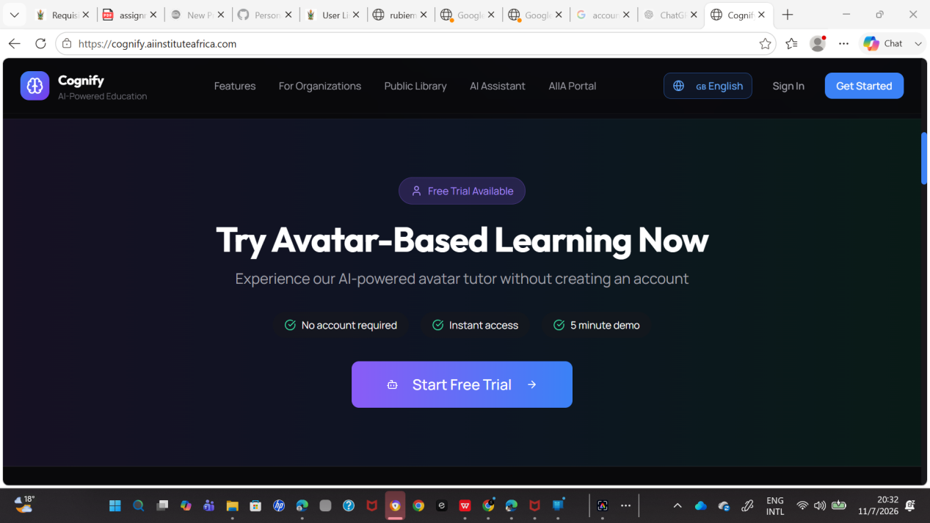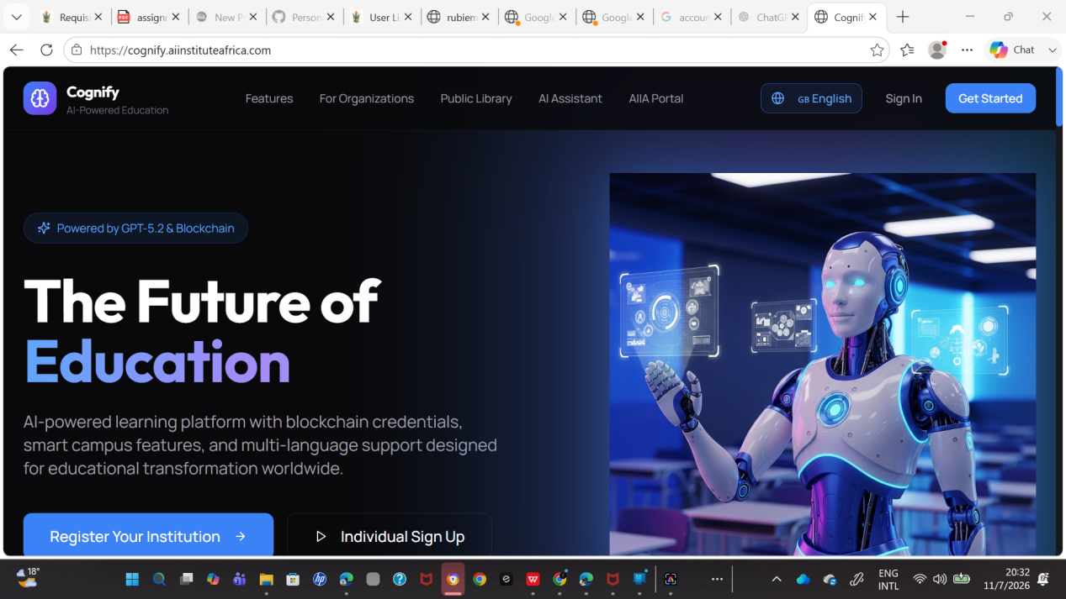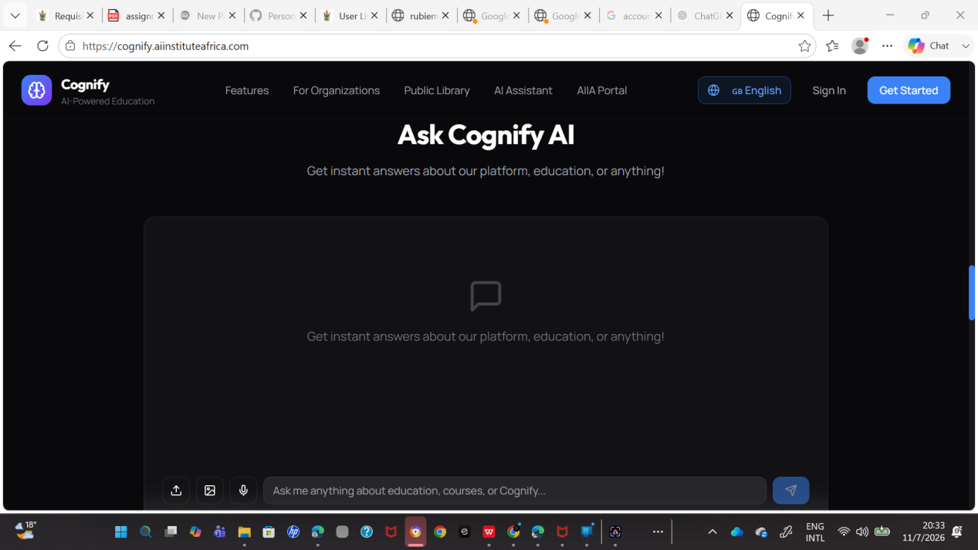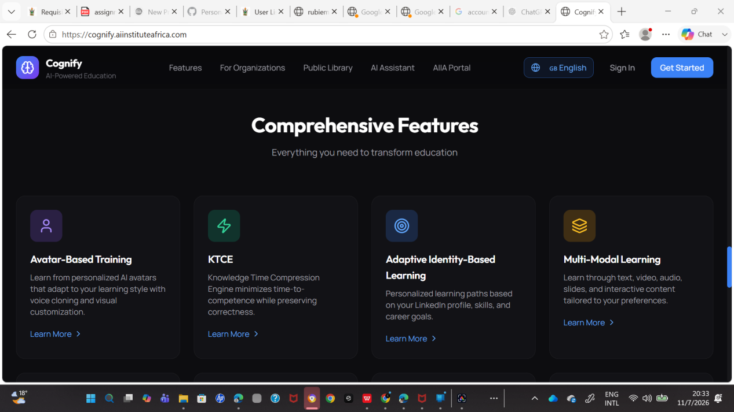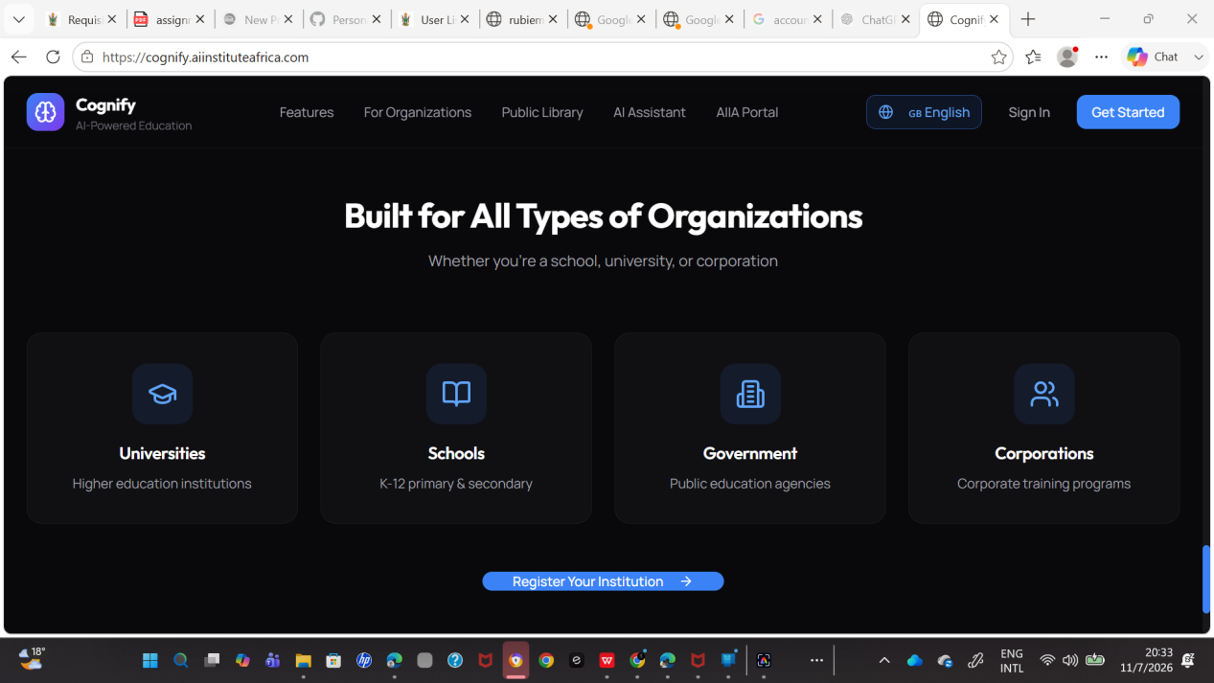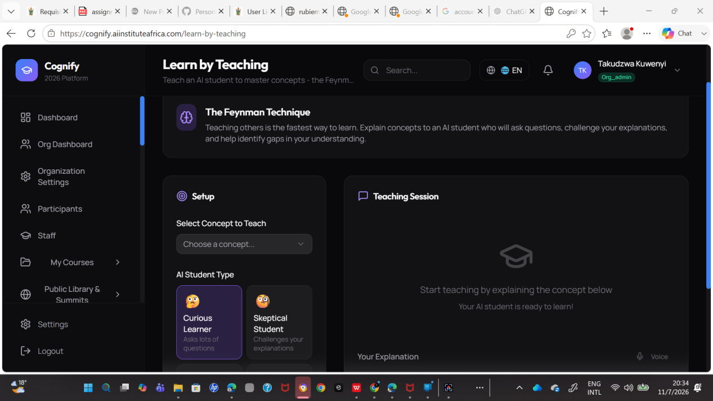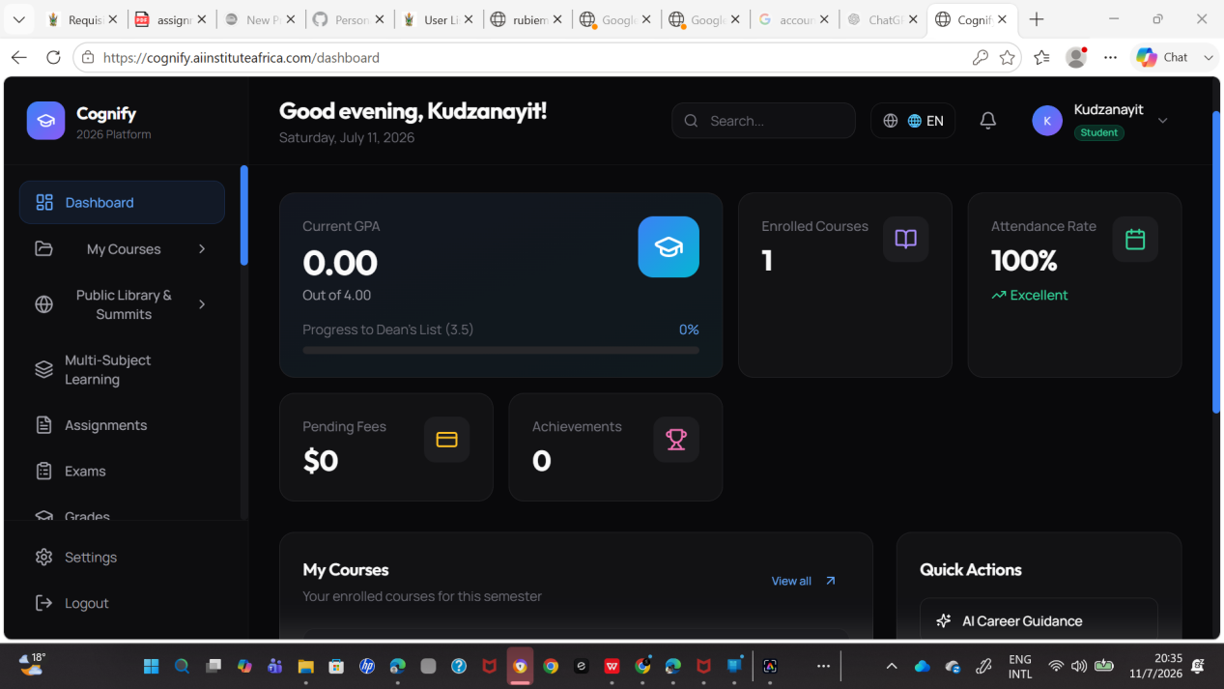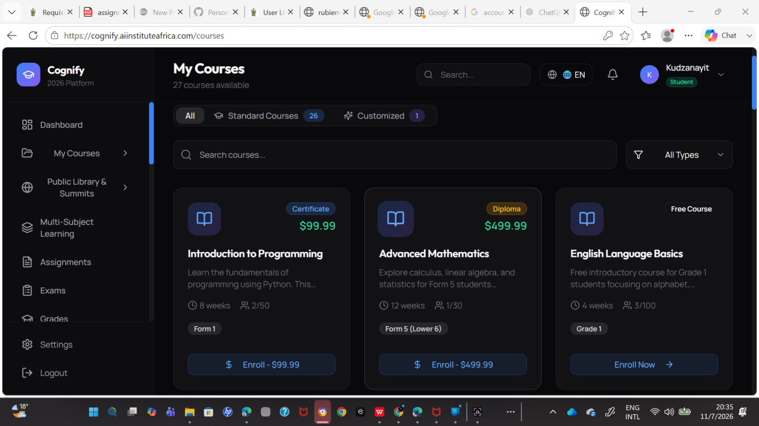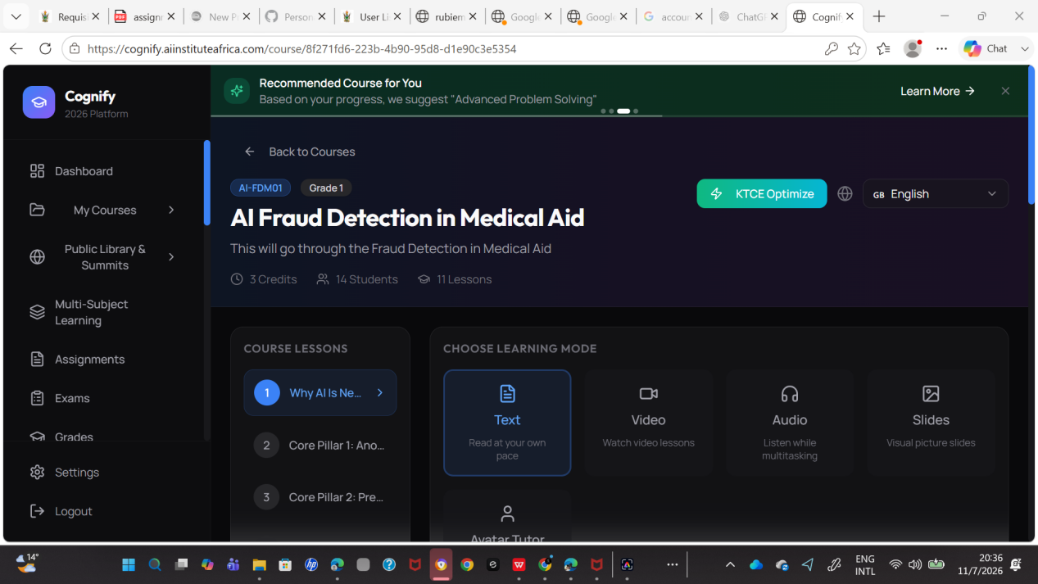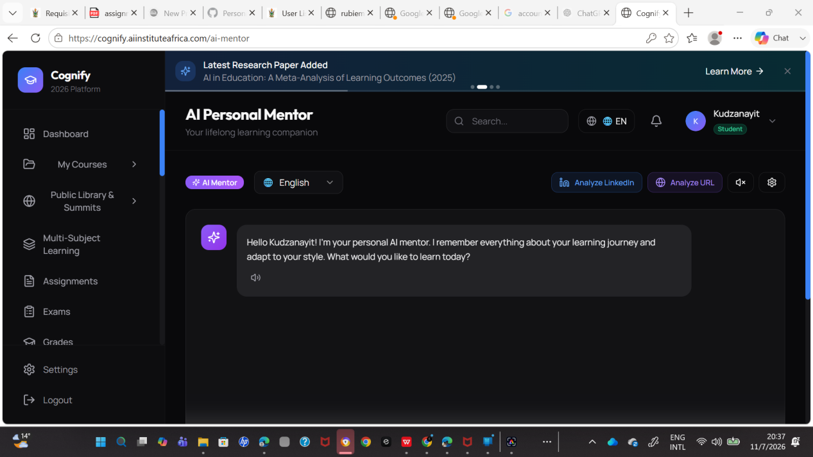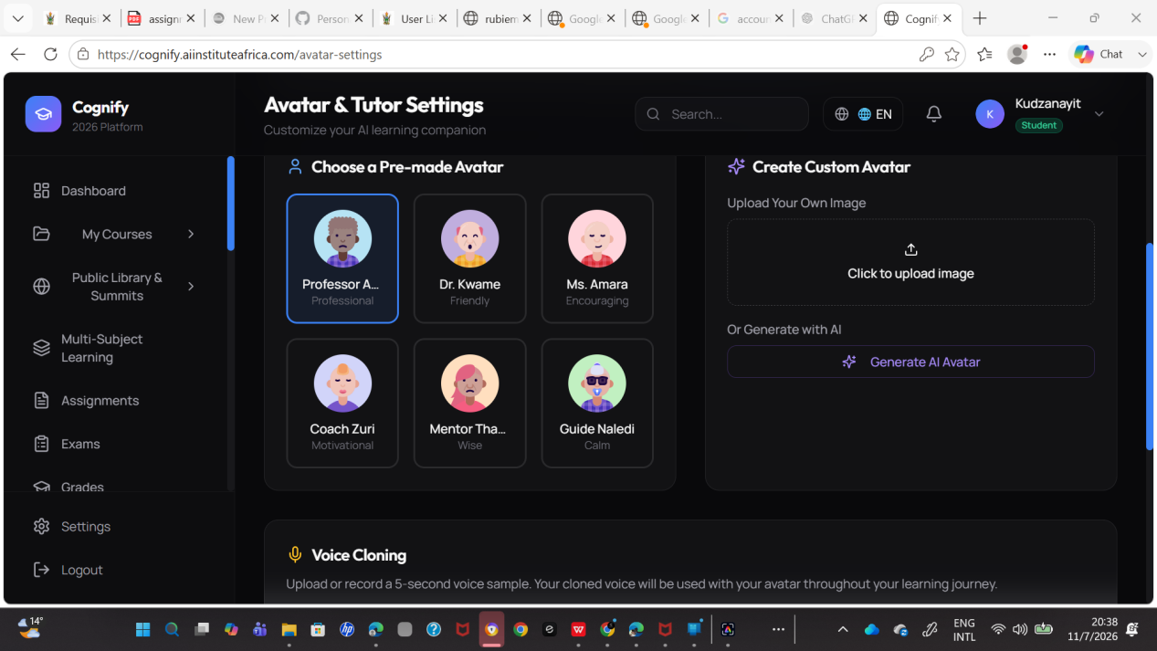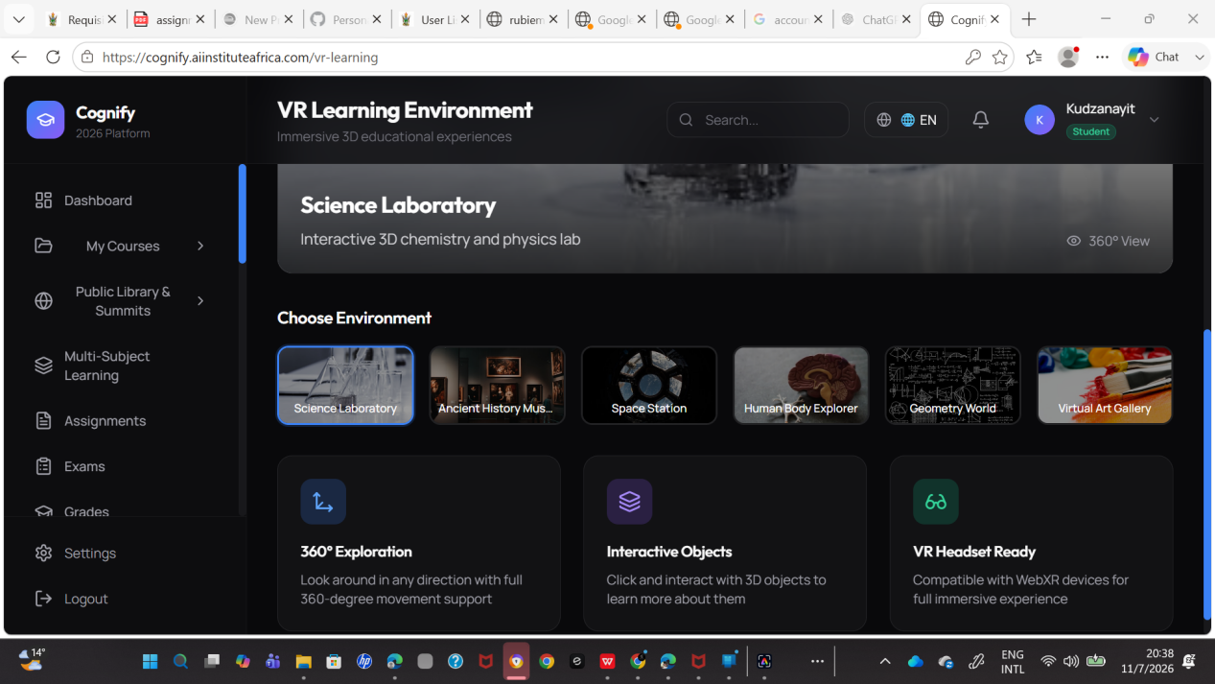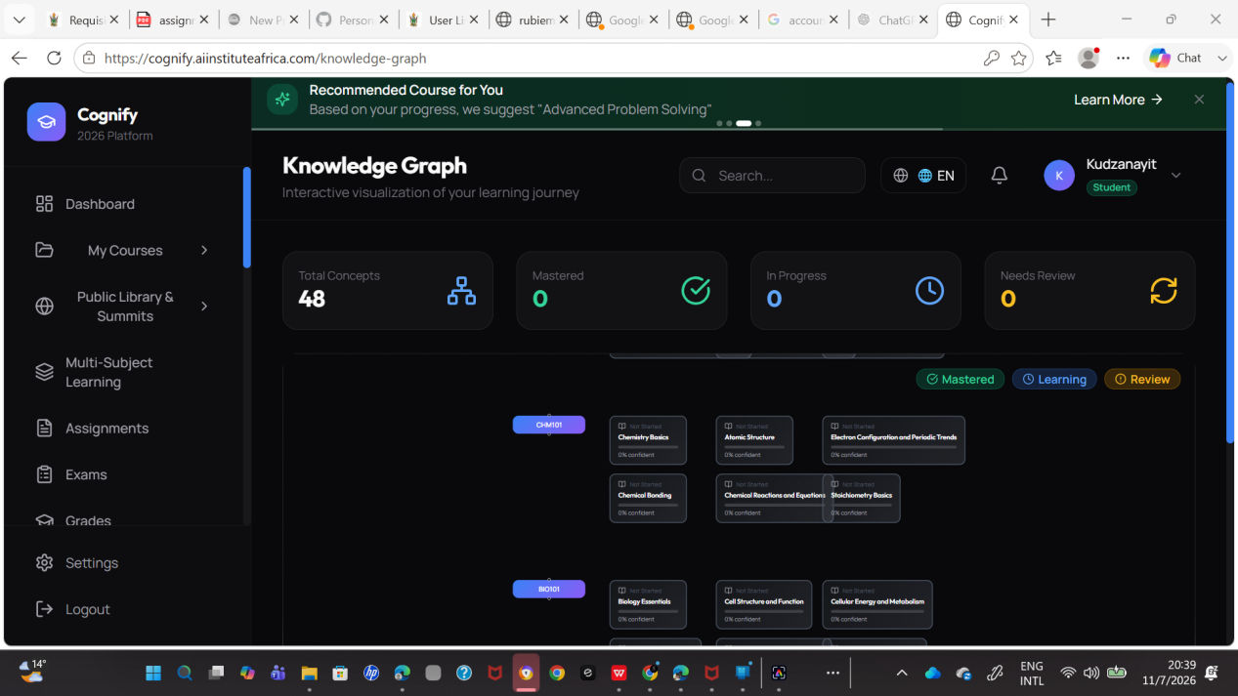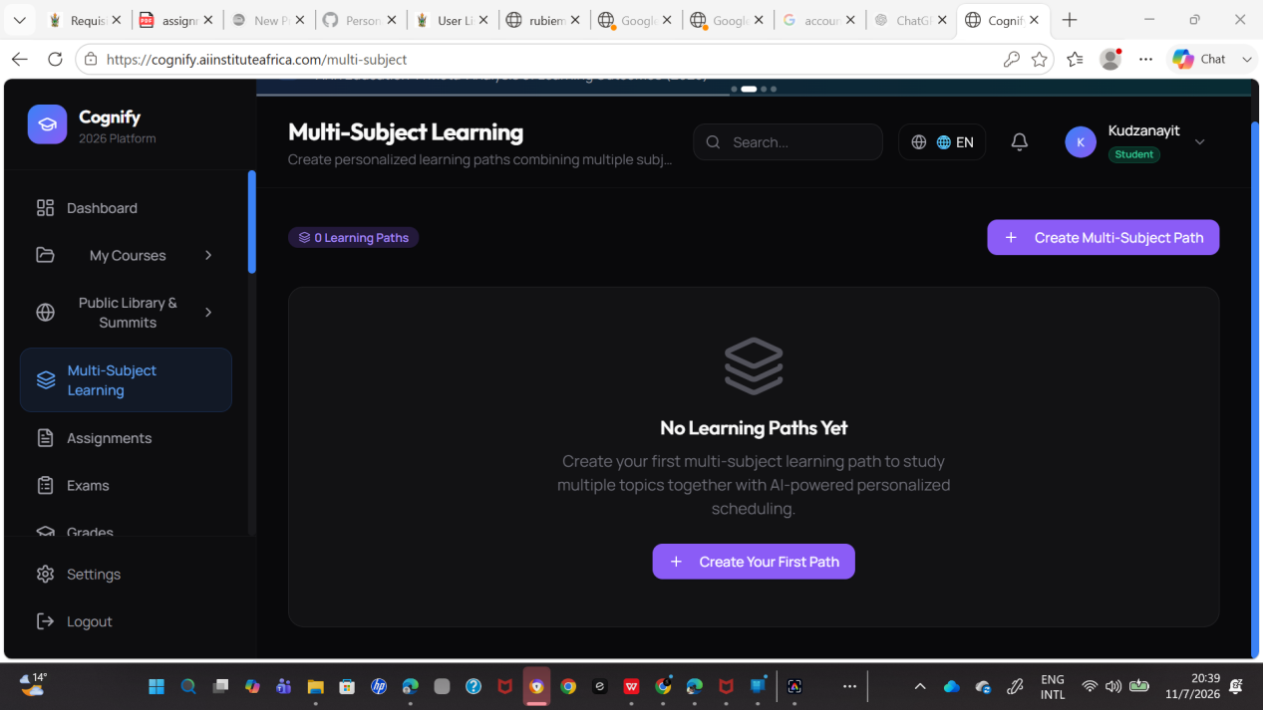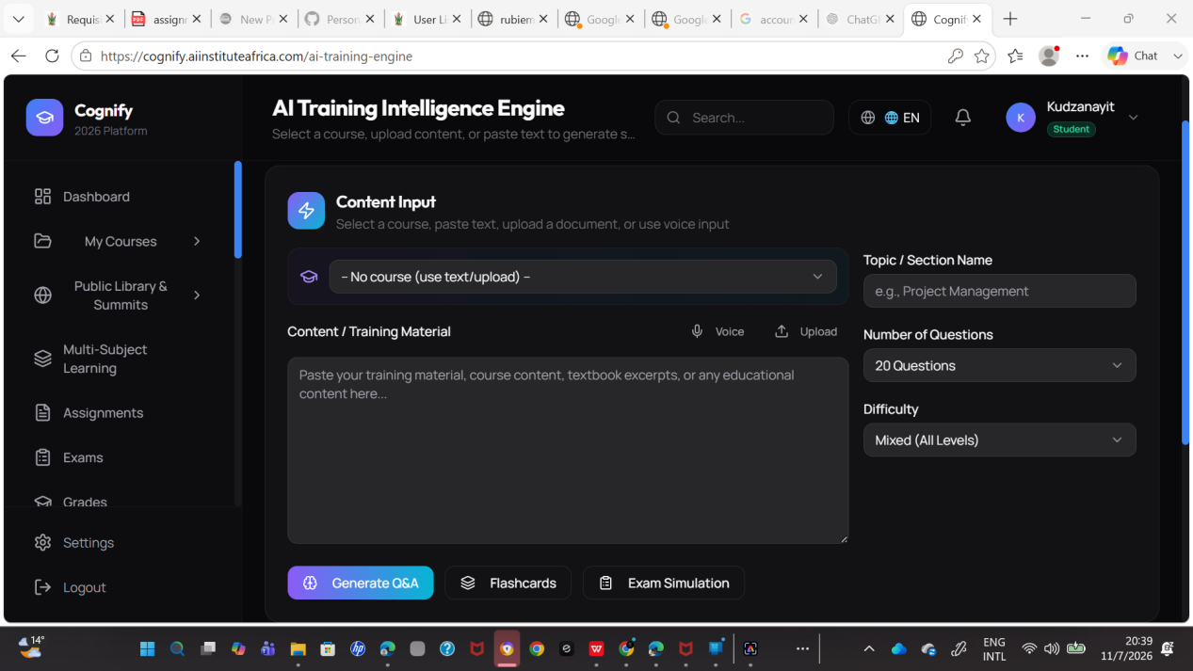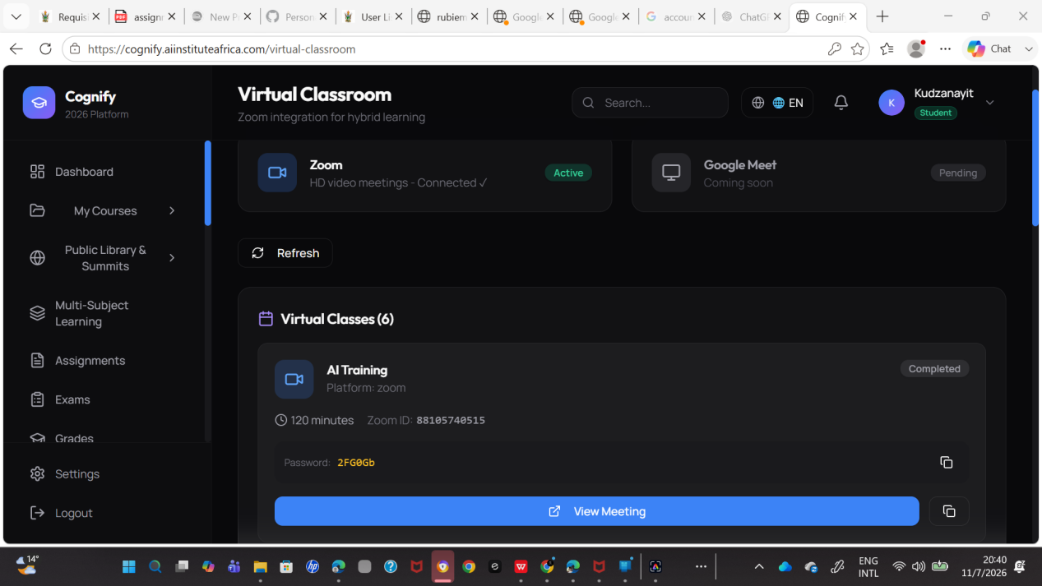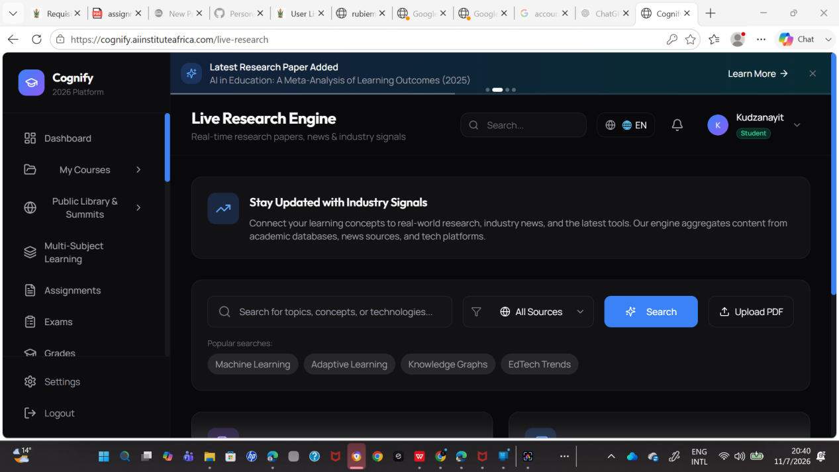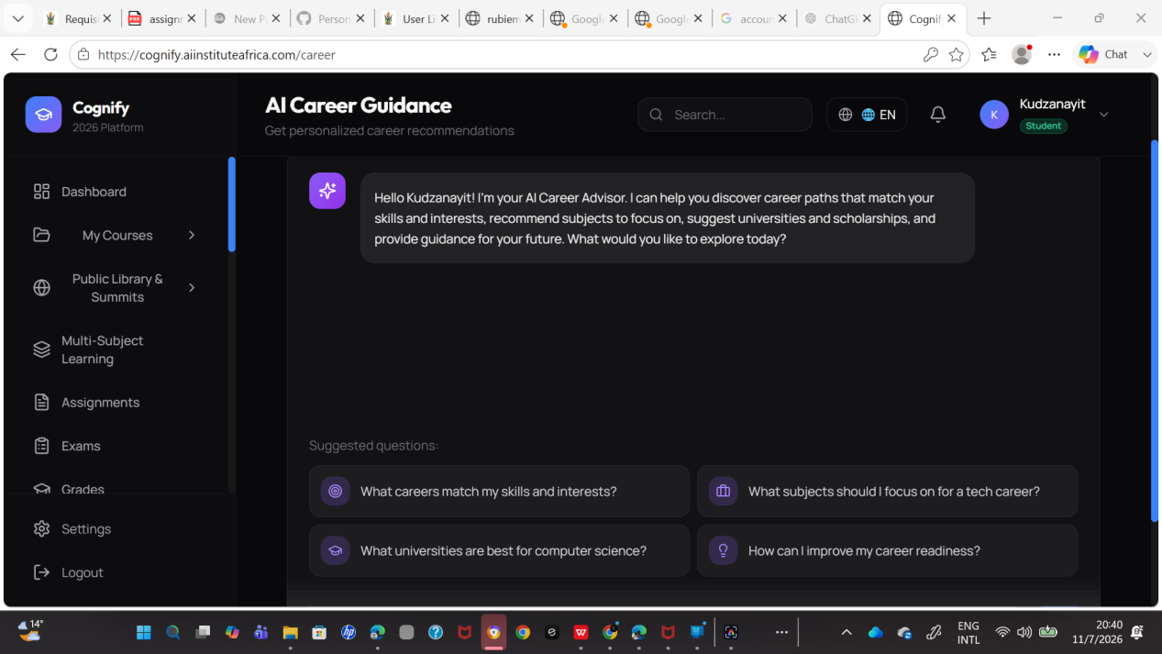

Annexure B: Cognify System Architecture Diagram
Purpose: Satisfy Technical Architecture requirements.
Include a high-level architecture diagram showing:
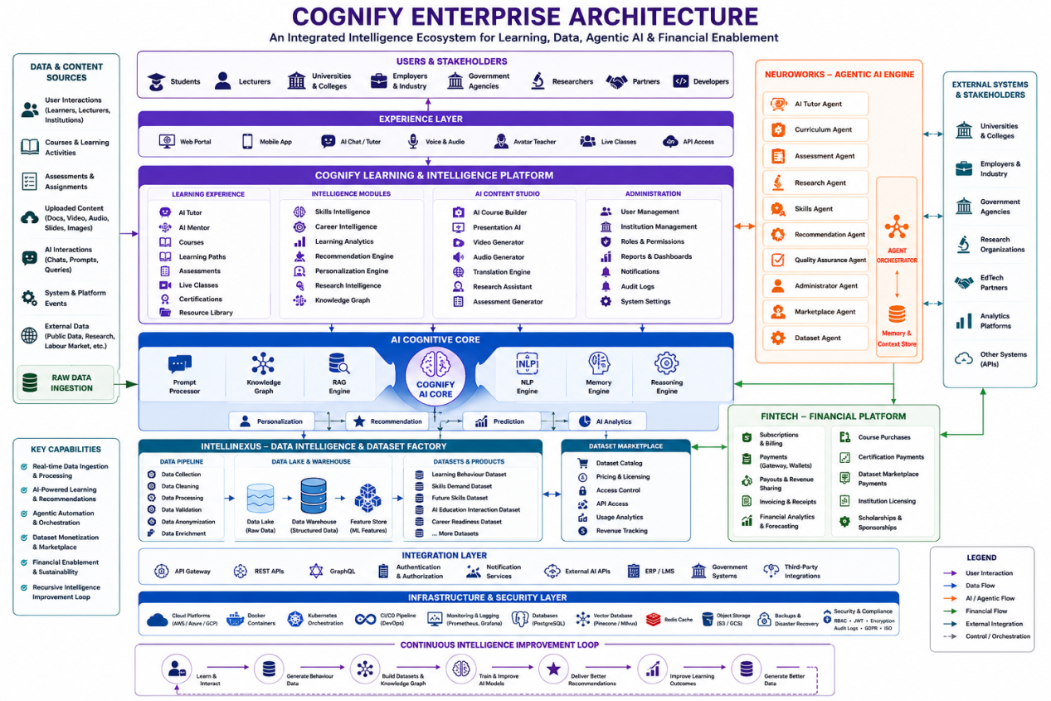

Annexure C: AI Model and Technical Justification
Purpose: Prove AI is necessary.
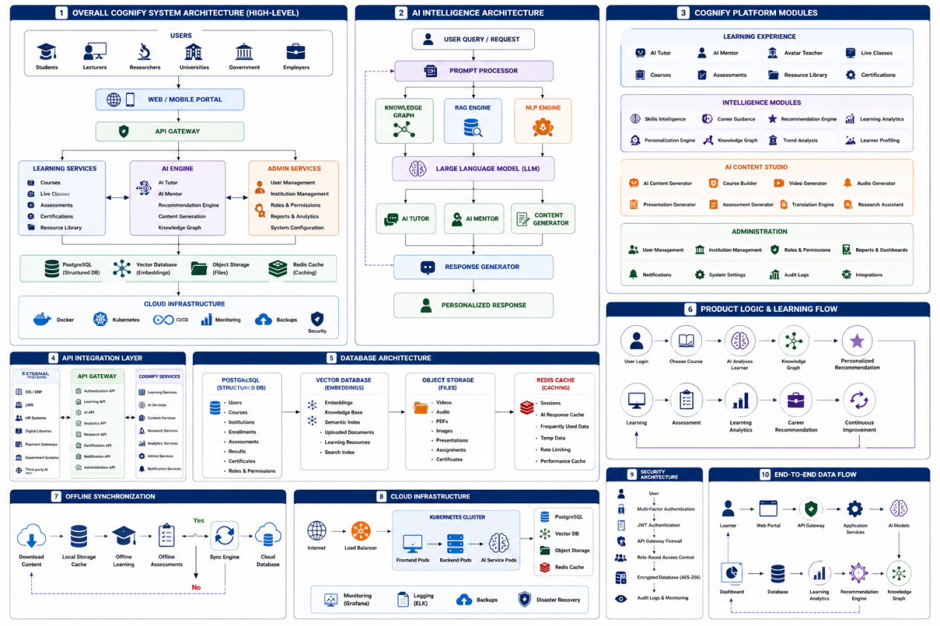

Annexure D: Dataset Statement and Data Governance
Purpose: Directly addresses the dataset requirement.
Include:

Current Data Sources
Dataset | Status | Purpose
Curriculum content | Available | Learning resources
Past examination materials | To be collected | Revision intelligence
Teacher-created content | To be collected | Lesson marketplace
Learner interactions | Generated internally | Personalization
Synthetic learner profiles | Simulated | AI testing

Data Categories
- User profiles
- Learning behaviour
- Course materials
- Assessment results
- AI conversations
- Knowledge Graph relationships

Data Limitations
Example:
At prototype stage, Cognify uses synthetic learner data and controlled educational datasets. Prod

Annexure E: Database Schema Design
Purpose: Demonstrate technical maturity.
Include database models:
Example:

Users Table
User_ID
Name
Role
Institution
Language
Learning_Profile

Courses Table
Course_ID
Subject
Level
Teacher_ID
Content
Rating

AI Memory Table
Memory_ID
User_ID
Previous Questions
Knowledge_Level
Learning_Preferences
Weak Areas

Teacher Table
Teacher_ID
Subjects
District
Availability
Rating
Revenue

Annexure F: User Interaction and Workflow Design
Purpose: Show how users interact with the product.
Include workflows:

Student Journey
Register
|
AI Assessment
|
Personal Learning Plan
|
Select Teacher / AI Tutor
|
Attend Lesson
|
Complete Assessment
|
Receive Recommendations

Teacher Journey
Register
|
Verification
|
Upload Lessons
|
Set Availability
|
Teach Live Classes
|
Receive Ratings
|
Earn Commission

Annexure G: Technical Stack and Dependency Register
Purpose: Address technical delivery standards.
Include:

Technology Stack
Frontend:
- React.js
- Next.js
- HTML5
- CSS3
Backend:
- Python
- Django
- FastAPI
Database:
- PostgreSQL/MySQL
AI:
- LLM APIs
- RAG Framework
- Vector Database
- Knowledge Graph
Infrastructure:
- Docker
- Kubernetes
- ZCHPC Cloud Environment

Dependency Register
Example:
Backend:
requirements.txt

Frontend:
package-lock.json

Containers:
Dockerfile
docker-compose.yml

Annexure H: Testing and Validation Report
Purpose: Score highly under Technical Feasibility.
Include:

Functional Testing
Test:
- User registration
- AI Tutor responses
- Course access
- Teacher uploads
- Payment workflow

AI Testing
Metrics:
- Response accuracy >90%
- Response time <3 seconds
- Retrieval accuracy
- Recommendation relevance

Security Testing
Testing:
- Authentication
- Authorization
- Data isolation
- API security

Annexure I: ZCHPC CCE Deployment Architecture
Purpose: Address deployment requirements.
Include:
Infrastructure diagram:
ZCHPC Cloud

GPU Cluster
|
AI Models
|
Container Platform
|
Kubernetes
|
Cognify Services
|
Databases
|
Users
Include:
Compute requirements:
- GPU-enabled servers
- Minimum 64 vCPU
- 256GB RAM
- Cloud storage
- Backup systems

Annexure J: Business Model and Sustainability
Purpose: Address commercial viability.
Include:

Revenue Model

Students
- Free basic access
- Premium AI tutoring
- Live revision classes
Example:
Premium lessons:
$10/month

Teachers
Revenue sharing:
Student payments
|
|
Cognify Platform
|
|
Teacher commission

Institutions
- School licensing
- University subscriptions
- Government deployment

Telecom Partnerships
Revenue sharing with telecom operators providing connectivity.

Annexure K: Teacher Marketplace Model
(This is a unique Cognify differentiator)
Include:
Teacher ecosystem:
Teacher Registration
|
Verification
|
District Allocation
|
Availability
|
Student Ratings
|
Ranking Algorithm
|
Student Booking
|
Teacher Commission
Features:
- District-based teacher allocation
- Teacher ratings
- Live classes
- Recorded lessons
- Teacher-owned content
- National teacher ranking

Annexure L: Responsible AI and Compliance
Include:
- Zimbabwe Data Protection Act compliance
- Consent management screenshots
- Privacy policy
- AI ethics framework
- Human oversight model

Annexure M: Risk Register
A simple table:
Risk | Impact | Mitigation
Poor connectivity | Reduced access | Offline caching
AI hallucination | Wrong answers | RAG validation
Data privacy | Trust issues | Encryption
Teacher adoption | Slow uptake | Training
AI cost | High operation cost | Model optimization

