ENGLISH LANGUAGE SCHOOL-BASED PROJECT

PROJECT TITLE:

Improving Story Summarising Skills at Northpark Primary School

Name of Student:
Eleazar Gondo

School:
Northpark Primary School

Learning Area:
English Language

Year:
2026

ACKNOWLEDGEMENTS
I would like to thank my English teacher, parents, and classmates for their support and encouragement during the completion of this project. Their guidance helped me understand the importance of summarising stories and improving reading comprehension skills. I also thank Northpark Primary School for providing a conducive learning environment.

INTRODUCTION
Reading is an important skill that helps learners gain knowledge, improve vocabulary, and develop communication skills. One of the important reading skills taught in English Language is summarising stories. Summarising involves identifying the main ideas in a story and expressing them briefly using one's own words.
Many learners find it difficult to summarise stories correctly because they include too many details or fail to identify important information. This project seeks to investigate this problem and develop a practical solution that can help learners improve their summarising skills.

STAGE 1: PROBLEM IDENTIFICATION (5 MARKS)

1.1 Description of the Problem
At Northpark Primary School, some learners experience difficulties when summarising stories. Instead of selecting important ideas, they often copy large sections of the text. Others leave out important events, making their summaries incomplete.
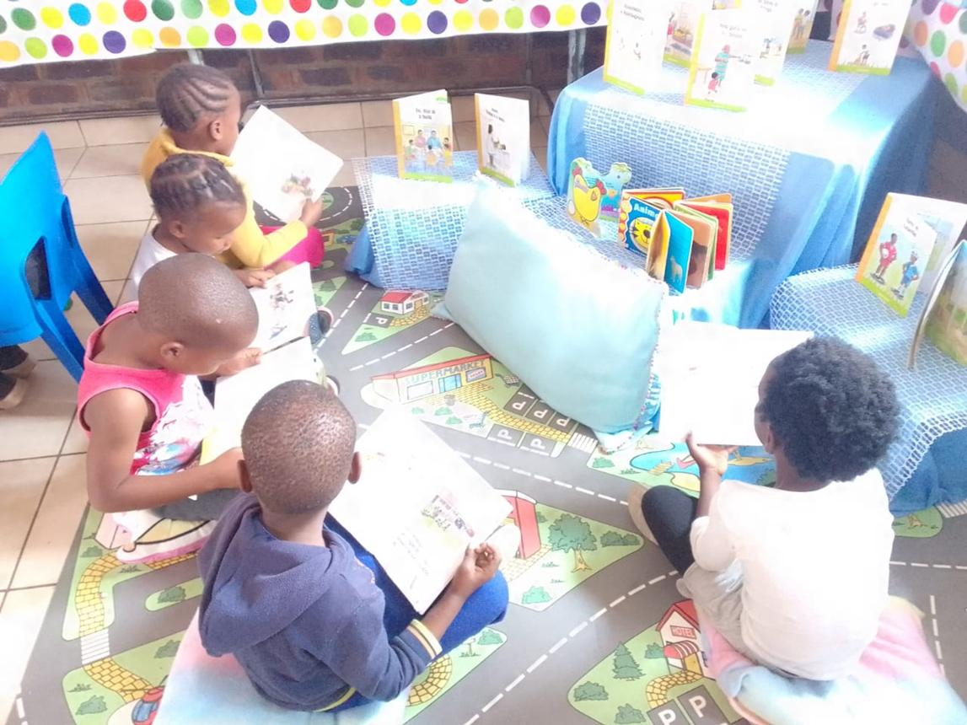
These challenges affect reading comprehension, writing ability, and performance in English Language assessments.

Evidence of the Problem
During classroom activities, learners were asked to read a story and write a summary. The following problems were observed:
- Some learners copied directly from the story.
- Some summaries were too long.
- Some summaries omitted key events.
Some learners struggled to identify the main message. These observations showed that learners need additional support in learning how to summarise effectively.

1.2 Statement of Intent
The purpose of this project is to develop a simple and effective strategy that helps learners summarise stories accurately and confidently.
The project aims to:
- Improve learners' reading comprehension.
- Help learners identify main ideas.
- Improve writing skills.
- Encourage independent learning.
- Increase learner confidence in summarising stories.

1.3 Project Specifications
The solution should:
- Be simple and easy to understand.
- Help learners identify key information.
- Improve reading comprehension.
- Encourage active participation.
- Be suitable for primary school learners.
- Be inexpensive to produce and use.

STAGE 2: INVESTIGATION OF RELATED IDEAS (10 MARKS)
Before developing a solution, existing methods used to help learners summarise stories were investigated.

Related Idea 1: Highlighting Important Information

Description
This method involves learners using coloured highlighters or underlining important sentences while reading a story.

Merits
- Helps learners focus on important information.
- Easy to use.
- Encourages active reading.
- Improves concentration.

Demerits
- Learners may highlight too much information.
- Some important details may still be missed.
- Requires highlighters or coloured pens.

Analysis
This method is useful but does not always help learners organise information into a proper summary.
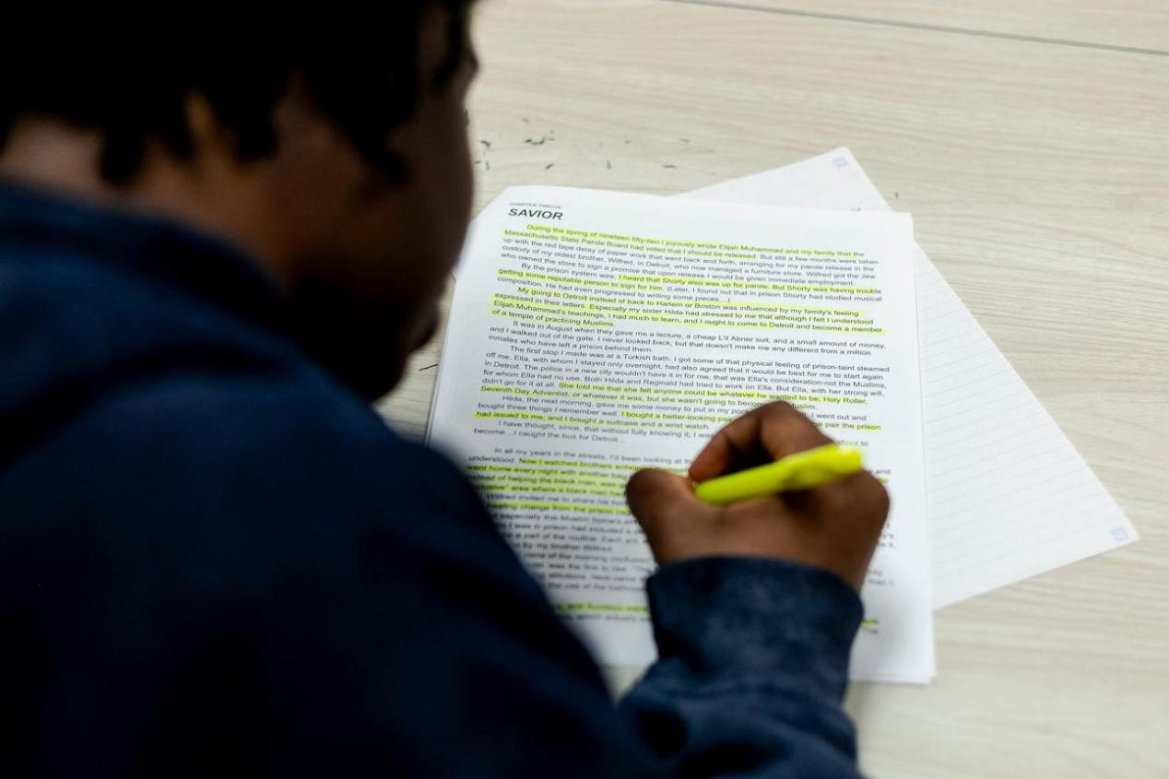

Related Idea 2: Story Mapping

Description
Story mapping is a graphic organiser that helps learners identify:
- Characters
- Setting
- Problem
- Events
- Solution

Merits
- Organises information clearly.
- Improves understanding of story structure.
- Helps learners remember events.

Demerits
- Can take a long time to complete.
- Some learners may find it difficult.
- Requires additional worksheets.

Analysis
Story mapping improves comprehension but may be too detailed for some learners.

Related Idea 3: Question-and-Answer Method

Description
Learners answer comprehension questions after reading a story before writing a summary.

Merits
- Encourages understanding.
- Helps identify important information.
- Easy for teachers to assess.

Demerits
- Can become repetitive.
- Learners may focus only on answers.
- Does not always improve summarising skills directly.

Analysis
This method is effective for comprehension but may not fully develop summarising skills.
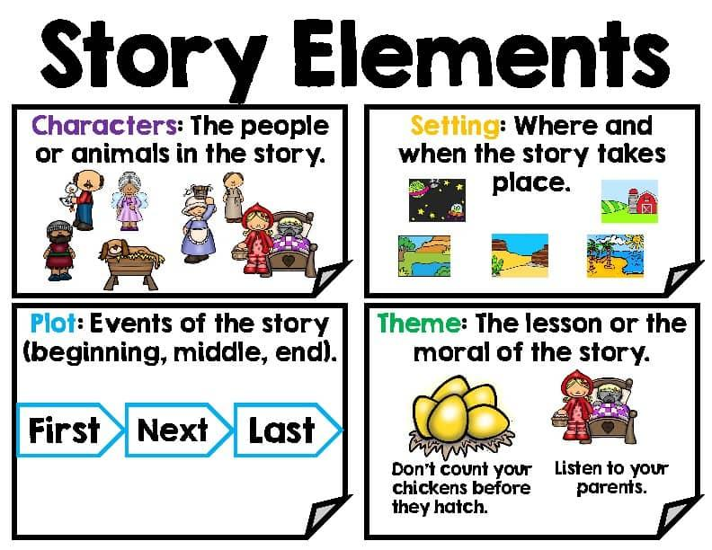

Conclusion of Investigation
The investigation revealed that all three methods have strengths and weaknesses. Therefore, a new solution should combine simplicity, effectiveness, and learner friendliness.

STAGE 3: GENERATION OF POSSIBLE SOLUTIONS (10 MARKS)
Based on the investigation, three possible solutions were developed.

Solution 1: Summary Checklist
A checklist would guide learners through important elements of a story.

Components
- Main character.
- Setting
- Problem
- Important events
- Solution
- Lesson learned

Advantages
- Easy to use.
- Helps learners stay focused.
- Ensures important information is included.

Disadvantages
- Learners may depend on it too much.
- May reduce creativity.

Solution 2: Summary Chart
A chart allows learners to organise information before writing.

Advantages
- Organises ideas clearly.
- Encourages critical thinking.
- Helps learners identify relationships.

Disadvantages
- Takes more time to complete.
- Requires additional writing.

Solution 3: Summary Template Card
A template card provides sentence starters.
Examples:
- The story is about…
- The main character is…
- The problem was…
- In the end...

Advantages
- Easy for young learners.
- Builds confidence.
- Supports writing development.

Disadvantages
- Learners may become dependent.
- Limits creativity.

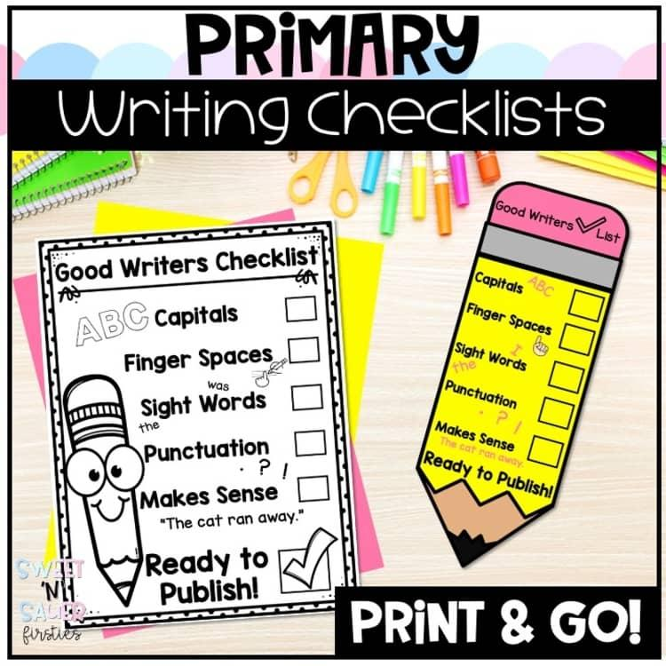

Comparison of Solutions
Solution | Strength | Weakness
Checklist | Simple and practical | May limit creativity
Chart | Organised and detailed | Time-consuming
Template Card | Easy for beginners | Creates dependence

STAGE 4: DEVELOPMENT AND REFINEMENT OF CHOSEN IDEA (10 MARKS)

4.1 Chosen Solution
After analysing the three solutions, the Summary Checklist was selected.

4.2 Justification of Choice
The Summary Checklist was chosen because:

Reason 1
It is easy for primary school learners to understand and use.

Reason 2
It helps learners identify important information without making the process complicated.

Reason 3
It can be used independently by learners.


4.3 Refinements Made

Refinement 1: Visual Icons
Pictures were added next to checklist items to make them easier to understand.
For example:
👦 Character
🏠 Setting
⚠ Problem
✅ Solution

Refinement 2: Guiding Questions
Questions were added to help learners think critically.
Examples:
- Who is the main character?
- Where does the story take place?
- What problem occurred?
- How was the problem solved?

Refinement 3: Self-Assessment Section
A self-check section was added.
Learners can tick:
☑ Main character included
☑ Setting included
☑ Problem included
☑ Solution included
☑ Lesson included

4.4 Final Impression
The improved Summary Checklist is attractive, easy to use, and effective in helping learners summarise stories.

STAGE 5: PRESENTATION OF THE FINAL SOLUTION (10 MARKS)

THE STORY SUMMARY CHECKLIST

Learner's Name: ___________________

Story Title: ___________________
Checklist Item | Tick
Main Character | □
Setting | □
Problem | □
Important Events | □
Solution | □
Lesson Learned | □

Instructions
- Read the story carefully.
- Complete the checklist.
- Use the information to write a summary.
- Review your work before submission.

Example of Use

Story Title: The Honest Boy

Checklist
Item | Information
Character | Tawanda
Setting | Village
Problem | Found a lost wallet
Events | Looked for owner
Solution | Returned wallet
Lesson | Honesty is important

Example Summary
The story is about a boy named Tawanda who found a lost wallet in his village. He searched for the owner and returned it. The owner thanked him for his honesty. The story teaches that honesty is important.
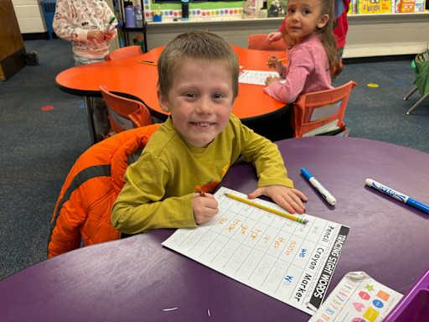

Expected Benefits
The checklist will:
- Improve reading comprehension.
- Improve writing skills.
- Build learner confidence.
- Increase participation in English lessons.
- Help learners achieve better examination results.

STAGE 6: EVALUATION AND RECOMMENDATIONS (5 MARKS)

6.1 Relevance to Statement of Intent
The project successfully achieved its purpose of helping learners summarise stories more effectively.
The Summary Checklist:
- Helps identify key information.
- Encourages active reading.
- Improves comprehension.
- Supports writing development.
Therefore, the solution is relevant to the statement of intent.

6.2 Challenges Encountered
Several challenges were encountered:
- Some learners struggled to identify important events.
- Some learners required additional teacher support.
- Limited resources were available for printing materials.
Despite these challenges, the project was completed successfully.

6.3 Recommendations
The following recommendations are made:
- Teachers should use the Summary Checklist regularly.
- Schools should provide more storybooks.
- Learners should read stories frequently.
- Parents should encourage reading at home.
- Similar tools should be developed for other English Language skills.

CONCLUSION
This project investigated the challenge of summarising stories among learners at Northpark Primary School. Through research and analysis of existing methods, several possible solutions were identified. The Summary Checklist was selected as the most suitable solution because it is simple, practical, and effective.
The final solution helps learners identify important information, organise ideas, and write concise summaries. It improves reading comprehension, writing skills, and learner confidence. If implemented consistently, the Summary Checklist can significantly improve English Language performance among learners.
Prepared By: Eleazar Gondo
School: Northpark Primary School
Learning Area: English Language
Project Title: Improving Story Summarising Skills at Northpark Primary School

