Website – Required Update 2
- Fix the complaints pop-ups so they display clearly after clicking uploads.
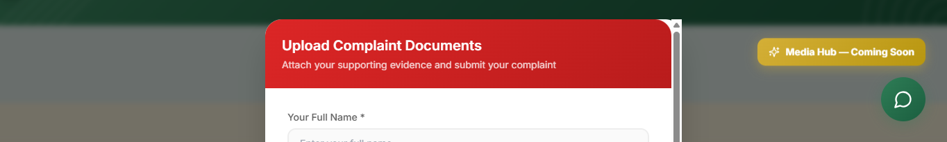
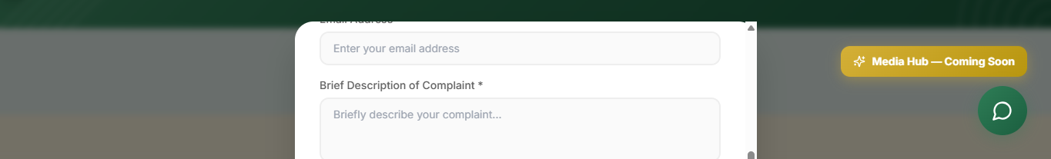
- The send button is not showing after scrolling down, it needs to be fixed.
- Fix the pop up that show under Submit Appeal.
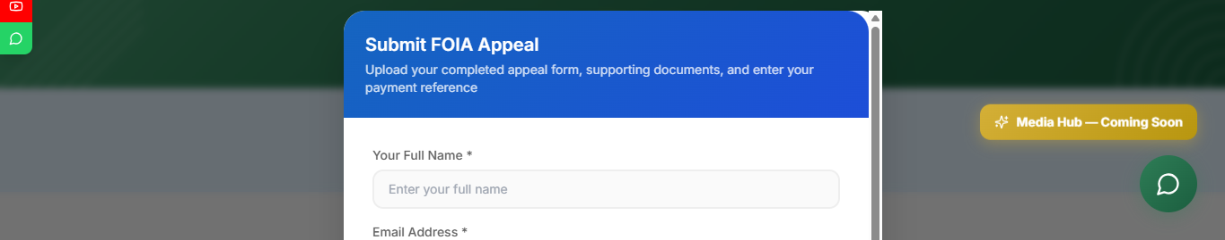
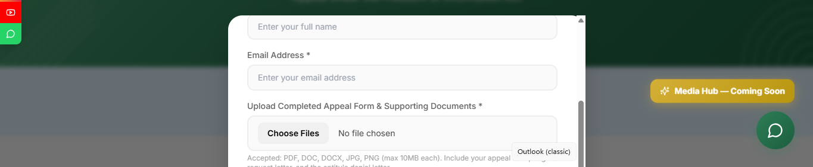
- The send button is not showing after scrolling down, it needs to be fixed.
- Change the following tabs to match the other tabs.
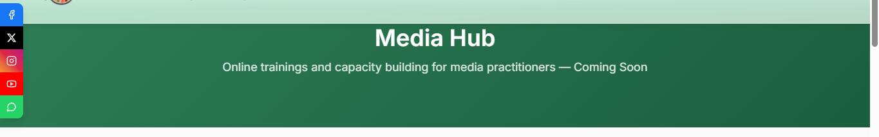
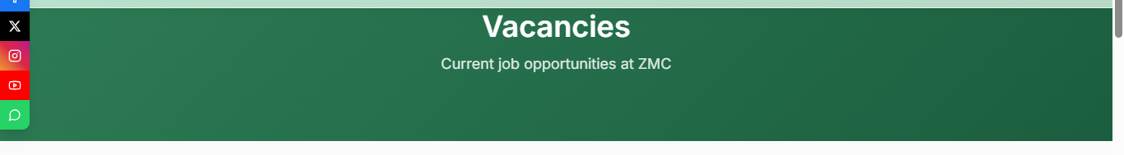
- When the accreditation link is clicked it must not direct people to the portal, rather it should direct them to the Accreditation tab under services just like Registration link.
- 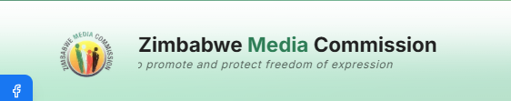
- Update the running through text under Zimbabwe Media Commission to “Fostering access to information and a professional national interest driven media by 2030”
- 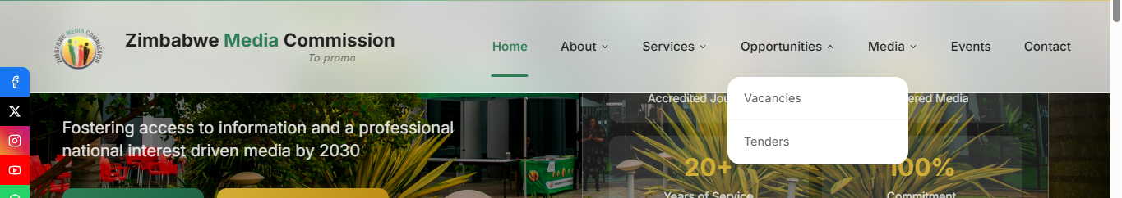
- Hover option not minimizing after clicking on menu tabs.
- 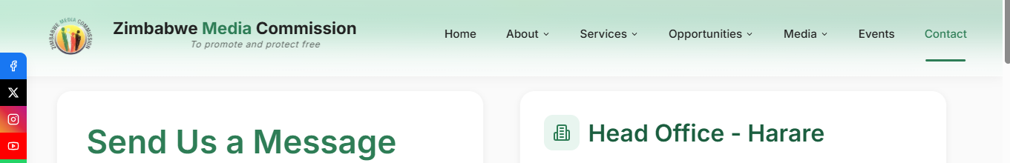
- On the Contact tab, kindly Add the Regional Office’s contact details below;
Regional Office – Bulawayo
Address
Zimbabwe Media Commission, 17 Rylanders Court, Windsor Park Complex, 16th Avenue, Famona, Bulawayo
Contact Number
+263 713 879 044

