Website – Required Update
- Pictures on home page to be set as a slideshow
- Retain the initial ZMC picture showing the building since it has HD quality and should be part of the slide show.
- Ensure all text is evenly aligned across the website.
- Make downloads more specific instead of redirecting to a general downloads page. For example, the Appeals form should allow users to click and download the form directly.
- Under downloads change FOIA APPEALS to FOIA FORMS
- Fix the complaints pop-ups so they display clearly after clicking uploads.
- Remove the “Download complaints” option under the Complaints section.
- Under Complaints, remove the “Download complaint form” option since there is no complaint form.
- Add a search option to the website.
- Under Appeals remove the download and the submit option at the bottom since they are appearing at the top.
- Under commissioners remove powers of the commission and leave functions of the commission. Put the functions as it is in the constitution or as indicated in the about section.
- Change the solid color to have some designs in the backend that are a little bit transparent.
Change this to look more like this this image but include media related light backgrounds on the solid green. You can maintain the green but have some designs at the back like the image below.

- Under home separate complaints and appeals to be two things. And on the descriptions remove issues to do with form on complaints.

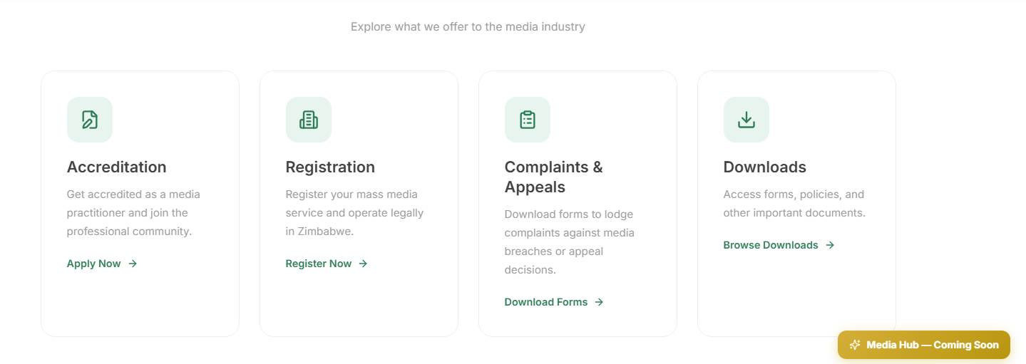
- On the appeals section the submit part will need to be linked with Pay Now and ensure that to submit the applicant will have to type in the payment reference from Pay Now after payment and successfully submit.

