Website – Required Update
- Under Service on Registration - Registration of Media Services
- Update the first sentence to this “Registration of mass media services is provided for by Statutory Instrument 169C of 2002 as read with Statutory Instrument 10 of 2004.”
- On both requirements of registering a local media service and a foreign representative office include the bullet point of fees as a requirement as you did on accreditation, “The application and registration fee as prescribed by Statutory Instrument 65 of 2022”
- On the Registration Process number 3, indicate that “submit application and pay the application fee” Step number 4 will then be “confirm your approval and proceed to pay the registration fee” Lets have the existing Step number 4 to be Step number 5 (Get Registered)
- Under Services on Accreditation - Requirements
- For accreditation also update the last bullet requirement for both local and foreign as, “An accreditation fee as prescribed by Statutory Instrument 65 of 2022.”
- Under Media Complaints – On Media-Specific Complaints Only Alert
- Change the summary sentence to “The ZMC handles complaints related to media and media practitioners. We address issues concerning:”
About Media Complaints
- “The Zimbabwe Media Commission receive and consider complaints from the public and, where appropriate, to take action against journalists and other persons employed in the media or broadcasting who are found to have breached any law or any code of conduct applicable to them.

How to Submit
- Change the last sentence to “Our team will review your complaint and contact you as soon as possible.”
- NB: On the Upload Documents ensure that the Audio-Visual Elements have are also part of the accepted formats & also include a separate paste link box maybe the evidence is on a certain site. Make These upload documents be optional so that people may be allowed to submit even if they don’t attach evidence.
NB: Make sure all the upload pop ups in the website are scrollable so that people are able to scroll down to the following options.
- Under Abou on Commissioners – Functions of the Commission
- Update the first sentence to “As set out in Section 249 of the Constitution of Zimbabwe and the Zimbabwe Media Commission Act [Chapter 10:35], the Commission shall perform the following functions:”
- Update the function, the following are the correct ones as it is in the Constitution;
- To uphold, promote and develop freedom of the media;
- To promote and enforce good practices and ethics in the media;
- To monitor broadcasting in the public interest and, in particular, to ensure fairness and diversity of views broadly representing the Zimbabwean society;
- To encourage the formulation of codes of conduct for persons employed in the media and, where no such code exists, to formulate and enforce one;
- To receive and consider complaints from the public and, where appropriate, to take action against journalists and other persons employed in the media or broadcasting who are found to have breached any law or any code of conduct applicable to them;
- To ensure that the people of Zimbabwe have fair and wide access to information;
- To encourage the use and development of all the officially recognised languages of Zimbabwe;
- To encourage the adoption of new technology in the media and in the dissemination of information;
- To promote fair competition and diversity in the media; and
- To conduct research into issues relating to freedom of the press and of expression, and in that regard to promote reforms in the law.
- 
- On the running text under Zimbabwe Media Commission, correct it to “Fostering access to information and a professional national interest driven media by 2030.”
- Update the following Mission, Vision & Our Objective
Mission
- Enhancing democracy by facilitating access to information and a diverse, plural and ethical media
Vision
- Fostering access to information and a professional national interest driven media by 2030
Our Strategic Objective (Add the Strategic part on it)
- To facilitate the development of an accessible and professional media
- Under FOIA Appels on Services
About FOIA Appeals
- Update in the bracket to (over 21 days and an extension of not more than 14 days)
- 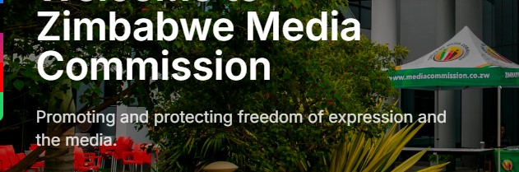
- Change the text under the Welcome to Zimbabwe Media Commission to, “Fostering access to information and a professional national interest driven media by 2030”

