Website Comments

- Logo font should match the font used on the buttons.
- Home buttons should be bold and capitalized.
- Text should be evenly aligned between margins.
- Heading fonts should be uniform and adopt the same font style used on the Home buttons.
- About Us: Remove the phrase “photo coming” under Secretariat.
- Remove the “Contact Secretariat” option under secretariat.
- Board of Commissioners: Remove the organogram and place it in downloads as a downloadable pdf file
- Services as an example: Remove the full fee structure. Everywhere written full fee structure remove it
- On the Downloads page, be more specific about the document to be downloaded. Avoid sending users to a general downloads page where they must search for the required form or document.
- Which email address is linked to the contact form.
- “Subscribe for Updates” is not working; it redirects to Upcoming Events under Vacancies.
- Press releases are not displaying or they are yet to be posted.
- Magazine: Confirm whether content can be taken from the existing website.
- Language option needs to be fixed and add the other official languages and allow people to select a language of choice.
- WhatsApp link is connecting to the landline number ,instead of a mobile number 0719 299 150
- Remove the complaints form and only leave an option for uploading documents.
- Remove the “Go to Appeals” link from the complaints section & remove the “lodge a complaint” link from the Appeals Link.
- Notices should be displayed as a slideshow.
- Add the ability to upload event photos under photos.
- On FOIA can it just read FOIA Appeals and remove “FOIA” from brackets and make it “FOIA Appeals”.
- Remove all text on FOIA and only leave download FOIA form and About FOIA. Also, remove what happens after submission.
- Change Lodge Appeal Online to submit Appeal Form.
- Remove all text on the complaints link and only leave the submit a media complaint, Also, remove what happens after submission and what you can complain about. Only add the text to be included in the chat bot. The text is down below
- Bottom ribbon on Zimbabwe Media Commission, put in the organisational mission rather than the text displayed.
- Secretariat, remove the caption deputy secretary on the principal director.
- Secretariat photos to have a zoom option or click to view so that people are able to see, also increase the size of images.
- Rearrange the Secretariat under management — start with:
- Manager Procurement
- Manager Research, Training and Development
- Manager Human Resources
- Manager Legal
- Manager Audit
- Registrar
- Acting Chief Accountant
- Then let those vacant post follow and remove the text photo coming.
- Service Charter to be added to the downloads page (the document will be shared)
- Media Hub space (online training) to be added as a working space for upcoming online trainings — and indicate it is coming soon (With the ZMC team will pursue the other system that patience shared with me yesterday like cognify system, l think it will be then integrated via the Media Hub link.
- Complaints tab to be renamed to Media Complaints
- Appeals to be changed to FOIA Appeals
- On the logo change the message below written “promoting media freedom” and put in our vision below where it is written Zimbabwe Media Commission in the form of a running script like a slider
- 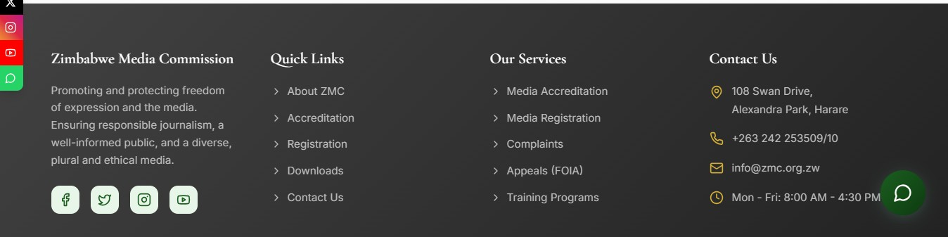
- On the part Zimbabwe Media Commission, remove the text there and add our mission there.
- Under downloads tab add in “Annual Reports”
- Chat Bot
- Accreditation – add the following information;
Accreditation of journalists and other people employed in the media is provided by Statutory 169C of 2002. The Statutory Instrument prescribes the manner and form in which an individual can lodge an application for accreditation with the Zimbabwe Media Commission. Statutory Instrument 65 of 2022 also prescribes the fee payable for accreditation.
The following are the requirements needed;
- A certified copy of National Registration (I.D).
- Certified copies of professional and academic certificates or sample of past work.
- Where diplomas or certificates are not available, present at least five (5) copies of past work.
- One passport sized photograph per applicant.
- Any other relevant attachments such as referees’ letters, testimonial and citations where available.
- Application fee – for both full time and free-lance journalists.
- Please note: A stamp of the employer on page 5 of the form.
NB: Fees are also payable in local currency at the prevailing official bank rate of the day of payment.
- Registration – add the following information
Registration of mass media services is provided by Statutory 169C of 2002 as read with Statutory Instrument 10 of 2004. The Statutory Instrument prescribes the manner and form in which an individual can lodge an application for registration with the Zimbabwe Media Commission. Statutory Instrument 65 of 2022 prescribes the fee payable for registration.
The following are the requirements needed;
- Projected cash flow statement for three years.
- Projected balance sheet for three years.
- Editorial charter.
- Code of ethics.
- Code of conduct for employees.
- Market analysis.
- Certified I.Ds for directors.
- In-house style book.
- Attach dummy (copy of publication)
- Attach mission statement.
- Attach certificate of incorporation.
- Attach memorandum of association.
NB: Fees are also payable in local currency at the prevailing official bank rate of the day of payment.
- FOIA Appels
Under the Freedom of Information Act (FOIA), the Zimbabwe Media Commission (ZMC) is required to review decisions relating to access to information held by public entities. The Commission receives appeals from members of the public who are denied access to requested information from government and public bodies.
To lodge an appeal, download the appeal form from our downloads page, complete the required information and submit online together the original information request which is date stamped. Also provide the response letter of refusal if available.
- Media Complaints
The Zimbabwe Media Commission (ZMC) receives and consider complaints from the public and, where appropriate, to take action against journalists and other persons employed in the media or broadcasting who are found to have breached any law or any code of conduct applicable to them. Submit a media complaint online.

