EXASERVE
Framework Reference Card
Scaling LLM Inference on HPC — One OpenAI-Compatible Endpoint from N Compute Nodes • github.com/AI-ModCon/exaserve
ExaServe is a framework for scaling LLM inference across the compute nodes of an HPC system. From one YAML file and one command, it turns a batch-scheduler allocation (e.g. a PBS job) into a single OpenAI-compatible inference service: it launches a Ray cluster over the allocation, stages model weights to node-local storage with an MPI broadcast, deploys vLLM replicas in plan-derived Ray Serve applications, and fronts them with one head-owned HAProxy. A companion evaluation harness measures deployments end to end. ExaServe has been evaluated from 1 to 256 Aurora nodes, including Llama-3-8B serving and pipeline-parallel Llama-3.1-405B inference, on earlier snapshots of this code; the current tree has not been re-measured at that scale. This is development and research source: no artifact is production-qualified, and production submission fails closed. Fix-specific regression coverage belongs to the changelog and does not redefine the system's demonstrated scale.
1 · Why ExaServe?
Existing LLM serving stacks assume cloud environments; HPC systems bring batch-queue scheduling, MPI-only launch paths, Lustre metadata costs, exotic accelerators, and scale cliffs that only appear past a hundred nodes. ExaServe packages the engineering needed to cross that gap:
Turnkey N-node serving
One YAML file plus one command turns a batch-scheduler allocation into an OpenAI-compatible service; clients see the standard API and need no HPC knowledge.
Demonstrated scale
Scale evaluations of earlier snapshots reached 256 nodes / 3,072 replicas behind HAProxy front end: 27.1k non-streaming QPS with Llama-3-8B (one replica per tile) — 96% weak-scaling efficiency at 256 nodes (27.1k of 28.2k offered, 0% errors). A quantified comparison of head-node proxies (HAProxy, Envoy, LiteLLM, Ray Serve proxy) records gateway-specific throughput and latency limits.
Frontier-model research
Multi-node pipeline parallelism serves Llama-3.1-405B (TP8 × PP2, two nodes per replica) with shard-aware weight staging, demonstrated from 2 to 128 replicas (4 to 256 nodes, streaming): 67% weak-scaling efficiency with direct dispatch and 50% through HAProxy.
Measurement built in
A declarative benchmark harness generates traces and scheduler jobs, replays load through a Go client, and scores per-request TTFT/TBT against latency SLOs.
2 · What’s in a deployment?
A deployment is a small stack of cooperating pieces, all driven from one configuration file:
Component | Description
Launcher | exaserve-serve-submit (batch, from a login node) or exaserve-launch-cluster (interactive) bring up the whole stack on a scheduler allocation
MPI weight staging | One-source-many-sinks MPI broadcast from the shared file system (e.g., Lustre) to node-local storage; shard-aware per pipeline stage for very large models
Inference replicas | Dense single-model TP=1/PP=1 serving uses one multi-replica model application plus node proxies. Sparse, multi-device, pipeline-parallel and multi-model plans retain per-replica applications; replicas span devices as planned
Head-node proxy | One head-owned HAProxy in the Aurora reference deployment exposes a single allocation-internal endpoint
Compatibility profile | Version-pinned targeted activation plus per-process attestation before READY
Benchmark harness | eval/: declarative specs → traces + scheduler jobs → replay → SLO scoring

3 · Installation
Install steps are site-specific — they depend on how the host provides Ray, the inference engine, MPI, and the accelerator toolchain. The recipe below targets ALCF Aurora; recipes for other sites will be added as they are supported.
ALCF Aurora
Use the operator-provisioned site interpreter and ExaServe wheel together with the profiled Ray, vLLM, MPI and accelerator stack. Job isolation disables user-site packages, so an installation made only with --user is not a serving runtime. The README and getting-started guide describe provisioning and preflight.
module load frameworks
unset ONEAPI_DEVICE_SELECTOR
PYTHONNOUSERSITE=1 PYTHONSAFEPATH=1 python3 -c \
'import sys, exaserve; print(sys.executable); print(exaserve.__file__)'
command -v mpiexec
command -v haproxy

One-time extras: provision HAProxy with scripts/build_haproxy.sh on a compute node; build the evaluation load generator with module load go && make -C eval/go_client.
4 · Example
ALCF Aurora
One flat canonical YAML file describes deployment semantics. This compact example uses two nodes for readability. Before submission, select an authorized validation configuration or an admitted release profile; the current default profile fails production admission closed. Submission itself runs from a login node; query the endpoint only after canonical READY:
exaserve-serve-submit my_config.yaml --project-account YOUR_PROJECT --wait
# 1234567.aurora-pbs-0001... <- PBS job id
# http://<head-node>:4001 <- service URL
curl -sS -X POST "http://<head-node>:4001/v1/chat/completions" \
-H 'Content-Type: application/json' \
-d '{"model":"meta-llama/Meta-Llama-3-8B-Instruct",
"messages":[{"role":"user","content":"hello"}],"max_tokens":8}'
# {"id":"chatcmpl-...","choices":[{"message":{"content":"Hi!"...}}],...}
qdel 1234567 # tear down

The configuration it references: Llama-3-8B on two nodes (24 replicas) behind HAProxy. model_storage_path (your model directory on the shared file system) and local_stage_path (node-local staging) are typically the only fields that vary per user.
# my_config.yaml
num_nodes: 2
ray_port: 6379
node_cpus: 64
model_storage_path: /lus/flare/projects/<PROJECT>/<user>/models
local_stage_path: /tmp/hf_home
num_gpus_per_node: 12
models:
- model_id: meta-llama/Meta-Llama-3-8B-Instruct
tensor_parallel_size: 1
pipeline_parallel_size: 1
max_model_len: 4096
size: 8
gateway:
kind: haproxy
port: 4001
backend_port: 8000
options: {balance: leastconn, maxconn: 8000}

Learn more: the README covers interactive launches inside qsub -I, custom PBS integration via --dry-run, and every configuration field (examples/config.reference.yaml is fully annotated).

5 · Measured scaling on Aurora
The published evaluations span 1–256 Aurora nodes and were made on earlier snapshots of this code; the current tree has not been re-measured at that scale. These measurements describe the tested workloads, runtime configurations and gateway modes; individual fixes have their own verification coverage. Production-release admission remains artifact-specific and is recorded in the hardening status.
Front-end proxy at scale
All client traffic enters through the head-node proxy. Non-streaming completions scale nearly linearly through a single HAProxy — 27.1k QPS with Llama-3-8B at 256 nodes / 3,072 single-tile replicas, 0% errors. Streaming (SSE) is harder on a centralized front end: the per-token delivery path saturates the head node’s network at large node counts, so requests still complete but slowly — streaming throughput plateaus around 4.7k QPS from 128 nodes, and p99 end-to-end latency reaches 17 s at 256 nodes while non-streaming p99 stays near 2 s at every scale. Budget streaming capacity per proxy and prefer non-streaming completions at extreme scale.
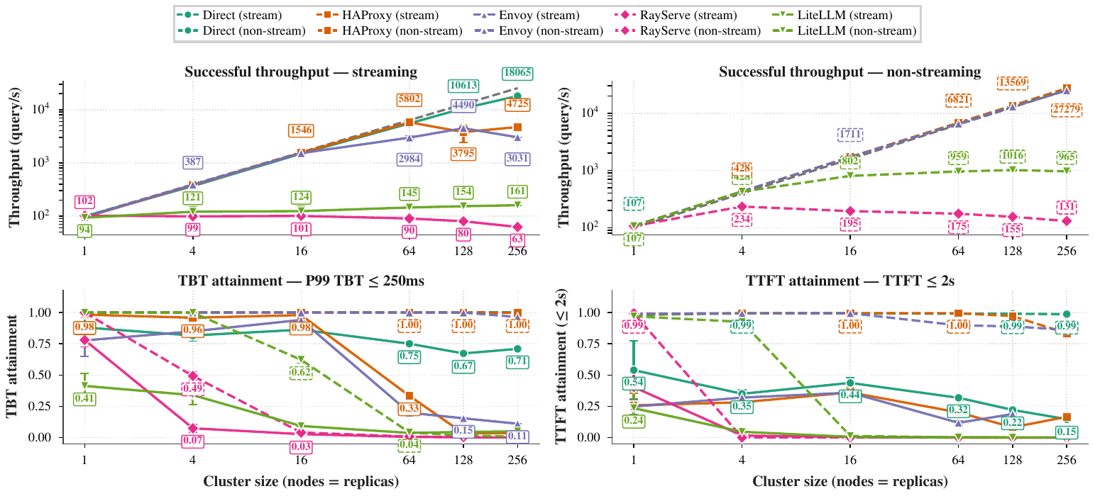
Weak scaling, 1–256 nodes (Llama-3-8B, 64 in / 64 out, 110 QPS/node offered): successful throughput and SLO attainment per front end, streaming (solid) vs non-streaming (dashed). Non-streaming HAProxy reaches 27.1k QPS; streaming through any centralized proxy plateaus or collapses. “Direct” is the benchmark-only backend-isolation diagnostic.
Note: for benchmarking only, the harness’s client can bypass the proxy and dispatch to per-node endpoints (client.dest: direct in a spec) to measure backend capacity without a front end — backends themselves scale linearly to 256 nodes when the proxy is bypassed. This mode exposes one endpoint per node and is not a deployment path.

Multi-node models
Models larger than a node are served with pipeline parallelism across node pairs (Llama-3.1-405B: TP8 within a node × PP2 across two nodes). Shard-aware staging gives each pipeline stage only its own weight shard (~380 GiB, which fits node-local tmpfs) and pins each replica to its nodes. All 405B measurements are streaming: at a fixed per-replica offered rate, direct dispatch (the routing-free reference) grows aggregate successful throughput from 0.7 QPS at 2 replicas to 31.0 QPS at 128 replicas (4 to 256 nodes), a 67% weak-scaling efficiency vs the 4-node base. Through a single HAProxy the service tracks direct dispatch within 5% through 8 replicas, falls behind from 16 replicas, and completes 22.9 QPS at 0.3% errors (50% efficiency) at 128 replicas. The paper attributes the remaining efficiency loss to requests still draining at the end of the fixed measurement window, not to routing. A non-streaming 405B configuration has not been measured.
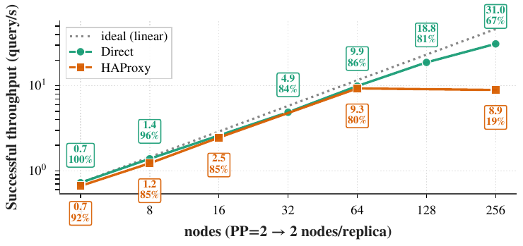
Llama-3.1-405B (TP8 × PP2) weak scaling, 2–128 replicas at a fixed offered rate per replica. Point labels: successful throughput and weak-scaling efficiency vs the 4-node base.
Robustness across workloads and models
Holding the 8B baseline fixed and varying one axis at a time (each row’s offered rate pinned at 90% of its single-node saturation), SLO attainment — the fraction of requests meeting TTFT ≤ 2 s and P99 TBT ≤ 250 ms — holds at 64 nodes for long-context and moderate-rate workloads and for the 120B model. The two rows that degrade (the short/high-rate baseline and Poisson arrivals at the same mean) lose their latency margin at the saturation knee once 64 nodes share the streaming path: the failure is load-shape specific, not model- or workload-specific.
Perturbation | attain (N=1) | attain (N=64) | Δ
(baseline) 8B, 64/64, fixed-interval | 0.94 | 0.65 | −0.29
Workload: ShareGPT 2K/2K | 1.00 | 0.98 | −0.02
Workload: ShareGPT 4K/4K | 1.00 | 1.00 | 0.00
Workload: Code (HumanEval) | 1.00 | 1.00 | 0.00
Workload: Chat (ShareGPT natural) | 0.99 | 0.99 | 0.00
Workload: Summarization | 1.00 | 1.00 | 0.00
Model: 120B (TP=8, rate 9) | 0.98 | 0.97 | −0.01
Arrival: Poisson | 0.92 | 0.60 | −0.32
Arrival: BurstGPT trace † | 0.46 | 0.46 | 0.00

† BurstGPT replays a fixed total arrival rate not scaled by N, so its N=64 cell is not a weak-scaling stress; reported for completeness.
Steady-state serving vs. startup time
Everything above is steady-state serving, measured after the cluster reports ready. Cluster bring-up behaves differently: it does not scale, and this is Ray’s key limitation at HPC scale. Model staging (~50 s for the 8B model), Ray cluster start (~45 s), and first-request warm-up (~8 s) are roughly flat in node count, but Ray Serve’s serve.run phase grows superlinearly — 154 s at 64 nodes, 456 s at 128, and 1,767 s (about 30 min) at 256 — and a 512-node bring-up fails outright. The growth is concentrated in the proxy readiness wait: on every deployment broadcast, every Ray Serve proxy resolves every replica handle against the Ray control store (GCS), work that is quadratic in node count and reaches 1.38 million GCS lookups at 256 nodes. Budget job walltime as bring-up plus serving window (405B weight loading adds more), and reuse a running cluster across experiments where possible.
Plan-bound validation controls
These controls are compiled into the immutable deployment plan; ambient environment variables do not select a different production topology:
Environment knob | Effect
engine: vllm | The Aurora production SiteProfile rejects unqualified engines such as SGLang
runtime.pp_shard_aware: true | Shard-aware multi-node pipeline-parallel staging and node-pinned replicas (405B-class models)
runtime.null_compute: true | Skip the engine and simulate latency — control-plane stress tests
runtime.clean_stage: true | Request a fresh staged-model validation run

Historical scale cliffs are catalogued in docs/KNOWN_ISSUES.md. The compatibility profile activates only version-pinned targeted changes and every required process attests the result before READY.
Portability. The code has scheduler, gateway, vendor, and engine interfaces, but interfaces are not support claims. The default Aurora SiteProfile admits only PBS, XPU, vLLM, and HAProxy as candidate dimensions, and production submission currently fails closed. Slurm/PSI-J, CUDA/ROCm, SGLang, streaming, direct exposure, and alternate gateways fail closed or require explicit validation-only plans until separately proven.

6 · Serving agents and OpenAI-compatible clients
The deployment exposes the standard OpenAI API, so any compatible client works unchanged — LangChain’s ChatOpenAI, Academy LLM agents, litellm, or the openai SDK — by pointing the usual environment variables at the service URL. This makes the framework the self-hosted, on-machine complement to a hosted inference gateway: the same agent code runs against either.
export OPENAI_BASE_URL=http://<head_node>:4001/v1
export OPENAI_API_KEY=EMPTY

The current HAProxy exposure is trusted-allocation/internal and has no public-network authentication claim. Do not expose it outside that boundary. LiteLLM is validation-only.
7 · Examples and Resources
Runnable configurations and benchmark specifications live in the repository; code is linked rather than copied here. Paths are relative to github.com/AI-ModCon/exaserve.
Resource | Location
Source code | github.com/AI-ModCon/exaserve
Documentation | README.md — install, configuration, console-script reference
Machine-actionable card | docs/exaserve.md — markdown version of this card for coding agents
Deployment templates | examples/ — HAProxy, LiteLLM, and a fully annotated reference config
Benchmark specs | eval/specs/refcard/ — the smoke, weak-scaling, and 405B pipeline-parallel specs referenced in this card
Scaling analyses | docs/operations_handbook.md and docs/KNOWN_ISSUES.md — limits, root causes, fixes

8 · Citation
The system and its 1–256-node evaluation are described in ExaServe: Large-Scale LLM Serving on Exascale HPC Systems, arXiv:2609.10812. https://arxiv.org/abs/2609.10812
@misc{wang2026exaserve,
title = {ExaServe: Large-Scale LLM Serving on
Exascale HPC Systems},
author = {Wenyi Wang and Shu Shi and Yadu Babuji and
Ian Foster and Kyle Chard},
year = {2026},
eprint = {2609.10812},
archivePrefix = {arXiv},
primaryClass = {cs.DC},
doi = {10.48550/arXiv.2609.10812},
url = {https://arxiv.org/abs/2609.10812}
}

