STUDENT GUIDE
Hermes–Nurse AI OS
Nursing Student Life & Learning
Empowerment Function
A student-controlled command center for nursing school, clinical preparation, wellbeing, career direction, and life goals
Core promise: The AI handles coordination. The student builds competence. Faculty and licensed human judgment remain in charge.
Prepared for nursing students at every stage
Version 1.0 • July 2026

Welcome: nursing school is rarely “just school”
The Nursing Student Life & Learning Empowerment Function is built around the whole student—the person studying, working, commuting, caregiving, budgeting, recovering, and trying to become a nurse without losing the rest of their life.
A student may be raising children, supporting family, learning in a second language, adjusting to a new country, living with a disability, returning after time away from education, or working long hours while completing clinical requirements. The system begins with that reality instead of assuming unlimited time, energy, money, or support.
Hermes–Nurse AI OS becomes a private coordination and learning environment. It helps the student see responsibilities, translate goals into steps, practice actively, prepare for clinical safely, communicate confidently, recognize when human help is needed, and preserve evidence of growth.
The purpose: This is not a shortcut through nursing school. It is a structure for moving through nursing school with greater clarity, competence, agency, and sustainability.

Executive overview
Element | Purpose
Hermes | Remembers only authorized information and coordinates goals, schedules, routines, and follow-through.
Nurse AI OS | Adds nursing values, educational safety, academic integrity, no-PHI boundaries, and human-verification rules.
Student dashboard | Provides one current view of learning, clinical preparation, life capacity, support needs, and future goals.

The system can plan, teach, quiz, simulate, reflect, draft, organize, and track. It cannot become the student, replace faculty, make clinical decisions, certify competence, or assume professional accountability.

Designed for different student realities
Student situation | How the system adapts | Boundary
First-term | Translates syllabi and unfamiliar expectations into a manageable structure. | Faculty directions remain authoritative.
Accelerated program | Prioritizes dense workloads and protects recovery. | Does not normalize unsafe sleep loss.
Working student | Coordinates shifts, class, clinical, study, and commute. | Student confirms official schedules.
Parent or caregiver | Plans around care responsibilities and creates backup options. | No shame or assumption of unlimited flexibility.
First-generation | Explains processes and prepares questions for support offices. | Institutional information must be verified.
Multilingual/international | Clarifies terminology and rehearses communication. | Accent is never equated with competence.
Disability/neurodivergence | Breaks work into steps and varies presentation. | Does not diagnose or grant accommodations.
Returning after setback | Builds a nonjudgmental recovery plan from the present. | Does not define the student by a prior result.
Financially constrained | Organizes deadlines and questions for aid staff. | Does not give authoritative financial advice.

The five-part student support system
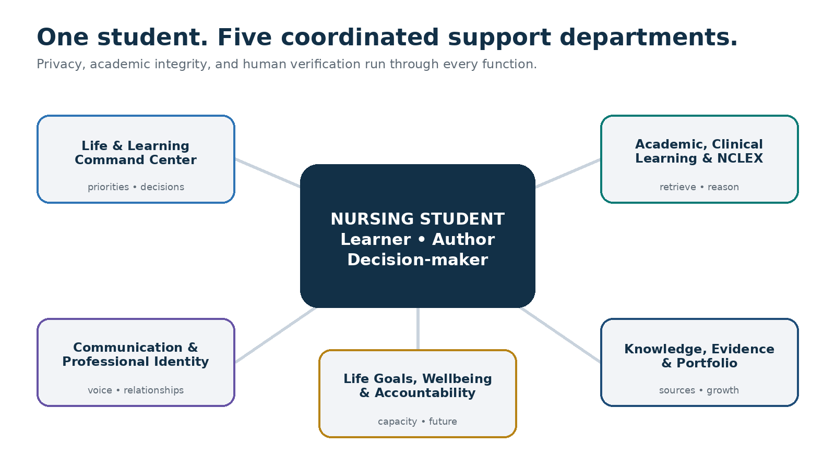
The student remains the learner, author, and decision-maker; all five departments operate through privacy, integrity, and human verification.

Benefits to the student

Less fragmentation
Courses, clinical days, work shifts, family responsibilities, appointments, recovery, finances, and career goals become part of one coordinated plan.

Better learning habits
The system emphasizes retrieval, teach-back, spaced review, case reasoning, and reflection instead of passive rereading.

Earlier recognition of difficulty
Deadlines, misconceptions, unclear instructions, and capacity problems become visible before they become emergencies.

Safer clinical preparation
Students can review approved checklists, rehearse communication, prepare questions, and use fictional cases without patient information.

More confident communication
The student can rehearse emails, office-hour questions, feedback conversations, and professional interviews while preserving their own voice.

Stronger professional identity
Values, strengths, experiences, feedback, and career interests become a student-controlled portfolio.

A more survivable path
Planning is based on the student’s actual time, energy, responsibilities, and need for recovery.

The Student Empowerment Compact

You remain the learner
The AI may explain, question, organize, and provide feedback. It does not complete restricted work or conceal AI involvement.

You control your information
Memory is opt-in; session-only use and deletion remain available.

The system does not surveil you
It does not rank, label, predict, or report you.

No patient information
Clinical learning uses fictional, faculty-provided, or safely generic material.

Clinical authority remains human
Faculty, preceptors, approved sources, policy, and licensed supervision remain authoritative.

Uncertainty stays visible
Verified facts, interpretation, limitations, and human validation are separated.

Help-seeking is strength
The system helps prepare contact with the right human.

Your life matters beyond grades
Sleep, health, relationships, finances, identity, and purpose remain part of the plan.

The five empowerment functions

1. Life & Learning Command Center
The student chief of staff brings together course schedules, clinical days, work, commute, family, appointments, study, finances, and recovery.
- Creates realistic daily, weekly, semester, and 90-day plans
- Identifies conflicts and safe deferrals
- Breaks large work into milestones
- Maintains Today’s Top Three and Plan B
- Rebuilds the plan after illness, work changes, or disruption

2. Academic, Clinical Learning & NCLEX Studio
This function turns approved objectives and sources into active learning. It asks the student to retrieve and reason before supplying a full explanation.
- Teach-back, retrieval practice, spaced review, and mixed practice
- Original practice questions with rationales
- Misconception and error-pattern analysis
- Fictional clinical reasoning, prioritization, delegation, and SBAR
- NCLEX development by domain without pass guarantees
Learning rule: The system is successful when the student can explain, decide, and perform without needing the AI to carry the thinking.

3. Communication & Professional Identity
This function helps the student ask for help, receive feedback, preserve their own voice, and become intentional about the nurse they are becoming.
- Faculty and office-hour questions
- Professional email drafts for student revision
- Feedback and difficult-conversation rehearsal
- Fictional handoff and speaking-up practice
- Résumé, interview, mentorship, and professional-values development

4. Knowledge, Evidence & Portfolio Infrastructure
This is the student’s governed learning memory: sources, course maps, rubrics, misconception logs, approved checklists, reflections, and evidence of growth.
- Source owner, version, date, and verification status
- Cross-course connections and learning maps
- NCLEX error log and scheduled review
- Student-controlled portfolio artifacts
- Clear separation of self-tracking from official validation

5. Life Goals, Wellbeing & Accountability Orchestration
This function protects the conditions that make learning possible: time, energy, sleep, finances, relationships, support, recovery, and future direction.
- Realistic capacity budgets with 10–15% buffer
- High-level student budgeting without account credentials
- Overload and recovery protocols
- Compassionate commitment tracking without punitive streaks
- Career, licensure, portfolio, and long-term life milestones
Capacity rule: Never schedule 100% of theoretically available time. A plan that requires chronic overload is not a valid plan.

The NURSE Compass for life goals
The dashboard connects today’s next action to a larger purpose, so nursing school does not become an endless sequence of disconnected deadlines.
Step | Guiding question | Result
N — Name the North Star | What kind of nurse and person do I hope to become? | A concise purpose statement
U — Understand reality | What strengths, constraints, resources, and uncertainties exist now? | An honest capacity map
R — Results for 90 days | What few outcomes would create meaningful progress? | Up to three measurable results
S — Systems and support | What routines, people, tools, and backup plans help? | A sustainable support system
E — Evaluate and evolve | What is working, and what should change without shame? | A learning and adaptation cycle

Five planning horizons
- Today — the next right action
- This week — what must be protected, completed, or discussed
- This semester — evidence of successful progress
- Licensure and first role — transition readiness
- Long-term life — work, impact, health, relationships, finances, and purpose

The embedded Student Life & Learning Command Center
The private dashboard should answer within one minute: What matters today? What am I learning? Does the plan fit my actual life? What needs a human rather than AI?
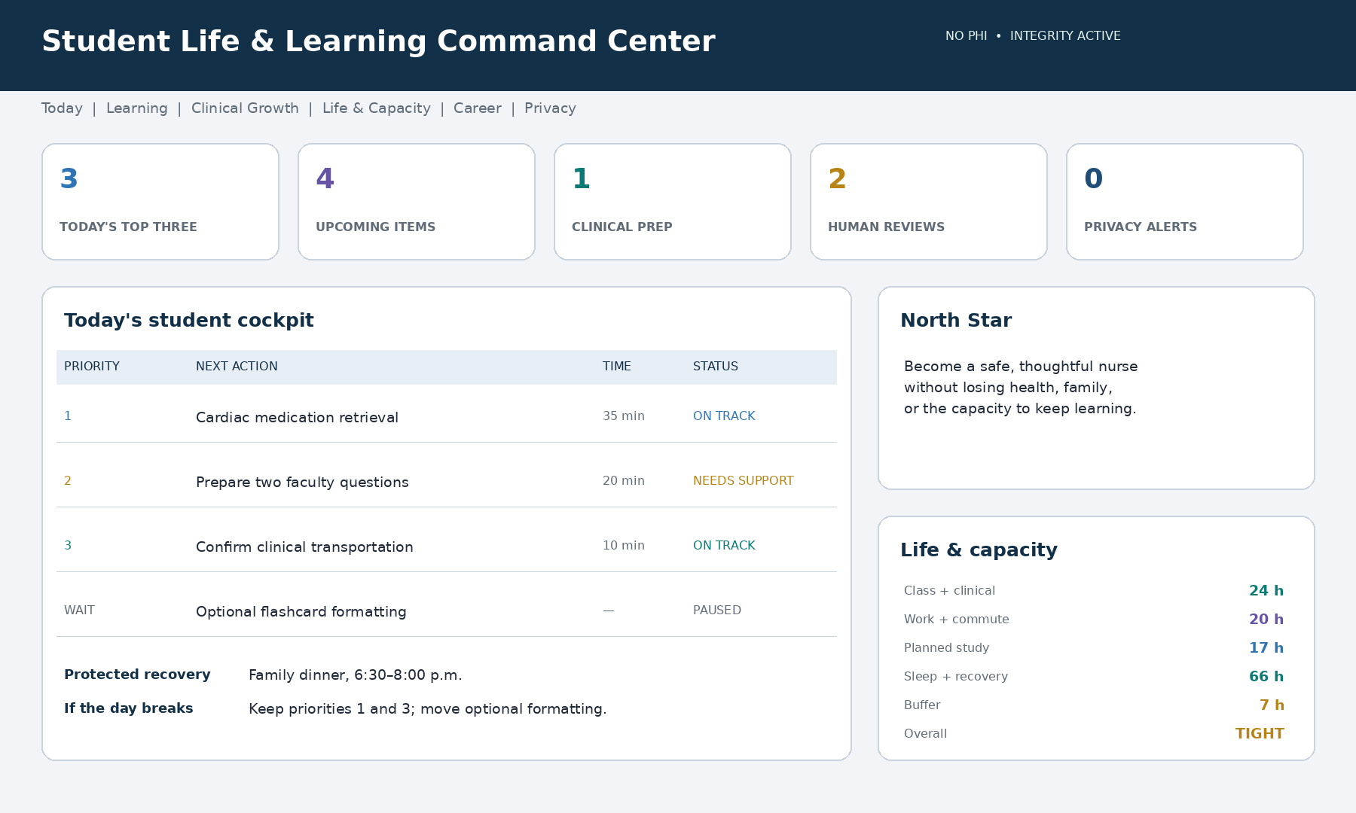
Illustrative dashboard using synthetic information. A student implementation should be private, no-PHI, and transparent about memory, sources, and human verification.

Required dashboard areas
Area | Question answered | Typical content
Today | What matters now? | Top Three, fixed commitments, recovery, Plan B
Learning | What am I building? | Assessments, retrieval, gaps, misconceptions
Clinical growth | How should I prepare safely? | Checklists, simulations, instructor questions
Life & capacity | Does the plan fit? | Work, family, commute, sleep, buffer
Support | Who should help? | Faculty, tutoring, access services, financial aid
Career & portfolio | Where is this leading? | NCLEX, professional evidence, next milestone
Governance | Is AI being used safely? | Memory, sources, integrity, no-PHI status

Status language: Use On track, Watch, Needs support, Paused intentionally, Awaiting human guidance, and Completed. Avoid shaming or predictive labels.

A day in the life

Orient
The student gives a brief capacity update. The command center protects essential clinical preparation, identifies the Top Three, and moves lower-value work if sleep, health, work, or family demands changed.

Prepare
Before class, the system presents learning objectives, short retrieval from prior material, one concept to listen for, and a question the student wants answered.

Use small windows well
A commute or break may support audio teach-back or five retrieval questions. Deep work is reserved for a suitable setting.

Consolidate
After class, the student explains the concept. Hermes identifies gaps and schedules later retrieval.

Verify clinical preparation
The system reviews the approved checklist, identifies questions for faculty, and reminds the student not to enter patient information.

Close the loop
The day ends with completed work, unresolved questions, tomorrow’s capacity, help needed, and what can be released until later.

A week in the life
- Preview fixed commitments, assessments, clinical preparation, work, family, and recovery.
- Assign intentional learning sessions rather than vague “study time.”
- Run a midweek capacity check before missed work accumulates.
- Complete deidentified clinical reflection focused on learning and questions.
- Review progress, misconceptions, help requested, recovery protected, and next priorities.

Academic integrity and clinical safety

What AI may support
- Personal planning and workload organization
- General explanations and active-learning practice
- Fictional simulations and deidentified reflection prompts
- Faculty-question and office-hour preparation
- Feedback on student-authored work when permitted
- Career, résumé, interview, and portfolio preparation

What requires policy confirmation or human verification
- Graded assignment support
- Care plans, case analyses, and clinical reasoning papers
- Editing or translating graded work
- Medication calculations and skills sequences
- Institutional policy or scope questions
- Accommodation, remediation, financial, or sensitive personal decisions

What is prohibited
- Taking an exam or quiz
- Impersonating the student
- Fabricating sources, hours, experiences, data, competencies, or signatures
- Concealing prohibited AI use
- Entering or retaining PHI
- Directing care for an actual patient
- Overriding faculty or institutional policy
Verification rule: Before relying on an AI-generated clinical statement, check faculty instruction, current course material, approved references, institutional policy, and licensed supervision when patient care is involved.

Privacy and memory controls
Memory class | Examples | Default
May remember with consent | Program stage, general courses, learning preferences, goals, routines | Approved categories
Optional or session-only | Grades, finances, health, family details, reflections, accommodations | Ask first
Never remember | PHI, credentials, government IDs, bank data, private third-party information | Blocked

The student should be able to ask: What do you remember? Forget this. Use this session only. Do not remember this category. Export my plan. Reset my dashboard.

90-day student rollout
Phase | Timing | Primary work | Evidence
Safety and clarity | Days 1–7 | Policy, no PHI, memory, North Star, fixed commitments, one pilot goal | Compact, dashboard, first week
Stabilize the week | Days 8–30 | Daily orientation, milestones, retrieval, capacity, recovery, help-seeking | Weekly template and Plan B
Personalize | Days 31–60 | Learning methods, fictional simulations, clinical routines, communication, portfolio | Personal learning playbook
Build forward | Days 61–90 | Review growth, prepare transitions, refine dashboard, set new results | 90-day progress brief

Start small: Pilot one course or one whole-life goal. Add functions only when they increase learning or agency without adding unacceptable burden or risk.

Student-controlled outcome measures
Domain | Possible measure | Why it matters
Organization | Major deadlines captured and planned | Reduces avoidable surprises
Learning | Retrieval completed and misconceptions corrected | Measures active learning
Understanding | Explains concepts without AI | Confirms independent competence
Clinical preparation | Checklist and instructor questions ready | Supports safer participation
Help-seeking | Time from concern to human contact | Encourages early support
Integrity | AI uses checked and disclosed | Protects trust
Wellbeing | Student-selected recovery protected | Supports sustainability
Career | Portfolio and professional actions completed | Connects school to future goals

Success is increased agency and learning—not usage volume. Personal dashboard information should not be shared without clear consent and authority.

Frequently asked questions

Will the system do my assignments?
No. It helps you understand instructions, organize your process, practice, and improve your own work when permitted. It does not replace your thinking or submit work.

What if faculty does not allow AI?
Follow the course policy. Personal scheduling or life-goal planning may still be appropriate if those uses are permitted.

Can I upload clinical information?
Use only fictional, faculty-provided, or clearly approved material. Do not enter patient information, even when you believe names were removed.

Can it tell me what to do for a patient?
No. Actual patient-care decisions belong in the approved clinical chain of supervision.

Can it help with medication calculations?
It may provide fictional educational practice. Any actual administration follows the school and clinical site’s verification process.

Can it prepare me for NCLEX?
Yes. It can plan, quiz, simulate, and analyze error patterns. It cannot reproduce protected items or guarantee a result.

Does it know my grades?
Only if you choose to enter them. Grade tracking is optional and is not a judgment of your worth or potential.

Will it label me “at risk”?
No. It may privately surface a deadline, learning gap, or capacity conflict and help you seek support.

Could I become dependent on AI?
The design should reduce dependence by requiring retrieval, reasoning, explanation, and reflection before answers are supplied.

What if I feel overwhelmed?
Ask for the next safe step and identify the right human support. AI planning is not a substitute for faculty help, healthcare, counseling, crisis support, or practical assistance.

Activation checklist
- Review applicable school, course, and clinical-site AI policies.
- Confirm which platform is approved.
- Establish the permanent no-PHI rule.
- Select permitted memory categories.
- Create the Do Not Remember list.
- Identify human escalation contacts.
- Choose one course or life goal for the pilot.
- Confirm that no information will be automatically shared.

Recommended first commands
- Help me create a survivable plan for this week.
- Quiz me without giving me the answer first.
- Help me prepare questions for my professor.
- Run a fictional SBAR simulation and challenge unsafe reasoning.
- Create Plan B if my work shift changes.
- Show me where human help is more appropriate than AI.
- Connect this semester to my long-term life and nursing goals.
- Show me what you remember and let me revise it.

Closing message to the student
You are not installing an artificial student to perform nursing school for you. You are building a personal operating system that helps you protect attention, strengthen learning, prepare deliberately, ask for help sooner, and keep sight of the life you are trying to create.
The AI can hold the plan, organize material, ask the next question, and remind you what matters. But the knowledge, judgment, professional character, and future must become yours.
Final operating principle: The system coordinates. You become the nurse.

Companion implementation file
Use Nursing-Student-Life-and-Learning-Hermes-Program.md as the build and activation specification to hand to Hermes–Nurse AI OS.

Concept provenance
This student adaptation translates a five-department AI operating-system concept into a whole-life nursing education environment with active learning, no-PHI clinical preparation, academic integrity, student-controlled memory, professional identity, and compassionate accountability.

