USER GUIDE
Hermes–Nurse AI OS
SuperPowers Pack
Skills, workflows, launch buttons, and safeguards for doing meaningful work with greater clarity and control
Core promise: SuperPowers do not make AI more powerful over you. They make you more capable, clear, and in control.
For nurse leaders, students, educators, staff nurses, and nurse-connected allies
Version 1.0 • July 2026

Welcome: these powers remain yours
Your AI OS provides the protected foundation. The SuperPowers Pack helps you think clearly, communicate authentically, design useful experiences, and safely turn intentions into action.
Hermes can organize, explain, compare, design, draft, rehearse, and stage work. You remain the owner of your purpose, identity, relationships, professional duties, decisions, and consequences. A recommendation is not a decision, a prototype is not validation, and a repeated workflow is not permission for autonomous action.
The strongest SuperPower: Informed human agency: knowing what matters, seeing what the system is doing, correcting it, and adding power only when the benefit is dependable.

What the pack can help you do
- Turn unclear goals into mission-aligned next actions
- Plan around real capacity instead of idealized productivity
- Convert loose notes into deliberate tasks, decisions, references, or deletion
- Compare options and make evidence, assumptions, and uncertainty visible
- Create writing that is truthful, specific, useful, and authentically yours
- Design accessible dashboards, forms, documents, checklists, and experiences
- Prepare repeatable workflows with visible permissions, approvals, and recovery
- Learn from completed work and remove capabilities that create burden

The Power Contract
- You own your goals, identity, information, and final decisions.
- Hermes explains what it needs, what it will do, and why.
- Important external actions require preview and exact approval.
- Sensitive information is minimized and session-only by default.
- Facts, inferences, assumptions, recommendations, and unknowns remain distinct.
- You can stop, correct, forget, export, revoke, hide, pause, or uninstall.
- High-consequence decisions return to the responsible qualified human or approved system.

Your secure digital vehicle
Think of the AI OS as a protected digital vehicle. You remain the driver; SuperPowers are equipment you choose for the journey.
Vehicle element | SuperPowers meaning
Driver | The user, who retains authority and can stop
Destination | The user's mission and chosen outcomes
Route | Goals, milestones, and workflows
Dashboard | Launchers, status, approvals, alerts, and stop controls
Engine | Skills and repeatable workflows
Safety systems | Trust Shield, permissions, evidence, accessibility, and human gates
Optional equipment | Role Kits and Power-Ups
Logbook | Activity history, decisions, corrections, and lessons

The metaphor does not mean a physical vehicle, transportation service, or guarantee of absolute security. It means a user-controlled operating workspace with visible controls and boundaries.

How the pack is organized
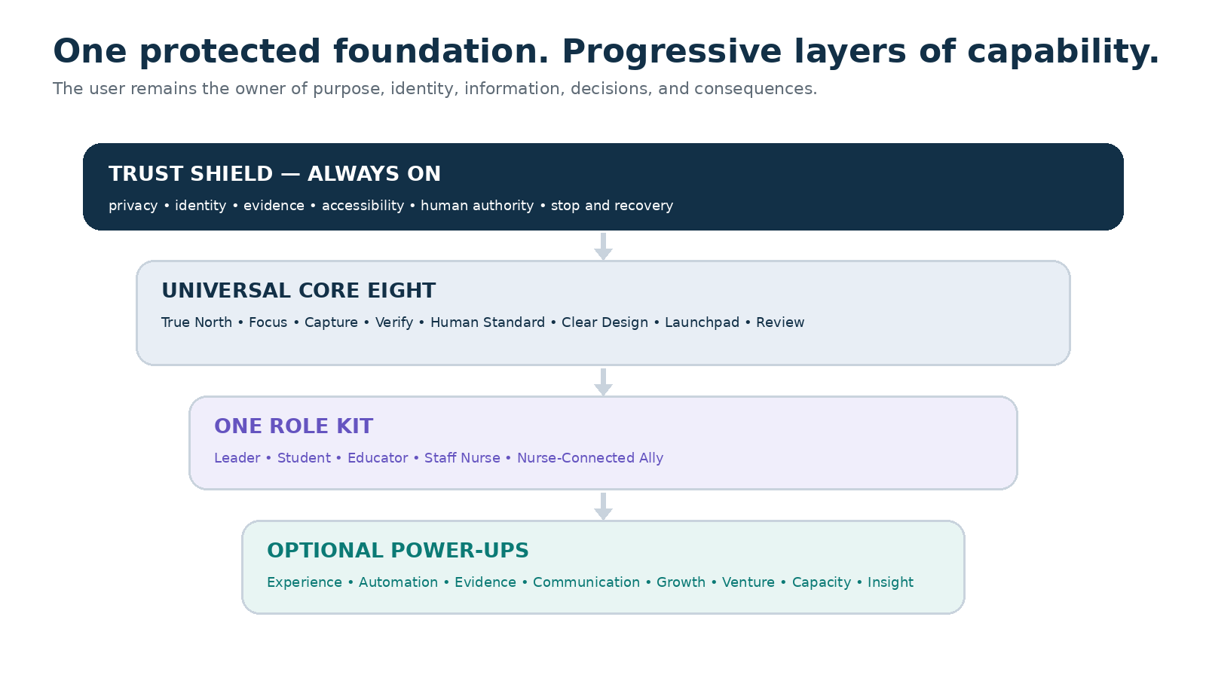
Trust Shield protects every layer. The universal Core Eight is available to everyone; one Role Kit and optional Power-Ups are added progressively according to the user's goals.

Skill, workflow, launcher, and automation
Term | What it means | Example
Skill | One reusable capability without an independent external effect | Check evidence or define a mission
Workflow | A documented sequence using one or more skills | Plan Today or Weekly Reset
Launcher | A dashboard control bound to one workflow | Make This Human
Automation | A proven workflow running at an approved maturity level | A monitored low-risk weekly summary

Before you begin
- Set aside 20–30 uninterrupted minutes for first setup.
- Use your own account and enable multifactor authentication or a passkey.
- Know which pathway you are activating: Leader, Student, Educator, Staff Nurse, or Nurse-Connected Ally.
- Choose one real but low-risk goal for the setup exercise.
- Do not enter patient information, personnel or student records, passwords, financial credentials, or confidential employer material.
- Keep external connections disabled until their purpose and permissions are clear.
- Identify a human reviewer for consequential professional work.
Recommended starting state: Memory: Ask before saving. Connections: None. External actions: Off. Automations: Manual, AI-assisted, or Preview only.

The universal Core Eight
Power | What it gives you | Launcher
True North Compass | Mission, values, roles, boundaries, and 90-day outcomes | Define My Mission
Focus & Capacity | Realistic daily and weekly plans with Plan B | Plan Today
Capture → Action | Deliberate next states for notes and ideas | Capture & Sort
Think & Verify | Evidence-aware options and decision briefs | Think It Through
The Human Standard | Truthful, specific, authentic communication | Make This Human
Clear Design | Accessible structure, flows, interfaces, and artifacts | Make This Clear
Safe Workflow Launchpad | Visible, testable, recoverable workflows | Run a Workflow
Review & Evolve | Weekly learning, cleanup, and one improvement | Weekly Reset

1. True North Compass
Use this during setup, transitions, or conflicting priorities. Hermes asks one question at a time, drafts alternatives, and creates a mission, values-in-action, role map, boundaries, not-now list, and up to three 90-day outcomes. You approve every identity statement before it is used or remembered.

2. Focus & Capacity
Use this for a day, week, disruption, or minimum-viable plan. Give fixed commitments, current capacity, recovery needs, deadlines, and desired outcomes. Hermes returns a Top Three, protected time, buffer, movable items, Plan B, and a minimum version. It does not change a calendar without approval.

3. Capture → Action
Use this for notes, ideas, or meeting takeaways. Hermes separates actions, decisions, projects, references, waiting items, questions, and delete candidates. Review the owner, date, destination, and memory state before saving, scheduling, sharing, assigning, merging, or deleting.

4. Think & Verify
Use this for an important choice or claim. Hermes identifies the decision owner, options, criteria, sources, contradictions, facts, inferences, assumptions, unknowns, risks, and the smallest reversible test. Qualified humans remain responsible for regulated or high-consequence decisions.

5. The Human Standard
Use this to improve a draft without inventing experience or flattening your voice. Provide audience, purpose, desired action, approved facts, preferred tone, and any phrases that must remain. Review changes, claims, names, recipients, consent, and consequences before use.

6. Clear Design
Use this for dashboards, forms, documents, presentations, wireframes, or service flows. Begin with the user, their primary task, context, friction, and access needs. Hermes provides hierarchy, flow, states, accessible copy, open questions, and a test plan—not a claim that an untested prototype is validated.

7. Safe Workflow Launchpad
Use this only after a repeated task is understood. Hermes maps inputs, data, permissions, tools, destinations, risks, approvals, failures, and recovery. It starts in Manual, AI-assisted, or Preview mode. A workflow cannot promote itself.

8. Review & Evolve
Use this weekly or after a project. Hermes reviews wins, friction, capacity accuracy, open loops, memory, permissions, and workflow value. You choose what to continue, customize, pause, release, verify, or uninstall.

Your SuperPowers Command Deck
The dashboard should show what matters, what is waiting for you, what the system can access, and how to stop it—without turning your life into a performance score.
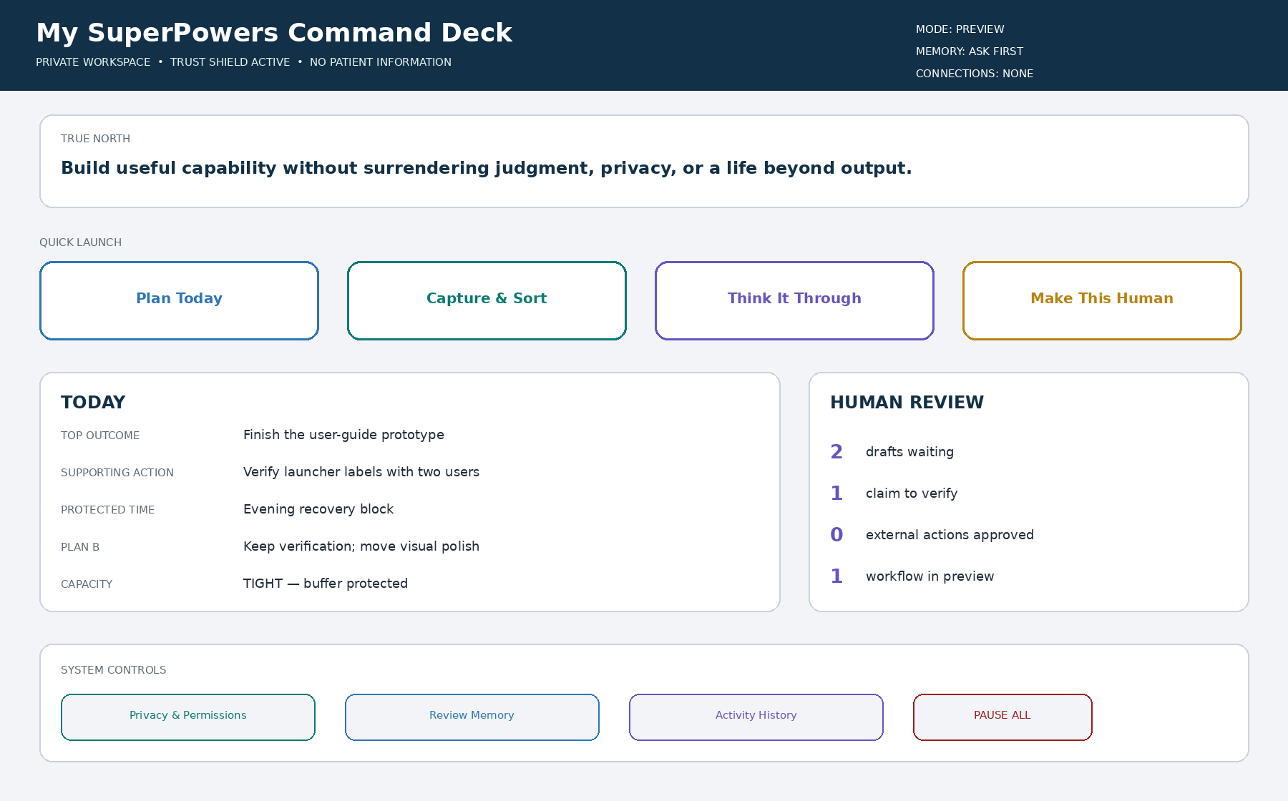
Illustrative home dashboard. Start with four primary launchers and keep Privacy & Permissions, activity history, and Pause All visible.

Your first four buttons
Button | What to expect | What it will not do silently
Plan Today | Top Three, protected time, buffer, and Plan B | Change calendars or commitments
Capture & Sort | Proposed actions, decisions, references, and destinations | Save, assign, share, schedule, or delete
Think It Through | Options, evidence, assumptions, uncertainty, and next test | Make the human decision
Make This Human | Revised draft, important changes, and claims to verify | Send, publish, fabricate, or evade detection

Anti-overwhelm rule: Pin no more than five launchers. Add no more than one workflow or Power-Up per week. Use “Reset my dashboard to the Core Four” whenever the command deck feels crowded.

Before selecting any launcher
- Read the expected outcome and estimated time.
- Confirm Draft, Assist, Preview, Approval-gated, or Monitored mode.
- Inspect the information and permissions it can access.
- Confirm the destination and any effect on another person or system.
- Identify who must review or decide.
- Know how to stop and recover before running it.

First-run setup wizard

1. Welcome and boundaries
Confirm that Hermes assists rather than decides, the workspace is not an emergency service, restricted information stays out, and consequential actions require human review.

2. Choose a pathway
Select Nurse Leader or Manager, Nursing Student, Nursing Educator, Staff Nurse, Nurse-Connected Ally, or General Core Pack.

3. Establish True North
Describe what matters now, important roles, what must not be optimized away, meaningful 90-day progress, and what you are deliberately not pursuing.

4. Establish capacity
Identify fixed and flexible commitments, care and household responsibilities, recovery needs, available focus, access needs, and current constraints.

5. Establish voice
Choose tone, audience, vocabulary, phrases to avoid, level of detail, and an optional low-sensitivity approved example.

6. Choose privacy and memory
Begin with Ask before saving or Session only. Keep sensitive and regulated information out of general memory.

7. Review connections
Recommended choice: Not now. Any connection must explain purpose, data, read/write access, destination, and disconnection.

8. Choose dashboard buttons
Pin Plan Today, Capture & Sort, Think It Through, and Make This Human. Keep system controls visible.

9. Conduct a safe test
Use a low-risk personal learning or organization example in Preview mode. Approve, revise, or reject the result.

10. Read the activation receipt
Confirm pathway, enabled skills, memory, connections, approvals, review date, and how to pause or reset.

Your seven-day quick start
Each activity should take about 10–20 minutes. Use one real but low-risk goal and keep all workflows private or in Preview mode.
Day | Activity | Result
1 | Define My Mission | Approved True North Compass
2 | Plan Today | Capacity-aware day and Plan B
3 | Capture & Sort | Clean action and reference list
4 | Think It Through | One low-risk decision brief
5 | Make This Human | Authentic draft and verification list
6 | Make This Clear | Accessible artifact and test plan
7 | Weekly Reset | Lessons, memory review, and next-week plan

End-of-day questions
- What did Hermes help prepare?
- What did I decide?
- What should be corrected, forgotten, or kept session-only?
- Would I trust this workflow with a slightly more important task? Why or why not?
Day-seven decision: For every launcher choose: Continue, Customize, Keep in Preview, Hide, Pause, or Uninstall. Do not enable unattended automation during the first week.

The Human Standard: authentic, not artificial
Make This Human is an integrity and communication workflow—not a detector-evasion tool.
Pass | Question
Truth | Are claims accurate, supported, and appropriately qualified?
Substance | Is there useful meaning rather than polished filler?
Specificity | Can vague language become concrete without invention?
Voice | Does it sound like the user's approved voice?
Audience | Is it understandable and appropriate for the reader and channel?
Integrity | Are fabricated experiences, sources, quotations, and results absent?
Ownership | Has the person reviewed and approved the final artifact?

What to provide
- Audience and purpose
- Desired action
- Approved facts and sources
- Preferred voice, tone, and length
- Words or expressions to preserve or avoid
- Statements that must not be changed
Always review names, facts, recipients, links, attachments, quotations, consent, and consequences before using the final draft.

Safe automation: earn it gradually
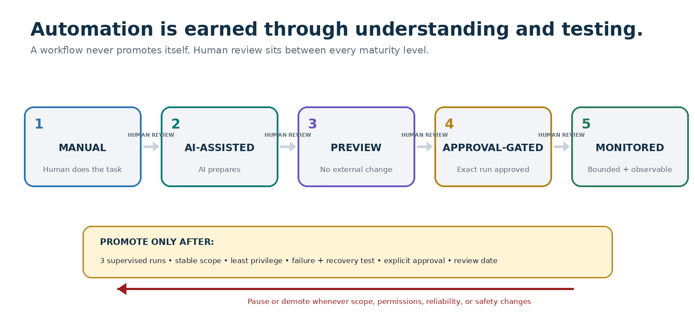
Automation progresses from Manual to Monitored only through supervised success, stable scope, least privilege, tested recovery, and explicit human approval. Any scope or safety change can return it to Preview or Manual.

Every workflow card must show
- Name, owner, purpose, and trigger
- Information accessed and prohibited inputs
- Action and destination
- Frequency and duplicate-prevention behavior
- Risk, mode, and approval gate
- Last run and current result
- Pause, stop, rollback, and recovery controls
- Review or expiration date
Never unattended by default: Sending, publishing, spending, transferring, signing, filing, deleting, changing access, representing another person, or making clinical, employment, legal, tax, investment, credit, insurance, grading, or similar consequential decisions.

If an automation behaves unexpectedly
- Select Pause All.
- Do not repeatedly relaunch the workflow.
- Review the activity receipt and destination system.
- Revoke unnecessary permissions.
- Correct or restore the affected item when possible.
- Record what happened and what remains uncertain.
- Obtain qualified help if privacy, money, safety, identity, or legal duties may be affected.

Choose your Role Kit
A Role Kit recommends the most useful Power-Ups and examples for a pathway. It never changes your identity or weakens the Trust Shield.
Pathway | Recommended Power-Ups | Key boundary
Nurse Leader | Evidence Scout, Bridge Builder, Command Deck, Insight Lens | No autonomous staffing, discipline, hiring, evaluation, or individual scoring
Nursing Student | Growth Engine, Capacity Guardian, Human Standard | Academic integrity; no fabricated work, clinical experience, or patient data
Nursing Educator | Experience Architect, Evidence Scout, Growth Engine | Educator approves assessment, grading, progression, and learner-facing material
Staff Nurse | Capacity Guardian, Growth Engine, Bridge Builder | No PHI, shadow documentation, live-care direction, or fitness determination
Nurse-Connected Ally | Venture & Impact, Capacity Guardian, Bridge Builder, Command Deck Lite | Independent identity; no nurse, employer, patient, or professional-authority access

Optional Power-Ups

Experience Architect
User journeys, task flows, information architecture, wireframes, accessibility reviews, and usability tests. Example launchers: Map the Journey; Simplify This Flow; Create a Wireframe.

Command Deck
Trigger/action workflows, connectors, scheduling, approvals, monitoring, exceptions, and recovery. Example launchers: Preview Automation; Review Exceptions.

Evidence Scout
Primary sources, evidence tables, contradiction maps, confidence labels, and refresh dates. Example launchers: Research This; Verify This Claim.

Bridge Builder
Stakeholder maps, meetings, listening, difficult conversations, boundaries, feedback, and follow-up. Example launcher: Prepare This Conversation.

Growth Engine
Skill gaps, learning sprints, retrieval practice, teach-back, scenarios, portfolios, résumés, and interviews. Example launchers: Build Study Sprint; Quiz Me.

Venture & Community Impact Lab
Listening, ethical offers, small experiments, partnerships, events, grants, storytelling consent, and impact learning. Example launcher: Test My Idea.

Capacity Guardian
Minimum-viable mode, recovery, commitment rebalancing, support planning, and general financial organization. Example launcher: Check My Capacity.

Insight Lens
Measure definitions, data quality, trends, scorecards, explanations, retrospectives, and next experiments. Example launcher: What Changed?
Activation rule: Add no more than one Power-Up per week. Keep it only when it solves a recurring problem and you understand its data, permissions, approvals, maximum automation, and uninstall behavior.

Privacy, memory, and permissions
Zone | Examples | Default
Personal | Private goals, plans, preferences, low-sensitivity drafts | Private; ask before remembering
Project | Material approved for one ongoing project | Purpose-limited and reviewable
Shared | One item shared with a named person for a defined purpose | Specific, minimal, time-limited, revocable
Restricted | Patient, personnel, student, secrets, protected cases, full financial credentials | Do not place in the general pack

Your memory controls
- Show what Hermes remembers and why
- Use this session only
- Correct inaccurate memory
- Forget one item or clear a project
- Turn memory off
- Export approved information
- Revoke a connection or permission
- Delete or uninstall a module
Important: Declining a permission request should not block unrelated Core Eight functions. A role, relationship, shared device, or prior access does not create standing consent.

Troubleshooting
Problem | What to do
Output sounds generic | Add audience, purpose, examples, constraints, and voice preferences; run Make This Human.
Plan is unrealistic | Run Check My Capacity and request a minimum-viable plan.
Information may be wrong | Stop; run Think It Through or Verify This Claim; inspect current primary sources.
Button does nothing | Check required inputs, mode, permissions, and connection. Do not repeatedly click.
Too many buttons | Reset the dashboard to the Core Four.
Hermes assumes too much | Ask it to separate facts, inferences, assumptions, and questions.
Sensitive data was entered | Stop, remove the material, clear related memory, inspect activity, and follow applicable policy.
Automation acted unexpectedly | Pause All, inspect the receipt, revoke access, verify the destination, recover, and escalate if needed.
Permission request is unclear | Decline and ask what exact data and action require it.
You feel overwhelmed | Use minimum-day/week mode and keep only one next action.

Hermes is not an emergency or crisis service. Contact local emergency services or an appropriate crisis resource when immediate safety is at risk.

Frequently asked questions

Do I need every SuperPower?
No. Begin with the Core Four launchers. Add capabilities gradually and hide or remove what does not help.

Can Hermes send or publish automatically?
Consequential actions should remain approval-gated. A low-risk workflow may earn monitored automation only after testing and explicit review.

Does the AI make decisions for me?
No. It prepares, organizes, compares, explains, and stages. You or the authorized professional decides.

Can I use patient, employee, or student information?
Not in the general pack. Use only formally approved governed systems and follow applicable policy.

Can a nurse-connected ally access the nurse's workspace?
No. Identities, accounts, permissions, memories, employer information, and clinical context remain separate.

Is Make This Human designed to defeat AI detectors?
No. It improves truthfulness, specificity, voice, clarity, and ownership.

What should Hermes remember?
Stable, low-sensitivity preferences that genuinely improve future work. Keep sensitive or temporary material session-only.

Can I undo an automation?
Every automatable workflow declares stop and recovery behavior before activation. Some external effects may not be reversible.

What if I disagree with the output?
Reject it, explain why, and revise or retire the workflow. Disagreement and correction are healthy controls.

Can I switch Role Kits?
Yes. Keep one primary pathway and add temporary tools for a defined purpose. Switching never merges identities or data.

Starter command library

Mission and direction
- “Guide me through defining a one-sentence mission. Ask one question at a time.”
- “Turn these values and responsibilities into three realistic 90-day outcomes.”
- “Help me create a not-now list that protects my current priorities.”

Planning and capacity
- “Plan today around these fixed commitments, current energy, and desired outcomes.”
- “Create a minimum-viable week that protects recovery and one essential result.”
- “Show what I should defer, delegate, decline, or shorten.”

Capture and organization
- “Sort these notes into actions, decisions, projects, references, waiting items, and delete candidates.”
- “Do not save, schedule, or send anything until I approve each destination.”
- “Identify missing owners, dates, or dependencies.”

Thinking and evidence
- “Separate what is known, assumed, inferred, preferred, and still unknown.”
- “Create a decision brief and identify which claims require verification.”
- “Find the strongest contrary view before recommending an option.”

Human communication
- “Revise this for clarity and authentic voice without inventing personal detail.”
- “Remove inflated, vague, repetitive, or overly polished language.”
- “Preserve these facts and phrases exactly; flag anything that needs verification.”

Clear design
- “Turn this process into a clear, accessible checklist.”
- “Propose a dashboard hierarchy with no more than five primary buttons.”
- “Create a usability test with five neutral tasks and observation questions.”

Safe workflows
- “Map this process without running it.”
- “Show required data, permissions, destinations, risks, approvals, and rollback.”
- “Run this once in Preview mode and issue an activity receipt.”

Review and improvement
- “Lead a weekly reset covering outcomes, capacity, lessons, memory, and next steps.”
- “Identify one workflow to stop, one to improve, and one small experiment.”
- “Show what Hermes remembers and recommend what should be corrected, forgotten, or retained.”

Final activation checklist
- My mission is user-approved.
- My role pathway is selected.
- My Core Four launchers are visible.
- I understand my memory mode.
- I reviewed connections and permissions.
- I completed one Preview workflow.
- I know how to use Privacy & Permissions and Pause All.
- I scheduled my first Weekly Reset.
- I know how to correct, forget, export, revoke, reset, and uninstall.

Closing message
Begin with one real goal and four launch buttons. Learn what each workflow does, correct it when necessary, and add power only when it produces a dependable benefit.
Final operating principle: Greater clarity, craft, recall, and follow-through must come before greater autonomy.

Companion implementation package
Use the Hermes-Nurse-AI-OS-SuperPowers-Pack-v1.0 folder or ZIP as the complete installer, modular skill and workflow library, dashboard contract, templates, role kits, Power-Up catalog, and acceptance-test suite.

Authoritative reference points
- NIST — AI Risk Management Framework: https://www.nist.gov/itl/ai-risk-management-framework
- NIST — Privacy Framework: https://www.nist.gov/privacy-framework
- NIST — Cybersecurity Framework 2.0: https://www.nist.gov/cyberframework
- W3C — Web Content Accessibility Guidelines 2.2: https://www.w3.org/TR/WCAG22/
- Digital.gov — Plain Language Guide: https://digital.gov/guides/plain-language
- HHS — HIPAA De-identification Guidance: https://www.hhs.gov/hipaa/for-professionals/special-topics/de-identification/index.html

