STAFF NURSE GUIDE
Hermes–Nurse AI OS
Staff Nurse Life & Practice
Empowerment Function
A nurse-controlled command center for shift readiness, learning, communication, career development, recovery, finances, relationships, and a whole life
Core promise: The AI prepares and coordinates. The nurse assesses, cares, communicates, escalates, and decides within their role. Patient care remains in approved clinical systems. The nurse’s life remains visible.
For staff nurses in every setting, schedule, and season
Version 1.0 • July 2026

Welcome: staff nursing is rarely “just a shift”
Staff nurses assess, prioritize, communicate, educate, document, coordinate, advocate, learn, adapt, and respond to constant change—while carrying a life that does not stop at the unit door.
A staff nurse may rotate schedules, commute, parent, provide family care, manage health needs, pursue education, navigate finances, recover from difficult shifts, and plan a future beyond the present role. Much of that work is fragmented across schedules, learning platforms, policy systems, personal notes, and memory.
The Staff Nurse Life & Practice Empowerment Function creates one nurse-controlled environment around the person doing the work. It reduces avoidable coordination burden and protects what only the nurse and human team can provide: assessment, judgment, presence, advocacy, compassion, communication, and accountable care.
The purpose: This is not an artificial staff nurse or point-of-care decision-maker. It prepares, organizes, and supports the nurse outside live patient-care decisions so the nurse can practice, grow, recover, and live with greater clarity.

Executive overview
Element | Purpose
Hermes | Coordinates nurse-approved goals, schedules, learning, drafts, routines, reminders, and follow-through.
Nurse AI OS | Adds no-PHI boundaries, clinical-safety stops, scope awareness, source verification, privacy, and human authority.
Staff Nurse dashboard | Provides one private view of shifts, recovery, learning, credentials, communication needs, career goals, finances, relationships, and personal priorities.

The system may organize, plan, retrieve, compare, outline, draft, rehearse, and track. It may not assess patients, recommend patient-specific interventions, interpret live clinical data, make staffing or delegation decisions, certify competency or fitness for duty, provide legal determinations, or replace the approved human chain.

Designed for real staff-nurse situations
Staff-nurse situation | How the system adapts | Boundary
New graduate or resident | Stages orientation, learning, questions, confidence-building, and recovery. | Preceptors, educators, leaders, and competency processes remain authoritative.
Night or rotating shift | Plans sleep transitions, meals, caregiving, commute, and a minimum viable week. | No medical treatment or fitness-for-duty determination.
Float, per-diem, agency, or travel | Maintains portable routines, credential reminders, and verification questions. | Current local policy and jurisdiction govern each setting.
Parent or family caregiver | Protects caregiving, family routines, appointments, and backup plans. | No assumption of unlimited flexibility or free labor.
Disability, chronic condition, or neurodivergence | Supports chosen routines, accessibility, and energy-aware planning. | No diagnosis or accommodation decision.
Rural or resource-limited setting | Favors portable, low-bandwidth, locally maintainable resources. | Does not assume unavailable staff, equipment, or services.
Internationally educated or multilingual | Supports professional communication and system navigation. | Language, accent, and background never become a competence score.
Returning after leave, injury, or burnout | Builds a gradual, human-approved re-entry and learning plan. | Qualified humans and policy determine readiness and support.
Career stability or transition | Supports mastery, flexibility, advancement, education, or an intentional choice to stay. | The OS never imposes promotion as the goal.

One nurse, five coordinated support functions
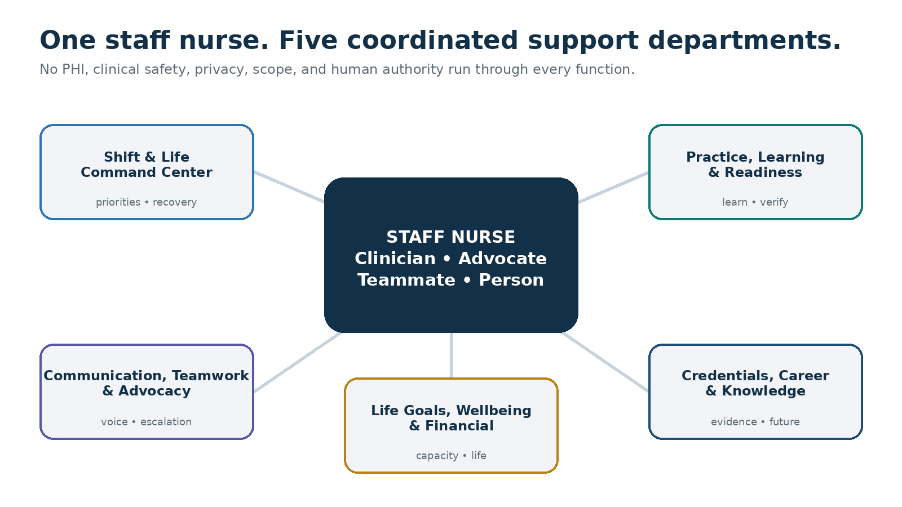
The staff nurse remains the clinician, advocate, teammate, and decision-maker. All five support departments operate through no-PHI protection, clinical safety, privacy, current scope and policy, and human authority.

Benefits to the staff nurse

Less cognitive fragmentation
Shifts, mandatory learning, credential renewals, appointments, family responsibilities, finances, recovery, and career goals become one coordinated plan without becoming one unsafe data store.

Better preparation without hidden unpaid labor
Approved learning and administrative work are staged inside realistic time boundaries. Open time is not automatically converted into work.

More confident professional communication
Hermes helps rehearse questions, boundaries, feedback, manager conversations, and escalation language using nonidentifying information.

Safer professional learning
General learning stays separate from live care; sources, uncertainty, local-policy requirements, and human-review points remain visible.

Visible growth and contribution
Certifications, precepting, committees, quality work, mentoring, recognition, and continuing education become nurse-controlled portfolio evidence.

More intentional career and financial direction
The nurse can explore specialties, education, certifications, schedules, and self-selected financial goals without automatically sharing intentions with an employer.

A life larger than work
Sleep, relationships, caregiving, health, community, finances, restoration, and joy remain visible alongside professional goals.

The Staff Nurse Empowerment Compact

You remain the nurse
AI may organize and prepare. You retain assessment, professional judgment, accountability, advocacy, communication, and care within your role.

Patient care remains in the clinical system
No patient identifiers, live observations, medication details, clinical images, chart content, handoff data, or patient-specific questions enter the general Hermes workspace.

Urgent care follows the human chain
During deterioration, emergencies, medication questions, device concerns, procedural uncertainty, or safety risk, stop and use the approved clinical, pharmacy, supervisory, rapid-response, or emergency process.

Local authority remains visible
Current law, scope, organizational policy, unit procedure, authorized orders, approved references, and qualified human leaders remain authoritative.

Competency remains human-determined
Hermes may help the nurse study or prepare questions. It cannot validate competence, authorize practice, or replace supervised assessment.

Your private life remains yours
Health, disability, pregnancy, family, finances, union activity, career intentions, mood, and recovery data are private by default.

The system does not become surveillance
Private data never feed manager dashboards, productivity scores, scheduling decisions, discipline, or hidden risk models.

Rest is legitimate capacity
Sleep opportunity, meals, relationships, caregiving, and protected personal time are not empty spaces waiting to be filled.

Drafts remain drafts
External messages, applications, reports, calendar changes, purchases, and disclosures require deliberate nurse review and confirmation.

Asking for support is a valid outcome
The system should make it easier to recognize overload, use the chain of command, request help, and pause what cannot be completed safely.

The five empowerment functions

1. Shift & Life Command Center
Coordinates shifts, commute, personal readiness, sleep opportunity, recovery, appointments, caregiving, boundaries, and the next realistic actions.
- Today’s Top Three, fixed commitments, protected recovery, and Plan B
- Pre-shift personal checklist with no patient or assignment data
- Post-shift transition that does not become unpaid clinical work
- Schedule-cycle capacity map and minimum viable week
- Overtime reflection that preserves the nurse’s decision and human safety pathway

2. Professional Practice, Learning & Readiness Studio
Supports general education, credentials, certifications, confidence, orientation, and preparation to use approved clinical resources.
- Study plans from approved sources
- Synthetic cases and questions for an educator or preceptor
- Credential and renewal calendar with official verification
- General concept maps and source-status labels
- Accomplishment and learning log without declaring competence

3. Communication, Teamwork & Advocacy Partner
Helps prepare respectful, factual, policy-aware human communication while preserving professional judgment and the chain of command.
- Fact–impact–request conversation briefs
- Boundary, schedule, feedback, and support language
- General delegation verification questions—not live decisions
- Speaking-up and workload-concern preparation
- Private, nonidentifying reflection after difficult interactions

4. Credentials, Career & Knowledge Infrastructure
Builds a private, portable system for professional evidence, renewals, learning resources, career options, and future opportunities.
- Credential inventory and source-verified timeline
- Achievement bank, résumé bullets, interview stories, and portfolio
- Career pathway and education comparison
- Mentorship map and professional-association plan
- Compensation and opportunity information labeled time- and location-sensitive

5. Life Goals, Wellbeing & Financial Orchestration
Connects nursing work to the person, relationships, stability, purpose, joy, and future the nurse is trying to build.
- NURSE Compass goal map and 90-day results
- Sleep, recovery, movement, meals, relationships, and caregiving chosen by the nurse
- General savings, debt, education, housing, and major-purchase planning
- Support map for moral distress, injury, fatigue, or crisis
- Compassionate replanning without diagnosis, shame, or productivity pressure
Capacity rule: Never schedule 100% of theoretically available time. A plan dependent on chronic exhaustion, unsafe overtime, off-the-clock work, or constant availability is not a valid plan.

The NURSE Compass for staff-nurse life goals
The dashboard connects today’s next action to a larger purpose, so the nurse’s health, relationships, stability, and future do not disappear beneath the next shift.
Step | Guiding question | Result
N — Name the North Star | What kind of nurse, colleague, family member, community member, and person do I want to become? | A concise purpose statement
U — Understand reality | What responsibilities, strengths, constraints, supports, fatigue patterns, and uncertainties exist now? | An honest capacity map
R — Results for 90 days | What few professional and personal outcomes would create meaningful progress? | Up to three high-value results
S — Systems and support | What routines, people, tools, boundaries, and backup plans will help? | A sustainable support system
E — Evaluate and evolve | What is helping, what creates burden, and what should change without shame? | A learning and adaptation cycle

Example North Star: Practice with skill, courage, and compassion while protecting my health, family, financial stability, and future choices.

Five planning horizons
- Today — the next right action, the next recovery need, and one protected commitment
- This schedule cycle — shifts, sleep transitions, family, learning, administration, finances, and restoration
- This month — renewals, appointments, professional growth, and life-goal progress
- The next 90 days — a small number of meaningful professional and personal results
- Long-term life — career, education, relationships, health, finances, community, purpose, and joy

The embedded Staff Nurse Life & Practice Command Center
The private dashboard should answer within one minute: What matters today? What requires a qualified human? Does the plan fit my actual energy and life? What can be deferred without guilt?
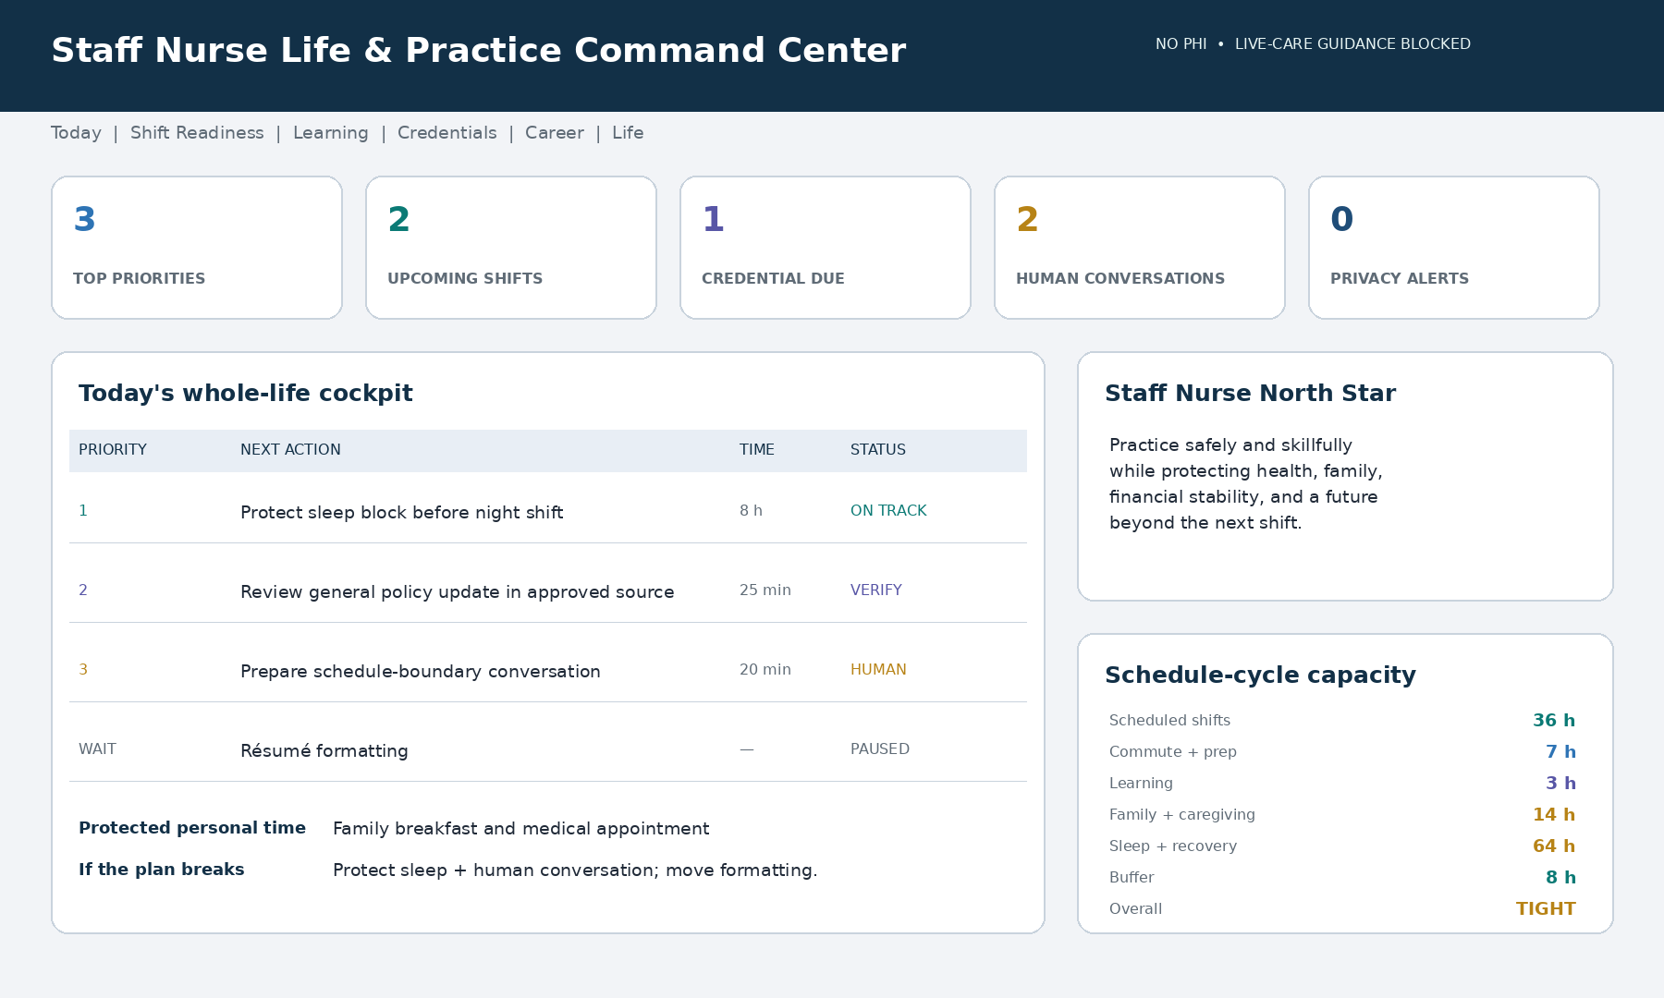
Illustrative dashboard using synthetic, nonclinical information. The canonical Markdown dashboard remains accessible, nurse-controlled, no-PHI, and separate from employer performance systems.

Required dashboard areas
Area | Question answered | Typical content
Today | What matters now? | Top Three, fixed commitments, protected recovery, Plan B
Next shift | What personal preparation is needed? | Schedule, commute, essentials, meals, approved learning
Learning | What am I developing? | Study plan, educator questions, source and policy verification
Credentials | What is approaching? | Renewal windows, official source, next step, unverified status
Communication | What human conversation needs preparation? | Purpose, facts, questions, desired outcome, escalation route
Recovery & capacity | Does this plan fit? | Shift pattern, sleep opportunity, caregiving, personal time, buffer
Career & life | What future am I building? | Accomplishments, education, finances, relationships, joy
Privacy & authority | Is the OS safe and controlled? | No-PHI status, EDENA state, memory, sources, human decisions

Dashboard language: Use Ready, Needs nurse review, Awaiting educator, Local policy required, Needs support, Recovery protected, Paused intentionally, and Completed. No status is a judgment of worth or performance.

A shift and week in the nurse’s life

Before the shift
The command center shows only personal readiness: schedule, commute, essentials, required administrative items, approved learning, meals, recovery, and the nurse’s chosen intention. It does not request patient assignments or encourage unpaid preparation.

During the shift
Patient-specific care remains in the EHR, approved clinical tools, current policy, and the human team. Hermes does not receive patient information, maintain a shadow task list, or give live-care direction.

After the shift
The OS may offer a short no-PHI close: what to release, a general learning question for later, whether an official follow-up belongs in an approved system, the next recovery action, and what can wait.

On a day off
The default is restoration, not automatic productivity. The nurse may choose a brief learning, career, money, relationship, or life-goal action, but open time is not automatically reassigned to work.

A sustainable schedule-cycle rhythm
- Review shifts, sleep transitions, commute, fixed commitments, caregiving, and recovery.
- Place required learning and administration inside realistic time boundaries.
- Protect family, health-supporting routines, relationships, and one source of joy.
- Prepare one important professional conversation if needed.
- Advance one learning, career, financial, or life goal.
- Keep buffer for overtime, illness, caregiving, or emotional recovery.
- Close the cycle by naming progress, unresolved human decisions, and what can be released.

Clinical and practice-safety boundaries

Hermes may support
- General education using current, approved sources
- Study planning for required competencies and certifications
- Synthetic practice cases reviewed by an educator or preceptor
- Questions to bring to a charge nurse, provider, pharmacist, educator, or other qualified resource
- General no-PHI reflection, renewal reminders, and portfolio organization

Hermes must not
- Accept, repeat, transform, log, or remember patient information—even if a name was removed
- Assess, triage, diagnose, monitor, or prioritize an actual patient
- Interpret live symptoms, vital signs, laboratory results, ECGs, images, alarms, or clinical messages
- Recommend a medication, dose, calculation, route, timing, compatibility, hold parameter, device setting, intervention, or disposition
- Draft actual charting, a handoff, incident report, care plan, or patient task list
- Make an assignment or live delegation decision, certify competence, determine scope, or certify fitness for duty
- Silence, bypass, override, reprogram, or improvise with a clinical device

Safety-stop sequence
- Stop the general AI interaction and do not enter patient details.
- Maintain immediate safety within role and follow the approved emergency or clinical process.
- Contact the appropriate qualified human without delay.
- Use current orders, policy, approved references, and authorized systems.
- Return to Hermes later only with synthetic or fully generic learning context.
Point-of-care rule: If you are wondering whether immediate escalation is needed, do not wait for AI. Use the organization’s criteria and human chain now.

EDENA safety and authority ladder
State | Typical request | System response
GREEN | Personal organization, synthetic learning, career and life planning | Proceed with nurse review and minimum data.
YELLOW | Policy-sensitive question, workplace communication, uncertainty, wellbeing concern | Label uncertainty; require current source or human verification.
ORANGE | Live clinical uncertainty, medication or device ambiguity, delegation, unsafe staffing, fatigue affecting practice | Stop ordinary workflow; contact the responsible human now.
RED | Patient deterioration, active violence, self-harm or harm to others, immediate danger | Emergency pathway only; do not delay for AI questions.

Communication, delegation, and advocacy

Communication rehearsal
Using nonidentifying facts, Hermes may organize the conversation’s purpose, observable events, impact, desired outcome, questions, respectful opening, and escalation route. It may draft language, but it must not send, file, record, or make unsupported claims about motive, diagnosis, discrimination, retaliation, or legal liability.

Delegation preparation
Hermes may teach a general delegation framework with synthetic examples. Before actual delegation, the nurse uses current law and policy, patient circumstance, the delegatee’s verified competence, communication, supervision, follow-up, and nursing judgment. Critical decision-making and nursing judgment cannot be delegated to AI.

Workload and safety advocacy
The OS may help organize observable, nonidentifying concerns, find the appropriate policy owner or reporting path, and prepare neutral questions for the charge nurse, manager, safety office, ethics service, union, HR, compliance, or another approved resource. It does not determine legal rights, declare an assignment safe or unsafe, or replace official reporting and emergency action.
Human-action rule: Official communication, documentation, reporting, delegation, escalation, and care remain deliberate human actions in approved systems.

Fatigue, workplace safety, and human support

Shift work and long hours
Hermes may help plan sleep opportunity, meals, childcare, commuting, recovery, and schedule transitions. It may not certify fitness for duty or convert fatigue into a performance score. If fatigue may affect safe practice, use the supervisor or charge-nurse pathway and current policy. If driving feels unsafe, arrange safe transportation rather than attempting to push through.

Workplace violence or active threat
During an active threat, move to immediate safety and use the facility alarm, security, and emergency process. Do not pause for an AI-led de-escalation plan or confront an aggressor because the OS suggested it. Afterward, Hermes may help locate approved reporting, occupational health, trauma support, employee assistance, union, or representative resources.

Personal distress or crisis
Wellbeing prompts are not diagnosis or therapy. Possible self-harm, harm to others, severe symptoms, acute impairment, or immediate danger requires qualified human help now. In the United States, use 911 for immediate danger and call or text 988 for suicide or mental-health crisis support; outside the United States, use local emergency and crisis resources. The OS does not autonomously notify an employer.

Human support matrix
Situation | Human pathway to consider
Patient danger or clinical uncertainty | Charge nurse, responsible provider, pharmacist, rapid response, code or emergency pathway per policy
Scope, delegation, or policy | Charge nurse, supervisor, educator, manager, policy owner, regulator as appropriate
Unsafe workload or assignment concern | Charge nurse, manager, house supervisor, nursing administration, union or representative
Fatigue, injury, exposure, or health | Supervisor, occupational health, personal healthcare professional, approved employee resource
Violence, harassment, discrimination, retaliation | Immediate security/emergency process, manager, HR, compliance, union or qualified advice
Ethical conflict or moral distress | Charge nurse, manager, ethics, spiritual care, peer support, employee assistance
Licensure, legal, or employment | Licensing authority, professional association, union, malpractice carrier, qualified counsel
Career, education, benefits, or money | Mentor, educator, recruiter, school adviser, benefits office, qualified financial or tax professional

Privacy, memory, and safe degraded mode
Memory class | Examples | Default
May remember with consent | General role, shift pattern, learning preferences, broad goals, credential dates, dashboard settings | Approved categories
Optional or session-only | Fatigue patterns, family, health scheduling, finances, workplace strain, career-search intentions | Ask first
Approved system only | Competency records, employee education, evaluations, workplace complaints, official schedules | Restricted
Never in a general AI workspace | PHI, passwords, license or government IDs, bank details, EHR exports, protected investigations | Blocked

The nurse should be able to ask: What do you remember? Use this session only. Who can access this? Show the retention date. Export my plan. Correct this. Forget this. Reset my dashboard. Pause all automations.
Private by default: Health, disability, pregnancy, family, finances, recovery, union activity, job-search intentions, and career uncertainty do not appear in employer analytics unless the nurse deliberately shares a specific item through an approved process.

When trusted tools or sources fail
Clinical and policy-dependent functions fail closed. The dashboard displays “Unavailable—use unit resources,” disables sending and automation, retains only nurse-configured emergency contacts and nonclinical checklists, and does not substitute cached clinical content. Personal planning may continue only when it does not depend on the failed source or connection.

90-day staff-nurse rollout
Phase | Timing | Primary work | Evidence
Trust and boundaries | Days 1–14 | Role, no PHI, clinical stops, privacy, memory, North Star, capacity, one pilot | Compact and synthetic dashboard
Command rhythm | Days 15–30 | Weekly reset, shift transitions, protected recovery, one learning or life-goal workflow | Reliable plan and Plan B
Validate support | Days 31–60 | Communication, learning, renewal, portfolio, or career workflows | Usefulness, corrections, review burden, trust
Expand carefully | Days 61–90 | One career, money, relationship, or life goal; privacy and workload review | Nurse-controlled activation report

Start small: Pilot one low-risk use: a weekly plan, credential study schedule, manager-conversation brief, portfolio item, or private life goal. Expand only when the benefit exceeds review burden and risk.

Nurse-controlled outcome measures
Domain | Possible measure | Safeguard
Agency | Nurse-rated clarity and control | Never a performance score
Burden | Coordination time or post-shift spillover | Do not manufacture hours saved
Recovery | Protected recovery commitments kept | Optional and private
Learning | Approved milestones and human verification completed | Completion is not competence
Communication | Nurse-rated readiness for important conversations | No surveillance of drafts
Career | Portfolio, mentoring, certification, or application progress | Intentions remain nurse-owned
Whole life | Progress toward nurse-selected personal goals | Not shared without consent
Trust & safety | Corrections, declined suggestions, privacy events, required human checkpoints | Declining AI is valid

Success means greater agency, clearer preparation, visible growth, lower avoidable burden, protected recovery, and sustainable progress—not usage volume, constant availability, overtime accepted, or a composite productivity score.

Frequently asked questions

Will Hermes replace the staff nurse?
No. It cannot assess patients, deliver care, provide accountable clinical judgment, advocate in real time, or create the human relationships on which nursing depends.

Can I enter patient information?
No. Patient information belongs only in approved clinical systems. Removing a name alone does not make a narrative safe for a personal AI workspace.

Can it answer a patient-care question?
The staff-nurse function does not provide live-care direction. Use current orders, policy, approved references, the charge nurse, provider, pharmacist, rapid response, or emergency chain.

Can it help with delegation?
It can teach and rehearse general principles with synthetic cases. The nurse makes the actual decision under current law, policy, patient circumstances, team capability, communication, supervision, and required follow-up.

Can it write my charting or handoff?
No. It must not receive patient data or draft an actual chart note, handoff, incident report, or patient task list in the personal OS.

Can it prepare a difficult conversation?
Yes. It can organize nonidentifying facts, questions, boundaries, desired outcomes, and respectful language. The nurse chooses what to say and which approved channel to use.

Can my manager see my dashboard?
The private dashboard is not an employer tool. Institutional implementations must make access explicit, minimal, revocable, and auditable; private life data stay blocked by default.

Can it decide whether I am burned out or fit to work?
No. It may help the nurse notice self-reported capacity and identify human support, but it cannot diagnose or certify fitness for duty.

What if the AI is wrong or unavailable?
Stop, correct it, and verify with an authoritative source or qualified human. Policy- and safety-sensitive functions fail closed rather than substituting stale content.

Do I have to share personal goals?
No. Life-goal support is optional. The nurse controls what is stored, what is session-only, and what—if anything—is shared.

Activation checklist
- Define the nurse’s role, broad setting, schedule pattern, and human authorities.
- Establish the permanent no-PHI and no-live-care rules.
- Configure the clinical, workplace-safety, fatigue, and crisis escalation paths.
- Review applicable policy, scope, privacy, employment, education, and accessibility requirements.
- Choose permitted memory categories and create a Do Not Remember list.
- Name a North Star and up to three 90-day results.
- Map shifts, commute, caregiving, learning, sleep opportunity, recovery, and buffer.
- Protect one personal commitment and one recovery period.
- Choose one low-risk pilot workflow and keep automations off until approved.
- Confirm export, correction, retention, deletion, isolation, and safe-degraded-mode controls.
- Run the acceptance tests and schedule a 30-day continue, revise, pause, or stop decision.

Recommended first commands
- Build my private staff-nurse dashboard around my real schedule, boundaries, and life goals.
- Plan this schedule cycle around these shifts and fixed commitments. Protect recovery and show what must move.
- Create a minimum viable week for reduced capacity.
- Build a study plan from these approved education resources.
- Prepare questions for my preceptor or educator without giving patient-care advice.
- Help me rehearse a difficult professional conversation using nonidentifying facts.
- Organize my certifications, continuing education, and renewal dates for official verification.
- Build a nurse-owned portfolio from these verified accomplishments.
- Compare these career paths and show assumptions, tradeoffs, and questions for a human mentor.
- Protect time for sleep, family, health-supporting routines, finances, and joy.
- Show what you remember, who can access it, and when it will be deleted.

Closing message to the staff nurse
Staff nurses hold together complex care, communication, coordination, education, advocacy, and human presence—often while carrying responsibilities that remain invisible after the shift ends.
Hermes–Nurse AI OS is designed to hold coordination, not authority. It can prepare, organize, remind, connect, and surface choices. It cannot replace the nurse’s assessment, judgment, courage, compassion, accountability, relationships, or lived experience.
Final operating principle: The system coordinates and prepares. The nurse assesses, cares, advocates, grows, recovers, and lives.

Companion implementation file
Use Staff-Nurse-Life-and-Practice-Hermes-Program.md as the complete build, dashboard, workflow, governance, and activation specification to hand to Hermes–Nurse AI OS.

Authoritative reference points
Current jurisdictional law, employer policy, authorized orders, approved clinical references, and the responsible human chain remain authoritative. Verify the current source and the version adopted locally.
- HHS — HIPAA de-identification guidance: https://www.hhs.gov/hipaa/for-professionals/special-topics/de-identification/index.html
- NCSBN — Scope of Practice Decision-Making Framework: https://www.ncsbn.org/nursing-regulation/practice/decision-making-framework.page
- NCSBN — National Guidelines for Nursing Delegation: https://www.ncsbn.org/public-files/NGND-PosPaper_06.pdf
- CDC/NIOSH — Training for Nurses on Shift Work and Long Work Hours: https://www.cdc.gov/niosh/publications/hcp/numbered/2015-115.html
- OSHA — Healthcare Workplace Violence resources: https://www.osha.gov/healthcare/workplace-violence
- Nursys — Official nurse licensure verification: https://www.nursys.com/
- SAMHSA — 988 Suicide & Crisis Lifeline: https://www.samhsa.gov/mental-health/988

Concept provenance
This staff-nurse adaptation translates a five-department AI operating-system concept into a nurse-controlled whole-life environment with a private dashboard, no-PHI protection, live-care stops, current scope and policy verification, human escalation, professional growth, financial and life planning, and recovery-aware capacity.

