LEADERSHIP GUIDE
Hermes–Nurse AI OS
Nurse Leader Empowerment Function
A governed AI command center for nurse managers and clinical-unit leaders
Core promise: The coordination capacity of a small digital leadership office—while judgment, authority, relationships, and accountability remain with the nurse leader.
Prepared for nurse leaders and managers
Version 1.0 • July 2026

Executive summary
The Nurse Leader Empowerment Function gives a nurse manager one place to see priorities, prepare decisions, organize communication, retrieve trusted unit knowledge, interpret approved aggregate information, and sustain follow-through.
Nurse leaders coordinate people, quality, communication, education, committees, compliance, strategic initiatives, and the daily exceptions that rarely fit neatly into a workflow. Yet the information required to lead is commonly scattered across email, messaging platforms, shared drives, meeting records, policy repositories, spreadsheets, and personal notes.
Hermes–Nurse AI OS turns that fragmented environment into a governed management and coordination layer. It behaves like a small digital leadership office: an AI chief of staff, communication assistant, knowledge manager, operational analyst, and accountability coordinator working through one command center.
Operating principle: The AI prepares and coordinates. The authorized person reviews. The nurse leader decides and remains accountable.
The recommended first deployment is nonclinical and no-PHI by default. Patient-specific recommendations, autonomous clinical actions, employment determinations, regulatory judgments, and other protected decisions remain outside the system’s authority.

The leadership problem it addresses
Leadership friction | Operational consequence | Empowerment response
Priority overload | Urgent work crowds out strategic work. | One ranked action and decision queue.
Action-item leakage | Meeting commitments lose owners or deadlines. | A validated action register and follow-up cycle.
Repeated context rebuilding | Leaders search for prior decisions and current versions. | A governed source and decision index.
Communication burden | One update must be rebuilt for several audiences. | Audience-specific drafts from one approved source.
Reporting burden | Data require manual interpretation and narrative preparation. | Source-traceable management briefs with limitations.
Loss of unit memory | Knowledge leaves with experienced staff. | Preserved project, committee, and policy history.

The five-part leadership office
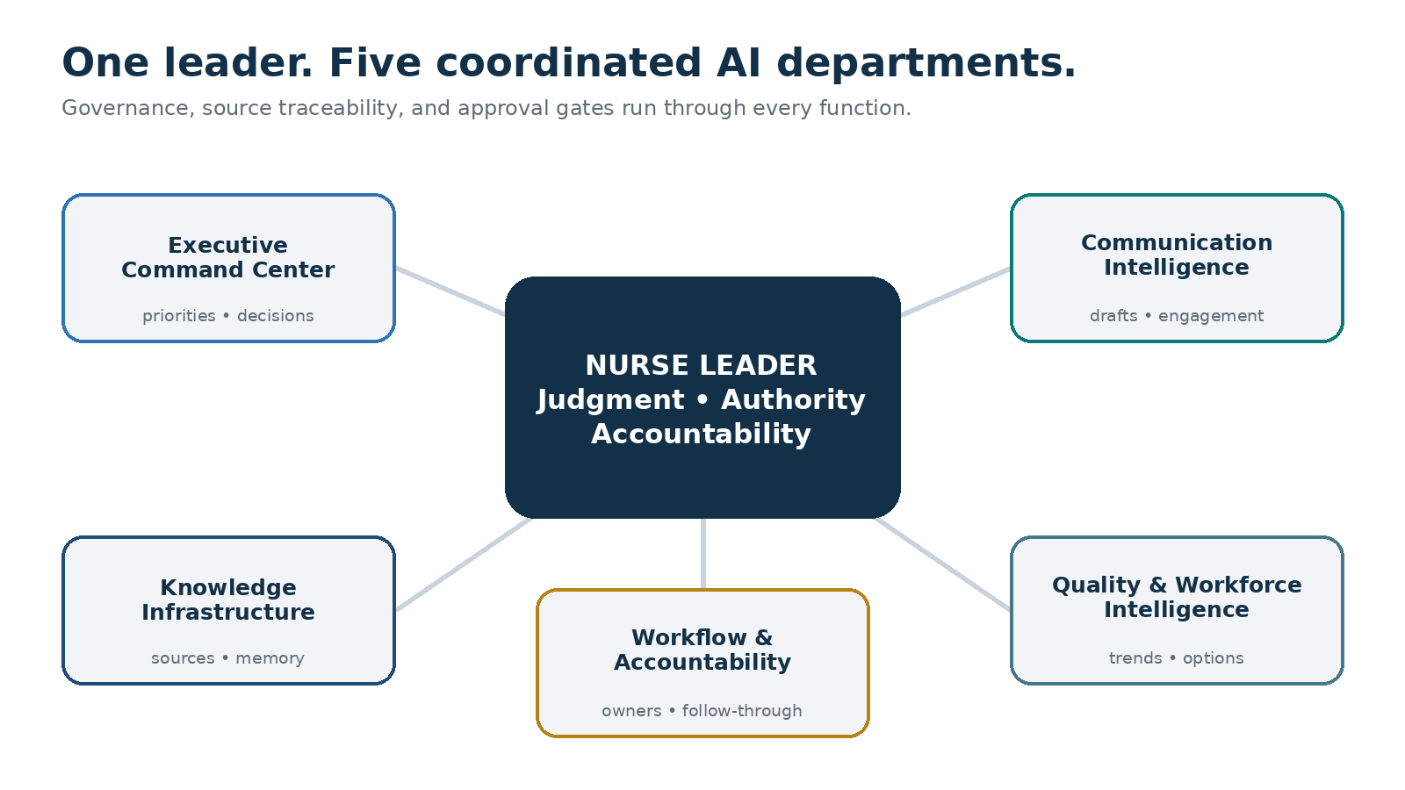
The nurse leader remains at the center; all five departments operate through governance and human approval.

Benefits for the nurse leader

Clearer situational awareness
The dashboard consolidates current priorities, approvals, deadlines, operational signals, project status, and source freshness.

More reliable follow-through
Decisions and actions retain an owner, due date, dependency, next step, and review status.

Faster preparation
Hermes can prepare agendas, briefs, huddle messages, project summaries, and executive updates from approved sources.

Stronger institutional memory
Prior decisions, policies, committee records, evidence, and project histories become easier to retrieve.

More time for human leadership
Time recovered from searching, formatting, and reconstructing status can be redirected toward rounding, coaching, visibility, and staff support.
Evidence standard: These are intended benefits, not guaranteed savings. Establish a baseline, run a supervised pilot, and report only observed value.

The five empowerment functions

1. Executive Command Center
The Executive Command Center serves as the nurse leader’s AI chief of staff. It receives a request, identifies the information and support functions required, and returns one coordinated, leadership-ready response.
- Daily and weekly leadership briefs
- Decision memos and option comparisons
- Meeting-preparation packets
- Priority, risk, and deadline summaries
- Delegation proposals and project plans
Boundary: The Command Center may prepare options and recommendations. It does not make final clinical, staffing, employment, labor, legal, or regulatory decisions.

2. Communication Intelligence
Communication Intelligence organizes approved incoming information and prepares clear, audience-appropriate drafts. It extracts requests, promises, owners, and deadlines so communication becomes part of the accountability system.
- Draft staff updates, huddles, replies, FAQs, and executive summaries
- Adapt one approved message for several audiences
- Track unanswered questions and promised follow-ups
- Identify recurring themes in deidentified staff feedback
Review requirement: Clinical directives and communications involving performance, discipline, labor, legal, adverse-event, patient-specific, regulatory, or organizational commitments require authorized human review before release.

3. Knowledge and Document Infrastructure
Knowledge Infrastructure gives the unit a governed institutional memory. It indexes approved material and helps the leader find the right source without relying on personal folders or recollection.
- Record title, owner, version, approval date, review date, and location
- Identify duplicates, conflicts, gaps, and possibly outdated versions
- Link projects to policies, evidence, and prior decisions
- Preserve committee and accreditation histories
Trust standard: The official organizational repository remains authoritative. The AI provides navigation and synthesis unless the organization explicitly designates another source of truth.

4. Quality and Workforce Intelligence
This function converts approved aggregate information into understandable management intelligence. It explains what changed, what remains uncertain, what deserves validation, and what options the leader could consider.
- Aggregate staffing, coverage, skill-mix, and education readiness
- Approved quality, safety, experience, and engagement trends
- Project, committee, and accreditation readiness
- Data-quality limitations and contextual questions
Analytical discipline: An association is not a cause. The system must separate verified observation, hypothesis, limitation, recommendation, and human decision.

5. Workflow and Accountability Orchestration
This function keeps approved work moving after meetings and decisions. It maintains owners, deadlines, dependencies, reminders, and recurring operating reviews.
- Daily approval and overdue-action scans
- Weekly project, committee, education, and quality reviews
- Monthly unit performance and governance summaries
- Quarterly strategy, capability, and portfolio reviews
Automation rule: Scheduled workflows prepare and surface drafts. They do not silently approve, send, change, close, or commit.

The embedded Nurse Leader Command Center
The dashboard is designed to answer three questions within seconds: What requires attention now? What is at risk? What decision or approval is waiting for me?
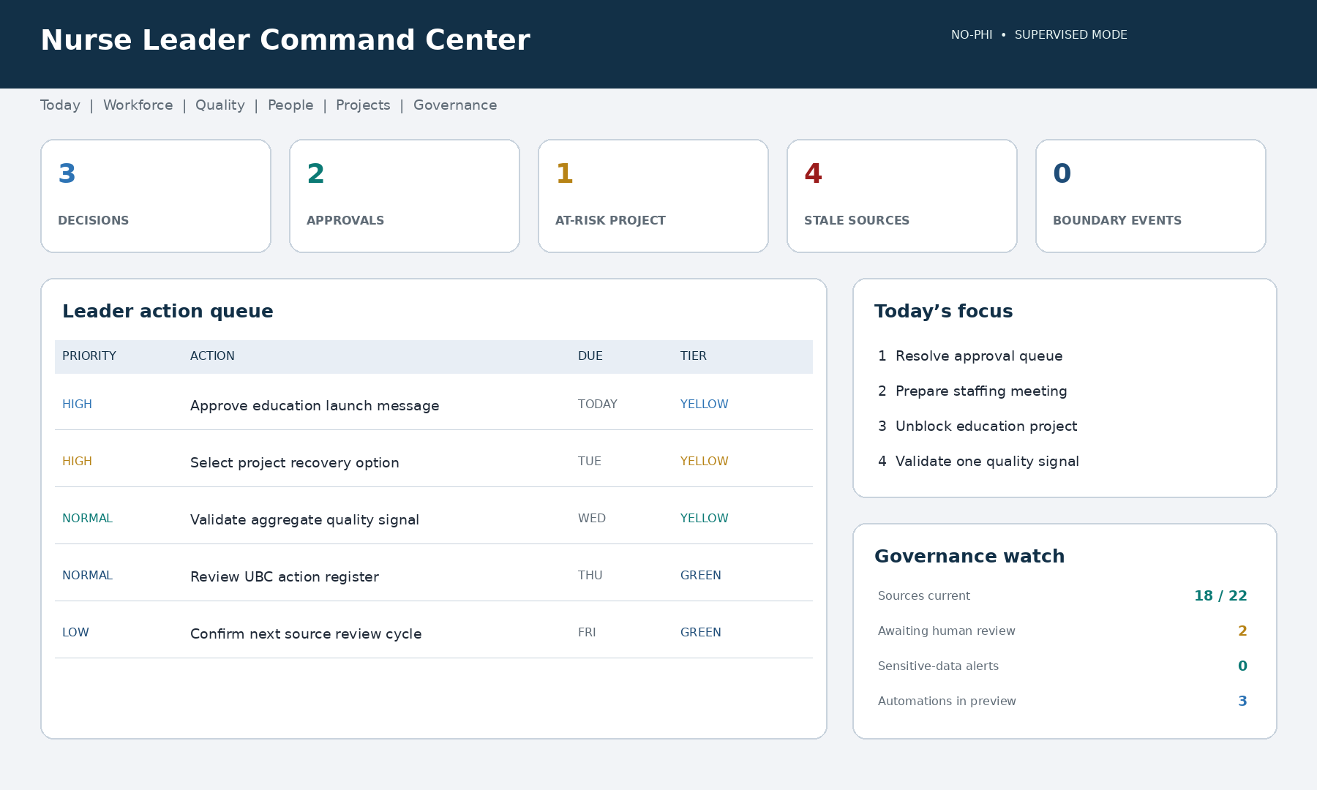
Illustrative dashboard using synthetic data. A live implementation must display source, reporting period, freshness, risk tier, and approval state.

Required dashboard areas
Area | Leadership question | Typical content
Today | What needs me now? | Priorities, decisions, meetings, watch items
Approval queue | What is waiting for authorization? | Drafts, reports, options, proposed actions
Workforce | Can the unit execute the work? | Aggregate coverage, competency, education, workload
Quality and safety | What needs validation? | Signals, trends, measures, limitations
People | What does the team need? | Aggregate themes, recognition, engagement actions
Projects | Are commitments moving? | Milestones, owners, dependencies, overdue work
Governance | Is the AI operating safely? | Approvals, stale sources, corrections, alerts

Every consequential item should show
- Status and responsible owner
- Due date or reporting period
- Source and last-updated date
- Next action
- EDENA risk tier
- Required approval level
- Known limitation or confidence when interpretation is present
Design rule: Red means human attention required. It must never be used to label a person as a problem or imply blame.

A day in the life of an AI-empowered nurse leader

Beginning of the day
The leader opens one concise brief instead of reconstructing the day from multiple systems. The command center shows decisions, approvals, deadlines, operational watch items, preparation needs, and safe delegation opportunities.

Before a meeting
The leader asks Hermes to prepare the Unit-Based Council meeting. Hermes retrieves approved prior records, identifies unresolved actions, attaches relevant sources, and prepares the decisions required today.

When an operational concern emerges
Hermes may organize approved aggregate information and prepare options. The nurse leader evaluates context, fairness, policy, competency, workload, and current conditions before deciding.

After the meeting
Hermes converts notes into a draft decision and action register. The leader corrects and approves the record before actions become active.

At closeout
The system prepares completed priorities, deferred work, new risks, commitments due next, and a draft leadership handoff.
The value: The AI did not manage the unit. It gave the nurse leader a clearer, more reliable record of what happened and what must happen next.

Governance and safety

Nonclinical and no-PHI by default
The safest starting configuration uses approved policies, non-sensitive operational documents, deidentified or aggregate reports, project plans, committee records, education material, approved templates, and task information.
Appropriate starting content | Keep outside the default workspace
Approved policies and templates | Patient names, identifiers, or clinical narratives
Deidentified or aggregate reports | Unredacted incident reports or screenshots with PHI
Project and committee records cleared for use | Protected employee-relations or disciplinary files
Education and competency resources | Occupational-health or accommodation information
Tasks, owners, milestones, and deadlines | Credentials, passwords, tokens, or prohibited data

Human accountability model
- AI prepares.
- Authorized person reviews.
- Accountable leader decides.
- Approved person executes.

EDENA risk tiers
Tier | Typical use | Required control
Green | Formatting, templates, task organization, non-sensitive summaries | Routine review as appropriate
Yellow | Trend interpretation, staffing options, policy comparison, leadership briefs | Nurse leader validation
Orange | Employment, labor, patient-specific review, regulatory, high-impact workflow | Authorized specialist plus leadership approval
Red | Autonomous clinical or disciplinary decisions, unauthorized PHI, policy override | Prohibited; offer a safer alternative

Use the organization’s approved EDENA definitions when available. The program does not invent an expansion of the EDENA acronym.

Minimum controls
- Role-based access and minimum-necessary data
- Approved source list with dates and version control
- Explicit human approval gates
- Retention, deletion, correction, and escalation rules
- Bias, fairness, and workforce-impact review
- Automation logs and visible failures
- Periodic access and governance review
- Staff transparency about appropriate system use

90-day implementation roadmap
Phase | Timing | Primary work | Decision gate
0. Governance | Weeks 1–2 | Owner, sponsor, no-PHI charter, approved sources, baseline, three workflows | Boundaries and authority documented
1. Limited pilot | Days 15–30 | Dashboard, approved resources, training, shadow mode, correction log | Useful without unacceptable risk
2. Stabilize | Days 31–60 | Improve sources, refine views, add drafts and recurring reports | Traceable outputs and reliable review
3. Expand | Days 61–90 | Approved aggregate views, selected users, SOP, value review | Scale, revise, or stop based on evidence

Recommended first three workflows
- Daily leadership brief
- Meeting action tracker
- Approved-policy and document retrieval
Pilot discipline: Begin with one nurse leader, one unit, and three low-risk workflows. Do not begin with patient-level data, automated staffing decisions, or employee-performance workflows.

Performance measures and ROI

What to measure
Domain | Examples
Adoption | Weekly active use, workflow use, training, usefulness rating
Process | Brief preparation time, source retrieval time, on-time actions, draft turnaround
Quality | Source-traceable output rate, correction rate, freshness compliance
Safety | PHI events, unauthorized actions, review compliance, fairness concerns
Leadership value | Administrative burden, coaching time, priority clarity, follow-through confidence

Use measured value—not promotional assumptions
Validated annual labor capacity = verified hours recovered per week × loaded hourly cost × active weeks × participating leaders.
Net annual value = validated labor value + documented avoidable costs − annual system, implementation, training, and oversight costs.
Recovered time is not automatically a cash saving. It may represent added leadership capacity. Report capacity and direct financial savings separately.

Leader readiness checklist
- A nurse leader owns operational use.
- An executive sponsor understands the pilot purpose.
- The no-PHI boundary and prohibited data are documented.
- Approved sources and source owners are named.
- Yellow and Orange approvers are identified.
- Three low-risk workflows are selected.
- Baseline time, error, and follow-through measures are recorded.
- The dashboard uses synthetic or approved aggregate data.
- Users can correct, reject, forget, and audit outputs.
- A 30-day review date and stop criteria are established.

Frequently asked questions

Does the system replace the nurse manager?
No. It supports preparation, organization, analysis, and follow-through. Authority, relationships, professional judgment, and accountability remain human.

Can it use patient information?
The recommended default is no PHI and no patient-level information. Any regulated-data use requires formal institutional approval and an appropriately secured environment.

Can it make the staffing assignment?
It may prepare options from approved information. An authorized nurse leader must assess acuity, competency, fairness, policy, and current conditions before deciding.

Can it send messages automatically?
Routine low-risk sending may be considered only after explicit workflow approval. Sensitive clinical, employment, labor, legal, regulatory, or executive communication requires human review.

What happens when the AI is wrong?
The leader should inspect the source, correct or reject the output, and preserve the correction. Repeated errors should trigger workflow suspension and review.

Is the dashboard the source of truth?
Not automatically. It is a coordination and presentation layer. Official clinical, HR, quality, scheduling, and policy systems remain authoritative.

Will it monitor individual nurses?
The initial design focuses on unit operations and aggregate trends, not individual surveillance. Workforce use requires transparency, fairness review, and appropriate governance.

How long does implementation take?
A supervised no-PHI pilot can be structured over 30 to 90 days, depending on source readiness, governance, and organizational capacity.

Recommended pilot call to action
- Name the nurse-leader owner and executive sponsor.
- Select the daily brief, meeting tracker, and source retrieval workflows.
- Confirm the nonclinical, no-PHI guardrails.
- Measure current preparation time and follow-through reliability.
- Run a 30-day supervised pilot.
- Review value, corrections, safety, and user experience.
- Expand only what demonstrates measurable benefit and acceptable risk.
Pilot success statement: At the end of the pilot, the nurse leader should be able to determine whether Hermes–Nurse AI OS improved situational awareness, preparation, and follow-through while preserving privacy, human judgment, and professional accountability.

Final leadership message
The purpose of the Nurse Leader Empowerment Function is not to automate leadership. Leadership is relational, contextual, ethical, and accountable.
Its purpose is to give the nurse leader stronger operational support: one place to see the work, one method for preserving unit memory, one system for tracking commitments, and one governed environment for AI-assisted preparation.
Final operating principle: The AI coordinates the work around the decision. The nurse leader makes the decision.

Companion implementation file
Use the companion Markdown program, Nurse-Leader-Empowerment-Function-Hermes-Program.md, as the build and activation specification to hand to Hermes–Nurse AI OS.

Concept provenance
This adaptation translates a five-department AI operating-system concept—executive command center, communication intelligence, document infrastructure, business intelligence and reporting, and task orchestration—into a nurse-leadership environment with healthcare governance, no-PHI defaults, source traceability, and human approval gates.
Source concept: Structure Webworks, “I Built a $30,000 AI Operating System with Claude Agents,” video transcript dated July 10, 2026. The healthcare adaptation, safeguards, and implementation model in this guide are original to the Nurse Leader Empowerment Function.

