EDUCATOR GUIDE
Hermes–Nurse AI OS
Nursing Educator Life & Practice
Empowerment Function
An educator-controlled command center for teaching, learner development, clinical and simulation safety, scholarship, career direction, and a whole life
Core promise: The AI coordinates and prepares. The educator teaches, evaluates, supervises, and decides. Learners grow. Life remains visible.
For nursing educators in every setting and season
Version 1.0 • July 2026

Welcome: nursing education is rarely “just teaching”
Nursing educators teach, assess, coach, supervise, document, update evidence, respond to learners, support clinical safety, contribute to programs, pursue scholarship, and manage a life beyond work.
Many educators are also practicing nurses, graduate students, caregivers, parents, community leaders, adjuncts, or first-generation faculty members. Their work is essential, but it is often fragmented across calendars, email, learning platforms, clinical systems, personal notes, and memory.
The Nursing Educator Life & Practice Empowerment Function creates one coordinated operating environment around the educator. It reduces avoidable coordination burden and protects the human work that matters most: judgment, relationships, coaching, presence, creativity, and professional formation.
The purpose: This system is not an artificial faculty member. It prepares and coordinates so the educator can teach, support, judge, and live with greater clarity.

Executive overview
Element | Purpose
Hermes | Coordinates educator-approved goals, schedules, drafts, evidence, routines, and follow-through.
Nurse AI OS | Adds learner dignity, academic integrity, no-PHI boundaries, clinical safety, accessibility, and human authority.
Educator dashboard | Provides one current view of teaching, feedback, clinical and simulation readiness, evidence, capacity, career, and private life goals.

The system can plan, map, retrieve, compare, outline, draft, simulate, organize, and track. It cannot approve curriculum, release unreviewed content, assign final grades, determine progression, certify competence, direct patient care, decide accommodations, certify compliance, or make personnel decisions.

Designed for real educator situations
Educator situation | How the system adapts | Boundary
New faculty | Stages preparation, explains processes, and prepares mentoring questions. | Local leaders and faculty handbook remain authoritative.
Adjunct or part-time | Builds reusable workflows around limited paid time. | Does not normalize unpaid hidden labor.
Clinical instructor | Coordinates site readiness, supervision, travel, observation, and follow-up. | No PHI or unsupervised clinical direction.
Simulation educator | Coordinates objectives, scenario, equipment, accessibility, and debriefing. | Trained human facilitation and approval remain required.
Working clinician and educator | Separates roles and plans around shifts, teaching, grading, and recovery. | No cross-role data leakage.
Graduate student or scholar | Protects research, teaching, writing, and milestone time. | Research, authorship, and ethics rules remain human governed.
Program or curriculum lead | Maintains versioned maps, evidence, and decision queues. | Does not certify compliance.
Parent or caregiver | Creates flexible blocks and a minimum viable week. | No assumption of unlimited flexibility.
Rural or resource-limited | Favors portable, low-bandwidth, locally maintainable options. | Does not assume unavailable staff or equipment.

The five-part educator support system
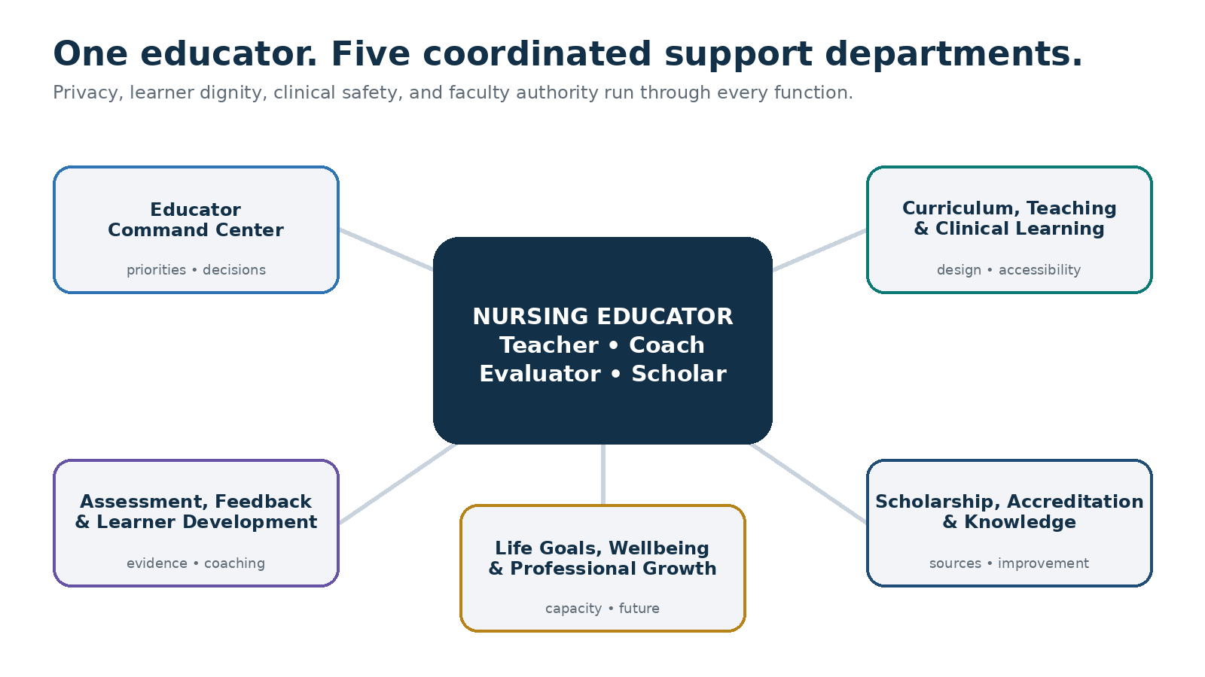
The educator remains the teacher, evaluator, coach, and decision-maker; all five departments operate through privacy, learner dignity, clinical safety, accessibility, and faculty authority.

Benefits to the educator

Less cognitive fragmentation
Courses, clinical groups, simulations, feedback, advising, scholarship, service, family, health, and recovery become part of one coordinated plan without mixing them into one unsafe data store.

Faster preparation with human quality
Hermes creates structured first drafts; the educator applies expertise, local context, voice, evidence, and final approval.

Stronger educational alignment
Outcomes, learning activities, formative checks, assessments, and feedback can be reviewed as one coherent learning system.

Safer clinical and simulation preparation
Synthetic cases, readiness gates, current-source checks, accessibility, stop criteria, and human approval remain visible.

More humane learner support
Observable events lead to curious conversations and approved resources—not labels, diagnoses, or hidden risk scores.

Visible scholarship and often-unrecognized work
Mentoring, curriculum revision, simulation development, evidence work, service, and faculty growth become educator-controlled portfolio evidence.

A more sustainable professional life
Plans reflect actual time, family, finances, health, relationships, career direction, and the need for recovery.

The Nursing Educator Empowerment Compact

You remain the educator
The AI may prepare and organize. You retain curriculum, assessment, clinical, learner-support, and professional judgment within your role.

Learners remain people
The system does not diagnose, rank worth, predict success, or infer character, motivation, disability, or honesty.

Consequential evaluation remains human
Every grading suggestion displays rubric evidence; you inspect the work, determine the evaluation, approve feedback, and preserve due process.

No patient information
Clinical and simulation learning defaults to synthetic material. Patient-specific care questions follow the approved human chain.

Your information remains under your control
Memory is optional. Personal goals, health, family, finances, and career intentions remain educator-private unless you choose otherwise.

Sources and uncertainty stay visible
Drafts, verified facts, interpretations, missing evidence, source versions, and human approvals are clearly separated.

Accessibility is built in
Learning materials and dashboards are checked for structure, keyboard access, captions, alt text, contrast, scalable text, and approved accommodations.

Your life matters beyond output
Sleep, health, relationships, caregiving, finances, community, restoration, and joy remain part of the plan.

The five empowerment functions

1. Educator Command Center
The educator chief of staff coordinates courses, clinical and simulation work, feedback, advising, meetings, service, scholarship, clinical practice, and life.
- Creates realistic daily, weekly, semester, academic-year, and 90-day plans
- Maintains Today’s Top Three, protected time, and Plan B
- Batches low-risk preparation while preserving individualized judgment
- Surfaces human approvals, deadline collisions, and safe deferrals
- Measures review work created as well as time saved

2. Curriculum, Teaching & Clinical Learning Studio
This studio turns approved outcomes and sources into active, accessible teaching and safely prepared clinical or simulation learning.
- Outcome, activity, practice, assessment, and feedback alignment
- Lesson, case, discussion, retrieval, and teaching-aid drafts
- Synthetic clinical learning and simulation design
- Accessibility, learner-level, source, and local-policy checks
- Faculty release approval before student use

3. Assessment, Feedback & Learner Development
This function organizes evidence, prepares useful feedback, and coordinates humane learner support without surrendering faculty judgment.
- Assessment blueprints and rubric drafts
- Observable evidence linked to rubric criteria
- Individualized feedback drafts for educator revision
- Supportive conversation briefs based on facts—not predictions
- Bias, consistency, approval, and appeal-path checks
Evaluation rule: Hermes may organize evidence and draft feedback. The educator inspects the student’s work, determines the grade or evaluation, and approves the official record.

4. Scholarship, Accreditation & Knowledge Infrastructure
This is the governed evidence environment for curriculum improvement, program evaluation, accreditation readiness, scholarship, and faculty development.
- Versioned standards, policy, curriculum, and evidence sources
- Curriculum maps and evidence matrices
- Evidence not located queues instead of invented compliance
- Verified literature, manuscript, presentation, and grant workflows
- Citation, copyright, authorship, disclosure, ethics, and provenance checkpoints

5. Life Goals, Wellbeing & Professional Growth
This function connects the educator’s work with the person, career, contribution, and life they are trying to create.
- North Star and 90-day professional and personal results
- Protected scholarship, family, health, relationship, and recovery time
- Career, certification, mentoring, leadership, promotion, and transition plans
- Workload boundaries, minimum viable weeks, and compassionate accountability
- Private goals excluded from administrative analytics
Capacity rule: Never schedule 100% of theoretically available time. A plan that requires chronic overload is not a valid plan.

The NURSE Compass for educator life goals
The dashboard connects today’s next action to a larger purpose, so the educator’s life does not disappear beneath urgent teaching and institutional work.
Step | Guiding question | Result
N — Name the North Star | What kind of educator, nurse, colleague, scholar, leader, and person do I hope to become? | A concise purpose statement
U — Understand reality | What responsibilities, strengths, constraints, supports, and uncertainties exist now? | An honest capacity map
R — Results for 90 days | What few professional and personal outcomes would create meaningful progress? | Up to three high-value results
S — Systems and support | What routines, people, tools, boundaries, and backup plans will help? | A sustainable support system
E — Evaluate and evolve | What is working, what creates burden, and what should change without shame? | A learning and adaptation cycle

Five planning horizons
- Today — the next right actions and protected commitment
- This week — teaching, feedback, clinical or simulation, service, scholarship, and recovery
- This term — coherent learning, learner support, evidence, and sustainable delivery
- This academic year — curriculum improvement, professional growth, and meaningful contribution
- Long-term life — career, leadership, clinical identity, health, family, finances, relationships, and purpose

The embedded Educator Life & Practice Command Center
The private dashboard should answer within one minute: What matters today? What needs my professional judgment? Is teaching and clinical learning ready? Does the plan fit my actual life?
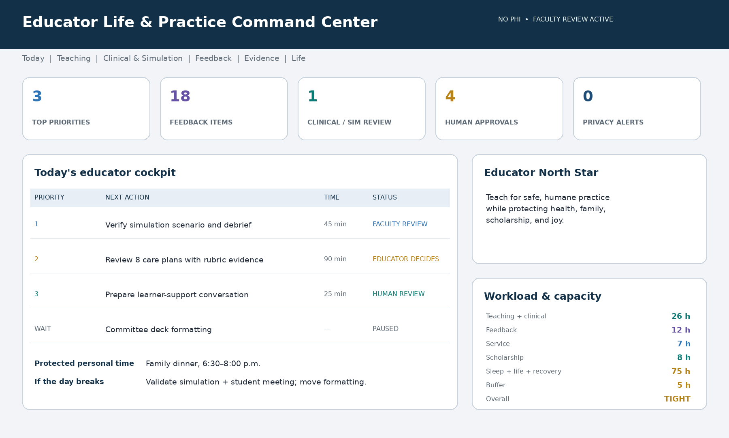
Illustrative dashboard using synthetic information. An educator implementation should remain no-PHI, transparent about sources and memory, and explicit about every item requiring human approval.

Required dashboard areas
Area | Question answered | Typical content
Today | What matters now? | Top Three, fixed commitments, protected life time, Plan B
Teaching | What must be ready? | Sessions, outcomes, accessibility, sources, release status
Clinical & simulation | Is learning prepared safely? | Synthetic data, site check, stop criteria, debrief, approval
Assessment & feedback | What needs my judgment? | Rubric evidence, queue, faculty review, official record
Learner support | Who needs a human conversation? | Observable events, strengths, resources, owner
Evidence & scholarship | What is verified or missing? | Versions, mappings, evidence gaps, milestones
Life & capacity | Does the plan fit? | Workload, recovery, private goals, boundaries, buffer
Governance | Is AI being used safely? | Privacy, sources, memory, retention, approvals

Status language: Use On track, Watch, Needs support, Awaiting faculty review, Awaiting institutional guidance, Paused intentionally, Evidence not located, and Completed. Status never represents student worth or educator performance.

A day in the educator’s life

Orient
The educator gives a brief capacity update. The command center protects safety-critical preparation, names the Top Three, shows human approvals, and moves lower-value work if health, family, clinical, or institutional demands changed.

Prepare
Before class, clinical, or simulation, Hermes presents approved outcomes, learner level, source status, accessibility checks, uncertainty, and the exact items the educator must verify.

Teach and observe
After teaching, the educator records a brief nonidentifying reflection. Hermes organizes what learners understood, where confusion remained, what should change, and which artifact belongs in the teaching portfolio.

Assess with judgment
Hermes organizes rubric evidence and drafts comments. The educator reads the work, corrects context and bias, determines the evaluation, approves feedback, and creates the official record.

Protect the whole person
The system keeps one personal or recovery commitment visible and does not convert every open space into work.

Close the loop
The day ends with completed work, unresolved human decisions, tomorrow’s capacity, help to request, and what can be released until later.

A sustainable week
- Orient — review fixed commitments, teaching, feedback, clinical or simulation, service, scholarship, life, and recovery.
- Prepare — batch reusable low-risk work and reserve high-energy time for judgment.
- Pulse check — identify learner confusion, workload drift, evidence gaps, and safety concerns.
- Develop — protect a scholarship, portfolio, mentoring, career, or life-goal block.
- Close — complete follow-up, capture impact, release low-value work, and preview the next week.

Academic integrity, assessment fairness, and learner trust

What AI may support
- Outcome alignment, lesson drafts, authentic assessment options, and transparent instructions
- Assessment blueprints, original practice items, rubric drafts, and ambiguity checks
- Rubric-evidence organization and feedback drafts in an approved environment
- Clear assignment-specific AI-use guidance and disclosure examples
- Policy-process preparation and neutral questions when a concern arises

What remains human
- Final grades, clinical evaluations, competency, progression, remediation, and discipline
- Accommodation decisions and learner due process
- Misconduct findings; AI-detection output is not proof
- Interpretation of context, effort, improvement, and professional judgment
- Release of consequential feedback or official communication

Evidence-first feedback
- Show the rubric criterion and exact observable evidence behind every suggestion.
- Separate facts, interpretation, unknowns, and proposed language.
- Test comparable work for inconsistent recommendations and demographic proxies.
- Preserve educator edits, approval, the official record location, and the review path.
Trust rule: AI may organize evidence. It must not accuse, diagnose, label, or decide a learner’s future.

Clinical, simulation, and evidence safety

Non-negotiable rules
- Use synthetic or institution-approved information; do not enter patient identifiers.
- Align with learner level, approved objectives, supervision, current sources, and site policy.
- Verify medications, calculations, equipment, emergency actions, and patient-care implications independently.
- Require qualified educator approval before use and human-led debriefing.
- Follow the approved clinical chain and emergency procedure during live events.

Simulation readiness gate
Verify | Question
Purpose | Are objectives, learner level, prerequisites, and evaluation approach approved?
Safety | Are prebrief, psychological safety, confidentiality, stop criteria, and escalation ready?
Operations | Are roles, equipment, staffing, timing, environment, and failure plans ready?
Accessibility | Can every learner access the materials, space, media, and role expectations?
Evidence | Are sources current, applicable, versioned, and independently checked?
Authority | Has the qualified educator approved release and the human-led debrief plan?

Verification rule: Confidence language never replaces source review, site policy, qualified faculty judgment, or the approved clinical chain.

Privacy and memory controls
Memory class | Examples | Default
May remember with consent | Role, general courses, teaching preferences, goals, routines, dashboard settings | Approved categories
Optional or session-only | Workload, career intentions, scholarship plans, family, finances, health-related scheduling | Ask first
Approved environment only | Student work, grades, evaluations, accommodations, complaints, research or personnel information | Restricted
Never in a general AI workspace | PHI, credentials, government IDs, bank data, secure item banks, unauthorized records | Blocked

The educator should be able to ask: What do you remember? What student information is active? Who can access this? Use this session only. Forget this. Show the retention date. Export my private plan. Reset my dashboard.
Private by default: Personal goals, health, family, finances, recovery, and career intentions do not appear in supervisor, faculty-evaluation, promotion, or institutional analytics unless the educator deliberately shares them.

90-day educator rollout
Phase | Timing | Primary work | Evidence
Trust and boundaries | Days 1–14 | Roles, policies, no PHI, privacy, authority, North Star, capacity, one pilot | Compact and synthetic dashboard
Command rhythm | Days 15–30 | Daily brief, weekly reset, protected time, one teaching and one life-goal workflow | Reliable weekly plan and Plan B
Validate workflows | Days 31–60 | Two contained teaching, feedback, clinical, simulation, evidence, or portfolio workflows | Usefulness, accuracy, time, trust
Expand carefully | Days 61–90 | Scholarship or career goal, privacy review, workload effect, retire low-value automation | 90-day activation report

Start small: Pilot one course, clinical group, simulation, feedback queue, evidence project, scholarship goal, or whole-life goal. Expand only when value exceeds review burden and risk.

Educator-controlled outcome measures
Domain | Possible measure | Important safeguard
Time | Preparation or administrative time sampled before and after | Do not manufacture hours saved
Teaching | Outcome alignment, accessibility, and source review completed | Human interpretation required
Feedback | Turnaround, evidence linkage, educator revisions | Speed does not replace quality
Clinical & simulation | Required readiness and approval steps completed | Completion alone is not proof of safety
Learner support | Time from observable concern to human contact | No hidden risk scores
Evidence & scholarship | Verified sources, mapped evidence, milestones | Missing evidence stays visible
Whole life | Protected commitments and educator-rated sustainability | Optional and educator-private
Trust | Corrections, declined suggestions, usefulness | Declining AI is valid

Success is stronger teaching, clearer judgment, increased educator agency, and sustainable progress—not usage volume, constant availability, or a composite productivity score.

Frequently asked questions

Will Hermes replace nursing educators?
No. It supports preparation and coordination. Teaching judgment, relationships, assessment accountability, professional formation, and clinical oversight remain human responsibilities.

Can Hermes grade learner work?
It may organize rubric evidence and draft feedback in an approved workflow. The educator reads the work, determines the final interpretation and grade, and approves the official record.

Can I use learner information?
Only in an institution-approved system, for an authorized purpose, with minimum necessary access, isolation, retention, and audit controls. Use synthetic or nonidentifying context when identifiable data are unnecessary.

Can I use it for clinical teaching?
Yes, as an educator-support tool using synthetic or approved information, qualified review, current sources, site policy, supervision, and institutional safety procedures.

What if AI is wrong?
Correct it, identify the source or process problem, and mark the content for review. Safety-sensitive content remains paused until qualified humans verify it.

Can it handle suspected academic misconduct?
It can organize policy steps and evidence. It cannot determine guilt, treat detection output as proof, replace conversation, or make a disciplinary decision.

Do I have to share personal goals?
No. Life-goal support is optional and educator-private. You control what is stored and what, if anything, is shared.

How will I know it is helping?
Review whether preparation is clearer, decisions are more visible, net workload is lower, learner trust and safety remain strong, and professional and life goals are progressing.

Activation checklist
- Define educator roles, work settings, and human authorities.
- Review applicable institutional, course, clinical-site, privacy, accessibility, assessment, and research policies.
- Establish the permanent no-PHI rule and approved student-record environment.
- Choose permitted memory categories and create the Do Not Remember list.
- Name three professional priorities, one private life goal, and protected time.
- Map actual workload, hidden work, recovery, and buffer.
- Choose one low-risk pilot workflow.
- Configure faculty-review and institutional-verification gates.
- Confirm export, correction, retention, deletion, audit, and safe-degraded-mode controls.
- Schedule a 30-day continue, revise, pause, or stop decision.

Recommended first commands
- Build my educator dashboard around my real roles, boundaries, and private life goals.
- Plan my week around these fixed commitments and show what must move.
- Turn these approved outcomes into an active, accessible lesson draft for my review.
- Prepare a synthetic clinical or simulation brief and flag every safety check.
- Organize rubric evidence and draft feedback without assigning a grade.
- Prepare a supportive learner conversation using observable facts only.
- Build a versioned curriculum or accreditation evidence matrix.
- Protect time for scholarship, family, health, and recovery.
- Show every open item requiring professional judgment or institutional guidance.
- Show what you remember, who can access it, and when it will be deleted.

Closing message to the educator
Nursing education depends on people who can see both the learner and the larger purpose of the profession. Educators cannot offer sustained presence when every detail, deadline, and unfinished task must be carried alone.
Hermes–Nurse AI OS is designed to hold the coordination—not the authority. It can prepare, organize, remind, connect, and surface choices. It cannot replace the educator’s judgment, courage, empathy, standards, relationships, or lived experience.
Final operating principle: The system coordinates and prepares. The educator teaches, judges, supports, and lives.

Companion implementation file
Use Nursing-Educator-Life-and-Practice-Hermes-Program.md as the build and activation specification to hand to Hermes–Nurse AI OS.

Authoritative reference points
Local institutional policy, clinical-site requirements, accessibility processes, accreditation decisions, research oversight, and applicable law remain authoritative. Verify the current source and the edition adopted locally.
- U.S. Department of Education — FERPA resources: https://studentprivacy.ed.gov/ferpa
- U.S. Department of Health and Human Services — HIPAA de-identification guidance: https://www.hhs.gov/hipaa/for-professionals/special-topics/de-identification/index.html
- American Association of Colleges of Nursing — The Essentials, 2026 Edition: https://www.aacnnursing.org/Portals/0/PDFs/Publications/Essentials-2026.pdf
- U.S. Department of Education — 2025 responsible AI guidance: https://www.ed.gov/media/document/opepd-ai-dear-colleague-letter-7222025-110427.pdf

Concept provenance
This educator adaptation translates a five-department AI operating-system concept into an educator-controlled whole-life nursing education environment with accessible teaching, no-PHI clinical preparation, human-owned evaluation, learner dignity, versioned evidence, scholarship, career growth, and compassionate capacity planning.

