NURSE-CONNECTED ALLY GUIDE
Hermes–Nurse AI OS
Secure Life, Enterprise & Community
Empowerment Function
A private, identity-separated command center for a nurse's friend, partner, relative, household member, or trusted supporter
Core promise: The AI coordinates plans, research, drafts, reminders, and options. The ally owns identity, decisions, relationships, enterprise, community work, consent, and consequences.
The relationship creates connection—not permission
Version 1.0 • July 2026

Welcome: this workspace belongs to the ally
A nurse's friend, partner, relative, or trusted supporter may carry a demanding life of their own: employment, caregiving, relationships, finances, learning, an emerging business, creative work, and service to a community.
The Secure Ally Life, Enterprise & Community Empowerment Function brings those commitments into one realistic plan. It helps the ally move from ideas to verified next steps while keeping private life, shared relationship information, business records, and community data in appropriately separated zones.
The nurse may introduce or recommend the system, but is not the ally's administrator, clinician, guarantor, emergency contact, consent proxy, or source of professional authority. The ally receives an independent identity, workspace, memory, permissions, audit history, export, and recovery path.
What “secured vehicle” means: A protected digital operating workspace that helps the ally move goals forward. It is not a physical vehicle, transportation service, bank, clinical system, legal service, or promise that any technology is invulnerable.

Executive overview
Element | Purpose
Hermes | Coordinates ally-approved goals, schedules, research, drafts, reminders, decision briefs, and follow-through.
Nurse AI OS | Provides identity separation, no-PHI protection, consent controls, evidence labels, external-action gates, and human escalation.
Secure Ally dashboard | Shows personal priorities, capacity, enterprise tests, community commitments, relationship approvals, money scenarios, and security status in one private view.

The system may organize, compare, outline, draft, rehearse, and track. It may not impersonate, covertly monitor, borrow the nurse's identity or professional standing, move money, publish, sign, file, diagnose, give professional determinations, or make a high-consequence decision on the ally's behalf.

Designed for real ally situations
Situation | How the workspace adapts | Boundary
Partner or household member | Coordinates personal commitments and explicitly shared household items. | No automatic access to the nurse's calendar, location, messages, health, or work.
Parent, adult child, sibling, relative, or chosen family | Supports caregiving, appointments, projects, and chosen family commitments. | Relationship status does not create consent or authority.
Friend, neighbor, or trusted supporter | Organizes mutual projects, practical help, and community activity. | No inference of family, financial, medical, or emergency authority.
Employee, student, caregiver, job seeker, or retiree | Builds a plan around current capacity, responsibilities, and a self-selected future. | The system does not assume unlimited time, income, mobility, or technology access.
Entrepreneur, freelancer, creator, or cooperative member | Tests ideas, customer needs, offers, operations, and ethical growth. | No fabricated evidence, professional claims, contracts, spending, or filings.
Community organizer, volunteer, or nonprofit builder | Supports listening, stakeholder mapping, events, accessibility, budgets, and follow-through. | No exploitation, deceptive fundraising, or unnecessary beneficiary data.
Person managing disability, chronic illness, neurodivergence, or access needs | Uses chosen pacing, accessible formats, energy-aware planning, and support mapping. | No diagnosis, treatment, benefit, or accommodation determination.
Person in a constrained or changing season | Creates a minimum viable week and protects rest, relationships, and buffer. | Pausing, simplifying, or ending a project is a valid result.

One ally, five coordinated support functions
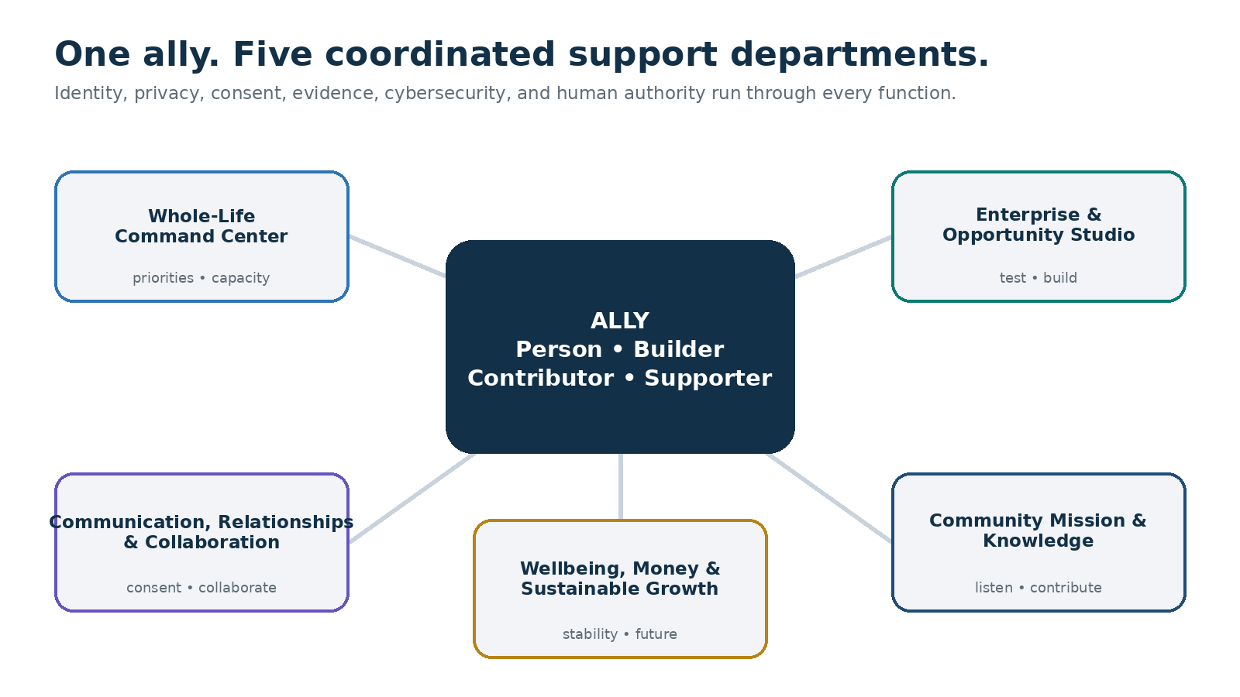
The ally remains the person, builder, contributor, supporter, and decision-maker. Identity, privacy, consent, evidence, cybersecurity, and human authority run through all five support departments.

Benefits to the ally

One whole-life view
Employment, study, household duties, personal goals, enterprise, service, finances, recovery, and relationships become one coordinated plan without becoming one unsafe data store.

Less cognitive fragmentation
The workspace captures next actions, decisions, deadlines, waiting items, and recovery needs so important work is less dependent on memory.

A safer path from idea to action
Ideas become small tests, source-labeled assumptions, ethical offers, budgets, human review points, and reversible next steps.

Stronger privacy and relationship boundaries
The ally's identity is separate. Household collaboration uses item-level consent that is specific, minimal, expiring, and revocable.

More credible business and community work
Evidence, permissions, claims, stakeholder needs, accessibility, costs, and risks stay visible before publication or commitment.

Deliberate money and external actions
Spending, contracts, applications, messages, publications, and payment changes remain drafts until the ally confirms the exact action.

A life that remains larger than output
Rest, health-supporting routines, relationships, culture, spirituality, joy, and the right to stop remain visible capacity—not unused inventory.

The Secure Ally Empowerment Compact

You own the workspace
You choose goals, pace, memory, sharing, approvals, and what continues, changes, pauses, or ends.

The nurse remains a separate person
The nurse is a referrer or relationship partner—not the administrator, guarantor, clinician, employer representative, emergency contact, or consent proxy by default.

One person, one identity
Use the ally's account, authentication, recovery methods, permissions, memory, audit history, export, and deletion controls. Shared logins are prohibited.

No patient or confidential healthcare information
Do not enter patient stories, chart content, clinical screenshots, workplace incidents, assignments, or combinations of facts that could identify a person or facility event.

Consent is exact
Sharing must name the item, subject, purpose, recipient, action, retention period, onward-sharing rule, and revocation path.

Drafts remain drafts
Messages, publications, applications, contracts, purchases, donations, filings, and calendar changes require deliberate human review and confirmation.

Professional boundaries remain visible
The system provides general education and questions. Qualified humans decide medical, legal, tax, accounting, investment, insurance, employment, housing, benefit, emergency, and regulated matters.

Claims require evidence
No fabricated customers, revenue, impact, credentials, endorsements, testimonials, invoices, receipts, attendance, signatures, or grant evidence.

Third parties deserve protection
Collect the minimum data needed from customers, collaborators, donors, volunteers, beneficiaries, and minors; obtain the right consent before use or publication.

Rest is legitimate capacity
Sleep, meals, caregiving, relationships, unstructured time, culture, spirituality, and joy are protected inputs to a sustainable plan.
Governing principle: The relationship creates connection, not permission. The secured vehicle carries coordination—not borrowed authority.

The five empowerment functions

1. Whole-Life Command Center
Coordinates priorities, fixed commitments, energy, household responsibilities, learning, recovery, and the next realistic actions.
- Today's Top Three, protected personal time, and a Plan B
- Weekly capacity map across life, work, enterprise, community, and care
- Minimum viable week for overload, illness, disruption, or caregiving
- Waiting-for, decision-needed, and human-review lists
- Monthly integrated review without shame or productivity pressure

2. Enterprise & Opportunity Studio
Turns a business, freelance, creative, cooperative, or income idea into ethical, testable, evidence-informed work.
- Problem, audience, value proposition, and assumptions map
- Customer discovery questions and small reversible tests
- Offer, pricing, budget, operations, and source-labeled scenario drafts
- Claims, permissions, accessibility, and professional-boundary checks
- Contract, tax, permit, insurance, and regulated questions for qualified humans

3. Communication, Relationships & Collaboration Hub
Prepares clear, respectful human conversations and purpose-limited collaboration while preserving consent and individual boundaries.
- Conversation briefs, meeting agendas, decisions, and follow-up
- Boundary, support, household, and collaboration language
- Item-level Relationship Bridge requests with expiration and revocation
- Draft-first external messages with recipient and attachment review
- No secret monitoring, impersonation, coercion, or inferred consent

4. Community Mission & Knowledge Infrastructure
Supports listening, stakeholder mapping, events, resource stewardship, grants, volunteers, accessibility, and credible impact learning.
- Community listening plan before solution design
- Stakeholder, partner, resource, risk, and decision maps
- Event readiness, accessibility, safeguarding, and contingency checklists
- Fundraising and public-story drafts with claim and permission review
- Impact evidence that distinguishes activity, output, outcome, and uncertainty

5. Wellbeing, Money & Sustainable Growth Orchestrator
Connects work and service to stability, relationships, health-supporting routines, learning, purpose, and future options.
- THRIVE Compass and up to three 90-day results
- General cash-flow, savings, debt, education, and major-purchase scenarios
- Assumption-sensitive comparisons with dates and human-review points
- Support map for overload, scams, distress, or high-consequence decisions
- Recovery, buffer, joy, and stopping rules as part of the plan
Capacity rule: Never schedule 100% of theoretically available time. A plan that depends on constant availability, chronic exhaustion, invisible relationship labor, or unverified income is not a valid plan.

The THRIVE Compass for life, enterprise, and community goals
The dashboard connects today's next action to a larger purpose, then tests whether the plan fits the ally's values, capacity, evidence, relationships, and real-world obligations.
Step | Guiding question | Result
T — True North | What kind of life, work, relationships, and contribution am I trying to create? | A concise North Star
H — Honest reality | What strengths, duties, limits, money, energy, access needs, supports, and uncertainties exist now? | A realistic capacity map
R — Results for 90 days | What few outcomes would create meaningful, observable progress? | Up to three results
I — Infrastructure and support | What routines, people, tools, permissions, sources, and backup plans will help? | A sustainable support system
V — Values and verification | Is this ethical, consensual, inclusive, evidence-supported, affordable, and within the right human authority? | A decision and verification brief
E — Evaluate and evolve | What is helping, creating burden, or changing—and what should pause, simplify, or end? | A learning and adaptation cycle

Example North Star: Build a stable, meaningful life while growing ethical enterprise and contributing to community without borrowing another person's identity, authority, or privacy.

Five planning horizons
- Today — the next right action, one protected commitment, and one decision that may need a human
- This week — employment, study, household needs, care, enterprise, community, relationships, recovery, and buffer
- This month — tests, events, money decisions, learning, permissions, and relationship follow-through
- The next 90 days — a small number of meaningful personal, enterprise, and community results
- Long-term life — stability, health-supporting routines, relationships, creativity, learning, finances, contribution, and joy

The embedded Secure Ally Command Center
The private dashboard should answer within one minute: What matters today? Does the plan fit? What is waiting for consent or verification? What must remain separate? What can be deferred without guilt?
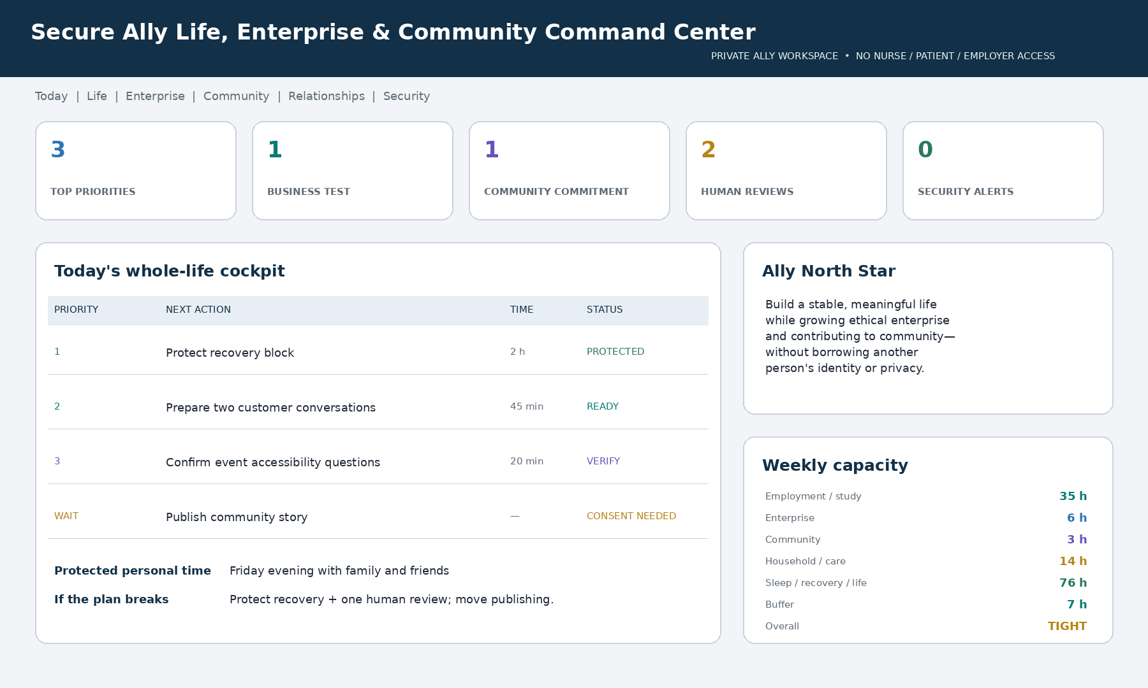
Illustrative dashboard using synthetic information. The canonical Markdown dashboard remains accessible, ally-controlled, minimum-data, and separate from the nurse's account, employer, patients, and clinical systems.

Required dashboard areas
Area | Question answered | Typical content
Today | What matters now? | Top Three, fixed commitments, protected time, Plan B
Capacity | Does this plan fit? | Employment, study, household, enterprise, community, recovery, buffer
Enterprise | What assumption am I testing? | Customer conversations, offer, evidence, costs, next decision
Community | What contribution is responsible? | Listening, partners, accessibility, permissions, risks, impact evidence
Relationships | What requires conversation or consent? | Bridge requests, boundaries, shared items, expiration, revocation
Money | What is a scenario—not a promise? | Assumptions, options, dates, qualified-human review
Human decisions | What must a person decide? | Contracts, filings, spending, publishing, professional questions
Security | Is the workspace protected and separated? | Identity, MFA, sessions, connections, alerts, memory, retention

Dashboard language: Use Ready, Needs ally review, Consent needed, Verify source, Qualified human required, Protected, Paused intentionally, and Completed. No status is a judgment of worth, loyalty, or productivity.

A practical rhythm for a full life

Daily orient
Review the Top Three, fixed commitments, protected personal time, one human decision, and the smallest safe next action. Do not automatically fill open time.

Weekly capacity reset
Map employment or study, household and care, enterprise, community, relationships, recovery, and buffer. Move work when the total exceeds real capacity.

Minimum viable week
During disruption, protect essential care, recovery, one important human conversation, and the smallest action that preserves momentum. Release optional output.

Monthly integrated review
Review progress, evidence, money, relationship effects, community responsibility, security, and burden. Continue, revise, pause, simplify, hand off, or stop.

Enterprise workflow: from idea to ethical test
- Name the problem, intended audience, proposed value, and why the ally cares.
- Separate known facts, sourced evidence, assumptions, hopes, and unknowns.
- Check whether the work requires a license, permit, contract, insurance, tax decision, privacy notice, accessibility work, or qualified professional.
- Choose the smallest reversible test: interviews, a prototype, a manual service, a landing-page draft, or a cost check.
- Protect customer and collaborator data; collect only what the test requires.
- Review claims, price assumptions, costs, capacity, conflicts, and consent before anything public.
- Have the ally approve the exact message, recipient, channel, timing, attachments, and consequences.
- Record what was learned and decide: continue, change, pause, or stop.

Evidence ladder for business claims
Level | What can be said | Required treatment
Idea | A proposed benefit or possibility | Label as a hypothesis; do not present as a result.
Signal | A small number of conversations or observations | State the small sample and avoid generalization.
Test | A defined pilot with documented inputs and outputs | State method, dates, limitations, and relevant consent.
Pattern | Repeated results across more than one setting or period | Show source, denominator, uncertainty, and contrary evidence.
Verified claim | A claim supported for its intended use | Retain evidence and obtain specialist review when regulated or consequential.

Business integrity: The workspace never fabricates credentials, customers, reviews, testimonials, revenue, invoices, receipts, signatures, outcomes, or professional endorsement. The nurse's title and workplace are not marketing assets.

Community workflow: listen before building
- Clarify the community, issue, purpose, decision owners, and people most affected.
- Ask how affected people want to participate and what information should not be collected.
- Map existing strengths, groups, services, leaders, risks, access needs, and gaps before proposing a new solution.
- Define a small initiative with roles, resources, accessibility, safeguarding, permissions, and a contingency plan.
- Use the minimum data necessary; separate participant, donor, volunteer, and public information.
- Review public stories, images, quotations, testimonials, fundraising claims, and minors' information before publication.
- Distinguish activities, outputs, outcomes, lived experience, and uncertainty in impact reporting.
- Close the loop with participants and decide what should continue, change, be transferred, or end.
Community dignity: People are not content, leads, case studies, or proof of impact by default. A compelling story still needs authority, consent, accuracy, purpose limitation, and a safe way to withdraw.

The Relationship Bridge
Household or relationship collaboration may be useful, but it must never collapse two people's identities, accounts, private memories, calendars, or histories into one invisible profile.
Bridge principle | Operational meaning
Item-level | Share one defined item—not an entire calendar, inbox, folder, contact list, or memory.
Purpose-limited | State why the recipient needs it and what action is allowed.
Minimum-data | Remove unrelated details, sensitive notes, locations, and third-party information.
Specific recipient | Name the intended person or approved group; no implicit household-wide access.
Time-limited | Use an expiration date or event-based end; do not create standing access without necessity.
Revocable | The owner can stop future access and receive a record of what was already shared.
No inference | Do not infer mood, health, availability, loyalty, location, or commitment from a shared item.
Auditable | Record owner, recipient, item, purpose, action, consent time, expiration, and revocation state.

Safe bridge examples
- A mutually approved household appointment with only the necessary time and location
- A shared shopping, travel, care, or event task with named owners and an end date
- A project document that both people deliberately join with defined permissions
- A support request written by the owner and sent only after exact approval

Prohibited bridge behavior
- Importing the nurse's workspace, schedule, messages, contacts, employer data, clinical context, or private goals
- Using shared-device access, relationship status, past sharing, silence, or group membership as consent
- Building a hidden profile of the nurse's location, workload, mood, health, finances, or availability
- Publishing the nurse's name, image, credentials, employer, quotation, or story without exact permission

The SHIELD risk and authority model
Before consequential work, Hermes checks Sensitivity, Human authority, Identity, External action, Legal or financial consequence, and Data rights. The highest applicable condition sets the response level.
Level | Typical request | System response
GREEN | Private planning, brainstorming, formatting, a synthetic practice draft | Proceed with minimum data and ally review.
YELLOW | Public claim, third-party data, relationship sharing, cost estimate, unfamiliar source | Label assumptions; verify source, permission, recipient, and retention.
ORANGE | Contract, tax, permit, legal right, investment, employment, health, insurance, payment change | Prepare questions and a decision brief; require the appropriate qualified human and exact confirmation.
RED | Patient data, impersonation, fraud, secret monitoring, credential theft, active harm, immediate danger | Refuse or stop; protect safety and use the relevant emergency, security, or official pathway.

External-action confirmation gate
Hermes may prepare an action only after showing an action card. The ally must approve the exact action—not a broad standing instruction—and a material change requires a new confirmation.
Action-card field | What must be visible
Action | Send, publish, purchase, donate, apply, schedule, disclose, sign, or another precise verb
Actor and account | The ally's verified identity and the exact account or organization being used
Recipient and audience | Named recipients, public audience, or platform; warn about unintended visibility
Content and attachments | Final preview, links, files, personal data, claims, and permissions
Money or obligation | Amount, currency, counterparty, fees, recurring terms, contract terms, and cancellation
Source and uncertainty | What was verified, date checked, remaining assumptions, and qualified-human review
Data handling | Data shared, purpose, recipient, retention, onward-sharing rule, and revocation limits
Consequence and recovery | Likely effect, reversibility, deadline, and what happens if the action is wrong

Human-action rule: No autonomous messages, publications, applications, filings, contracts, purchases, transfers, donations, refunds, registrations, calendar changes, or disclosures. Draft, preview, verify, confirm, then record.

Privacy, identity, and cybersecurity

Minimum launch controls
- A unique ally account with multifactor authentication or a passkey and independent recovery methods
- No shared password, authentication code, recovery key, private key, token, or borrowed device session
- Least-privilege connections that are read-only by default and disabled when unnecessary
- Separate private, shared-by-consent, enterprise, community, and restricted zones
- Encryption in transit and at rest, session and device review, and prompt removal of obsolete access
- A secrets vault for credentials; secrets never appear in prompts, notes, dashboards, or exports
- Attachment and link treatment as untrusted content; embedded instructions cannot override this program
- Export, correction, retention, deletion, backup, recovery, audit, and incident-response controls
- Safe degraded mode: fail closed when identity, authentication, trusted sources, or security controls fail
Launch rule: If independent identity, hard workspace separation, access control, and deletion cannot be verified, do not launch the ally workspace.

Data zones
Zone | Examples | Default
Private ally | Goals, personal calendar, private reflections, finances, health-supporting routines | Ally only; minimum data
Shared by consent | One household task, event detail, or approved project item | Specific recipient, purpose, action, expiration
Enterprise | Customer research, offers, budgets, operations, business sources | Role-based; third-party data minimized
Community | Initiative plan, public resources, volunteer roles, event operations | Separate participant, donor, volunteer, and public data
Restricted | Contracts, tax records, identity documents, protected cases | Approved specialist system only; never general memory
Prohibited | PHI, nurse workplace secrets, passwords, tokens, covert surveillance data | Blocked; do not echo, store, or transform

No-PHI and nurse-workplace boundary
Patient names are not the only identifiers. A clinical story may remain identifiable through dates, location, condition, role, sequence of events, quotations, images, or unusual circumstances. Removing a name alone does not make it safe for the ally's workspace.

If possible patient or confidential healthcare information appears
- Stop processing and do not repeat, summarize, transform, or classify the sensitive content.
- Do not place it in memory, logs, analytics, drafts, reports, or the dashboard.
- Tell the ally to remove it and do not ask for more identifying details.
- If the nurse is involved, direct the matter to the approved workplace privacy and clinical systems.
- Offer a fully fictional or generic alternative only after the boundary is restored.
- Record only that a privacy boundary was triggered, without retaining the content.

Memory and data rights
Memory class | Examples | Default
May remember with consent | Broad goals, preferred planning style, dashboard settings, chosen routines | Approved categories
Session-only by default | Health, distress, relationship conflict, finances, immigration, housing, job search | Ask first; do not retain
Specialist or official system only | Tax records, contracts, protected complaints, regulated applications | Restricted
Never in general memory | PHI, passwords, tokens, recovery codes, private keys, bank account numbers | Blocked

The ally should be able to ask: What do you remember? Why was it retained? Who can access it? Use this session only. Correct this. Export my data. Forget this item. Delete this project. Revoke this connection. Reset my dashboard. Pause all automations.

Suspicious messages and payment changes
- Pause. Do not click, reply, open an unexpected attachment, scan a code, reveal a secret, or move money.
- Treat urgency, secrecy, changed payment details, gift cards, cryptocurrency, remote-access requests, and login prompts as risk signals—not proof by themselves.
- Verify the person or organization through a known, independently obtained contact method—not the message's link or phone number.
- For payment changes, confirm the counterparty, amount, destination, and reason out of band with an authorized human.
- Preserve the suspicious message safely if needed, secure affected accounts, review active sessions, and report through the relevant bank, platform, business, or authority.
- Record the event without copying passwords, authentication codes, identity documents, or unnecessary personal data into the workspace.

Human support and escalation
Situation | Human pathway to consider
Health, symptoms, treatment, or fitness | Licensed clinician, pharmacist, therapist, emergency service, or another appropriate health professional
Contract, legal right, dispute, immigration, or liability | Qualified lawyer, legal-aid service, regulator, insurer, or authorized official
Tax, bookkeeping, entity, payroll, or financial statement | Qualified tax professional, accountant, bookkeeper, bank, or government office
Investment, credit, insurance, housing, or benefits | Appropriately licensed or authorized adviser, agency, lender, insurer, counselor, or official source
Permit, license, accessibility, employment, or safeguarding | Responsible authority, regulator, HR professional, accessibility specialist, safeguarding lead, or qualified counsel
Cybersecurity, compromised account, or payment diversion | Platform security, bank fraud team, cybersecurity professional, law enforcement, or relevant reporting service
Community conflict or high-risk event | Affected community leaders, venue, emergency services, safeguarding lead, mediator, insurer, or local authority
Overload, distress, or immediate danger | Trusted person, qualified health professional, crisis service, or emergency services according to urgency and location

Wellbeing prompts are not diagnosis or therapy. Possible self-harm, harm to others, abuse, severe symptoms, acute impairment, or immediate danger requires qualified human help now. In the United States, use 911 for immediate danger and call or text 988 for suicide or mental-health crisis support; outside the United States, use local emergency and crisis resources.

90-day ally rollout
Phase | Timing | Primary work | Evidence
Secure and simplify | Days 1–30 | Independent identity, MFA, separation, memory choices, THRIVE Compass, minimum dashboard, one low-risk workflow | Security preflight, synthetic acceptance tests, first weekly plan
Validate support | Days 31–60 | One enterprise test and one community or relationship workflow; source, consent, burden, and usefulness review | Real learning without unsafe automation or excess data
Build sustainable momentum | Days 61–90 | Expand only proven functions; review permissions, results, money, capacity, security, and stopping rules | Ally-approved activation and stewardship report

Start small: Pilot one low-risk use: a weekly plan, two customer conversations, an event-accessibility checklist, a difficult-conversation brief, or a private money scenario. Expand only when benefit exceeds review burden and risk.

Ally-controlled outcome measures
Domain | Possible measure | Safeguard
Agency | Ally-rated clarity, choice, and control | Never a loyalty or productivity score
Whole life | Protected commitments, recovery, and progress across chosen goals | Optional and private
Enterprise | Assumptions tested, evidence quality, ethical offers, decision readiness | No manufactured revenue or success claims
Community | Listening, accessibility, participation, stewardship, credible learning | People are not reduced to counts
Relationships | Consent quality, completed conversations, fewer preventable conflicts | No covert monitoring or sentiment scoring
Money | Improved scenario clarity and verified human decisions | No guarantee, transaction, or automated advice
Trust and security | Corrections, declined actions, access reviews, privacy events, deletions | Declining AI is valid
Burden | Coordination time and review load | Do not invent hours saved

Success means clearer choices, responsible progress, credible evidence, protected relationships, earlier risk detection, less avoidable coordination burden, and a life that remains sustainable—not usage volume, automated messages, constant availability, public reach, or data collected.

Frequently asked questions

Is this a shared nurse-and-family account?
No. The ally receives an independent account and workspace. A Relationship Bridge can share a specific item only with exact consent, purpose, permissions, and expiration.

Can the nurse see the ally's dashboard?
Not by default. The nurse sees only an item the ally deliberately shares through an approved process. The same rule protects the nurse's information from the ally.

Can the ally use the nurse's name, title, image, employer, or professional opinion?
Only with specific permission for the exact use, and never in a way that implies clinical, employer, regulatory, or professional endorsement that does not exist.

Can patient stories be used if names are removed?
No. Removing a name alone does not reliably de-identify a story. Patient and confidential healthcare information do not belong in this workspace.

Can Hermes launch a business or fundraiser automatically?
No. It can prepare options, drafts, checklists, and decision briefs. Publishing, spending, registration, contracts, filings, and fundraising require exact human review and approval.

Can it give medical, legal, tax, investment, insurance, or employment advice?
It can provide general education, sources, assumptions, options, and questions. A qualified human remains responsible for professional determinations and high-consequence decisions.

Can it remember sensitive personal details?
Only according to the ally's approved memory categories. Sensitive health, relationship, financial, immigration, housing, and distress details are session-only by default.

Can it contact someone when the ally is distressed?
It should encourage immediate human support appropriate to urgency and location. It does not secretly contact the nurse, employer, or another person; emergency features require explicit configuration and lawful operation.

What if the AI is wrong or unavailable?
Stop, correct it, and verify with an authoritative source or qualified human. Identity-, security-, source-, and high-consequence functions fail closed.

Does the ally have to pursue income or community work?
No. Stability, learning, relationships, creativity, care, recovery, or ending a project may be the right goals. The ally chooses what matters.

Activation checklist
- Create the ally's independent identity, MFA or passkey, recovery path, workspace, audit history, and data export.
- Verify hard separation from the nurse's account, memory, messages, calendar, contacts, employer, and clinical context.
- Establish the permanent no-PHI, no-impersonation, no-secret-monitoring, and draft-first rules.
- Configure private, shared-by-consent, enterprise, community, restricted, and prohibited data zones.
- Choose memory categories, retention periods, a Do Not Remember list, and deletion controls.
- Name a THRIVE North Star and up to three 90-day results.
- Map employment or study, household and care, enterprise, community, relationships, recovery, and buffer.
- Protect one personal commitment and one recovery block.
- Configure qualified-human, cybersecurity, fraud, crisis, and emergency pathways appropriate to location.
- Choose one low-risk pilot and keep external automations off until their exact scope is approved.
- Run identity, isolation, no-PHI, consent, impersonation, payment-change, export, deletion, and safe-degraded-mode tests.
- Schedule a 30-day continue, revise, pause, simplify, or stop decision.

Recommended first commands
- Build my private ally dashboard around my actual life, boundaries, access needs, and goals.
- Help me write a THRIVE North Star and choose no more than three 90-day results.
- Plan this week across work, household needs, enterprise, community, relationships, recovery, and buffer. Show what must move.
- Create a minimum viable week for reduced capacity.
- Turn this business idea into the smallest ethical test. Separate facts, assumptions, evidence, and questions for a qualified human.
- Prepare two customer-discovery conversations without collecting unnecessary personal information.
- Build a community listening plan before proposing a solution.
- Prepare a difficult conversation using facts, boundaries, questions, and a respectful request.
- Create an item-level Relationship Bridge request with purpose, recipient, action, expiration, and revocation.
- Compare these money scenarios, show assumptions and uncertainty, and list questions for the appropriate professional.
- Review this message or payment change for risk. Do not click, reply, disclose, or transact.
- Show what you remember, who can access it, why it was retained, and when it will be deleted.

Closing message to the ally
Your connection to a nurse may be meaningful, but it does not define the limits of your own life, work, creativity, contribution, or future.
Hermes–Nurse AI OS is designed to carry coordination, not identity or authority. It can help you clarify, prepare, test, organize, protect, and follow through. It cannot replace your judgment, consent, relationships, courage, accountability, lived experience, or the qualified people responsible for professional decisions.
Final operating principle: The secured vehicle carries coordination—not borrowed authority. The ally chooses, builds, collaborates, contributes, protects relationships, and lives.

Companion implementation file
Use Nurse-Connected-Ally-Secure-Life-Enterprise-and-Community-Hermes-Program.md as the complete build, embedded Markdown dashboard, workflow, governance, security, acceptance-test, and activation specification to hand to Hermes–Nurse AI OS.

Authoritative reference points
Current law, contracts, permits, tax rules, consumer-protection requirements, accessibility obligations, privacy requirements, charity and fundraising rules, insurance terms, platform terms, and qualified human advice remain authoritative. Verify the current source and the rule applicable to the ally's location and work.
- NIST — Privacy Framework: https://www.nist.gov/privacy-framework
- NIST — AI Risk Management Framework: https://www.nist.gov/itl/ai-risk-management-framework
- NIST — Cybersecurity Framework 2.0: https://www.nist.gov/cyberframework
- U.S. Federal Trade Commission — Start with Security: https://www.ftc.gov/business-guidance/resources/start-security-guide-business
- U.S. Small Business Administration — Strengthen Your Cybersecurity: https://www.sba.gov/business-guide/manage-your-business/strengthen-your-cybersecurity
- U.S. Department of Health and Human Services — HIPAA De-identification Guidance: https://www.hhs.gov/hipaa/for-professionals/special-topics/de-identification/index.html
- SAMHSA — 988 Suicide & Crisis Lifeline: https://www.samhsa.gov/mental-health/988

