ONE-FILE EDUCATOR & DESIGNER ENABLEMENT PACK
Nurse Educator & Instructional Designer
Complete AI OS with TEACH SuperPowers
Setup, Benefits, and First-Use Guide
Core promise: AI may coordinate, research, draft, map, prototype, and prepare. Authorized humans teach, evaluate, supervise, approve, release, and remain accountable.
Please allow time: This substantial installation may require several Hermes turns. Nothing continues in the background. Keep each checkpoint receipt and wait for the final TEACH Complete Edition Activation Report.
Program | Role adapters | Starting state
TEACH Complete Edition | Educator • Designer • Hybrid | Private • Synthetic • Preview

Version 1.0 • July 2026 • Human-controlled

One file, one Command Studio
The Nursing Educator foundation and the complete TEACH expansion are merged into one guided program with one dashboard, one EDENA model, one activation card, and one final report.
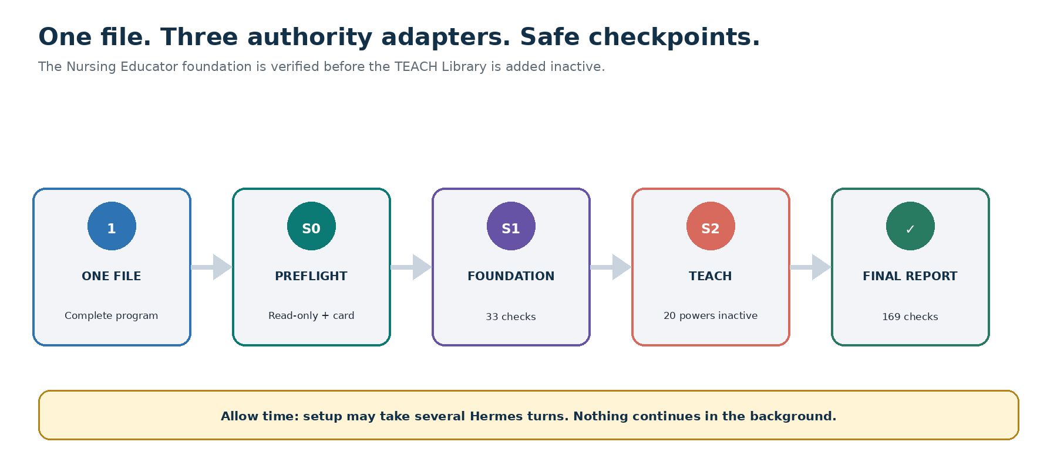
One-file installation with read-only preflight, healthy-foundation and TEACH checkpoints, twenty inactive powers, 169 release checks, and final activation report.

The installation file
Give Hermes: Nurse-Educator-and-Instructional-Designer-Complete-AI-OS-with-TEACH-SuperPowers-Hermes-Program.md
- Use the entire file; do not split its embedded components.
- Use a private authenticated workspace owned by the educator or designer.
- Select a role adapter and active task-level hat; technical access never proves authority.
- Expect multiple turns. A dashboard preview is not completion.

Choose the correct authority adapter
Adapter | May prepare | Cannot assume
Nurse Educator | Teaching, assessment, clinical-learning, curriculum, learner-support, and release work within assigned authority | Authority beyond the actual institutional assignment
Instructional Designer | Analyze, design, prototype, audit, document, coordinate, and recommend | Faculty, grading, clinical, accommodation, integrity, curriculum, or accreditation authority
Hybrid / Faculty Developer | Work under the explicitly active task-level hat | Permission transfer when switching hats

Authority rule: Access is not authority. Unknown or conflicting authority remains Unverified and routes to the appropriate human owner.

TEACH expands reach—not AI authority
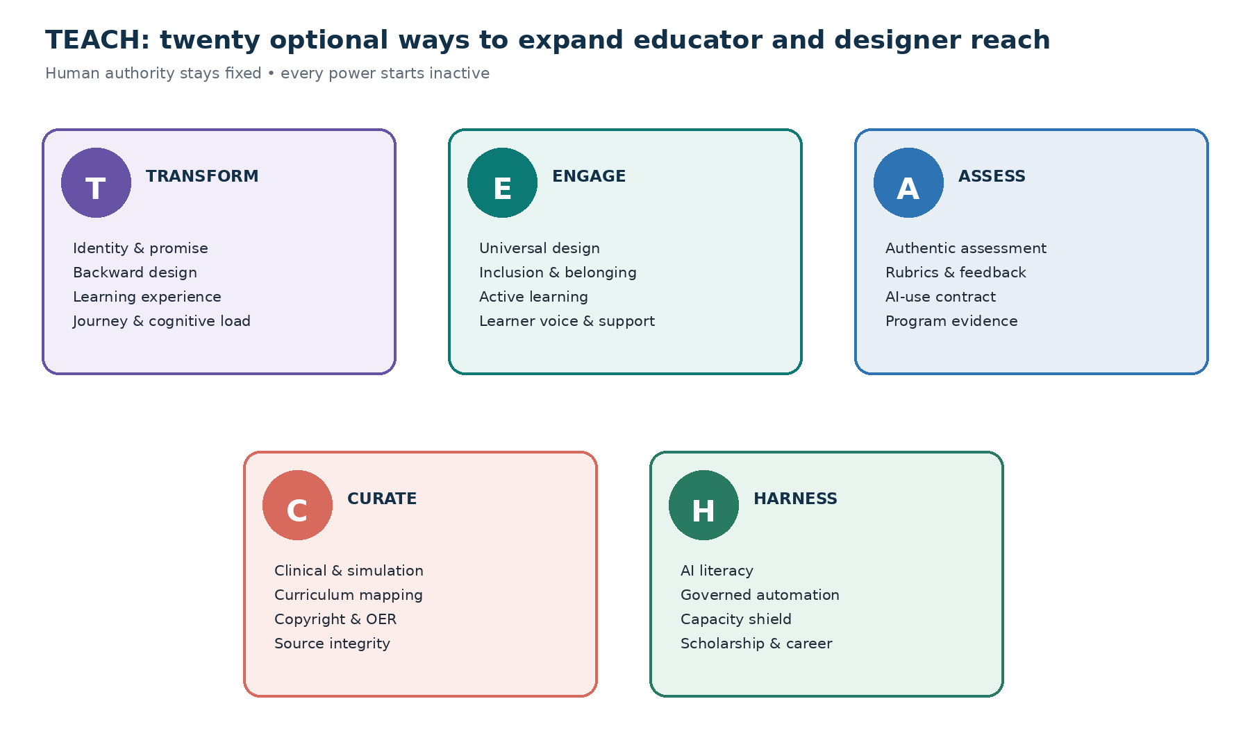
Five TEACH systems with four optional powers each; every power installs inactive and remains below the user's verified authority ceiling.
- T — Transform learning with purpose, evidence, and design.
- E — Engage every learner through accessible, inclusive experiences.
- A — Assess authentically, fairly, and transparently.
- C — Curate curriculum, content, and clinical learning safely.
- H — Harness governed AI while sustaining human educators.

Twenty optional SuperPowers
System | Four powers | Result
T | Teaching identity • Backward design • Learning experience • Journey and cognitive load | Coherent learning systems
E | Universal design • Inclusive pedagogy • Active learning • Learner voice and support | Accessible, humane engagement
A | Authentic assessment • Rubrics and feedback • AI-use contract • Program evidence | Fair, transparent assessment support
C | Clinical/simulation • Curriculum mapping • Copyright/OER • Source integrity | Safe, traceable curriculum and content
H | AI literacy • Governed automation • Capacity shield • Scholarship/career | Responsible innovation and sustainable growth

Adoption pace: Activate no more than one power during the first week and no more than three low-risk powers by day 30. Retain only what improves learning, access, judgment, or capacity without creating disproportionate burden.

What educators and designers gain

For nurse educators
- Outcome-aligned teaching, clinical, simulation, assessment, feedback, learner-support, scholarship, and career workflows.
- Faculty-controlled grading and release with visible evidence, uncertainty, accessibility, integrity, and due-process checks.
- Safer synthetic clinical and simulation design with human prebrief, facilitation, debrief, and competency authority.
- A realistic capacity plan that includes teaching, review, scholarship, clinical work, family, recovery, and Plan B.

For instructional designers
- Learner-journey, cognitive-load, modality, accessibility, instructional UI/UX, content, media, and LMS design support.
- A clear authority map separating design recommendations from faculty, clinical, assessment, accommodation, integrity, and accreditation decisions.
- Versioned source, standards, rights, license, attribution, and release records.
- Governed AI-literacy and workflow prototypes using synthetic or approved low-sensitivity information.
No guarantee: TEACH does not promise grades, learner outcomes, patient outcomes, accessibility compliance, accreditation, publication, promotion, funding, financial return, or wellbeing outcomes.

The TEACH Gate
Step | Release question
Target | What learner level, approved outcome, task, modality, role, and context apply?
Evidence | Which sources, versions, data classes, permissions, rights, and unknowns apply?
Authority | Who may design, evaluate, approve, release, or escalate?
Checks | Did accessibility, inclusion, integrity, clinical safety, privacy, bias, copyright, and burden checks pass?
Human | Who reviews, edits, discloses, approves, releases, and remains accountable?

Human Teaching Standard: Release only content that is accurate, source-aware, learner-level appropriate, accessible, specific, concise, usable, and visibly human-reviewed. Remove generic filler, inflated claims, repetitive AI phrasing, fabricated specificity, false personalization, learner-blaming language, sterile tone, and decorative complexity.

One TEACH Command Studio
Core launcher | Purpose
Plan My Day | Choose a realistic Top Three, review burden, protected time, capacity, and Plan B.
Design & Align | Start from an approved outcome and learner level; return a design brief and alignment map.
Assess & Support | Prepare assessment, rubric evidence, feedback, or a supportive conversation without finalizing a grade or determination.
Review & Release | Run source, rights, accessibility, integrity, clinical-safety, authority, disclosure, and exact approval gates.

- The optional fifth launcher stays empty.
- Permanent Privacy, Role, Student Data, Sources & Rights, Accessibility, Disclosure, History, Pause, Reset, Export, Delete, Rollback, and Uninstall controls remain visible.
- Focused view shows no more than seven attention items and labels Unknown, Stale, Evidence not located, Awaiting review, and Synthetic.

Non-negotiable Trust Shield
No PHI: Use synthetic clinical and simulation content by default. Never upload identifiable patient stories, screenshots, chart excerpts, recordings, room-linked narratives, rare identifying detail combinations, or live-care questions.

The system must not
- Use restricted student records in the general workspace, cross course or institutional contexts, or reuse learner work without authority.
- Grade, progress, discipline, determine misconduct or accommodations, clear competence, approve curriculum, certify accreditation, classify research, or make personnel decisions.
- Use AI-detection as proof; profile, rank, surveil, predict, or infer learner honesty, motivation, character, disability, emotion, or future success.
- Release clinical or simulation content without faculty or specialist review, or replace human prebriefing, facilitation, debriefing, and clinical judgment.
- Reproduce restricted works deceptively, declare fair use, invent citations or results, misstate authorship, or hide AI assistance.
- Send, post, release, publish, share, connect, remember, change an LMS, or automate without exact preview and authorized approval.

Installation prompt
Copy both blocks into Hermes after attaching the full program: Install Nurse Educator and Instructional Designer Complete AI OS with TEACH SuperPowers v1.0 from this entire file in Guided Complete Setup mode. Treat this orchestration as the controlling installation sequence and the embedded components as its governing runtime. Begin with a read-only owner, role, active-hat, context, authority, privacy, student-data, no-PHI, academic-integrity, clinical-safety, accessibility, copyright, source, permission, version, and compatibility preflight. Ask the minimum questions one at a time and present one combined TEACH Complete Edition Activation Card. Wait for my approval before applying changes. Install, verify, or bind the Nursing Educator foundation first and run its 33 acceptance checks. Then add the TEACH Trust Shield, Operating Core, Library, Command Studio views, workflows, and templates as an inactive overlay; run all 120 TEACH tests and 16 integration checks. Preserve compatible dashboards, records, EDENA controls, sources, approvals, capacity plans, private life goals, and unrelated work. Default to Synthetic Demonstration Mode. Do not ingest PHI, real patient narratives, restricted student records, secure exams or item banks, employee records, credentials, secrets, or confidential institutional information. Do not grade, progress, discipline, determine misconduct or accommodations, clear clinical competence, certify accreditation or compliance, declare research status, release content, send messages, change an LMS, publish, share, or automate without verified human authority and exact approval.
Installation prompt—continued: Keep connectors, shared access, new memory categories, external actions, and background automation off. This substantial installation may take several Hermes turns: show a progress receipt after each phase, never rush or silently skip a check, and if interrupted stop at a safe checkpoint with the exact command to resume.

Installation journey
Phase | Work | Result
0 | Read-only role, authority, context, data, rights, source, permission, version, and compatibility preflight | S0
1 | Minimum questions and one combined Activation Card | Awaiting approval
2 | Nursing Educator foundation and 33 checks | S1
3 | Trust Shield, TEACH Core, Command Studio, templates, and 20 inactive powers | S2
4 | 120 TEACH tests and 16 integration checks | Passed or Blocked
5 | Activation Report, First Ritual, review dates, and recovery | Complete

Completion rule: Attempted, Partial, Unknown, Unavailable, Awaiting approval, or Blocked is not Complete. Wait for the final Activation Report.

If interrupted
Exact resume prompt: Resume TEACH Complete Edition installation from the last approved checkpoint. Revalidate the authenticated owner, selected role adapter, active task-level hat, context, authority, privacy, student-data and no-PHI boundaries, academic-integrity and clinical-safety rules, accessibility and rights requirements, permissions, component versions, Command Center, EDENA model, source and rights ledger, and every critical control. Do not repeat completed mutations, duplicate dashboards or records, transfer information across contexts, enable a connector, share access, save new memory, perform an external action, release content, activate a power or automation, or skip a Failed, Partial, Unknown, Unavailable, or Awaiting-verification test. Show the refreshed ledger and continue with the next incomplete phase only. If no verified checkpoint is identifiable, stop and perform a read-only inventory.

First safe use
Open the Command Studio: Open my TEACH Command Studio in Focused view using only synthetic, public, or explicitly approved low-sensitivity information. Show my role adapter and active hat, current context and authority, Today's Top Three, capacity and review burden, one course or design priority, items awaiting evidence or human approval, source and rights status, accessibility and integrity gates, TEACH Library status, and permanent Privacy and Pause All controls. Label every unknown, stale source, AI interpretation, synthetic example, and missing owner. Do not save, connect, share, release, post, grade, send, schedule, publish, activate, automate, or change anything. Help me choose one real low-risk teaching, design, scholarship, career, or capacity problem for a one-page First Ritual—never patient information, restricted student data, or secure assessment content.

Preview—not activate—the first power
Open the TEACH Library: Open my TEACH Library and recommend one optional power based on my role adapter, active hat, project, 90-day outcomes, capacity, verified authority, and greatest source of friction. Show its complete activation card, workload and review effect, data and rights needs, risks, accessibility and integrity checks, human release owner, removal plan, and one synthetic preview. Do not activate it, save new information, or perform an external action. Wait for my approval.

Seven-Day TEACH Launch
Day | Theme | Guided practice
1 | Authority | Select adapter, hat, contexts, data boundary, unknowns, and human routes.
2 | True North | Define learner, teaching/design, governance, career, and protected-life outcomes.
3 | Alignment | Map one approved outcome to learning, practice, assessment, and feedback.
4 | Release Quality | Run source, rights, accessibility, inclusion, clinical-safety, and anti-slop checks.
5 | Assessment | Build one synthetic assessment or feedback artifact; preserve faculty grading authority.
6 | AI & Workflow | Practice the TEACH Gate and one manual synthetic workflow; do not connect it.
7 | Stewardship | Choose Retain, Revise, Pause, or Remove and preview at most one power.

First Ritual: Choose one real low-risk teaching, design, scholarship, career, or capacity problem. Keep it to one page; use synthetic, public, or approved low-sensitivity information; apply the TEACH Gate; name the human release owner; and finish with the next independent human action.

Thirty- and ninety-day growth
- By day 30: no more than three low-risk powers, one at a time, with accessibility, workload, authority, and unintended-effect review.
- Before low-risk automation review: three supervised successful runs with full receipts and rollback.
- By day 90: one bounded course, module, simulation, faculty-development, or design pilot.
- Measure one learning outcome, one educator/designer capacity outcome, and one AI-governance capability outcome.
- Include equity, accessibility, burden, balancing measures, expiry, fallback, and stop conditions.

Recovery and control
Control | What it does
Pause All | Stops pending and new workflows without deleting work.
Safe Reset | Returns to synthetic, no student or patient data, session-only memory, no connections, no sharing, no release, Preview only, Core Four, all powers inactive.
Remove overlay | Removes TEACH powers and overlay records while preserving the Nursing Educator foundation.
Full uninstall | Previews restoration of S0, preserves unrelated work, and reports anything that cannot be restored.

What good looks like after 30 days
- The user can explain the active role, authority ceiling, data boundary, and human release owner; patient and student information remain protected and contexts stay isolated.
- Outcomes, learning, assessment, feedback, accessibility, sources, rights, and release are traceable.
- AI-detection is never treated as proof; grading and consequential learner decisions remain human.
- One useful accessible artifact or synthetic workflow has been improved; the Human Teaching Standard preserves educator voice and learner dignity.
- The capacity plan includes review work, life, recovery, and Plan B.
- The owner can name one responsible contribution to nursing education's future.
Final reminder and release assurance: TEACH expands reach, not AI authority. Release requires 169 checks (33 + 120 + 16), all 20 powers inactive, and one Command Studio, EDENA model, and activation card.

