ONE-FILE NP ONBOARDING PACK
NP Complete AI OS
with NP Wings
One-File Setup Guide
Simple setup: Give Hermes one Markdown program, use one installation prompt, and approve one combined setup card. Hermes protects the foundation-first and Wings-second order internally.
Please allow time: This is a substantial installation and may take considerably longer than a normal prompt. It may require several Hermes turns. Progress receipts and safe checkpoints are expected; completion requires the final activation report.
Program | ID | Default state
NP Complete AI OS with NP Wings | NAIO-NP-COMPLETE-WINGS-1.0 | Private • no-PHI • Preview

Version 1.0 • July 2026 • Nurse practitioner-owned

One file replaces two user-managed installs
The NP foundation and every NP Wings runtime module are embedded in one Complete Edition program.
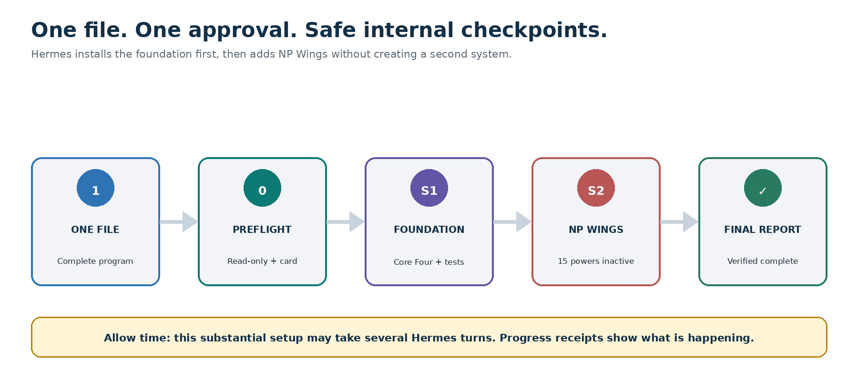
One-file setup with read-only preflight, healthy-foundation checkpoint, NP Wings overlay, and final report.

The only installation file
Give Hermes: NP-Complete-AI-OS-with-Wings-Hermes-Program.md
Do not divide the file, install an embedded component separately, or copy only its opening instructions. The full file contains the foundation, fifteen powers, workflows, templates, manifest, tests, checkpoints, and rollback behavior.
Existing users: If a compatible component already works, Hermes should verify and bind to it. It must not reinstall a healthy component, create a second dashboard, or duplicate base records.

Quick setup

1. Use a private workspace
Use one authenticated workspace owned by the nurse practitioner. Do not use a shared account or a workspace containing patient information.

2. Upload the complete program
Attach the entire Complete Edition Markdown file to Hermes–Nurse AI OS.

3. Paste the single installation prompt
Copy and paste: Install NP Complete AI OS with NP Wings v1.0 from this entire file in Guided Complete Setup mode. Treat the Complete Edition orchestration as the controlling installation sequence and the embedded component sources as its governing runtime content. Complete the read-only safety preflight, ask the minimum setup questions one at a time, and present one combined activation card. Wait for my approval before applying changes. Then install the NP foundation first, run its critical tests, add NP Wings as an inactive overlay, and run the Wings tests. Preserve existing data, dashboards, safeguards, permissions, and unrelated work. Do not enable connectors, external actions, new memory categories, or background automation. Use synthetic, public, fictional, or low-sensitivity information for testing. This is a substantial installation and may take several turns: show a progress receipt after every phase, never rush or silently skip a check, and if you reach a limit stop at a safe checkpoint with the exact command to resume.

4. Review one combined activation card
Hermes asks the minimum questions one at a time, then shows one card covering the foundation, inactive Wings overlay, dashboard, memory, permissions, connections, automation, sources, protected life, rollback, and success measure.

5. Wait for the final report
A dashboard preview or progress message is not completion. Setup is finished only after the Complete Edition Activation Report confirms every critical gate passed.

Why installation may take a while
Hermes is not merely copying buttons. It is verifying identity, privacy, professional boundaries, records, dashboard integrity, rollback, and 145 component tests.
Phase | Work | Checkpoint
0 | Read-only inventory and safety preflight | S0 — pre-install state
1 | Minimum questions and combined activation card | NP approval
2 | Foundation create, bind, or repair; critical tests | S1 — healthy foundation
3 | NP Wings overlay; all optional powers inactive | S2 — healthy complete state
4 | 63 foundation tests, 82 Wings tests, integration checks | Passed or Blocked
5 | Combined report, first use, review dates, rollback | Complete

Normal during setup
- Several Hermes turns may be needed.
- Hermes pauses for the activation-card approval.
- The foundation may complete before NP Wings begins.
- Testing may take longer than the dashboard preview.
- A response limit may require a safe checkpoint and resume.

Not acceptable
- Reporting Complete before the final activation report
- Silently skipping checks because setup is taking too long
- Creating a second dashboard or duplicate records
- Enabling a connector, action, memory category, or automation to speed installation
- Continuing unattended after the session ends

If setup pauses
A safe pause is better than a rushed or duplicated installation.
Hermes should provide a non-sensitive checkpoint receipt with the install ID, component versions, completed phase, test status, applied changes, unresolved items, rollback target, and next phase. Keep this receipt if progress is session-only.

Use the exact resume command
Copy and paste: Resume NP Complete Edition installation from the last approved checkpoint. Revalidate identity, privacy, permissions, versions, current dashboard state, and all critical controls before continuing. Do not repeat completed mutations, assume a prior result, enable a connector, save new memory, or skip a failed or unknown test. Show the refreshed progress ledger and continue with the next incomplete phase only.
If the checkpoint is unclear: Select Pause All and request a read-only inventory. Do not guess the state or rerun mutations from the beginning.

Checkpoint meanings
Checkpoint | Meaning | Rollback result
S0 | Verified pre-install state | Remove Complete Edition changes; preserve unrelated data
S1 | Healthy NP foundation | Remove Wings changes while keeping the foundation
S2 | Healthy Complete Edition | Current verified complete state

Safety before setup
If a critical control is missing, installation is Blocked. Hermes must show a remediation list; it must not imitate the control.
- Confirm — one authenticated NP owns a private workspace
- Confirm — no patient information or patient-linked narrative is present
- Confirm — clinical, prescribing, EHR, payer, credentialing, employer, messaging, and business connectors are off
- Confirm — external actions and background automation are off
- Confirm — Privacy & Permissions, Activity History, and Pause All are visible
- Confirm — memory inspection, correction, restriction, export, deletion, and session-only use work
- Confirm — personal, employer, academic, business, and community contexts remain separate
- Confirm — the Markdown dashboard works as fallback
- Confirm — synthetic, public, fictional, or low-sensitivity test information is ready
- Confirm — a pre-install snapshot or change manifest and rollback are available

Never provide
- Patient names, images, recordings, chart text, results, prescriptions, messages, claims, or re-identifiable narratives
- Patient-specific assessment, diagnosis, treatment, triage, dosing, prescribing, orders, documentation, coding, billing, or prior-authorization content
- Passwords, tokens, keys, recovery codes, signature images, or controlled-substance credentials
- Full sensitive contracts, peer-review material, personnel data, learner records, or unnecessary private financial detail
Important: Removing a name does not automatically make a clinical narrative safe to use.

What the Complete Edition installs
Layer | Included capability
Foundation safeguards | NP Empowerment Compact, Trust Shield, no-PHI boundary, Practice Boundary Check, EDENA tiers, human escalation
Command Center | Professional and whole-life planning, base records, privacy, memory, permission, pause, reset, export, deletion, and rollback
Core Four | Plan My Whole Day • Think & Verify • Credential Radar • Make This Human
NP Wings | W verified authority • I influence • N navigation • G growth and impact • S sustainability and future
Control model | One dashboard; five pinned launchers maximum; optional powers inactive until approved

One dashboard: The foundation owns My NP Life, Practice & Purpose Command Center. NP Wings adds Wings Library, Flight Status, and an optional Next Horizon view to that same Command Center.

Every optional Wing begins inactive
Installation makes the power library available. It does not activate a professional workflow, expand memory, grant authority, or enable automation. Each Wing receives its own later activation card.

Verify completion
- Confirm — Complete Edition, foundation, and Wings component IDs are correct
- Confirm — one Command Center exists and the Core Four remain visible
- Confirm — base records and unrelated work were preserved
- Confirm — no duplicate foundation record or dashboard was created
- Confirm — connectors, external actions, new memory categories, and background automation remain off
- Confirm — 63 foundation tests, 82 Wings tests, and integration checks passed
- Confirm — S0, S1, S2, Wings-only removal, and full rollback are documented
- Confirm — every optional Wing remains inactive
Release rule: Failed, Partial, Unknown, Awaiting approval, or Awaiting verification is not Complete.

First safe use
After the final report: Show my current season, capacity, Core Four, permanent controls, Wings status, permissions, sources needing verification, and one safe next step. Keep external actions off and do not save anything new without asking me.

Preview one Wing
Copy and paste: Open my Wings Library and recommend one Wing based on my 90-day aspiration, greatest pain point, current capacity, and protected-life commitment. Show the full activation card and one synthetic preview. Do not save new information or perform an external action. Wait for my approval.
- Activate no more than one new Wing during the first week.
- Complete three supervised successful runs before considering greater automation.
- Keep Orange work approval-gated and patient-specific or Red work blocked or human-only.

Pause, reset, or remove
Pause: Pause all NP Complete Edition workflows now. Do not delete anything. Stop triggers and external actions and show every pending, attempted, completed, failed, partial, or unknown action.
Reset: Reset NP Complete Edition to safe defaults: connectors off, external actions off, Manual/Assist/Preview only, Core Four visible, and all optional Wings inactive. Preview the complete change manifest before applying it.
Remove Wings only: Preview removal of only np_wings.* records, views, launchers, permissions, and pending runs. Preserve NP-LPPEF, its safeguards, Core Four, base records, and unrelated data. Wait for my approval.

Final principle
Complete Edition compact: One file makes setup easier. It does not make safety optional. The NP's license leads, professional judgment remains human, patient information stays protected, and every advanced power remains under the NP's control.

