STANDALONE RESIDENT PRACTICE, LEARNING & LIFE ENABLEMENT PACK
ROUNDS
Medical Resident Complete AI OS
Setup, Benefits, Care-Orchestration & Agent-Management Guide
Core promise: Learn deliberately. Orchestrate reliably. Escalate early. Live beyond training. AI prepares and checks; residents reason and act within supervision; authorized humans decide and remain accountable.
Please allow time: This substantial one-file installation may require several Hermes turns. Nothing continues in the background. Keep S0, S1, and S2 receipts and wait for the final ROUNDS Activation Report.
Program | Resident identity | Starting state
ROUNDS Complete Edition | Separate lane • My ROUNDS home | Private • No PHI • Agents Off

Version 1.0 • July 2026 • Resident-controlled

One complete file, one resident-only installation
ROUNDS merges a whole-resident foundation, care-orchestration system, and governed software-agent layer into one guided program with one My ROUNDS dashboard and one final human-controlled release report.
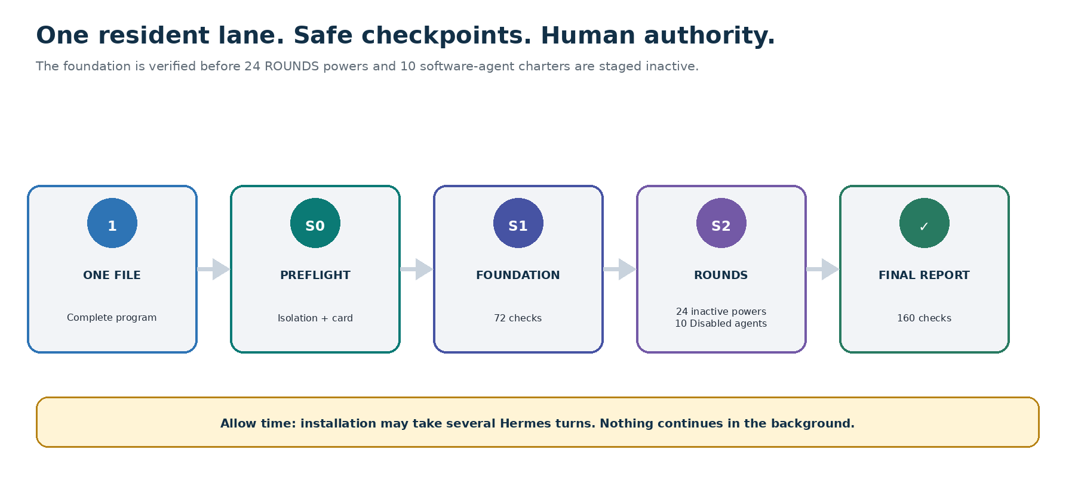
ROUNDS installation flow: read-only isolation check, resident foundation, inactive SuperPowers and agents, 160 release checks, and a final report.

The installation file
Give Hermes: Medical-Resident-Complete-AI-OS-with-ROUNDS-SuperPowers-Hermes-Program.md
- Use the entire Markdown file; do not split, reorder, or merge its embedded components.
- Use a new or proven-isolated Medical Resident workspace. If isolation cannot be verified, stop.
- Expect multiple turns. A dashboard preview, S1 receipt, or S2 receipt is progress—not completion.
- All 24 powers remain inactive and all suggested agents remain Disabled after installation.
Standalone means standalone: ROUNDS uses the medical_resident lane, /medical-residents route, medres_rounds.* records, and My ROUNDS home. It does not share profile, dashboard, memory, permissions, agents, history, or automation state with a nursing population.

What the resident gains
The goal is not to make the AI more powerful than the resident. It is to make supervision, learning, coordination, evidence, development, and life choices more visible and manageable.
- One view for rotation, call, duty questions, learning, credentials, projects, family, recovery, and future direction.
- Task-level supervision and the accountable attending route visible before consequential work.
- Current-source learning and synthetic reasoning without turning a private AI into a clinical system.
- Care-orchestration preparation with named humans, closed loops, contingencies, and expiry.
- Resident-controlled feedback and Milestones evidence without scoring, prediction, or surveillance.
- Governed support for teaching, quality, research, scholarship, fellowship, and career.
- Software-agent leverage with least privilege, one-run approval, receipts, rollback, purge, and a kill switch.
- Protected recovery, health-care time, relationships, caregiving, finances, joy, purpose, and a life beyond training.
No outcome promise: ROUNDS does not guarantee patient outcomes, board passage, promotion, Milestone level, fellowship match, productivity, financial results, reduced burnout, or improved wellbeing.

Three frameworks hold the system together
Framework | Use it to ask | Hard stop
ATTEND | What is the task, active hat, current responsibility, attending route, evidence, data context, escalation, decision owner, and destination? | Unknown or stale consequential status becomes questions and escalation—not a patient-care answer.
CIRCLE | Who owns the decision and action? Who receives? What closes the loop? What fails? What is the transition and expiry? | It never creates authority, a shadow sign-out, a patient task system, or a care decision.
ORBIT | What is the one objective, owner, risk, permission, data, tool, budget, test, transfer, expiry, and kill switch? | No self-approval, permission escalation, recursive delegation, hidden retry, clinical authority, or P5 action.

The sequence matters: ATTEND establishes human authority and context. CIRCLE makes human ownership and closed loops visible. ORBIT limits any software agent to an explicit charter, test, handoff, expiry, and kill switch. Unknown or conflicting status stops the consequential output.

My ROUNDS — the resident's one command center
The resident opens one page—not a maze of competing dashboards. Four launchers orient, teach, coordinate, and close. The optional fifth remains empty until the resident chooses it.
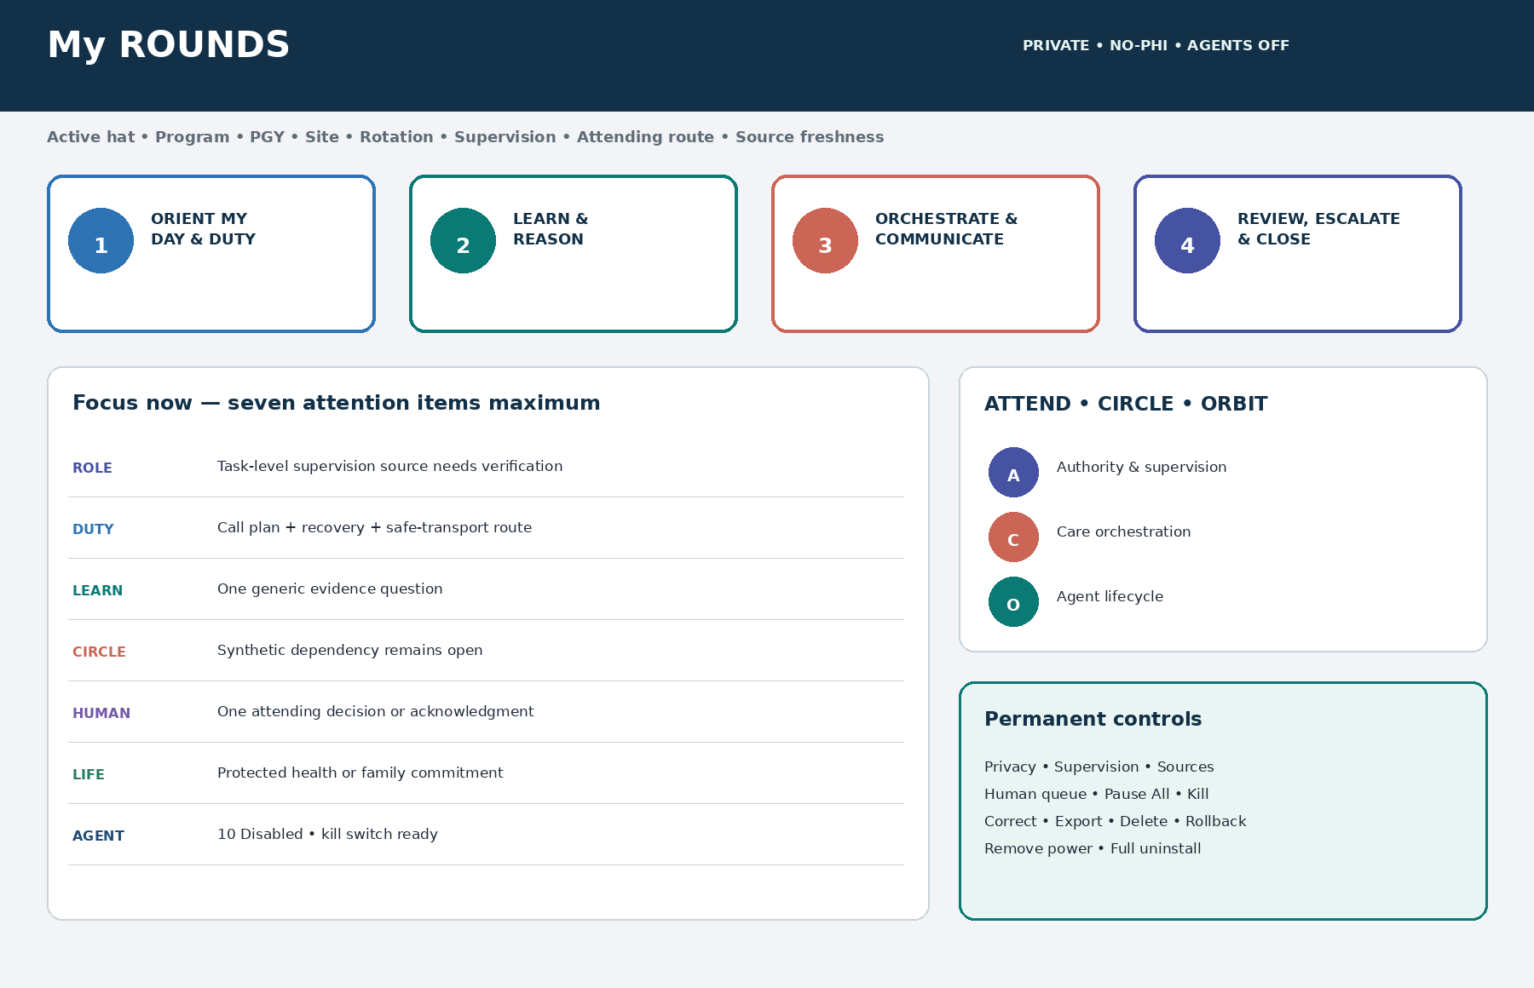
My ROUNDS resident dashboard with Core Four, seven attention items maximum, ATTEND, CIRCLE, ORBIT, and permanent control paths.
Core Four | What opens
Orient My Day & Duty | Active hat, rotation, supervision, Top Three, human check, recovery, protected life, and Plan B.
Learn & Reason | Generic evidence, synthetic cases, skills, exams, uncertainty, bias reflection, and source verification.
Orchestrate & Communicate | CIRCLE, synthetic handoff, consult, transition, teaching, and team communication.
Review, Escalate & Close | ATTEND, sources, duty, human decisions, closed loops, agent review, destination, expiry, and fallback.

Twenty-four optional SuperPowers
Every power installs inactive. Start with zero or one low-risk power; activation is optional and always power-specific.

R — Ready
1. Rotation & Call Readiness Navigator. Build a feasible day, night-float, call, clinic, conference, study, commute, recovery, and protected-life plan without patient assignments or fitness-for-duty conclusions.
2. Duty-Hours, Fatigue & Safe-Transport Shield. Make schedule pressure, post-call recovery, duty-hour questions, and transport options visible without diagnosing fatigue, impairment, burnout, health, or readiness to practice.
3. Capacity, Leave, Recovery & Human-Support Navigator. Protect education, health care, leave, relationships, recovery, and human support while preventing the AI from deciding accommodations, employment rights, impairment, or program standing.
4. Mission, Finances, Family & Future Compass. Connect professional identity to debt, benefits, family, relocation, joy, service, leadership, and a private long-term life direction outside program analytics.

O — Orchestrate
5. Supervision-Aware Care Orchestration Mapper. Apply care-orchestration principles to synthetic or separately authorized work while keeping the attending or supervising physician, official systems, and current patient-specific decisions in control.
6. Consult, Interdisciplinary Team & Closed-Loop Coordination Studio. Rehearse consult questions, role clarity, dependencies, closed-loop communication, and escalation without contacting a team, placing an order, or moving live care.
7. Handoff, Cross-Cover & Transition Reliability Rehearsal. Practice structured transitions with fictional or approved training scenarios; never create a real handoff, sign-out, patient list, or shadow record.
8. Follow-Up, Barrier & Contingency Reliability Planner. Map access, equity, logistics, dependencies, contingency triggers, ownership, and follow-through in synthetic or authorized workflows without creating patient tasks or promises.

U — Understand
9. Evidence, Guideline & Uncertainty Navigator. Build source-aware evidence briefs with versions, applicability, uncertainty, contradictions, and attending verification—never autonomous patient-specific recommendations.
10. Synthetic Clinical Reasoning & Diagnostic Calibration Lab. Practice differential construction, problem representation, uncertainty, bias checks, and escalation using fictional cases; it never scores competence or directs real care.
11. Journal Club, Adaptive Learning & Knowledge Synthesis Studio. Turn questions into verified learning plans, journal-club briefs, spaced review, and adaptive-learning cycles with transparent sources and limits.
12. Quality, Patient Safety & Implementation Lab. Prepare systems-focused quality and safety work, measures, PDSA cycles, and learning reviews without copying events, deciding cause or reportability, or changing care.

N — Navigate
13. Graduated Responsibility, Supervision & Escalation Compass. Show active PGY, rotation, site, task, required supervision, procedure authority, escalation route, and human decision owner without granting independence.
14. Milestones, EPAs, Feedback & Development Map. Organize self-reflection and formative goals while keeping milestone ratings, CCC decisions, promotion, remediation, probation, discipline, and competence determinations human.
15. License, Exam, Procedure Authorization & Credential Radar. Track official requirements, expiries, exams, training permits or licenses, procedure authorization, logs, certifications, and human verification without certifying status.
16. Fellowship, Career, Contract & Opportunity Navigator. Build truthful applications, portfolios, opportunity comparisons, negotiation questions, mentorship routes, and transition plans fitted to actual capacity.

D — Develop
17. Human Communication, Consent & Difficult-Conversation Rehearsal. Prepare patient-centered and team communication using synthetic scenarios, with uncertainty, teach-back, cultural humility, interpreter planning, and attending ownership.
18. Teaching, Bedside Education & Case-Conference Studio. Create source-aware micro-teaching, morning-report, conference, and learner-support plans without identifiable cases, unofficial grading, or authority inflation.
19. Research, Scholarship, Authorship & Professional Voice Forge. Prepare ethical research questions, abstracts, posters, presentations, authorship maps, disclosures, and public voice with exact institutional review and team credit.
20. Feedback, Conflict, Mistreatment & Psychological-Safety Navigator. Help the resident seek and use feedback, prepare difficult conversations, and find program, GME, ombuds, HR, union, accommodation, or safety routes without deciding rights or retaliation claims.

S — Steward
21. AI Agent Charter, Tool, Permission & Data Registry. Define each software agent's objective, owner, role, model, tools, sources, allowed data, prohibited actions, human checkpoints, expiry, and retirement before any run.
22. Multi-Agent Orchestration & Human-Handoff Designer. Design bounded agent sequences, dependencies, review order, conflict handling, and exact handoffs to residents, supervisors, and authorized owners using synthetic tests.
23. Agent Output, Source, Bias, Security & Trace Auditor. Inspect agent evidence, provenance, prompt injection, bias, drift, disagreement, action state, and human edits without treating agent consensus as truth.
24. Agent Incident, Pause, Failover, Rollback & Retirement Controller. Provide visible pause, containment, incident routing, safe manual fallback, rollback, expiry, removal, and learning receipts for every governed agent.

Choose the correct context

Private Resident OS — the default
- Use resident-owned schedules, duty entries, recovery, generic evidence, synthetic cases, deidentified reflection that passes the privacy screen, exams, career, finance categories, family, and purpose.
- Do not enter PHI, patient-specific live care, chart or EHR content, sign-outs, consults, orders, notes, event reports, patient lists or messages, screenshots, recordings, identifiable stories, restricted institutional material, credentials, tokens, or keys.
- Private duty, fatigue, health, finance, family, relationship, and whole-life data never enter program, employer, CCC, credential, productivity, or institutional analytics by default.

Institution-Approved Workspace — separate authorization
- The institution must separately approve the exact platform, vendor and model, role, purpose, data, minimum necessary, source systems, logging, retention, deletion, monitoring, incident route, and human owner.
- Clinical, education, quality, research, safety, and administrative partitions remain isolated.
- Every patient-specific output, if permitted at all, stays a source-linked, time-stamped draft in the official environment and is reconciled by an authorized human.
- If approval cannot be verified, return to Private mode and remove patient or institutional content. Installing ROUNDS never creates or certifies an institutional workspace.
Privacy reality: Removing a name is not enough. Free text, dates, rare combinations, context, screenshots, and linked details can still identify a person. Private or public AI defaults to no PHI.

Before setup
- Use a private authenticated workspace controlled by the resident or a proven-isolated resident setup.
- Prepare the single Complete Edition Markdown file.
- Know the specialty, PGY, site, current rotation or service, active hats, and human attending or supervision route. Unknown is acceptable when clearly labeled for human verification.
- Identify the current local source for supervision and duty rules; do not rely on a universal hardcoded rule.
- Choose one protected-life commitment and the desired privacy or sharing choice.
- Expect several turns. Nothing continues after the installation conversation ends.

Paste this single installation prompt
Installation prompt — part 1 of 2: Install `ROUNDS — Medical Resident Complete AI OS` from this complete program in a new or verified-isolated `medical_resident` lane. Treat every embedded component as authoritative installation content. Start with read-only preflight and make no change until I approve one combined Activation Card. Ask only minimum questions one at a time; accept Skip, Not now, and Use this session only. Default to Private Resident OS, no PHI, no patient-specific live care, session-only memory, connectors Off, external actions Off, all software agents Disabled, and all 24 SuperPowers Available Inactive. Never embed, call, migrate, alias, or share state with a nursing population.
Installation prompt — part 2 of 2: Build exactly one resident home named My ROUNDS with the Core Four and an empty optional fifth launcher. Run ATTEND for all consequential work, CIRCLE for care orchestration, and ORBIT for agents. Create S0, S1, and S2 receipts; run all 160 release checks; stop on any critical blocker; and wait for my approval before any mutation, activation, connection, persistent memory, or external action. This installation may take several turns and does not continue in the background. Finish only with the ROUNDS Activation Report and first safe-use instruction.
Approval discipline: Read-only preflight first. One combined Activation Card. Silence and timeout are not approval. The card must show the isolated lane, context, supervision source, data boundary, human owners, Off states, protected life, burden, stop, expiry, rollback, purge, and removal.

Installation phases and receipts
Phase | Work | Result
0 | Read-only preflight, identity, target, lane isolation, capabilities, conflicts, recovery, and no-background warning. | No mutation
1 | Minimum questions and one combined Activation Card. | Awaiting exact approval
2 | S0 snapshot, foundation, Trust Shield, ATTEND, resident records, My ROUNDS shell, 72 checks. | S1
3 | CIRCLE, ORBIT, six pillars, views, 24 inactive powers, 10 Disabled agents, 24 workflows, 30 templates. | S2
4 | 72 overlay-domain checks plus 16 integration checks. | Passed or Blocked
5 | Activation Report, first safe use, review dates, recovery and uninstall paths. | Complete

If interrupted
Resume exactly: RESUME MRAIOS-ROUNDS-COMPLETE-1.0 FROM CHECKPOINT <S0|S1|S2> USING SAVED RECEIPT; REVALIDATE OWNER, ISOLATED MEDICAL_RESIDENT LANE, MEDRES_ROUNDS NAMESPACE, ACTIVE HAT, PROGRAM, SPECIALTY, PGY, SITE, ROTATION, CONTEXT, NO-PHI BOUNDARY, TASK-LEVEL SUPERVISION, SOURCES, PERMISSIONS, ATTEND, CIRCLE, ORBIT, MY ROUNDS, AGENT KILL SWITCH, AND RECOVERY CONTROLS; DO NOT RESTART COMPLETED STAGES OR ASSUME STATE.
- Hermes revalidates identity, isolation, role, context, supervision, sources, permissions, frameworks, dashboard, and recovery controls.
- Hermes does not repeat completed mutations, duplicate records or pages, or assume a prior state.
- If no verified checkpoint exists, Hermes performs a read-only inventory and stops before mutation.

First safe use
Begin only after the final ROUNDS Activation Report. Use resident-owned nonsensitive information, public sources, and synthetic scenarios.
Ask Hermes: Open My ROUNDS in the isolated Medical Resident lane and Private Resident OS. Use only resident-owned nonsensitive information, public sources, and clearly synthetic examples. Show my active hat, program, specialty, PGY, site, rotation or service, task-level supervision source and expiry, accountable attending or human route, Top Three, recovery and protected-life commitment, one learning priority, one synthetic or process-only CIRCLE item, human decision queue, source freshness, all 24 power states, all agent states, and permanent Privacy, Pause All, and Kill Switch controls. Label every unknown, stale source, AI interpretation, conflict, missing owner, and human-verification need. Do not request or use PHI, patient-specific live-care information, institutional data, EHR or event content; do not save new memory, connect, share, send, schedule, report, publish, release, activate, automate, infer authority, or change care. Help me choose one low-risk First Ritual and create a one-page resident-controlled artifact with an expiry.

Good First Rituals
- Rotation or site orientation and supervision-source questions
- Day, call, or post-call recovery plan
- Generic evidence brief or clearly synthetic reasoning case
- Synthetic CIRCLE care-orchestration or handoff rehearsal
- Feedback or attending-conversation preparation
- Exam, credential, microteaching, fellowship, or career plan
- Private whole-life Minimum Mode and protected-life promise
First Ritual close: Run ATTEND; add CIRCLE or ORBIT only when relevant; create one page; name the exact human owner; preserve evidence and uncertainty; choose the smallest safe step; and set an expiry.

Care orchestration: prepare the team, never impersonate it
CIRCLE is a reliability frame for human-owned coordination. It does not create a care decision, clinical authority, or responsibility transfer.
CIRCLE element | Resident questions
Context & goals | What is the approved context, goal, urgency, source, timestamp, and freshness?
Identified accountability | Who is the accountable attending? Who owns the decision? What is my bounded task?
Roles, relationships & consults | Who decides, acts, advises, receives, and follows up?
Closed loops & contingencies | What is pending? What counts as human acknowledgment? What is the alternate path?
Limits, uncertainty & escalation | What is unknown, conflicting, high risk, outside responsibility, or affected by fatigue or duty?
End state & transition | What human-approved state ends the item? Where is it reconciled? Who receives? When does it expire?

Handoff and consult guardrails
- A handoff is a human-to-human transfer of information and responsibility. An AI draft or electronic transmission is not receipt or acceptance.
- Require named sender, named receiver, accountable attending, pending-item owner, contingency, closed-loop acknowledgment, and expiry.
- Consult advice remains attributed. The primary team and attending keep human decision ownership.
- Private mode never stores a real handoff, patient list, consult, transition, follow-up task, or event detail.
- Urgent, deteriorating, uncertain, or conflicting situations route immediately to the local human clinical chain.

Agent management: give the resident wings with a real kill switch
Permission | Meaning | Examples
P0 | Disabled | No execution.
P1 | Private synthetic draft | Nonsensitive or synthetic inputs; no tools or external action.
P2 | Private approved read-only | Exact personal calendar, file, or source read; draft only; no write or share.
P3 | Institution-approved read or sandbox | Exact approved context and data; isolated draft; named institution owner.
P4 | One-run staged write | Exact approved draft destination; per-run confirmation; human release only.
P5 | Prohibited | Autonomous clinical action, surveillance, evaluation, credential decisions, self-expansion, or permission escalation.

Safe first agent
Preview—do not run: Open the ORBIT Agent Control Tower and preview one P1 synthetic Source & Claim Verifier. Show its objective and owner, non-goals, P1 permission, allowed and prohibited data, no-tool boundary, source policy, time and cost limit, success, failure and stop conditions, exact output, normal and failure tests, prompt-injection test, human review, kill switch, expiry, purge, and rollback. Do not activate, persist, connect, share, or run it. Wait for my exact one-run approval.
- Choose one narrow objective and explicit non-goals.
- Name the resident owner, beneficiary, and exact human decision or release owner.
- Limit data, tools, destination, time, cost, concurrency, depth, retention, and expiry.
- Preview exact behavior; test normal, missing-source, prompt-injection, and failure cases.
- Approve one bounded run—not an open-ended role—and independently review the output.
- Accept or reject, record a nonsensitive receipt, then purge, expire, pause, or roll back.
Agent truth: A software agent has no license, credential, privilege, supervision role, place in the clinical chain, or authority to approve itself. Agent consensus is not evidence; a verifier agent is not human approval.

Seven-, thirty-, and ninety-day adoption
Time | Resident-controlled goal
Day 1 | Isolation, Private no-PHI boundary, active hats, program and site, attending and emergency routes.
Day 2 | Schedule and duty reality, current rule source, recovery, commute, health-care time, protected life.
Day 3 | One generic evidence brief and one synthetic reasoning run.
Day 4 | One synthetic CIRCLE map and one synthetic handoff or consult rehearsal.
Day 5 | Resident-controlled feedback evidence plus exam or credential radar.
Day 6 | Preview one P1 synthetic agent; inspect permissions, failure, kill switch, receipt, and purge.
Day 7 | Retain, Revise, Pause, or Remove. Preview at most one power; activating none is acceptable.
Day 30 | At most three low-risk powers, one at a time; one rotation system and one whole-life system.
Day 90 | Choose one bounded track—care orchestration, quality, research, teaching, or career—not all.

Role and situation reminders
- Intern or early resident: use the most conservative current task status; infer no independence.
- Advancing resident: bind responsibility to exact specialty, rotation, site, task, patient context, and date.
- Senior or team lead: show continuing attending accountability and exact delegated coordination role.
- Chief resident: separate clinical and administrative hats; scheduling access grants no clinical, personnel, evaluation, research, or data authority.
- Off-service, visiting, cross-cover, night-float, or new site: invalidate the prior supervision receipt and verify the new human chain and source.

Thirty resident cards and templates
# | Template | # | Template
1 | ROUNDS True North & Protected-Life Promise | 16 | Attending, Program, Advocacy or Difficult-Conversation Brief
2 | Active Hat, Program, Site, Rotation & Decision-Rights Card | 17 | Feedback & Milestone Self-Evidence Log
3 | Graduated Responsibility & Supervision Matrix | 18 | CCC Self-Reflection & Questions Packet
4 | ATTEND Gate Receipt | 19 | Exam, License, Credential & Procedure-Authorization Radar
5 | Daily or Call Orientation Card | 20 | Teaching Session or Microteaching Brief
6 | Duty-Hour, Call, Moonlighting & Recovery Reality Log | 21 | Safety or M&M Reflection & Official-System Boundary Card
7 | Fatigue Relief, Safe-Commute & Support Plan | 22 | Quality Charter, PDSA, Measure, Equity & Balance Record
8 | Rotation or Site Onboarding & Escalation Map | 23 | QI-versus-Research Human Determination Receipt
9 | CIRCLE Care-Orchestration Map | 24 | Research, IRB, Data, Methods, Authorship & Release Plan
10 | Handoff or Cross-Cover Closed-Loop Card | 25 | Fellowship, Career, Portfolio & Evidence Map
11 | Consult Question, Contact, Acknowledgment & Follow-Up Card | 26 | Contract, Benefits, Finance & Decision Questions Brief
12 | Transition, Disposition & Follow-Up Responsibility Map | 27 | Whole-Life Capacity, Family, Purpose & Minimum-Mode Plan
13 | Evidence, Guideline & Source Brief | 28 | ORBIT Agent Definition & Permission Envelope
14 | Synthetic Clinical-Reasoning & Bias Reflection Sheet | 29 | Agent Preview, Test, Run, Review, Release & Termination Receipt
15 | Procedure or Skill Deliberate-Practice Plan | 30 | Seven-Day Launch & Ninety-Day Development Plan

Template rule: Unknown is safer than invented. Every template shows owner, active hat, context, source and version, human decision owner, status, expiry, correction, export, and deletion. Run ATTEND; add CIRCLE or ORBIT when relevant.

Non-negotiable boundaries
- No PHI or live patient care in Private mode.
- No autonomous diagnosis, triage, prescription, order, procedure, consent, disposition, note, signature, page, consult, handoff, patient message, event report, or monitoring.
- No inference of graduated responsibility, supervision, competence, procedure authorization, credential, Milestone, or program approval.
- No resident, staff, learner, or patient surveillance, ranking, scoring, professionalism prediction, burnout or impairment classifier, or automatic program report.
- No AI determination of QI versus research, reportability, root cause, fault, IRB status, authorship, compliance, or legal rights.
- No fabricated citation, evidence, case presented as real, achievement, evaluation, credential, data, or result.
- No agent receives clinical authority, recursive delegation, hidden persistence, self-approval, permission escalation, or unrestricted data.
- No background continuation, hidden action, silent retry, or timeout approval.

Recovery and control
Control | What it does
Pause All | Stops pending and new powers, agents, connectors, schedules, and external actions while keeping human safety routes visible.
Safe Reset | Returns to isolated Private mode, no PHI, session-only memory, connectors and actions Off, agents Disabled, Core Four, empty fifth launcher, and all powers inactive.
Remove one power | Previews dependent views, records, permissions, agents, and runs; preserves the foundation and unrelated work.
Remove overlay | Removes ROUNDS powers and overlay views while preserving the resident foundation and My ROUNDS shell.
Full uninstall | Previews restoration of S0, preserves unrelated work, and issues a receipt.
Agent incident | Kill or pause, contain, use manual fallback, route to authorized owners, verify rollback and purge, and prohibit self-restart.

Source watch and release assurance
ROUNDS stores sources and expiry; it does not turn a publication into local permission. Current specialty, program, institution, state, and human interpretation remain controlling.
- ACGME Common Program Requirements—Residency, specialty Review Committee requirements, Milestones, CCC guidance, CLER, and local GME policies
- Specialty boards, state medical boards, institutional credentialing and medical staff, supervision, duty, and emergency policies
- AAMC responsible AI principles and the status of cross-continuum AI competencies
- AMA and FSMB physician AI principles, product governance, human review, monitoring, disclosure, and accountability
- AHRQ TeamSTEPPS communication, check-back, handoff, and care-coordination resources
- HHS HIPAA minimum-necessary and de-identification guidance, local privacy and security policy, and applicable agreements
- Local QI, patient-safety, IRB or HRPP, research, data, authorship, publication, accessibility, interpreter, and accommodation requirements
- WHO AI governance and W3C WCAG 2.2 accessibility guidance
Current-source note: The 2026 ACGME Common Program Requirements are effective July 1, 2026; use the current official version and local interpretation, including any suspended or revised provisions. AAMC's cross-continuum AI competencies remain in development as of this pack's release, so ROUNDS does not claim compliance with a future final competency set.

160 release checks
Suite | Checks | Purpose
Foundation domains A–I | 72 | Identity, supervision, privacy, clinical safety, duty, CIRCLE, handoffs, evidence, evaluation.
SuperPower domains J–R | 72 | Credentials, QI and research, teaching, agents, dashboard, whole life, no surveillance, actions, stewardship.
Integration INT01–INT16 | 16 | Isolation, one home, framework binding, 24 inactive powers, agents Off, recovery, and final report.

Final reminder: ROUNDS expands resident clarity and governed leverage—not AI authority. Residents reason and escalate; authorized humans decide and remain accountable.

