ONE-FILE GUIDED LEARNING & FUTURE-READINESS PACK
Nursing Student & Nursing Assistant
Complete AI OS with FUTURE SuperPowers
Setup, Benefits, and First-Use Guide
Core promise: Build the judgment, learning habits, technology fluency, career evidence, and human courage needed for nursing's next era—without giving up authorship, privacy, dignity, or accountable human guidance.
Please allow time: This expanded installation may require several Hermes turns. Nothing continues in the background. Keep the checkpoint receipt and wait for the final FUTURE Complete Edition Activation Report.
Program | Pathways | Starting state
FUTURE Complete Edition | Student • Assistant • Bridge | Private • Synthetic • Preview

Version 1.0 • July 2026 • Learner-controlled

One file, one guided setup
The foundation, role pathways, AI Literacy Passport, FUTURE Library, dashboard, safeguards, and tests are merged into a single Hermes program.
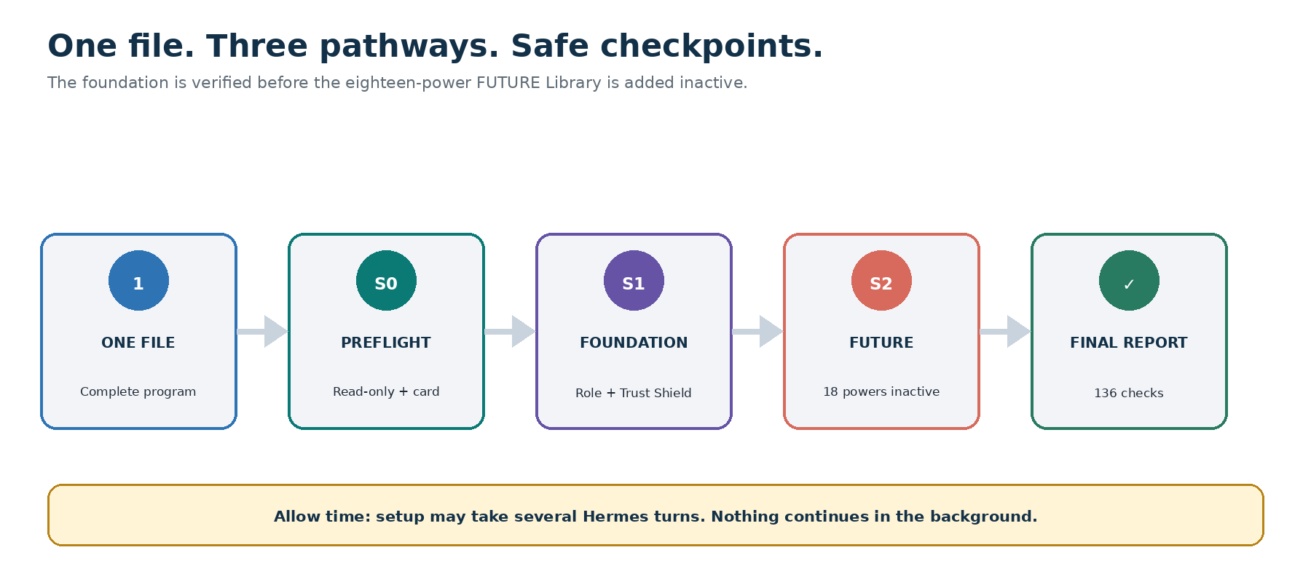
One-file installation with read-only preflight, foundation and expansion checkpoints, eighteen inactive powers, 136 checks, and final activation report.

The installation file
Give Hermes: Nursing-Student-and-Assistant-Complete-AI-OS-with-FUTURE-SuperPowers-Hermes-Program.md
- Use the entire file; do not split its embedded components.
- Use a private authenticated workspace owned by the learner.
- Select Student, Nursing Assistant, or Bridge. Hermes must not infer scope from a title.
- Expect multiple turns. A dashboard preview is not completion.

Choose the right pathway
Pathway | Designed for | Authority that remains human
Nursing Student | Coursework, active learning, fictional simulation, NCLEX preparation, professional identity | Faculty, program, clinical site, preceptor, assessment policy
Nursing Assistant | Role knowledge, certification review, communication, career growth, work-life capacity | Employer, supervising nurse, supervisor, verified role and delegation policy
Bridge | An assistant who is also pursuing nursing education | Both authority chains; school and employment contexts remain separate

Role rule: A title does not prove authority, scope, competence, or permission. Unknown local rules are labeled Unverified and routed to the appropriate human.

FUTURE gives learners a runway
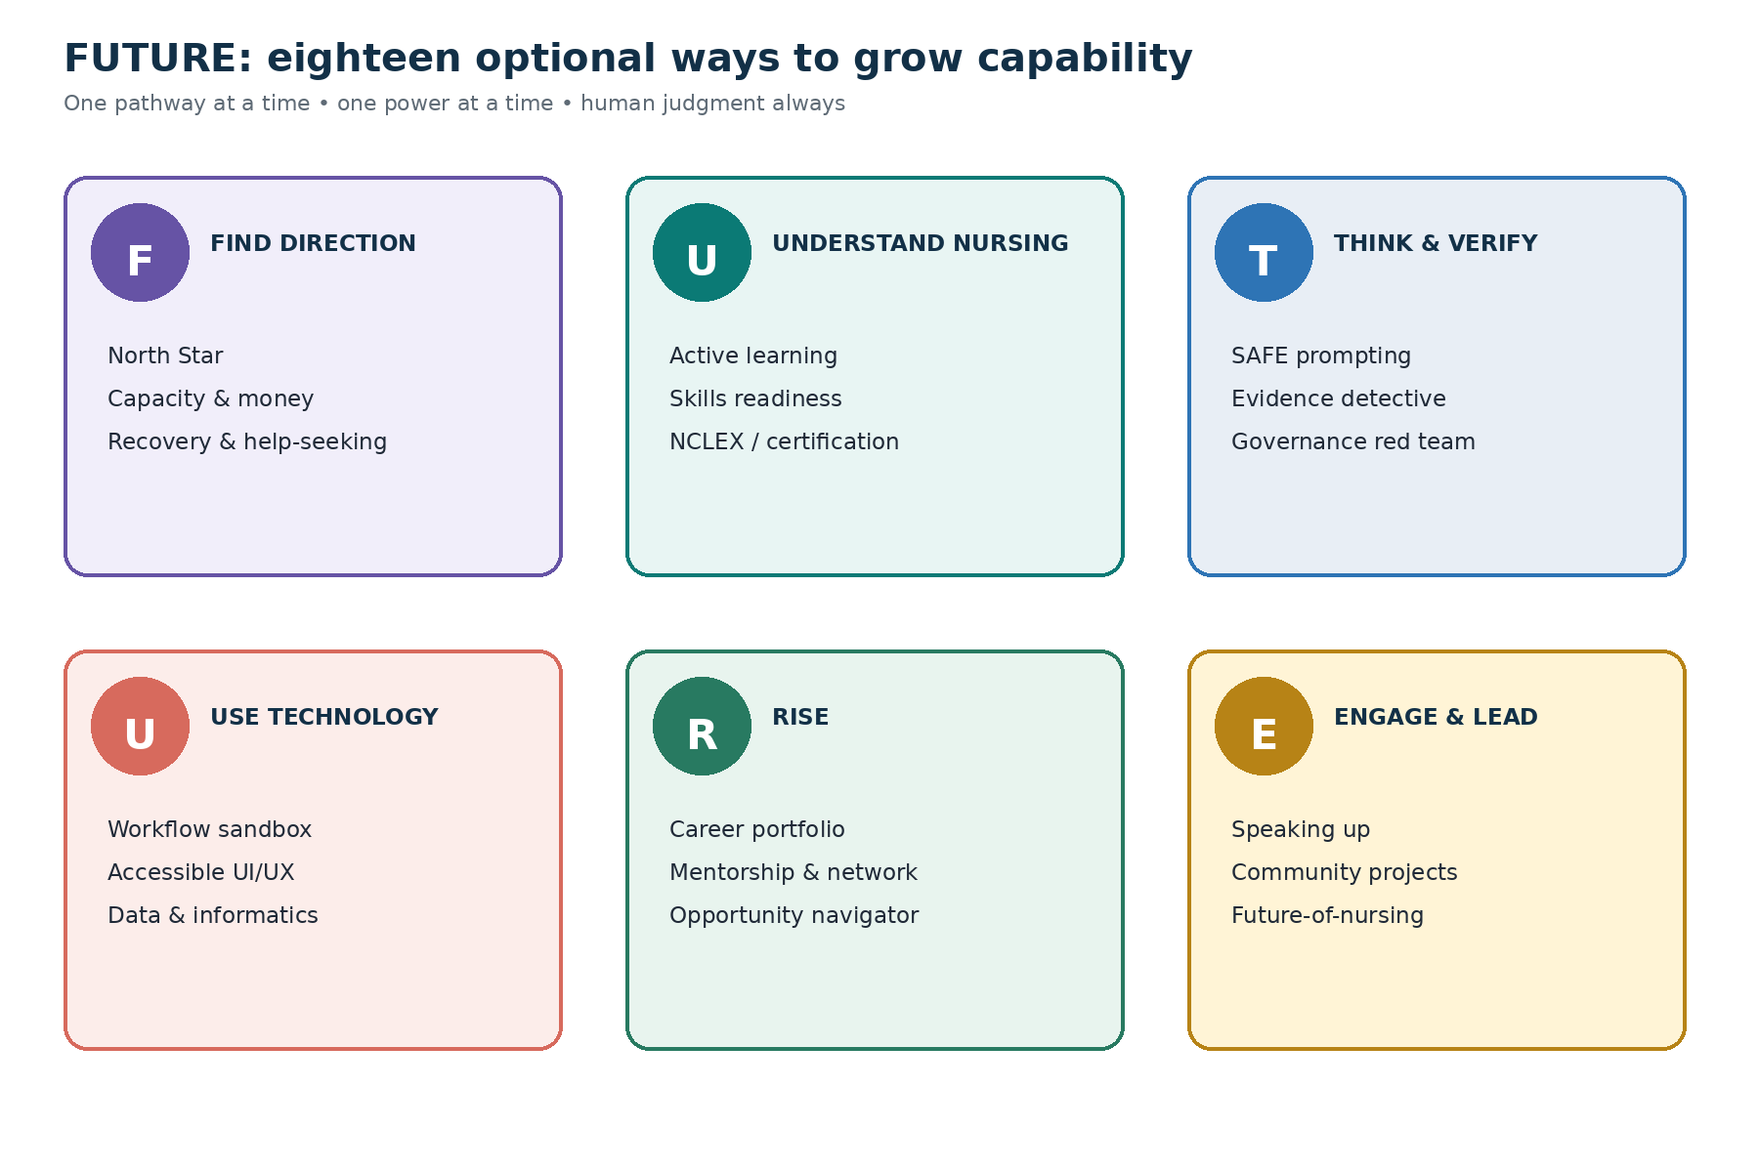
Six FUTURE growth systems with three optional powers each; all eighteen are inactive after installation.

The six systems
- F — Find direction and protect capacity.
- U — Understand nursing and learn deeply.
- T — Think, verify, and use AI ethically.
- U — Use technology to create and improve safely.
- R — Rise professionally and economically.
- E — Engage leadership, community, and future impact.

Eighteen optional SuperPowers
System | Powers | Capability built
F | North Star • Capacity, money & logistics • Recovery & help-seeking | Direction that fits a real life
U | Active learning • Skills readiness • NCLEX/certification | Durable knowledge and supervised readiness
T | SAFE prompting • Evidence detective • Governance red team | Judgment before speed
U | Workflow sandbox • Accessible UI/UX • Data & informatics | Safe creation and technology fluency
R | Career portfolio • Mentorship & network • Opportunity navigator | Truthful evidence and mobility
E | Speaking up • Community projects • Future-of-nursing explorer | Leadership, service, and responsible innovation

Adoption pace: Activate no more than one optional power in the first week. Keep a power only if it builds independent capability and creates more value than burden.

What users gain

For nursing students
- A whole-life plan that coordinates school, clinical, work, family, commute, sleep, money, and recovery.
- Retrieval practice, teach-back, fictional scenarios, misconception repair, and role-appropriate exam preparation.
- Academic-integrity coaching that preserves authorship and makes AI use visible.
- Truthful portfolio, résumé, interview, scholarship, mentorship, and career-path evidence.
- Guided exploration of informatics, robotics, data, genomics, education, public health, entrepreneurship, and responsible AI.

For nursing assistants
- Private support for certification learning, role knowledge, professional communication, and work-life capacity.
- A safe bridge-to-nursing or career-development map based on verified requirements.
- Speaking-up, feedback, boundary, teamwork, mentorship, and interview rehearsal using generic scenarios.
- Technology and workflow practice outside patient care and restricted employer systems.
- A truthful record of service, learning, leadership, and future aspirations—never a hidden employer score.
No guarantee: FUTURE does not promise grades, exam results, certification, employment, clinical competence, patient outcomes, financial return, or wellbeing outcomes.

One Command Center
Core launcher | What it helps the user do
Plan My Next Move | Choose Today's Top Three, protect capacity, and create minimum or re-entry mode.
Learn & Practice | Retrieve, teach back, rehearse fictional scenarios, and prepare human questions.
Check It with SAFE AI | Classify data and authority, verify sources, inspect bias, and create an integrity receipt.
Build My Future | Develop portfolio evidence, pathways, opportunities, mentorship, community, and the 90-day plan.

- The optional fifth launcher stays empty.
- Permanent Privacy, Context, Rules, Sources, Disclosure, History, Pause, Reset, Export, Delete, Rollback, and Uninstall controls remain visible.
- Focused view shows no more than seven attention items and clearly labels synthetic, stale, unknown, and AI-interpreted content.

Learn AI by practicing judgment

The SAFE habit
Step | Question
Situation | What minimum low-risk context is necessary?
Aim | What do I want to learn, practice, decide, or create?
Facts | Which verified, non-sensitive facts and sources may be used?
Expectations | What limits, uncertainty labels, verification, human review, and next learner action are required?

Truth rule: Model output is a draft or hypothesis until verified. Confidence is not evidence, and a recommendation is not a decision.

AI Literacy Passport
- Privacy and data judgment
- SAFE prompting
- Source verification
- Fairness and integrity
- Human authority and escalation
- Workflow design and recovery
Explorer → Safe User → Verified Creator → Workflow Builder → Future Steward
Passport boundary: The Passport is a private developmental record. It is not licensure, certification, faculty validation, employer assessment, or proof of clinical competence.

Technology creation without unsafe shortcuts
- Prototype dashboards, apps, task flows, study systems, and low-risk workflows with synthetic information.
- Map trigger, input, owner, approval, output, failure, manual fallback, and rollback before considering automation.
- Run accessibility, fairness, privacy, burden, and affected-person checks.
- Require three supervised successful uses before a low-risk reminder or workflow becomes eligible for monitored operation.
- Never cross the clinical, academic, employment, financial, or public-action authority ceiling.

Non-negotiable Trust Shield
No PHI: Never upload patient names, screenshots, chart excerpts, recordings, room-linked narratives, identifiable stories, rare detail combinations, or live-patient questions.

The system must not
- Direct real-patient care, interpret live patient data, authorize a skill, recommend medication administration, set a device, make an assignment, determine scope or competence, or create shadow documentation.
- Take an exam, complete prohibited assessed work, conceal AI involvement, or fabricate citations, hours, competencies, reflections, experiences, credentials, or signatures.
- Ingest restricted student, worker, disciplinary, grievance, accommodation, health, investigation, peer-review, incident, credential, or security information.
- Score, rank, surveil, profile, infer attitude or mental health, predict success, or report private data to school or employer.
- Send, submit, schedule, purchase, post, share, connect, remember, or automate without exact preview and approval.

If sensitive information appears
- Stop processing the affected content.
- Do not repeat or summarize it.
- Prevent further use or retention where controls permit.
- Show deletion and activity controls.
- Use the authorized faculty, clinical-site, supervisor, privacy, security, HR, compliance, or incident-response route.

Installation prompt
Copy into Hermes after attaching the full program: Install Nursing Student and Nursing Assistant Complete AI OS with FUTURE SuperPowers v1.0 from this entire file in Guided Complete Setup mode. Treat this Complete Edition orchestration as the controlling installation sequence and the embedded components as its governing runtime. Begin with a read-only owner, pathway, context, privacy, academic-integrity, clinical-authority, employer-authority, permission, version, and compatibility preflight. Ask the minimum questions one at a time and present one combined FUTURE Complete Edition Activation Card. Wait for my approval before applying changes. Install or verify the FUTURE Foundation first, run its 24 tests, then add the eighteen-power FUTURE Library as an inactive overlay and run all 96 overlay tests and 16 integration checks. Default to Synthetic Demonstration Mode. Do not ingest PHI, patient stories, screenshots, chart content, live-care questions, restricted student or employee information, exams, passwords, credentials, or confidential school/employer information. Do not complete prohibited assessed work, fabricate sources or experiences, decide clinical care, scope, competency, assignment, delegation, employment, discipline, grades, progression, credentialing, or certification. Do not enable connectors, shared access, external actions, new memory categories, or background automation. This substantial installation may take several Hermes turns: show a progress receipt after every phase, never rush or silently skip a check, and if interrupted stop at a safe checkpoint with the exact command to resume.

Installation journey
Phase | Work | Result
0 | Read-only owner, role, context, data, authority, rule, permission, version, and compatibility preflight | S0
1 | Minimum questions and one combined Activation Card | Awaiting approval
2 | Foundation, Trust Shield, role adapters, Passport structure, and 24 tests | S1
3 | FUTURE Library, workflows, templates, and 18 inactive powers | S2
4 | 96 FUTURE tests and 16 integration checks | Passed or Blocked
5 | Activation Report, First Ritual, reviews, and recovery | Complete

Completion rule: Attempted, Partial, Unknown, Awaiting approval, or Blocked is not Complete. Wait for the final Activation Report.

If interrupted
Exact resume prompt: Resume FUTURE Complete Edition installation from the last approved checkpoint. Revalidate the authenticated owner, selected pathway, active context, privacy and no-PHI boundaries, academic and employer rules, clinical and role authority, permissions, component versions, current Command Center, source state, and every critical control. Do not repeat completed mutations, duplicate dashboards or records, transfer information across contexts, enable a connector, share access, save new memory, perform an external action, activate a power or automation, or skip a Failed, Partial, Unknown, or Awaiting-verification test. Show the refreshed progress ledger and continue with the next incomplete phase only. If no verified checkpoint is identifiable, stop and perform a read-only inventory.

First safe use
Open the Command Center: Open my FUTURE Command Center in Focused view using only synthetic or explicitly approved low-sensitivity information. Show my pathway and active context, current season and capacity, Today's Top Three, one learning target, one source or rule needing verification, one human conversation, my AI Literacy Passport next practice, FUTURE Library status, and permanent Privacy and Pause All controls. Label every unknown, estimate, AI interpretation, stale source, and synthetic example. Do not save, send, submit, schedule, purchase, share, post, activate, automate, or change anything. Help me choose one real low-risk study, work-growth, life, career, or community problem for the First Ritual—never patient information or a live assessed task.

Preview—not activate—the first power
Open the FUTURE Library: Open my FUTURE Library and recommend one optional power based on my pathway, active context, 90-day outcomes, capacity, verified authority, and the capability I most need to build. Show its complete activation card, expected workload, data and permission needs, risks, human review, removal plan, and one synthetic preview. Do not activate it, save new information, or perform an external action. Wait for my approval.

Seven-Day FUTURE Launch
Day | Theme | Guided practice
1 | Protect | Select pathway and contexts; learn no-PHI, integrity, authority, and Pause All.
2 | Point | Define North Star, 90-day outcomes, protected-life commitment, and capacity mode.
3 | Learn | Run one retrieval-based study or certification sprint and create a human-question queue.
4 | Verify | Use SAFE, verify two claims, find a limitation, and write an AI-use receipt.
5 | Create | Prototype one synthetic low-risk workflow or accessible dashboard; do not connect it.
6 | Rise | Add truthful portfolio evidence and prepare one mentorship, faculty, or supervisor conversation.
7 | Serve | Design a small consent-based contribution; decide what to retain, revise, pause, or remove.

Humane cadence: Come when you can, skip when you must. One power and one low-risk problem are enough for the first week.

Ninety-Day Future Flight Plan
- One learning or certification outcome
- One career or work-growth outcome
- One protected-life outcome
- One leadership or community outcome
- Minimum, Standard, and Stretch versions
- Reviews at days 7, 30, 60, and 90
Measure capability—not addiction: Track independent capability, verified evidence, time returned, workload, accessibility, human review, and unintended effects—not streaks, screen time, or output volume.

Recovery and control
Control | What it does
Pause All | Stops pending and new workflows without deleting work.
Safe Reset | Returns to synthetic, session-only, no connections, no sharing, no actions, Preview only, Core Four, all powers inactive.
Remove overlay | Removes FUTURE powers and expansion records while preserving the foundation.
Full uninstall | Previews restoration of S0, preserves unrelated work, and reports anything that cannot be restored.

What good looks like after 30 days
- The learner can explain when not to use AI and identify the responsible human.
- Patient and institutional information stays protected.
- SAFE prompts and source verification are normal habits.
- AI assistance, learner authorship, human review, and institution validation remain distinct.
- One safe synthetic workflow or accessible prototype has been built and reviewed.
- The portfolio contains truthful evidence and a realistic next pathway.
- The weekly plan protects capacity and includes a human-support route.
- The learner can describe one responsible contribution to nursing's future.
Final reminder: FUTURE gives learners a runway, not autopilot. Nursing's future still depends on human judgment, compassion, courage, evidence, accountability, and trust.

Release assurance
- 24 foundation tests
- 96 FUTURE overlay tests
- 16 integration checks
- 136 total release checks
- All eighteen optional powers inactive after installation
- One Command Center, one governance model, and one combined activation card

