ONE-FILE PRACTICE, LIFE & QUALITY ENABLEMENT PACK
Staff Nurse & Quality Contributor
Complete AI OS with SHIFT SuperPowers
Setup, Benefits, Boundaries, and First-Use Guide
Core promise: Own your practice. Improve the system. Protect the life beyond the shift. AI may prepare and coordinate; nurses judge and steward; authorized teams approve and own consequential change.
Please allow time: This substantial installation may require several Hermes turns. Nothing continues in the background. Keep every checkpoint receipt and wait for the final SHIFT Complete Edition Activation Report.
Program | Role adapters | Starting state
SHIFT Complete Edition | Direct care • Champion • QI lead • Hybrid | Private • Synthetic • Preview

Version 1.0 • July 2026 • Human-controlled

One complete file, one safe installation
The Staff Nurse Life and Practice foundation and the SHIFT quality expansion are merged into one guided program with one dashboard, one EDENA model, one activation card, safe checkpoints, and one final report.
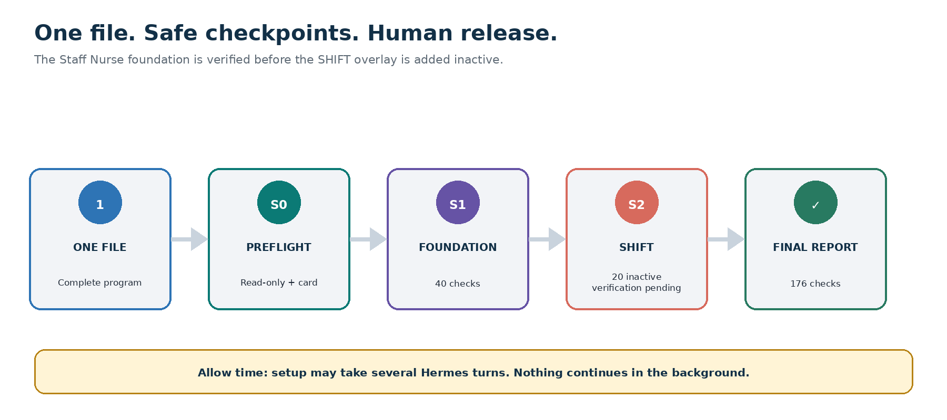
One-file installation with read-only preflight, foundation and SHIFT checkpoints, twenty inactive powers, 176 release checks, and a final human-controlled activation report.

The installation file
Give Hermes: Staff-Nurse-and-Quality-Contributor-Complete-AI-OS-with-SHIFT-SuperPowers-Hermes-Program.md
- Use the entire Markdown file; do not split or reorder its embedded components.
- Use a private authenticated workspace owned by the nurse for the initial install.
- Choose a role adapter and active task-level hat; access, title, or committee membership never proves authority.
- Expect multiple turns. A dashboard preview or progress receipt is not completion.

What this gives the staff nurse

Practice and life
- A realistic shift-cycle plan that protects sleep, commute, meals, recovery, relationships, learning, and a Plan B.
- Private deidentified reflection, communication rehearsal, scope questions, career planning, and whole-life direction.
- A Minimum Mode when workload is high, with simplification and human support instead of a denser plan.

Frontline quality contribution
- Systems-focused problem framing, huddles, process maps, measure definitions, PDSA plans, and governed run-chart sensemaking.
- Visible sponsor, charter, decision rights, data stewardship, QI or research determination, capacity, source, equity, burden, and release gates.
- Truthful quality portfolios, team credit, AI disclosure, and career evidence without inflated claims or borrowed authority.
Expected benefits—not guarantees: The pack is designed to support clarity, follow-through, learning, nurse voice, safer improvement planning, and protected capacity. Measure observed value in a supervised pilot; do not promise patient, quality, career, financial, or wellbeing outcomes.

Choose the correct role adapter
Adapter | May prepare | Cannot assume
Direct-Care Staff Nurse | Personal plans, generic learning, deidentified reflection, communication rehearsal, and improvement-idea preparation | Authority to use employer data, represent the unit, change workflow, direct peers, or launch QI
Unit Champion / Preceptor / Shared Governance | Documented huddle, peer-learning, education, and QI-contributor work | Supervisory, disciplinary, staffing, credentialing, competency-signoff, or peer-ranking authority
Chartered Staff-Nurse QI Project Lead | Sponsor-approved work inside a current charter and documented decision rights | Power to self-authorize data, classify QI or research, alter care or policy, publish, release, or expand scope
Hybrid / Multiple Employer | Work only under the explicitly active task-level hat and employer | Permission transfer between roles, employers, projects, or contexts

Authority rule: Least privilege wins. Unknown, conflicting, or expired authority is Unverified and routes to the named clinical, quality, data, privacy, research, operational, labor, legal, or communication owner.

Keep two contexts separate
Context | What belongs | What must stay out
Private Personal Mode — default | Schedule, recovery, private life goals, generic learning, synthetic templates, deidentified reflection, and private rehearsal | Institutional data, PHI, patient or event narrative, coworker information, restricted work product, employer connection, or real measure export
Institution-Approved Quality Workspace | Only synthetic or explicitly approved aggregate or properly deidentified information for a sponsor-approved charter | Private readiness, fatigue, health, relationships, finances, other projects or employers, unapproved fields, small cells, and unrestricted exports

Provisioning boundary: The Complete Edition does not create or certify an institutional quality workspace. Use that mode only after the organization separately provisions it with role access, sponsor, data-steward receipt, deidentification and small-cell rules, retention, deletion, auditability, and a release owner.
Whole-life privacy: Sleep, recovery, health, relationships, finances, and private life goals may inform the nurse's personal planning only. They never become institutional quality metrics, manager dashboards, exports, staffing or performance inputs, or evidence of project success.

Before using real institutional information
- Run the Institutional Workspace Readiness & Bind workflow: confirm the authorized workspace, employer and project, sponsor, staff-nurse role, exact decision rights, current QI or research human determination, and clinical, operational, privacy, data, and release owners.
- Bind only the data named in a current data-steward receipt. Confirm purpose, operational definitions, provenance, deidentification, approved grouping, small-cell rules, access, retention, deletion, logging, release, and expiry before live data use.
- When an authorized coordination task truly requires it, allow only minimum-necessary business contact metadata—such as name, institutional role, and work contact—inside that institutional mode. Keep it out of measures, surveillance, performance, and the private workspace.
- Return Ready and bound or Blocked / human verification pending. Technical access is never permission, and nothing outside the receipt may be used.

SHIFT gives frontline improvement wings
Pillar | Promise | Four optional powers
S | Safeguard practice, privacy, readiness, and recovery | Shift & Life Readiness Navigator • Fatigue, Recovery & Safe-Transport Shield • Practice Boundary & Escalation Compass • Deidentified Reflection & Learning Loop
H | Humanize teamwork, advocacy, and peer learning | Communication & Advocacy Rehearsal Studio • Team Huddle, Psychological Safety & Systems-Learning Builder • Assignment, Delegation & Speak-Up Question Navigator • Preceptor, Peer-Learning & Difficult-Conversation Coach
I | Improve quality through governed frontline action | Quality Opportunity & System Problem-Framing Studio • Process Map, Standard Work & Reliability Designer • PDSA & Small-Test-of-Change Planner • Measurement, Run-Chart, Equity & Balancing-Measure Sensemaker
F | Flourish in learning, career, wellbeing, and life | Learning, Competency & Credential Growth Map • Quality Portfolio, Certification & Career Catalyst • Workload, Moral-Distress & Human-Support Navigator • Mission, Relationships, Finances & Whole-Life Compass
T | Trust governed AI, authorized data, and reversible automation | QI, EBP, Research & Authority Navigator • Aggregate Data, Provenance & Small-Cell Steward • Responsible AI & Quality-Technology Literacy Lab • Preview-First Automation, Release & Rollback Controller

Starting state: All twenty powers install inactive. Preview at most one during the first week; it cannot self-activate, expand authority, connect systems, share data, save a new memory category, or perform an external action.

The twenty powers at a glance

S — Safeguard
- Shift & Life Readiness Navigator — Top Three, schedule, commute, sleep, meals, recovery, learning, protected-life commitment, and Plan B; never patient assignments.
- Fatigue, Recovery & Safe-Transport Shield — makes recovery and transport risks visible without diagnosing fatigue, impairment, burnout, health, or fitness.
- Practice Boundary & Escalation Compass — prepares scope, source, policy, delegation-question, and human-chain prompts; authorized people decide.
- Deidentified Reflection & Learning Loop — converts experience into general learning without patient, family, coworker, event, chart, timestamp, or rare identifying detail.

H — Humanize
- Communication & Advocacy Rehearsal Studio — observable facts, uncertainty, questions, desired safe outcome, human route, and nurse-voice drafts; no autonomous sending.
- Team Huddle, Psychological Safety & Systems-Learning Builder — systems, teamwork, decisions, and follow-through; never names, rankings, blame, or hidden evaluation.
- Assignment, Delegation & Speak-Up Question Navigator — clarifying questions and escalation paths; never an actual assignment, delegation, competence, or staffing decision.
- Preceptor, Peer-Learning & Difficult-Conversation Coach — micro-teaching, teach-back, boundary, and conflict preparation without unofficial scoring or personnel records.

I — Improve
- Quality Opportunity & System Problem-Framing Studio — a neutral process frame; active events route immediately to care and official reporting.
- Process Map, Standard Work & Reliability Designer — current and proposed future-state options without workarounds or changing live policy or workflow.
- PDSA & Small-Test-of-Change Planner — sponsor, aim, smallest reversible test, prediction, learning question, approvals, stop, fallback, and learning log; planning is not implementation.
- Measurement, Run-Chart, Equity & Balancing-Measure Sensemaker — synthetic or approved aggregate data with definitions, provenance, denominators, missingness, annotations, equity, burden, and limits.

F — Flourish
- Learning, Competency & Credential Growth Map — verified learning and official-check plans without certifying competence, hours, credit, licensure, or fitness.
- Quality Portfolio, Certification & Career Catalyst — truthful evidence maps, posters, presentations, and career plans with exact role, team credit, disclosure, and approvals.
- Workload, Moral-Distress & Human-Support Navigator — burden, protected or paid time, Minimum Mode, and human routes without diagnosis or normalizing off-clock QI.
- Mission, Relationships, Finances & Whole-Life Compass — private purpose and a realistic ninety-day life plan that stays outside employer analytics.

T — Trust
- QI, EBP, Research & Authority Navigator — prepares a human determination request and blocks consequential work while status is unknown.
- Aggregate Data, Provenance & Small-Cell Steward — tracks permission, deidentification, definitions, access, retention, suppression, expiry, and release; refuses reidentification.
- Responsible AI & Quality-Technology Literacy Lab — verification, automation bias, disclosure, prompt injection, synthetic media, bias, workload, and when not to use AI.
- Preview-First Automation, Release & Rollback Controller — exact inputs, actions, destinations, exact per-run approvals, tests, receipts, pause, fallback, and rollback; no clinical, incident, staffing, or surveillance automation.

One embedded Command Center
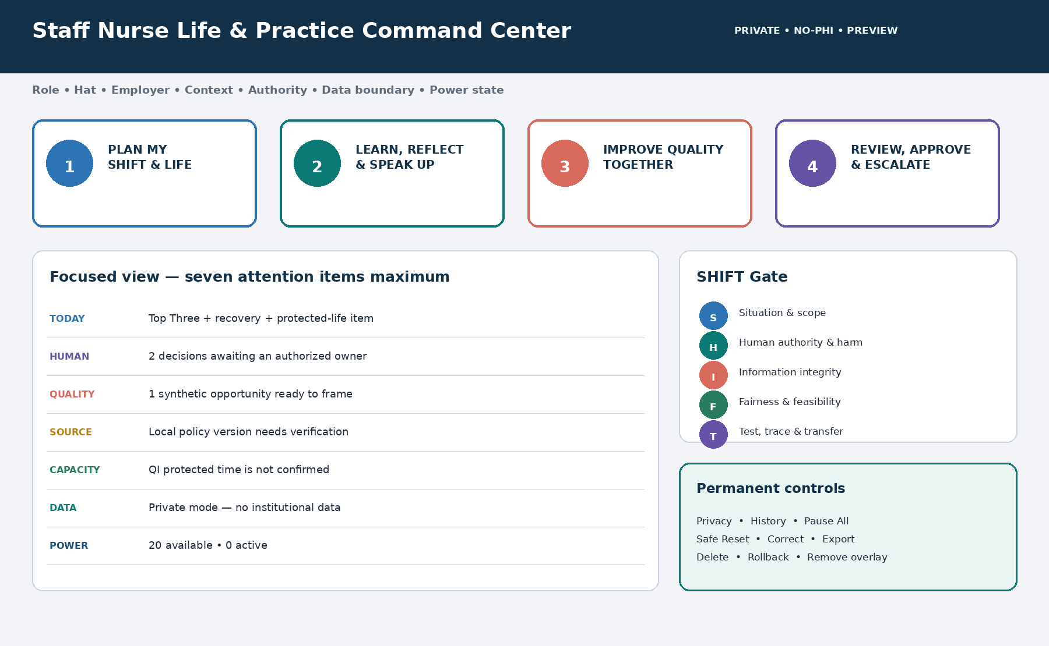
The existing Staff Nurse Life and Practice Command Center is extended—not duplicated—with Core Four launchers, a seven-item focused view, SHIFT Gate, and permanent nurse-controlled safety controls.
Core launcher | Purpose
Plan My Shift & Life | Top Three, fixed commitments, commute, sleep, recovery, meals, learning, protected-life item, and Plan B; no patient assignments.
Learn, Reflect & Speak Up | Generic learning, deidentified reflection, communication rehearsal, scope questions, and the appropriate human route.
Improve Quality Together | Authority and charter check, systems problem frame, process and measure draft, and PDSA preview; never launches change.
Review, Approve & Escalate | Run the SHIFT Gate; show exact human decisions, destination, disclosure, fallback, rollback, and next safe action.

- The optional fifth launcher stays empty until one bounded power is separately previewed and approved.
- Permanent Privacy, Role & Employer, Data Boundary, Sources & Policy, QI or Research Determination, History, Pause All, Safe Reset, Correct, Export, Delete, Rollback, Overlay Removal, and Full Uninstall controls remain visible.
- The opening view has no more than seven attention items. It supports keyboard, screen reader, contrast, zoom, reflow, reduced motion, mobile, print, and Markdown or manual degraded modes.

Use the SHIFT Gate before consequential work
Gate | Release question
S — Situation & scope | What is the exact purpose, role, hat, employer, context, deployment mode, approved charter, scope, and live-safety status?
H — Human authority & harm | Who owns clinical, quality, data, research, privacy, operational, release, and escalation decisions; who may be affected?
I — Information integrity | Is information synthetic or authorized aggregate or properly deidentified; are provenance, definitions, sources, missingness, unknowns, and small-cell risk visible?
F — Fairness & feasibility | Are system language, equity, accessibility, protected capacity, workflow burden, unintended effects, and balancing measures addressed?
T — Test, trace & transfer | What is the smallest reversible preview, exact approval, audience, destination, disclosure, receipt, expiry, fallback, rollback, and removal plan?

Human Work & Quality Standard: Release only accurate, source-aware, locally contextualized, accessible, specific, feasible, decision-useful, visibly human-reviewed work. Remove blame, vague best-practice claims, invented precision, fabricated sources, false causality, inflated impact, vanity metrics, repetitive AI phrasing, faux empathy, and appropriated team credit.

Non-negotiable safety and governance
No PHI or identifiable stories: Never enter identifiers, screenshots, chart excerpts, recordings, handoffs, patient lists, room-linked facts, exact timestamps, event reports, peer-review material, unapproved narrative containing sensitive or identifying detail, or rare combinations that could identify a patient, family member, or worker. Removing a name is not necessarily deidentification.

The system must not
- Provide actual triage, diagnosis, medication, compatibility, device, alarm, treatment, handoff, charting, assignment, delegation, competence, or fitness decisions.
- Delay an active safety, emergency, deterioration, violence, or security concern for QI work; route immediately to the responsible human chain.
- Replace the official event-report, patient record, task, investigation, peer-review, workforce, clinical-monitoring, or staffing system.
- Determine reportability, cause, fault, discipline, corrective action, event closure, compliance, special cause, improvement, or project success.
- Rank, score, predict, profile, or monitor patients or workers, or use information for staffing, discipline, credentialing, compensation, performance, or retaliation.
- Send, post, share, publish, release, connect, pilot, spread, change policy or workflow, or automate without exact preview and exact per-run authorized human approval.

QI, EBP, evaluation, and research
Human determination required: AI never declares work QI, EBP, research, program evaluation, exempt, approved, or outside IRB review. A current authorized local determination controls. Missing, expired, or materially changed status blocks data use, live testing, spread, and dissemination beyond generic planning.

Frontline quality starter menu
- Process reliability: fall prevention, pressure-injury prevention, central-line and urinary-catheter processes, hand hygiene, and medication-safety workflow.
- Team and workflow learning: deterioration or escalation education, handoffs and care transitions, alarm or documentation burden, and workplace or psychological safety.
- Co-design: patient, family, community, and frontline perspectives gathered only through authorized, privacy-preserving human processes.
Starter topics—not protocols: Use synthetic information or a separately authorized institutional project. Current local policy, approved evidence, affected-team input, a sponsor, data permission, and authorized clinical and operational review control. The menu does not authorize care changes.

Installation prompt
Authoritative wording: The Single installation prompt inside the attached complete program is authoritative. The block below mirrors it for convenience; if a later program version differs, use the program's prompt.
Copy both blocks into Hermes after attaching the full program: Install Staff Nurse and Quality Contributor Complete AI OS with SHIFT SuperPowers v1.0 from this entire file in Guided Complete Setup mode. Treat this orchestration as the controlling installation sequence and the embedded components as its governing runtime. Begin with a read-only authenticated-owner, role, active-hat, employer, context, deployment-mode, authority, no-PHI, privacy, clinical-safety, event-reporting, quality, research, data, source, policy, accessibility, equity, capacity, permission, version, compatibility, and recovery preflight. Ask the minimum questions one at a time and present one combined SHIFT Complete Edition Activation Card. Wait for my approval before applying changes. Install, verify, repair, or bind the Staff Nurse Life & Practice foundation first and run its 40 acceptance checks. Then add the Staff Nurse Trust Shield, SHIFT Operating Core, Command Center views, workflows, templates, and twenty powers as an inactive overlay; run all 120 SHIFT tests and 16 integration checks. Preserve compatible records, five departments, NURSE Compass, the one canonical dashboard, EDENA controls, sources, approvals, capacity plans, private life goals, and unrelated work.
Installation prompt—continued: Default to Private Personal Mode and Synthetic Demonstration Mode. Do not ingest PHI, patient or family narratives, charts, screenshots, handoffs, event reports, restricted patient-safety or peer-review content, row-level exports, coworker performance, health, private, inferred, or narrative information, credentials, secrets, or confidential employer information. Use minimum-necessary sponsor or decision-owner work name, role, or approved work contact only inside a separately authorized institutional quality workspace. Do not direct live care; decide assignments, delegation, competence, reportability, fault, discipline, causality, compliance, QI versus research, policy, workflow, pilot, spread, or release; contact anyone; send, schedule, post, publish, share, connect, or automate without verified human authority and exact approval. Keep connectors, shared access, new memory categories, external actions, and background automation off. This substantial installation may take several Hermes turns: show a progress receipt after each phase, never rush or silently skip a check, and if interrupted stop at a safe checkpoint with the exact command to resume.

Installation journey
Phase | Work | Result
0 | Read-only owner, role, employer, context, authority, privacy, clinical, quality, data, source, permission, version, and compatibility preflight | S0
1 | Minimum questions and one combined SHIFT Complete Edition Activation Card | Awaiting approval
2 | Staff Nurse Life and Practice foundation and 40 checks | S1
3 | Trust Shield, SHIFT Core, Command Center, records, templates, workflows, and 20 inactive powers | S2 — verification pending
4 | 120 SHIFT tests and 16 integration checks | Passed or Blocked
5 | Activation Report, First Ritual, review dates, limits, and recovery commands | Complete

Completion rule: Attempted, Partial, Unknown, Unavailable, Awaiting approval, or Blocked is not Complete. Release requires 40 foundation + 120 SHIFT + 16 integration = 176 checks, zero critical blockers, all twenty powers inactive, and the final Activation Report.

If interrupted
Exact resume prompt: Resume SHIFT Complete Edition installation from the last approved checkpoint. Revalidate the authenticated owner, active role adapter and task-level hat, employer, context, deployment mode, authority, no-PHI and live-care boundaries, event-reporting boundary, QI or research status, data permission and provenance, policy and source versions, accessibility, equity and capacity requirements, component versions, one canonical Command Center, EDENA model, SHIFT Gate, and every critical control. Do not repeat completed mutations, duplicate dashboards or records, transfer information across personal, project, employer, or institutional contexts, enable a connector, share access, save a new memory category, perform an external action, release content, activate a power or automation, or skip a Failed, Partial, Unknown, Unavailable, Awaiting-approval, or Awaiting-human-verification check. Show the refreshed ledger and continue with the next incomplete phase only. If no verified checkpoint is identifiable, stop and perform a read-only inventory.

First safe use
Open the Command Center: Open my Staff Nurse Life & Practice Command Center in Focused SHIFT view in Private Personal Mode using only synthetic, public, or nurse-owned personal information permitted by the foundation. Show my active role, hat, employer or personal context, deployment mode and authority; my Top Three, capacity, recovery and protected-life commitment; one learning or communication priority; any protected or paid QI capacity; the human decision and escalation queue; source and policy status; all twenty power states; and permanent Privacy and Pause All controls. Label every unknown, stale source, AI interpretation, synthetic example, missing owner, and human-verification need. Do not use institutional data, save new information, connect, share, send, schedule, report, post, publish, release, activate, automate, change care, change policy, or launch QI. Help me choose one low-risk personal-practice, learning, communication, synthetic quality-preparation, career, or capacity problem for a one-page First Ritual—never patient information, event detail, chart or handoff content, restricted institutional data, or identifiable coworker information.

Preview—not activate—the first power
Open the SHIFT Library: Recommend one optional SHIFT power based on my active role and hat, current season, 90-day goals, capacity, verified authority, and greatest source of friction. Show the complete activation card, data and memory needs, workload and review effect, risks, sources, accessibility and equity checks, human owner, stop conditions, fallback, expiry, rollback, removal plan, and one synthetic preview. Do not activate it, save new information, connect, share, release, or perform an external action. Wait for my exact approval.

Seven-Day SHIFT Launch
Day | Theme | Guided practice
1 | Boundaries | Select adapter, hat, employer, contexts, no-PHI and live-care limits, human routes, and snapshot.
2 | Direction | Define SHIFT True North, whole-life promise, actual schedule, recovery, and protected or paid QI capacity.
3 | Human practice | Complete one generic learning, reflection, communication, or speak-up workflow.
4 | Systems lens | Frame one synthetic quality opportunity with no patient, event, or coworker detail.
5 | Improvement | Build one synthetic aim, process map, measure family, and PDSA plan through the SHIFT Gate.
6 | Governance | Rehearse the QI or research request and one manual synthetic workflow; do not connect it.
7 | Stewardship | Choose Retain, Revise, Pause, or Remove and preview at most one optional power.

First Ritual: Choose one real low-risk practice, learning, communication, career, capacity, or synthetic quality-planning problem. In Private Personal Mode use only synthetic, public, or nurse-owned personal information permitted by the foundation. Use institutional aggregate, properly deidentified, or minimum-necessary business-routing information only after the separate workspace-readiness and bind receipt passes. Keep the artifact to one page, apply the SHIFT Gate, name the human decision owner, and finish with the next independent human action.

Thirty- and ninety-day growth
- By day 30: consider no more than three low-risk powers, one at a time after exact preview and only when expected value exceeds workload and review burden; continue weekly authority, privacy, data, source, accessibility, equity, capacity, and unintended-effect review.
- Complete one bounded sponsor-approved quality artifact—not a live change—inside paid or protected time.
- Before any eligible low-risk automation review: three supervised successful runs with full receipts, exact per-run approval, a manual fallback, expiry, pause, and rollback.
- By day 90: at most one bounded sponsor-approved QI pilot, only after current QI or research determination and data, clinical, operational, privacy, and change approvals.
- For an institutional pilot, measure an outcome or process result, a balancing or burden measure, an equity check, and an authorized nurse-capability, capacity, or workload measure; keep null and adverse findings visible. Evaluate whole-life effects only in the private workspace and never export them.
- At each review choose Retain, Revise, Pause, or Remove. Do not claim causality or generalizability beyond the governed design and evidence.

Recovery and control
Control | What it does
Pause All | Stops pending and new SHIFT workflows without deleting work or hiding action state; immediate human safety routing remains available.
Safe Reset | Returns to private, synthetic, no-PHI, session or minimum memory, no connections, no sharing, no release, Preview only, Core Four, and all powers inactive.
Remove overlay | Removes SHIFT powers and overlay records while preserving the Staff Nurse Life and Practice foundation and handling overlay data through the approved choice.
Full uninstall | Previews restoration of S0, preserves unrelated work, and reports anything that cannot be restored.
Correct / Export / Delete | Keeps nurse-controlled correction, expiry, export, retention, and deletion paths visible; institutional records remain subject to authorized policy.

What good looks like after thirty days
- The nurse can explain the active role, authority ceiling, deployment mode, data boundary, quality sponsor, and human decision routes.
- Patient, event, coworker, and private-life information remain protected; personal and institutional contexts stay isolated.
- The Command Center supports realistic shifts, recovery, learning, speak-up preparation, quality contribution, and one visible approval queue without becoming a shadow clinical or reporting system.
- One useful synthetic or approved low-risk quality artifact has improved through systems language, sources, operational definitions, equity, balancing measures, and the Human Work & Quality Standard.
- QI time is protected or paid; workload and review burden remain visible; the nurse can invoke Minimum Mode, Pause, Reset, or Remove without penalty language.
- The owner can describe one truthful contribution, team credit, limitation, AI disclosure, and next human action.
Final reminder and release assurance: SHIFT expands nurse capability, not AI authority. Release requires 176 checks (40 + 120 + 16), zero critical blockers, all twenty powers inactive, one canonical Command Center, one EDENA and SHIFT governance layer, and one approved activation card.

