ONE-FILE LEADERSHIP ONBOARDING PACK
Nurse Leader Complete AI OS
with LEAD SuperPowers
Setup and Leadership Guide
Core promise: Turn leadership noise into clear priorities, governed decisions, trusted communication, and accountable action—while protecting staff dignity, organizational authority, and the leader's own capacity.
Please allow time: This is a substantial installation and may take considerably longer than a normal prompt. Several Hermes turns may be needed. Progress receipts and safe checkpoints are expected; completion requires the final Activation Report.
Program | ID | Starting state
Nurse Leader Complete AI OS with LEAD | NAIO-NL-COMPLETE-LEAD-1.0 | Private • Synthetic • Preview

Version 1.0 • July 2026 • Nurse leader-owned

One file. One Command Center. One approval.
The Nurse Leader foundation and the complete LEAD SuperPowers Pack are merged into one installation program.
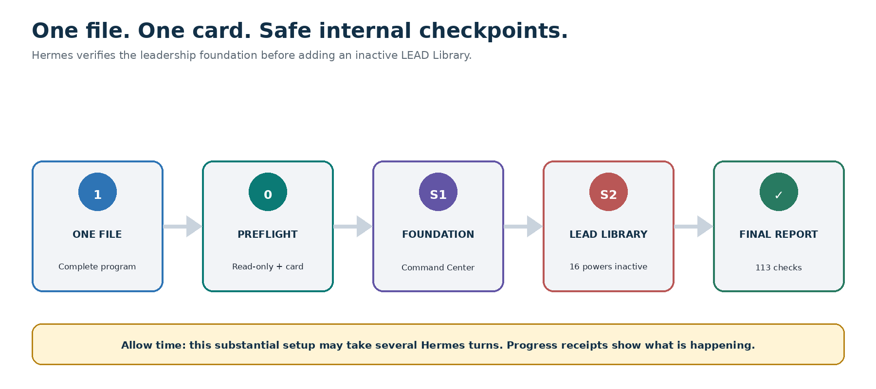
One-file setup with read-only preflight, healthy-foundation checkpoint, inactive LEAD overlay, 113 release checks, and final activation report.

The only installation file
Give Hermes: Nurse-Leader-Complete-AI-OS-with-LEAD-SuperPowers-Hermes-Program.md
Do not divide the file or install an embedded component separately. It contains the foundation, Authority and People Shield, Leadership Operating Core, sixteen optional powers, Command Center extension, workflows, templates, manifest, tests, and recovery behavior.
Existing users: Hermes should verify and bind to a healthy foundation. It must not replace the Command Center, duplicate records, or overwrite compatible sources, permissions, or unrelated work.
Deployment boundary: The default is a private leader workspace—not an automatically authorized unit or enterprise system. Live data, shared access, integrations, staff-facing use, and organizational deployment require separate governance.

Quick setup

1. Use a private workspace
Use one authenticated workspace owned by the nurse leader. Do not use a shared account or a workspace containing patient or restricted employee information.

2. Upload the complete program
Attach the entire Complete Edition Markdown file to Hermes–Nurse AI OS.

3. Paste the single installation prompt
Copy and paste: Install Nurse Leader Complete AI OS with LEAD SuperPowers v1.0 from this entire file in Guided Complete Setup mode. Treat the Complete Edition orchestration as the controlling installation sequence and the embedded sources as its governing runtime content. Begin with a read-only safety, governance, authority, privacy, permission, version, and compatibility preflight. Ask the minimum setup questions one at a time and present one combined Nurse Leader Complete Edition Activation Card. Wait for my approval before applying changes. Then install or bind to the Nurse Leader foundation first, run its acceptance tests, add the LEAD SuperPowers Library as an inactive overlay, and run all overlay and integration tests. Preserve compatible data, dashboards, safeguards, permissions, records, and unrelated work. Default to Synthetic Demonstration Mode. Do not enable connectors, external actions, new memory categories, shared access, or background automation. Do not ingest PHI, personnel files, performance or disciplinary records, employee health information, privileged peer-review or quality material, labor-relations material, credentials, secrets, or unnecessary identifiable staff information. Do not score, rank, profile, or infer the attitude, intent, loyalty, health, competence, or future behavior of an individual. Do not automate clinical, employment, disciplinary, scheduling, credentialing, compensation, resource-allocation, policy, safety-event, legal, labor, regulatory, or organizational decisions. This is a substantial installation and may take several Hermes turns: show a progress receipt after every phase, never rush or silently skip a check, and if interrupted stop at a safe checkpoint with the exact command to resume.

4. Review one combined activation card
Hermes asks the minimum questions one at a time, then shows one card covering owner, scope, deployment, leadership outcomes, decision rights, data boundaries, sources, memory, permissions, connections, dashboard, tests, and rollback.

5. Wait for the final report
A dashboard preview or foundation checkpoint is not completion. Setup finishes only after the Nurse Leader Complete Edition Activation Report confirms every critical gate passed.

Why installation may take a while
Hermes is verifying authority, privacy, people protections, source integrity, dashboard state, recovery, and 113 release checks—not merely copying buttons.
Phase | Work | Checkpoint
0 | Read-only owner, scope, authority, privacy, and compatibility inventory | S0 — pre-install
1 | Minimum questions and one combined activation card | Leader approval
2 | Foundation create, bind, or repair; 21 tests | S1 — foundation
3 | LEAD core and Library; all sixteen powers inactive | S2 — complete state
4 | 80 LEAD tests and 12 integration checks | Passed or Blocked
5 | Final report, first use, limitations, and recovery | Complete

Normal during setup
- Several Hermes turns may be needed.
- Hermes pauses for the activation-card approval.
- The foundation may complete before LEAD begins.
- Testing may take longer than the dashboard preview.
- A response limit may require a safe checkpoint and resume.

Not acceptable
- Reporting Complete before the final Activation Report
- Silently skipping tests because setup is taking too long
- Creating a second dashboard or duplicate records
- Enabling access, actions, memory, sharing, or automation to speed installation
- Continuing unattended after the session ends

If setup pauses
A safe pause is expected when the response or session limit is reached. Save the progress receipt before continuing.
Exact resume command: Resume Nurse Leader Complete Edition installation from the last approved checkpoint. Revalidate the authenticated owner, workspace scope, privacy and workforce-data boundaries, decision authority, permissions, component versions, current Command Center, source state, and every critical control before continuing. Do not repeat completed mutations, duplicate dashboards or records, assume a prior result, enable a connector, share access, save new memory, perform an external action, activate automation, or skip a Failed, Partial, Unknown, or Awaiting-verification test. Show the refreshed progress ledger and continue with the next incomplete phase only. If no verified checkpoint can be identified, stop and perform a read-only inventory.
Checkpoint | Verified state | Safe rollback
S0 | Read-only pre-install state | Restore the state before installation
S1 | Healthy Nurse Leader foundation | Remove LEAD work and keep the foundation
S2 | Healthy Complete Edition | Verify before first use or optional activation

No background installation: Hermes stops when the conversation or session ends. It must provide a checkpoint receipt and exact resume command; it must not claim to be continuing elsewhere.

Every progress receipt should show
- Phase, status, and current safe checkpoint
- What was checked, created, bound, repaired, skipped, or preserved
- Permissions, connections, sharing, memory, external-action, and automation state
- Tests passed, failed, blocked, partial, unknown, or awaiting verification
- Leader response needed, next phase, rollback target, and resume command

What LEAD helps the nurse leader accomplish
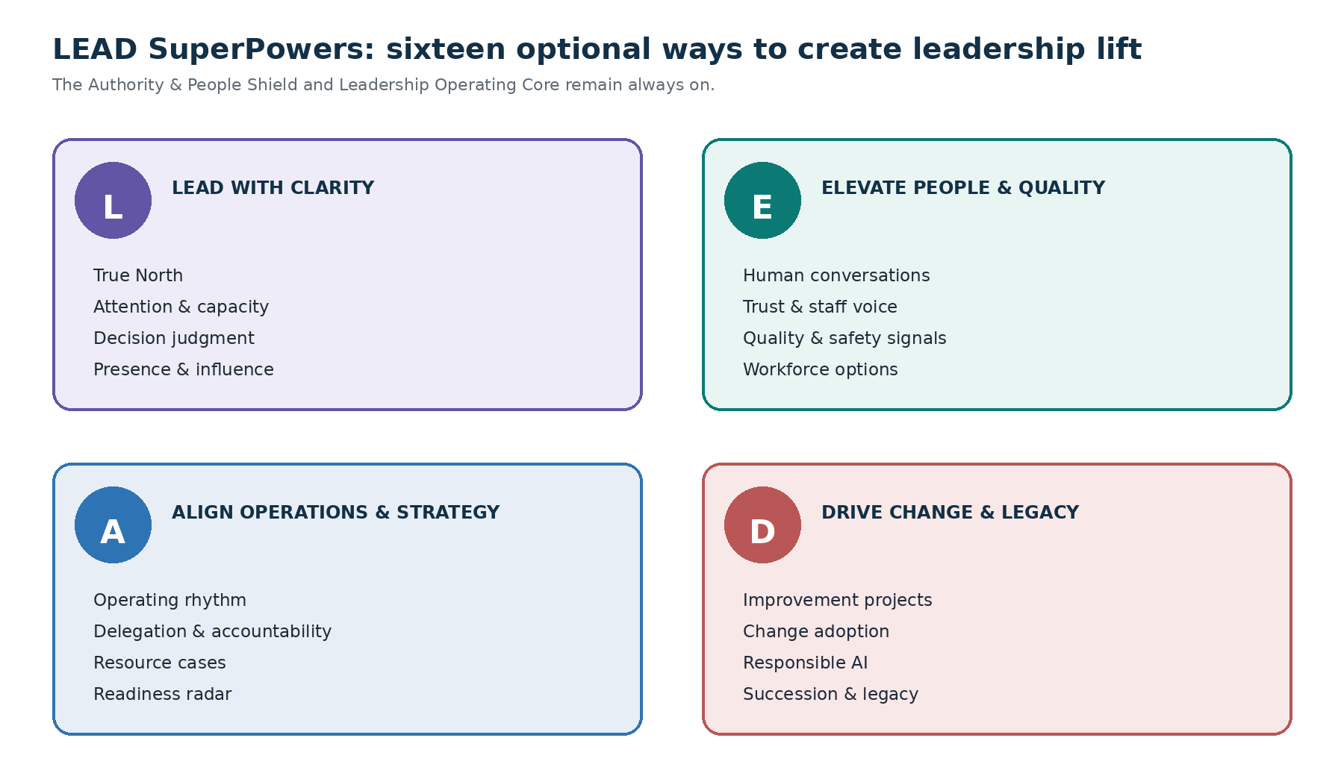
Sixteen optional powers grouped across clarity, people and quality, operations and strategy, and change and legacy.
- Regain a clear view of priorities, approvals, commitments, and unresolved decisions
- Turn meetings into verified decisions, accepted owners, due dates, and follow-through
- Prepare source-led briefs without disguising unknowns as facts
- Coordinate quality, workforce, operations, projects, resources, readiness, and communication in one view
- Prepare staff and executive communication without sending it automatically
- Understand approved aggregate signals without jumping to cause or blame
- Manage change with participation, burden, risk, dependency, fallback, and stop conditions
- Protect staff dignity, leader capacity, source freshness, corrections, and accountable human judgment
Evidence standard: LEAD does not guarantee patient, staffing, culture, safety, compliance, financial, or liability outcomes. Measure carefully and report only independently verified effects.

L and E — lead clearly and elevate people

L — Lead with clarity, presence, and capacity
- True North Leadership Compass — mission, priorities, decision rights, people commitments, and Now / Next / Not Now / Stop / Protect
- Leadership Attention and Capacity Shield — top three, tradeoffs, delegation proposals, protected presence, Minimum and Re-entry modes
- Decision Clarity and Executive Judgment Studio — facts, options, affected groups, tradeoffs, approvals, and smallest reversible step
- Leadership Presence and Influence Rehearsal — stakeholder-aware speaking, listening, boundary, dissent, and repair practice

E — Elevate people, culture, quality, and safety
- Coaching, Recognition, and Difficult Conversation Studio — respectful preparation with due-process and specialist gates
- Team Trust, Staff Voice, and Culture Builder — voluntary aggregate listening and visible follow-through without surveillance
- Quality and Safety Signal Sensemaking Lab — measure definition, context, hypotheses, limitations, and governed next step
- Workforce Capacity and Fair Options Navigator — transparent scenarios without assignments or adequacy claims
People boundary: LEAD never scores, ranks, profiles, diagnoses, surveils, or predicts an individual. Employment, staffing, performance, discipline, credentialing, and safety decisions remain human-owned.

A and D — align the work and drive safe progress

A — Align workforce, operations, resources, and strategy
- Unit Operating Rhythm and Meeting-to-Action Engine — fewer status meetings, clearer decisions, accepted owners, and closure evidence
- Delegation and Accountability Architect — outcomes, authority, resources, workload, equity, check-ins, and owner acceptance
- Resource, Budget, and Business Case Builder — actuals, estimates, assumptions, ranges, full burden, sensitivity, and approvals
- Policy, Competency, Accreditation, and Readiness Radar — version-controlled evidence and gaps without compliance or competence claims

D — Drive decisions, change, innovation, and legacy
- Improvement and Project Acceleration Lab — bounded experiments, measures, fallback, stop conditions, and learning decisions
- Change Adoption and Stakeholder Alignment Studio — participation, impact, support, feedback, local adaptation, and recovery
- Responsible AI and Digital Transformation Governor — non-AI alternatives, data, evidence, fairness, workflow, security, pilot, and exit gates
- Succession, Career, and Leadership Legacy Map — leader-owned aspirations and role-level continuity without secret rankings
Activation rule: All sixteen powers install inactive. Preview one power at a time, approve its exact card, and complete at least three supervised successful uses before broader-use review.

The Command Center after installation
Only one Nurse Leader Command Center should exist. LEAD adds bounded views and preserves the foundation as the source of truth.
Core launcher | Leadership job
Lead My Day | Priorities, decisions, approvals, meetings, ownership, protected presence, and Plan B
Prepare a Decision | Sources, options, tradeoffs, affected groups, unknowns, and decision rights
Align & Communicate | Human conversation, staff, stakeholder, huddle, meeting, and executive preparation
Move Work Forward | Commitments, projects, improvement, change, resources, readiness, and follow-through

Permanent controls
- Privacy & Permissions and Data Boundary
- Decision Rights and Review Sources
- Activity and Correction History
- Pause All and Reset to Safe Defaults
- Export, Correct, Delete, Rollback, and Uninstall
Focused view shows no more than three decisions, five priority commitments, three upcoming items, three signals needing context, three ownership clarifications, one protected commitment, and one safe next step. Unknown information stays visibly Unknown.
First safe use: Open my Nurse Leader Command Center in Focused view. Show my current leadership season and capacity, the three decisions needing my attention, up to five priority commitments, approvals waiting, upcoming meetings, delegation opportunities, sources or authority needing verification, LEAD SuperPowers status, permanent privacy and Pause All controls, and one safe next step. Use only synthetic or explicitly approved information. Label every Unknown, estimate, AI interpretation, stale source, and missing owner. Do not save, send, assign, schedule, publish, or change anything without asking me.

Privacy, people, and decision boundaries

Do not enter
- PHI or a real patient narrative, even when a name is removed
- Personnel, performance, disciplinary, accommodation, employee-health, grievance, labor, investigation, credential, or private-message information
- Privileged legal, peer-review, patient-safety, incident, quality, risk, claims, or regulatory material outside an authorized environment
- Passwords, tokens, private keys, recovery codes, signatures, security answers, or other secrets
- Raw EHR, HR, payroll, staffing, scheduling, finance, quality, incident, credentialing, or messaging exports
- Small-group information that could reasonably reveal an individual

Hermes may prepare; authorized humans decide
- Patient care, staffing, scheduling, and assignments
- Employment, compensation, performance, discipline, promotion, remediation, and termination
- Competence, credentialing, privileges, health, impairment, and fitness for duty
- Policy, legal, labor, regulatory, compliance, accreditation, and reportability conclusions
- Quality, safety, incident, peer-review, investigation, and corrective action
- Budgets, procurement, contracts, resources, vendors, and organizational commitments
- External sending, publishing, filing, purchasing, scheduling, assigning, and system changes
Staff dignity: No covert surveillance, hidden scoring, sentiment inference, protected-trait inference, shadow personnel files, staff ranking, or prediction of performance, loyalty, competence, resignation, misconduct, promotion, or future behavior.

Private workspace versus organizational deployment
Approval for a private leader workspace does not authorize a unit, service, or organization deployment.
Separate organizational approval is required before using live data, identifiable workforce information, staff-facing or multi-user workflows, system integrations, external actions, monitored automation, or enterprise security, retention, audit, access, downtime, incident, vendor, and continuity controls.

Governance routes may include
- Privacy and information governance
- Security, IT, architecture, and incident response
- HR, labor relations, union, employment, and accommodation owners
- Clinical, quality, safety, peer-review, and risk owners
- Legal, compliance, accreditation, and regulatory owners
- Finance, procurement, contracting, accessibility, operations, and executive sponsors

Preview the first SuperPower
Copy and paste: Open my LEAD SuperPowers Library and recommend one power based on my 90-day organizational outcome, people-and-culture outcome, greatest source of drag, current capacity, decision authority, and protected-life commitment. Show its full activation card, risks, permissions, expected workload effect, and one synthetic preview. Do not activate it, save new information, or perform an external action. Wait for my approval.

Recommended adoption pace
- Activate no more than one optional power during the first week.
- Complete three supervised successful uses before broader-use review.
- Keep live integrations and shared access off until separately governed.
- Review accuracy, burden, staff impact, accessibility, and unintended effects after seven and 30 days.
- Retain, revise, pause, or remove a power based on evidence—not novelty.

Pause, reset, and remove safely
Pause: Pause all Nurse Leader Complete Edition workflows now. Do not delete anything. Stop triggers and external actions, keep shared access off, and show every pending, attempted, completed, failed, partial, paused, blocked, or unknown action.
Safe reset: Reset Nurse Leader Complete Edition to safe defaults: Synthetic Demonstration Mode, connections off, shared access off, external actions off, new memory categories off, Manual/AI-assisted/Preview only, four Core launchers, and every optional LEAD SuperPower inactive. Preview the complete change manifest and wait for my approval.
Remove LEAD only: Preview removal of only the nl_lead overlay records, views, launchers, permissions, connections, and pending runs. Preserve the Nurse Leader foundation, Command Center, safeguards, base records, approved sources, and unrelated work. Offer an approved export before deletion and provide a completion receipt.
Remove the Complete Edition: Preview restoration of the verified pre-install state S0. Preserve unrelated data and offer an approved export of permitted information before deletion. Show exactly what will be removed, retained, restored, or could not be restored. Wait for my approval and provide a final uninstall receipt.
Sensitive-information incident: Pause immediately. Do not repeat or summarize the sensitive content. Prevent further use or retention where controls permit, show the applicable deletion and activity controls, and direct me to the organization's authorized privacy, security, HR, labor, quality, peer-review, safety, legal, or incident-response process.

Recovery rules
- Preview the exact change manifest and wait for authorized approval.
- Offer an export only for permitted information the leader chooses to retain.
- Preserve the foundation or unrelated data when removing only the overlay.
- Report completed, failed, partial, unknown, retained, and unrestored items honestly.

Troubleshooting and release checks

Preflight blocked
Correct the missing control; never ask Hermes to bypass it.

Foundation already exists
Verify and bind; do not reinstall a healthy component.

Duplicate dashboard or record
Pause, restore the last safe checkpoint, inventory, and preserve the foundation source of truth.

Critical test failed
Keep activation Blocked, correct the cause, and rerun the failed and related tests.

Sensitive information entered
Pause without repeating it; use deletion, memory, Activity History, and the authorized incident route.

Dashboard feels overwhelming
Return to Focused view, keep the Core Four, and leave every optional power inactive.

Enhanced interface failed
Use the canonical Markdown Command Center; no critical control may depend on the enhanced interface.

Changes are unclear
Request the Activation Report, progress receipts, Activity History, and before/after change manifest.
Final principle: The Complete Edition helps the nurse leader see clearly, prepare wisely, communicate humanly, and move work forward. It does not replace leadership judgment, organizational governance, staff voice, or accountable human decisions.

