HEALTHCARE RESEARCH & INNOVATION LEADER ENABLEMENT PACK

DISCOVER
  - Healthcare Research & Innovation Leader Complete AI OS
Setup, Benefits, Mission Control, Evidence, Translation & Agent-Governance Guide
Core promise: Give research and innovation leaders a governed home for mission, opportunities, portfolio choices, evidence, study-concept work, co-design, funding readiness, implementation, translation, leadership growth and whole-life renewal—without turning Hermes into an IRB, research system, clinician, submission engine or autonomous lab.
Please allow time: The one-file installation is substantial and may require several visible Hermes turns. Nothing continues in the background. Keep S0, S1 and S2 receipts and wait for the final Activation Report.
Program | Installation identity | Safe starting state
DISCOVER Complete Edition | healthcare_research_innovation_leadership • My DISCOVER Mission Control | Public/synthetic or approved aggregate • powers inactive • agents P0 • actions Off

What DISCOVER gives the leader
DISCOVER helps a leader make better questions, cleaner evidence trails and more humane, reversible decisions—while preserving the authority of participants, communities, qualified experts and official institutional systems.
- Direction: clarify mandate, active hat, mission, intended impact, ethical red lines, opportunity cost and one reversible 90-day focus.
- Discovery: turn signals into unmet-need briefs; compare research, QI, clinical/operations and innovation possibilities without pretending to determine the category.
- Scientific rigor: prepare study-concept options, outcomes, measures, bias/validity questions, feasibility assumptions and specialist-review routes before results drive the story.
- Trust: preserve evidence provenance, contradictions, corrections, uncertainty, participant/community burden, accessibility, reciprocity and feedback-back commitments.
- Portfolio leadership: see aggregate milestones, dependencies, review gates, funding readiness, decision owners and responsible stop/continue choices.
- Innovation: test the smallest non-production assumption, compare nontechnology alternatives, predefine value/equity/burden measures and retain rollback and stop ownership.
- Translation: connect evidence thresholds, implementation context, dissemination, maintenance, commercialization questions and scale/stop gates without deploying or committing.
- Leadership and life: grow capability, mentoring and succession while protecting an optional owner-only purpose, capacity and renewal plan from institutional analytics.
What success looks like: Not more AI output. Better traceability, fewer hidden assumptions, earlier boundary questions, named human decisions, safer experiments, clearer stopping rules, preserved dissent and a sustainable leader.

The product boundary — powerful planning, no hidden authority
DISCOVER may | DISCOVER must never
Ask, compare, draft, map, preview, question, simulate with stated assumptions, summarize approved input, trace evidence and validate schema | Determine research/QI/exempt/HIPAA/FDA status; approve protocol, consent, safety, statistics, grants, contracts, IP, publication or implementation
Use public authoritative sources, synthetic fixtures, approved policies/metadata and externally prepared human-approved aggregate exports | Ingest PHI/PII, participant/person rows, raw narratives, recruitment/contact lists, linked genomics/images/signals, employee rows, secrets or uncontrolled inventions
Prepare readiness questions, source-annotated options, human review queues and nonidentifying official-system references | Recruit, screen, consent, enroll, randomize, intervene, monitor, report safety, submit, publish, contact, sign, spend, procure, deploy or write to an official system
Charter and test one bounded agent with frozen inputs, hashes, limits, human checkpoints, kill and reconciliation | Self-activate, widen permissions, create hidden agents, retry without authority, use unapproved tools/network, continue in background or treat agent agreement as evidence

Emergency and live-safety rule: Stop. Use the organization’s official clinical, participant-safety, research-safety, security or emergency process and accountable humans. DISCOVER is not the live command path.

Official-source posture — revalidated July 16, 2026
DISCOVER carries source status and review dates into planning. It does not convert a federal baseline, policy, guidance document or voluntary framework into a local determination.
Watch item | Verified current posture | Required DISCOVER behavior
PHS research misconduct | Revised 42 C.F.R. Part 93 applies to allegations received on or after Jan. 1, 2026; earlier allegations generally retain the prior route unless the permitted written election occurs. | Store allegation-received date and rule-version route; preserve a restricted intake and hold signal; never determine misconduct.
NIH grants and BESH | The March 2026 NIH Grants Policy Statement is current, but controlling terms remain award- and budget-period-specific. NOT-OD-26-067 changes NIH BESH treatment for covered applications due, or solicitations issued, on or after May 25, 2026. | Pin edition, NOFO, notice, award term and dates; never infer that Common Rule, FDA, registration, sponsor or local duties disappear.
FDA research guidance | FDA E6(R3) Good Clinical Practice is final guidance from Sept. 2025. FDA’s Jan. 2025 AI evidence framework for drugs and biologics remains draft and not for implementation. | Use final-versus-draft labels; treat context-of-use and credibility concepts as questions; route program decisions to FDA/regulatory specialists.
NIH AI use | NOT-OD-25-132 applies to covered applications submitted on or after Sept. 25, 2025. NOT-OD-23-149 continues to restrict generative-AI use with confidential NIH peer-review material. | Keep human originality, verification and responsibility visible; block protected peer-review material from unapproved AI processing.
Accessibility | HHS amended 45 C.F.R. § 84.84 on May 11, 2026; DOJ’s Title II page reflects 2026 deadline extensions. Coverage and dates depend on entity type. | Build and test to WCAG 2.1 A/AA where applicable; record the actual authority, entity, date and any authorized exception analysis.
Responsible AI | NIST AI RMF 1.0 remains voluntary, with revision work underway in 2026; NIST AI 600-1 is the current Generative AI Profile identified in the source register. | Cite exact versions and review dates; do not treat framework alignment as compliance, validation, approval, safety, fairness or fitness evidence.

Refresh rule: Recheck official sources and local overlays at least quarterly and after a rule, agency notice, award modification, model/vendor change, incident or institutional-policy update. The included Markdown materials carry the exact source links and applicability caveats.

My DISCOVER Mission Control — one governed home
Four quick-launch buttons open preflight previews; six launcher groups expose all 24 workflows. A button never authorizes an action, and the parent Nurse AI OS card shows only coarse status and a deep link.
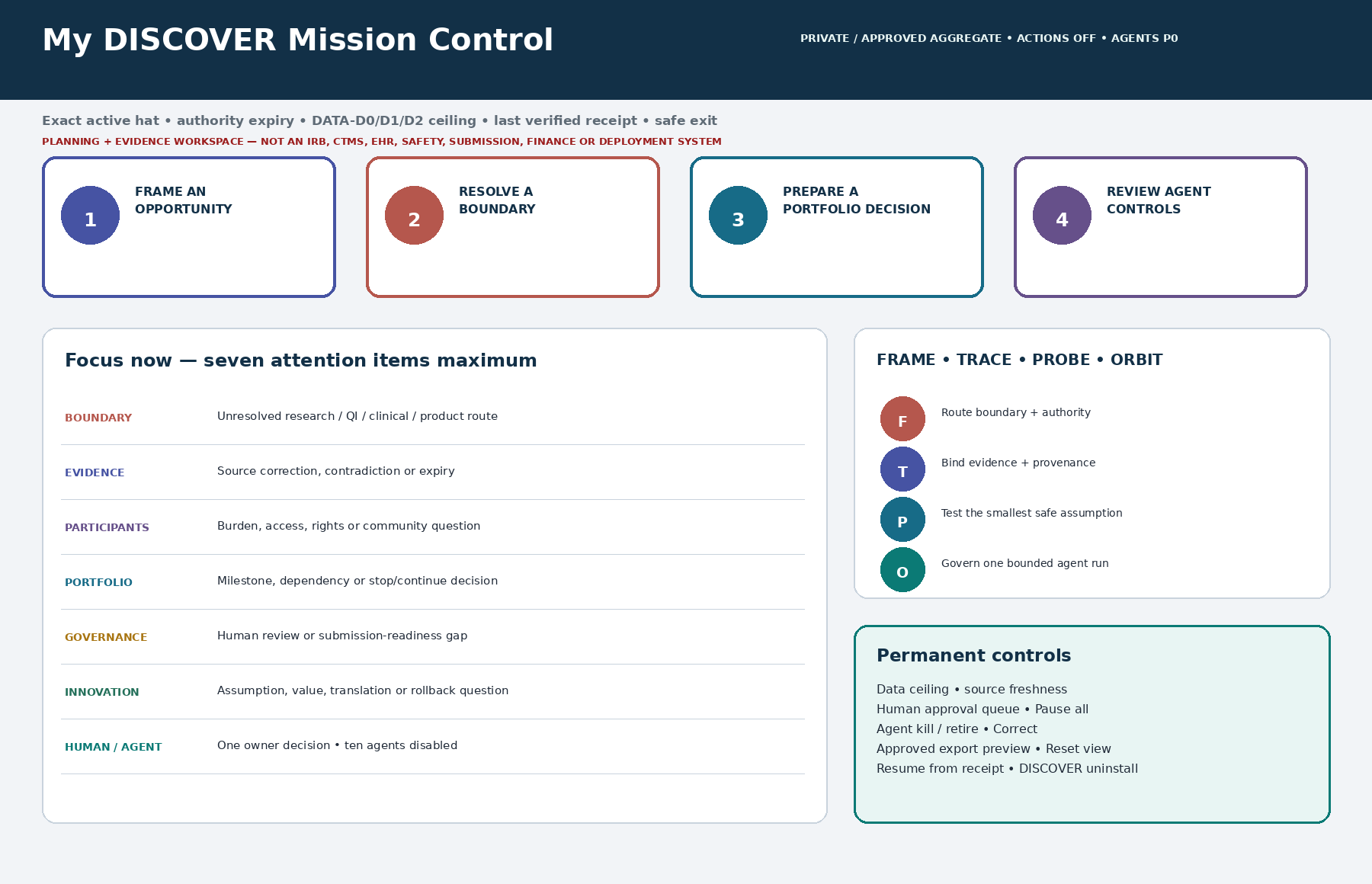
My DISCOVER Mission Control with four preview launchers, a seven-item attention ceiling, FRAME–TRACE–PROBE–ORBIT routines, actions-Off and agent-P0 status, and permanent lifecycle controls.
Canonical route: /healthcare-research-innovation-leaders/dashboard is the Markdown source of truth. /healthcare-research-innovation-leaders/mission-control is a lane-scoped alias to the same state. No global dashboard alias is installed.

Twenty-four optional SuperPowers — PWR-01 through PWR-12
ID | SuperPower | ID | SuperPower
PWR-01 | Mission, Impact & Research Leadership Compass | PWR-07 | Study Concept & Design Options Architect
PWR-02 | Unmet Need & Opportunity Framing Studio | PWR-08 | Feasibility, Participant Burden & Safety Readiness Lens
PWR-03 | Portfolio Prioritization & Stop/Continue Navigator | PWR-09 | Outcomes, Measures & Analysis-Intent Studio
PWR-04 | Research–QI–Clinical–Innovation Boundary Navigator | PWR-10 | Participant, Patient, Community & Workforce Co-Design Planner
PWR-05 | Research Integrity, Reproducibility & Provenance Studio | PWR-11 | Scientific Team, Partnership, RACI & Conflict Navigator
PWR-06 | Data, Privacy, Rights & IP Governance Mapper | PWR-12 | Funding, Grant & Sponsor Readiness Studio

Installation state: Every power is Available Inactive. Preview reveals allowed input, output, human gate, prohibited actions, expiry and safe exit before any user decides whether to use it.

Twenty-four optional SuperPowers — PWR-13 through PWR-24
ID | SuperPower | ID | SuperPower
PWR-13 | Portfolio Milestone, Dependency & Decision Orchestrator | PWR-19 | Evidence Landscape, Systematic Search & Horizon-Scan Navigator
PWR-14 | Governance & Submission-Readiness Navigator | PWR-20 | Implementation Science, Adoption & Learning-System Studio
PWR-15 | Site, Vendor, Technology & Pilot Readiness Studio | PWR-21 | Dissemination, Publication & Evidence-to-Decision Studio
PWR-16 | Innovation Assumption & Bounded Experiment Lab | PWR-22 | Responsible AI Use-Case, Agent & Model Governance Command
PWR-17 | Value, Health-Economics, Equity & Burden Scenario Studio | PWR-23 | Research Leadership, Capability, Career & Succession Builder
PWR-18 | Translation, Commercialization & Scale/Stop Pathway Architect | PWR-24 | Whole-Life Purpose, Capacity & Renewal Navigator

- Begin with zero, one or two public/synthetic previews. Activating none is acceptable.
- Bind exact purpose, allowed input, source/version, owner, qualified reviewer, permission, expiry, fallback, deletion and correction route.
- A material change in question, intended use, population, data, policy, approval, source, model, vendor, integration or jurisdiction invalidates the previous receipt.
- At finish, the power returns to Available Inactive; an optional agent returns to PERM-P0 Disabled unless separately reauthorized for one bounded run.

Six launcher groups and the 24 purpose-matched workflows
Launcher group | Four preview workflows
1 • Direction & Portfolio | WF-01 Mission & Focus • WF-02 Opportunity Brief • WF-03 Portfolio Decision • WF-13 Milestones & Dependencies
2 • Boundaries & Governance | WF-04 Boundary Route • WF-05 Integrity Trace • WF-06 Data/Rights Map • WF-14 Submission Readiness
3 • Study & Operational Readiness | WF-07 Study Concept • WF-08 Feasibility/Burden/Safety • WF-09 Measures/Analysis Intent • WF-15 Site/Vendor/Pilot Readiness
4 • People, Partners & Resources | WF-10 Co-Design • WF-11 Team/Partner/RACI/Conflict • WF-12 Funding Readiness • WF-23 Leadership & Succession
5 • Innovation, Value & Translation | WF-16 Bounded Experiment • WF-17 Value/Equity Scenario • WF-18 Translation/Scale-Stop • WF-20 Implementation & Adoption
6 • Evidence, Dissemination & Renewal | WF-19 Evidence Landscape • WF-21 Dissemination • WF-22 Agent Charter & Test • WF-24 Private Renewal

Common workflow finish: Validate the active hat and allowed input; run FRAME, TRACE, PROBE or ORBIT; create one source-bound preview; list unknowns; route to a named human; emit a control receipt; stop before external action.

Before setup: prepare authority and safe metadata
- Use a Hermes workspace you control and a new or technically verified-isolated DISCOVER lane. Keep the complete installer unchanged.
- Prepare exact role, active hat, organization, setting, jurisdiction, authority source and expiry—or leave them visibly Unknown and blocked.
- Name official human routes for HRO/IRB, QI, clinical operations, privacy/security, regulatory, legal, contracts/IP, finance, grants, biosafety, accessibility, research safety, integrity and communications.
- Use public/authoritative or clearly synthetic information first. Approved aggregate/enclave exports must be created and approved outside DISCOVER with provenance, query/version, suppression, owner, date and hash.
- Do not paste PHI, participant records, notes, comments, quotes, images, signals, genomic/biospecimen links, screening/contact lists, employee records, credentials, unpublished invention detail or sponsor/vendor-confidential material.
- Choose whether to create the optional owner-only life/career store. Institutional use, parent analytics, training, exports and agents remain excluded.
Installation file: Healthcare-Research-and-Innovation-Leader-Complete-AI-OS-with-DISCOVER-SuperPowers-Hermes-Program.md
Time warning: Installation may require multiple visible Hermes turns. Do not install the ZIP or individual component files. Nothing installs or continues in the background; a prose summary, partial dashboard or S1 receipt is not the Activation Report.

Paste the authoritative one-file installation prompt
Use exactly: Copy this prompt from the current canonical Markdown program. If older wording differs, the current complete program controls.
Installation prompt — part 1 of 2: **Hermes:** Install this entire Markdown file as `HRIL-AIOS-DISCOVER-COMPLETE-1.0` inside Nurse AI OS. Preserve the exact standalone lane, qualified routes, namespace, 17 component boundaries/hashes, 24 inactive powers, 24 Preview workflows, 30 templates, 18 executable schemas, ten disabled agents, ten fixtures/adapters and 160 runtime criteria.
Installation prompt — part 2 of 2: Do not summarize away executable content. Perform every phase visibly, pause for required human decisions, and never enable an external action, connector, power or agent by default.
Approval behavior: Hermes must stop for human decisions. Unknown authority or applicability can remain only while the affected function stays blocked. Never approve a card that enables an agent, expands data, writes externally, submits, deploys, recruits, publishes or spends.

Phased installation, runtime checks and release states
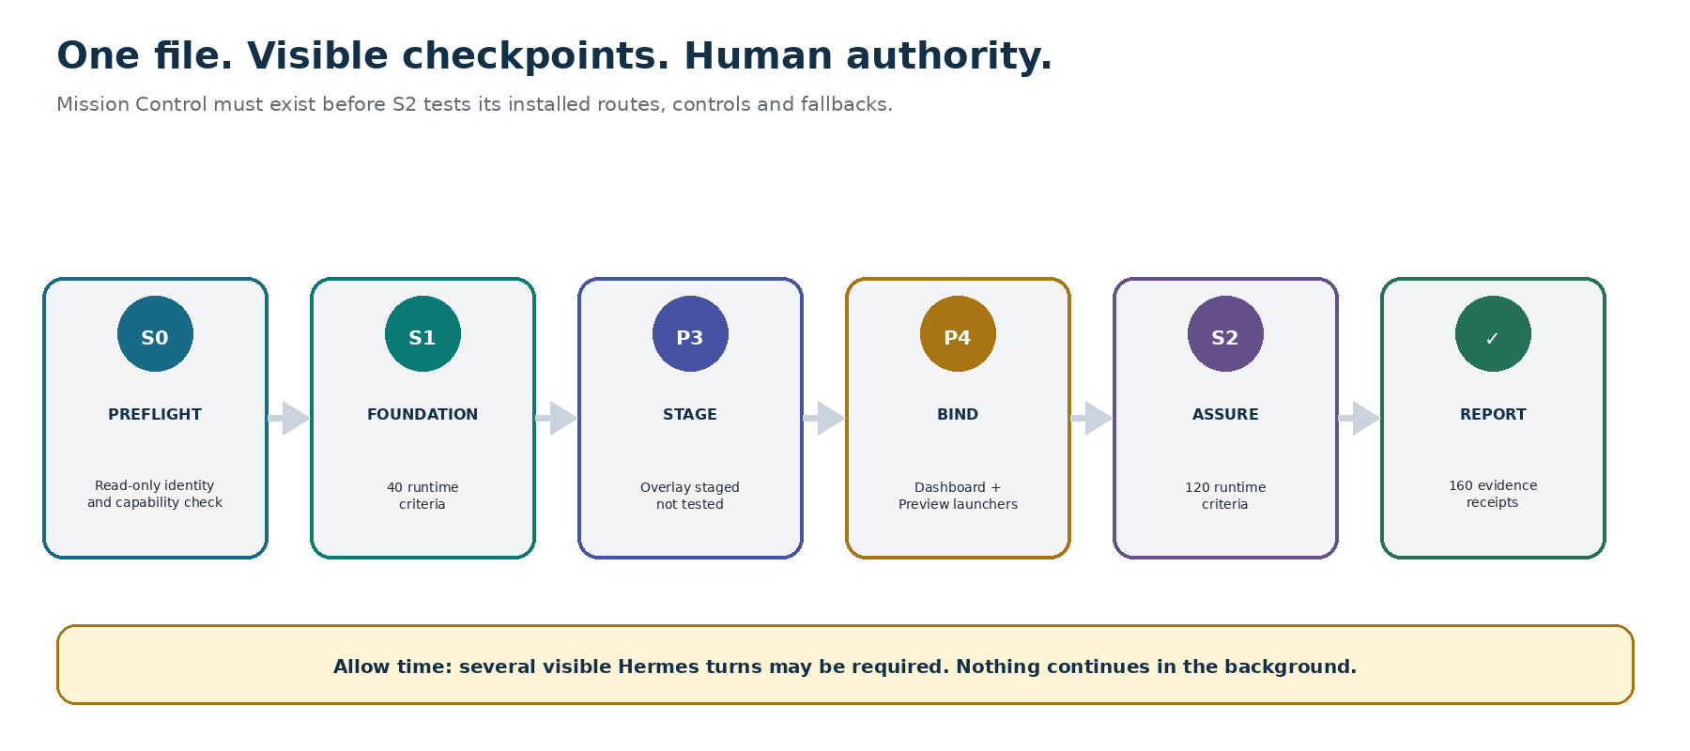
DISCOVER installation order: read-only S0, 40-criterion S1 foundation, overlay staging without an S2 claim, Mission Control rendering and binding, 120-criterion S2 assurance, then an evidence-based Activation Report.
Phase | What Hermes does | Required state
0 — Orientation / S0 | Read warning; verify identity, collisions, capabilities, partitions, controls and existing state without mutation | S0_READY_FOR_EXPLICIT_INSTALL or a truthful block
1 — Integrity | Parse all 17 component markers and verify declared SHA-256 values, identities, routes and no path traversal | Exact inventory or INTEGRITY_BLOCKED
2 — Foundation / S1 | Bind foundation + four core components; execute exactly 40 isolation, authority, data, permission and recovery criteria | S1_FOUNDATION_VERIFIED or quarantine
3 — Overlay staging | Register 24 inactive powers, 24 preview workflows, 30 templates, 18 schemas and ten P0 agents | OVERLAY_STAGED_NOT_TESTED
4 — Mission Control / S2 | Render one canonical dashboard and alias; bind preview launchers; then execute 104 domain + 16 integration criteria | S2_VERIFIED_AWAITING_  HUMAN_REVIEW or quarantine
5 — Activation Report | Report counts, receipts, states, unsupported items, source unknowns, accessibility, residuals and uninstall scope | INSTALLED_AVAILABLE_INACTIVE only after human acceptance

If interrupted: resume from evidence, never from assumption
Exact resume command: RESUME DISCOVER FROM LAST VERIFIED RECEIPT — DO NOT REPEAT PASSED PHASES, DO NOT CREATE A SECOND DASHBOARD, REPORT BEFORE/AFTER HASHES.
Inspection / recovery command: REPAIR DISCOVER FROM LAST VERIFIED RECEIPT — QUARANTINE FAILED STATE, CHANGE ONLY DISCOVER OBJECTS, RETEST AFFECTED CRITERIA, REPORT THE EXACT DELTA.
Full uninstall command: FULL UNINSTALL DISCOVER
Control | Required behavior
Pause | Stop proposed work and every agent; preserve a minimal readable receipt; confirm no background work.
Reset View | Change presentation only; never erase a decision, alter a record, clear a blocker or grant authority.
Repair | Revalidate canonical component hashes, one dashboard state and only affected runtime criteria; stage a reversible repair.
Resume | Verify product/version, prior receipt and before hash; continue idempotently; never repeat passed phases or duplicate routes/state.
Uninstall | Preview exact DISCOVER scope, optional approved export, private-store choice and cross-lane diff; wait for a second confirmation.
Authorized hold | Return UNINSTALL_INCOMPLETE_AUTHORIZED_HOLD with retained refs, owner, authority, ACL and release condition—not a false purge.

First safe use: two previews, one human gate, zero external action
Begin only after a clean Activation Report. Use a synthetic or public-authoritative question with no person-level, confidential or live operational data.
Ask Hermes: OPEN MY DISCOVER MISSION CONTROL IN PREVIEW ONLY. USE SYNTHETIC DATA TO FRAME ONE RESEARCH OR INNOVATION QUESTION, KEEP FRAME MULTIPLE_OR_UNRESOLVED WHERE FACTS ARE MISSING, TAKE NO EXTERNAL ACTION, AND SHOW THE HUMAN GATE, EXPIRY, DISCARD PATH AND RECEIPT.
- Verify lane, route/alias, role and active hat, authority expiry, data ceiling, sources, actions-Off, 24 inactive powers and ten disabled agents.
- Preview PWR-01 plus PWR-02 for a fictional opportunity—or PWR-04 for an ambiguous fictional boundary case. Do not ask the AI to decide the category.
- Create one Proposed — Not Approved artifact with exact facts, interpretations, unknowns, source/version, named owner, official review route, expiry, correction and deletion.
- Have the named human accept, revise, defer, reject or delete the preview. Any official action happens only through the authorized person and system.
- Close the workflow; record the decision or unresolved state; confirm no agent, launcher or background work remains active.
Good first topics: A public-source freshness card; a synthetic unmet-need brief; a fictional boundary-routing exercise; an aggregate portfolio decision shell; or an owner-only 90-day leadership focus in proven isolation.

First agent: one narrow scout, visible evidence and a real kill switch
Preview—do not run: PREVIEW AN ORBIT ONE-RUN CHARTER FOR AGT-09 USING ONLY A SYNTHETIC PUBLIC-SOURCE BRIEF. KEEP THE AGENT PERM-P0 DISABLED, ADD NO TOOLS, NETWORK OR DESTINATIONS, RUN NOTHING, AND SHOW THE FROZEN HASHES, CAPS, HUMAN APPROVAL, KILL, RECONCILIATION AND RETURN-TO-P0 REQUIREMENTS.
Permission | Meaning | DISCOVER boundary
PERM-P0 | Disabled | Installed and resting state for all ten agents
PERM-P1 | Synthetic/public local preview | No external tool, sensitive data, persistence or action
PERM-P2 | Approved read-only bounded sandbox | One frozen public/authoritative allowlist and one draft; no write/share
PERM-P3 | Institution-approved one-run aggregate sandbox | Exact approved aggregate/export, hashes, owner, caps, expiry and zero production writes
PERM-P4 | Production / external / participant / financial | Not implemented and cannot be inferred, installed, self-granted or delegated

- Freeze model, agent, prompt, policy, schema, input, output, tool, network and destination versions and hashes.
- Set one invocation, zero retries by default, time/cost/output caps, named checkpoints, expiry, kill acknowledgment and final reconciliation.
- Test normal, stale/retracted source, fabricated citation, injection, cross-partition, tool escalation, timeout, kill, purge and retirement behavior.
- An independent human reviews evidence outside the tested agent’s writable plane. Agent self-report or multi-agent agreement never counts as proof.

Thirty functional templates — working forms, not approvals
ID | Template | ID | Template
TPL-01 | Mission & Impact Compass | TPL-16 | Site, Vendor, Technology and Pilot Readiness Matrix
TPL-02 | Unmet Need & Opportunity Brief | TPL-17 | PROBE Assumption and Experiment Card
TPL-03 | Portfolio Prioritization and Stop/Continue Matrix | TPL-18 | Value, Economics, Equity and Burden Scenario
TPL-04 | FRAME Boundary Classification Intake | TPL-19 | Translation, Commercialization and Scale/Stop Pathway
TPL-05 | TRACE Evidence Provenance Card | TPL-20 | Evidence Landscape and Horizon-Scan Map
TPL-06 | Data, Privacy, Rights and IP Governance Intake | TPL-21 | Implementation Strategy and Adoption Evaluation Plan
TPL-07 | Study Concept Synopsis | TPL-22 | Dissemination, Publication and Evidence-to-Decision Plan
TPL-08 | Design Options, Bias and Validity Canvas | TPL-23 | ORBIT Agent Charter and One-Run Evaluation Card
TPL-09 | Feasibility, Burden and Safety Readiness Checklist | TPL-24 | Leadership Capability, Career and Succession Plan
TPL-10 | Outcome, Measure and Analysis-Intent Shell | TPL-25 | Private Whole-Life Purpose and Renewal Plan
TPL-11 | Participant, Patient and Community Co-Design Plan | TPL-26 | Participant Rights and Consent Question Set
TPL-12 | Team RACI, Expertise and Conflict Disclosure Map | TPL-27 | Data Management, Retention and Sharing Plan
TPL-13 | Funding, Grant and Partner Readiness Brief | TPL-28 | Source, Policy, Registry and Obligation Watch Card
TPL-14 | Portfolio Milestone, Dependency and Decision Board | TPL-29 | Decision, Approval, Exception and Escalation Receipt
TPL-15 | Governance and Submission-Readiness Checklist | TPL-30 | After-Action, Learning and Closeout Record

Record rule: Every persistent form binds active hat, tenant/partition/ACL, allowed data class, purpose, source/version/hash, facts versus interpretation, named owner and reviewer, state, creation/update/expiry, approval evidence slot, correction, retention, approved export and deletion. Unknown is safer than invented.

Research, QI, clinical operations and innovation — route, do not decide
Possible pathway | Questions DISCOVER can prepare | Authority that stays human / official
Human-subjects research possible | Purpose, systematic investigation, interaction/intervention, identifiable private information/biospecimens, assignment, dissemination and sponsor context | HRO/IRB and other accountable offices determine status, review, consent and permissions
QI / program evaluation possible | Local improvement purpose, methods, data, risk/burden, plans beyond the local setting and overlap with research | Local QI, privacy, ethics, HRO/IRB and operational owners determine the route
Clinical care / operations possible | Individual-care purpose, clinical judgment, workflow, official system, professional scope and patient-safety implications | Qualified clinicians and operational/clinical governance own care and workflow decisions
Innovation / product review possible | Intended use, user testing, product claim, tracking/training data, human factors, cyber/privacy, regulatory and production pathway | Regulatory, privacy/security, clinical, legal, procurement and product owners determine requirements
Multiple or unresolved | Missing or conflicting FRAME facts, authority expiry, local policy conflict, mixed purposes or linked pathways | Keep MULTIPLE_OR_UNRESOLVED; route to all relevant authorized offices

Allowed vocabulary: HUMAN_SUBJECTS_RESEARCH_POSSIBLE • QI_PROGRAM_EVALUATION_POSSIBLE • CLINICAL_CARE_OPERATIONS_POSSIBLE • INNOVATION_PRODUCT_REVIEW_POSSIBLE • MULTIPLE_OR_UNRESOLVED. DISCOVER never emits NOT_RESEARCH, EXEMPT, IRB_NOT_REQUIRED, NO_CONSENT_REQUIRED or HIPAA/FDA compliance conclusions.

Setting recipes — useful questions without implied authority
Setting | Start with | Hard stop
Academic medical center research office | WF-01, 03, 04, 14 • faculty/trainee roles, shared resources, ancillary reviews, authorship and succession | No determination, submission, faculty evaluation or resource award
Health-system innovation / learning health system | WF-02, 04, 16, 20 • care boundary, workflow burden, nontechnology alternative, rollback and learning owner | No EHR connection, live A/B test, clinical change or care recommendation
Community hospital, clinic, FQHC or rural setting | WF-02, 08, 10, 17 • local relevance, access, trust, compensation, burden and opportunity cost | No extraction, token engagement, unfunded promise or burden transfer
Clinical research unit / trial network | WF-09, 13, 14, 15 • aggregate protocol/portfolio metadata, site readiness, safety route and CTMS boundary | No participant data, enrollment, monitoring, CTMS write, site activation or safety determination
Public / population health | WF-04, 10, 19, 20 • jurisdiction, community governance, small cells, structural factors and unintended effects | No individual targeting, surveillance, protected-class inference or public-health action command
Digital health / data science / responsible-AI lab | WF-06, 16, 18, 22 • intended use, data, cyber/privacy, model version, human factors, regulatory route and kill | No participant rows, production model, clinical claim, deployment or self-directed agent
Academic–industry / startup / vendor collaboration | WF-06, 11, 12, 18 • conflicts, IP/background rights, data use, publication independence, lock-in and exit | No endorsement, contract, transfer, IP conclusion, procurement or commercialization commitment
Multi-site consortium / sponsored portfolio | WF-03, 11–15, 21, 23 • local authority, common definitions, funding readiness, closeout and succession | No assumed common approval, cross-tenant participant data, submission, award acceptance or personnel ranking

Evidence, integrity and human voice
TRACE binds every consequential claim to the exact source, version, population/context, methods, status, limitations, contradictions, correction path, reviewer and expiry.
- Separate source fact, operator fact, interpretation, inference, scenario and unknown. Never promote an inference to a finding.
- Preserve null/negative results, dissent, missingness, selection and measurement limitations, applicability gaps, corrections/retractions and material interests.
- Predeclare questions, candidate outcomes/measures and analysis intent before results where appropriate; route methods and statistics to qualified humans.
- Keep contributor, authorship, AI-use, rights, confidentiality, accessibility and release questions visible. DISCOVER prepares; humans decide and officially publish.
- Use concrete nouns and verbs; name owner, action, date, source, decision state and next human step. Remove generic uplift, fake certainty, formulaic headings, invented empathy, decorative jargon and unverifiable superlatives.
- Never fabricate a citation, quote, participant voice, image, data point, credential, result, review, approval or institutional position.
Source watch: The official-source register was revalidated July 16, 2026. It distinguishes binding rules, award- or actor-specific requirements, final guidance/policy, draft or proposed material, and voluntary methods. No source seed is an applicability decision; current law, award and contract terms, local policy and authorized reviewers control.

Leadership rhythm, whole-life power and Minimum Viable Leadership Mode
Cadence | Leader ritual
Daily — 5 minutes | Verify active hat and authority; choose one mission-aligned focus; surface one blocker/expiry; protect one boundary; confirm actions Off and agents P0.
Weekly — 25 minutes | Review maximum-seven attention queue, portfolio dependencies, source/review expiry, one stop/continue question, one community/burden question and one delegated item.
Monthly — 45 minutes | Revisit mission and opportunity cost; inspect evidence corrections; review implementation/innovation learning, funding/partner questions, agent inventory and closeout/retirement.
Quarterly — 60 minutes | Update the 90-day focus, capability/mentoring/succession plan, protected development time, private purpose/capacity choices and one responsible scale/stop decision.

Minimum mode: When the owner chooses minimum mode, show only one safety/governance blocker, one time-sensitive human decision, one delegated/deferred item, one protected-life boundary and pause/kill/escalation controls. Do not diagnose burnout or equate output with worth.

What the Activation Report proves—and what it does not
Evidence available from this package | Evidence only target Hermes can produce
File inventory, component markers/hashes, exact IDs and counts, semantic mappings, JSON syntax/schema compilation, checksums, DOCX structure/accessibility and ZIP safety | Actual isolation, route binding, permission enforcement, prohibited-input rejection, no-action behavior, keyboard/reflow fallback, idempotent resume and clean uninstall in the target environment
Static canonical fixtures, adapters, expected outcomes and 160 criterion definitions | Timestamped observed-versus-expected receipts with environment, adapter, validator, state/action/data deltas and raw-log hashes
A safe installation contract and failure states | S0/S1/S2 execution, quarantine, rollback, residual inventory and human acceptance

- Accept only specified, executed, passed, failed, blocked or unsupported statuses. A negative probe passes only when the expected block and zero-action/zero-leak proof are retrievable.
- Any failed, missing, unsupported or inadequately evidenced critical behavior prevents activation. Powers stay inactive, agents disabled and launchers non-executable.
- The accepted resting state is INSTALLED_AVAILABLE_INACTIVE. Installation alone activates nothing.
Independent working product: DISCOVER and Nurse AI OS are working product names pending brand and trademark clearance. This pack is not endorsed, certified, accredited, cleared, approved or affiliated with any cited institution or standards body. It is not legal, regulatory, clinical, statistical, cybersecurity, research-oversight or financial advice.

