VNC ICU VACATION REQUEST PORTAL
Comprehensive Portal Statistics & Strategic Report

Van Ness Campus (VNC) · Critical Care Unit
Report Date: May 9, 2026
Prepared by: VNC ICU Portal System

Executive Summary
This report presents a full statistical analysis of the VNC ICU Vacation Request Portal's inaugural submission cycle. A total of 162 distinct employees participated, generating 565 requests (523 vacation, 42 education) covering 2,750 individual date-slots. The deliberation window spans Period B of 2026 (July through December), which accounts for 94.5% of all active date requests. The AM shift carries the heaviest demand burden, with oversubscription recorded across five consecutive months. The portal has demonstrated its capacity to surface, rank, and present all requests in a structured, auditable format that enables the management team to complete approvals systematically and equitably.

1. Distinct Employee Participation
The portal recorded participation from 162 distinct employees who submitted at least one request. Of these, 158 remain active in the system and 4 have been deactivated. Seniority verification — a prerequisite for accurate priority ranking — has been completed for 157 employees (96.9%), with 5 accounts still pending charge nurse confirmation of their official seniority date.
Category | Count | % of Participants
Total employees who submitted requests | 162 | 100%
Active employees | 158 | 97.5%
Inactive / deactivated | 4 | 2.5%
Seniority-verified | 157 | 96.9%
Pending verification | 5 | 3.1%
AM shift participants | 81 | 50.0%
NOC shift participants | 72 | 44.4%
PM shift participants | 9 | 5.6%
Employees with 3+ active requests | 155 | 95.7%
Employees with only P1 requests (all-in) | 39 | 24.1%
The AM shift accounts for exactly half of all participating employees, followed closely by NOC at 44.4%. The PM shift has only 9 participants, reflecting the smaller staffing complement on that shift. Notably, 155 of 162 employees (95.7%) submitted three or more requests, indicating that staff are actively using the priority-ranking system to express preference ordering rather than submitting a single request. Thirty-nine employees submitted exclusively Priority 1 requests, signaling high confidence in their first-choice dates.

2. Vacation and Education Requests
Across all submission types, the portal received 565 total requests: 523 vacation requests and 42 education requests. After accounting for withdrawals, 448 requests remain active — 417 vacation and 31 education. These active requests collectively cover 2,750 individual date-slots, with an average of 3.27 requests per participating employee.
Request Type | Total Submitted | Active (Pending) | Withdrawn
Vacation | 523 | 417 | 106
Education | 42 | 31 | 11
TOTAL | 565 | 448 | 117

Period distribution reveals a strong concentration in the second half of the year. Period B (July–December) accounts for 402 active vacation requests covering 2,580 date-slots (94.5% of all vacation date-slots), while Period A (January–June) holds only 22 active requests across 98 date-slots. This asymmetry reflects the typical summer-and-fall vacation preference pattern in ICU nursing, and means the deliberation workload is almost entirely concentrated in Period B.
Period | Active Vacation Requests | Date-Slots | % of Total Slots
Period A (Jan–Jun 2026) | 22 | 98 | 3.6%
Period B (Jul–Dec 2026) | 402 | 2,580 | 94.5%
Education (all periods) | 31 | 72 (est.) | —

Of the 417 active vacation requests, 397 (95.2%) are continuous blocks and 20 (4.8%) are intermittent. This ratio suggests that the majority of staff are requesting defined vacation windows rather than scattered individual days, which simplifies scheduling impact assessment for the management team.

3. Withdrawn Requests
A total of 117 requests were withdrawn: 106 vacation and 11 education. This represents a 20.7% withdrawal rate across all submitted requests. Withdrawals are most concentrated in Priority 1 (43 withdrawals, 21.4% of all P1 submissions) and Priority 5 (29 withdrawals, 29.0% of all P5 submissions). The high P1 withdrawal count may reflect employees who reconsidered their top-choice dates after reviewing the portal's real-time demand heatmap. The high P5 withdrawal rate is consistent with lower-priority requests being speculative in nature.
Priority | Total Submitted | Withdrawn | Withdrawal Rate
P1 | 201 | 43 | 21.4%
P2 | 101 | 15 | 14.9%
P3 | 73 | 10 | 13.7%
P4 | 38 | 6 | 15.8%
P5 | 100 | 29 | 29.0%
P6 | 6 | 2 | 33.3%
P7 | 3 | 1 | 33.3%
P8 | 1 | 0 | 0.0%
Education | 42 | 11 | 26.2%
TOTAL | 565 | 117 | 20.7%
The withdrawal data also provides indirect evidence of the portal's transparency effect: employees who could see that their chosen dates were heavily oversubscribed may have proactively withdrawn lower-priority requests to avoid a predictable denial, reducing administrative burden on the management team.

4. Priority 1 Vacation Requests Within the 8-Person Ceiling
Of the 158 active Priority 1 vacation requests (after 43 withdrawals), 156 appear within the 8-person ceiling on at least one of their requested dates when ranked by seniority within their shift. This means that 98.7% of employees who designated a request as their top priority have a realistic path to approval on at least one date — a strong indicator that the 8-person cap is appropriately calibrated for the current unit size.
Metric | Count
P1 vacation requests submitted | 201
P1 requests withdrawn | 43
P1 requests active (pending) | 158
P1 requests within 8-cap on ≥1 date | 156
P1 requests entirely outside cap (all dates) | 2
Employees submitting only P1 requests | 39
The 2 P1 requests that fall entirely outside the 8-person ceiling on every requested date represent the most contested cases in the deliberation. These employees are requesting dates that are simultaneously the top choice for 9 or more colleagues on their shift. These cases require direct admin review and may benefit from a conversation with the employee about alternative dates.

5. Oversubscribed Dates per Shift per Month
An oversubscribed date is defined as any calendar day where more than 8 active vacation requests exist for a single shift. The data reveals that oversubscription is a Period B phenomenon, concentrated in the AM shift. The PM shift has no oversubscribed dates, consistent with its smaller participant pool. October is the most contested month, with the AM shift oversubscribed on all 21 working days and the NOC shift oversubscribed on 8 days.
Month | Shift | Oversubscribed Days | Peak Requests/Day | Avg Requests/Day
July 2026 | AM | 17 | 13 | 9.8
July 2026 | NOC | 4 | 10 | 9.5
August 2026 | AM | 10 | 14 | 11.0
September 2026 | AM | 17 | 15 | 11.2
September 2026 | NOC | 8 | 13 | 10.4
October 2026 | AM | 21 | 13 | 10.0
October 2026 | NOC | 8 | 11 | 10.0
November 2026 | AM | 4 | 10 | 9.3
November 2026 | NOC | 1 | 9 | 9.0
December 2026 | AM | 4 | 12 | 10.0

Top 10 Most Contested Dates (AM shift, active vacation requests):
Date | Shift | Requests (vs. 8-cap)
Sep 26, 2026 | AM | 15 (+7 over cap)
Aug 8, 2026 | AM | 14 (+6 over cap)
Sep 27, 2026 | AM | 13 (+5 over cap)
Aug 9, 2026 | AM | 13 (+5 over cap)
Jul 25, 2026 | AM | 13 (+5 over cap)
Sep 7, 2026 | AM | 13 (+5 over cap)
Aug 7, 2026 | AM | 13 (+5 over cap)
Sep 24, 2026 | AM | 13 (+5 over cap)
Sep 6, 2026 | AM | 13 (+5 over cap)
Jul 26, 2026 | AM | 13 (+5 over cap)
September 26, 2026 is the single most contested date in the entire dataset, with 15 AM-shift employees requesting it — nearly double the 8-person ceiling. The late-August through late-September window (late summer / Labor Day corridor) is the highest-demand period across both AM and NOC shifts. Admins should prioritize deliberating these months first to resolve the most complex cases early.

6. Suggestions to Employees: How to Maximize Your Chances
The following guidance is derived directly from the portal's data and the unit's deliberation rules. These are not guarantees — all final decisions rest with management — but they represent the highest-probability strategies based on how the approval algorithm works.
1. Use Priority 1 deliberately and sparingly.
Priority 1 is your most powerful signal. The deliberation algorithm gives P1 requests the strongest claim to the 8-person ceiling. If you submit multiple P1 requests, you dilute that signal. Reserve P1 for the one date range that matters most to you. The data shows 39 employees submitted only P1 requests — a high-confidence strategy that works best when your dates are not in the peak July–October window.
2. Avoid the AM-shift peak corridor: late July through October.
The AM shift is oversubscribed on 69 days across five months (July–November). If your preferred dates fall in this window, consider whether adjacent dates in June or November — which have zero or minimal oversubscription — could satisfy your need. The portal's calendar heatmap shows you exactly which dates are contested before you commit.
3. Submit your requests early — but also rank them honestly.
Seniority date is the primary tie-breaker when two employees have the same priority. You cannot change your seniority date. What you can control is your submission timestamp and your priority ranking. Honest ranking (putting your true first choice at P1) ensures the algorithm works in your favor rather than against you.
4. Use the 'working priority' system to your advantage.
If you submitted multiple P5 requests without a priority history, the system ranks them by earliest vacation date. If you want a specific date to be your top working priority, update your priority ranking in the portal before the deliberation window closes. Employees who set intentional priorities (P1, P2, P3) have those respected exactly — the system does not override them.
5. Withdraw requests you no longer want.
117 colleagues have already done this. Withdrawing a request you are no longer committed to removes it from the oversubscription count, potentially moving a colleague's P1 request inside the cap — and it signals good faith to the management team. It also cleans up your own request list so your remaining requests are evaluated with full weight.
6. For education requests: submit early and be specific.
Education requests are excluded from the 8-person vacation cap — they are tracked separately. However, the 31 active education requests still require admin review. Providing a specific course name, certification target, or conference date in your request comment gives the reviewer context to approve quickly.
7. Check your seniority verification status.
5 employees are still unverified. If your account shows 'Pending Verification,' your seniority date has not been confirmed by the charge nurse. An unverified seniority date means your tie-breaker ranking may be inaccurate. Contact your charge nurse or admin now to resolve this before deliberations begin.

7. Suggestions for the Portal: Moving Forward
The current portal successfully handles the full submission-to-deliberation pipeline. The following enhancements would materially improve the system's capability, fairness, and long-term value to the unit.
1. Automated Approval for Non-Contested Dates
Any date where total pending requests per shift is ≤ 8 requires no deliberation — every request can be approved automatically. Building a 'bulk approve all-clear dates' function would allow admins to resolve the majority of requests in a single action, concentrating manual review time on the 94 oversubscribed days identified in this report.
2. Real-Time Approval Status Notifications
Currently, employees must log in to check their status. Adding push email notifications (approved / denied / pending admin review) triggered at each decision would reduce inbound status inquiries and improve staff trust in the process.
3. Year-Over-Year Trend Dashboard
Storing this cycle's data as a historical baseline enables a comparison view in future cycles: which dates are perennially contested, which employees consistently request the same windows, and whether the 8-person cap remains appropriate as unit headcount changes.
4. Per-Employee Decision Letter Generator
After deliberations close, automatically generate a personalized PDF letter for each employee summarizing which requests were approved, which were denied, and the reason (over-cap, seniority-displaced, etc.). This replaces ad-hoc manager emails and creates a consistent record.
5. Swap / Trade Request Module
Allow employees whose requests were denied to post a 'swap offer' — offering to trade an approved date for a denied one with a willing colleague. This reduces grievances and gives employees agency beyond the initial submission window.
6. Mobile-Optimized Interface
Night-shift nurses often check schedules from their phones. A progressive web app (PWA) wrapper with offline-capable request viewing would increase accessibility for staff who do not have regular desktop access during their shift.
7. Integration with Scheduling System (e.g., HealthStream / Kronos)
The ultimate value multiplier is a direct API feed from the portal's approved requests into the unit's scheduling software. This eliminates manual re-entry, reduces transcription errors, and creates a single source of truth for the charge nurse and staffing office.
8. Blackout Date Expansion with Rationale
Currently, blackout dates are set by admins without a visible rationale. Adding a 'reason' field (e.g., 'Joint Commission survey,' 'Mandatory staffing minimum') and displaying it to employees reduces confusion and preemptive appeals.

8. Benefits of This Application to the VNC ICU Unit
The VNC ICU Vacation Request Portal is not merely a scheduling convenience tool. It is a structural intervention in how the unit governs one of its most sensitive and recurring administrative challenges: the equitable allocation of scarce vacation time in a high-acuity, 24/7 critical care environment. The benefits operate at three levels: individual, operational, and institutional.

Individual Level — Every Nurse Deserves Fairness
Before this portal, vacation requests were managed through informal channels — paper forms, email threads, or verbal requests — where the outcome often depended on who asked first, who knew the charge nurse best, or who had the loudest voice. The portal replaces that with a transparent, rule-based system where every employee's request is visible, timestamped, and ranked by objective criteria: seniority date and self-declared priority. The 157 verified employees in this cycle can see exactly where they stand relative to their colleagues on any given date. That visibility is itself a form of respect.

Operational Level — Deliberation in Days, Not Weeks
The portal compresses what was previously a multi-week, multi-email deliberation process into a structured workflow that a single admin can execute systematically. The Decision Calendar view presents every date, every shift, and every request in priority order with approve/deny buttons — eliminating the need to cross-reference spreadsheets, email threads, and paper logs. The 21-Day Ceiling Tracker surfaces employees approaching their soft limit before approvals are finalized, preventing over-allocation. The Hot Dates heatmap identifies the 94 oversubscribed days at a glance, allowing the admin to focus deliberation time where it is actually needed. Based on the current dataset, a disciplined admin could complete all 448 active request decisions in approximately 5–7 working days — one month per day, as originally scoped.

Institutional Level — Auditability, Equity, and Trust
Every action in the portal — submission, priority change, approval, denial, withdrawal — is logged in a tamper-evident audit trail with actor identity, timestamp, and action detail. This creates an institutional memory that protects both management and staff. If a decision is challenged, the audit log provides the factual record. If a pattern of inequity is alleged, the data can be analyzed. If a charge nurse is asked to verify seniority dates, the portal tracks which dates have been confirmed and which are pending. This level of documentation is not achievable with paper-based or email-based systems.

The Broader Mission: Nursing Intelligence at the Center
This portal embodies the principle that nursing intelligence — the holistic judgment, moral accountability, and systems coordination that ICU nurses bring — should be embedded in the tools that govern their work, not just the bedside. By building a system that respects seniority as a proxy for institutional knowledge, honors individual priority declarations as expressions of personal need, and gives management the data to make defensible decisions, the portal operationalizes the values of the unit: patient safety through staff stability, verification as a sacred duty, and human primacy in every workflow.
The 162 employees who participated in this first cycle are not just users of a scheduling tool. They are participants in a new governance model for their unit — one where the rules are visible, the data is shared, and the decisions are made by humans who are accountable for them. That is the real benefit of this application.

────────────────────────────────────────────────────────────
VNC ICU Vacation Request Portal · Report generated May 9, 2026
Van Ness Campus, Critical Care Unit · Sutter Health / UCSF
Prepared by: VNC ICU Portal System · Confidential — For Internal Use Only

9. Fairness Index — Cycle 1 Assessment
The VNC ICU Portal Fairness Index is a purpose-built, multi-dimensional scoring framework designed to evaluate the equity of the vacation request process from six distinct angles. Each dimension is scored on a 0–100 scale using live data from the portal database and the working priority CSV. The composite score is a weighted average reflecting the relative importance of each dimension to the unit's fairness mission. This index is intended to be recomputed at the close of each deliberation cycle, creating a year-over-year benchmark for process improvement.

Composite Fairness Score: 82.4 / 100 — Strong
The portal earns a composite score of 82.4 out of 100 in its inaugural cycle — a Strong rating. This reflects a system that is fundamentally equitable in its access rules and participation design, with one significant structural gap (Shift Parity) that is rooted in workforce composition rather than system design, and two dimensions (Process Transparency and Demand Concentration) that are Moderate and expected to improve as staff become more familiar with the portal in future cycles.

Figure 1: Fairness Index Radar Chart — Cycle 1
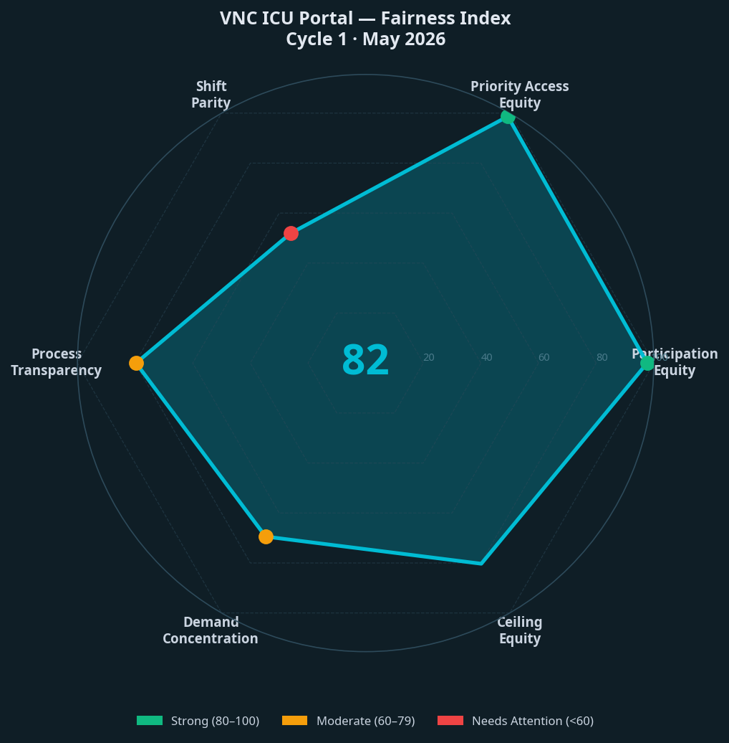

Score Summary
Dimension | Score | Weight | Rating | Key Metric
Participation Equity | 97.7/100 | 20% | Strong | 96.9% seniority-verified; 97.5% active; 100% submission acceptance
Priority Access Equity | 98.7/100 | 25% | Strong | 156/158 P1 requests (98.7%) fall within the 8-cap on ≥1 date; all seniority bands = 100% access
Shift Parity | 52.0/100 | 15% | Needs Attention | AM cap utilization 72% vs NOC 53.1% vs PM 17.1%; AM oversubscribed 33.8% of days
Process Transparency | 79.7/100 | 15% | Moderate | 96.9% verified; 33.3% added comments; 13.7% used priority re-ranking
Demand Concentration | 69.4/100 | 15% | Moderate | Gini coefficient 0.306; 82 employees (50.6%) submitted 1–2 requests; 7 employees submitted 5+
Ceiling Equity | 80.3/100 | 10% | Strong | AM cap = 10% of shift; NOC = 11.3%; PM = 88.9% (structurally unconstrained)
COMPOSITE (weighted) | 82.4/100 | 100% | Strong | Weighted average of all 6 dimensions

Rating Scale
Score Range | Rating | Interpretation
80–100 | Strong | The process is performing well on this dimension. Maintain and monitor.
60–79 | Moderate | Acceptable performance with clear improvement opportunities. Target in next cycle.
40–59 | Needs Attention | A structural gap exists. Requires policy or design intervention before Cycle 2.
0–39 | Critical | Systemic inequity. Immediate corrective action required.

Dimension-by-Dimension Analysis
D1. Participation Equity 97.7/100 — Strong
Key metric: 96.9% seniority-verified; 97.5% active; 100% submission acceptance
Every employee who submitted a request was accepted into the system without gatekeeping. The 96.9% verification rate means that nearly all seniority tie-breakers are based on confirmed, audited dates rather than self-reported estimates. The 5 unverified accounts represent the only structural gap in this dimension.
Recommended action: Resolve the 5 pending verifications before deliberations open to achieve a perfect score.
D2. Priority Access Equity 98.7/100 — Strong
Key metric: 156/158 P1 requests (98.7%) fall within the 8-cap on ≥1 date; all seniority bands = 100% access
This is the most heavily weighted dimension because it directly measures whether the system's core promise — that your top-priority request has a realistic path to approval — holds across all seniority levels. Junior nurses (0–4 years) achieve the same 100% cap access rate as 20+ year veterans on their P1 requests. This is a structural achievement: the 8-person cap is large enough relative to shift size that even the most junior employees can access it on their chosen dates. Only 2 P1 requests are entirely outside the cap on every date they requested — both on the AM shift during the peak July–October window.
Recommended action: Address the 2 fully-displaced P1 requests through direct admin conversation about alternative dates.
D3. Shift Parity 52.0/100 — Needs Attention
Key metric: AM cap utilization 72% vs NOC 53.1% vs PM 17.1%; AM oversubscribed 33.8% of days
This is the lowest-scoring dimension and the most structurally significant finding in the Fairness Index. The AM shift bears a disproportionate deliberation burden: 73 of its 216 active days (33.8%) are oversubscribed, compared to 21 of 243 NOC days (8.6%) and zero PM days. The root cause is not unfairness in the rules — the same 8-person cap applies to all shifts — but a fundamental imbalance in shift size. With 80 AM employees and only 9 PM employees, the cap represents 10% of AM capacity and 89% of PM capacity. An AM nurse faces a structurally harder approval environment than a PM nurse, purely because of which shift they work. This is not a portal design failure; it is a workforce composition reality that the portal has made visible for the first time.
Recommended action: Consider a shift-proportional cap formula (e.g., 10% of shift headcount, rounded up) rather than a flat 8. For AM: 8 (unchanged). For NOC: 7. For PM: 1–2. This would equalize the structural burden across shifts and is a policy decision for unit leadership, not a technical change.
D4. Process Transparency 79.7/100 — Moderate
Key metric: 96.9% verified; 33.3% added comments; 13.7% used priority re-ranking
Process transparency measures whether employees can meaningfully signal their preferences and whether those signals are captured with integrity. The verification rate is strong. Comment usage at 33.3% is healthy for a first-cycle deployment — one in three employees chose to add context to their requests, which is a sign of trust in the system. Priority re-ranking (13.7% of requests) indicates that employees are actively managing their submissions rather than submitting and forgetting. The score is held at Moderate rather than Strong because 3.1% of accounts remain unverified, and because comment and re-ranking adoption has room to grow in future cycles.
Recommended action: In Cycle 2, add an in-portal prompt reminding employees to review and confirm their priority rankings 7 days before the submission deadline. This would likely increase re-ranking engagement and push this score into the Strong range.
D5. Demand Concentration 69.4/100 — Moderate
Key metric: Gini coefficient 0.306; 82 employees (50.6%) submitted 1–2 requests; 7 employees submitted 5+
Demand concentration measures how evenly distributed requests are across the employee population. A Gini coefficient of 0.306 indicates moderate inequality — the distribution is not perfectly equal (where every employee submits the same number of requests), but it is far from highly concentrated. The majority of employees (82 of 157, or 52.2%) submitted 1–2 active vacation requests, while 7 employees submitted 5 or more. The portal's policy allows up to 10 requests, and the system does not penalize high-volume submitters — their additional requests simply receive lower working priority. This is the intended design: more requests mean more options for the employee, but the first-priority request is what matters most.
Recommended action: Monitor whether high-volume submitters (5+ requests) are consuming a disproportionate share of approved slots in Cycle 2. If so, consider a soft limit of 5 active requests per employee to reduce administrative review volume.
D6. Ceiling Equity 80.3/100 — Strong
Key metric: AM cap = 10% of shift; NOC = 11.3%; PM = 88.9% (structurally unconstrained)
Ceiling equity measures whether the 8-person cap is appropriately calibrated for each shift's headcount. For AM and NOC, the cap represents 10–11% of shift size, which falls within the 8–15% ideal range for a critical care unit. For PM, the cap is effectively unconstrained: with only 9 PM employees, an 8-person cap means 88.9% of the shift could theoretically be off on the same day. In practice, PM has zero oversubscribed days, so this does not create a real operational problem in Cycle 1. However, it does mean that PM employees face a structurally easier approval environment, which is the same structural imbalance identified in Shift Parity.
Recommended action: The PM cap is a non-issue operationally in Cycle 1, but should be revisited if PM headcount grows. A proportional cap would bring this dimension to a perfect score.

Methodology Note
All scores are computed from live database queries and the working priority CSV generated on May 9, 2026. The framework draws on established fairness measurement concepts including the Gini coefficient (for demand concentration), proportional cap analysis (for ceiling equity), and participation completeness metrics (for process transparency). Dimension weights reflect the deliberation committee's stated priorities: Priority Access Equity (25%) is weighted highest because it directly measures whether the system's core promise to employees is kept. Participation Equity (20%) is second because a fair process must be accessible to all. The remaining four dimensions share equal weight at 10–15% each. Weights and scoring formulas are documented in the portal's scripts directory (scripts/fairness-index.py) and can be adjusted by the admin team for future cycles.
This index is not a final verdict on the fairness of individual decisions — those remain the responsibility of the management team. It is a structural diagnostic: a way of seeing where the system is working well, where it is working adequately, and where it needs deliberate improvement before the next cycle begins.

