ACP-Gini: An Ancestor-Correlation Penalized Splitting Criterion for Multicollinearity-Robust Decision Trees
Huynh Khang Lam | Tuan Dat Phan | Trong Nhan Nguyen | Xuan Huy Nguyen
Artificial Intelligence, FPT University, Ho Chi Minh City, Vietnam
khanglhse200666@fpt.edu.vn | ptundatwork@gmail.com | hi.gesar@gmail.com | HuyNX23@fe.edu.vn
Abstract. Decision trees avoid coefficient-identification problems associated with linear regression, but correlated predictors can still make their selected feature sets redundant and their importance profiles difficult to interpret. We introduce ACP-Gini, a single-tree splitting criterion that multiplies each candidate's raw Gini gain by a product of correlation penalties against distinct features already used on the root-to-node path. The implementation reduces exactly to CART at α=0, excludes self-penalties, and uses raw gain for stopping. Evaluation combines a controlled correlated-feature generator with five real binary-classification data sets, 15 repeated cross-validation folds, and 50 bootstrap refits per fold. At selected α, ACP-Gini reduces bootstrap weighted redundancy by 12.1% on WDBC, 29.6% on Wine, 12.9% on Ionosphere, and 10.8% on Sonar, while predictive differences from CART are not statistically significant. A real-data operating sweep shows that WDBC at α=0.6 reduces weighted redundancy by 38.5% over three seeds with a 0.17 percentage-point accuracy change; the seed-42 five-fold result is 46.5% with identical accuracy. Synthetic group coverage and within-group concentration increase from α=0 to 1 at every tested correlation level, with a small rise in noise importance. Stability improves on Wine and Pima but decreases on WDBC and Sonar, revealing a stability--redundancy tradeoff rather than a uniform stability gain.
Keywords: Decision trees, multicollinearity, feature redundancy, model stability, interpretable machine learning

Introduction
Decision trees are often described as “immune” to multicollinearity because a split uses one predictor at a time. This claim is narrower than it first appears. Trees do avoid simultaneous coefficient estimation, yet greedy induction must still choose among correlated variables with nearly interchangeable gains. Small sample changes can alter the representative chosen from a correlated block, while a single fitted tree may repeatedly use several members of the same block along different branches. Consequently, prediction can remain strong while the selected feature set is internally redundant and impurity-based importance is spread across substitutes.
The distinction matters for interpretable machine learning. A model can be accurate but give a needlessly repetitive account of the evidence used for its decisions. Correlated-feature effects on variable importance are well documented for forests [4, 5, 7], while tree instability motivated resampling methods such as bagging [9]. For an auditable single tree, however, preprocessing by variance-inflation-factor (VIF) pruning discards variables globally, and regularized-tree methods apply feature-level penalties that do not express the pairwise relationship between a candidate and the path that leads to the current node.
ACP-Gini addresses this local redundancy problem. At a node T, it discounts the Gini gain of candidate Xⱼ according to its absolute correlation with distinct features used by ancestors of T. The design retains the familiar CART induction procedure [1, 11], remains exactly backward-compatible at α=0, and leaves raw gain responsible for deciding whether an informative split exists.
This study makes four contributions:
- an ancestor-correlation penalty for a single interpretable tree, including explicit no-self-penalty and raw-gain stopping rules;
- two direct measures of selected-set redundancy, plus bootstrap stability and split-composition measures;
- controlled group-level synthetic evaluation and a five-data-set real benchmark against CART, VIF+CART, and an RRF-inspired single tree;
- a reproducible from-scratch implementation whose tables and figures are generated from committed CSV outputs.
The scope is interpretable model construction and model diagnostics, complementing the broader argument for directly usable interpretable models in consequential settings [12].

Related Work

CART and instability.
CART greedily maximizes an impurity decrease at each node [1]. Greedy induction is sensitive to perturbations because an early alternative split changes all descendants. Li and Belford studied instability across decision-tree induction algorithms [10]; bagging was motivated partly by exploiting the variance of unstable learners [9]. These results concern predictive variance and structure, but do not directly regulate correlation among selected split features.

Correlated predictors and importance.
Conditional permutation importance was proposed to address dependencies among predictors [4]. Nicodemus et al. demonstrated that correlation changes permutation-importance behavior [5]; Genuer et al. examined variable selection in random forests [6]; and Louppe et al. analyzed impurity-based importance in randomized trees [7]. These approaches are mainly diagnostic or ensemble-oriented. ACP-Gini changes the construction of one tree and retains unpenalized impurity gain for comparable feature-importance accounting.

Feature regularization and preprocessing.
Regularized Random Forest penalizes the gain of newly introduced features [2], and guided RRF incorporates external importance information [3]. Our RRF-style baseline is explicitly a single-tree adaptation so that all splitting methods share one implementation. VIF pruning represents the preprocessing family; the threshold of 10 follows common practice summarized by Dormann et al. [8]. Unlike global removal, ACP-Gini can retain a correlated predictor for a branch where it supplies useful conditional information.
The gap is therefore specific: prior work does not inject an interpretable pairwise correlation with root-to-node ancestors into the split criterion of a single tree. ACP-Gini is not an ensemble replacement; it is a local criterion for reducing repetitive feature use while preserving the mechanics and inspectability of CART.

Methodology
Let T contain n_T samples and let T_L,T_R be a candidate split. With class proportions p_k(T), Gini impurity and raw gain are
For each feature, the best threshold is found by sorting its values and evaluating midpoints between distinct adjacent values using cumulative class counts.
Let A(T) be the set of distinct feature indices used by ancestors on the root-to-T path. ACP-Gini excludes the candidate itself from the penalty set:
The selected candidate maximizes (S,Δ G,-j) lexicographically. Thus ties first favor larger raw gain and then the lowest feature index. Repeated splits on the same continuous predictor are not spuriously multiplied by (1-α).

Properties.
For fixed raw gain, the score is non-increasing in each absolute ancestor correlation and in α. The product accumulates moderate redundancy across several distinct ancestors. For α<1, all factors remain positive, so no feature is excluded by a hard threshold. At α=0, every factor equals one and the candidate ordering is exactly CART's ordering. Importantly, stopping depends only on whether any candidate has positive raw gain; the penalty reorders informative candidates but never turns an informative node into a leaf.
Pearson correlation is computed once on the full training fold by default. Spearman correlation rank-transforms columns before the same calculation. Constant-column NaNs are replaced by zero correlation. A node-local ablation recomputes correlations when at least 30 samples reach the node and otherwise falls back to the global matrix. Global preprocessing costs O(nd^2) once; lookup of ancestor correlations adds O(d,|A(T)|) per node beyond the threshold scan.

Parameter selection.
Inner stratified folds evaluate α ∈ 0.2,0.4,0.6,0.8,1.0. Eligible values have macro-F1 within one standard deviation of the α=0 mean, and importance rank correlation selects among eligible values. The final data-set value is the lower quartile of fold-level selections, rounded down to the grid. This conservative aggregation biases disagreements toward a weaker, more CART-like penalty, analogous in spirit to a one-standard-error rule. The RRF-style lambda ∈ 0.5,0.7,0.9 uses the upper quartile because larger lambda is the weaker penalty.

Experimental Setup
We use WDBC from scikit-learn [13], Wine Quality, Ionosphere, and Sonar from UCI [14], and Pima Diabetes from OpenML. All are numeric binary-classification tasks. Pairwise |r|>0.7 occurs most frequently in WDBC and Sonar; Pima serves as a low-collinearity control. Cached CSV files accompany the code.
Synthetic data contain five independent Gaussian signals with weights (1,.8,.6,.4,.2), three correlated copies per signal, and five noise features. A copy is ρ Z+sqrt1-ρ^2epsilon for ρ ∈.7,.8,.9,.95,.99. Group coverage is the fraction of the five signal groups represented among the top-five importance features. Group concentration averages max_j ∈ gI_j/sum_j ∈ gI_j over all five groups; a zero-mass group contributes zero. Noise importance is the total mass on the five noise columns.
All main methods use depth 6 and minimum leaf size 5. Three shuffled five-fold runs (seeds 42--44) provide 15 paired observations. Each training fold is additionally bootstrapped 50 times. Predictive metrics are accuracy, macro-F1, and AUC. Stability metrics comprise Jaccard similarity of all used-feature sets, top-five-importance Jaccard, Spearman correlation of importance vectors, and split-composition distance, defined as one minus multiset Jaccard over (depth,feature) internal-node pairs.
For a fitted tree with used set U, selected-set redundancy is the mean |r_ij| over pairs in U. Importance-weighted redundancy is
Both use the full-data correlation matrix for a consistent diagnostic scale and are reported for main fits and averaged bootstrap fits. Wilcoxon signed-rank tests use paired fold observations [15]. Root agreement is retained in raw CSVs but omitted from headline tables because ACP-Gini is identical to CART at the root by construction.

Results and Discussion

Correctness and Synthetic Ground Truth
The α=0 sanity suite passed all 15 seed--data-set cases. Pearson and Spearman modes produced identical structures and predictions when the penalty was inactive; held-out accuracy differed from scikit-learn's tree by at most 0.01.
Figure~fig:synthetic reports group-level results. At ρ=.9, group coverage increases from.68 to.74 and group concentration from.690 to.745 between α=0 and 1. Across the five ρ values, endpoint coverage gains range from.04 to.10 and endpoint concentration gains from.027 to.098. Intermediate values are not strictly monotone for every ρ, but every endpoint improves. Figure~fig:sensitivity shows that accuracy remains near.79 at ρ=.9, while noise importance rises from.018 to approximately.033. This is a small but real side effect: discouraging redundant signal variables occasionally exposes weak noise splits.
RRF-style also attains strong synthetic concentration because its fixed penalty rewards rote reuse of already-used features, without considering correlation strength. This behavior does not transfer to real data: bootstrap weighted redundancy is.603 versus CART's.621 on WDBC and.181 versus.183 on Wine, while ACP-Gini reaches.545 and.128. The contrast motivates a correlation-aware penalty rather than a fixed new-feature penalty.
Exact-original recovery is less suitable at high ρ: an original and its copy are close substitutes, and selecting one representative should not be counted as failure merely because it is not the designated original column. The group metrics align the evaluation with the method's intended behavior.

Prediction and Selected-Set Redundancy
The conservative selected values are.2 (WDBC), 1.0 (Wine),.4 (Ionosphere),.2 (Sonar), and.2 (Pima). Accuracy differences from CART are statistically indistinguishable on every data set. Sonar's direction is negative but shrinks to only.65 percentage points after lower-quartile aggregation; Ionosphere changes from.885 to.886.
The primary result is lower internal correlation. Bootstrap weighted redundancy falls from.621 to.545 on WDBC (12.1%),.183 to.128 on Wine (29.6%),.168 to.146 on Ionosphere (12.9%), and.218 to.195 on Sonar (10.8%). All four reductions are significant at p<.001. Pima changes by only.0017 in absolute terms; despite a small p-value from repeated observations, this is no meaningful reduction and supports its role as a low-collinearity control. Figure~fig:redundancy visualizes the comparison.
VIF+CART reaches lower WDBC redundancy (.343 versus ACP-Gini's.545) by globally deleting 13 of 30 features before training. That reduction entails irreversible information loss and a fixed feature set; ACP-Gini keeps every feature available for branch-conditional use at equal accuracy.
The operating sweep in Fig.~fig:sweep separates a conservative default from attainable operating points. Across all three seeds, WDBC at α=.6 reduces main-fit weighted redundancy from.634 to.390 (38.5%) while accuracy changes from.934 to.932. The pre-specified seed-42 five-fold check reproduces.656 to.351 (46.5%) with accuracy unchanged at.926. Wine shows a smooth redundancy decline from.166 to.118 while accuracy stays between.746 and.748. Thus practitioners can increase α when redundancy reduction is worth a small tolerance in predictive performance.

The Stability--Redundancy Tradeoff
Importance rank correlation rises by.179 on Wine and.017 on Pima; top-five Jaccard rises by.069 and.010, respectively. Wine's gains are significant at p=.0001. Conversely, rank stability decreases by.057 on WDBC and.040 on Sonar, with smaller negative changes on Ionosphere. Table~tab:stability shows this conditional pattern.
This is not equivalent to predictive failure. CART's apparent stability can arise from repeatedly selecting the same correlated block, whereas ACP-Gini deliberately diversifies downstream evidence. Lower redundancy and higher cross-bootstrap rank agreement are distinct goals. ACP-Gini improves both where redundant choice drives instability (Wine), but trades rank consistency for less correlated feature use in block-correlated WDBC and Sonar.

Ablation, Runtime, and Qualitative Analysis
The ablation does not identify a universally dominant configuration. Spearman obtains the highest WDBC accuracy (.937), while Pearson-min is strongest on synthetic accuracy (.796); product-Pearson-global remains the simplest pre-specified default. Global-scope runtime ranges from.85 to 1.33 times CART across data sets, and node-local scope from.84 to 1.44 times. The overhead is data dependent and is not uniformly below 10%.
Figure~fig:trees illustrates that the WDBC root and left branch remain identical, while the right child changes from mean texture to texture error under ACP-Gini. Average node counts remain comparable because raw-gain stopping preserves informative splitting: for example, WDBC uses 24.2 nodes for ACP-Gini and 24.7 for CART.
Across the WDBC repeated folds, CART and ACP-Gini disagree on 65 predictions. CART alone is correct in 33 cases and ACP-Gini alone in 32; 20 disagreements are near a [.4,.6] probability boundary. The near balance is consistent with unchanged aggregate accuracy.

Research questions.
RQ1 is conditional: stability improves on Wine and Pima but decreases on WDBC and Sonar. RQ2 is supported by synthetic group metrics and the lower selected-set redundancy on four collinear real data sets. RQ3 is supported: selected settings have statistically indistinguishable accuracy, while the sweep exposes the adjustable tradeoff. RQ4 is not supported as originally framed: node counts and depth are comparable; compactness is better characterized as lower redundancy of the selected evidence.

Limitations.
ACP-Gini is a greedy heuristic without a global optimality guarantee. Correlation does not distinguish redundancy from useful conditional interaction. High α can increase noise importance and, on WDBC at α=1, reduce accuracy to.921. Results concern numeric binary data and one tree; categorical association measures such as Cramer's's V and ensemble integration remain future work. The five data sets provide varied correlation structures but do not establish universal behavior.

Conclusion
ACP-Gini introduces an interpretable path-dependent correlation penalty while preserving CART behavior at α=0, repeated-feature splitting, and raw-gain stopping. The strongest evidence concerns redundancy rather than a uniform stability gain: selected feature sets are less internally correlated on four collinear real data sets without statistically significant predictive loss, and synthetic group-level recovery improves across all tested correlation endpoints. Stability depends on data structure, yielding an informative stability--redundancy tradeoff. Future work should study theoretical conditions for beneficial penalties, categorical association, regression trees, and ensemble variants.

Generated Evidence Tables
Table 1. Data-set statistics.
dataset | n | d | positive_rate | pair_fraction_abs_r_gt_07
WDBC | 569 | 30 | 0.627 | 0.161
Wine | 6497 | 11 | 0.633 | 0.018
Ionosphere | 351 | 34 | 0.359 | 0.005
Sonar | 208 | 60 | 0.534 | 0.031
Pima | 768 | 8 | 0.349 | 0.000

Table 2. Mean predictive performance over 15 folds.
dataset | method | accuracy | macro_f1 | auc
Ionosphere | ACP-Gini | 0.886 | 0.876 | 0.904
Ionosphere | CART | 0.885 | 0.874 | 0.910
Ionosphere | RRF-style | 0.885 | 0.875 | 0.910
Ionosphere | VIF+CART | 0.885 | 0.874 | 0.910
Pima | ACP-Gini | 0.733 | 0.692 | 0.774
Pima | CART | 0.737 | 0.698 | 0.774
Pima | RRF-style | 0.735 | 0.696 | 0.776
Pima | VIF+CART | 0.737 | 0.698 | 0.774
Sonar | ACP-Gini | 0.731 | 0.729 | 0.764
Sonar | CART | 0.737 | 0.736 | 0.752
Sonar | RRF-style | 0.726 | 0.724 | 0.750
Sonar | VIF+CART | 0.715 | 0.712 | 0.754
WDBC | ACP-Gini | 0.934 | 0.929 | 0.957
WDBC | CART | 0.934 | 0.929 | 0.953
WDBC | RRF-style | 0.941 | 0.936 | 0.958
WDBC | VIF+CART | 0.931 | 0.926 | 0.962
Wine | ACP-Gini | 0.746 | 0.726 | 0.800
Wine | CART | 0.747 | 0.725 | 0.797
Wine | RRF-style | 0.748 | 0.724 | 0.799
Wine | VIF+CART | 0.747 | 0.724 | 0.798

Table 3. Bootstrap selected-set redundancy.
dataset | method | bootstrap_set_redundancy | bootstrap_weighted_redundancy
Ionosphere | ACP-Gini | 0.159 | 0.146
Ionosphere | CART | 0.183 | 0.168
Ionosphere | RRF-style | 0.183 | 0.166
Ionosphere | VIF+CART | 0.182 | 0.167
Pima | ACP-Gini | 0.169 | 0.178
Pima | CART | 0.170 | 0.180
Pima | RRF-style | 0.169 | 0.180
Pima | VIF+CART | 0.170 | 0.180
Sonar | ACP-Gini | 0.204 | 0.195
Sonar | CART | 0.234 | 0.218
Sonar | RRF-style | 0.226 | 0.216
Sonar | VIF+CART | 0.220 | 0.195
WDBC | ACP-Gini | 0.338 | 0.545
WDBC | CART | 0.465 | 0.621
WDBC | RRF-style | 0.458 | 0.603
WDBC | VIF+CART | 0.283 | 0.343
Wine | ACP-Gini | 0.220 | 0.128
Wine | CART | 0.245 | 0.183
Wine | RRF-style | 0.244 | 0.181
Wine | VIF+CART | 0.238 | 0.169

Table 4. Bootstrap stability metrics.
dataset | method | feature_set_jaccard | top5_jaccard | importance_rank_corr | structural_distance
Ionosphere | ACP-Gini | 0.322 | 0.293 | 0.372 | 0.880
Ionosphere | CART | 0.335 | 0.303 | 0.388 | 0.878
Ionosphere | RRF-style | 0.319 | 0.304 | 0.378 | 0.882
Ionosphere | VIF+CART | 0.338 | 0.305 | 0.393 | 0.877
Pima | ACP-Gini | 0.899 | 0.677 | 0.714 | 0.663
Pima | CART | 0.928 | 0.668 | 0.698 | 0.664
Pima | RRF-style | 0.862 | 0.671 | 0.701 | 0.669
Pima | VIF+CART | 0.928 | 0.668 | 0.698 | 0.664
Sonar | ACP-Gini | 0.122 | 0.106 | 0.088 | 0.953
Sonar | CART | 0.149 | 0.111 | 0.128 | 0.947
Sonar | RRF-style | 0.128 | 0.111 | 0.112 | 0.952
Sonar | VIF+CART | 0.166 | 0.128 | 0.155 | 0.945
WDBC | ACP-Gini | 0.268 | 0.224 | 0.241 | 0.908
WDBC | CART | 0.306 | 0.250 | 0.298 | 0.899
WDBC | RRF-style | 0.246 | 0.239 | 0.265 | 0.901
WDBC | VIF+CART | 0.311 | 0.266 | 0.308 | 0.884
Wine | ACP-Gini | 0.898 | 0.675 | 0.845 | 0.512
Wine | CART | 0.986 | 0.606 | 0.666 | 0.568
Wine | RRF-style | 0.953 | 0.603 | 0.666 | 0.573
Wine | VIF+CART | 0.993 | 0.620 | 0.766 | 0.549

Figures
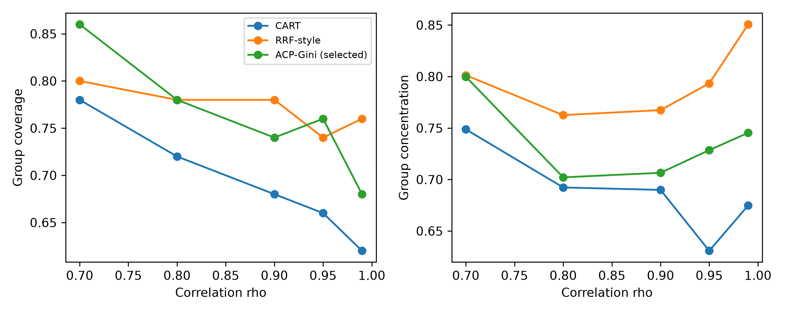
Figure 2. Synthetic group coverage and concentration.
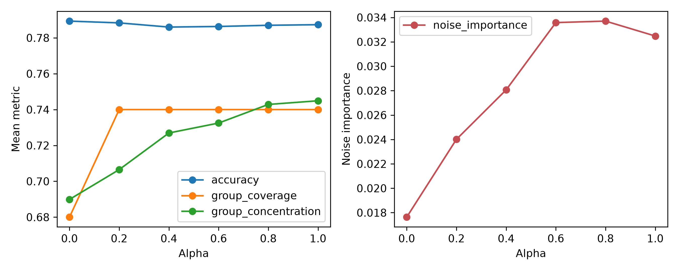
Figure 3. Alpha sensitivity and noise importance.
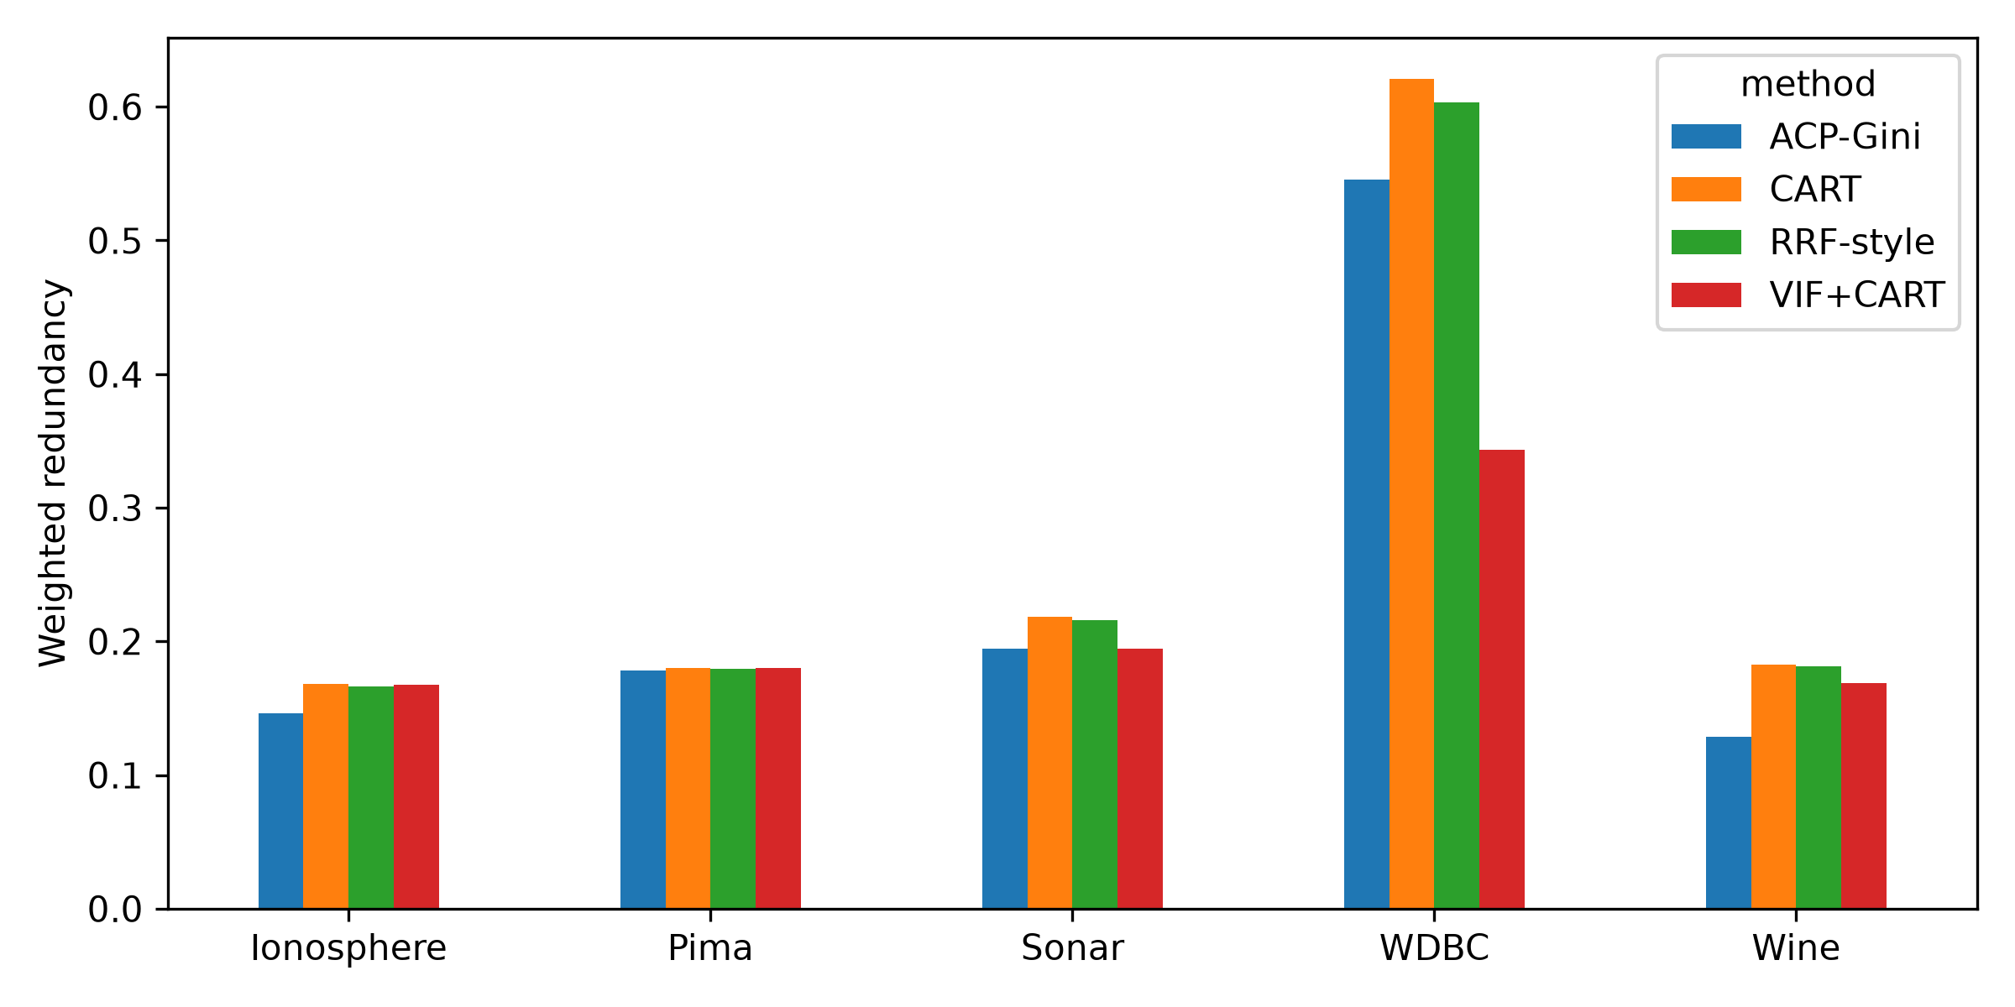
Figure 4. Bootstrap weighted redundancy.
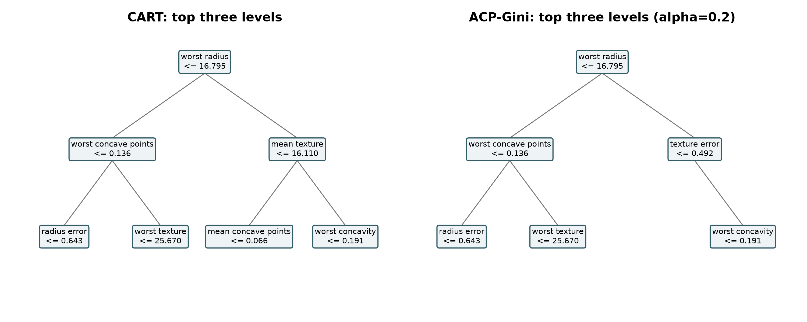
Figure 5. WDBC tree comparison.
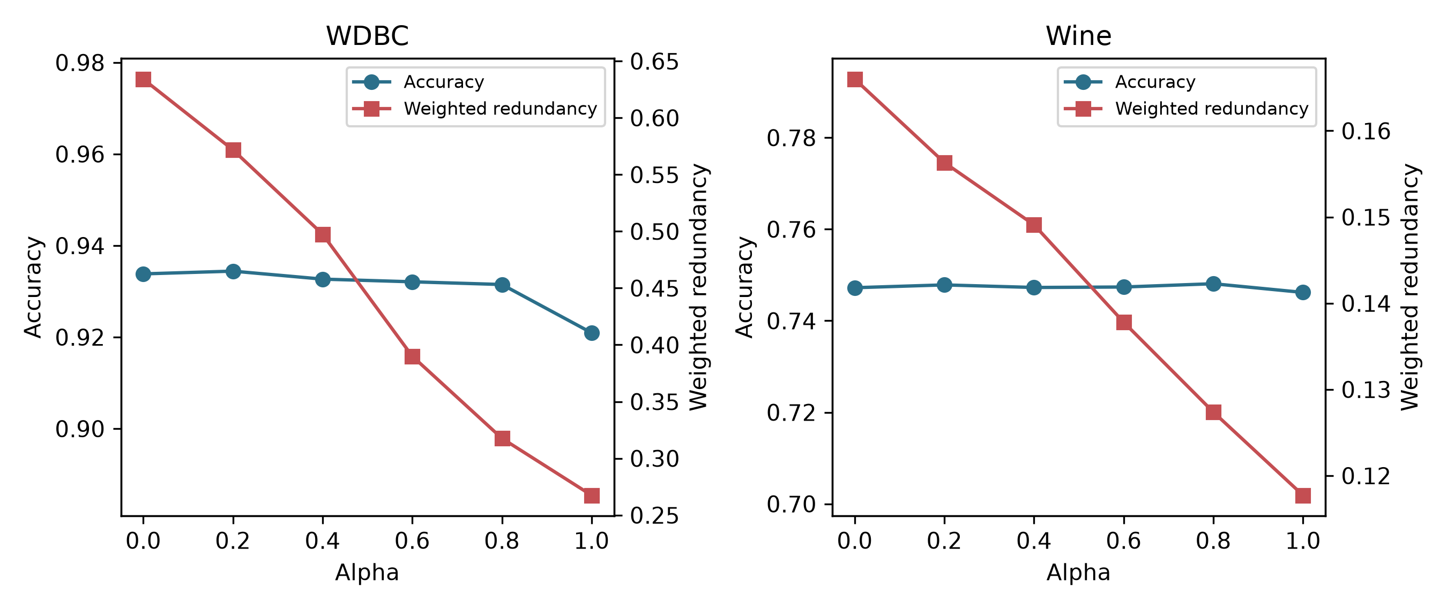
Figure 6. WDBC and Wine operating characteristics.

References
[1] Breiman, Leo and Friedman, Jerome H. and Olshen, Richard A. and Stone, Charles J.. Classification and Regression Trees. 1984.
[2] Deng, Houtao and Runger, George. Feature Selection via Regularized Trees. 2012.
[3] Deng, Houtao and Runger, George. Gene Selection with Guided Regularized Random Forest. 2013.
[4] Strobl, Carolin and Boulesteix, Anne-Laure and Kneib, Thomas and Augustin, Thomas and Zeileis, Achim. Conditional Variable Importance for Random Forests. 2008.
[5] Nicodemus, Kristin K. and Malley, James D. and Strobl, Carolin and Ziegler, Andreas. The Behaviour of Random Forest Permutation-Based Variable Importance Measures under Predictor Correlation. 2010.
[6] Genuer, Robin and Poggi, Jean-Michel and Tuleau-Malot, Christine. Variable Selection Using Random Forests. 2010.
[7] Louppe, Gilles and Wehenkel, Louis and Sutera, Antonio and Geurts, Pierre. Understanding Variable Importances in Forests of Randomized Trees. 2013.
[8] Dormann, Carsten F. and Elith, Jane and Bacher, Sven and Buchmann, Carsten and Carl, Gudrun and Carr'e. Collinearity: A Review of Methods to Deal with It and a Simulation Study Evaluating Their Performance. 2013.
[9] Breiman, Leo. Bagging Predictors. 1996.
[10] Li, Ruey-Hsia and Belford, Geneva G.. Instability of Decision Tree Classification Algorithms. 2002.
[11] Hastie, Trevor and Tibshirani, Robert and Friedman, Jerome. The Elements of Statistical Learning. 2009.
[12] Rudin, Cynthia. Stop Explaining Black Box Machine Learning Models for High Stakes Decisions and Use Interpretable Models Instead. 2019.
[13] Pedregosa, Fabian and Varoquaux, Ga"e. Scikit-learn: Machine Learning in Python. 2011.
[14] Kelly, Markelle and Longjohn, Rachel and Nottingham, Kolby. The UCI Machine Learning Repository. 2024.
[15] Demvs. Statistical Comparisons of Classifiers over Multiple Data Sets. 2006.

