Goldman Sachs Convertible Bond Model

Contents

Goldman Model 1994: designed by Emanuel Derman 1

Assessment: Goldman 1994 model still valid with some caveats 1

Goldman Pricing: $126.82 3

RAV Pricing (FinCaD): $128.38 4

# Goldman Model 1994: designed by Emanuel Derman

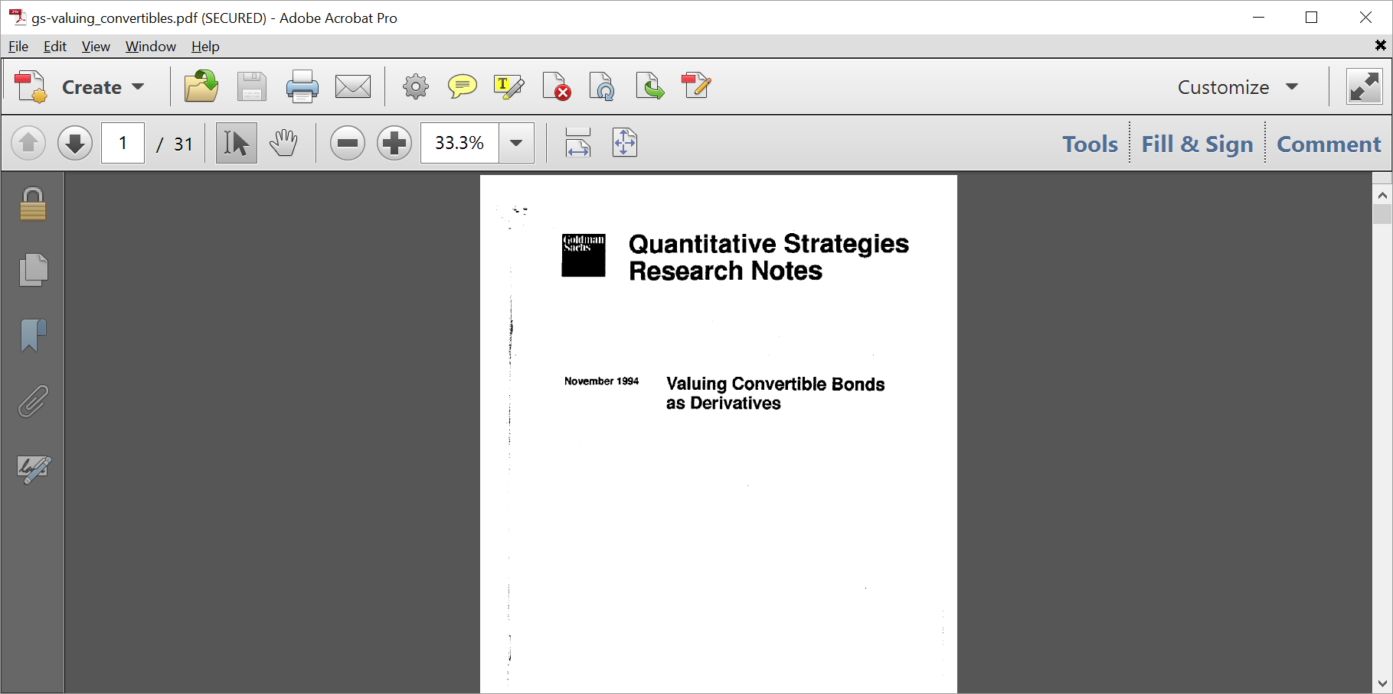

# Assessment: Goldman 1994 model still valid with some caveats

Convertible bonds models are particularly complex because of the intrinsically hybrid nature of the product. They are usually issued deep out-of-the-money with a lower coupon and present attractive feature for both issuer (generally subordinate debt, lower coupons) and investor (higher yield, option to own company equity in case of substantial appreciation).

Although very old, Goldman 1994 model still gives a reasonably good valuation of convertible bonds and corresponds to market practice. The percentage difference between Goldman 1994 and RAV (via FinCad pricing) is only 1.22%, see valuation in the next two paragraphs.

Caveat: the model assumes that the only source of uncertainty is stock volatility, everything else being deterministic, in particular in this Goldman 1994 model:

1. Interest rates are deterministic
2. Credit spreads are deterministic

Assumptions a. and b. pose no problem in case the conversion option is deep-in-the-money (surely conversion to equity) or deep-out-of-the-money (straight bond), because in the former case it is fair to assume your product is equivalent to an equity option fully characterized by equity volatility and in the latter case we have a cash (linear) product that does not require interest rate modeling.

The sensitive region, where more sophisticated models may be required, is in between, especially for long maturity convertibles: in this case the simple Goldman 1994 may present differences w.r.t. multifactor models that take into account stochastic behavior of the interest rates.

# Goldman Pricing: $126.82

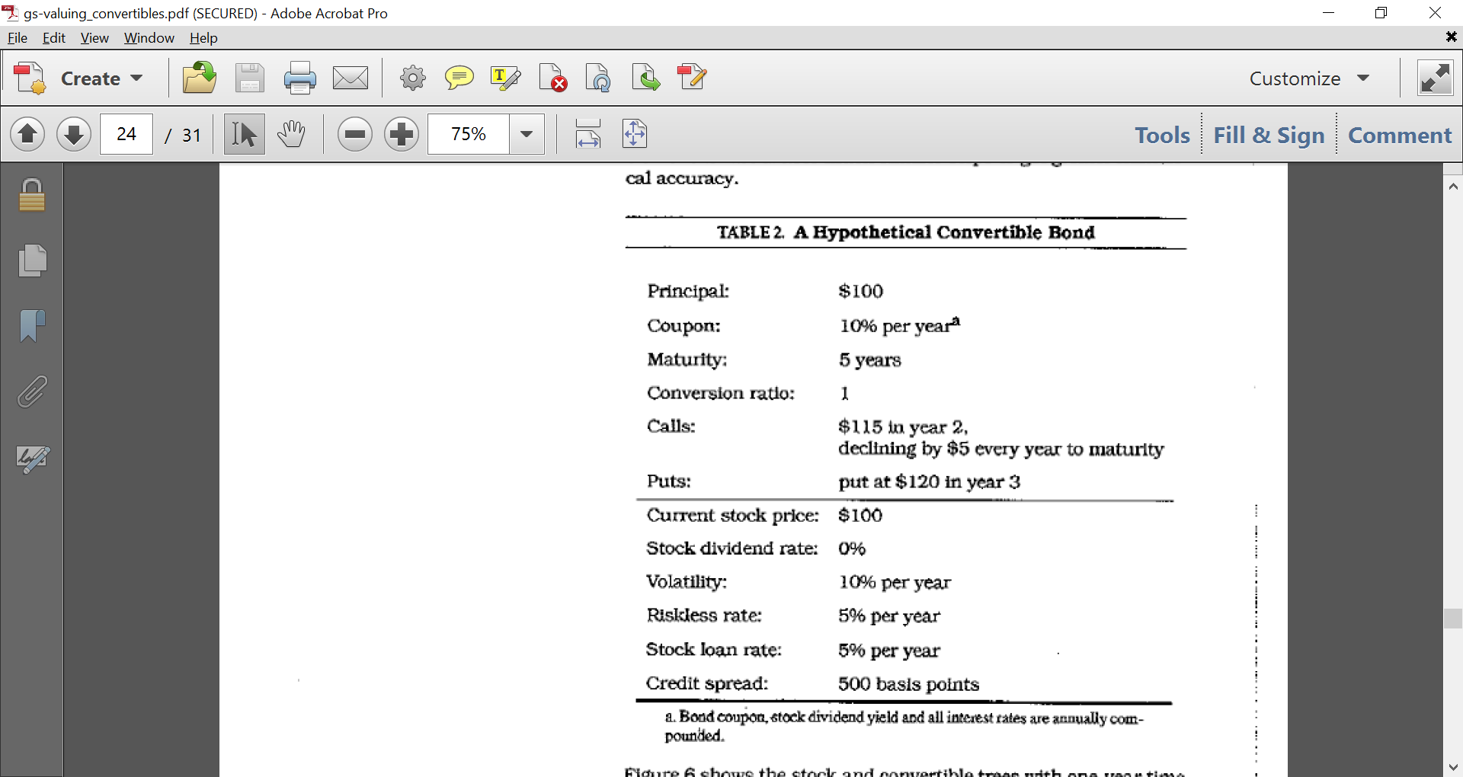

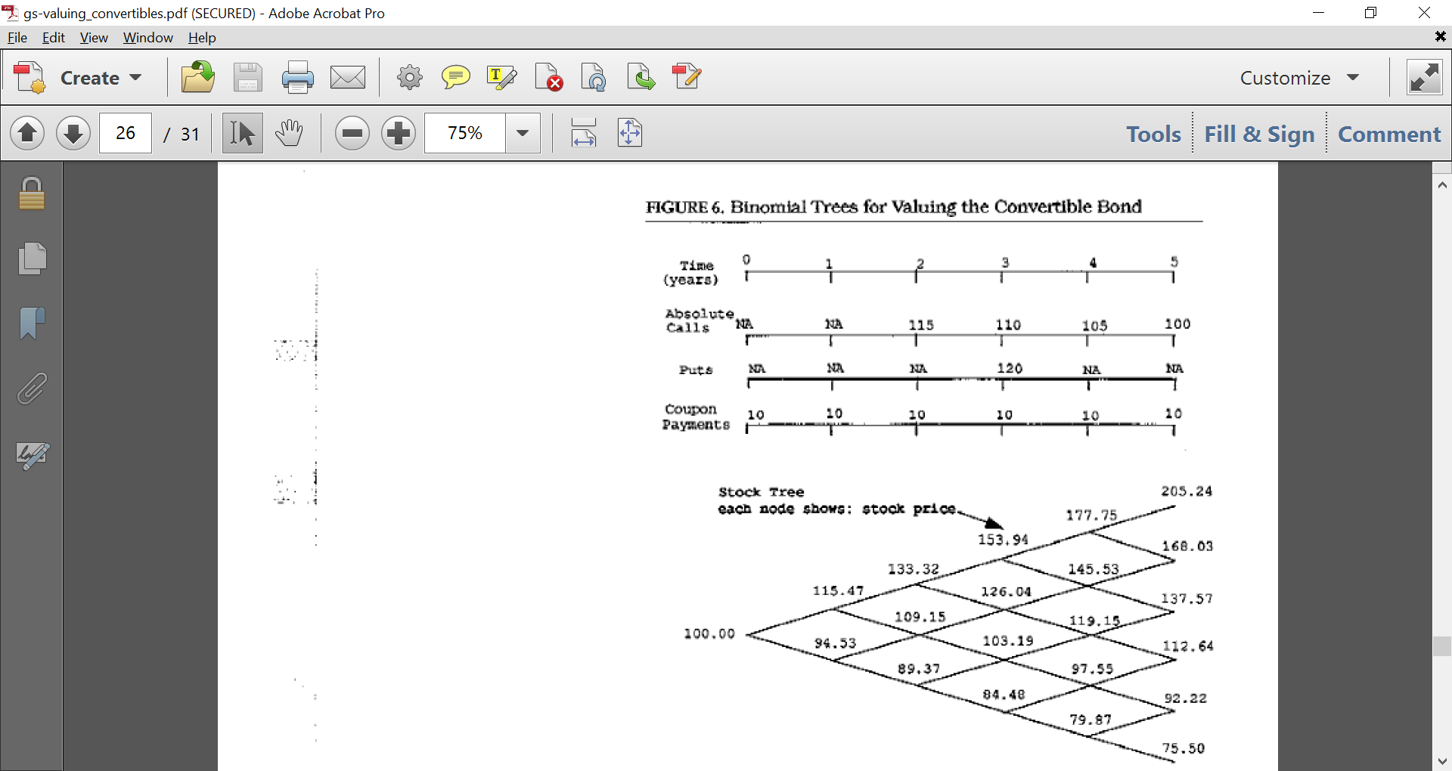

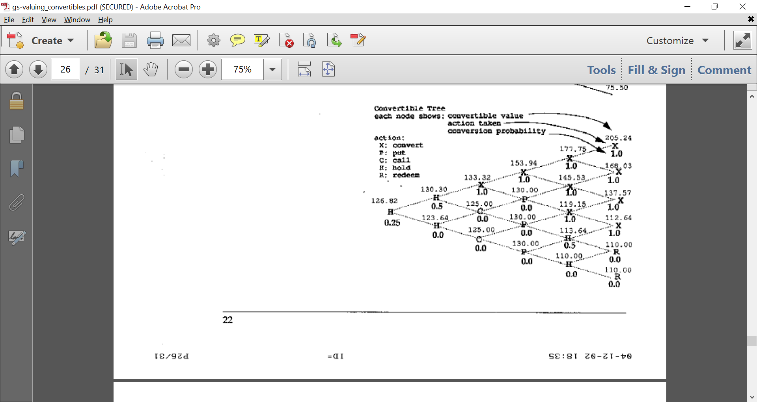

# RAV Pricing (FinCaD): $128.38

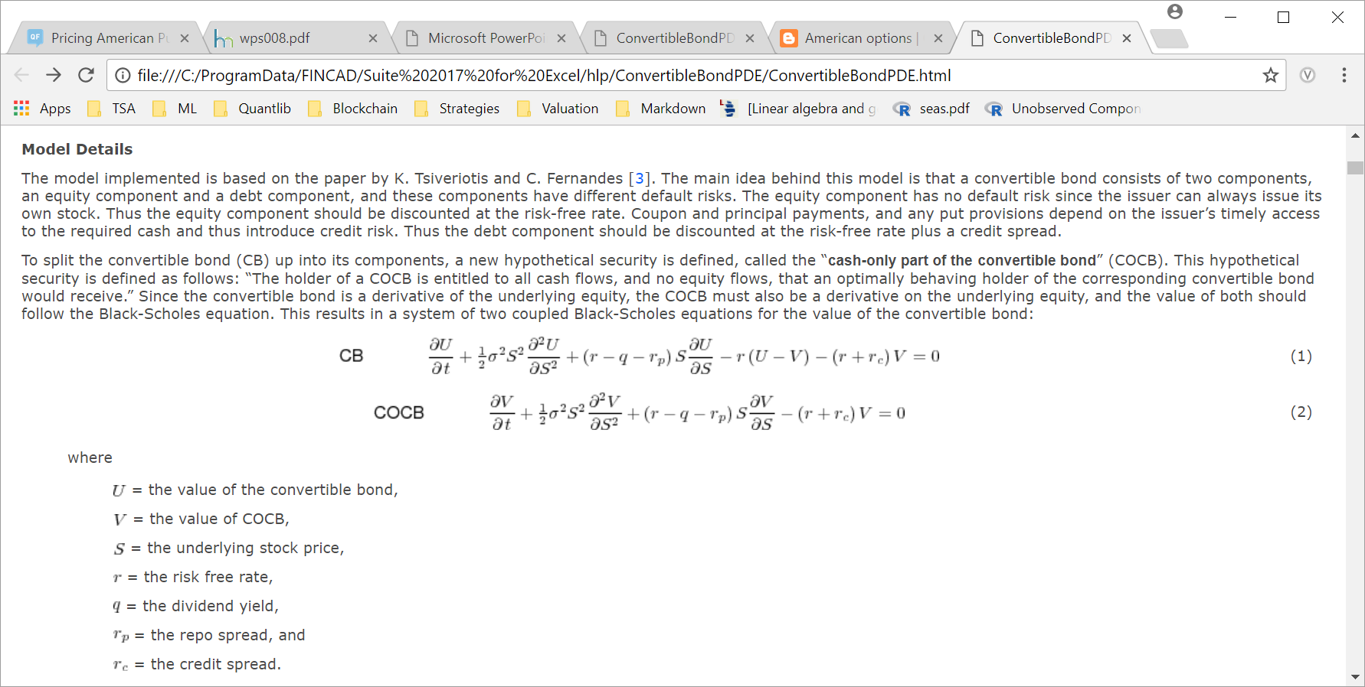

[3]    Tsiveriotis, K. and Fernandes, C. (1998), Valuing Convertible Bonds with Credit Risk, *Journal* *of* *Fixed* *Income*, **8**(2): pp. 95–102.

