Introduction to Revised Application and Response to Reviewers

This proposal represents a resubmission. Our decision to resubmit is based on the reviewer’s comments that “the problem being addressed is highly significant and success in this project would have considerable impact” (Summary) and “this project must be done by someone in the immediate future” (Critique 2), and the reviewers’ impression and our belief that we have assembled a team with the experience and record of productivity necessary to address this important problem.

The reviewers of the original proposal identified two related concerns that we believe we are able to clearly and directly address. The first was that “the application is considered quite ambitious and concern is expressed about feasibility.” The second concern was that “a lesser weakness of the application is the lack of collaborations outside the University of Georgia.” In fact, these are related, as both concerns are rooted in whether we have a plan for and can achieve adoption by the target community.

We start with the main concern on collaboration, and address how we intend to achieve acceptance and adoption by the community of biologists (as also asked in Critique 3). In the past, many tools have been developed that have not been adopted outside of their lab of origin, thus limiting the value of the research investment by NIH. To avoid this problem, our approach has following components:
- Use of relevant technical and community standards: At the infrastructure level these standards primarily involve Web technologies combined with Java and an open source development environment under the Eclipse foundation; at the communication and application interoperability level we adopt Web services standards such as XML/SOAP/UDDI and additional industry leading standards under OASIS with leadership by IBM and Microsoft); at the information modeling level we adopt W3C’s Semantic Web Standards for RDF and OWL for metadata and ontology representation; and at the level of biology community’s data exchange standards we demonstrate the ability to create messages that comply with relevant XML-based formats.
- Membership in key consortia. These include the Semantic Web Services Initiative’s Architecture (SWSA) committee, of which Dr. Sheth is a member and Dr. Miller is an alternate member (http://www.daml.org/services/swsa/), and the Human Proteome Organization (HUPO, http://www.hupo.org) Glycomics in Disease Initiative which is just being started and to which Dr. Sheth has been invited as an expert on ontology.
- Release of tools as open source. We will release the tools with detailed documentation, use cases and training material through Eclipse open-source foundation and license. Eclipse is “an independent open eco-system built around royalty-free technology and a universal platform for tools integration (http://www.eclipse.org).” This is particularly appropriate given that in January, the Large Scale Distributed Information (LSDIS) lab headed by the PI became a recipient of an Eclipse Innovation Grant from IBM. In this context, Eclipse toolset is now integral to the METEOR-S research project as well as in advanced courses such as Semantic Web Services and Processes (CSCI 8351, http://lsdis.cs.uga.edu/SemWebProcess/) taught by the PI and Advanced Information System taught by co-PI, Dr. Aprinar.
- Deployment, training, evaluation and user feedback at leading labs outside of the UGA, and from community leaders. This is the most important aspect of the revised application; the reviews as well as additional time afforded during the revision allowed us to interact with several key members of the community and seek their participation to ensure dissemination, evaluation and adoption of the key technological results of this project. In most cases, we have committed support for initial installation and adoption of the tools, and visits by project members to the labs of evaluators and adaptors for purposes of demonstrations and explanations. Specifically, the support letters attached with the revised application can be summarized as follows:
- Matthew Berriman (Sanger Center, UK) is the project manager of the Pathogen Sequencing Unit that uses the GUS database for pathogen genomes, and has agreed to use our tools for programmatic exchanges via Web Services between the GeneDB developed by his unit, Dr. Kissinger's lab and GUS databases (Human, Mouse, Plasmodium and Toxoplasma) at the University of Pennsylvania..
- J. Michael Cherry (Stanford University) has agreed to test and use the Web Services tools for providing Web Services based access to the Saccharomyces Genome Database (http://www.yeastgenome.org/).
- Christopher Hogue (Samuel Lunenfeld Research Institute) has agreed to test and use the tools for providing integrated access and analysis involving multiple data types and databases, specifically his BIND database (http://www.bind.ca) and data and tools from Dr. Arnold’s lab.
- Mark Gerstein and Kei Cheung (Yale University) have created an XML language (YHX, “Yeast Hub XML”) for integrating yeast data sources and the Yeast Hub web site. They have offered collaboration in which they will offer XML tags as a resource for developing an ontology, and then will use the ontology with semantic annotation, browsing and a Web Service Composition tool to support much more elaborate queries.
- Lincoln Stein (Cold Spring Harbor Laboratory), a member of the W3C, developer of WormBase (http://www.wormbase.org) and Gramene (http://www.gramene.org), and co-developer of the Distributed Annotation System (DAS) has agreed to install tools from this project to provide Web services based access and sharing of databases his lab hosts. Dr. Stein, himself a proponent of Web Services, has recognized the value of developing tools based on research in the Semantic Web and Web Services.
- Christian Stoeckert (University of Pennsylvania) is the director of the Computational Biology and Informatics Laboratory and a developer of the GUS (Genomics Unified Schema) architecture as part of an open source project. He has agreed to test, adapt and implement the tools developed in this proposal on the several GUS databases under his control with the intent of making them a part of the standard GUS distribution. We notes that the Web Services based database access will facilitate programmatic access to GUS databases and between GUS and other databases.

We agree with the reviewer’s comments that the proposal is ambitious. However, we feel confident that we will succeed in this admittedly ambitious agenda, for the following reasons:
- Substantial prior work at the technical and technological level: We have already built some of the tools and others are under development; this application will fund their adaptation and enhancement. Further, the past and ongoing collaboration between the biology and computer science members of the team is significant and well documented (e.g., publications).
- The LSDIS lab is one of the leading academic research groups on Semantic Web and Web Services. Recent highly competitive awards from NSF and NIH with over $1.5 million in funding since the original submission have further validated our competitive position and complement our ability to deliver the proposed work. (See the Semantic Discovery project and Bioinformatics for Glycan Expressions in the PI’s biosketch). Research output including publications and talks continue at a brisk pace. For example, the PI has given five keynotes in the area of Semantic Web and Web Services at international meetings during the last half of 2003.
- Research at the LSDIS lab is focusing on bioinformatics as an application area. The LSDIS lab stands apart from other research efforts in Semantic Web and Web Services in its focus on bioinformatics. In fact, three of the five keynotes mentioned in the above item focused on bioinformatics. Also, the prior six months have allowed us to validate our ability to rapidly develop targeted ontologies utilizing commercial products resulting from our own past research (and available free of cost to this project): SWETO ontology has been populated with a very large knowledgebase (so far approx. 1 million instances, http://lsdis.cs.uga.edu/proj/Sweto/) and is in the process of being offered to W3C’s Semantic Web Activity; GlycO ontology for glycan structures and glycobiology, (http://lsdis.cs.uga.edu/Projects/Glycomics/index.php) will be further refined to support the HUPO Glycomics in Disease Initiative.

We wish to clarify one particularly important point about our proposal: we do not consider achieving “general community-wide agreement of semantic terms” to be within the scope of this application. Instead, we intend to provide the methodology and tools that can be used with already developed ontologies. The biological community is arguably the most aggressive adopter of the ontology-based approach and perhaps has the greatest number of public ontologies, knowledge bases and nomenclatures, which are the building blocks of semantic agreement (e.g., GO, UMLS, KEGG, etc.). The BioSem ontology discussed as part of this proposal is just a focused and narrow ontology with the coverage encompassing the identified databases and datasets, and will reference (and reuse components of) existing relevant ontologies. It should be seen as a proof of concept of relevant ontology in the Semantic Web Service approach. Other researchers will be able to use our tools with their choice of databases/data sets and relevant ontologies.

Key reasons that we do not seek additional funding and consider the prior level of request to be adequate include (a) we do not intend to develop a new ontology with community wide agreement , (b) we have prototype versions of many of the proposed tools and thus need not develop these tools entirely from scratch, as described in (f) above.

Finally, this application has been updated to bring it to the latest in relevant research and technology, and includes additional published work.

Note: Additions are marked in the remainder of the application (deletions and minor editorial and formatting changes are not marked to avoid distraction).

Overview and Specific Aims
Laboratories are generating genomics data at an exponential rate. These data are generated at sites around the world and are typically accessible via the Web. At the same time, various groups are developing a variety of tools for analyzing such data. However, because of a lack of standards in how these data are stored and annotated, and a similar lack of standards in the way that tools are accessed and invoked, the task of using these various resources to combine data and tools in comparative or integrative analyses is not a straightforward task. The needs for interoperability and data integration are enormous. Web services (Stein, 2002), built on now widely accepted standards for data exchange (i.e., the extensible markup language (XML)), are the best candidate for a standardized interoperability infrastructure. Further, semantics-based approaches and the use of standards-based interoperability infrastructures can substantially improve scalability and automation in meeting these needs. Semantics involves the formal description of resources so that both humans and machines (i.e., software agents or programs) can understand and automatically use the resources. Components of a semantic solution include the use of (a) standard or consensus-based ontologies/semantic networks such as the GO Ontology (Gene Ontology Consortium, 2000) and the Unified Medical Language System (UMLS) (NLM, 2003), (b) evolving ontologies such as the protein-to-protein mapping ontology, and (c) common annotation frameworks such as the Distributed Annotation System (DAS) (Dowell et al., 2001). We propose to develop techniques, algorithms, and tools to support the development of Web services for integrating genomic databases, analysis tools and other genomic resources.
To illustrate the usefulness of the types of tools being proposed, we begin with a simple example. Imagine you wish to travel from Atlanta to London, and to make all your travel arrangements though the Web. This means contacting sites such as Delta.com or American.com, Hertz.com or RentAWreck.com, and Hilton.com or Microtel.com to arrange services on your trip. Imagine further that your goals include limitations on cost, time, availability, and quality. Ideally, one tool could access and arrange for all of these services to be provided. This tool could be created if each of these Web sites could be enhanced to support Web services. A Web service describes its inputs and outputs and allows standards based interoperability through messaging with other Web services. Through an orchestration of communication between Web services, a composite service can carry out the steps in constructing an itinerary. This composite service, designed to achieve certain goals, is called a Web process. This involves locating the Web services that perform a desired function, finding and comparing with competing Web services, selecting from among Web services (based on constraints such as cost or quality), putting each Web service in a form that can be executed, invoking the services with appropriate inputs, monitoring the execution of the Web services, and informing the traveler when the process is complete and presenting the result.
Biological examples that we will use include: four Web resources: (Saccharomyces Genome Database (SGD) (Weng et al., 2003), Genomics Unified Schema (GUS) (Davidson et al., 2001; Kissinger et al., 2002), Fungal Genome Database (FGDB) (Kochut et al., 2003), GO (Gene Ontology Consortium, 2000)) and BLAST® (Altschul et al., 1997). A Web service for the BLAST® algorithm (Altshul et al., 1997) and gene ontology queries (GO) permit the opportunity to compare data contained in the three different DB architectures (SGD, GUS and FGDB) which together support 13 genome projects (Bennett and Arnold, 2001; Kissinger et al., 2002). Example 1 embodies a proof of concept goal, to develop a Web services process that permits the comparison of the fungi Pneumocystis carinii, Saccharomyces cerevisiae, and the protist Plasmodium falciparum genomes to identify genes in common. Example 2, a second proof of concept goal involves identifying a reaction network or biological circuit for one of the early paradigms for eukaryotic gene regulation, the galactose (GAL) cluster, involved with galactose metabolism in S. cerevisiae (Ideker et al., 2001).
In summary, making Web services useful for carrying out a specific task (as illustrated in the above examples) on the Web involves implementing three steps: (1) discovering the relevant Web services; (2) composition of all needed Web services to carry out a task forming a Web process, and (3) execution of the Web process. The specific aims of this proposal are:
- Specific Aim 1 - Construct a Toolkit Needed for the Automated or Semi-automated Generation of Web Services – Using Web services involves three steps: Development, Invocation and Discovery. We propose to develop a toolkit that will facilitate the automatic or semi-automatic generation of Web services from existing Web accessible resources. The tools we will develop will be applicable to relational and object-relational databases as well as applications written in Java, Perl or C++.
- Specific Aim 2 - Develop a Toolkit to Facilitate Web Service Composition – As numerous Web services become available, managing these services to construct a Web process and following the execution of that process become significant issues. We propose to extend our existing collection of tools to create a GUI Web process designer integrated with Web service discovery (linking together the correct sequence of Web services to perform the requested task) and an execution engine for managing and monitoring the process once invoked.
- Specific Aim 3 - Develop Semantic Web Services for Bioinformatics – Currently, there is little practical semantic structure within which Web services can function. Many issues related to Web service discovery (finding the right service for the job), interoperability and composition of a Web process from existing Web services would be greatly facilitated by a semantic framework. We propose to extend existing tools we have developed, to facilitate semantic-based selection, integration, composition, and coordination of Web services.
- Specific Aim 4 - Develop Tools to Permit Ontology-Based Semantic Querying of Web Services - This task will involve the creation of a prototype ontology, referred to in this proposal as “BioSem”, for use in query formation, query planning and decomposition and data integration. BioSem will be a super-ontology that heavily relies on linkages to existing ontologies and semantic networks, principally GO and UMLS. This ontology will be sufficient to achieve the biological goals of this proposal, and will serve as an example of the type of ontology that will be needed in applying these techniques to a wide range of biological databases, analysis tools, and other web-accessible resources.
Background and Significance

The biological and computational problem:
There are 14 fungal genome projects reviewed in the Biology of the Fungal Cell (Bennett and Arnold, 2001), and over 700 genome projects in progress (Bernal and Kyripedes, 2001), as of the submission of this proposal. Most of these projects have their own databases with local curation and their own bioinformatics analysis tools. Relatively little communication occurs among the sites responsible for these resources; as a result, effort is unnecessarily expended. One source of unnecessary effort lies in the duplication of work in the creation of analysis and management tools to deal with databases that employ different schema, or data that has different formats. Another type of unnecessary work is the effort that must be expended by researchers who need to integrate or compare data maintained in different places. We seek to create tools that will avoid this unnecessary effort and will permit researchers to more easily perform tasks such as querying different genome databases for the genes in common or integrating the disparate data sources needed to identify the role of the GAL cluster in fundamental processes such as the cell cycle, vesicular transport, metal uptake, and RNA processing.

Another approach to this problem is creating data warehouses such as Genome Information Management System (GIMS) (Cornell et al., 2001), Kyoto Encyclopedia of Genes and Genomes (KEGG) (Kanehisa, 2002) and (Yeast Protein Database) YPD (Incyte Genomics, 2002), in which a single resource provides integrated storage of diverse kinds of genomic data. Warehouses usually contain summary information in centralized storage. In a similar vein, a federated database is an integrated repository of multiple data sources presented with consistent and coherent semantics. The data sources may be heterogeneous. Federated databases typically do not provide any summary information, and the data reside only at the source. While these approaches are helpful for improving access to the data included in the warehouse or federated database, they do not solve the problem of simplifying access by outside tools, or integrating data maintained in different warehouses or databases. Further, they address the problem of access to data resources, but do not address the problem of access to computational resources.
A different solution for integrating bioinformatics resources (e.g., databases and analysis software), proposed by Lincoln Stein (2002), is to use Web services. Web services are "self-contained, self-describing modular applications that can be published, located, and invoked across the Web" (Tidwell, 2001). The Web services architecture (Austin et al., 2002) models software as individual components available on the Web. Such software components are usually described by an interface listing the collection of operations that are network accessible through standard eXtensible Markup Language (XML) messaging (Colan, 2001). Through the use of Web services, bioinformatics data and computational services can be made more accessible.

Web Services: How do they work?
Web services (unlike earlier distributed computing models) are suitable for integrating bioinformatics resources for the following reasons: (i) they tend to be XML based, allowing them to address data encoding problems that existed in earlier models, (ii) they tend to support XML based distributed computing using SOAP (Simple Object Access Protocol) so that scripts can be automatically generated to connect Web services, (iii) they tend to be described using WSDL (Web

Services Description Language), and are published in a UDDI (Universal Description, Discovery and Integration) registry and (iv) can be accessed using ubiquitous transport protocols like HTTP and SMTP. Web service composition (i.e., the integration of multiple Web services as shown in Figure 1) will permit the creation of Web processes to accomplish larger experimental goals (i.e., identifying the eukaryotic core gene set for a group of specified organisms). Web processes provide several advantages over the current day practice of writing Perl, Python and PHP scripts: (i) they can be developed automatically or largely in a computer-aided way reducing or eliminating script-writing effort, (ii) they are more easily maintained and are reusable, (iii) they can work on a larger scale since they are Web-based, and (iv) they are not as error-prone as custom-coded scripts.
Web process composition involves creating an abstract process, with each service in the process carrying out a specific task that is part of an activity the process supports. A Web service registry such as UDDI may be contacted to find an appropriate set of services that match the researcher’s requirements (this is called Web service discovery). Since the inputs for each service are the outputs from another service, the mappings between the inputs and the outputs are important criteria in selecting the right service from the set of possible services. After the services have been selected, they are executed in the order prescribed by the Web process (Figure 1).
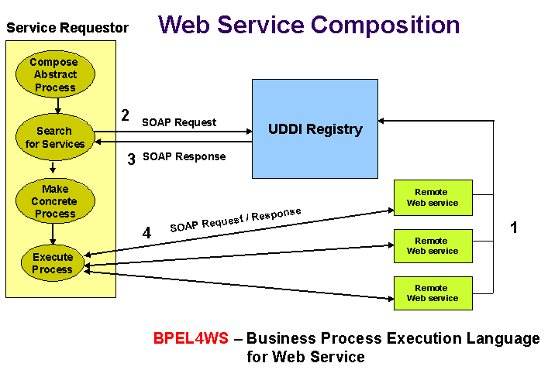
Figure 1. Diagram of Web Service Composition
The pillars of Web services technology are (see Figure 3) the tools for (a) the development of Web services, (b) the invocation of Web services, (c) their discovery (with the possible assistance of a registry), and (d) some way to understand what each Web service does. Providing meaning to each Web service, which enables more automated activities since the descriptions are machine-readable, is referred to as providing semantics. Semantic Web Services, which are Web Services with semantic annotations, will permit researchers to create queries of Web services efficiently, to plan queries, and to decompose queries and to carry out data integration of disparate genomic resources. Providing a semantic framework involves creating/utilizing ontologies for Web Services describing at a high level how the services are related.

Examples of bioinformatics Web services and resources that will contribute to, or benefit from, web services:
In several current projects, Web service technology is being applied to bioinformatics services. The DNA Database of Japan (DDBJ) focuses on the standardization of bioinformatics services on the Internet and the improvement of their interoperability. They have created a list of Web services and their WSDL description files. They have converted bioinformatics services such as BLAST®, ClustalW, DDBJ, FASTA, GetEntry, SRS and TxSearch to Web services and have made them available for public use (http://www.ddbj.nig.ac.jp). Project BioDas (Peterson, 2002) aims to use SOAP as the standard transport encapsulation for DAS/2 messages. BioMoby (Wilkinson and Links, 2002) has an architecture similar to a Web service architecture, but is custom-coded. They use a central repository for services, which supplies WSDL description files to clients. Clients process these WSDL files and contact the relevant service. Their aim is to develop a mechanism by which a researcher is able to simultaneously interact with multiple sources of highly disparate biological data regardless of the underlying data format or schema. OmniGene (Whitehead Institute, 2001) is another project that attempts to provide middleware, which will allow transparent access to disparate data repositories. It aims to

provide a federated view of all these services by adhering to a Web services model.
The Distributed Annotation System (DAS) project of Lincoln Stein and Sean Eddy is a good example of what can be accomplished when attempting to link remote servers through a standard protocol, in this case the WWW and DAS XML data exchange format. DAS permits any number of annotators to annotate any number of features in their favorite genome(s) and provides their annotation back to the community. Any researcher who has a DAS client or server side integration can obtain any one or more particular annotations from their genome(s) of interest. This feat is accomplished by utilizing a standard data exchange format (DAS XML) and a reference genome sequence rather than one large centralized database. Researchers annotate a reference genome and then post their annotation on an annotation server. Any researcher who would like to use this particular annotation can request it. Annotators are not required to use any common vocabularies and may create their own style sheets to facilitate the display and interpretation of their annotation. Two DAS viewers have been constructed, Geodesic, a stand-alone Java application (Dowell and Jokerst, 2001), and DasView (http://www.tigr.org/tdb/DAS/dasview.html), a server side Perl application. The researcher can import data from multiple different annotation servers and the viewers will create integrated images of data retrieved. Such integration is easily accomplished since all annotators use the same reference sequence and a common data exchange format.
AmiGO (http://www.godatabase.org), the GO consortium ontology browser has also manually developed a tool that is indicative of the type of tool we are discussing. At AmiGO, researchers can search a precompiled cross-referenced index of all annotated genes among the GO consortium genomes with specific GO ID’s. The tool returns a list of genes, by name, which have been assigned a particular GO ID. Researchers can then click on any particular ID and they are taken to that gene in the database of origin where they can either obtain the sequence or collect additional information. The use of a common vocabulary to describe genes by different databases provides a clear opportunity and point of access for linking disparate resources. We will create such tools in an automated fashion for Web services.
The information stored in databases such as GenBank (Benson et al., 2002) can be also made more accessible through Web services. Rather than encoding messages in special formats for each information source, a more uniform style of access based on XML request/query messages can be used. Responses will also be in the form of XML messages. Using XML as a common substrate opens the door for greater automation (Kochut et al., 2003) and will require less custom coding of format converters. In addition to the benefits of XML based SOAP messages for input and output, Web services also involving WSDL and UDDI provide better interoperability of distributed software component as well as discovery and usage.

Semantic Web services: What are they and how can they be created?
While commercial development of Web services is progressing rapidly and in a sustained manner (http://www.websevices.org; also, Sheth and Miller, 2003), significant research is ongoing to make Web services more useful. Currently, Web services are described in registries (e.g., UDDI registries) using keywords. Languages and techniques are being developed to define more precisely the meaning and purpose of a Web service. These efforts to bring more meaning to the description of Web services parallels current work on the Semantic Web and are referred to as Semantic Web Services (Mcllraith et al., 2001, Sollazzo et al., 2002). Their composition is referred to as Semantic Web Processes (Cardoso et al., 2002). Not only will these advances help researchers find and utilize, for example, biochemical networks in KEGG (Kanehisa, 2002), biological data interchange by OmniGene (at http://omnigene.sourceforge.net) profiling data on the Stanford Genome Centers Web site (at http://genome-www.stanford.edu), and protein-protein interaction mapping data in the Biomolecular Interaction Network Database (BIND) (Bader et al., 2001) as Web services for information sharing and understanding a particular process, it will allow automated tools to do so, thus facilitating automated Web service composition to construct a reaction network or to test some particular hypothesis requiring access to multiple data sources (Ideker et al., 2001; Battogtokh et al., 2002).
In general, the emerging Semantic Web and Web services are seen as the new infrastructure for tomorrow's e-businesses and scientific applications (Hendler, 2003). The type of interactions between scientists and their communities is dramatically and rapidly changing. With the advent of global consortia and dynamic collaborations, whole communities have begun to rely heavily on the Internet as a medium for communication to carry out their research. The coordination and management of interactions become especially important when organizations establish links of cooperation to form dynamic processes (Sheth et al., 1999). In dynamic research environments, selection of the most appropriate Web services and composition of a global process utilizing the selected Web services becomes a challenge, since the Web services need to be dynamically identified, selected, and integrated to form a process that meets its objectives. For example, research partnerships may be envisaged in which KEGG maintains reaction networks (Kanehisa, 2002), another two groups maintain information about gene knockouts (Glaever et al., 2002), and several groups maintain protein-protein interaction maps in BIND (Bader et al., 2001) and elsewhere (Uetz et al., 2000). All of these resources are relevant to understanding a particular process such as carbon metabolism or the cell cycle.
Many of the databases in the Bioinformatics domain that contain gene sequence data have GO annotations associated with them. In other words, the schemas of these databases have an attribute that represents a GO term associated with that gene. The use of the controlled vocabulary that GO represents allows the “same” gene to be easily identified in disparate organisms even though the primary gene sequence and the gene name are different. In fact, it is just this ease of understanding and communication that is envisioned by the GO consortium. However, for the purposes of this proposal, GO lacks features useful for composing semantic Web services. In particular, GO lacks a rich set of relationships between concepts, the concepts lack explicit definitions, and ambiguity exists in the location of new concepts. Thus for improved composition, we propose to supplement GO with the richer set of relationships between concepts provided by the UMLS ontology. Some work has already been done in this area at the National Library of Medicine in at attempt to better link diseases and their molecular underpinnings. Our starting point will be the study of overlap between UMLS and Gene Ontologies reported in (Mitchell, 2002). This will lead to a limited prototype ontology that permits semantic links between concepts that are not currently connected. During the last year, we have gained further experience in building such a richer ontology being developed as part of the Integrated Technical Resource for Biomedical Glycomics (http://lsdis.cs.uga.edu/Projects/Glycomics/).
Currently, Web services are based mainly on commercial efforts. Languages and protocols include SOAP (Box et al., 2000), WSDL (Christensen et al., 2001), Web Services Flow Language (WSFL) (Leymann et al., 2001), XLANG (Thatte, 2001) and Business Process Execution Language for Web Services (BPEL4WS) (Curbera et al., 2002). Semantic Web services promise to make the search for and use of information even easier. This will help researchers more quickly and reliably find information relevant to their research. Semantic Web service technology is largely being developed by the academic community and includes languages and protocols such as Web Ontology Language (OWL) (Dean, 2002) and OWL-Service (Martin, 2003).
In order to better understand semantic Web services, let us consider a use case that we have envisioned arising from Example 1 (see the next section). The geneticist using our tools will be provided with a user interface in which she will be able to formulate a hypothesis by selecting terms from an Ontology browser. This browser will be loaded with the Gene Ontology (GO) terms and UMLS terms. One aim is to relate pathogenicity in UMLS to genes in the GO ontology, and this relationship may assist a researcher in identifying genes that assist P. carinii in causing a lethal pneumonia in humans. The hypothesis to be examined is that there are genes unique to P. carinii that allow it to adopt a pathogenic lifestyle in the lung. A possible strategy involves the researcher formulating a query that identifies genes unique to P. carinii by comparing S. cerevisiae, S. pombe, and P. carinii, using the GO Ontology or a BLAST® Web service.
As another example, another aim is to carry out gene-validated product discovery of antifungals by identifying essential genes in P. carinii (Example 1) not shared by humans. A possible strategy involves the researcher formulating a query that identifies genes shared by P. carinii, S. cerevisiae, and S. pombe (and not Homo sapiens) using the GO ontology or a BLAST® Web service. The hypothesis to be examined is that there are essential genes shared between all three of these fungi, but for which there is no detectable homolog in humans.
Given that we propose to provide tools to wrap existing Web resources in Web services, which will be "advertised" at registries, it will be possible to search for the relevant services automatically based on some specific criterion. In this case, the criteria for such a search are the parts of the GO (Gene Ontology) such as process, function and component in different genome databases such as FGDB and SGD, and relating elements of the GO ontology to pathogenicity in the UMLS ontology. Since both of these data sources (like many genome databases) are annotated using terms from GO, it is possible to relate the information obtained from one database with the information obtained from another. The hypothesis formulated by the researcher will then be decomposed and converted into searches for Web services that can supply the gene sequences that satisfy the constraints in the hypothesis. Once both services have been found, the queries to each will be formulated and executed. The results returned by the services will then be merged and displayed in the user interface.
A broader objective of this proposed work is to investigate and develop techniques and technologies for making bioinformatics research more cooperative and productive. Web services will be used to make databases and applications interoperable and sharable, making it much easier to access and analyze the data collected and managed by multiple research groups. Two novel aspects of this work are that (a) it will adapt workflow technology (Sheth et al., 1996; Kochut et al., 2003) to the problem of composing Web services into Web processes, and (b) it will adapt our research in semantic interoperability (Sheth, 1999), Semantic Web (Sheth and Meersman, 2002), and Semantic Web Processes (Cardoso and Miller, 2003; Cardoso et al., 2003) to issues ranging from semantics-enabled access (contextual search and browsing) to heterogeneous data sources, to making the Web more effective, meaningful and efficient for the composition of Web services.
The tools proposed differ from those discussed thus far in that manual coding efforts of Web services (Miyazaki et al., 2002) are to be replaced with automated approaches to the creation of Web services and the semantic discovery and querying of Web services.

Examples to be used throughout this proposal:
Our ongoing work on questions of biological interest will drive this research in integrating disparate resources. The two examples to be used throughout this proposal represent the utilization of resources and expertise that we have on site: (1) identifying the core set of genes shared by several disparate eukaryotes (the basic parts list of most eukaryotes!) and (2) identifying how some of these parts function together in the reaction network for galactose metabolism (Ideker et al., 2001; Arnold et al., 2004).
Example 1 – identifying a conserved eukaryotic core. In identifying this shared, and presumably essential, eukaryotic core, the task is to query multiple databases such as FGDB (Kochut et al., 2003), SGD (Weng et al., 2003) and PlasmoDB (Kissinger et al., 2002) and ask which genes are shared in common, as identified by their GO annotations and by BLAST® searches for genes with no GO term assigned (Altschul et al., 1997). Identification of the set of shared genes between fungi and an apicomplexan parasite yields a eukaryotic parts list for the metabolomics (Arnold et al., 2004) of most eukaryotes.
With the shared parts list in hand, the job of reassembling the pieces is possible. In the subject of metabolomics, the guide to data integration is to explain fundamental biological processes through the identification of biochemical and regulatory networks that rationalize these processes with a mechanistic model (Battogtokh et al., 2002; Ideker et al., 2001). The mechanistic model is a reaction network to explain a particular biological process such as carbon metabolism, the cell cycle, or a biological clock.
Example 2 – identifying a reaction network for galactose metabolism. The process of reaction network or biological circuit identification for the GAL cluster is as follows (Ideker et al., 2001; Arnold et al., 2004): The system is perturbed with gene mutations, chemically (i.e., by potential antifungals) or environmentally (i.e., by changing carbon source). The system is observed through RNA and protein profiling. A biological circuit is fitted to the available profiling data constrained by protein-protein and protein-DNA interaction data (Ito et al., 2000; Uetz et al., 2002; Ren et al., 2001; Gavin et al., 2002). The fitted model is then used to predict the total response of the system, and this fit is evaluated (Battogtokh et al., 2002). The model is revised, and a new perturbation experiment is designed. The cycle then repeats itself. This is the discovery process for metabolomics, and this process requires integration of disparate data sources to enact the discovery cycle.

Preliminary Studies

The specific aims in this proposal constitute a continuation of the past and current research focus of the Large Scale Distributed Information Systems (LSDIS) Laboratory (http://lsdis.cs.uga.edu) and UGA genomics community. This proposal specifically benefits from our previous work on Workflow Process Management, Semantic Interoperability and the Semantic Web, and our longstanding collaborations between Dr. Arnold's laboratory, which has been federally funded in Fungal Genomics since 1989 by NIH, NSF, and USDA and the Computer Scientists that are part of the LSDIS Lab and the Computer Science Department. This collaboration extends over 14 years and includes numerous publications and grants in Genomics and Bioinformatics (Miller et al., 1992; Kochut et al., 1993; Prade et al., 1997; Kelkar et al., 2001; Kraemer et al., 2001; Fang et al., 2002; Kochut et al., 2003; Cardoso et al., 2003; Hall et al., 2003; Xu et al., 2003; Arnold et al., 2004). The group has met regularly once per week as a formal seminar since 1997, and members of the group provide a NSF-funded summer research experience for 10 undergraduates each year since 2000. The group has recently expanded with the addition of Dr. Kissinger, a genomicist and developer of PlasmoDB. Table 1 shows the list of tools we plan to develop for this project, along with earlier versions of or functionally related tools that we have developed at the LSDIS Lab.

Tool to be Developed | Previous/Current Tool at LSDIS Lab
METEOR-S Composer | SCET (Chandrasekaran et al., 2002; Chandrasekaran et al., 2003, Sivashanmugam et al, 2004)
METEOR-S Executor | METEOR WebWork (Miller et al., 1998),  METEOR OrbWork (Kochut et al., 1999)
METEOR-S Annotation Framework | MWSDI (Verma et al., 2003; Sivashanmugam et al., 2003),  MUSAF (Patil et al 2004)
METEOR-S Discoverer | MWSDI (Verma et al., 2003; Sivashanmugam et al., 2003)
METEOR-S Choreographer | METEOR OrbWork’s Dynamic and Adaptive Workflow Capabilities
Multi-Ontology Querying Tool | InfoQuilt (Sheth et al., 2003), OBSERVER (Mena et al., 2000)
Table 1: Prior Tool Development
The above capabilities in informatics are complemented by our biological expertise as well as successful past bioinformatics collaborations. Our foundational capabilities started with building the Fungal Genome Database (Kochut et al., 1993; Kochut et al., 2003) and our involvement in building Plasmodium Genome Resource (PlasmoDB) (Kissinger et al., 2002). We have hands on experience with linking diverse data types and communicating with other databases. We have developed Java, Bioperl and Biopython applications used by many groups. These projects produce object oriented programs that are maintained by a team of developers. If these tools are wrapped as Web services, they will reach an even wider audience. Table 2 lists the databases and algorithms either developed or implemented at UGA that will be used as a part of this project.

Implmentations | References
Web Services and Registry for FGDB and GUS | FGDB (Kochut et al., 2003); GUS (Kissinger et al., 2002)
Web Service for FGDB and created KINSOLVER | Parallel BLAST® Web Resource (Xu et al., 2003) and KINSOLVER (Aleman-Meza et al., 2002)
Ensemble Identification Method for Reaction networks | Battogtokh et al. (2003)
Semantic annotation of Web services | GO Ontology within GUS (Kissinger et al., 2002)
Tools for querying ontologies, such as GO and UMLS | InfoQuilt (Sheth et al., 2003)
Table 2: On-site database access and algorithm implementations

Preliminary Studies Specific Aim 1 – Construct a Toolkit Needed for the Automated or Semi-Automated Generation of Web Services.

Two Web services have been developed at UGA, the first Web service named GQService (Gene Query Service) has been developed and deployed on FGDB. This service takes any valid SQL Query to the database and returns the result of the query. The description of this Web service can be found in the WSDL descriptor file located in http://gene.genetics.uga.edu:7001/axis/services/GQService?wsdl. Apache Axis has been used as the SOAP engine. The code fragment to run the query and retrieve the result is written in Java. Java and Perl clients to access this Web service are also available. We will deploy additional Web services that return results to standard and more frequent queries. Once popular queries such as retrieving an integrated genetic and physical map (Xu et al., 2003) are deployed, they can also be used in conjunction with one another to make effective retrieval of the data available in FGDB. The second, a Web Service named GOIDService (Gene Ontology ID Service) has been developed and deployed on the mirror installation of PlasmoDB at UGA. This service takes the existing query “find all annotated genes” with this particular GO ontology term (specified by GO ID) and returns the list of annotated genes containing this term. The GOIDService Web service uses a Java API for XML Messaging (JAXM) to provide the response portion of the request-response paradigm. JAXM provides a standard mechanism to send XML documents over the Internet from the Java platform. It is based on the SOAP 1.1 and SOAP with Attachments specifications, which define a basic framework for exchanging XML messages. Similarly JAXM is used by the client to access known Web services.

As we plan to develop additional Web services for GUS and FGDB, it is necessary to a maintain a list of services and hence we have created a UDDI registry exclusively for this purpose. The registry is operational on http://mango.ctegd.uga.edu/registry-server. This is an XML based registry that implements the UDDI specification, and it is available as a part of the Java Web Services Developer Package (JWSDP) (Sun Microsystems, 2003). An API (JAX-RPC and JAXR) permits access to this registry via SOAP. A replica of this registry is available at

http://gene.genetics.uga.edu:7001/registry-server. The METEOR-S Web Service Discovery Interface (MWSDI) (Verma et al., 2003) provides a peer-to-peer network to access Web service registries

Preliminary Studies Specific Aim 2 – Develop a Toolkit to Facilitate Web Service Composition.

Our past research on workflow process management gave us a strong set of core competencies in process specification, verification, enactment, monitoring, applications deployment, integration and interoperability of processes, performed as part of the METEOR project, which is one of the most referenced research project in the area of the workflow process management (Google, 2002). METEOR includes the capability to design graphically workflow processes, support for coordination and collaboration, and two enactment services for Web-based distributed processes on heterogeneous computing infrastructure, ORBWork (Kochut et al., 1999) and WebWork (Miller et al., 1998). Additionally, we have carried out extensive research on exception handling (Luo et al., 2002), multi-organizational processes (Luo, 2001), authorization and access control (Wu et al., 2002), security (Kang et al., 1999), and on simulation (Miller et al., 1999). Recently, we have adapted our experience in workflow processes and the Semantic Web (discussed below) to Web processes created by semantic discovery and composition of Web services (Cardoso and Sheth, 2003; Chandrasekaran et al., 2002), and the associated issues of definition of quality of service (Cardoso et al., 2003) and its evaluation using simulation (Miller et al., 2002). The impact of our work has been significant and can be seen:
- in education support (through the use of METEOR software tools in courses world-wide and through tutorials at major international conferences such as ACM SIGMOD and IEEE Data Engineering),
- through the licensing and technology transfer leading to METEOR EAppS, a commercial product from Infocosm, Inc. (with several prototype or product deployments at Boeing, Bellcore, Medical College of Georgia, MCC, Naval Research Laboratory, NIST, and several other organizations), and
- through collaborations and application development in various domains, such as bioinformatics applications (Hall et al., 2003; Kochut et al., 2003), healthcare (Anyanwu et al., 2003), telecommunications (Luo, 2000) and military (Kang et al., 1999). The above collaborations have also allowed us to identify a set of problems that need to be answered to allow scientific communities to achieve greater research cooperation and impact.

The Service Composition and Execution Tool (SCET) is a tool for statically composing Web services (Chandrasekaran et al., 2002; Chandrasekaran et al., 2003). The SCET tool includes a graphical designer that allows Web services to be linked together forming a network of Web services or Web process. Once a design is complete, it can be saved as an XML document in a standard form for Web processes (e.g., WSFL). This specification can be further processed to generate code to execute the Web process as a workflow.

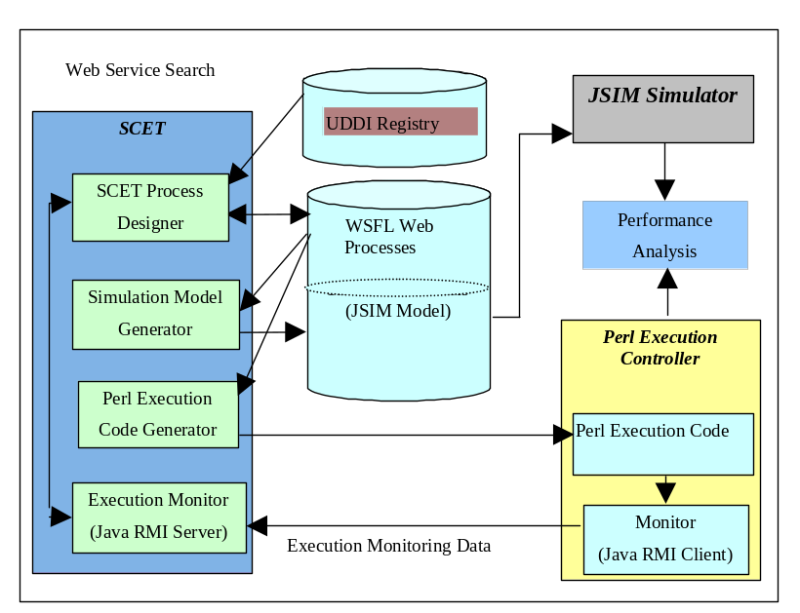
Within SCET, the researcher can also generate simulation models. Finally, the tool also supports a limited form of process monitoring. A picture of its architecture is shown in Figure 2.
Figure 2. Service Composition and Execution Tool (SCET)

Preliminary results Specific Aim 3 – Develop Semantic Web Services for Bioinformatics

Semantic Web services can be created by applying Semantic Web technologies to Web services standards. The LSDIS Lab has considerable experience with using semantics for searching the Web. Recent work involves using DAML ontologies in order to much more precisely search the Web (Arumugam et al., 2002). Ontologies form important aspects of a specification to support semantic interoperability and knowledge sharing. The RDF, RDFS, DAML+OIL and OWL standards advocate and provide a basic facility to define and associate ontologies with resources (or components and services in our

case). An example of our extensive research in developing multi-ontology systems appears in (Kashyap and Sheth, 1998; Mena et al., 2000).
An important issue in semantic Web services is dynamic composition of Web services. Our proposed work on dynamic composition of Web services will be based on our extensive work on Adaptive Workflow (Sheth and Kochut, 1998). This includes our ability to create executable specifications of processes for distributed execution environments (Kochut et al., 1999), use of XML repositories for maintaining meta-data about workflows and tasks for their reuse (Arpinar, 2001), and ORBWork’s enactment support for several types of well-defined dynamic changes (Chen, 2000). Since adaptation mechanisms rely on dynamic change mechanisms to modify processes, we have developed a taxonomy and an API to dynamically change processes at runtime (Chen, 2000). These capabilities are further based on related research on flexible specification driven exception handling (Luo, 2001), study on the effects of process exceptions and how they can trigger dynamic adaptation (Luo, 2001), safety and correctness considerations on dynamic changes (Aalst et al., 1999), and techniques for adaptation feasibility analysis via analytic models (Cardoso et al., 2003) as well as simulation models (Miller et al., 1995; Miller et al., 1999; Miller et al., 2002). This body of work has given us considerable experience in composing processes/workflows. The scope and dynamicity of the problem is clearly greater with Web services than traditional workflows, but our work, especially in the areas of adaptive workflow and multi-organization workflow, has been pushing us in this direction already. Recently, this work has been extended to include research on discovery of Web services and composition of Web services (Cardoso and Sheth, 2003). This work deals with Web service composition by using ontologies for handling syntactic and semantic heterogeneities. Another approach for semantic querying of Web services is also described in (Verma et al., 2003). (Sivashanmugam et al., 2003) describes adding semantics to current Web service standards. (Zhang et al., 2003) described an interface-matching automatic composition technique for semantic Web services. This is done by capturing user requirements, constraints and goals and matching them with all possible options and using a composition algorithm to find the optimal collection of services considering the Semantic and QoS requirements (Cardoso et al, 2004).

Preliminary results Specific Aim 4 – Develop Tools to Permit Ontology-Based Semantic Querying of Web Services.
Our research experience on semantic interoperability involving access to distributed and heterogeneous data spans well over a decade. It has involved research leadership (projects InfoHarness, VisualHarness, OBSERVER, InfoQuilt), deployed applications and two technology commercializations. Here we review some of the relevant work.
A key requirement for developing semantic querying of Web services involves handling syntax, structure and semantic heterogeneity, and providing corresponding interoperability solutions (Sheth et al., 1999). A key example of syntactic heterogeneity involves different representations of data, such as different representation schemes and data formats. Representational heterogeneity involves modeling data constructs that affect structural interoperability. Schematic heterogeneity, which appears particularly in structured databases, including different schemas of databases, is also an aspect of structural heterogeneity. As part of developing multidatabase and federated database systems, we have significant experience in dealing with such heterogeneity (Sheth and Larson 1990; Kashyap and Sheth, 1996; Elmagarmid et al., 1998). In (Kashyap and Sheth, 1996), we provided a more detailed taxonomy of types of structural heterogeneity that needs to be addressed when providing an interoperability solution involving multiple databases. Recent progress towards adoption of XML and RDF has now provided better infrastructure to apply the principles we have outlined in our work on handling syntactic and structural heterogeneity. As future information systems increasingly address the information and knowledge level issues, they increasingly require semantic interoperability. Semantic interoperability requires that the information system understands the semantics of the researcher’s information request and those of information sources.
We have also performed extensive past research in semantic interoperability (Sheth, 1999; Kashyap and Sheth, 1996), and Semantic Web (Berners-Lee, 1999), which some view as the second phase in the Web’s evolution (Sheth and Meersman, 2002). This proposal envisages developing limited aspects of a Semantic Web for Fungal Genomics and other microbial researchers. Our relevant work has been performed as part of the InfoHarness (Shah and Sheth, 1999), InfoQuilt (Sheth et al., 2003) and OBSERVER (Mena et al., 2000) projects. In particular, we have discussed issues of semantic meta-model and object interoperability (Kashyap and Sheth, 1998; Kashyap and Sheth, 2000), ontology interoperation (Mena et al., 2000), and information correlation and complex relationships in Semantic Web (Thacker et al., 2002). The InfoQuilt prototype system consists of a GUI-based tool to define an ontology, software to create metadata extractor agents, a GUI to specify complex multi-ontology queries, and a multi-agent system for processing such queries against heterogeneous resources such as static and dynamic (query-driven) Web sites and wrapped databases.
The SCORE (Semantic Content Organization and Retrieval Engine) technology (Sheth et al., 2002) resulting

from the academic research at the LSDIS lab at UGA supports several Semantic Web capabilities including (a) automatic classification, (b) ability to create and maintain domain and application specific ontologies, (c) domain specific metadata extraction from a document resulting in semantic annotation (Hammond et al., 2002) enhancing the meaning of the original document and allowing it to be linked with documents from multiple sources of different formats, and (c) a pioneering concept of Blended Semantic Browsing and Querying (BSBQ), which allows a researcher to browse and query a broad variety of heterogeneous information sources interchangeably and in context (where the context is provided by the chosen ontology). SCORE and InfoQuilt tools and the BSBQ concept will be adapted for the semantics-driven agenda for our project. SCORE was licensed for commercialization and is marketed under the product name of Freedom by Semagix (http://www.semagix.com). Freedom (commercial list prices starting at $150,000) is available free of cost for R&D at the LSDIS lab, and can be used without imposing restrictions on scientific results. Since the original application, Semagix and its Freedom product has achieved significant market adoption and technology maturity. This is exemplified by IBM becoming a Semagix partner, and by deployment of Freedom powered applications at the likes of the Citigroup and Fannie Mae. This experience of making technology work will be useful in achieving evaluation and adoption of the tools from this project by the community as indicated in the introduction to the revised application.

Research Design and Methods

Our research plan involves utilizing, extending, and developing Web service technologies to facilitate bioinformatics research at UGA and to develop toolkits and methodologies that can be used by other research groups to facilitate their research. Development will be layered according to our Specific Aims (see Figure 3). These tools and techniques will applied in the Fungal Genome Database (Kochut et al., 2003; Bennett and Arnold, 2001) in the Fungal Genome Resource and GUS (Davidson et al., 2001; Kissinger et al., 2002) as maintained at the Center for Tropical Emerging Global Diseases containing the Plasmodium, Trypanosoma, and Cryptosporidiumgenomes. Once we have established the utility of the Web services tools to be developed, we will seek to apply them to more disparate data sources of SGD (Weng et al., 2003), KEGG and BIND as well as XML Web documents containing protein-protein interaction maps and protein-DNA interaction maps for identification of the GAL reaction network. In the subsections below, we discuss the software that we propose to develop as well as potential biological applications. Tools will be intially made available through a repository at http://gene.genetics.uga.edu.
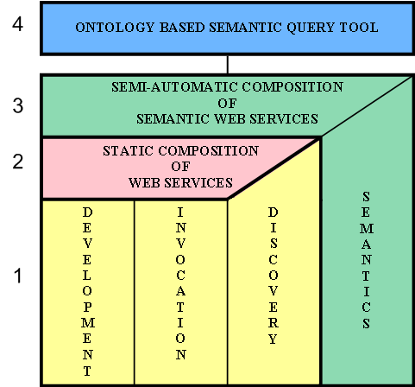
Using Web services allows us to attain a number of our goals. In order to use Web services for our project, we will need to create tools for semi-automatically generating/developing Web services, improve the existing discovery mechanism, and develop/enhance GUI toolkits for Web service composition. We plan to improve the discovery of Web services by developing a scheme that allows the service creator to specify the intent (semantics) of the Web service. One way of indicating semantics is by making services conform to existing ontologies such as GO (Gene Ontology Consortium, 2000).
Figure 3: Pillars for Web Services
Much of this project will be based on two prior research efforts carried out in the LSDIS Lab, namely METEOR and InfoQuilt. As discussed in the preliminary results, the METEOR project created groundbreaking prototype workflow systems during the 1990’s (Sheth et al., 1996; Kochut et al., 1999; Miller et al., 1998). The current proposal will draw upon this work to create METEOR-S for composing Web services. The InfoQuilt project (Sheth et al., 2002) provides a general framework for processing high-level queries on multiple data sources. In addition, the proposed work will reuse software developed for the SCET prototype (Chandrasekaran et al., 2003).
Figure 3 shows the overall system architecture for the project. In the subsections below, we elaborate upon each of our specific aims.

Specific Aim 1 – Construct a Toolkit for the Automated or Semi-Automated Generation of Web Services.

As shown in Figure 3, there are three fundamental pillars needed to fully utilize Web service technology, namely, development, invocation and discovery. The development of Web services should be made as easy as possible through the use of state-of-the-art toolkits. In this project, we will combine and extend freely available, state-of-the art tools. A brief overview including some of our proposed extensions is given below for development and discovery (good toolkits for invocation already exist).

Development

Encapsulating a Program as a Web Service

Currently, there are a number of bioinformatics Web data sources available on the Web, and they offer tools with customized query interfaces like those of PlasmoDB and FGDB (Kissinger et al., 2002; Kochut et al., 1993). These applications are available either as forms or APIs. They can be accessed either manually by submitting forms or by writing computer programs that use an API. These services can be made more easily accessible with reduced requirement for human interaction by converting them to Web services. Applications can be wrapped to create Web services by adding a SOAP interface to them without rewriting the existing code. One could then publish the services into registries allowing more people to find them. By wrapping applications to run as Web services, the researcher is given control over the presentation and manipulation of the results at the client end.
We will wrap analysis programs, such as BLAST® (Altschul et al., 1997) and ODS3 (Xu et al., 2003) in Example 1 and KINSOLVER (Aleman-Meza et al., 2002) and protein3D (Fang et al., 2002) in Example 2, so that they may be accessed as Web services. The advantage of this is that it enforces some standardization of access as well as description/documentation of the service, thereby making it easier to use and reducing the need for custom coding. The wrapped tools can be made to inter-operate with each other, as all of them act as Web services and use SOAP for communication. There are many development tools to convert programs to Web services.

Tools like Apache Axis (AXIS, 2001) provide an easily usable development environment for Web services from Java programs. Take the example of the simple program shown in Figure 4. It can easily be converted to a Web service by allowing its methods to be invoked using SOAP messages from remote clients.

package my.java;

class MyProgram
{
public String getName (int SSN) {…}
public Address getAddress (int SSN ) {…}
}

Figure 4. Simple Java Application
In order to accomplish this, we create a deployment descriptor file, which can be generated through a GUI tool like Apache Axis Admin Tool. The file typically contains the location of the Java program and the names of the methods which may be remotely accessed. The file contains the name of the class as MyProgram, and it allows methods, getName and getAddress, to be remotely accessed, and it contains mappings for Address, which is a complex type parameter.
The program can then be deployed as a Web service by using either the command line or the administration client of the SOAP protocol implementation. In Apache Axis, deploying the Web service automatically creates a WSDL descriptor file for it. After the program is deployed as a Web service, remote clients can access it. A Web service client can be created using the following steps: 1) Retrieve the WSDL descriptor file for the Web service to be accessed. 2) The method calls for accessing the service can either be created manually or automatically. For automatic creation, tools such as WSDL2Java from Apache Axis can be used to create stubs for the service, which can then be used by the client. Tools like Web Service Invocation Framework (WSIF, 2002) can also used for invoking Web services. WSIF API allows stubless or completely dynamic invocation of a Web service, based upon examination of the meta-data about the service at runtime.
Similar facilities also exist for creating Web service in other languages such as C++ and Perl. In C++, tools such

as gSOAP (Engelen and Gallivan, 2002) generate C/C++ skeletons and WSDL files from header files. Clients can also be easily created using the gSOAP WSDL importer. In Perl, a simple CGI script can be written to pass the request to a program and return the SOAP response to the client. A SOAP client is also easy to create. The SOAP::Lite (Kulchenko, 2001) modules can be used to create clients after the endpoint URL, the method namespace Uniform Resource Identifier (URI), and the remote method names and parameters have been extracted from the WSDL file.
Automatic Generation of Query Oriented Web Services

We will develop code generators to produce data access oriented Web services using a high-level GUI designer. This designer will be capable of producing code to access modern object-relational databases such as Oracle using the SQL language in which both GUS (Davidson et al., 2001) and FGDB (Kochut et al., 2003) are implemented. The designer will also enable access to XML databases (Sipani et al., 2002) using the X-Query language. Query results will be output as XML and formatted using the Extensible Stylesheet Language Transformations (XSLT, 1999) to assist in Web service composition.
Initially, we will develop Web services for accessing data in two bioinformatics labs at the University of Georgia. The first is the Fungal Genome Resource directed by Dr. Jonathan Arnold. The Fungal GenomeDatabase (FGDB) stores information on fungal DNA sequences and physical maps (Kochut et al., 2003), as well as fungal proteins and their interactions (Fang et al., 2002). The second resource is the GUS database for Plasmodium, Cryptosporidium and Trypanosoma maintained in the Center for Tropical Emerging Global Diseases by Dr. Jessica Kissinger. This GUS database utilizes the genomics unified schema (Davidson et al., 2001) developed at the University of Pennsylvania for several genome projects including the human and mouse genomes and EST sequences.
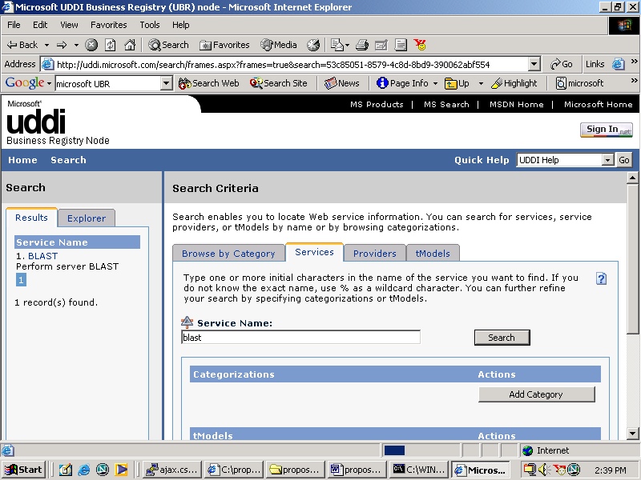
A tool will be created to generate Web services that access databases with frequently used queries. This will involve creating a GUI, through which a researcher can specify the database, the connection details for the database and the query with some parameters in it (i.e., a parametric query). The connection details could be the name of the connectivity driver, access point of the database (URL) and security information. Along with the parametric query, the number of parameters will also have to be specified. Since the code for connecting to databases and executing the query is going to be the same for all queries, it can be straightforwardly generated. Once that code is generated, it can be wrapped to convert it to a Web service. When this aim is complete, we will have the ability
Figure 4. Microsoft UDDI Browser

to rapidly add new Web services that provide parametric database query capabilities.
A tool will be created to allow users to use terms from shared vocabularies while creating a Web services descriptions. This will be done by creating a user interface that will allow users to define the operations and their parameters in a Web service description using terms from a standard shared vocabulary. Use of shared vocabularies will standardize the descriptions and meanings of names used to describe the Web service. In specific aim 3, we discuss an advanced tool to semi-automatically annotate existing Web services with vocabularies or ontologies.

Discovery

In an attempt to disassociate itself from any particular Web service description format, the UDDI specification does not support registering the information from the service descriptions in the registry. The descriptions in WSDL standards focus primarily on the structure of the messages and data types, and the bindings. Suggestions have been made to register WSDL descriptions in UDDI. However, it would be registering just the operational information and not the service capabilities, as WSDL descriptions are primarily syntactic and not semantic. Hence the effectiveness of UDDI is limited, even though it provides a very powerful interface for keyword and taxonomy based searching. Figure 4 shows the browser for the Microsoft UDDI Registry.
If a user wishes to search for a Web service that provides BLAST analysis, the only way to search would be to either do a keyword search on ‘BLAST’ in UDDI or search for Web services categorized by tModels. TModels are used in UDDI to relate Web services to technical specifications.

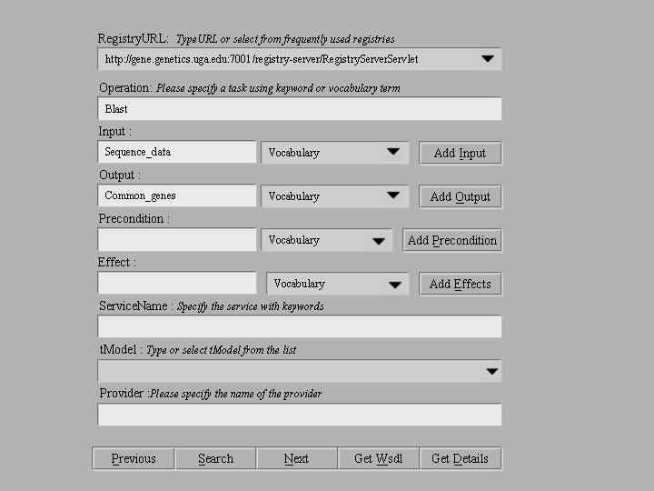
Figure 5:Service Template Based Registry Browser
We aim to develop a tool that allows publishing and discovery of Web services. However, our tool will provide a powerful interface to augment the existing features such as keyword search, taxonomy classification and pattern matching

Figure 4. UDDI Interface
supported by the UDDI API. We plan to use synonyms/homonyms/hyponyms to enhance keyword search. Apart from this, the search mechanism will also be improved by the use of shared vocabularies to publish and discover services. As a simple extension of the current search mechanism, Web services having terms from certain shared vocabularies can be searched. Querying can be done by creating service templates (Verma et al., 2003; Sivashanmugam et al., 2003) as shown in Figure 5.

A significant improvement can be achieved by using standard vocabularies in Web service descriptions and using it in search templates for querying. This approach of using vocabularies provides a more accurate discovery mechanism than simple key word searches. In case the user decides not to use the shared vocabularies, simple keyword based search can be used. A template for looking for a service that takes genes from two databases and provides the common genes is shown in Figure 5. This template allows users to make a
more comprehensive search than simple keyword searching. The features of the template are indicated below.

RegistryURL: A drop down list of frequently used registries
Operation: Specifies the task required from the Web service using a keyword or vocabulary term
Parameters: Inputs and outputs taken by the operation specified using keywords or vocabulary term
Precondition: Precondition for operation to execute
Effect: Effect of the operation
serviceName: Name of Service
tModel: tModel number
provider: Name of provider

Specific Aim 2 – Develop a Toolkit to Facilitate Web Service Composition.

In this project, we will develop a comprehensive set of tools for Web service composition. These tools will be based on prior tools developed in the LSDIS lab, primarily the METEOR project and the recent prototype called SCET, which are described in the preliminary results section. This toolset is divided into two main components, which form the foundation for the proposed METEOR-S project.
- METEOR-S Composer - A graphical tool for composing a set of Web services into a Web process.
- METEOR-S Executor - A tool for executing and monitoring a Web process.

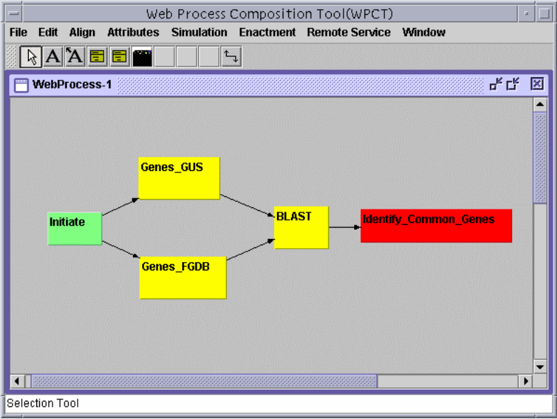
Specific aim 1 mentioned the pillars of Web services, which are required for utilizing Web services or processes. Specific aim 2 will build on the previous one by integrating them into a comprehensive toolkit as well as adding additional functionality. Each of the METEOR-S tools mentioned above is explained in subsequent subsections.
Central to the architecture is the METEOR-S Composer, a graphical design tool allowing researchers to compose Web processes. Researchers can design a network (or directed graph) with nodes being services/tasks and links being the flow within the Web process representing the process and specify the necessary information associated with the nodes and the links of the network. The designer can store the composed process as an XML document in a file,
Figure 6: Snapshot of Web Process Composition Tool
in a UDDI registry or in a special repository (e.g., using the Db4XML native XML database system (Sipani et al., 2002)). As explained earlier, the languages WSFL, XLANG, BPEL4WS,DAML-S and OWL-S are among those that can specify composition of Web services. The language BPEL4WS will be chosen as the language for specifying composed processes in our system because it permits a sophisticated blending of both graph-like and program-like control regimes and currently has the most support (if the standards committees pick another composition language, we will switch to it).
The METEOR-S Executor will be capable of generating Java or Perl execution code for the composed process,

allowing for straightforward execution of a Web process. The METEOR-S Executor will traverse the BPEL4WS specification of the Web process and generate a Java or Perl program, with code blocks that correspond to the elements encountered in the specification file.
A useful bio-informatics process designed using Web services is shown in Figure 6. This process accesses both GUS and FGDB using a separate Web services for each database. Each Web service returns all genes in the respective databases. The last Web service in the figure uses BLAST to compare genes from both databases and identify similar genes between organisms. In addition, internal processes/workflows may utilize Web service technology for several reasons. As developers become accustomed to this paradigm, it will facilitate code reuse between cooperating labs and lead to a development approach in which components are more loosely coupled and better documented (e.g., their descriptions are stored in a registry). It is initially unlikely that specific, small workflows coded as Perl scripts or created with WfMSs would need to be redeveloped; rather they would be wrapped as Web services and put into larger Web service processes as individual sub-workflows with the tools we propose to develop.

METEOR-S Composer
As individual services are limited in their capability, one may need to compose existing Web services to create new functionality in the form of Web processes. Composition of Web services can be performed either statically or dynamically (Benatallah et al., 2002).
Creating a process involves the exploratory approach of either observing previously created processes or analyzing suitable Web services. The user can either create concrete processes by specifying the exact Web services for the process or abstract processes with requirements/capabilities for Web services. In addition, the user can create partially concrete processes with some exact Web services and some requirements, where the user does not know the particular Web services required. Binding of actual Web services to activities can occur at design time (early/static), at deployment time or at runtime (late/dynamic). METEOR-S Composer will support all of these kinds of bindings, but will feature binding at deployment/re-deployment as this represents a useful compromise between flexibility and complexity.
Many issues arise when composing processes using Web services. A friendly GUI is required to visualize the process, so that the users can interactively work with the tool. Users should also be allowed to have a discovery interface that allows them to either query or browse for the required Web services. In case the user is unsure about the Web service to be used, he can use the service template described in specific aim 1 to find Web services based on a number of criteria. After identifying the most appropriate Web services, the control and data flows of the process have to be updated.
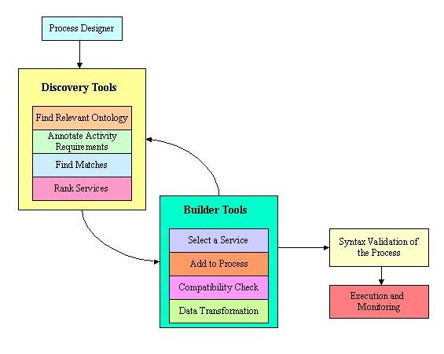
The architecture of the METEOR-S Composer is shown in Figure 7. Here is the step by step procedure to create a Web process using the toolkit. (1) Design or open a generic process template using control flow constructs describing activities (data flow is optional at this stage). (2) Fill in discovery details for each activity. (3) Services that match the needs are discovered and ranked. (4) Select services for each activity. (5) WSDL files are retrieved for each activity and the execution details are extracted from the services. (6) Establish data flow between the selected service implementations. (7) The executable specification is generated. (8) Deploy the process linking it to the selected services discovered. (9) The process is now ready to be executed.
Figure 7: Architecture of METEOR-S Composer

In addition to assisting users in building Web processes, our toolkit also helps in establishing data flow between services. If two activities involved in a data flow are in the same domain and utilize the same shared vocabulary, the tool could suggest data flow after service selection using the mappings in the WSDL files. If the activities related by data flow link utilize different vocabularies, the user may have to explicitly state the mapping between output parameters of one service to the input parameters of the other.

In the process shown in Figure 6, the Web service for BLAST can be located using the template shown in Figure 5. While adding the Web service to the process both the data and control flow have to be changed. In this case the outputs from Genes_Gus and Genes_FGDB are genes in proprietary format of the respective databases. They have to be converted to BLAST understandable format, before they can be given as inputs to the BLAST Web service. This would require some kind of adapter or mediator in the data link from the previous services to take care of the difference in formats. Control links are used to specify the order of execution of the services in the process. In this process, the BLAST Web service can only be executed after Genes_Gus and Genes_FGDB have been executed. Languages like BPEL4WS have a number of constructs to specify these kinds of control links.

METEOR-S Executor: Process Execution and Monitoring
A Web process execution is similar to a workflow enactment, the difference being that the components of a workflow are activities, while the components of a Web process are services. Web services differ from workflow activities in their distribution, autonomy and heterogeneity. Substantial research on workflow enactment has been done in the Large Scale Distributed Information Systems Lab (LSDIS) at the University of Georgia (Miller et al., 1996; Miller et al., 1998; Kochut et al., 1999). Both centralized and distributed enactment engines were developed as part of the METEOR project (Kochut et al., 1999; Miller et al., 1998; Sheth and Kochut, 1998).
A composed Web process can be executed either via a centralized approach or a distributed approach. The centralized approach is based on the client/server architecture, with a scheduler, which controls the execution of the components of the Web process. The controller (client) can reside either on the host where the composition is made or at a separate host to allow for better load balancing. The controller/scheduler invokes a Web service, gets the results, and based on the results and the Web process design specification, the controller then invokes the next appropriate Web service. This is the easiest approach for executing Web processes. An example of such a system with a centralized execution engine is eFlow (Casati et al., 2001).
The distributed approach for Web process execution is more complex. In a distributed approach, the Web services involved are expected to collaborate and share the execution context to realize the distributed execution. In this approach, each Web service involved hosts a coordinator component, which collaborates with other coordinators to realize the execution (Benatallah et al., 2001; Benatallah et al., 2002). A slightly modified version of distributed execution involves coordinators, which control a set of Web services. The process is executed in a distributed fashion by these coordinators, but internally each coordinator implements a centralized model for executing the tasks controlled by it (Benatallah et al., 2001). A state of the art tool for executing Web services is BPWS4J (BPWS4J, 2002) from IBM. It takes BPEL4WS process specifications along with the required WSDL files and executes the process. Since BPWS4J provides a quick way for executing Web processes, we will use it initially and later we plan to develop custom centralized and distributed execution engines.
There are many alternatives for choosing a language for executing Web processes. (e.g., Java, C#, Perl, Python and Ruby). We plan to develop execution engines for both Java (using the Apache Axis (APACHE, 2002) toolkit) and Perl (using SOAP::Lite (Kulchenko, 2002) modules). Both Java and Perl provide the necessary control structures as well as thread management capabilities to realize the control flows represented in BPEL4WS.
Specific aims 1 and 2 intend to enhance the usability of Web services without requiring significant additional work by Web service providers. The next specific aim, (#3) will require additional work by providers to specify the semantics of their services precisely. This will facilitate better and more automated discovery and composition of Web services.

Specific Aim 3 – Develop Semantic Web Services for Bioinformatics.

We will extend the existing infrastructure for Web services for Bioinformatics by adding semantics to them. Many problems concerning discovery, interoperability and composition of Web resources are being encountered in Web services development. Mr. Berners-Lee's proposed solution, the Semantic Web (Berners-Lee, 1999), is becoming equally important for emerging Web services. The semantics-based discovery, composition, and integration and coordination of Web services cannot be successfully accomplished without a deep study of the concept of the Semantic Web.

In the LSDIS lab, we have seen a steady progress from syntax, to representation and structure, and to semantics (Sheth, 1999) in the ways we approach and solve the challenges of finding, integrating and using information of diverse types and from diverse sources. In the next few sections, we discuss some of the sub-projects to be undertaken at the LSDIS lab which will add the notion of semantics to Web services. We further discuss the semantic annotation, semantic discovery and dynamic composition of Web services by describing the following proposed tools.
- METEOR-S Annotator - A tool to annotate Web service descriptions with ontologies.
- METEOR-S Discoverer - A tool for semantic discovery of Web services.
- METEOR-S Choreographer - A graphical tool for dynamically composing a set of Web services into a
Web process.
All of these tools are based on adding ontological support to Web services built upon the tools developed under specific aims 1 and 2 (see the pillars of Web services in Figure 3). Adding semantics to Web services will lead to enriched publication and discovery of Web services, and ultimately help in our aim of dynamic Web service composition for complex comparative genome tasks or for reaction network identification from disparate genome data sources.

METEOR-S Annotator: Semantic Annotation of Web Services

For an application to use a Web service, the programmatic interface of the Web service must be precisely described. In this sense, the Web Service Definition Language (WSDL) plays a role analogous to the Interface Definition Language (IDL) used in distributed programming. The language WSDL is an XML dialect for specifying properties of a Web service such as what it does, where it is located and how it is invoked. While WSDL provides an operational description of Web services, it provides very little about functionality of the service. Description and publication of Web services can be enriched by marking Web services with ontologies (Gruber, 1993). An ontology, which can be defined as a specification of a shared conceptualization/vocabulary with definitions of terms and their relationships, can be used to describe a Web Service semantically. Associating semantic information from an ontology with the Web services’s operations as well as their inputs and outputs will aid in better Web service discovery and process composition.

Adding semantics to Web services to use them for Web service discovery could be done either by semantically extending the WSDL descriptions of a service or its description in UDDI. Extending these standards with additional markup using ontologies without entirely changing the specifications will help in preserving the standards as well as achieving improved discovery. Adding a semantic layer over UDDI registries is one approach where the service entry in UDDI will be annotated using an ontology such as GO. Another way is to annotate the WSDL description. This is done by extending the WSDL file of the relevant service to support ontological concepts in its operations, inputs and outputs. Equality of names, equality of synonyms, equality of canonical name representations after stemming and other processing and range matching are some of the techniques which are used to map inputs and outputs of Web services to ontological concepts.
Figure 8 shows a screenshot of the tool we have developed to annotate WSDL files with ontological concepts. After the WSDL file to be annotated is opened, the tools will display the concepts in a WSDL file as a tree structure and . In this example, we take the gene nomenclature of Neurospora crassa possibly related to galactose metabolism (i.e., example 2) written out in a WSDL file and map this nomenclature onto the relevant portion of the GO ontology in S. cerevisiae. The related concepts in the GO ontology are displayed too and as a tree structure. The mapping between concepts is then done using the tools based on BLAST searches (already available through a Web service), keyword searches and queries on local databases, and motif searches (using existing algorithms, but wrapped as Web services). Linkages in the mapping have weights varying from 0 (no similarity) to 1 (highest similarity). This will display the mappings and degree of similarity of concepts (note that only results are shown in the figure, not underlying data and algorithms).
In addition, once we retrieve a set of semantically eligible Web services using mapping criteria, a relevant service is chosen from among the options using operation and parameter matching. (Cardoso and Sheth, 2003) describes an algorithm using parameter matching and quality of service to try to choose the best possible service.

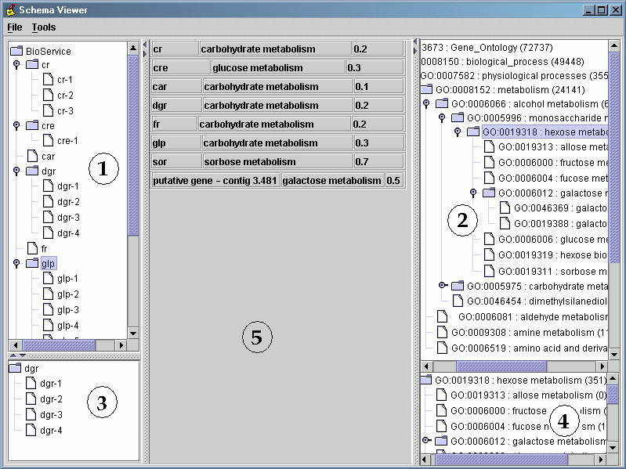
Figure 8: Screenshot of the prototype system showing mapping

METEOR-S Discoverer: Semantic Discovery

Semantic discovery involves locating the right Web service to perform a semantically desired functionality. It is necessary to discover efficiently the desired Web services from a potential pool of thousands of services available on the Internet. UDDI is the present standard for Web service discovery. The UDDI specification deals with registries where services can be registered and searched for. Current searching of UDDI registries is mainly keyword based. Hence this discovery mechanism does not provide any way to find a service based on the capabilities expected to achieve some activity. Semantic discovery of services is a technique whereby the services are discovered based on their capabilities. In our approach to semantic discovery, the user requirements are captured semantically and these requirements are matched against the available services. When a service is published in UDDI, the annotation details from its annotated WSDL file are registered in UDDI. These details will act as a semantic layer over UDDI, which will be used in conjunction with a relevant ontology and a synonym dictionary to compare the user requirements with the UDDI details to get a similarity measure of match between them. The user requirements are also annotated with ontological concepts. Since both the user requirements and the service details are annotated with respect to ontologies, the matchmaking and calculating of a similarity measure are possible. The similarity measure can then be used to rank the services retrieved. (Sivashanmugam et al., 2003) describes how adding semantics will improve the service discovery mechanism. In this work, we have investigated how the semantic details from an annotated WSDL file can be registered in UDDI. This involves using UDDI tModel constructs to link each operation in a WSDL file to the concepts in a functional ontology, inputs and outputs of the operation to the concepts in a domain ontology, pre and post conditions to concepts in ontology or terminology in a vocabulary. When the user creates his requirements as a service template annotated with concepts from functional and domain ontologies, this can be used to match these formally described requirements to the service entries to find a better match.

METEOR-S Choreographer: Dynamic Composition

Dynamic composition of Web services involves run-time searching of service registries to discover suitable Web services. In a more advanced form it involves generating control and data-flow for a composition automatically with minimal or no human intervention and adapting the composition on-the-fly if it does not perform satisfactorily. These capabilities can be facilitated using semantic discovery and composition of Web services. Once the desired Web services have been found, mechanisms are needed to facilitate the resolution of structural and semantic heterogeneity (Cardoso and Sheth, 2003) as different Web services found need to interoperate with each other. For automatic composition, semantic definitions of services can be used to assess how individual services can meet user demands for each activity in the composition and it also helps in doing compatibility checks.
Dynamic composition (Benatallah et al., 2001) of Web services is an important goal for Web Service technology and its applications to bioinformatics. It encompasses three essential characteristics:
- A Web process can be modified while it is running, without shutting it down.
- The time taken to modify the process is short, relative to conventional re-designs.
- Human interaction is kept to a minimum. Full automation would reduce this to zero. This is valid for both automatic composition and dynamic adaptation. We use dynamic composition to refer both of these capabilities.
Our approach is three-fold for enabling these three characteristics:
- Improving and extending the METEOR-S framework, which is built on top of our long-term workflow experience and expertise to enable a template-oriented and human-supervised discovery, composition, integration, enactment, and dynamic adaptation of Web services.
- Automating to a good extent Web service composition and adaptation as well as resolving interface and interoperation conflicts with minimal human intervention using semantic definitions of Web services and ontologies.
- Building a test-bed and test-cases for generating a reaction network describing galactose metabolism which requires utilizing a large number of Web services from different resources.
As a first step, METEOR-S Composer will be enhanced to make automatic composition and adapting a composition faster, easier and more reliable. This will be done by allowing the researcher to specify a set of tasks/activities as a set of templates, instead of actual Web services as in static composition. In the proposed extension of the SCET designer we will provide the researcher with means to give a high level description of the process. This high level description will then be used in conjunction with the appropriate ontology to create a template in addition to finding Web services to satisfy each step. Since each Web service will take its inputs from the previous Web service, a Service Template will be automatically generated based on the text input from the researcher and the outputs of the previous Web service. Then a powerful Web service discovery algorithm (Cardoso and Sheth, 2003; Sivashanmugam et al., 2003) will be applied to find Web services on the fly. Since inputs to most Web services in the process are outputs from other Web services, using semantic discovery helps in interoperability of the services, as all the inputs and outputs are mapped to ontological concepts. In addition, structural differences between inputs and outputs can be resolved using XSLT as discussed earlier in Specific Aim 2. Careful user interaction will be required to verify that the right service has been chosen for each task. The net effect will move us from static composition (Specific Aim 2) toward dynamic composition in terms of characteristics b and c. We will also enhance the METEOR-S Executor to facilitate process changes while the process is still running. This will rely heavily on prior work on adaptive workflows.
An important issue that needs to be addressed is how to compose a Web process involving services from different laboratories. They usually operate in different ways, have different structures, use different information models (Cheung et al., 2001) and may use different domain specific vocabularies. The heterogeneity between laboratories and communities makes the design and composition of Web processes a complex task. In order to establish the set of interactions to be taken among organizations, their interface needs to be not only understood syntactically, but also semantically. In this proposal, we also present a framework for semantically annotating such existing services using ontologies such as GO. This will facilitate efficient searching for services as well as their smooth integration and interoperation. Integration and coordination are related to two fundamental issues. The first issue concerns the semantic, dynamic identification and reconfiguration of process components and the subsequent resolution of the schematic differences between the service to be integrated and the system integrator to create "dynamically trading processes" (Sheth et al., 1999). The second important issue relates to the access and use of Web services without prior knowledge of their behavior, operation or function. Achieving these goals in the areas of Web services is much more complex than in traditional information systems due to the high autonomy, high distribution, and high heterogeneity of the services involved, and due to the semi-structured and unstructured nature of the data being accessed.
To achieve Web process integration and coordination we choose to adapt the most advanced technology in this area: workflow management technology. Workflow systems have been used successfully to support and manage business processes for more than a decade now. Current workflow systems provide a generic solution to the coordination of activities. Enhancements and extension of workflow technologies constitute the best candidate to develop a reference architecture for interoperable e-commerce applications (Yang and Papazoglou, 2000) and to provide answers to Web service coordination requirements. The development of new workflow technologies needs to be in the direction of "networked economy" (Sheth et al., 1999), “bioinformatics nation” (Stein, 2002), and "internet-mediated workflow”, which will most likely be the single most important technology of the early 21st century (Petrie and Sarin, 2000). We plan to base our research in this area on our experience in specifying executable specifications of processes for distributed execution environments (Kochut et al., 1999), in multi-organizational processes (Kang et al., 1999; Luo, 2001), and our work on specifying semantic information requests with user defined functions and complex inter-ontological relationships (Thacker et al., 2001), and recent work on distributed knowledge sharing environments with support for searching of relevant ontologies (Arumugam et al., 2001) and personalization (Kim, 2001). For example, we used workflow technology to begin to automate the process of circuit identification like that of the GAL cluster (Kochut et al., 2003).
In certain domains, we will automate the whole composition process. A case in point is the construction of Web oriented processes in which data are retrieved from a set of Web services for identification of the reaction network for the GAL cluster, merged into meaningful results (i.e., the fitting of the reaction network) and presented in the appropriate form (i.e., predicted and observed trajectories of chemical species, (Battogtokh et al., 2002) to the researcher (see Specific Aim) 4). In similar cases, our aim is to minimize human intervention to find the best possible services to meet user’s information needs and generate control and data-flow for a composition. This can be accomplished by a matching algorithm, which locates a collection of services either matching user-supplied inputs or user-desired outputs. Then the algorithm further iterates to find complementary services to build a composition using semantic definitions of Web services (Zhang et a.l, 2003). Besides functional definitions of Web services, details that describe their actual computation (e.g., preconditions and effects) can be very useful and reduce the risk of surprising a user at run-time with unexpected computations. In addition, a human-assisted composition technique can further improve the quality of a composition by enabling users to make choices where there is more than one alternative for a service placement or semantic interface or functional definitions of services may not be adequate to resolve the conflicts or ambiguities.
As a final step in this specific aim, we will build a test-bed using METEOR-S for dynamic composition, interoperation, and enactment of heterogeneous Web services from different resources for building a reaction network describing galactose metabolism. First, the relevant gene knockouts for perturbation experiments are needed from the Yale Genome Analysis Facility (Glaever et al., 2002). Next, the relevant RNA and protein profiling data are needed from relevant Web pages (Ideker et al., 2001). Then, one of several competing Web resources are needed to constrain the fitting of the reaction network to profiling data with observed protein-protein and protein-DNA interaction mapping data in BIND (Bader et al., 2001) and other Web sites (Ito et al., 2000; Uetz et al., 2000). A protein-protein mapping ontology (Bader et al., 2001) can facilitate resolution of semantic heterogeneity, including terminological and modeling differences, between different sources. The KEGG resource would then be used to identify relevant biochemical pathways for GAL metabolism, and finally ensemble fitting procedures would be invoked on the Web to identify the reaction network (Battogtokh et al., 2003). The researcher wishes to complete this “itinerary” by creating a Web process that is the composition of all of these Web resources, without writing customized, error prone communication code. In the end, the tool needed (and proposed for development in this proposal) will convert these Web resources into Web services, allow the design of a composite Web process to identify the reaction network for the GAL cluster, execute the Web process, monitor its execution, and report back its findings in light of selected constraints on availability, cost, and quality.

Specific Aim 4 – Develop Tools to Permit Ontology-Based Semantic Querying of Web Services.
In previous sections, we discussed how Web services provide a flexible and standardized means to create a scalable system to access a large number of genome data sources. The infrastructure set up by the previous sections will provide the researcher with automated access to the various data sources needed, for example, in identifying the shared eukaryotic core of genes (Example 1) or the biological circuit describing galactose metabolism (Example 2) without having to know exactly where these sources are located or what they are called. This section will describe the part of the system that will allow the researcher to pose queries against these data sources (including bioinformatics tools like

BLAST®) and actually relate the data from one source to the data in another source.
This section will focus on key issues involved in any system supporting heterogeneous data access and integration, including modeling the domain, query formulation, query planning and optimization, and resolving the various heterogeneities between the data sources (Kashyap and Sheth, 2000; Patel and Sheth, 2001). We include usage scenarios and motivating examples that will support our discussion.

Example 1- Identifying shared eukaryotic genes in diverse organisms
There are two very common and related situations in biological research and genomics that arise in example 1. One involves taking an unknown protein sequence, identifying similar sequences from community databases using BLAST®, retrieving these similar sequences using Entrez (Schuler et al., 1996) and making a multiple sequence alignment using CLUSTAL (Jeanmougin et al., 1998) for further analysis such as constructing a phylogenetic tree using PAUP* (Swofford, 1998). Another scenario assumes that the researcher knows the type of gene she is interested in, but sequences pertaining to that gene need to be gathered from various community resources. In this second situation, the researcher, upon learning the GO ID of the gene, would search a specified list of databases for genes annotated with the GO ID of interest, retrieve those sequences from the specified databases and then proceed as above by making a multiple sequence alignment and analyzing this alignment further.
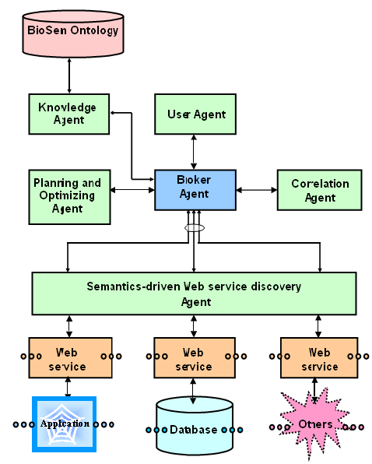
The average researcher spends many hours a week in these activities and utilizes a large number of different databases and Web based or local analysis tools. Computationally sophisticated labs have made this process more streamlined by maintaining local databases and applications and establishing a pipeline or workflow (Xu et al., 2003). Web services are another approach that has the capacity to reach a much wider audience and that would not involve much time or monetary investment by the average researcher. We envisage that if the typical process discussed in the previous paragraph is automated, it will greatly reduce the drudgery involved in conducting research in this domain. We will adapt our work performed as part of the InfoQuilt (Sheth et al., 2003) and SCORE systems (Sheth et al., 2002) to support the following important issues involved in ontology-driven querying described above.
An architectural overview of the proposed system is given in Figure 9. This architecture is an adaptation of the InfoQuilt system. The following sections describe the query formulation, planning and optimization modules of the system in addition to the data integration required. The broker agent shown is responsible for the overall control of all the modules.

Figure 9: Architecture for Query Processing

Query Formulation
The proposed user interface will allow the researcher to formulate queries or hypotheses based on GO, BioSem or any other ontology that is represented in a compatible representation using acceptable ontology specification language standards of the Resource Description Framework Schema - RDFS (http://www.w3.org/TR/rdf-schema/) or Web Ontology Language – OWL (http://www.w3.org/TR/owl-features/). Once the specific ontology has been selected the researcher will then be allowed to select specific terms in the ontology that she wants in the query/hypothesis. The query is formed with the terms of the ontology for which the researcher enters values. That is, instead of a keyword-based search it is an

attribute-based query. The attribute here is a term (i.e., concept) selected from the ontology. Different levels in the ontology will have different terms and the terms of a level are inherited to the sub-levels. This allows refinement in providing results from the query by grouping them with respect to the ontology. Let us consider the typical process that a researcher goes through as described in the motivating example. The steps are the following:
1. Taking an unknown protein sequence, identifying similar sequences from community databases using BLAST®
1a. Taking the GO ID corresponding to the known gene as input to step 2.
2. Retrieving these similar sequences using Entrez
3. A multiple sequence alignment using CLUSTAL
4. Constructing phylogenetic tree using PAUP*
Let us consider the alternative to Step 1 in which the researcher already knows the gene that she is interested in, i.e.,Step 1a. The researcher would enter the GO ID of the gene as a constraint on the attribute that represents the GO ID. The researcher would then specify the type of operation that she wants to perform on the GO ID. The type of operations could be one of the following (List 1):
- Sequence matching and similar sequence retrieval
- Sequence retrieval given a GO ID
- Sequence alignment given multiple sequences
- Phylogenetic tree creation
The list of operation types shown above is an incomplete list of somewhat loose, imprecise functional descriptions of the various applications and database types that exist in the bioinformatics domain. In our approach, the Web services will wrap these applications, and the databases will be annotated with respect to the GO or BioSem ontology. These annotations will be precise terms that uniquely identify the type of functionality a particular service provides, and support the mapping from normalized term used in the GO or BioSem ontology to the local terms, if different. Hence the <operation_type, input> pair will form one of the conjuncts in a conjunctive query of the following form (O₁,I₁)AND(O₂,I₂)AND…….AND(O_{n},I_{n}) where O and I represent the operation type and input, respectively. Since the services registered at various registries will have annotations with respect to one or more ontologies, the constituent components of the query can be automatically mapped to appropriate Web services.

Query Planning and Decomposition
Query decomposition will involve dividing a conjunctive query into sub-queries. That is, we will consider how to decompose the query into sub-queries with respect to (i) the Web services to be found, (ii) the location of known data sources (i.e., genomic databases), and (iii) how to exploit the explicit knowledge in an ontology.
Each of these sub-queries represents information requests that can be satisfied by distinct sources. Hence each such sub-query will be mapped to a Web service that provides the necessary functionality. This distributed query planning and decomposition will be based on the approach and algorithm used in the InfoQuilt system (Patel and Sheth, 2001). Since the Web services will be annotated with respect to the GO or BioSem ontology, the Semantic Web services discovery process described in earlier sections will facilitate finding an appropriate Web service.

Data Integration
The data sources and analysis programs that are available in the domain of Genetics have very different data formats. There are several types of heterogeneity issues that need to be resolved before the data from these sources can be combined into one representation. There are syntactic, schematic and semantic heterogeneities across the various data sources (Sheth, 1999). Differences in the data models used for the various sources, the transaction languages of the data sources and the schemas of the databases themselves can lead to heterogeneity. This is, however, a simpler problem in comparison to semantic heterogeneity in which an attribute in one database may be syntactically identical to an attribute in another database, but they may both refer to slightly different real-world objects (Kashyap and Sheth, 1996; Madhavan et al., 2001).
The query formulation section as shown above is concerned merely with the type of function that each step performs and the inputs to that step. The outputs of each to these steps, however, have widely differing formats. Here are

some of the formats that are prevalent in the domain:
IG/Stanford | Fitch | PIR/CODATA
GenBank/GB | Pearson/Fasta | MSF
NBRF | Phylip3.2 | ASN.1
EMBL | Phylip | PAUP/NEXUS
GCG | Plain/Raw | Pretty
DNAStrider
For the query to execute smoothly with minimal interventions from the researcher, the output format of one step should match the input format of the next step.
Since GO has become the de-facto standard for annotation of gene data, we will face fewer problems with syntactic heterogeneity. Many data sources that provide gene sequence data have an attribute pertaining to the GO annotation. To assist some of our applications, we will create a semantically richer prototype ontology called BioSem by supplementing GO with the relationships from the UMLS® Semantic Network. This will further help in standardizing the "language" spoken by these various data sources. Where appropriate we will utilize our work in the METIS tool of the InfoQuilt system to provide additional mappings (Guntamadugu, 2000; Sheth et al., 2003). We will also consider using emerging services and tools that support an automated means to convert from one format to the other. READSEQ Sequence Conversion version 2-93 (Gilbert, 1993) is an application that allows conversion of data between any of the formats listed in the table above. The query planner in our system will identify mismatches between the input and output formats and will automatically insert the READSEQ Web service at the appropriate point in the query.

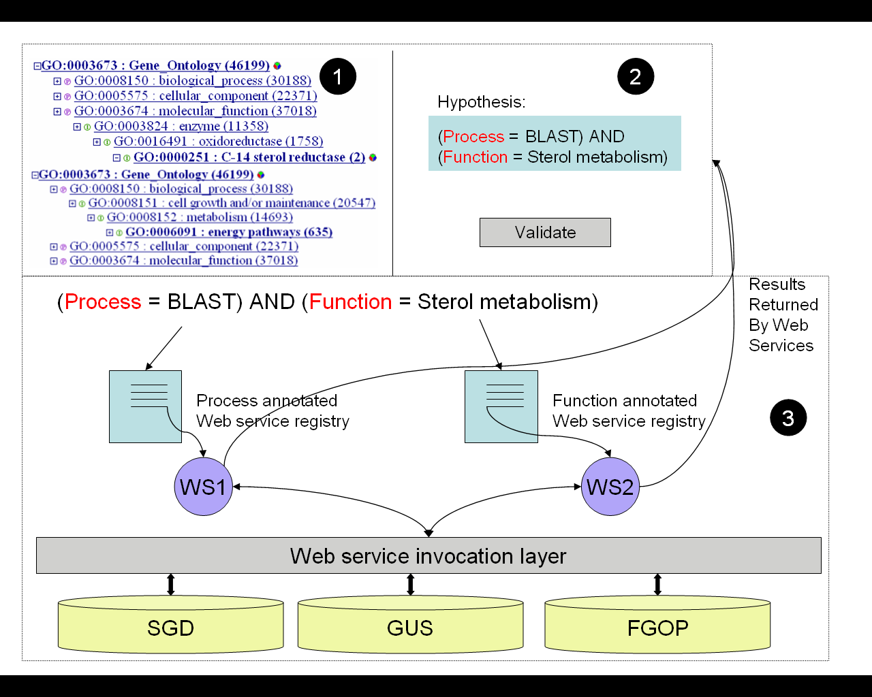
Figure 10 Abstract view of Query Execution

Figure 10 above is an attempt to visualize how our proposed system will work. The figure shows a part of the user interface marked which is the ontology browser. The portion of the ontology shown is from GO. For this component of the interface, we will also provide a more visual display of the ontology we have developed recently using the open source software from TouchGraph (http://www.touchgraph.com/). The researcher will be allowed to select terms from the ontology and associate values constraining the query on that term as described in the section on Query Formulation. The part of the user interface marked shows the full query with all the conjuncts. In part marked there is a visual description of the how the query is processed. It shows how the query is mapped to Web services and how the results returned from the services are combined and presented in one user interface screen.

Example 2 – Identifying a reaction network for galactose metabolism.
In the example shown in Figure 8, relevant data sources include the gene knockout resources for perturbing the system (Glaever et al., 2002), available RNA and protein profiling data (Ideker et al., 2001), protein-protein interaction data (Bader et al., 2001; Uetz et al., 2000, Ito et al., 2000), and protein-DNA interaction data (Ren et al., 2001), reaction network simulator (Aleman-Meza et al., 2002), and reaction network fitting method (Battogtokh et al., 2002). In order to integrate all of the relevant pieces of data at the semantic level the following steps will need to be taken.
1) An existing ontology for protein-protein interaction mapping data will be expanded to describe the data needed to identify biological circuits including nomenclature for describing protein-protein interaction data, protein-DNA interaction data, RNA profiling data, and protein profiling data, as well as the reaction network structure itself. The ontology for biological circuits will be derived from a UMLS semantic network for our reaction network database. Ideally, all of the relevant Web-accessible resources would need to be converted to Web Services. 2) We have already created a Web Service for FGDB and will also do so for SGD and BIND (see letters of support). For simplicity, we have also loaded additional relevant data sources (Ideker et al., 2001; Bader et al., 2001; Uetz et al., 2000; Ito et al., 2000, Ren et al., 2001) into FGDB. Chris Hogue and Mike Cherry (see letters of support) have agreed to try out our Web services tools and they may be added to our service registry. 3) The relevant gene knockouts will be retrieved through a Web Service to design the perturbation experiments. 4) The relevant protein or RNA profiling data will be obtained from an FGDB Web Service 5) KINSOLVER (Aleman-Meza et al., 2002) and ensemble fitting methods for circuit identification (Battogtokh et al., 2002) biological circuits will be converted to Web services through their Java front and backends. 6) METEOR-S will utilize the ontology descriptions to retrieve relevant services for circuit identification. The ontology browser will then enable us to connect the GO ontology with services that can be used to test hypotheses about what groups of genes are relevant to identifying the GAL biological circuit, i.e., genes in RNA processing, cell cycle, and vesicular transport.
Use of a semantic Web service, in which a Web service is annotated with a description with reference to relevant ontology or ontologies, will help in the task of finding the relevant Web services for circuit identification. The use of Web services will solve the problem of knowing how to retrieve the information from a particular Web service through XML messaging. Once the relevant Web services are identified and the data are available, the Web process choreographer would then link the data sources as described by their ontologies together so that they could be used by the relevant analysis programs for simulating and fitting reaction networks. It would take the desired linkages of resources, adapt or write filters to translate data into the right format for use with KINSOLVER or fitting method, and invoke the fitting service. In the case of protein-protein interaction mapping data, there are at least three Web resources that are available. The researcher would need to resolve which one is the "better" service and possibly insert a validation step since the interactions reported by the different services are largely non-overlapping. This might mean going to another site on RNA profiling data and seeking a validation of reported interactions by asking whether or not the genes, whose products are reported interacting, are also transcriptionally correlated. Using validated interactions, the resulting fitted model could then be evaluated for fit and new perturbation experiments suggested.
Summary
Timeline
In Year 1 we propose to develop a toolkit for converting (i.e., wrapping) existing Web resources into Web Services. By the end of Year 2 we propose to wrap FGDB and GUS as Web services to identify the shared eukaryotic genes (Example 1). In Years 1 and 2 we propose to develop a toolkit that facilitates Web Service Composition and to illustrate its use in the identification of the shared eukaryotic genes (Example 1). In Years 2 and 3 we proposed to develop semantic Web services for identifying the shared eukaryotic genes (Example 1) and a reaction network for galactose metabolism (Example 2). In Years 4 and 5 we will develop tools to permit ontology-based semantic querying and illustrate them in identifying the shared eukaryotic genes and a reaction network for galactose metabolism.
Timeline | Year 1 | Year 2 | Year 3 | Year 4 | Year 5
Specific Aim 1 – Toolkits for Generation of Web Services | X
Specific Aim 2 – Toolkits for Web Service Composition | X | X
Specific Aim 3- Build Semantic Web Services |  | X | X
Specific Aim 4 - Ontology-Based Queries of Web Services (with overall system integration) |  |  |  | X | X

Support for Testing, Evaluation and Adaptation

The tools that we develop will also be made available through Ecplise open source program under the Eplipse open source license policy (http://www.eclipse.org). Eclipse is an open platform for tool integration built by an open community of tool providers. LSDIS lab is an IBM Eclipse Innovation Grant recipient in 2004 and has made commitment to use and extend the Eclipse environment for teaching as well as research. All tools will also be made freely available via a repository at http://gene.genetics.uga.edu. Our plan calls for a yearly major release cycle with semi-annual updates. Each major release will consist of user guide, use cases, and training guide. Furthermore, the project has made commitment to provide additional support for installation, testing and adaptation by members of the community (see support letters and introduction to revised application).

Letters of Support Attached

Number | Letter from | Page
1 | Matthew Berriman (Sanger Center, UK) | 70
2 | J. Michael Cherry (Stanford University) | 71
3 | Mark Gerstein and Kei Cheung (Yale University) | 72-73
4 | Christopher Hogue (Samuel Lunenfeld Research Institute) | 74
5 | Lincoln Stein (Cold Spring Harbor Laboratory) | 75
6 | Christian Stoeckert (University of Pennsylvania) | 76

The object-relational database GUS currently supports a large number of projects, Allgenes (Human and mouse); PlasmoDB (Plasmodium Genome) (Bahl et al., 2003) ; EPConDB (Endocrine Pancreas Consortium); TcruziDB (Trypanosoma cruzi genome); GeneDB (Schizosaccharomyces pombe, Saccharomyces cerevisiae, Aspergillus fumigatus, Leishmania major and Trypanosoma brucei genomes) and RAD (RNA abundance database) (Stoeckert et al., 2001).
The Object-relational database FGDB contains the fungal pathogen genome of Pnuemocytis carinii, Neurospora crassa and Aspergillus flavus.

