Claude Managed Agents
vs Claude on Amazon Bedrock
A platform comparison for building and deploying Claude AI

Overview
As of May 2026, there are three ways to run Claude on AWS: Claude on Amazon Bedrock (AWS-operated, data inside the AWS boundary), the new Claude Platform on AWS (Anthropic-operated, billed through AWS Marketplace), and the direct Anthropic API. Per-token rates are identical across all three. The differences are billing mechanics, feature availability, data residency, and cost visibility.
This document compares the two most relevant paths for enterprise teams: Claude Managed Agents (via Claude Platform or Claude Platform on AWS) and Claude on Amazon Bedrock.

The table above lists Claude Platform and Claude Platform on AWS as two billing options for Claude Managed Agents. Here is what the difference actually means:

Claude Platform (direct)
They are the same product — just with different billing and login plumbing.

• Sign up directly at platform.claude.ai with Anthropic
• Pay Anthropic directly via credit card or invoice
• Manage your own API keys in the Anthropic Console
• Full access to Claude Managed Agents, MCP, Skills, code execution, and all platform features

Claude Platform on AWS
Exact same Anthropic platform and features — same API, same Console, same Managed Agents. The only difference is how you connect and pay:

• Access through your existing AWS account — no separate Anthropic account or contract needed
• Login uses AWS IAM instead of Anthropic credentials
• Billing goes through AWS Marketplace using Claude Consumption Units (CCUs) on your existing AWS bill
• Launched in general availability on May 11, 2026 — AWS is the first cloud provider to offer this integration

Why does “Claude Platform on AWS” exist?
Many enterprise companies have existing AWS procurement contracts, IT policies requiring all cloud spend to flow through AWS, and teams already managing everything via AWS IAM. Claude Platform on AWS lets those companies access the identical Claude platform without needing a separate vendor relationship with Anthropic.

Simple analogy
Think of it like buying Microsoft Office directly from Microsoft vs. buying it through your company’s AWS Marketplace subscription. Same software, same features — just a different checkout counter and a different invoice.

Bottom line: If your company already buys software through AWS, Claude Platform on AWS simplifies procurement significantly. If you are fine with a direct Anthropic relationship, the direct Claude Platform works just as well. The features are identical.

Feature Comparison
Feature | Claude Managed Agents | Claude on Amazon Bedrock
Operated by | Anthropic | AWS
Data boundary | Outside AWS boundary | Inside AWS boundary
Login / auth | Anthropic account or AWS IAM | AWS IAM only
Billing | Anthropic Console or AWS CCUs | Standard AWS bill
New features | Day-one access | Weeks to months behind
Claude Managed Agents | ✓ Full support | ✗ Not available yet
MCP connector | ✓ Native | ✗ Not available
Code execution | ✓ Built-in | ✗ Not native
Web search / fetch | ✓ Built-in | ✗ Not native
Skills / Files API | ✓ Included | ✗ Not available
Multi-model support | ✗ Claude only | ✓ Llama, Mistral, etc.
AWS Guardrails | ✗ Not available | ✓ Full support
PrivateLink / VPC | ✗ Not supported | ✓ Supported
Runtime pricing | $0.08/session-hr + tokens | Tokens only
HIPAA / FedRAMP | SOC 2, ZDR available | HIPAA, FedRAMP High, SOC 2

Pros & Cons
Claude Managed Agents | Claude on Amazon Bedrock
Pros  ✓ All latest Anthropic features on day one  ✓ Full agentic stack: tools, code, web, MCP connector  ✓ Fastest path from prototype to production agent  ✓ Built-in session state — no custom loop needed  ✓ Can bill via AWS (Claude Platform on AWS)  ✓ Isolated containers per session (gVisor) | Pros  ✓ Data stays inside AWS security boundary  ✓ HIPAA, FedRAMP High, GDPR, SOC 2 compliant  ✓ PrivateLink / VPC — no public internet API calls  ✓ AWS Guardrails, Knowledge Bases, AgentCore available  ✓ Multi-model: Llama, Mistral, Titan, and others  ✓ Deep AWS service integrations (Lambda, S3, CloudWatch)
Cons  ✗ Data processed outside AWS security boundary  ✗ No AWS Guardrails or Knowledge Bases  ✗ No PrivateLink / VPC endpoint support  ✗ Extra $0.08/session-hour runtime fee on top of tokens  ✗ Claude only — no multi-model support | Cons  ✗ Claude Managed Agents not yet available  ✗ New Anthropic features lag by weeks to months  ✗ No native MCP connector or Skills API  ✗ No built-in web search or code execution  ✗ Less tight Anthropic Console integration

When to Choose Each
Choose Claude Managed Agents if... | Choose Amazon Bedrock if...
✓ You want day-one access to all Anthropic features  ✓ You are building autonomous agents with long-running tasks  ✓ You need MCP connectors, Skills, or the Files API  ✓ You want built-in code execution or web search  ✓ You want the shortest path from prototype to production  ✓ You are already billing through AWS (use Claude Platform on AWS) | ✓ You need data to stay inside the AWS security boundary  ✓ HIPAA, FedRAMP High, or GDPR compliance is required  ✓ Your CISO requires VPC endpoints / PrivateLink (no public internet)  ✓ You use AWS Guardrails or Knowledge Bases  ✓ Your team already uses multiple foundation models via Bedrock  ✓ Your workload is pure inference (no agentic features needed)

Pricing Summary
Token pricing is identical across all paths. The key difference is the additional runtime cost for Managed Agents.
Model | Input (per 1M tokens) | Output (per 1M tokens)
Claude Haiku 4.5 | $1.00 | $5.00
Claude Sonnet 4.6 | $3.00 | $15.00
Claude Opus 4.7 | $5.00 | $25.00
Managed Agents runtime | +$0.08 / session-hour | n/a
Note: Batch processing is 50% cheaper. Prompt caching reduces input costs by up to 90%.

Verdict
Bottom Line
Token prices are identical across both paths. The decision comes down to two things:
• Compliance needs: If your company is in healthcare, finance, or government and requires data inside the AWS boundary, VPC endpoints, or FedRAMP — choose Bedrock.
• Feature needs: If you want to build and deploy agents with the full Claude toolset today (MCP, code execution, Skills, Managed Agents) — choose Claude Platform on AWS or the direct Claude API.
Many enterprises use both: Bedrock for compliance-sensitive inference workloads, and Claude Managed Agents for agentic development.

Sources: platform.claude.ai/docs, aws.amazon.com/bedrock, anthropic.com/news — May 2026

Architecture Reference
How both platforms integrate with applications hosted on Azure or AWS

The two architecture diagrams below illustrate how your application — whether hosted on Azure or AWS — connects to each Claude platform. The network path, data boundary, authentication model, and available services differ significantly between the two approaches.

Architecture 1: Claude Managed Agents
Your application calls the Anthropic API directly over HTTPS. The Managed Agent runtime in Anthropic's cloud handles session state, tool execution (web search, code, MCP), and retry logic. No special network peering is required — any cloud-hosted app can connect.

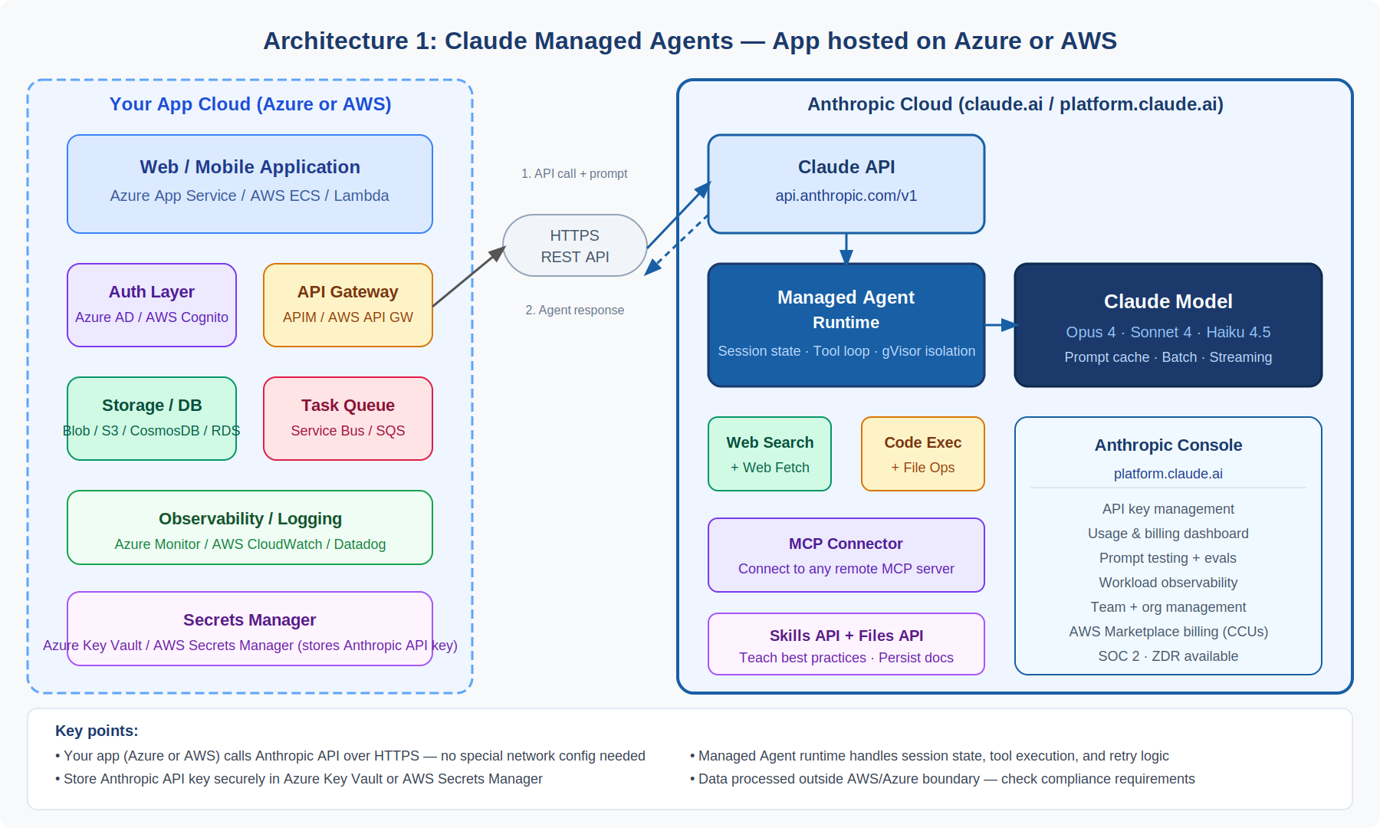
Figure 1 — Claude Managed Agents: app hosted on Azure or AWS → Anthropic Cloud (HTTPS)
App side (Azure / AWS) | Anthropic Cloud
• Your app (Azure or AWS) calls Anthropic API over HTTPS  • No special network configuration or peering required  • Store Anthropic API key in Azure Key Vault or AWS Secrets Manager  • SDK available for Python, TypeScript, and other languages | • Managed Agent runtime handles session state and tool loop  • Built-in: web search, code execution, MCP connector, Files API  • Each session runs in a gVisor-isolated container  • Data processed outside AWS/Azure boundary — verify compliance

Architecture 2: Claude on Amazon Bedrock
Your application connects to Amazon Bedrock through a VPC PrivateLink endpoint — no traffic leaves the AWS boundary. AWS IAM handles authentication. Bedrock Guardrails filter requests before they reach the model, and Knowledge Bases provide managed RAG. Azure-hosted apps can also connect via cross-account IAM or API keys, though data still flows into AWS.

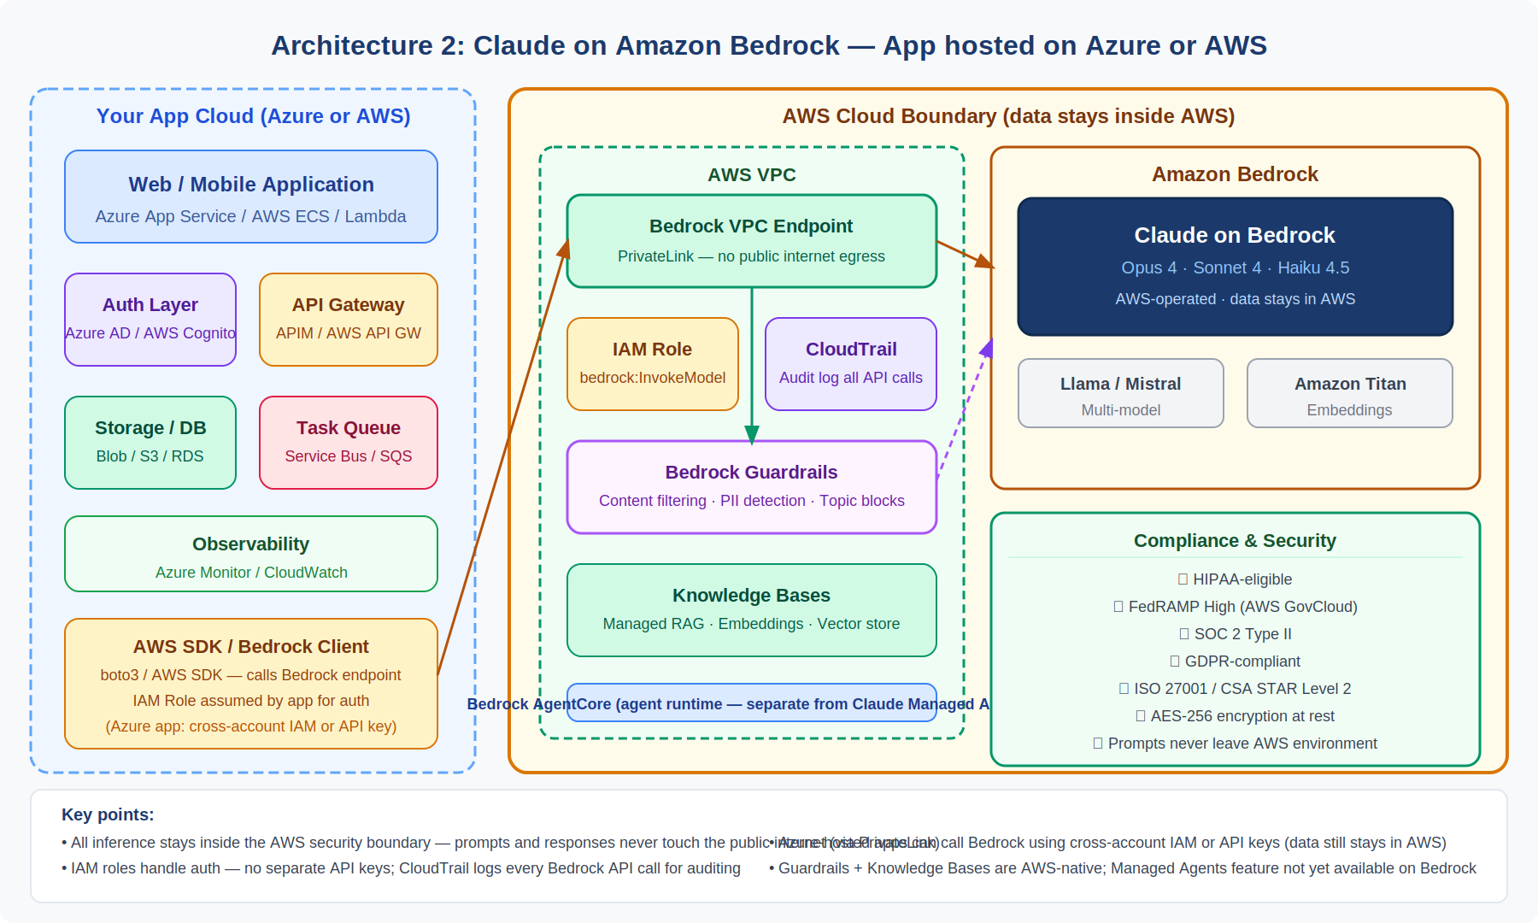
Figure 2 — Claude on Amazon Bedrock: app hosted on Azure or AWS → Bedrock (VPC PrivateLink or HTTPS)
App side (Azure / AWS) | AWS Cloud / Bedrock
• All inference stays inside AWS — no public internet egress via PrivateLink  • IAM roles handle auth — no separate Anthropic account needed  • CloudTrail logs every Bedrock API call for auditing  • Azure-hosted apps can connect via cross-account IAM or API keys | • AWS Guardrails filter content before/after model inference  • Knowledge Bases enable managed RAG with vector search  • HIPAA, FedRAMP High, SOC 2, GDPR compliant out of the box  • Claude Managed Agents features not yet available on Bedrock

Architecture Decision Summary
• Azure-hosted apps: Both architectures work. Use Claude Managed Agents for agent features; use Bedrock if data must stay in AWS and your team can set up cross-account IAM.
• AWS-hosted apps: Bedrock gives native VPC integration with zero egress. Managed Agents works too but data leaves the AWS boundary — confirm with your security team.
• Many enterprises run both: Bedrock for compliance-sensitive inference, Claude Managed Agents for agentic development and new feature access.

Sources: platform.claude.ai/docs, aws.amazon.com/bedrock, anthropic.com/news — May 2026

