72TB CLOUD MIGRATION
Azure Blob Storage (West US 2) → AWS S3 (us-east-2)
Using Azure Data Box Heavy + AWS Snowball Edge
Date  April 2026 | Classification  Confidential

1. Executive Summary
This document provides a complete technical migration plan for transferring 72TB of archived data from Azure Blob Storage (West US 2) to AWS S3 (us-east-2) using hardware appliance-based transfer — specifically the Azure Data Box Heavy and AWS Snowball Edge Storage Optimized devices. The organization currently uses Cohesity/HubStor software on Azure for data management and archiving.

Key Recommendation: Azure Data Box Heavy is strongly preferred over raw SATA drives. One device covers the full 72TB in a single shipment, eliminates egress fees by design, and provides enterprise-grade chain of custody. Both Microsoft and AWS teams must be engaged — neither provider can complete the full migration alone.

Parameter | Detail
Data Volume | 72 TB
Source | Azure Blob Storage, West US 2
Destination | AWS S3, us-east-2 (Ohio)
Source software | Cohesity / HubStor on Azure
Hardware method | Azure Data Box Heavy + AWS Snowball Edge
Estimated timeline | 30–45 days end-to-end
Estimated one-time cost | ~$3,000–$3,500 (before enterprise negotiation)
Ongoing S3 storage cost | ~$1,657/month (S3 Standard, us-east-2)

2. Can AWS Do Everything? (Provider Responsibility Split)
This is one of the most common questions in cross-cloud migrations. The short answer is: No — both Azure and AWS must be engaged. Here is why, and what each provider is responsible for:

2.1 What AWS Can Do
- Provide, configure, and ship the Snowball Edge Storage Optimized devices to your datacenter
- Provide the AWS OpsHub GUI and Snowball CLI tools for data ingestion onto the device
- Receive the returned Snowball device at an AWS ingestion facility
- Import data from the Snowball into your S3 bucket in us-east-2 at no charge
- Send SNS completion notifications and provide ingestion job status in the AWS Console
- Provide your AWS Account Manager and Snow Family team as technical contacts
- Advise on S3 bucket structure, lifecycle policies, and IAM permissions

2.2 What Azure Must Do (AWS Cannot)
- Create and manage the Data Box Heavy export order from the Azure Portal
- Copy your Blob Storage data internally onto the Data Box (only Azure has access to your Blob data)
- Generate the device encryption passcode and provide it to your team via the Azure Portal
- Ship the Data Box Heavy to your datacenter
- Process the returned Data Box and issue a data erasure certificate (required for compliance)
- Waive or negotiate egress fees under your Enterprise Agreement
- Provide Azure FastTrack or migration engineering support

Bottom line: Azure controls the source data. Only Azure can extract and load your Blob Storage onto a physical device. AWS controls the destination. Only AWS can import data into S3. Your team is the bridge — physically receiving the Data Box, copying data to the Snowball Edge, and shipping the Snowball back to AWS.

2.3 Responsibility Matrix
Task | Azure | Your Team | AWS
Create Data Box export order | Yes
Copy Blob data to Data Box | Yes
Ship Data Box to your site | Yes
Receive Data Box, verify data |  | Yes
Order Snowball Edge devices |  |  | Yes
Copy Data Box content to Snowball |  | Yes
Return Data Box to Azure |  | Yes
Ship Snowball to AWS |  | Yes
Ingest Snowball to S3 |  |  | Yes
Validate data in S3 |  | Yes
Update app configs to S3 |  | Yes
Delete Azure Blob data |  | Yes (with Azure confirmation)

3. HubStor Pre-Export Requirements
Your organization used HubStor (integrated with Cohesity) as the archiving layer on Azure. HubStor will not be active in AWS — it is being decommissioned as part of this migration. The goal is to extract your data cleanly out of HubStor's control before the physical migration begins, so what lands in S3 is standard, accessible data — not a HubStor-proprietary archive format.

Key point: HubStor stores archived data in Azure Blob Storage, but wraps it in its own metadata layer. If you copy the raw Blobs without first performing a proper HubStor export, you may get data that is chunked, deduplicated, or encrypted in HubStor's proprietary format — unreadable without the HubStor software. The steps below must be completed before the Data Box export order is placed.

3.1 What HubStor Stores in Azure (and Why It Matters)
- Archived files stored as blobs — but potentially chunked, compressed, or deduplicated in HubStor's internal format
- A metadata catalog (SQL Azure or Cosmos DB) that maps original file paths and attributes to stored blob objects
- Retention policies, legal hold tags, and classification labels stored in the HubStor catalog — not embedded in the blobs themselves
- HubStor system containers mixed into Azure Blob Storage alongside your actual archive containers — these must be excluded from the Data Box export
- Encryption keys managed by HubStor — if HubStor-managed encryption is enabled, blobs cannot be read without HubStor decrypting them first

3.2 Required Pre-Export Steps (Must be Done Before Data Box Order)

Step A — Audit HubStor containers in Azure Blob Storage
Log into the HubStor administration console and identify which Azure Blob containers hold your actual archive data vs. HubStor internal system containers. Do not export system containers — they are not portable and will not be usable in S3.
- In HubStor Admin: go to Settings > Storage > Azure Blob — this lists all containers HubStor manages
- Identify and document the containers that hold end-user archive data (typically named with your org prefix)
- Flag and exclude HubStor system containers (typically named hubstor-system, hubstor-index, hubstor-journal)

Step B — Run HubStor native export to a local NAS (critical)
Use HubStor's built-in export function to extract your archived data in standard file format with metadata intact. This reconstructs original files from HubStor's internal format and writes them as readable files. These exported files — not the raw Blob containers — are what you will copy onto the Data Box.
- In HubStor Admin console: go to Archive Management > Export Jobs > New Export
- Set export destination: a UNC path or NFS mount pointing to a local NAS or staging server with sufficient capacity
- Choose export format: Native Files with Sidecar Metadata (produces original files + a JSON sidecar per file with all metadata attributes), or BagIt format for compliance or eDiscovery use
- Select only the archive data containers identified in Step A
- Run the export and monitor progress — for 72TB this will take several days depending on NAS network throughput
- Once export completes, verify file counts and spot-check a sample of files to confirm they open correctly in their original application
Note: The output of this step is standard files on your NAS. These are what you copy to the Data Box in Phase 4 — not the raw HubStor Blob containers. This is the single most important preparation step in the entire migration.

Step C — Export HubStor metadata catalog for compliance records
Even though HubStor will not run in AWS, retain an export of the full metadata catalog for compliance, legal hold records, and audit purposes.
- In HubStor Admin: go to Reports > Export Catalog — generates a CSV or XML listing all archived items with metadata (retention dates, legal holds, custodian, original path)
- Store this catalog export securely, separate from the archive data
- If any items are under active legal hold, consult your legal team before proceeding — legal holds must be honoured even after HubStor is decommissioned

Step D — Decommission HubStor after full validation
- Do not decommission HubStor or cancel licensing until the NAS export is complete and validated, and the full migration to S3 has been confirmed
- Contact your Cohesity/HubStor Account Executive to initiate the formal decommission process
- Retain the Azure Blob containers (HubStor's original store) as a fallback until S3 validation is signed off
- Once S3 migration is validated, delete the Azure Blob containers and finalise HubStor decommission

3.3 HubStor Pre-Export Steps Summary
Step | Action | Owner
A | Audit HubStor admin console — identify archive vs. system containers | Your HubStor admin
B | Run HubStor native export to local NAS (native files + sidecar metadata) | Your HubStor admin
C | Validate export — compare file counts and spot-check file integrity | Your team
D | Export HubStor metadata catalog for compliance and audit records | Your HubStor admin + legal team
E | Contact Cohesity/HubStor AE to initiate decommission planning | Your Cohesity AE
F | Proceed to Data Box export using NAS content (not raw Blob containers) | Your team

HubStor export support: Contact your Cohesity/HubStor Account Executive or call Cohesity support at 1-855-926-4310. Ask specifically for HubStor decommission and native export assistance — they have a standard runbook for this scenario and can provide a PS engagement if needed.

4. Step-by-Step Migration Plan

Important: Order the AWS Snowball Edge devices (Step 4) at the same time as Step 1. Device delivery takes 4–6 business days. Ordering in parallel saves 5–7 days on the overall timeline.

Phase 1 — Pre-Migration Preparation (Days 1–5)

4.1 Azure side — Identify archive data with Cohesity
- Log into the Azure Portal and navigate to your Blob Storage account in West US 2
- Log into the HubStor Admin console and identify which Azure Blob containers hold archive data vs. HubStor system containers (see Section 3)
- Run the HubStor native export to a local NAS — this must complete and be validated before the Data Box order is placed
- Document NAS export path, file counts, and total size for reference during Data Box setup
- Export HubStor metadata catalog (compliance records) and store securely
- Raise an Azure Support ticket: Category = Data Box, Priority = A (business critical)

4.2 Azure contacts for this phase
Contact | Purpose | How to reach
Microsoft Account Executive | Enterprise Agreement, fee waivers, expedited Data Box | Your existing EA contact
Azure Support — Data Box team | Technical order setup, shipping coordination | Azure Portal > Help + Support > New ticket > Data Box
Azure FastTrack for Azure | Free migration engineering (eligible accounts) | aka.ms/fasttrack or your account exec
Cohesity/HubStor Account Executive | HubStor native export guidance, decommission planning | Your existing Cohesity AE or 1-855-926-4310

Phase 2 — Create Azure Data Box Export Order (Days 3–5)
In the Azure Portal, navigate to All Services > Data Box > Create order and fill in the following:
Field | Value
Transfer type | Export from Azure
Source subscription | Your corporate subscription
Source storage account | Your Blob Storage account, West US 2
Device type | Data Box Heavy (100TB capacity — covers 72TB in one shipment)
Containers to export | Do NOT export raw HubStor Blob containers — point to the NAS export path instead (see Section 3)
Destination address | Your corporate datacenter shipping address
Notification emails | Your migration team distribution list

Note: Azure copies the data internally from Blob to the Data Box device. This process takes 3–7 days depending on load. There is zero egress charge — this is the primary cost advantage of Data Box over SATA drives.

Phase 3 — AWS Snowball Edge Order (Days 1–5, run in parallel)
While Azure is preparing the Data Box, simultaneously order AWS Snowball Edge devices:
- AWS Console > Snow Family > Order a device
- Device type: Snowball Edge Storage Optimized (80TB usable per device)
- Quantity: 2 devices (provides 160TB capacity — safe headroom for 72TB + metadata)
- Destination region: us-east-2 (Ohio)
- Shipping address: your datacenter
- S3 bucket: pre-create your destination bucket in us-east-2 before ordering

4.3 AWS contacts for this phase
Contact | Purpose | How to reach
AWS Account Manager | Enterprise pricing, Snowball expedited delivery | Your existing AWS AM
AWS TAM (Tech. Account Manager) | Technical guidance, Snow Family setup | Via AWS Support console
AWS Snow Family team | Device configuration and ingestion status | Console support chat or your TAM
AWS Migration Acceleration Program | Potential cost offsets for migration | Ask your AWS AM if you qualify

Phase 4 — Data Box Arrives at Your Datacenter (Days 12–15)
The Data Box Heavy arrives on a pallet and requires a forklift or pallet jack. Plan for this in advance with your facilities team. Connection steps:
- Connect to your network using the 40GbE QSFP+ port (preferred) or 10GbE SFP+
- Obtain the device passcode from the Azure Portal under your Data Box order
- Unlock the device using the local web UI (browse to the device IP)
- The device presents as NFS and SMB shares — mount to a server on the same network segment
- Verify data: compare the Azure-provided manifest (BOM file on the device) against your expected container list
Note: The data on the Data Box will be in standard file format as produced by the HubStor native export (Step B in Section 3). Do not mount the raw Azure Blob container structure — only the NAS-exported files should be copied onto the Data Box.

Phase 5 — Copy Data from Data Box to Snowball Edge (Days 15–20)
Connect both devices on the same LAN segment for maximum throughput. Unlock the Snowball Edge using the manifest and unlock code from the AWS Console.

Using AWS CLI (recommended for large datasets):
aws s3 cp /mnt/databox/container-name/ s3://your-snowball-bucket/archive/ --recursive --endpoint http://<snowball-ip>:8080 --no-verify-ssl
At 40GbE speeds, 72TB transfers in approximately 3–4 days of continuous operation. Monitor progress using:
aws s3 ls s3://your-snowball-bucket/ --recursive --summarize --endpoint http://<snowball-ip>:8080
Note: Keep the Data Box and Snowball on the same physical network switch if possible. Routing through multiple hops reduces effective throughput significantly.

Phase 6 — Verify, Return Data Box, Ship Snowball (Day 20–22)
- Run a checksum comparison between the Data Box manifest and the Snowball object list
- Return the Data Box: print the return shipping label from the Azure Portal under your order. Azure provides a pre-paid FedEx label — no cost to you
- Power off the Snowball Edge and apply the AWS return label from OpsHub
- Ship both devices on the same day if possible to minimize timeline overlap
- Azure will provide a data erasure certificate within 7 days of receiving the Data Box — retain this for compliance records

Phase 7 — AWS Ingests Snowball to S3 (Days 22–28)
- AWS receives the Snowball at the us-east-2 ingestion facility (typically within 2–3 business days of arrival)
- AWS verifies the device manifest and begins copying to your S3 bucket
- You receive an SNS notification and email when ingestion is complete
- Monitor job status in AWS Console > Snow Family > your job
- S3 ingestion is free — no data transfer charges for Snowball imports

Phase 8 — Validate in S3 and Cutover (Days 28–35)
- Enable S3 Inventory on your bucket to generate a complete object manifest (CSV/ORC format)
- Compare object counts, sizes, and keys against your Azure Blob export manifest
- Spot-check checksums using: aws s3api head-object --bucket your-bucket --key sample-file --checksum-mode ENABLED
- Validate that archived files in S3 are readable and match the HubStor export manifest (file counts, sizes, spot-check file integrity)
- Update application connection strings, IAM roles, and any hard-coded storage endpoints
- Delete Azure Blob containers only after full validation is confirmed and signed off
- Cancel the Data Box order billing period in the Azure Portal once the device is returned

5. Data Recovery: S3 Archive to On-Site (Recommended Approach)
Once data is archived in AWS S3, your team needs a reliable, fast, and cost-effective method to retrieve archived data back to on-premises when required. This section covers the recommended architecture for on-demand recovery.

5.1 Recovery Architecture Options
Method | Best for | Speed | Cost
Direct S3 download via AWS Direct Connect | Frequent or large recoveries (>1TB) | Up to 10Gbps | ~$0.02/GB egress + Direct Connect port fees
S3 download via internet (HTTPS) | Small recoveries (<100GB), occasional use | Limited by WAN | ~$0.09/GB egress from us-east-2
AWS Snowball Edge (reverse) | Very large recoveries (>10TB), one-time | Physical device | ~$300/device + shipping
AWS Storage Gateway (File Gateway) | Ongoing transparent access from on-site | NFS/SMB throughput | ~$0.03/GB data retrieval + S3 fees

5.2 Recommended: Tiered Recovery Architecture
Recommendation: Use AWS Storage Gateway (File Gateway) as the primary recovery mechanism for day-to-day archive retrieval. For large bulk recoveries (>10TB), use AWS Snowball Edge in reverse import mode. For emergency or small restores, use direct S3 HTTPS download via the AWS CLI or Console.

5.3 Option 1 — AWS Storage Gateway File Gateway (Best for Regular Use)
AWS Storage Gateway runs as a VM (VMware ESXi, Hyper-V, or KVM) or hardware appliance at your on-premises datacenter. It presents an NFS or SMB share to your local systems, backed by S3. When a file is requested, Gateway retrieves it from S3 transparently.

Setup steps:
- Deploy the Storage Gateway VM at your datacenter (download from AWS Console > Storage Gateway > Create gateway)
- Choose gateway type: File Gateway (NFS or SMB)
- Connect the gateway to your AWS account and point it at your S3 bucket in us-east-2
- Create a file share: NFS for Linux/Unix systems, SMB for Windows
- Mount the NFS/SMB share on your on-premises servers — it appears as a standard network drive
- To restore a file: simply copy it from the mounted share to your local storage — Gateway handles S3 retrieval
Note: Storage Gateway caches recently accessed files locally on the VM's cache disk. For frequently accessed archives, size the local cache at 20–25% of expected working set for best performance.

5.4 Option 2 — AWS Snowball Edge (Bulk Recovery, >10TB)
For large one-time recoveries (disaster recovery scenarios, data center rebuilds, or migrating large datasets back on-premises), order a Snowball Edge in reverse — AWS loads it from S3 and ships it to you.

Steps for bulk on-site recovery:
- AWS Console > Snow Family > Create import job (select Import into S3 — this is the reverse: AWS loads S3 data onto the device for you)
- Specify the S3 bucket and prefix (folder path) containing the data you need recovered
- AWS ships the Snowball Edge pre-loaded with your data
- Receive the device, connect to your network, and copy data to local storage using the Snowball CLI or OpsHub
- Return the device using the pre-paid AWS label
Note: For true disaster recovery where you need data in hours, not days, use Option 1 (Storage Gateway) or direct S3 download via Direct Connect. Snowball recovery has a 5–10 day lead time including shipping.

5.5 Option 3 — Direct S3 Download (Small/Emergency Restores)
For small recoveries (individual files, folders under 100GB), direct download via AWS CLI is the simplest approach:
aws s3 cp s3://your-bucket/archive/path/to/file.dat ./local-restore/ --region us-east-2
aws s3 sync s3://your-bucket/archive/folder/ ./local-restore/folder/ --region us-east-2
For faster large-file downloads, use S3 Transfer Acceleration or multipart downloads. If you have AWS Direct Connect to us-east-2, egress costs drop from $0.09/GB to approximately $0.02/GB and throughput increases significantly.

5.6 S3 Storage Class Recommendations for Archive Recovery Speed
The S3 storage class you choose directly impacts how quickly you can recover data. Choosing the wrong class can add hours to a recovery — or significant cost.
S3 Class | Retrieval time | Retrieval cost | Storage cost/TB/mo | Best for
S3 Standard | Immediate | $0 | ~$23 | Frequently accessed archive
S3 Standard-IA | Immediate | $0.01/GB | ~$12.50 | Monthly or quarterly restores
S3 Glacier Instant Retrieval | Milliseconds | $0.03/GB | ~$4 | Quarterly restores, instant access needed
S3 Glacier Flexible Retrieval | 3–5 hours (standard) | $0.01/GB | ~$3.60 | Annual restores, cost priority
S3 Glacier Deep Archive | 12–48 hours | $0.02/GB | ~$1 | 7+ year retention, rarely accessed

For a corporate archive that may need rapid recovery in DR scenarios, we recommend S3 Standard-IA. At $12.50/TB/month, 72TB costs ~$900/month vs. $1,657/month for S3 Standard. Retrieval is immediate with no wait time, and the per-GB retrieval fee is only relevant when you actually restore. For data you expect to access less than once per quarter, consider Glacier Instant Retrieval.

5.7 Recovery Tools Without HubStor
Since HubStor will not be active in AWS, file recovery from S3 is handled directly using standard AWS tools. The files in S3 will be in their original native format (as exported by HubStor in Section 3), so any standard tool can read them.
- AWS Management Console: browse and download individual files directly from the S3 Console — suitable for ad-hoc single file restores
- AWS CLI: use aws s3 cp or aws s3 sync commands for scripted or bulk restores (see Appendix A5)
- AWS Storage Gateway File Gateway: mounts S3 as an NFS/SMB share at your site — most transparent for end users and applications expecting a file share
- Third-party archive tools (e.g., Commvault, Veritas, Veeam): if your organisation adopts a new archive platform after HubStor decommission, most enterprise tools support S3 as a source for restore jobs
- The HubStor metadata catalog export (Section 3, Step C) provides a searchable record of what is in S3 — retain this CSV/XML for reference when locating specific archived items

6. Full Cost Summary

6.1 One-Time Migration Costs
Item | Provider | Estimated Cost | Notes
Azure Data Box Heavy — export job | Azure | $2,400 | Flat fee, includes Azure-side data copy and return shipping
Azure egress fees (72TB) | Azure | $0 | Waived by design when using Data Box Heavy
AWS Snowball Edge x2 (10-day job) | AWS | $600 | $300 per device
Device shipping to your site (Snowball) | AWS | $150–$200 | Pre-paid; return label is free
HubStor native export (staff time) | Internal | $0 + staff time | No third-party fee; completed before Data Box order
AWS Storage Gateway (one-time setup) | AWS | $0 | Software — runs on your existing VM infrastructure
Total one-time |  | ~$3,150–$3,600 | Excluding internal staff time for HubStor pre-export work

6.2 Ongoing Monthly Costs (Post-Migration)
Item | Cost/month | Basis
S3 Standard-IA storage (72TB) | ~$900 | 72TB x $12.50/TB
S3 Standard storage (72TB) | ~$1,657 | 72TB x $23/TB — if you prefer instant access
AWS Storage Gateway | ~$125 | 0.5TB local cache VM + $0.03/GB retrieval when used
S3 egress for recoveries (estimated) | Variable | $0.02–$0.09/GB depending on Direct Connect usage
Azure Blob Storage (cancel after cutover) | $0 | Stop charges after validated deletion of source data

7. Overall Timeline
Phase | Activity | Days | Owner
Pre-migration | HubStor native export to NAS, audit containers, engage Azure/AWS contacts | 1–10 | Your HubStor admin + team
Parallel ordering | Create Azure Data Box order + AWS Snowball order simultaneously | 3–5 | Your team
Azure data copy | Azure copies 72TB Blob data internally to Data Box | 5–10 | Azure (automated)
Device shipping | Azure ships Data Box to your site | 5–7 | Azure / FedEx
On-site transfer | Copy Data Box to Snowball Edge | 3–5 | Your team
Verify and ship | Verify checksums, return Data Box, ship Snowball to AWS | 1–2 | Your team
AWS ingestion | AWS ingests Snowball data to S3 us-east-2 | 3–5 | AWS (automated)
Validation | Validate S3 data, file integrity check, app cutover | 5–7 | Your team
Total |  | 30–45 days

8. Key Contacts and Escalation Paths
Organization | Role / Team | Purpose | How to Reach
Microsoft / Azure | Your Microsoft Account Executive | EA pricing, Data Box order, egress fee waiver | Your existing EA contact
Microsoft / Azure | Azure Support — Data Box | Technical order issues, shipping, passcode | Azure Portal > Help + Support > Data Box category
Microsoft / Azure | Azure FastTrack for Azure | Free migration engineering support | aka.ms/fasttrack or via your AE
AWS | Your AWS Account Manager | Snowball order, pricing, MAP program eligibility | Your existing AWS AM
AWS | AWS TAM | Technical guidance, Snow Family setup | AWS Support console > contact your TAM
AWS | Snow Family team | Device tracking, ingestion job status | Console chat or via your TAM
Cohesity | Your Cohesity Account Executive | Professional Services engagement, licensing | Your existing Cohesity AE
Cohesity | Professional Services | Catalog migration, S3 target config, DR runbooks | 1-855-926-4310

9. Risks and Mitigations
Risk | Likelihood | Impact | Mitigation
HubStor export skipped — raw Blobs copied instead — data unreadable in S3 | High if skipped | High | Complete HubStor native export to NAS and validate before placing Data Box order. Do not export raw Blob containers.
Data Box or Snowball device lost or damaged in transit | Low | High | Both devices are tracked, insured, and encrypted. Azure/AWS replace devices at no charge. Data is AES-256 encrypted.
Transfer takes longer than expected due to Blob container size | Medium | Medium | Pre-audit container sizes with azcopy. Add 10-day buffer in timeline.
Egress fee dispute with Azure | Low (EA accounts) | Medium | Confirm Data Box order waives egress before placing order. Get written confirmation from your AE.
S3 storage class wrong — slow recovery in DR event | Medium | High | Select S3 Standard-IA at minimum. Document and test recovery procedures before deleting Azure source data.
App endpoints not updated before Azure deletion | Medium | High | Maintain a parallel running period. Do not delete Azure Blobs until all apps are validated against S3.

10. Migration Architecture Diagram
The diagram below illustrates the complete end-to-end migration flow across four swim lanes: Azure Side, Your Site, AWS Side, and S3 / Recovery. The colour coding matches the provider responsible for each step. The timeline bar at the bottom shows the estimated day ranges for each phase.

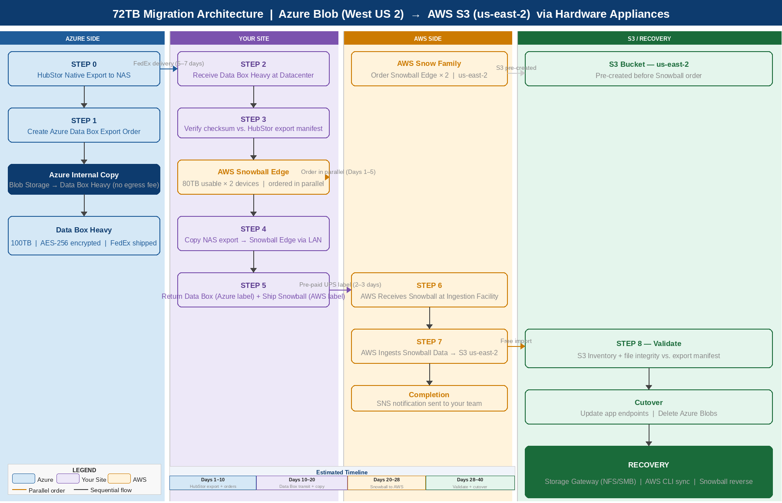

Figure 1 — End-to-end migration architecture: Azure Data Box Heavy + AWS Snowball Edge

11. Tentative Project Plan
The Gantt chart below shows a six-week (42-day) tentative schedule. The HubStor pre-export work and AWS Snowball device order run in parallel during Week 1 to maximise time efficiency. All dates are indicative — actual timelines depend on Azure Data Box availability, HubStor export throughput, and your on-site network speed.

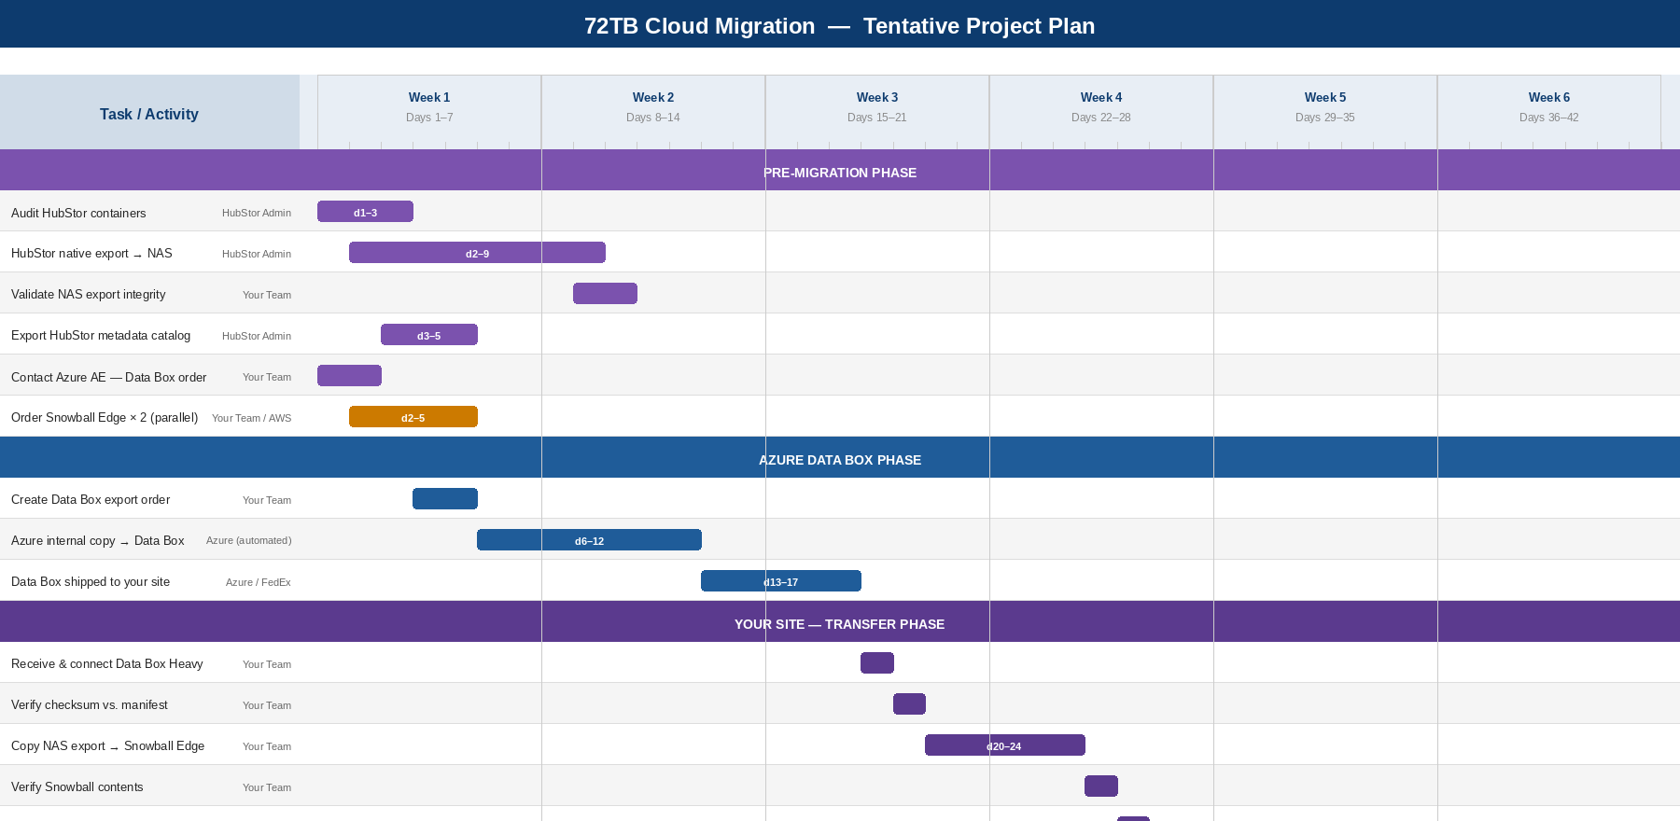

Figure 2 — Tentative project plan (42 days). Adjust based on actual HubStor export throughput and device delivery times.

11.1 Key Milestones
Milestone | Target Day | Owner | Gate Condition
HubStor native export complete & validated | Day 10 | HubStor Admin | File count and spot-check pass before Data Box order is placed
Data Box export order placed with Azure | Day 10 | Your Team | NAS export validated; Azure AE confirmed no egress fee
Snowball Edge devices ordered | Day 5 | Your Team / AWS AM | Order placed in parallel with pre-migration work
Data Box arrives at your datacenter | Day 17 | Azure / FedEx | Tracked via Azure Portal; facilities team notified for pallet receipt
Snowball copy complete & verified | Day 25 | Your Team | Checksum verified against HubStor export manifest
Snowball shipped to AWS | Day 26 | Your Team | Pre-paid UPS label applied; tracking number logged
S3 ingestion complete (SNS received) | Day 34 | AWS (automated) | SNS notification received; ingestion job shows success in console
S3 validation sign-off | Day 38 | Your Team | S3 Inventory matches export manifest; test restores pass
Application cutover to S3 | Day 40 | Your Team | All app endpoints updated and tested against S3
Azure Blobs deleted; HubStor decommissioned | Day 42 | Your Team + Cohesity AE | Deletion confirmed; Azure billing stopped; HubStor licence cancelled

11.2 Assumptions and Dependencies
- Azure Data Box Heavy availability: standard lead time is 5–7 business days from order. Engage your Microsoft AE early to confirm availability in West US 2.
- AWS Snowball Edge availability: standard delivery is 4–6 business days. Your AWS AM can expedite to 2–3 days for enterprise accounts.
- HubStor export throughput: the 72TB NAS export rate depends on your internal network. At 1Gbps sustained, 72TB takes approximately 6–7 days; at 10Gbps, approximately 16 hours. Plan accordingly.
- NAS staging capacity: your local NAS must have at least 75TB free space to hold the HubStor export before it is copied to the Data Box.
- Parallel device presence: the Data Box and Snowball Edge must be present at your site simultaneously for the most efficient transfer. Sequence the orders to ensure overlap.
- S3 bucket pre-created: the destination S3 bucket in us-east-2 must exist before the Snowball order is placed. Apply appropriate IAM policies and bucket encryption before ingestion.
Note: These timelines assume no significant delays from device availability, shipping, or HubStor export issues. Add a 5–7 day contingency buffer when communicating the plan to stakeholders.

Appendix — Useful Commands

A1. List Azure Blob containers and sizes
azcopy list 'https://<account>.blob.core.windows.net/<container>' --properties ContentLength

A2. Unlock and mount Data Box (Linux)
sudo mount -t nfs <databox-ip>:/data /mnt/databox -o nolock

A3. Copy to Snowball Edge
aws s3 sync /mnt/databox/ s3://your-bucket/ --endpoint http://<snowball-ip>:8080 --no-verify-ssl

A4. Validate S3 data after import
aws s3 ls s3://your-bucket/ --recursive --summarize --region us-east-2

A5. Restore from S3 to on-site
aws s3 sync s3://your-bucket/archive/path/ /local/restore/path/ --region us-east-2

