High-Density 2D Fiber Shuffling and Reworkable PIC Interfaces
Supplementary Report on Extreme Spatial Routing for 1.6T+ Optical Front Panels

Abstract
The rapid scaling of Photonic Integrated Circuit (PIC) bandwidth requires an equally radical approach to passive optical routing inside the switch chassis. This report investigates the mechanical and optical parameters required to transition from a centralized TFLN optical engine outward to dense front-panel I/O configurations using 2D laminated fiber shuffles. Furthermore, we outline the necessity of detachable, precision socket interfaces directly at the chip-level to mitigate total assembly loss.

1. 2D Laminated High-Density Fiber Shuffles
Routing hundreds of passive Single-Mode Fibers (SMF-28) within a confined 1RU (Rack Unit) housing introduces severe spatial constraints. In disorganized cable bundles, arbitrary pressure points induce macro-bending losses, severely degrading transmission capabilities.

1.1 Bend Radius Management ($R_{\text{min}}$)
A 2D laminated fiber shuffle meticulously organizes individual fiber strands across multiple cross-over layers. - Macrobending Floor: To maintain compliance, the minimum bend radius ($R_{\text{min}}$) of compliant bend-insensitive SMF-28 is strictly held $>7.5\text{ mm}$ throughout the shuffle matrix. - Laminated Layering: Cross-overs are distributed precisely across vertically stacked laminated sheets. This prevents localized pressure points while allowing a clean fan-out from highly dense centralized bundles to the wider pitch of 64 discrete front panel MPO-12/MPO-16 receptacles.
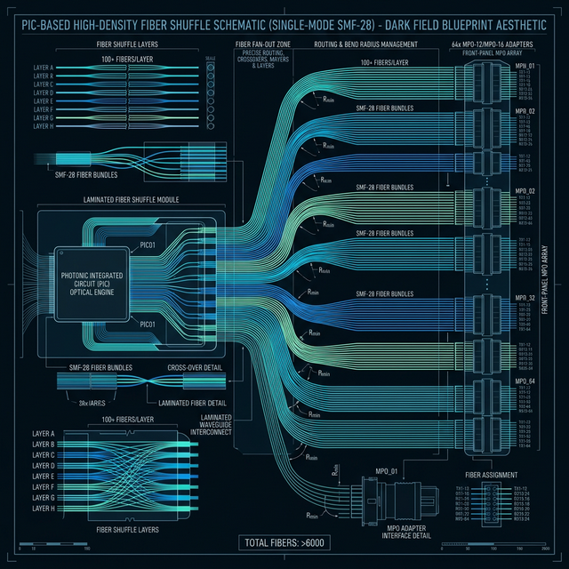
High Density Fiber Shuffle

2. Detachable Optical Sockets at the PIC Interface
As optical module values skyrocket due to integrated DSPs, DFB lasers, and complex TFLN modulators, permanent hard-bonding of fiber arrays presents an unacceptable manufacturing and field-failure risk. If a single fiber strand breaks during assembly, a permanently epoxied module is entirely scrapped.

2.1 The Reworkability Mandate
Instead of permanent UV curing, high-density detachable sockets must be utilized directly at the photonic interface.

2.2 Electro-Mechanical Alignment Parameters
To achieve $<0.5\text{ dB}$ coupling loss repeatedly: 1. Precision Guide Pins: Stainless steel dowel pins enforce sub-micron horizontal and vertical alignment before optical surfaces touch. 2. Multi-Lens Arrays (MLA): Beam expansion occurs immediately at the PIC facet edge. By expanding the optical mode field diameter via an MLA, the interface becomes far less sensitive to microscopic dust particles or lateral offset vibrations. 3. Spring-Loaded Latching: The socket block utilizes integrated springs to maintain uniform, constant pressure against the Si-substrate. This negates thermal expansion drift during heavy operating loads.
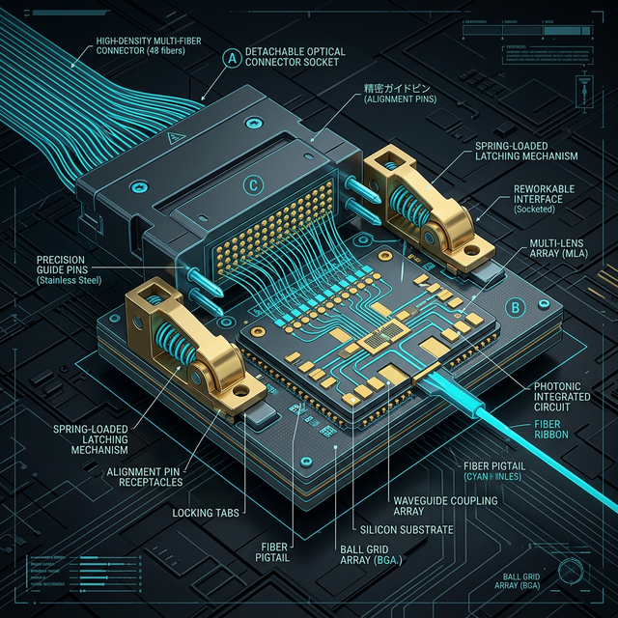
Detachable Chip Connector

3. Conclusion
Achieving Tb/s signaling densities necessitates advanced internal geometries. The 2D laminated fiber shuffle ensures that dense core processing power can physically reach the front panel without signal degradation. Simultaneously, utilizing multi-lens arrays and spring-loaded detachable sockets mitigates manufacturing risks, enabling field-replaceable photonic engines in next-generation architectures.

