Homework06
AIChen
2026-04-27

1. 在QGIS中安装Quickmapservices和quickOSM插件，利用它们访问和下载doubs的Openstreetmap数据，通过选择特征获得doubs，并将图层以doubs_river.shp格式，保存到postgresql数据库中。
步骤1：安装插件 打开 QGIS，在菜单栏点击“Plugins → Manage and Install Plugins”，进入插件管理界面。在搜索框中分别输入“QuickMapServices”和“QuickOSM”，找到后点击“Install Plugin”进行安装。 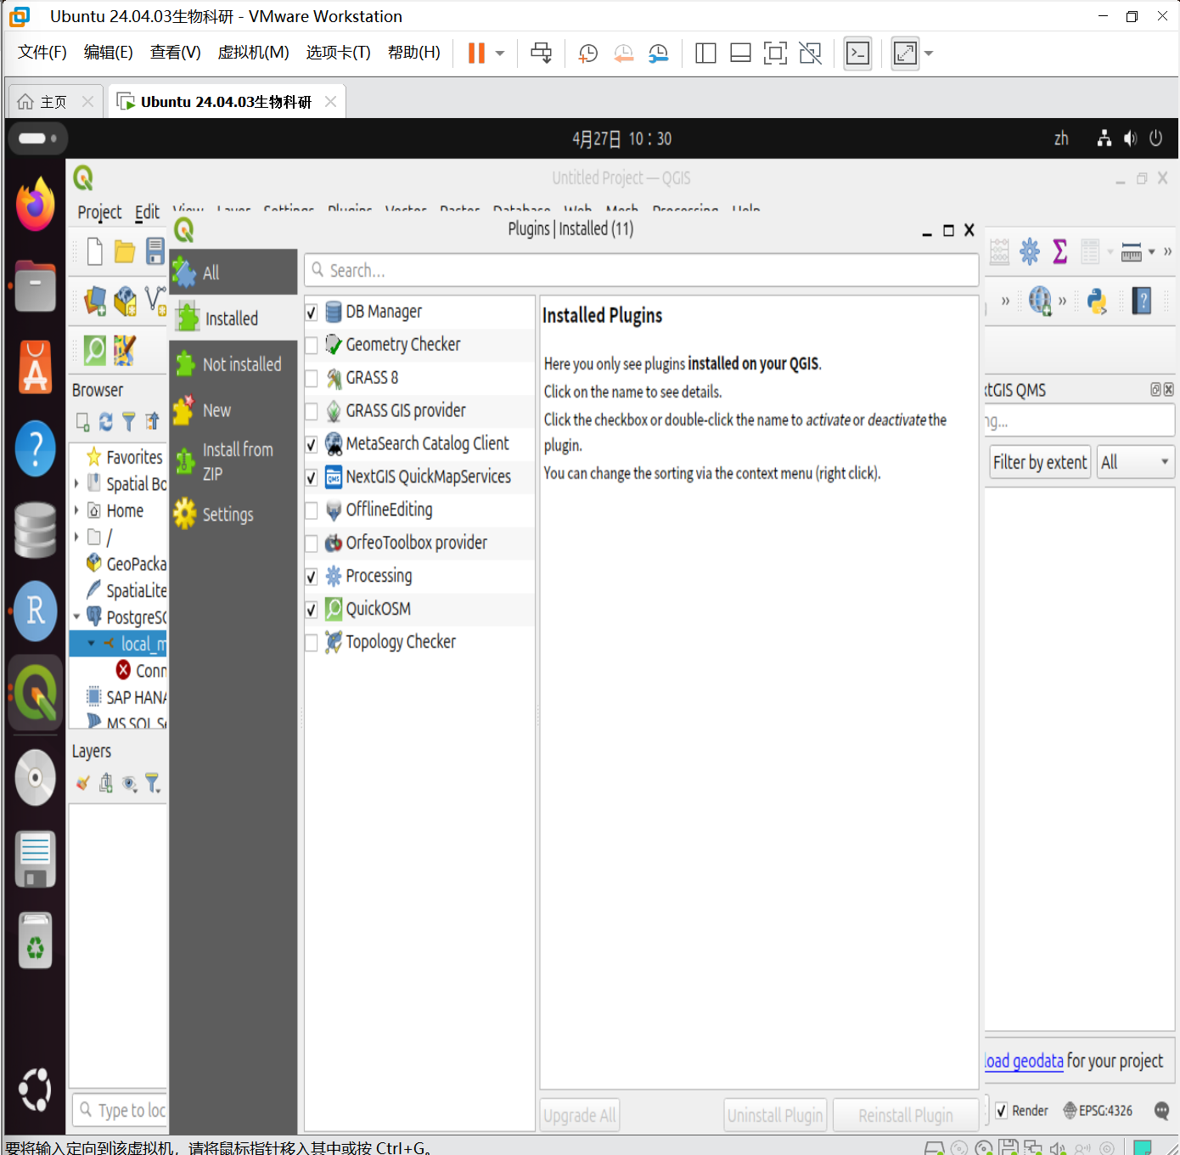 步骤2：加载底图（QuickMapServices） 在菜单栏点击“Web → QuickMapServices → Settings”，进入设置后点击“More services → Get contributed pack → OK”。然后返回菜单，点击“Web → QuickMapServices → OSM → OSM Standard”，加载 OpenStreetMap 底图。 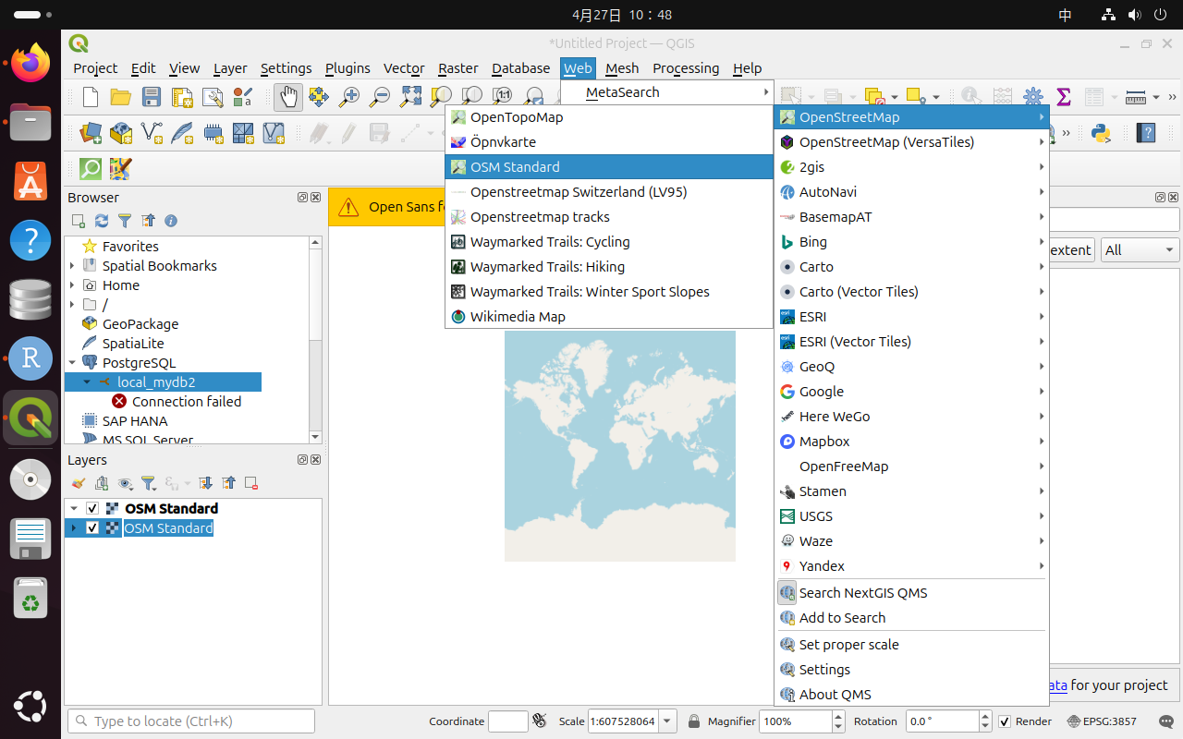 步骤3：下载 Doubs 河流数据（QuickOSM） 在菜单栏点击“Vector → QuickOSM → QuickOSM”，打开工具后，在 Quick Query 中设置：Key 为“waterway”，Value 为“river”，In 为“Doubs”，然后点击“Run query”运行查询，获取相关河流数据图层。 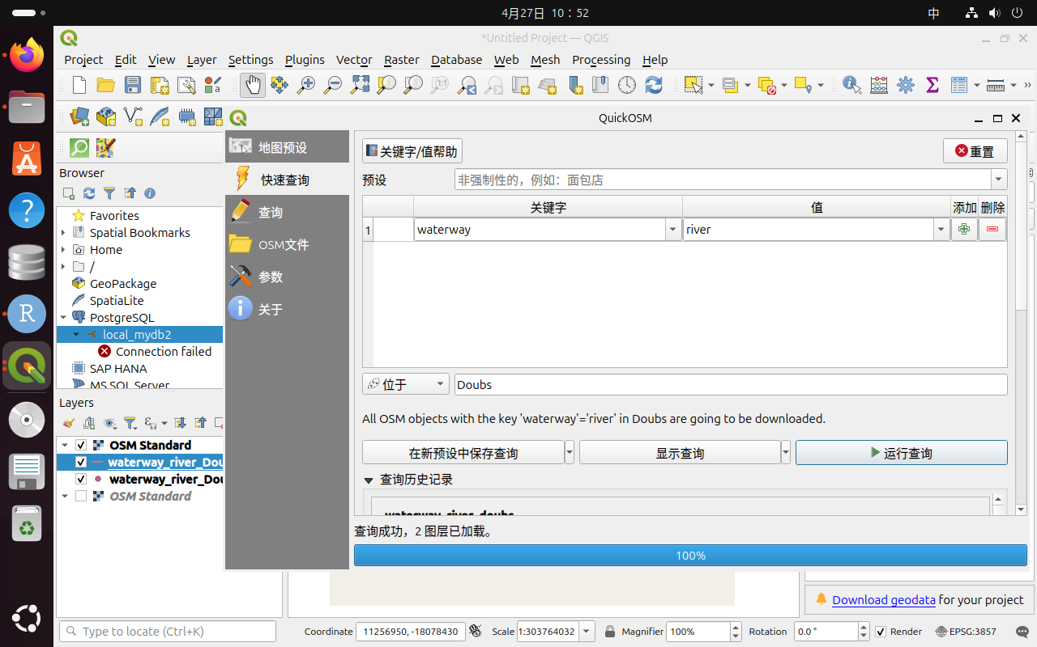 步骤4：筛选 Doubs 河流要素 在图层面板中选择下载得到的河流图层，右键打开属性表，点击“Select by Expression”，输入表达式 “name” = ‘Doubs’，执行选择操作，从所有河流中筛选出 Doubs 河。 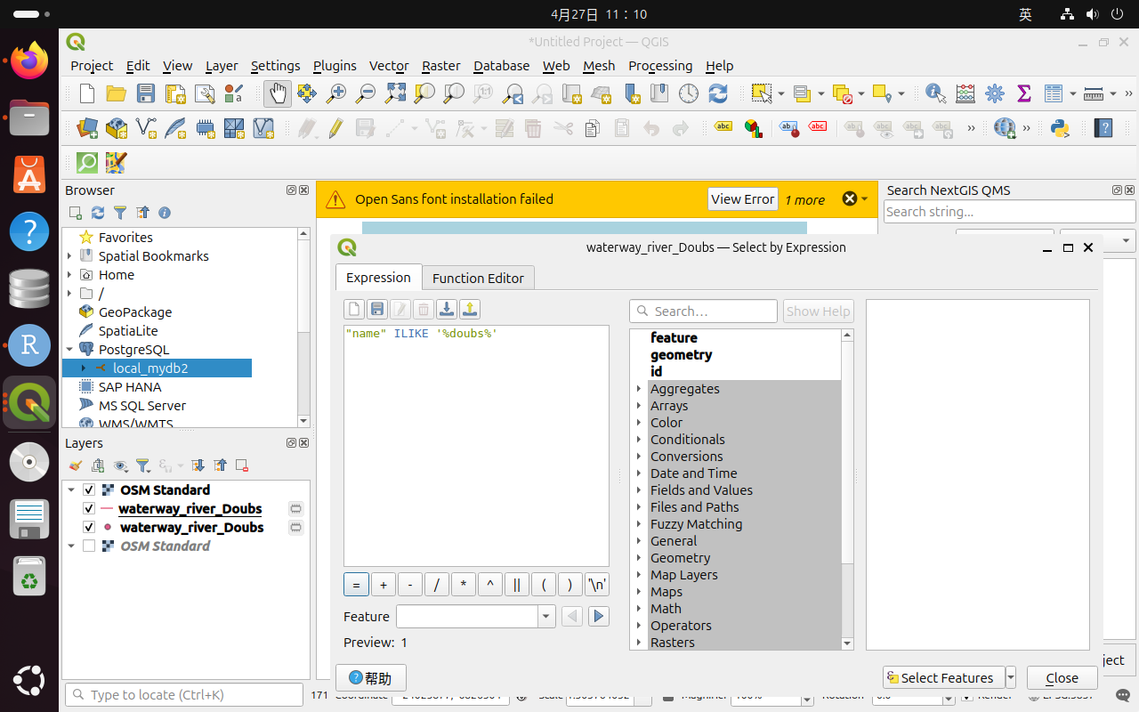
步骤5：导出为 Shapefile 文件 右键图层选择“Export → Save Selected Features As”，在弹出窗口中设置格式为“ESRI Shapefile”，文件名为“doubs_river.shp”，并勾选“Save only selected features”，点击“OK”完成导出。 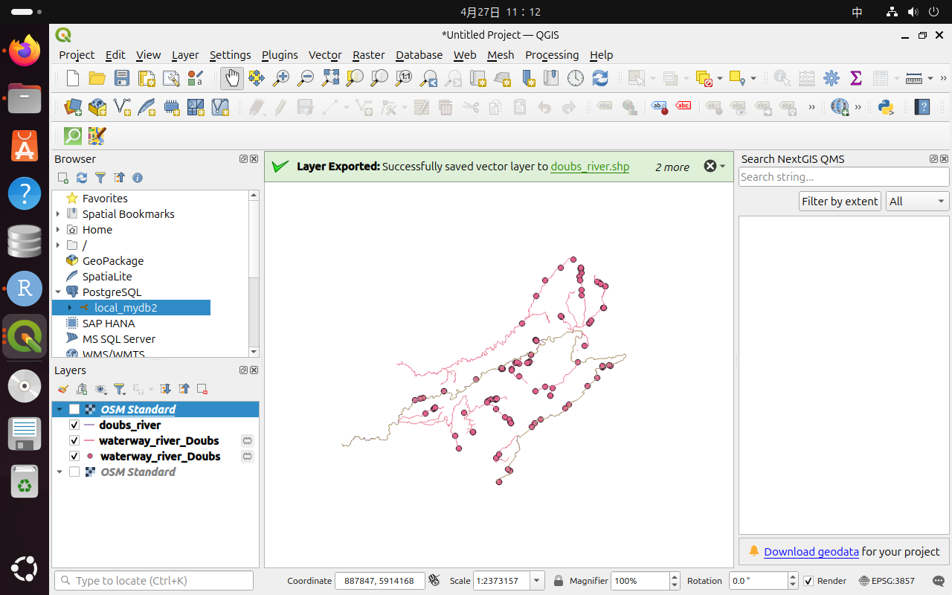 步骤6：导入 PostgreSQL 数据库 在 Browser 面板中右键“PostgreSQL”新建连接，填写数据库信息并连接成功后，打开“Database → DB Manager”，选择“Import Layer/File”，导入“doubs_river.shp”，设置 schema 和表名（如 doubs_river），完成后即可在数据库中查看并使用该图层。 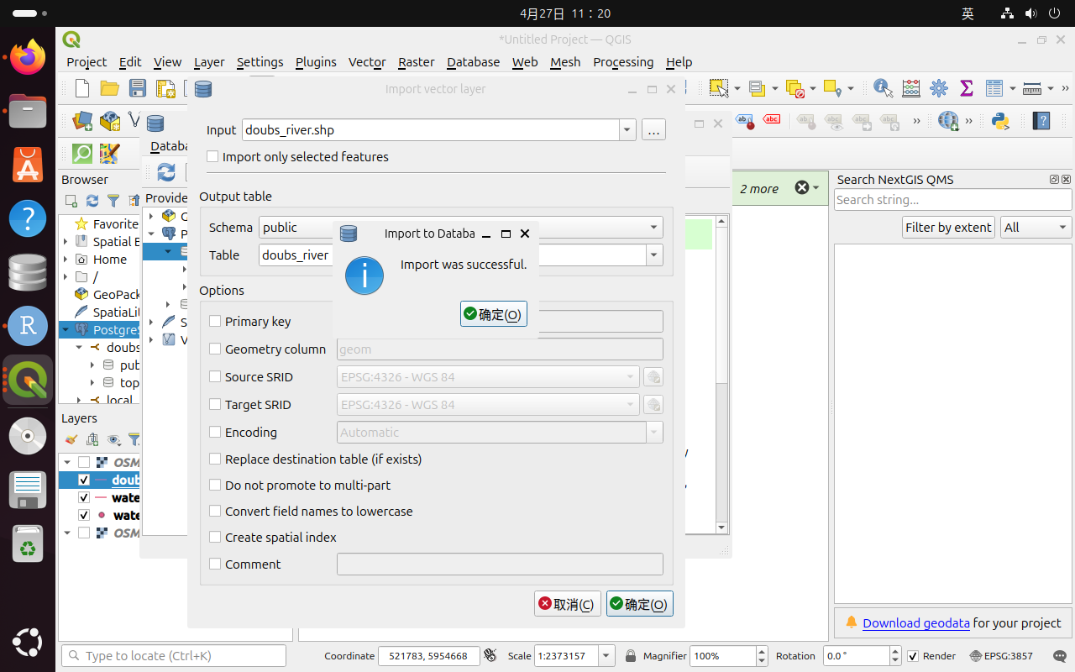 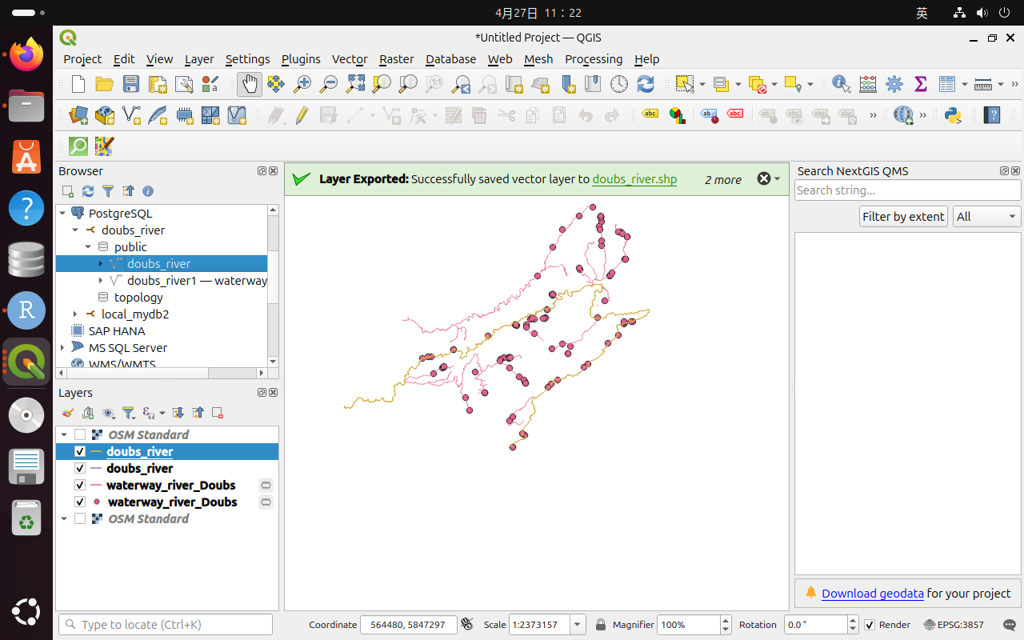 ## 2. 以R内置的doubs数据集为例，进行探索分析（Exploratory Data Analysis, EDA），并回答如下问题，涉及代码嵌入文本中： 1）将doubs数据集导入R，查看其中的fish表中各个观察站点的鱼群，从fish、env、xy表中删除无鱼站点，形成新数据表xx_clean。
library(ade4)
library(vegan)
## 载入需要的程序包：permute
library(dplyr)
##
## 载入程序包：'dplyr'
## The following objects are masked from 'package:stats':
##
## filter, lag
## The following objects are masked from 'package:base':
##
## intersect, setdiff, setequal, union
library(cluster)
data(doubs)
# 将 doubs 数据中的三个表分别提取出来
fish <- doubs$fish # 鱼类群落数据
env <- doubs$env # 环境变量数据
xy <- doubs$xy # 样点空间坐标数据
# 计算每一个样点中所有鱼类的总个体数
row_sums <- rowSums(fish)
# 查看哪些样点没有鱼
which(row_sums == 0)
## 8
## 8
# doubs 数据集中第 8 个样点没有鱼，因此删除第 8 个样点
fish_clean <- fish[-8, ]
env_clean <- env[-8, ]
xy_clean <- xy[-8, ]
# 查看删除后的数据维度
dim(fish_clean)
## [1] 29 27
dim(env_clean)
## [1] 29 11
dim(xy_clean)
## [1] 29 2
# 检查删除无鱼样点后，是否还存在鱼类总数为 0 的样点
rowSums(fish_clean)
## 1 2 3 4 5 6 7 9 10 11 12 13 14 15 16 17 18 19 20 21 22 23 24 25 26 27
## 3 12 16 21 34 21 16 14 14 11 18 19 28 33 40 44 42 46 56 62 72 4 15 11 43 63
## 28 29 30
## 70 87 89
2）对于fish_clean，先执行hellinger转换，然后计算样地/样点的鱼群之间的欧式距离，进行相似性分析（即Q-mode），并绘制ward最小方差的聚类图。
#Hellinger转换
spe_hel <- decostand(fish_clean, method = "hellinger")
head(spe_hel)
## Cogo Satr Phph Neba Thth Teso Chna Chto Lele Lece
## 1 0 1.0000000 0.0000000 0.0000000 0 0 0 0 0.0000000 0.0000000
## 2 0 0.6454972 0.5773503 0.5000000 0 0 0 0 0.0000000 0.0000000
## 3 0 0.5590170 0.5590170 0.5590170 0 0 0 0 0.0000000 0.0000000
## 4 0 0.4364358 0.4879500 0.4879500 0 0 0 0 0.0000000 0.2182179
## 5 0 0.2425356 0.2970443 0.2425356 0 0 0 0 0.3834825 0.2425356
## 6 0 0.3779645 0.4364358 0.4879500 0 0 0 0 0.2182179 0.3086067
## Baba Spbi Gogo Eslu Pefl Rham Legi Scer Cyca Titi
## 1 0 0 0.0000000 0.0000000 0.0000000 0 0 0.0000000 0 0.0000000
## 2 0 0 0.0000000 0.0000000 0.0000000 0 0 0.0000000 0 0.0000000
## 3 0 0 0.0000000 0.2500000 0.0000000 0 0 0.0000000 0 0.0000000
## 4 0 0 0.2182179 0.3086067 0.3086067 0 0 0.0000000 0 0.2182179
## 5 0 0 0.2425356 0.3429972 0.3429972 0 0 0.2425356 0 0.2970443
## 6 0 0 0.2182179 0.2182179 0.2182179 0 0 0.0000000 0 0.3086067
## Abbr Icme Acce Ruru Blbj Alal Anan
## 1 0 0 0 0.0000000 0 0 0
## 2 0 0 0 0.0000000 0 0 0
## 3 0 0 0 0.0000000 0 0 0
## 4 0 0 0 0.0000000 0 0 0
## 5 0 0 0 0.3834825 0 0 0
## 6 0 0 0 0.2182179 0 0 0
summary(spe_hel)# 查看转换后的鱼类数据
## Cogo Satr Phph Neba
## Min. :0.00000 Min. :0.0000 Min. :0.0000 Min. :0.0000
## 1st Qu.:0.00000 1st Qu.:0.0000 1st Qu.:0.0000 1st Qu.:0.1195
## Median :0.00000 Median :0.2132 Median :0.2673 Median :0.3015
## Mean :0.07299 Mean :0.2472 Mean :0.2581 Mean :0.2721
## 3rd Qu.:0.15076 3rd Qu.:0.4364 3rd Qu.:0.4714 3rd Qu.:0.4629
## Max. :0.33333 Max. :1.0000 Max. :0.6030 Max. :0.5590
## Thth Teso Chna Chto
## Min. :0.00000 Min. :0.00000 Min. :0.00000 Min. :0.00000
## 1st Qu.:0.00000 1st Qu.:0.00000 1st Qu.:0.00000 1st Qu.:0.00000
## Median :0.00000 Median :0.00000 Median :0.00000 Median :0.00000
## Mean :0.07133 Mean :0.06813 Mean :0.06897 Mean :0.07664
## 3rd Qu.:0.10721 3rd Qu.:0.10721 3rd Qu.:0.15162 3rd Qu.:0.15162
## Max. :0.39736 Max. :0.35355 Max. :0.25820 Max. :0.31623
## Lele Lece Baba Spbi
## Min. :0.0000 Min. :0.0000 Min. :0.0000 Min. :0.00000
## 1st Qu.:0.0000 1st Qu.:0.1890 1st Qu.:0.0000 1st Qu.:0.00000
## Median :0.1796 Median :0.2315 Median :0.0000 Median :0.00000
## Mean :0.1488 Mean :0.2331 Mean :0.1130 Mean :0.07879
## 3rd Qu.:0.2182 3rd Qu.:0.3015 3rd Qu.:0.2397 3rd Qu.:0.15811
## Max. :0.3835 Max. :0.5976 Max. :0.2673 Max. :0.30151
## Gogo Eslu Pefl Rham
## Min. :0.0000 Min. :0.0000 Min. :0.0000 Min. :0.00000
## 1st Qu.:0.0000 1st Qu.:0.0000 1st Qu.:0.0000 1st Qu.:0.00000
## Median :0.2236 Median :0.1581 Median :0.1260 Median :0.00000
## Mean :0.1724 Mean :0.1366 Mean :0.1103 Mean :0.08216
## 3rd Qu.:0.2582 3rd Qu.:0.2182 3rd Qu.:0.2144 3rd Qu.:0.21567
## Max. :0.4264 Max. :0.3430 Max. :0.3430 Max. :0.23973
## Legi Scer Cyca Titi
## Min. :0.00000 Min. :0.00000 Min. :0.00000 Min. :0.0000
## 1st Qu.:0.00000 1st Qu.:0.00000 1st Qu.:0.00000 1st Qu.:0.0000
## Median :0.00000 Median :0.00000 Median :0.00000 Median :0.1581
## Mean :0.08751 Mean :0.07113 Mean :0.07312 Mean :0.1345
## 3rd Qu.:0.18360 3rd Qu.:0.15250 3rd Qu.:0.15430 3rd Qu.:0.2390
## Max. :0.25820 Max. :0.30151 Max. :0.23905 Max. :0.3086
## Abbr Icme Acce Ruru
## Min. :0.00000 Min. :0.00000 Min. :0.0000 Min. :0.0000
## 1st Qu.:0.00000 1st Qu.:0.00000 1st Qu.:0.0000 1st Qu.:0.0000
## Median :0.00000 Median :0.00000 Median :0.0000 Median :0.2182
## Mean :0.06307 Mean :0.04423 Mean :0.1015 Mean :0.1862
## 3rd Qu.:0.14744 3rd Qu.:0.00000 3rd Qu.:0.2357 3rd Qu.:0.2988
## Max. :0.23702 Max. :0.23702 Max. :0.3651 Max. :0.5345
## Blbj Alal Anan
## Min. :0.00000 Min. :0.0000 Min. :0.00000
## 1st Qu.:0.00000 1st Qu.:0.0000 1st Qu.:0.00000
## Median :0.00000 Median :0.0000 Median :0.00000
## Mean :0.07713 Mean :0.1623 Mean :0.07283
## 3rd Qu.:0.21442 3rd Qu.:0.2673 3rd Qu.:0.16667
## Max. :0.26726 Max. :0.7071 Max. :0.23905
#计算欧式距离
spe_dist <- dist(spe_hel, method = "euclidean")
spe_dist# 查看距离矩阵
## 1 2 3 4 5 6 7
## 2 0.8420247
## 3 0.9391305 0.2716578
## 4 1.0616631 0.6206268 0.5163886
## 5 1.2308244 1.0494546 0.9767649 0.7049634
## 6 1.1153793 0.7212124 0.6594082 0.3660482 0.4976723
## 7 0.9391305 0.3767558 0.4370160 0.6078209 0.9206631 0.5762205
## 9 1.4142136 1.1083696 1.0879539 0.9539199 0.8706644 0.7401782 0.9572787
## 10 1.2105691 0.7093880 0.7113116 0.6647064 0.8310584 0.5430241 0.4371402
## 11 0.9775142 0.5726938 0.6362594 0.7278960 1.0468629 0.7736445 0.5703047
## 12 0.9725777 0.5512265 0.5972033 0.7190271 1.0589107 0.7645865 0.5426255
## 13 0.9869254 0.6488005 0.7001308 0.8573076 1.1353523 0.9207710 0.7421141
## 14 1.0746375 0.7671641 0.7334989 0.7538543 1.0235485 0.8131734 0.7667457
## 15 1.1417922 0.8713603 0.8867395 0.8133048 0.9138567 0.7214448 0.7251826
## 16 1.2051047 0.9882639 0.9556599 0.8302371 0.7827745 0.7172069 0.8579555
## 17 1.2544316 1.0368666 1.0060103 0.8809857 0.8316489 0.7906474 0.9412037
## 18 1.3005358 1.1067643 1.0736469 0.8968016 0.8280402 0.8120081 1.0092946
## 19 1.4142136 1.1727855 1.1278980 0.9813137 0.8144519 0.8621806 1.0945501
## 20 1.4142136 1.2871342 1.2429066 1.0571553 0.8385602 0.9469040 1.2020242
## 21 1.4142136 1.3139074 1.2672939 1.0804643 0.8618019 0.9895996 1.2455537
## 22 1.4142136 1.3719143 1.3289757 1.1370020 0.9052144 1.0406570 1.2838712
## 23 1.4142136 1.4142136 1.4142136 1.3348341 1.1721697 1.2137444 1.3228757
## 24 1.4142136 1.4142136 1.4142136 1.3145147 1.1906201 1.2257954 1.3481194
## 25 1.4142136 1.4142136 1.3598692 1.2231991 0.9117695 1.1104212 1.3032608
## 26 1.4142136 1.3592282 1.3121237 1.1398511 0.9267986 1.0389473 1.2827390
## 27 1.4142136 1.3689455 1.3164926 1.1469969 0.9329135 1.0453893 1.2887765
## 28 1.4142136 1.3713049 1.3277272 1.1568362 0.9452613 1.0627369 1.2893142
## 29 1.3362550 1.2769427 1.2331004 1.0665834 0.8889877 0.9926130 1.2054037
## 30 1.4142136 1.4142136 1.3762268 1.1982649 0.9537068 1.1213384 1.3477400
## 9 10 11 12 13 14 15
## 2
## 3
## 4
## 5
## 6
## 7
## 9
## 10 0.8761621
## 11 1.0188967 0.7252214
## 12 1.0148250 0.7295221 0.2292735
## 13 1.1939096 0.9113415 0.4632519 0.4341909
## 14 1.0946776 0.8212403 0.5308456 0.4904339 0.4030672
## 15 1.0000524 0.6619302 0.6853145 0.6561378 0.6448381 0.4536565
## 16 1.0027366 0.7918747 0.9491003 0.9302216 0.9133027 0.7607108 0.5822967
## 17 0.9981799 0.8956833 0.9599383 0.9514306 0.9593204 0.8316286 0.7429549
## 18 0.9871704 0.9286887 1.0040320 1.0008354 1.0349800 0.8832775 0.7977609
## 19 0.9581885 0.9735692 1.1850242 1.1742609 1.1951504 1.0661608 0.9631968
## 20 1.0073087 1.0929019 1.2590878 1.2596542 1.3191929 1.1761222 1.0724117
## 21 1.0772696 1.1424231 1.2891633 1.2945499 1.3368964 1.2009575 1.1147967
## 22 1.0961144 1.1835013 1.3367121 1.3333333 1.3869132 1.2431691 1.1408186
## 23 0.9315918 1.2735916 1.3032608 1.3282687 1.4142136 1.3457406 1.3032608
## 24 1.0831455 1.2593493 1.3340942 1.3519865 1.4142136 1.3283060 1.2855656
## 25 1.1477351 1.1472735 1.3483997 1.3630357 1.4142136 1.2692180 1.1943275
## 26 1.0648015 1.1905797 1.3334124 1.3245970 1.3787842 1.2411069 1.1537205
## 27 1.0820275 1.1962365 1.3388189 1.3335473 1.3850083 1.2395842 1.1474642
## 28 1.0909351 1.1983207 1.3355804 1.3321507 1.3865220 1.2539759 1.1653410
## 29 1.1097787 1.1326355 1.2247925 1.2297463 1.2472644 1.1106895 1.0477546
## 30 1.1834178 1.2632234 1.3745133 1.3832757 1.4142136 1.3005765 1.2202271
## 16 17 18 19 20 21 22
## 2
## 3
## 4
## 5
## 6
## 7
## 9
## 10
## 11
## 12
## 13
## 14
## 15
## 16
## 17 0.4592980
## 18 0.5557108 0.2289455
## 19 0.7071672 0.5062067 0.4499717
## 20 0.8507213 0.6167631 0.5088736 0.3043157
## 21 0.8941447 0.6926402 0.5837822 0.3774264 0.2013239
## 22 0.9287017 0.7608535 0.6480687 0.4840223 0.3036883 0.1755755
## 23 1.2721161 1.1278684 1.0981412 1.0778266 1.0233087 1.0652719 1.0621189
## 24 1.2345489 1.0994852 1.0043613 0.9147461 0.8360157 0.8527325 0.8308893
## 25 1.1271975 1.0692316 0.9876942 0.8953193 0.8272742 0.8365119 0.8427105
## 26 1.0061139 0.8246403 0.7053930 0.5302349 0.3436691 0.2734540 0.2551995
## 27 0.9588484 0.7965159 0.6857306 0.5152138 0.3311802 0.2263452 0.1856020
## 28 0.9726097 0.8090471 0.6967826 0.5377461 0.3610117 0.2460693 0.1796064
## 29 0.8497178 0.6500667 0.5471538 0.4694590 0.3585391 0.2518256 0.2637028
## 30 1.0026414 0.8275648 0.7272674 0.5936096 0.4129004 0.2779841 0.2591101
## 23 24 25 26 27 28 29
## 2
## 3
## 4
## 5
## 6
## 7
## 9
## 10
## 11
## 12
## 13
## 14
## 15
## 16
## 17
## 18
## 19
## 20
## 21
## 22
## 23
## 24 0.6732063
## 25 0.8114360 0.7184750
## 26 0.9985462 0.7519219 0.7789234
## 27 1.0495973 0.8160106 0.8271334 0.1743776
## 28 1.0562805 0.8245236 0.8496001 0.2084410 0.1313206
## 29 1.0985509 0.8830753 0.8824758 0.3314187 0.2800912 0.2634975
## 30 1.1154279 0.9228718 0.8787759 0.3332022 0.2809915 0.2255144 0.2921797
#Ward聚类
spe_clust <- hclust(spe_dist, method = "ward.D2")
plot(spe_clust,# 绘制聚类树
hang = -1,
main = "Q-mode cluster analysis of fish communities",
xlab = "Sampling sites",
ylab = "Euclidean distance")
# 添加矩形框，便于观察聚类结果
rect.hclust(spe_clust, k = 4, border = "red")
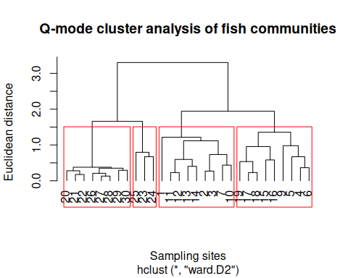 3）对于env_clean，可通过主成分分析（principle component analysis, PCA），开展列变量之间相关性分析（R-mode），并绘制和解释PCA双序图。 ① 对删除无鱼的第8号样本后的env_clean进行标准化（均值为0，标准差为1），执行如下代码：
# 删除无鱼的第 8 号样点后，对环境变量进行标准化
# method = "standardize" 表示均值为 0，标准差为 1
env_z <- vegan::decostand(env_clean, method = "standardize")
# 查看标准化后的环境变量
head(env_z)
## dfs alt slo flo pH har pho
## 1 -1.378189 1.717711 3.1366013 -1.228203 -0.8400173 -2.3880656 -0.6297049
## 2 -1.364578 1.710295 0.6331760 -1.219304 -0.2734940 -2.6805229 -0.6184601
## 3 -1.307270 1.643545 0.8194265 -1.174807 1.4260758 -1.9786253 -0.5847259
## 4 -1.247812 1.421047 0.6906945 -1.134204 -0.2734940 -0.8087959 -0.5285023
## 5 -1.226322 1.402505 0.3994499 -1.128086 0.2930293 -0.1068982 -0.2136499
## 6 -1.148239 1.391381 0.6906945 -1.115849 -0.8400173 -1.5106935 -0.4160550
## nit amm oxy bdo
## 1 -1.0553549 -0.55117785 1.2359060 -0.59473827
## 2 -1.0553549 -0.29169477 0.3749905 -0.80037058
## 3 -1.0412543 -0.42143631 0.4656131 -0.38910597
## 4 -1.0483046 -0.55117785 0.6921699 -0.95459482
## 5 -0.8297458 -0.03221169 -0.6671705 0.30490308
## 6 -1.0906063 -0.55117785 0.3296791 0.07356673
summary(env_z)
## dfs alt slo flo
## Min. :-1.37819 Min. :-1.1080 Min. :-1.4987 Min. :-1.228203
## 1st Qu.:-0.87531 1st Qu.:-0.8336 1st Qu.:-0.8660 1st Qu.:-1.007945
## Median :-0.04864 Median :-0.3552 Median :-0.1602 Median : 0.004354
## Mean : 0.00000 Mean : 0.0000 Mean : 0.0000 Mean : 0.000000
## 3rd Qu.: 0.79952 3rd Qu.: 1.0428 3rd Qu.: 0.6332 3rd Qu.: 0.326954
## Max. : 1.86474 Max. : 1.7177 Max. : 3.1366 Max. : 2.562911
## pH har pho nit
## Min. :-1.9731 Min. :-2.6805 Min. :-0.62970 Min. :-1.09061
## 1st Qu.:-0.8400 1st Qu.:-0.1069 1st Qu.:-0.52850 1st Qu.:-0.82975
## Median :-0.2735 Median : 0.1271 Median :-0.30361 Median :-0.06831
## Mean : 0.0000 Mean : 0.0000 Mean : 0.00000 Mean : 0.00000
## 3rd Qu.: 0.2930 3rd Qu.: 0.6535 3rd Qu.: 0.01124 3rd Qu.: 0.56621
## Max. : 3.1256 Max. : 1.4139 Max. : 4.10433 Max. : 3.17482
## amm oxy bdo
## Min. :-0.55118 Min. :-2.4343 Min. :-0.95459
## 1st Qu.:-0.55118 1st Qu.:-0.6219 1st Qu.:-0.59474
## Median :-0.29169 Median : 0.3297 Median :-0.23488
## Mean : 0.00000 Mean : 0.0000 Mean : 0.00000
## 3rd Qu.:-0.03221 3rd Qu.: 0.6922 3rd Qu.: 0.04786
## Max. : 4.11952 Max. : 1.3265 Max. : 3.00383
② 比较R自带的stats包里的prcomp()函数和vegan包rda()函数对标准化后的env_zS进行主成分分析，探讨变量相关性，并绘制双标图，代码如下：
pca_env_prcomp <- prcomp(env_z)
biplot(pca_env_prcomp, scale = 0)
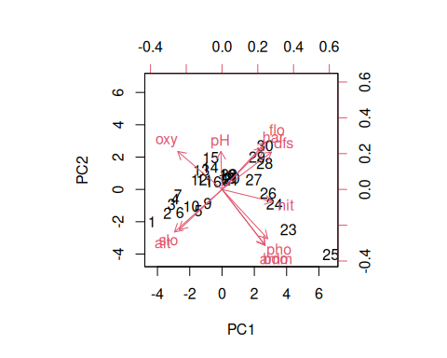
pca_env_rda <- vegan::rda(env_z)
biplot(pca_env_rda, scaling = 2)
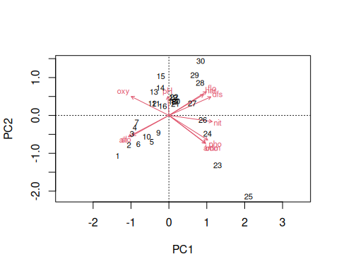 ③ 从样点或变量角度，解释步骤②产生的双标图biplot(pca_env_rda)的含义。 PCA 双标图可以同时展示样点和环境变量之间的关系。 在图中，点代表样点，箭头代表环境变量。箭头越长，说明该环境变量在 PCA 排序中的贡献越大。 两个箭头之间的夹角可以反映变量之间的相关性： 如果两个箭头方向接近，说明二者呈正相关； 如果两个箭头方向相反，说明二者呈负相关； 如果两个箭头接近垂直，说明二者相关性较弱。 从样点角度看，如果某些样点沿着某个环境变量箭头方向分布，说明这些样点在该环境变量上的数值较高。 从变量角度看，PCA 第一轴和第二轴通常反映环境梯度的主要变化方向，例如海拔、河流宽度、流速、营养盐或氧气等环境因子的综合变化。
4）对于fish与env之间关系的冗余分析（redundancy analysis，RDA），需要选择正确排序模型（单峰或线性模型）以及选择合适的env_z变量，根据最终结果绘图并解释。 ① 针对spe_hel与env_z关系分析，需要选择线性模型（RDA）和单峰模型（Canonical Correspondence Analysis，CCA），通过运行如下代码，获得第一轴DCA1长度，当DCA1_<3__，选择用RDA，当DCA1>4，选择CCA。
# 使用 DCA 判断应该选择线性模型 RDA 还是单峰模型 CCA
dca_spe <- decorana(spe_hel)
# 查看 DCA 结果
dca_spe
##
## Call:
## decorana(veg = spe_hel)
##
## Detrended correspondence analysis with 26 segments.
## Rescaling of axes with 4 iterations.
## Total inertia (scaled Chi-square): 1.2956
##
## DCA1 DCA2 DCA3 DCA4
## Eigenvalues 0.5284 0.1628 0.13955 0.06843
## Additive Eigenvalues 0.5284 0.1616 0.10433 0.05515
## Decorana values 0.5572 0.1532 0.04808 0.02734
## Axis lengths 3.8978 2.5320 1.81542 1.08788
② 如果进行spe_hel的RDA分析，通过手动删除env_z中_共线性较高（VIF > 10）的变量或者通过vegan包中ordiR2step()函数最大化调整后的 R²（adjusted R²），最终达到选择变量的目的。
#RDA 初步分析
# 使用 Hellinger 转换后的鱼类数据 spe_hel
# 使用标准化后的环境变量 env_z
rda_full <- rda(spe_hel ~ ., data = as.data.frame(env_z))
# 查看 RDA 结果
summary(rda_full)
##
## Call:
## rda(formula = spe_hel ~ dfs + alt + slo + flo + pH + har + pho + nit + amm + oxy + bdo, data = as.data.frame(env_z))
##
## Partitioning of variance:
## Inertia Proportion
## Total 0.5025 1.0000
## Constrained 0.3676 0.7315
## Unconstrained 0.1349 0.2685
##
## Eigenvalues, and their contribution to the variance
##
## Importance of components:
## RDA1 RDA2 RDA3 RDA4 RDA5 RDA6 RDA7
## Eigenvalue 0.2303 0.0535 0.03385 0.02763 0.006842 0.006189 0.003279
## Proportion Explained 0.4583 0.1065 0.06736 0.05499 0.013615 0.012316 0.006526
## Cumulative Proportion 0.4583 0.5647 0.63211 0.68709 0.700709 0.713025 0.719551
## RDA8 RDA9 RDA10 RDA11 PC1 PC2
## Eigenvalue 0.00299 0.001375 0.0008761 0.0007558 0.04367 0.02254
## Proportion Explained 0.00595 0.002736 0.0017434 0.0015041 0.08690 0.04485
## Cumulative Proportion 0.72550 0.728237 0.7299801 0.7314842 0.81839 0.86324
## PC3 PC4 PC5 PC6 PC7 PC8
## Eigenvalue 0.01776 0.01408 0.009679 0.008516 0.005212 0.004528
## Proportion Explained 0.03535 0.02801 0.019261 0.016947 0.010372 0.009011
## Cumulative Proportion 0.89859 0.92660 0.945863 0.962810 0.973182 0.982193
## PC9 PC10 PC11 PC12 PC13 PC14
## Eigenvalue 0.002978 0.002021 0.001328 0.001008 0.0007273 0.0003760
## Proportion Explained 0.005927 0.004022 0.002643 0.002005 0.0014474 0.0007482
## Cumulative Proportion 0.988119 0.992142 0.994784 0.996790 0.9982369 0.9989851
## PC15 PC16 PC17
## Eigenvalue 0.0003038 0.0001279 7.827e-05
## Proportion Explained 0.0006045 0.0002546 1.558e-04
## Cumulative Proportion 0.9995896 0.9998442 1.000e+00
##
## Accumulated constrained eigenvalues
## Importance of components:
## RDA1 RDA2 RDA3 RDA4 RDA5 RDA6 RDA7
## Eigenvalue 0.2303 0.0535 0.03385 0.02763 0.006842 0.006189 0.003279
## Proportion Explained 0.6265 0.1455 0.09209 0.07517 0.018613 0.016837 0.008921
## Cumulative Proportion 0.6265 0.7721 0.86415 0.93932 0.957928 0.974765 0.983686
## RDA8 RDA9 RDA10 RDA11
## Eigenvalue 0.002990 0.001375 0.0008761 0.0007558
## Proportion Explained 0.008134 0.003740 0.0023834 0.0020562
## Cumulative Proportion 0.991820 0.995560 0.9979438 1.0000000
# 检验整体模型是否显著
anova(rda_full, permutations = 999)
## Permutation test for rda under reduced model
## Permutation: free
## Number of permutations: 999
##
## Model: rda(formula = spe_hel ~ dfs + alt + slo + flo + pH + har + pho + nit + amm + oxy + bdo, data = as.data.frame(env_z))
## Df Variance F Pr(>F)
## Model 11 0.36758 4.2101 0.001 ***
## Residual 17 0.13493
## ---
## Signif. codes: 0 '***' 0.001 '**' 0.01 '*' 0.05 '.' 0.1 ' ' 1
# 检验每一条排序轴是否显著
anova(rda_full, by = "axis", permutations = 999)
## Permutation test for rda under reduced model
## Forward tests for axes
## Permutation: free
## Number of permutations: 999
##
## Model: rda(formula = spe_hel ~ dfs + alt + slo + flo + pH + har + pho + nit + amm + oxy + bdo, data = as.data.frame(env_z))
## Df Variance F Pr(>F)
## RDA1 1 0.230295 29.0147 0.001 ***
## RDA2 1 0.053495 7.1363 0.001 ***
## RDA3 1 0.033851 4.7666 0.030 *
## RDA4 1 0.027631 4.0955 0.167
## RDA5 1 0.006842 1.0648 1.000
## RDA6 1 0.006189 0.7797
## RDA7 1 0.003279 0.4132
## RDA8 1 0.002990 0.3767
## RDA9 1 0.001375 0.1732
## RDA10 1 0.000876 0.1104
## RDA11 1 0.000756 0.0952
## Residual 17 0.134932
## ---
## Signif. codes: 0 '***' 0.001 '**' 0.01 '*' 0.05 '.' 0.1 ' ' 1
# 检验每一个环境变量是否显著
anova(rda_full, by = "term", permutations = 999)
## Permutation test for rda under reduced model
## Terms added sequentially (first to last)
## Permutation: free
## Number of permutations: 999
##
## Model: rda(formula = spe_hel ~ dfs + alt + slo + flo + pH + har + pho + nit + amm + oxy + bdo, data = as.data.frame(env_z))
## Df Variance F Pr(>F)
## dfs 1 0.196095 24.7059 0.001 ***
## alt 1 0.031404 3.9566 0.018 *
## slo 1 0.016273 2.0503 0.105
## flo 1 0.039987 5.0380 0.003 **
## pH 1 0.010947 1.3792 0.215
## har 1 0.015607 1.9663 0.105
## pho 1 0.032578 4.1045 0.002 **
## nit 1 0.009711 1.2234 0.260
## amm 1 0.006267 0.7896 0.503
## oxy 1 0.003765 0.4744 0.807
## bdo 1 0.004943 0.6228 0.677
## Residual 17 0.134932
## ---
## Signif. codes: 0 '***' 0.001 '**' 0.01 '*' 0.05 '.' 0.1 ' ' 1
# 检查环境变量之间的共线性
vif.cca(rda_full)
## dfs alt slo flo pH har pho
## 135.817134 51.714483 5.324914 45.740857 1.807935 4.400607 27.453045
## nit amm oxy bdo
## 16.614554 30.685220 17.493662 18.210558
#使用 ordiR2step() 进行变量选择
# 建立空模型
rda_null <- rda(spe_hel ~ 1, data = as.data.frame(env_z))
# 使用调整后的 R2 作为标准进行逐步选择
# 目的是在不过度拟合的前提下，选择最合适的环境变量
rda_step <- ordiR2step(rda_null,
scope = formula(rda_full),
direction = "forward",
R2scope = TRUE,
permutations = 999)
## Step: R2.adj= 0
## Call: spe_hel ~ 1
##
## R2.adjusted
## <All variables> 0.55773873
## + dfs 0.36764742
## + alt 0.30317903
## + oxy 0.27664565
## + flo 0.26284719
## + nit 0.25885656
## + slo 0.23596877
## + bdo 0.16253018
## + har 0.14287362
## + pho 0.13366338
## + amm 0.12940835
## <model> 0.00000000
## + pH -0.01877893
##
## Df AIC F Pr(>F)
## + dfs 1 -31.319 17.279 0.001 ***
## ---
## Signif. codes: 0 '***' 0.001 '**' 0.01 '*' 0.05 '.' 0.1 ' ' 1
##
## Step: R2.adj= 0.3676474
## Call: spe_hel ~ dfs
##
## R2.adjusted
## <All variables> 0.5577387
## + oxy 0.4706162
## + bdo 0.4571904
## + amm 0.4324372
## + pho 0.4289620
## + alt 0.4106277
## + flo 0.4071549
## + har 0.3977492
## + nit 0.3879446
## + slo 0.3850158
## <model> 0.3676474
## + pH 0.3635505
##
## Df AIC F Pr(>F)
## + oxy 1 -35.568 6.2517 0.001 ***
## ---
## Signif. codes: 0 '***' 0.001 '**' 0.01 '*' 0.05 '.' 0.1 ' ' 1
##
## Step: R2.adj= 0.4706162
## Call: spe_hel ~ dfs + oxy
##
## R2.adjusted
## <All variables> 0.5577387
## + bdo 0.5368359
## + pho 0.5157252
## + alt 0.5076693
## + amm 0.5067082
## + har 0.5040440
## + slo 0.4937796
## + flo 0.4744451
## <model> 0.4706162
## + nit 0.4700184
## + pH 0.4588694
##
## Df AIC F Pr(>F)
## + bdo 1 -38.581 4.7173 0.003 **
## ---
## Signif. codes: 0 '***' 0.001 '**' 0.01 '*' 0.05 '.' 0.1 ' ' 1
##
## Step: R2.adj= 0.5368359
## Call: spe_hel ~ dfs + oxy + bdo
##
## R2.adjusted
## + alt 0.5759437
## + har 0.5681670
## + slo 0.5616857
## <All variables> 0.5577387
## + flo 0.5465345
## <model> 0.5368359
## + nit 0.5361868
## + pho 0.5336102
## + amm 0.5306263
## + pH 0.5269670
# 查看最终选择出的模型
rda_step
##
## Call: rda(formula = spe_hel ~ dfs + oxy + bdo, data = as.data.frame(env_z))
##
## Inertia Proportion Rank
## Total 0.5025 1.0000
## Constrained 0.2947 0.5865 3
## Unconstrained 0.2078 0.4135 25
##
## Inertia is variance
##
## Eigenvalues for constrained axes:
## RDA1 RDA2 RDA3
## 0.21874 0.05015 0.02581
##
## Eigenvalues for unconstrained axes:
## PC1 PC2 PC3 PC4 PC5 PC6 PC7 PC8
## 0.05422 0.04398 0.02639 0.01803 0.01486 0.01298 0.00971 0.00633
## (Showing 8 of 25 unconstrained eigenvalues)
# 查看最终 RDA 模型的详细结果
summary(rda_step)
##
## Call:
## rda(formula = spe_hel ~ dfs + oxy + bdo, data = as.data.frame(env_z))
##
## Partitioning of variance:
## Inertia Proportion
## Total 0.5025 1.0000
## Constrained 0.2947 0.5865
## Unconstrained 0.2078 0.4135
##
## Eigenvalues, and their contribution to the variance
##
## Importance of components:
## RDA1 RDA2 RDA3 PC1 PC2 PC3 PC4
## Eigenvalue 0.2187 0.05015 0.02581 0.05422 0.04398 0.02639 0.01803
## Proportion Explained 0.4353 0.09981 0.05137 0.10789 0.08752 0.05252 0.03587
## Cumulative Proportion 0.4353 0.53509 0.58646 0.69435 0.78188 0.83439 0.87026
## PC5 PC6 PC7 PC8 PC9 PC10
## Eigenvalue 0.01486 0.01298 0.009708 0.006335 0.005512 0.004085
## Proportion Explained 0.02957 0.02584 0.019318 0.012607 0.010969 0.008129
## Cumulative Proportion 0.89983 0.92567 0.944989 0.957595 0.968564 0.976693
## PC11 PC12 PC13 PC14 PC15 PC16
## Eigenvalue 0.003062 0.002203 0.001551 0.001331 0.0009825 0.0008679
## Proportion Explained 0.006094 0.004383 0.003086 0.002648 0.0019551 0.0017271
## Cumulative Proportion 0.982787 0.987170 0.990257 0.992905 0.9948601 0.9965872
## PC17 PC18 PC19 PC20 PC21
## Eigenvalue 0.0005029 0.0004099 0.0002537 0.0002227 0.0001342
## Proportion Explained 0.0010008 0.0008158 0.0005049 0.0004433 0.0002670
## Cumulative Proportion 0.9975880 0.9984038 0.9989087 0.9993520 0.9996189
## PC22 PC23 PC24 PC25
## Eigenvalue 8.469e-05 0.0000536 3.952e-05 1.368e-05
## Proportion Explained 1.685e-04 0.0001067 7.864e-05 2.722e-05
## Cumulative Proportion 9.998e-01 0.9998941 1.000e+00 1.000e+00
##
## Accumulated constrained eigenvalues
## Importance of components:
## RDA1 RDA2 RDA3
## Eigenvalue 0.2187 0.05015 0.02581
## Proportion Explained 0.7422 0.17018 0.08759
## Cumulative Proportion 0.7422 0.91241 1.00000
# 对最终模型进行显著性检验
anova(rda_step, permutations = 999)
## Permutation test for rda under reduced model
## Permutation: free
## Number of permutations: 999
##
## Model: rda(formula = spe_hel ~ dfs + oxy + bdo, data = as.data.frame(env_z))
## Df Variance F Pr(>F)
## Model 3 0.29470 11.818 0.001 ***
## Residual 25 0.20781
## ---
## Signif. codes: 0 '***' 0.001 '**' 0.01 '*' 0.05 '.' 0.1 ' ' 1
anova(rda_step, by = "axis", permutations = 999)
## Permutation test for rda under reduced model
## Forward tests for axes
## Permutation: free
## Number of permutations: 999
##
## Model: rda(formula = spe_hel ~ dfs + oxy + bdo, data = as.data.frame(env_z))
## Df Variance F Pr(>F)
## RDA1 1 0.218736 26.3147 0.001 ***
## RDA2 1 0.050153 6.2749 0.001 ***
## RDA3 1 0.025813 3.3539 0.002 **
## Residual 25 0.207808
## ---
## Signif. codes: 0 '***' 0.001 '**' 0.01 '*' 0.05 '.' 0.1 ' ' 1
anova(rda_step, by = "term", permutations = 999)
## Permutation test for rda under reduced model
## Terms added sequentially (first to last)
## Permutation: free
## Number of permutations: 999
##
## Model: rda(formula = spe_hel ~ dfs + oxy + bdo, data = as.data.frame(env_z))
## Df Variance F Pr(>F)
## dfs 1 0.196095 23.5909 0.001 ***
## oxy 1 0.059396 7.1455 0.001 ***
## bdo 1 0.039212 4.7173 0.005 **
## Residual 25 0.207808
## ---
## Signif. codes: 0 '***' 0.001 '**' 0.01 '*' 0.05 '.' 0.1 ' ' 1
#绘制最终 RDA 排序图
# 绘制 RDA 排序图
plot(rda_step,
scaling = 2,
main = "RDA ordination of fish communities and environmental variables")
# 添加样点编号
text(rda_step,
display = "sites",
scaling = 2,
col = "blue",
cex = 0.8)
# 添加物种名称
text(rda_step,
display = "species",
scaling = 2,
col = "red",
cex = 0.7)
