STRATEGIC STRATEGY & ARCHITECTURE BRIEF
THE "MOMENTO 0" SEMANTIC ARCHITECTURE
Prepared for: Charles Hoffman, CPA (Founder of the Seattle Method) & the DFRNT Team
Prepared by: Richard Gasca
Core Alignment: Zachman Framework, REA Ontology, W3C Semantic Standards (SHACL, JSON-LD), the Seattle Method, and ISO 21378 / ISO 15944 Standards
Date: May 20, 2026

1. Executive Summary & Philosophical Grounding
Traditional Enterprise Resource Planning (ERP) systems suffer from a severe ontological limitation: they are flat, retrospective, and functionally silent. They capture financial records as historical flat files, answering only what balances exist and when they were posted. In the era of artificial intelligence and automated decision-making, this structure creates an unsustainable gap—the 'Seam Problem'—between real-world business operations, internal ledgers, and final regulatory disclosures.
This structural limitation has forced the most representative leaders of the traditional enterprise software ecosystem (such as SAP with its semantic layer over SAP HANA, Oracle with NetSuite Analytics, and Microsoft with Dynamics 365) to retroactively patch a semantic layer onto their architectures in an attempt to translate and map complex relational tables to human-readable business terms for analytical tools and BI reporting. However, this retroactive, bolted-on semantic approach suffers from fundamental flaws: it is read-only, does not prevent transactional data corruption at the source, and continues to suffer from the 'seam problem' between operational transactions and final disclosure reporting.
This pattern of convergence is not a theoretical conjecture; it is an immediate market reality driven by the era of artificial intelligence. As demonstrated by recent industry publications (see Figure 1 and Figure 2), global giants like Microsoft (with its 'Fabric IQ' semantic layer and GraphRAG), Google (with Spanner Graph), and Cosmos DB (with OmniRAG) have unanimously converged on the same thesis: AI without a semantic layer hallucinates, and the only viable semantic layer is a graph. This ecosystem validation demonstrates that the enterprise knowledge graph category has been fully legitimized by the largest software corporations on earth, proving that the 'Momento 0' stack natively addresses at its core the fundamental design flaw that the rest of the industry is scrambling to patch retroactively.
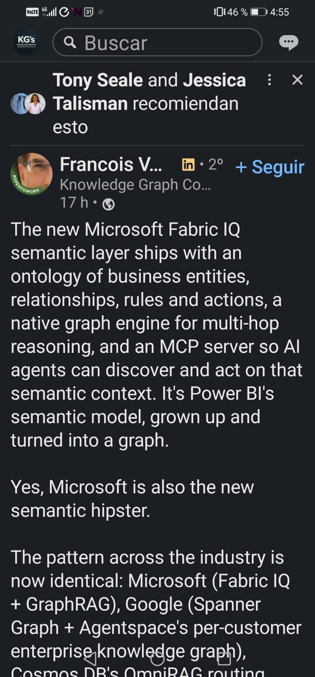
Figure: Ecosystem Evidence - Microsoft Fabric IQ and Graph-Based Semantic Layer Integration
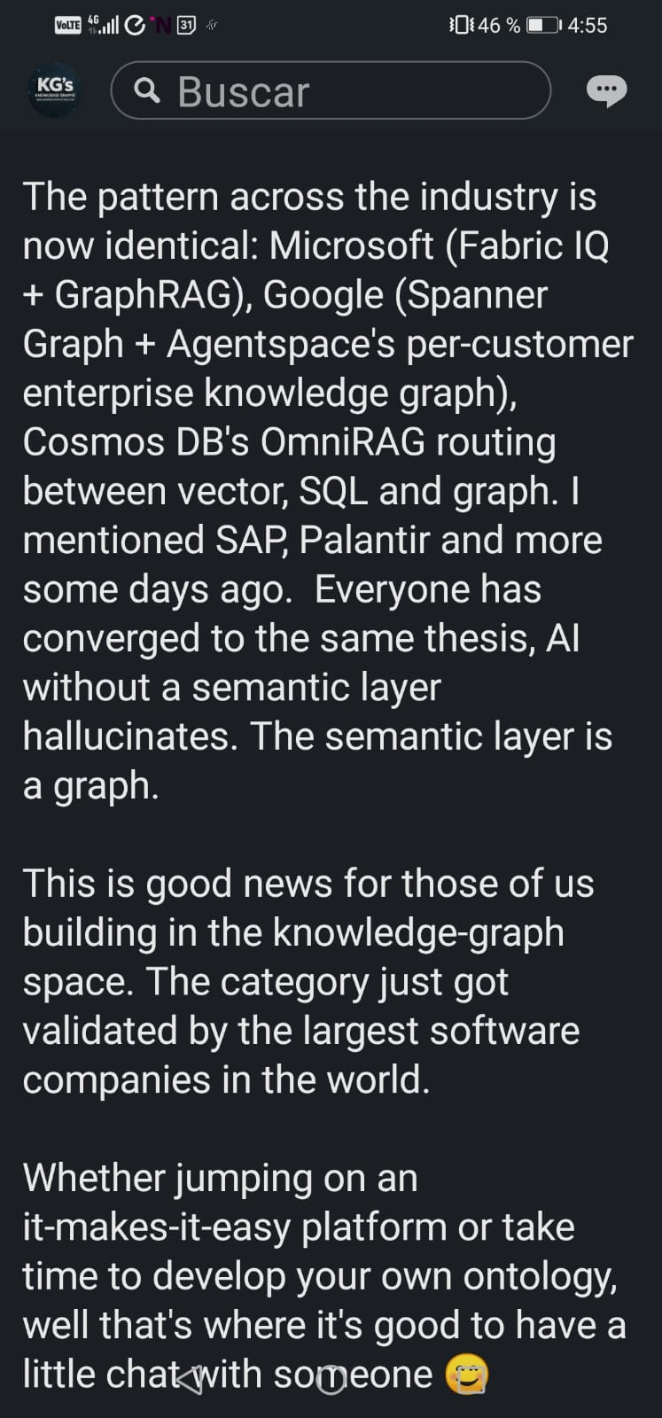
Figure: Ecosystem Evidence - Global Convergence Towards Semantic Graphs to Prevent AI Hallucinations
The 'Momento 0' Stack completely subverts this paradigm: instead of adding a semantic layer as an afterthought, the data is born semantic by design. The transaction is conceived, validated, and registered as W3C-compliant knowledge graph from its very first millisecond of existence. Consequently, multidimensional consistency, SHACL governance, and PROV-O provenance are native and structural foundation elements, not an analytical patch of last resort.
Zachman Framework as the Enterprise completeness matrix. Our semantic architecture solves this by adopting the
Fusing the columns of Zachman into a single Unified Semantic Graph (built on TerminusDB and visualized via DFRNT) yields a powerful 'Total Consistency and Traceability Grid' that answers all key dimensions of corporate existence simultaneously:
- WHO (Agent): The stakeholder registry of shareholders, partners, and regulators.
- WHAT (Resource): Corporate assets, inventories, and accounting charts mapped to standard schemas.
- WHERE (Location): Physical warehouses, digital endpoints, and jurisdictional nodes.
- WHEN (Event): Real-world economic facts mapped to ledger entries (XBRL GL).
- WHY & HOW (Contract): The binding legal contracts, board minutes, and logical double-entry policies.
- THE NEXUS (Entity): The macroscopic firm itself, conceived as a living Semantic Digital Twin.
Furthermore, from its foundational design, the stack natively targets compliance with key international standards for business and financial data management: ISO 21378 (Audit Data Collection), which defines standardized data structures to facilitate tax extraction and regulatory audit collection, and ISO 15944 (Information Technology - Business Operational Aspects), which governs electronic data interchange and enforces a rigorous commercial transaction semantics based on the REA (Resource-Event-Agent) framework. This double alignment ensures that the Semantic Digital Twin is not only technically seamless and logically consistent but also universally interoperable, legally compliant, and fully prepared for global audit scrutiny.
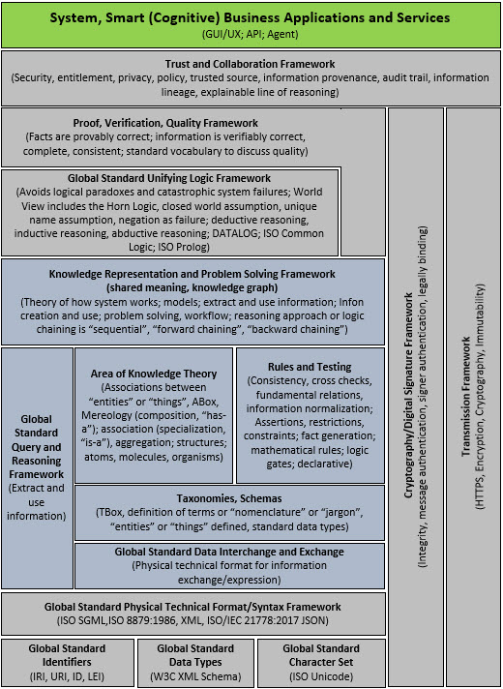
Figure: Cognitive System Stack - Semantic Accounting Systems Architecture
Under this framework, we define 'Momento 0' (Genesis State) as the exact legal, shareholder, and financial birth-state of the firm. Following the foundational work of Shyam Sunder in the theory of accounting and control (the firm as a 'nexus of contracts'), the Articles of Incorporation or audited Opening Balance (for an ongoing concern) represents the foundational document injected at Moment Zero. To guarantee absolute, legally binding immutability and transparency, these genesis documents are hosted on IPFS (InterPlanetary File System), with their unique IPFS CID permanently registered in the genesis JSON-LD instance injected into TerminusDB. Furthermore, it is critical to identify the shareholders and entities making up the capital of the organization, so that the semantic graph structures and generates real-time views of ownership, which is cryptographically sealed on the Algorand blockchain to guarantee absolute legal certainty against any audit.
Knowledge Representation and Reasoning (KR&R): The Scientific Foundation of the Stack. The 'Momento 0' stack is not merely a faster transactional database; it is a physical implementation of KR&R, a foundational branch of Artificial Intelligence. In traditional accounting, enterprise domain knowledge (double-entry rules, corporate policies, tax regulations, and IFRS standards) exists only within the accountant's head or scattered across hard-coded legacy ERP systems. Under the KR&R paradigm, we explicitly represent and reason over this knowledge within the graph. Through formal ontologies (UBL, REA, XBRL GL represented in JSON-LD), we capture the exact, multi-dimensional semantics of the business (the Who, What, Where, When, Why, and How). Using semantic validation engines (SHACL) and logical rulesets (such as the Seattle Method or Prolog-based reasoning engines like Pacioli), the system programmatically reasons over transactional data to infer logical consistency, deduce implicit relationships, execute automated reconciliations, and self-detect anomalies. This upgrades the accounting ledger into a Logical Digital Twin capable of self-auditing and serving as a zero-hallucination knowledge base for LLMs (GraphRAG).

Background, Intellectual Lineage, and the Creation of "El Bosque" (The Forest)
The design of the "Momento 0" Stack does not stem from abstract academic speculation. Instead, it is the product of a rich professional career in auditing, management control, and technology integration, deeply enriched by knowledge transfers from global pioneers in digital accounting and the semantic web:
1. XBRL and Accounting Automation Lineage: The stack's author received a direct transfer of knowledge from Gianluca Garbelotto (a global authority on XBRL GL), having actively contributed to the Spanish translation of the official XBRL GL taxonomy tags in the 2015 release. This foundation is complemented by rigorous hands-on experience as an auditor at PwC (PricewaterhouseCoopers) and as a Management Controller in a multinational corporate environment (where he spearheaded complex implementations of Oracle Hyperion). For the last 10 years, the author has built and optimized data automation and integration systems using the Altova Suite (particularly Altova MapForce). With the advent of generative AI, this accumulated domain knowledge has been unlocked and supercharged, enabling the rapid engineering of high-efficiency data pipelines that extract ledger balances into XBRL Global Ledger (XBRL GL) formats and dynamically remap them to local supervisory taxonomy frameworks (XBRL FR).
2. The Semantic Connection and DFRNT: The conceptual leap toward knowledge graphs was catalyzed by Timothy Thompson, an ontologist and metadata librarian at Yale University, who introduced the author to W3C's JSON-LD (JSON Linked Data) standard. This semantic engineering bridge facilitated the author's connection and subsequent collaboration with Philip and the team behind the DFRNT platform, establishing the physical layers of our active semantic ledger on TerminusDB.
3. The Genesis of "El Bosque": A Theoretical and Ontological Fusion: Driven by a well-founded suspicion that traditional automated accounting registries suffer from fundamental design flaws and profound semantic disconnections, the author consulted Eric Cohen (co-founder and primary champion of XBRL GL) to determine whether a formal, official W3C ontology existed for XBRL Global Ledger. Upon learning from Cohen that while multiple initiatives had been attempted, none held formal or official status, the author made the strategic decision to design and engineer "El Bosque" (The Forest). "El Bosque" represents the absolute integration of four core intellectual and technological pillars: the Zachman Framework (6x6) ensuring structural completeness; Tim Berners-Lee’s Semantic Standards Layer (RDF, JSON-LD, SPARQL/WOQL) for advanced document and linked data management; the REA (Resource-Event-Agent) Ontology by William McCarthy to overcome double-entry limitations; and Shyam Sunder’s economic paradigm conceiving the enterprise as a nexus of contracts.
4. Data Flows and Event Immutability: Under this paradigm, the legal and operational origin of the enterprise lies in its Contracts—the foundational legal documents that justify the continuity of the business as a going concern (as established by Shyam Sunder). Edward contracts are transformed and structured as active JSON-LD instances and ingested directly into the TerminusDB graph. To guarantee absolute system integrity, we implement three robust control layers: Blockchain as the Anchor of Truth (cryptographically sealing contracts and critical events to guarantee absolute legal immutability); SHACL for Internal Control by Design (enforcing constraints directly at the database ingestion level, validating mathematical, structural, and business rules at the exact millisecond of ingestion); and a Software-Agnostic and Native RDF architecture that remains completely independent of closed software vendors and is not constrained by traditional flat ETL pipelines.

2. The 'First Mile' to 'Last Mile' Architectural Pipeline
Under the Modular Open Systems Approach (MOSA) philosophy, our stack decouples data formats, validation rules, and disclosure standards into a highly portable, loosely coupled architecture.
The First Mile: Operational Genesis and Graph Validation
1. The Ingestion Pipelines (Altova MapForce and W3C XForms): We establish a Dual Ingestion Channel that accommodates both automated electronic documents and interactive, human-driven data capture, keeping the core system modular and completely format-independent:
- Altova MapForce Pipeline (Electronic Documents): Operational contracts and structured electronic documents like UBL 2.1 XML invoices are processed in the flow. They are translated directly into JSON-LD using visual mapping scripts in Altova MapForce, injecting the necessary accounting semantics. If a jurisdiction mandates JSON or any format other than UBL, the core semantic stack remains completely untouched; only the source mapping is adjusted in MapForce, securing high portability and syntax independence.
- W3C XForms and BaseX Pipeline (Interactive Data Capture): For manual inputs, we leverage W3C XForms to capture data directly into a structured XML database (BaseX) hosted on a DigitalOcean cloud server. The data is then programmatically extracted, transformed into W3C-compliant JSON-LD graph instances, and natively injected into TerminusDB to populate the graph.
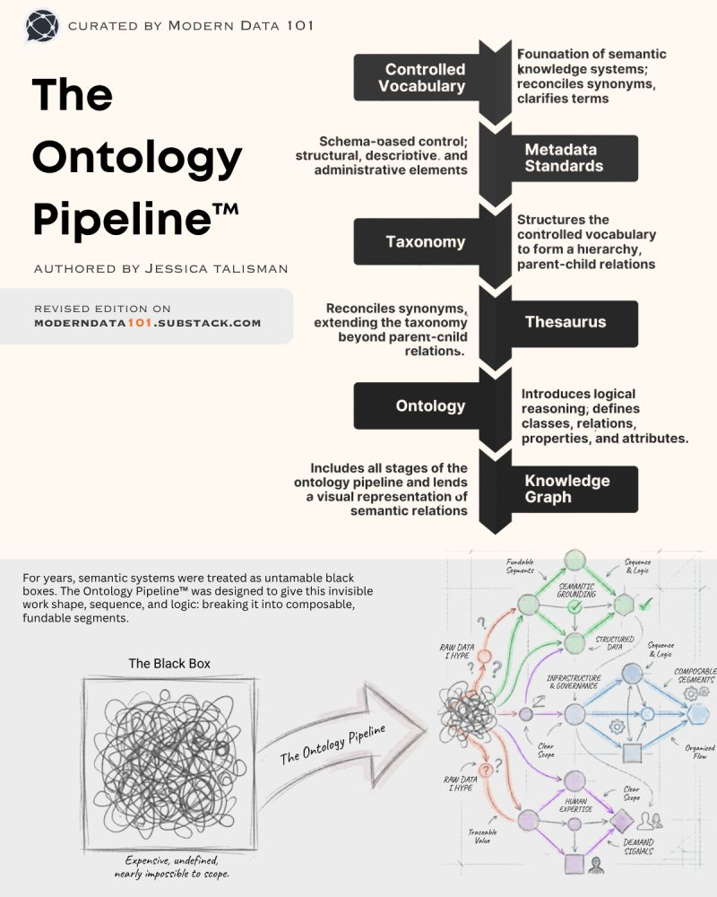
Figure: Ontology Pipeline Talisman - Ontological Mapping and Ingestion Pipeline
6. Bridging Labeled Property Graphs (LPG) and Semantic Graph Architectures: In the graph database ecosystem, two dominant paradigms coexist: Semantic Web Graphs (RDF/Triple Stores), which excel at global interoperability, web standards (W3C, JSON-LD), and formal logical reasoning (KR&R/SHACL); and Labeled Property Graphs (LPG), such as Neo4j or Google Spanner Graph, which are optimized for high-performance traversals, network analysis algorithms, and widespread developer adoption. The 'Momento 0' stack strategically bridges these two paradigms: first, the Semantic & Governance Core (RDF/JSON-LD + SHACL) in TerminusDB/DFRNT serves as a strongly typed semantic ledger that structurally rejects data corruption or schema anarchy; second, once transactional data is validated with 'zero defects' in the semantic core, the graph is projected into an LPG model (Neo4j / Spanner Graph) for advanced analytical operations like Fraud Detection & Network Analytics and High-Speed GraphRAG (powering LLMs with fast traversals to provide instant, contextual business intelligence). This delivers an unbeatable hybrid: Semantic Governance at the Core, LPG Performance in Analytics.

4. Strong Schema Enforcement & Closed-World Assumption (TerminusDB vs. Neo4j): Unlike traditional property graph databases (e.g., Neo4j) which operate under an Open-World Assumption and are schema-less, TerminusDB enforces a strict Closed-World Assumption. It is strongly typed and requires a formal logical schema. Here is where the formal ontology of XBRL GL fulfills its critical engineering purpose: instead of allowing transactional data anarchy, it acts as the unyielding logic gatekeeper, forcing all operational facts to comply strictly with standard types, properties, and relationships defined by the XBRL GL taxonomy. This is precisely where DFRNT provides critical support: given the lack of a formal W3C standard for transactional accounting in the Semantic Web (confirmed directly by Eric Cohen), we translate the XBRL GL taxonomy into a native JSON-LD semantic model. The design and refinement of this XBRL-GL ontology is a highly specialized and technically complex task, requiring close collaboration and active support from the DFRNT team. Under our active DFRNT subscription, we define the characteristics and constraints of this ontology to ensure that the JSON-LD instances injected into TerminusDB validate perfectly against the enterprise schema.
5. Ingestion into TerminusDB: Enriched JSON-LD is registered in TerminusDB. Using W3C PROV-O (prov:wasDerivedFrom), each ledger entry preserves an unbreakable semantic link to its original physical document.
6. SHACL (Shapes Constraint Language) - Auditing by Design: In this semantic stack, W3C SHACL represents the direct technological equivalent of Formula Linkbases within the traditional XBRL standard. Just as XBRL formulas validate logical and mathematical consistency in external financial reporting, W3C SHACL Shapes serve as the definitive internal control mechanism within the TerminusDB graph database. Rather than auditing post-facto, SHACL shapes enforce double-entry rules, strict transaction provenance (via PROV-O), and Zachman completeness constraints at the exact millisecond of ingestion, rejecting corrupt or unbalanced entries natively at the database engine level. This logical equivalence is conceptually validated by Charles Hoffman's research (see the enclosed SemanticWebStack_XBRLStack.pdf), which positions the W3C Unifying Logic Framework (RDFS, OWL, and SHACL under Closed World Assumption) as the ultimate target for cross-stack interoperability. By integrating SHACL as our database-level gatekeeper, the stack achieves a level of sophisticated, safe logical reasoning and automated control that far surpasses the capabilities and known deficiencies of legacy XBRL Formula processors.
The Last Mile: Regulatory Reporting and Disclosure
1. Graph Queries: Structured WOQL/GraphQL queries compile and aggregate graph nodes into target financial taxonomy segments (IFRS, US GAAP).
2. OIM Export: Extracted records are compiled into standardized xBRL-CSV / xBRL-JSON Open Information Model format.
3. The Seattle Method: Applying Charles Hoffman's logical rules, dimensions, and slots to the OIM reports ensures 100% consistency, resulting in a zero-defect, self-reconciling Audit Bundle.
4. Non-Financial Information, ESG, and Inventories: Electronic documents contain valuable non-financial information that we extract directly to the graph. Non-financial climate impact and sustainability data are captured to populate the graph and support disclosure taxonomies such as ISSB, GRI, and EFRAG. Quantitative physical item details are also extracted to feed inventory control systems in real time.
5. Multi-Book Posting Purposes (XBRL GL Purposes) and Self-Reconciliation: In accordance with the XBRL Global Ledger taxonomy, the stack allows associating a specific Accounting Purpose (purpose) to every ledger entry (e.g., Tax/Fiscal, IFRS, Local GAAP/Juzgada). This facilitates multi-book and cross-border reporting (particularly for IFRS which governs transactions, documents, events/risks, and conditions/contracts in the author's jurisdiction). Because the data resides in a continuous graph, the stack is capable of natively self-reconciling accounting information (cash, inventory, and contracts) without external reconciliation routines.
3. Coexistence and Ontological Preponderance: Governance over Legacy ERPs and Analytical Tools (Power BI & Similar)
To prevent operational friction and avoid a disruptive clean slate (borrón y cuenta nueva), this architecture establishes a non-disruptive coexistence model where both worlds meet under a strict hierarchy: the ontology holds absolute structural and logical preponderance over both traditional ERPs and downstream analytical tools (such as Power BI and similar platforms).
1. Preponderance over Legacy ERPs (The 'Passive Compliance Vault'): Real-world financial transactions are not registered first inside the ERP to be retroactively formatted. Instead, operational data (XML invoices, contracts, bank events) is mapped via Altova MapForce into JSON-LD and ingested directly into the TerminusDB/DFRNT semantic graph. Once validated with 'zero defects' via SHACL shapes, the system queries the graph to generate flat journal entries and pushes them downstream into the legacy ERP (SAP, NetSuite, Oracle, etc.) via unidirectional APIs. The ERP no longer controls the enterprise schema; it serves strictly as a passive compliance and historical vault.
2. Preponderance over Downstream Analytics and BI Tools (Power BI & Similar): Traditionally, analytical platforms like Power BI extract raw tables from databases and force data analysts to construct isolated semantic relationships and custom calculations (using Power Query or DAX) inside the BI tool. This results in fragmented definitions, fragmented data silos, and a high rate of compliance and reporting errors. Under our stack, Power BI does not define business logic or relationships; it merely acts as a high-fidelity visualizer. BI tools connect directly to pre-validated semantic views and graph projections via query APIs. Every relationship and business rule is governed and resolved at the ontological level, ensuring absolute logical consistency across all corporate dashboards.
4. Concrete End-to-End Technical Walkthrough
To illustrate this pipeline, we showcase the transformation, validation, and extraction of a standard service transaction:
Step 1: Input Document (UBL 2.1 XML Invoice Snippet)
<Invoice xmlns="urn:oasis:names:specification:ubl:schema:xsd:Invoice-2"
xmlns:cac="urn:oasis:names:specification:ubl:schema:xsd:CommonAggregateComponents-2"
xmlns:cbc="urn:oasis:names:specification:ubl:schema:xsd:CommonBasicComponents-2">
<cbc:ID>FAC-2026-0045</cbc:ID>
<cbc:IssueDate>2026-05-20</cbc:IssueDate>
<cbc:DocumentCurrencyCode>USD</cbc:DocumentCurrencyCode>
<cac:LegalMonetaryTotal>
<cbc:PayableAmount currencyID="USD">1190.00</cbc:PayableAmount>
</cac:LegalMonetaryTotal>
</Invoice>

Step 2: Altova MapForce JSON-LD Graph Instance
{
"@context": {
"rea": "https://w3id.org/rea/ontology#",
"gl-cor": "http://www.xbrl.org/int/gl/cor/2020-12-31#",
"prov": "http://www.w3.org/ns/prov#",
"ex": "https://momento0.org/schema#"
},
"@id": "ex:tx_FAC-2026-0045",
"@type": ["rea:EconomicEvent", "gl-cor:entryHeader"],
"prov:wasDerivedFrom": "file:///C:/NoSQL/Storage/FAC-2026-0045.xml",
"gl-cor:documentDate": "2026-05-20",
"gl-cor:entryDetail": [
{
"@id": "ex:tx_FAC-2026-0045_dr",
"gl-cor:accountMainID": "130505",
"gl-cor:debitCreditCode": "D",
"gl-cor:amount": 1190.00,
"rea:debtor": "ex:agent_NIT-800987654-3"
},
{
"@id": "ex:tx_FAC-2026-0045_cr",
"gl-cor:accountMainID": "415505",
"gl-cor:debitCreditCode": "C",
"gl-cor:amount": 1000.00,
"rea:creditor": "ex:agent_NIT-901234567-8"
}
]
}

Step 3: Native SHACL Constraint (shapes-contables.ttl)
# Provenance Constraint for Header Entries
ex:TransactionProvenanceShape
a sh:NodeShape ;
sh:targetClass gl-cor:entryHeader ;
sh:property [
sh:path prov:wasDerivedFrom ;
sh:minCount 1 ;
sh:nodeKind sh:IRI ;
sh:message "CRITICAL ERROR: Transaction is missing a verifiable provenance link."@en
] .

Step 4: WOQL Extraction Query (JavaScript)
const query = WOQL.and(
WOQL.triple("v:Entry", "type", "gl-cor:entryHeader"),
WOQL.triple("v:Entry", "gl-cor:entryDetail", "v:Detail"),
WOQL.triple("v:Detail", "gl-cor:accountMainID", "v:Account"),
WOQL.triple("v:Detail", "gl-cor:debitCreditCode", "v:Type"),
WOQL.triple("v:Detail", "gl-cor:amount", "v:Amount"),
WOQL.group_by(["v:Account", "v:Type"], ["v:Amount"], "v:Total", WOQL.sum("v:Amount", "v:Total"))
);

Step 5: iXBRL Regulatory Output Presentation
<ix:nonFraction id="revenue_1"
name="ifrs-full:RevenueFromContractsWithCustomers"
contextRef="current_period" unitRef="USD" decimals="2"
scale="0" format="ixt:numdotcomma">1.000,00</ix:nonFraction>

5. Strategic Materialization Roadmap
To implement this architecture and transition the firm to a semantic digital twin, we propose a 6-phase materialization plan:
- Phase 1: Ontological Foundation (Zachman Rows 1-2) - Establish the core TerminusDB/DFRNT transactional schema, defining classes for Resource, Event, Agent, Location, Contract, and Entity, translating XBRL GL to a JSON-LD vocabulary.
- Phase 2: Auditing-by-Design SHACL Modeling - Model and test SHACL shapes (.ttl) inside TerminusDB to enforce double-entry rules, strict transaction provenance, and completeness constraints prior to any data writes.
- Phase 3: Ingestion Pipeline Setup - Build the First Mile ingestion pipelines. Configure Altova MapForce visual mapping to convert raw transactional sources to JSON-LD. This mapping ensures absolute format independence: if a jurisdiction changes invoicing to JSON or any other language, only the source mapping in MapForce is updated, keeping the database, schemas, and SHACL validators fully intact. Integrate the W3C XForms and BaseX pipelines on DigitalOcean for interactive data capture.
- Phase 4: Seattle Method & Last Mile Integration - Develop WOQL and GraphQL extraction scripts to pull trial balances and map them to targeted regulatory taxonomies, exporting to standardized xBRL-CSV (OIM) formats aligned with Seattle Method rules.
- Phase 5: Cryptographic Anchoring & Legal Provenance - Implement provenance tracking via W3C PROV-O, linking financial states to physical XML files. Set up cryptographic anchoring on Blockchain for critical corporate minutes, shareholder registries, and assembly acts, fulfilling UNCITRAL criteria.
- Phase 6: ESG Semantic Fusion - Expand the graph schemas to integrate financial ledgers with ESG parameters (GRI, VSME, ISSB), linking cash accounts directly to carbon or societal impact indicators inside the same graph to eliminate greenwashing.
6. CFO Value Proposition & Thought Leadership
To establish a truly transformative paradigm, this architecture consciously pulls together four key sets of complementary skills, experience, and domain expertise:
- Philippe & the DFRNT Team (Technical Enablement & Graph Modeling): Serving as the core technical enabler, leveraging extensive experience with TerminusDB, enterprise semantic web architectures, and advanced data graph modeling.
- Jonathan Schmidt (Industrial Engineering & Lean Six Sigma): Optimizing accounting flows with his training as an Industrial Engineer, integrating Lean Six Sigma techniques, principles, and philosophies to design waste-free, high-efficiency ledger pipelines with rigorous internal control loops.
- Richard Gasca (Enterprise Systems & Operational Thought Leadership): Bringing visionary conceptual design and deep operational enterprise expertise, architecting the 'First Mile' transactional REA graph model, and bridging corporate business realities with advanced database mechanics.
- Charles Hoffman (Accounting Information Systems Generalist): An AIS pioneer who bridges the team by seeing the big picture from start (transaction entry) to finish (financial analysis of regulatory reports), leveraging deep research into the W3C Semantic Web Stack (RDF, OWL, SHACL, SKOS) to natively apply XBRL within modern reporting, auditing, ledger architectures, and cryptography (including digital distributed ledgers).
Fusing these four pillars establishes a massive competitive advantage:
- Unmatched Efficiency: Reduces traditional auditing and administrative reporting overhead by more than 80%.
- Continuous Auditing: Automated background queries perform bank reconciliations, tax checks, and control validations in real-time, moving the company from periodic retro-auditing to active continuous assurance.
- Mitigated Systemic Risk: Protects corporate entities against compliance failures, AI-system hallucinations, and data loss by utilizing immutable, mathematically perfect ledger shapes.
To establish market leadership, we propose launching a 7-Part Thought Leadership Series, positioned for CFOs, Big 4 Auditors, and Enterprise Architects:
- Episode 1: The AI Audit Crisis & The Future of Accounting - Why Pacioli's double-entry model fails in the AI era and how the Semantic Digital Twin solves it.
- Episode 2: Traceability in the Semantic Graph (Fusing KR&R and LPG) - The physical realization of the REA conceptual model under the KR&R paradigm and its bridge to Labeled Property Graphs (LPG). We showcase how mapping the REA ontology into W3C JSON-LD creates unbreakable, multi-dimensional paths of bidirectionality, showing how TerminusDB's semantic schema governance integrates with LPG high-performance analytical queries to achieve total Bidirectional Traceability and automated, zero-defect auditing.
- Episode 3: Provenance: The Ultimate Legal Anchor - Fusing W3C PROV-O with Blockchain for absolute legal and operational corporate history.
- Episode 4: The Global Open Industry Framework - Creating a universal transactional ontology by mapping XBRL GL to ISO standards.
- Episode 5: The 'Momento 0' Ingestion Pipeline - A hands-on walkthrough showing visual mapping from raw files to TerminusDB.
- Episode 6: Eradicating Greenwashing (Financial & ESG Fusion) - Linking accounts to ESG metrics in the same graph, allowing real-time sustainability audits.
- Episode 7: The Zachman Semantic Fusion Unveiled - Fusing Charlie's disclosure rules with our operational ledger into the complete Zachman grid.
The "Semantic Accounting" Book Plan (First Edition)
The collaborative agreement with DFRNT states that once the 7 episodes of the thought leadership series are completed, they will serve as the conceptual and development milestones. This methodological path will consolidate the foundations of what will become the pioneering book "Semantic Accounting" (1st Edition). This book will not only present the formal theory of the stack to an international audience, but will also mark the definitive step for the official release and deployment of the first productive version of the software, representing a landmark transition toward self-governing, logically perfect corporate information systems.

