Step 1. Request LEAP2 Access
- Go to the TXST ITAC service request page: https://services.txst.edu/TDClient/39/ITAC/Requests/ServiceDet?ID=86
- Click “Request Access” (you’ll need to log in with your TXST NetID).
- Fill out the form:
  - Purpose: Explain you need LEAP2 HPC access for research or coursework.
  - Supervisor/PI: Include your faculty advisor’s name and NetID if required. Don’t need to include me.
    - Jelena Tesic
    - jtesic@txstate.edu
  - Project name or title: “Multimorbidity Patterns of Type 2 Diabetes, Heart Failure, and Hypertension in MIMIC-IV: A Scalable Data-Driven Approach”
    - for now will change
- Submit the form.
  - You’ll receive an email when your LEAP2 account is created (usually within 1–3 business days). Fwd the email to Mirna for confirmation.
Step 2. Connect to LEAP2 via SSH
Once your access is approved:
- Open your local terminal (Mac/Linux) or PowerShell (Windows).
- Connect using your TXST NetID:
  - ssh NetID@leap2.txstate.edu
- If you’re off-campus, you will need to use the TXST VPN first
  - https://doit.txst.edu/hpc.html
VPN Site 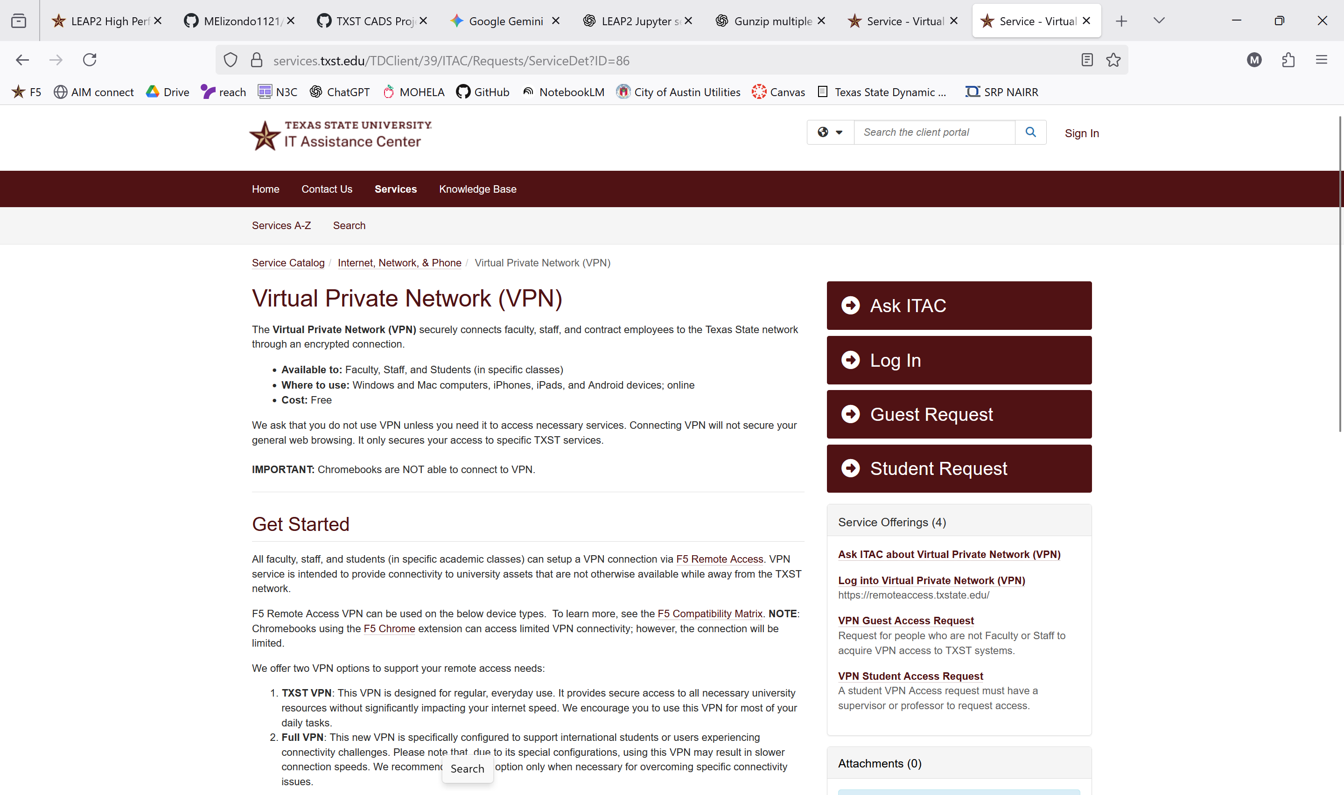
F5 Application 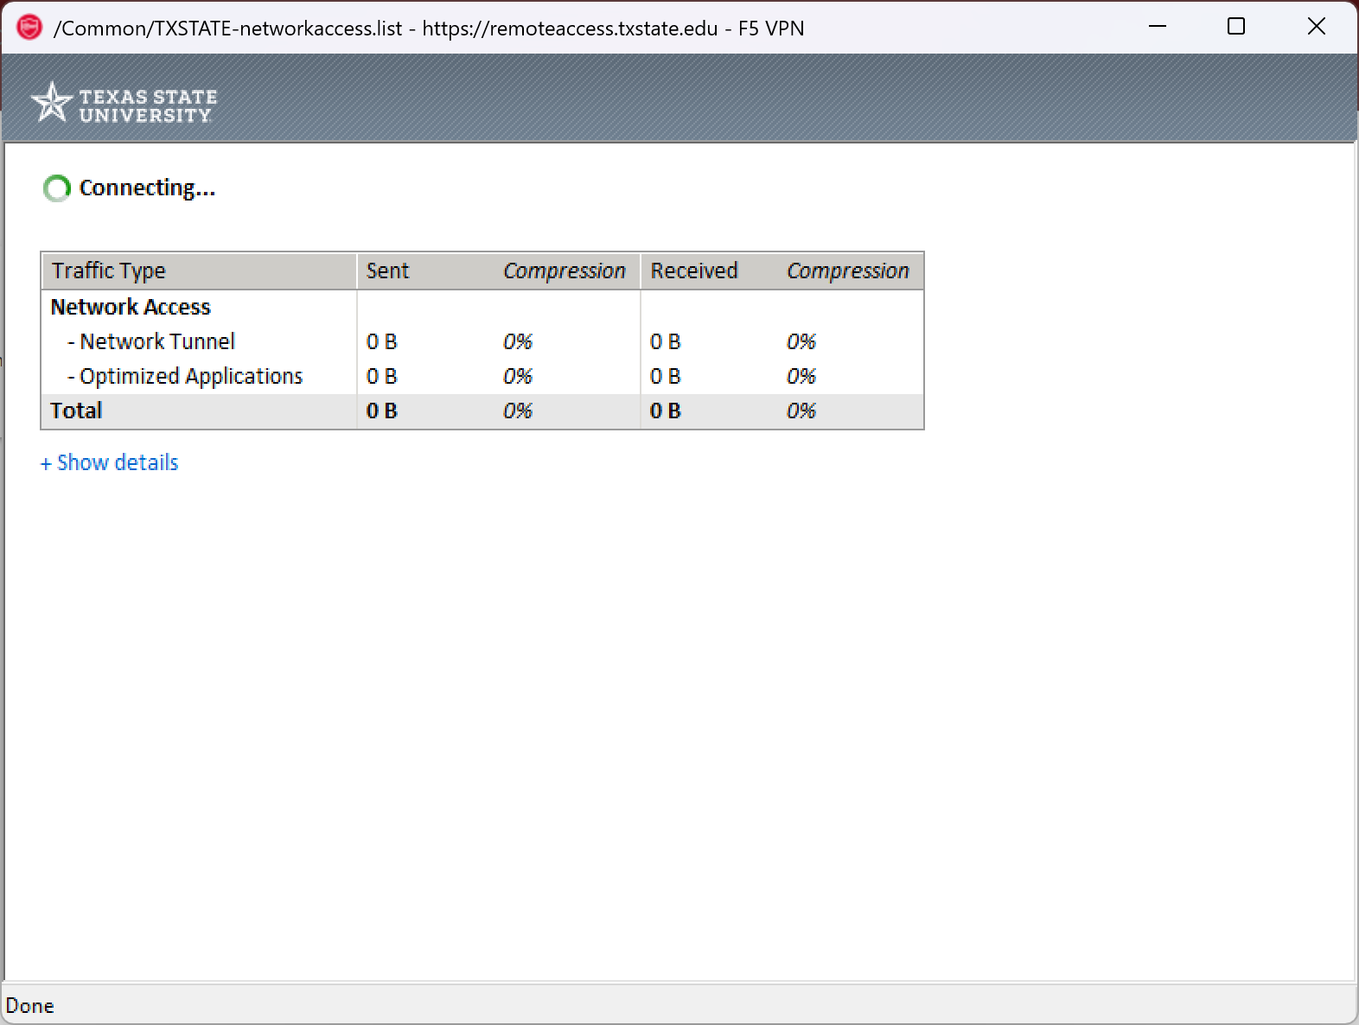
https://www.f5.com/

Step 3. Start a Jupyter Notebook (No Browser)
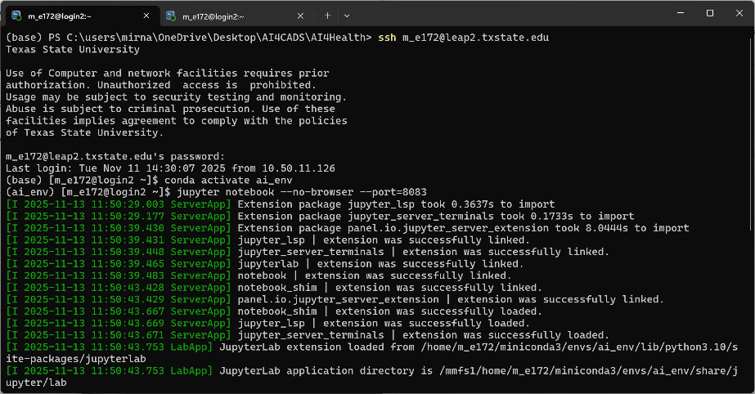
command: jupyter notebook --no-browser --port=8888

  - SSH into Leap2
  - Activate anaconda environment
  - Start jupyter

Step 4. Forward the Port to Your Local Machine
Open a terminal on your local machine and forward the port (the port # may be different for you); please note the directory you do step 3 or step 4 do not matter!
Command: ssh -N -f -L 8888:localhost:8888 NetID@leap2.txstate.edu
- -N: Do not execute remote commands (just forward the port).
- -f: Run in background.
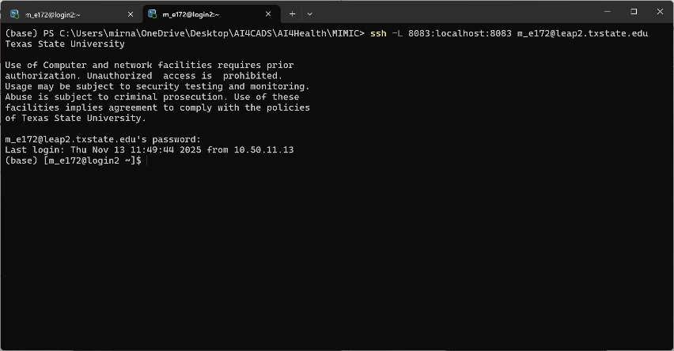
- -L 8888:localhost:8888: Forwards your local port 8888 to the remote server’s port 8888.

To transfer files, you can use command line entries, WinSCP, FileZilla
- scp /path/to/local/file.txt NetID@leap2.txstate.edu:/home/NetID/
- scp -r /path/to/local/folder NetID@leap2.txstate.edu:/home/NetID/
- rsync -avz /path/to/local/folder/ NetID@leap2.txstate.edu:/home/NetID/folder/
Connection settings (while on the VPN):
- Protocol: SFTP (SSH File Transfer Protocol)
- Hostname: leap2.txstate.edu
- Username: your TXST NetID
- Password: your TXST password
- Port: 22

