BSL Alarm Response Introduction to Time-Domain Moment Tensor INVerse Code (tdmt_invc_iso)

Douglas S. Dreger & Taka’aki Taira

June 6, 2023

**Introduction**

# This seismic moment tensor inverse software package has been in use at the University of California, Berkeley Seismological Laboratory (BSL) since 1993 and is employed to automatically investigate all ML>3.5 events in northern California (e.g. [www.seismo.berkeley.edu/~dreger/mtindex.html](http://www.seismo.berkeley.edu/~dreger/mtindex.html)). The package has been successfully implemented at the Japan National Research Institute for Earth Science and Disaster Prevention (NIED), Caltech, University of Alaska (AEIC), INGV Rome, University of Utah, Aristotle University, ETH, and has been used by individual researchers in the United States, Europe and Asia.

# This distribution includes the moment tensor software, utilities for processing real and synthetic data, and plotting the results. Green’s functions computed using Robert Herrmann’s Computer Programs for Seismology frequency-wavenumber integration are provided.

# Background, Methodology and Program Assumptions

The general representation of seismic sources is simplified by considering both a spatial and temporal point-source.

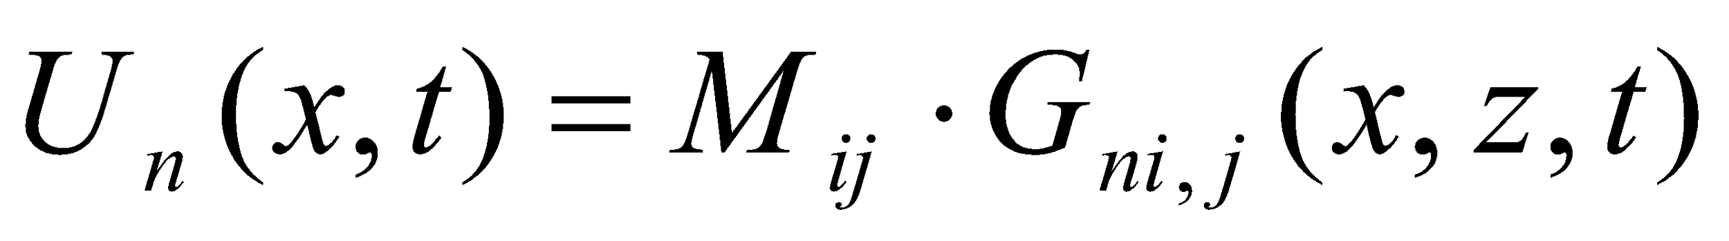

*Un*, is the observed nth component of displacement, *Gni,j* is the nth component Green’s function for specific force-couple orientations, and *Mij* is the scalar seismic moment tensor, which describes the strength of the force-couples. The indices i and *j* refer to geographical directions for force and derivative directions respectively. The above equation is solved using linear least squares for a given source depth. *Mij* is decomposed into the scalar seismic moment, a volumetric moment tensor (if the software switch is on), a double-couple moment tensor and a compensated linear vector dipole (CLVD) moment tensor. The decomposition is represented as percent isotropic (Piso), double-couple (Pdc), and CLVD (Pclvd). The tdmt_invc_iso code can be run either for a best fitting deviatoric solution in which the trace is constrained to be zero producing a zero percent isotropic component, or the full six degree of freedom moment tensor. The double-couple component of the moment tensor is further represented in terms of the strike, rake and dip of the two nodal planes. The basic methodology and the decomposition of the seismic moment tensor is described in Jost and Herrmann (1989). This point-source moment tensor method has been used to study events ranging from M 9.0 megathrust earthquakes (Guilhem et al., 2012) to M -2.0 icequakes in an alpine glacier (Walter et al., 2009). We have used it to investigate non-double-couple radiation of volcanic and geothermal events (Minson et al., 2007; Tkalcic et al., 2009; Boyd et al., 2015), nuclear explosions (Ford et al., 2009), and underground cavity collapse (Ford et al., 2008). The method is very versatile and only requires a well calibrated velocity model to compute appropriate Green’s functions for the source to receiver paths for a given application. In complex regions path dependent velocities models maybe used to account for propagation heterogeneity.

The event location is assumed from independent work, and a MT centroid is not determined.

Source depth is found iteratively by finding the solution that yields the largest variance reduction,

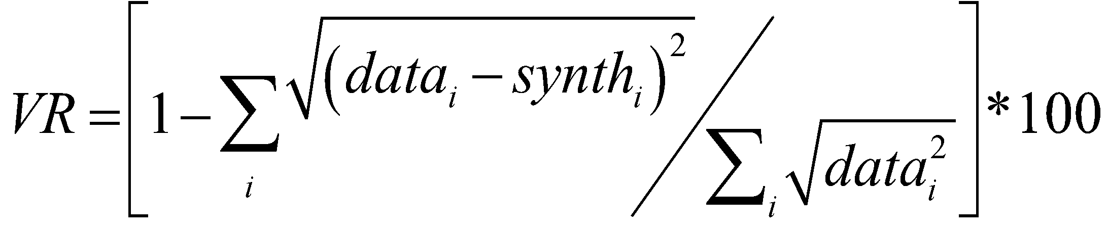,

where *data*, and *synth* are the data and Green’s function time series, respectively, and the summation is performed for all stations and components. The variance reduction is an output parameter of the code.

Another measure that could be useful for determining source depth in regions where volumetric events are unlikely is the variance reduction multiplied by the percent double-couple VR*Pdc/100. This will emphasize solutions that both fit well and have a large double-couple component which can be useful for tectonic earthquakes, but not for earthquakes that occur in volcanic and geothermal systems or for explosions and cavity collapse because such events may be expected to have significant non-double-couple solutions.

Finally, it is assumed that the crustal model is sufficiently well known to explain low frequency wave propagation. This software package will not perform well in a region if calibrated velocity models are not available. Calibrating velocity models to obtain a robust catalog of Green’s functions is singly the most important step in successful seismic moment tensor applications. Dreger et al. (2021) is an example of how one might calibrate regional paths for moment tensor applications. There are many other waveform modeling examples in the literature. Here we will not address such path calibration and will instead focus on the moment tensor application since for California paths are already well calibrated in the 0.01 to 0.10 Hz passband.

The following papers may be of interest for additional background as they illustrate the use of the program in different types of applications.

Boyd, O. S., D. S. Dreger, V. H. Lai, and R. Gritto (2015). A Systematic Analysis of Seismic Moment Tensor at The Geysers Geothermal Field, California, Bull. Seism. Soc. Am., 105, No. 6, doi:10.1785/0120140285.

Dreger, D. S., R. Gritto, and O. Nelson (2021). Path Calibration of the Democratic People’s Republic of Korea 3 September 2017 Nuclear Test. *Seismological Research Letters*, doi: <https://doi.org/10.1785/0220210105>

Ford, S., D. Dreger and W. Walter (2008). Source Characterization of the August 6, 2007 Crandall Canyon Mine Seismic Event in Central Utah, Seism. Res. Lett., 79, 637-644.

Ford, S. R., D. S. Dreger and W. R. Walter (2009). Identifying isotropic events using a regional moment tensor inversion, J. Geophys. Res., 114, B01306, doi:10.1029/2008JB005743.

Fukuyama, E., and D. Dreger (2000). Performance test of an automated moment tensor determination system for the future "Tokai" earthquake, Earth Planets Space, 52, 383-392.

Guilhem A., D. S. Dreger, H. Tsuruoka, and H. Kawakatsu (2012). Moment tensors for rapid characterization of megathrust earthquakes: the example of the 2011 M9 Tohoku-oki, Japan earthquake, Geophys. Journ. Int., doi:10.1093/gji/ggs045.

Minson, S. and D. Dreger (2008), Stable Inversions for Complete Moment Tensors, *Geophys. Journ. Int.,* 174, 585-592.

Minson, S. D. Dreger, R. Burgmann, Hiroo Kanamori, and K. Larsen (2007), Seismically and Geodetically Determined Non-Double-Couple Source Mechanisms From the 2000 Miyakejima Volcanic Earthquake Swarm, *Journ. Geophys. Res.,* 112, B10308, doi:10.1029/2006JB004847.

Tkalcic, H., D. S. Dreger, G. R. Foulger, and B. R. Julian (2009). The puzzle of the 1996 Bardarbunga, Iceland, Earthquake: No volumetric component in the source mechanism, Bull Seism. Soc. Am., 99, 3077-3085, doi:10.1785/0120080361.

Walter, F., J. F. Clinton, N. Deichmann, D. S. Dreger, S. E. Minson, M. Funk (2009). Moment tensor inversions of icequakes on Gornergletscher, Switzerland. *Bulletin of the* *Seismological Society of America*, 99-2A, doi:10.1785/0120080110.

**Short Course Overview and Schedule**

***Week1:*** Downloading and installing the software and setting up the working environment. Perform rudimentary tests with synthetic data to see that the software is working and that scripts are setup and working. Note the provided scripts are csh/zsh compatible. If you prefer to use bash you will need to rewrite them, or run the csh scripts using the ‘sh’ prefix. Greens functions are provided for this exercise, but if you are interested in learning to compute the FK-integration Greens functions using Robert Herrmann’s ‘Computer Programs for Seismology (CPS)’ software see Doug.

The following are the software packages that need to be installed on your computer:

* gcc
* gfortran
* xcode commandline tools (MacOS)
* Seismic Analysis Code (SAC) – MacOS you need xQuartz for x11
* anaconda/python(3.9)
* moment tensor software (compiling uses gcc & gfortran)

***Week2:*** We will work together on an exercise using synthetic data (with/without) noise to become familiar with the code and workflow. We will then compute a moment tensor solution for a local tectonic earthquake, learning to add stations, obtain optimal Greens-function-data alignment, evaluating fit, and interpreting solution output. You will need to finish the sensitivity work (evaluating errors using a jackknife approach and determining source depth) after class to discuss at the next class meeting.

***Week3:*** Discussion of solution sensitivity and uncertainty. In class exercise evaluating moment tensors for a tectonic earthquake, and an earthquake with a significant non-double-couple mechanism that was part of Long Valley Caldera unrest in 1996. We will also learn to evaluate solutions in source-type space (e.g. Hudson et al., 1989; Ford et al., 2009).

***Week4:*** Taka’aki Taira will demonstrate the use of the moment tensor software using the analyst interface which is used in alarm response duty.

# Week 1: Building the Program

You will need to install a gcc compiler, gfortran, python and Seismic Analysis Code (SAC). The following links to where these programs can be obtained:

Gfortran

MacOS: <https://github.com/fxcoudert/gfortran-for-macOS/releases>

Linux: <https://gcc.gnu.org/wiki/GFortran>

SAC <http://ds.iris.edu/ds/nodes/dmc/forms/sac/>

* SAC Tutroial http://ds.iris.edu/files/sac-manual/manual/tutorial.html
* for Mac users, you may need to install xquartz (<https://www.xquartz.org/>) to plot waveforms.

You need python >= 3.9 installed

Taka’aki sent an email with the link to a tarfile constraining the software. Unpacking the tarfile will create a “BSL_MT_Training” directory structure, where under the main directory you will find the following subdirectories and files: BIN, TDMT_GMT, UTILITIES, MT-Exercises, and bsl_mt_training.docx. Within MT-Exercises are tarballs to unpack for each week’s exercise.

You will need to install a gcc compiler, gfortran, python and Seismic Analysis Code (SAC) which is distributed through the Incorporated Research Institutions for Seismology (IRIS; <https://seiscode.iris.washington.edu/>).

To build the utility programs change into the UTILITIES directory, and type ‘**make all**’. This will compile the utilities and move the executables into the BIN directory.

To build the moment tensor code, tdmt_inv_iso change into the TDMT_GMT directory and type ‘**make all**’, then ‘**make install**’. The first will build the executables and the latter will move them to the BIN directory.

If you need to clean the directory removing the *.o files and local executables you can type “make clean” in each to perform the operation.

At this point you can check the BIN directory to see if the program timestamps have been updated. You will also notice some *.py programs in BIN which is used for plotting the moment tensor output. There is also a python notebook called **mtdecomp2.ipynb** which is a useful tool for decomposing the moment tensor and making plots of the decomposition and the source-type projection on the Tape and Tape (2012) lune. To use the python and notebook scripts you will need to copy them to your working directory.

You will need to add the executables to your search path. The syntax for doing so depends on whether you are using bash, csh or zsh shells. For zsh (MacOS) you can do the following:

**path+=($path ../../BIN)**

**export path**

# Week 2A EXERCISE

The purpose of this first exercise is to gain familiarity with the moment tensor code using synthetic data sets. Synthetic data provides the opportunity to determine solutions for cases where the correct answer is known and therefore we can more clearly investigate the method sensitivity to the numbers of stations used, the time alignment of data with the Green’s functions and the performance of the method with added noise. For this we will use precomputed Greens functions for the northern California velocity model GIL7.

In the MT-Exercises/Week2a_Exercise, there are two csh scripts to create the synthetic data files. These scripts call programs that are in the BIN directory you created above. One script, **run_mksyndata** generates synthetic data for four stations azimuthally distributed around the source. Read the script to understand what it is doing. The putmech program is called which will apply a double-couple mechanism and scalar moment to the Green’s functions to compute the synthetic data. To run **run_mksyndata** simply type the filename at the system prompt. Note these are csh scripts so you will want to be in a csh, tcsh, or zcsh shell. If you prefer a bash shell then you should be able to run the scripts by typing ‘sh **run_mksyndata**’ instead. Of course you can also modify the script code so that it conforms with bash syntax.

The successful execution of **run_mksyndata** will generate four data files stat1.dat, stat2.dat, stat3.dat and stat4.dat.

There is another script, **run_mksyndatanoise** which uses seismic analysis code (SAC) to generate random noise, add it to the Green's functions and then run putmech to construct synthetic data for a specified focal mechanism. The default level of noise is 35% of the maximum synthetic amplitude. The usage is the same as for **run_mksyndata**. We will use the noisy data to further explore the usage of the moment tensor code.

Now that we have our synthetic data with and without noise we are ready to invert these data for the moment tensor. The first case will be with the noise free synthetic data which should be fit perfectly by the moment tensor inverse code.

The input file for the moment tensor inversion is mt_inv.in. This is an ascii file that needs to be edited to add and remove stations, and to adjust model parameters primarily a time adjustment parameter that aligns the data with the Green’s function. The following describes the elements of the input file.

mt_inv.in:

4 8 1 5 1 <number of stations, source depth, distance weighting flag, 5-dev or 6-full, plotting flag>

stat1.dat 100 0.0 0 120 <data_filename, distance (km), azimuth (deg from north), sample-offset (Zcor), number_of_samples>

stat2.dat 200 83.0 0 120 <ditto for station 2>

stat3.dat 300 202.0 0 120 <ditto for station 3>

stat4.dat 400 233.0 0 120 <ditto for station 4>

gil7_100.0d8.0 0 120 <filtered GF_filename, zero-offset (always zero), number_of_samples (same as corresponding data>

gil7_200.0d8.0 0 120 <ditto for station 2>

gil7_300.0d8.0 0 120 <ditto for station 3>

gil7_400.0d8.0 0 120 <ditto for station 4>

mtinv.dat <ascii output file for plotting>

It is very important that you double check to make sure there are the correct number of data lines, and Green's function lines. In this case we are inverting four stations so there should be 4 stat* lines and 4 gil7* lines. The last line is the output file that is used for plotting the results. If the incorrect number of data and green’s function lines is provided it is possible that files could be overwritten by the code. So, it is a very good idea to double check that the input file is correct. Of course in the analyst interface that you will be using for the moment tensor alarm response this is all taken care of via software, but when running the code manually this way it is possible to damage files so double check.

To run the moment tensor code execute the following command:

**tdmt_invc_iso**

When tdmt_invc_iso is run the following information is output to the screen, and to a log file (mt_inv.out).

isoflag=5 Depth=8

Station Information

Station(0): stat1.dat R=100.0km AZI=0.0 W=1.000 Zcor=11

Station(1): stat2.dat R=200.0km AZI=83.0 W=2.000 Zcor=10

Station(2): stat3.dat R=300.0km AZI=202.0 W=3.000 Zcor=9

Station(3): stat4.dat R=400.0km AZI=233.0 W=4.000 Zcor=7

isoMo: 0

Mo=1.06249e+24 (1.20672e+24)

Mw=5.29

Strike=271 ; 25

Rake=139 ; 39

Dip=58; 56

Pdc=52

Pclvd=48

Piso=0

Station(0)=97.806221 0.00141357

Station(1)=97.304642 0.000503136

Station(2)=99.024948 0.000462836

Station(3)=49.610275 3.3313e-05

VAR=4.59353e-08

VR=97.27 (UNWEIGHTED)

VR=96.48 (WEIGHTED)

Var/Pdc=8.802e-10

Quality=4

Most of the output information is self-explanatory. W is the applied inverse distance weight. Because the inversion is least squares closer stations with larger amplitudes will have a controlling influence on the results. Therefore the inverse distance weighting, consistent with body wave geometrical spreading, is applied to equalize the influence of close and far stations. Zcor is the sample offset that the code obtains from cross-correlating the data with the fundamental fault Green’s functions (tss, tds, etc.) if Zcor is set to be 0. Zcor is a very important parameter that is used to align the data with the Greens functions prior to inverting the data. Because the cross-correlation is against fundamental fault Green's functions its value should be checked since the mechanism of the earthquake might be different than the fundamental fault mechanisms of the Green's functions. Typically testing Zcor values that are +- 3 samples from the value obtained automatically is sufficient for finding the optimal value, but sometimes when the data is noisy or the velocity model used to construct the Green's functions is not appropriate a larger search may be necessary.

Searching over Zcor is a large parameter space. While a grid search can fully examine the Zcor space for all stations it is not practical, nor are the results significantly better than what is obtained with the following streamlined approach. What I have found to be effective is to simply test the Zcor for each station individually beginning with the first and working your way through all of the stations. When doing this you examine the variance reduction only for the station in which the Zcor is being adjusted, ignoring the others (although it is often true that as the fit to a problematic station is improved the other stations are slightly improved as well. Again often the automatic cross-correlation works well and oftentimes no adjustment to the Zcor values are needed, however if adjustments are required they are typically within +-3 samples (+- 3 seconds of shift). If at the end of the timeshifting you find a station that just cannot be improved that may be due to high levels of noise on that path, possibly a problem with the data (check clipping etc), or an indication that the velocity model for the path is not very good. One can remove such problematic stations because as you will find there is a tremendous amount of information in three-component complete seismograms and often the data from a single three-component station is adequate (although we always strive to include as many stations as possible).

To plot the waveform fit and moment tensor solution we use a python script. You will need to copy the *.py files in the BIN directory to your working directory to use the script. The usage is:

**Prompt> python plot_mtwaveform2.py mtinv.dat**

This command produces the plot shown in Figure 1. mtinv.dat is the plotting output file from the inversion code. **plot_mtwaveform2.py** writes a waveform, focal mechanism and parametric information plot in pdf format. You can also request a png output file by pressing the save button on the graphical popup.

Figure 1. ***tdmt_invc_iso*** graphical output for exercise 1. The data are shown as solid lines, the synthetics are dashed. For each station three-component data and synthetics are compared, and the azimuth, the maximum three-component trace amplitude, cross-correlation samples (Zcorr), and variance reduction (VR) are provided. Solution information includes the strike, rake and dip for the two possible double-couple planes, the scalar seismic moment (Mo in dyne cm), and Mw. Information about the moment tensor decomposition in terms of percent double-couple (DC), CLVD, and isotropic (ISO) are also listed including six moment tensor elements (Mxx, Mxy, Mxz, Myy, Myz, Mzz). Fitting parameters such as the variance, the variance reduction (Var. Red)

Note that the weighted VR is only 96.48% where it should be 100% for the noise-free synthetic data inversion that was performed. This is due to the cross-correlation of the synthetic data against the fundamental fault Green’s functions yielded slightly incorrect time shifts. The correct time shifts are 10 samples (zcor=10) for all four stations. Make this change in mt_inv.in and rerun tdmt_invc_iso to verify that you are able to fit the synthetic data exactly, and recover the input mechanism (strike=23, rake=45, dip=67, moment=1.23e25 dyne cm). Figure 2 shows the solution obtained with the correct zcor values, and a perfect fit is accompanied with all of the input source parameters.

Figure 2. Plot showing the fit and solution for the correct Zcor values.

***Noisy Data Example***

Use the **run_mksyndatanoise** (see step 5) to generate the noisy data. The noise level is set at 35% of the peak amplitude giving a signal to noise ratio of 3 to 1.

Compare the cases for zcor=0 (cross-correlation alignment), and zcor=10 correct alignment with the no-noise cases. Feel free to test other noise levels to gain familiarity with the degradation of the inversion. You may also want to try inversions using only 1 or 2 stations to evaluate capabilities in sparse monitoring conditions. The uncertainty in solutions for this 4 station case can be evaluated by considering the mean and standard deviation of solutions for all permutations of 1-station, 2-station and 3-station cases. This type of jackknife test determines realistic uncertainty in strike, dip, rake and scalar moment parameters, and it is possible to do using the analyst interface (Week 4) to get a sense of how well a solution might be resolved (useful for those low magnitude high-noise cases). Another type of uncertainty estimate we have used in the past is to bootstrap residuals (e.g. Ford et al., 2009) though this is not implemented in the analyst interface and we won’t consider it this short course.

# Week2B EXERCISE

The objective of this exercise is to apply the data processing scripts to broadband data for a real earthquake, generate suitable Green’s functions, and invert the data for the seismic moment tensor. In the MT-Exercises/Week2b_Exercise subdirectory you will find the following files; 1998* (raw sac data files), *zp (sac polezero files), b2s.par, README, mt_inv.in, MODEL_gil7, **run_mkdatafile** script, and also the **run_fkrsortiso**, and **run_filtsyniso** scripts at GF subdirectory.

Data has been provided for 10 broadband stations for a moderate northern California earthquake. The following lists the station names, source station distance, and azimuths.

Station Distance(km) azimuth(deg from north)

BKS 142. 331.5

CMB 171. 33.6

HOPS 286. 330.8

JRSC 99.6 316.5

KCC 201. 71.1

MHC 67. 346.4

ORV 311. 359.4

PKD 122. 137.0

SAO 2.0 56.8

YBH 563. 349.3

**Step 1: Instrument correct and filter waveform data and write data to ascii files**

The first step is to produce the ascii, three-component data files used by tdmt_invc_iso. This step involves acquiring the pole-zero instrument response, using SAC to demean, deconvolve instrument response, integrate to displacement (cm), rotate to transverse and radial components, bandpass filter, resample to 1 sps, and finally write the ascii data files. The **run_mkdatafiles** accomplishes these tasks.

Edit the **run_mkdatafile** script to set the station name, and then execute the script. You will need to do this for each station separately. Read the script and study each of the processing steps. If you have questions on what the script is doing please raise them in class and I’ll be happy to discuss.

Do this for stations BKS, CMB, JRSC, KCC, ORV and PKD.

Note that the script is setup to use the 0.02 to 0.05 Hz passband, which is usually the best passband for regional distance moment tensor inversion because it is below the microseism peak, the wavelengths are long allowing the use of simplified plane-layered velocity models to compute Green's functions, and the passband is below the corner frequency up to about Mw 7.5. For closer stations and smaller events the 0.02 to 0.10 Hz passband can be helpful, however at 0.10 Hz basin effects along the path can start to be problematic. For events larger than Mw7.5 it is often desired to use a lowpass corner frequency below 0.05 Hz. We have used this method to determine a moment tensor for the Tohoku-oki Mw 9.0 earthquake using the 0.005 to 0.010 Hz passband. In the analyst interface three passbands are available 0.02 - 0.10, 0.02 - 0.05 and 0.01 - 0.05 Hz, for M <~ 4, 4 < M < 7 and M >~ 7 respectively. Note that the 0.02 - 0.05 Hz or 50 to 20 seconds period passband is the usually the best to use because of the point-source assumption, avoidance of microseismic noise, and the appropriateness of the plane-layered velocity models.

Also note that in this exercise we are using the GIL7 velocity model which is good for central California. In Week 3 you will use the SoCal velocity model which is appropriate for southern California and the Sierra Nevada. There is a third model available for the Mendocino region (MEND1). These three models are used by the automatic code and available to change in the analyst interface as you will learn in Week4.

**Step 2: Single Station Moment Tensor Inversion**

Edit the mt_inv.in for a single station inversion using the BKS data. Figure 3 shows the result that you should obtain. **Remember to double check that there are the correct number of data and Green's function lines in the input file, and after the Green's function line the name of the output file, mtinv.dat is given.

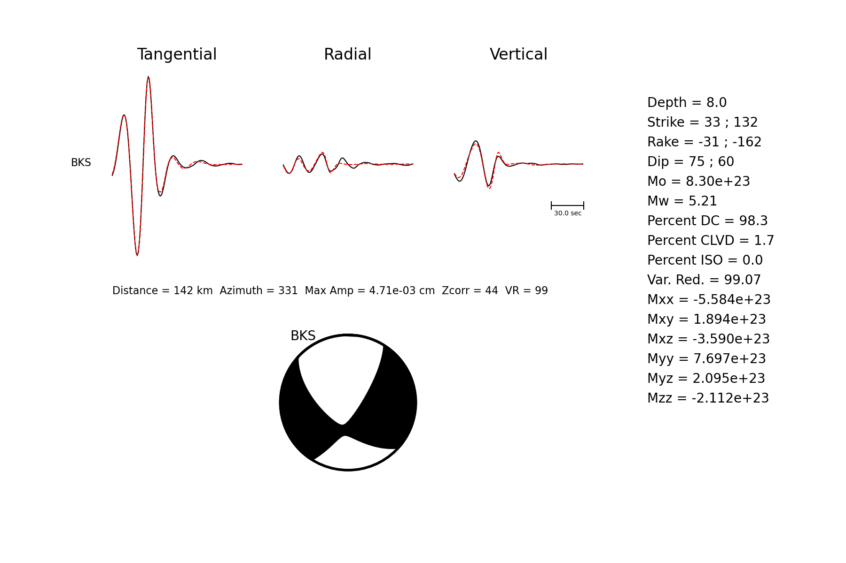

Figure 3. Single station inversion for BKS assuming a source depth of 8 km.

**Step 3: Three Station Moment Tensor Inversion**

Figure 4 shows an example of a three-station inversion using the automatic Zcor. See if you can improve on this solution by examining the Zcor parameter.

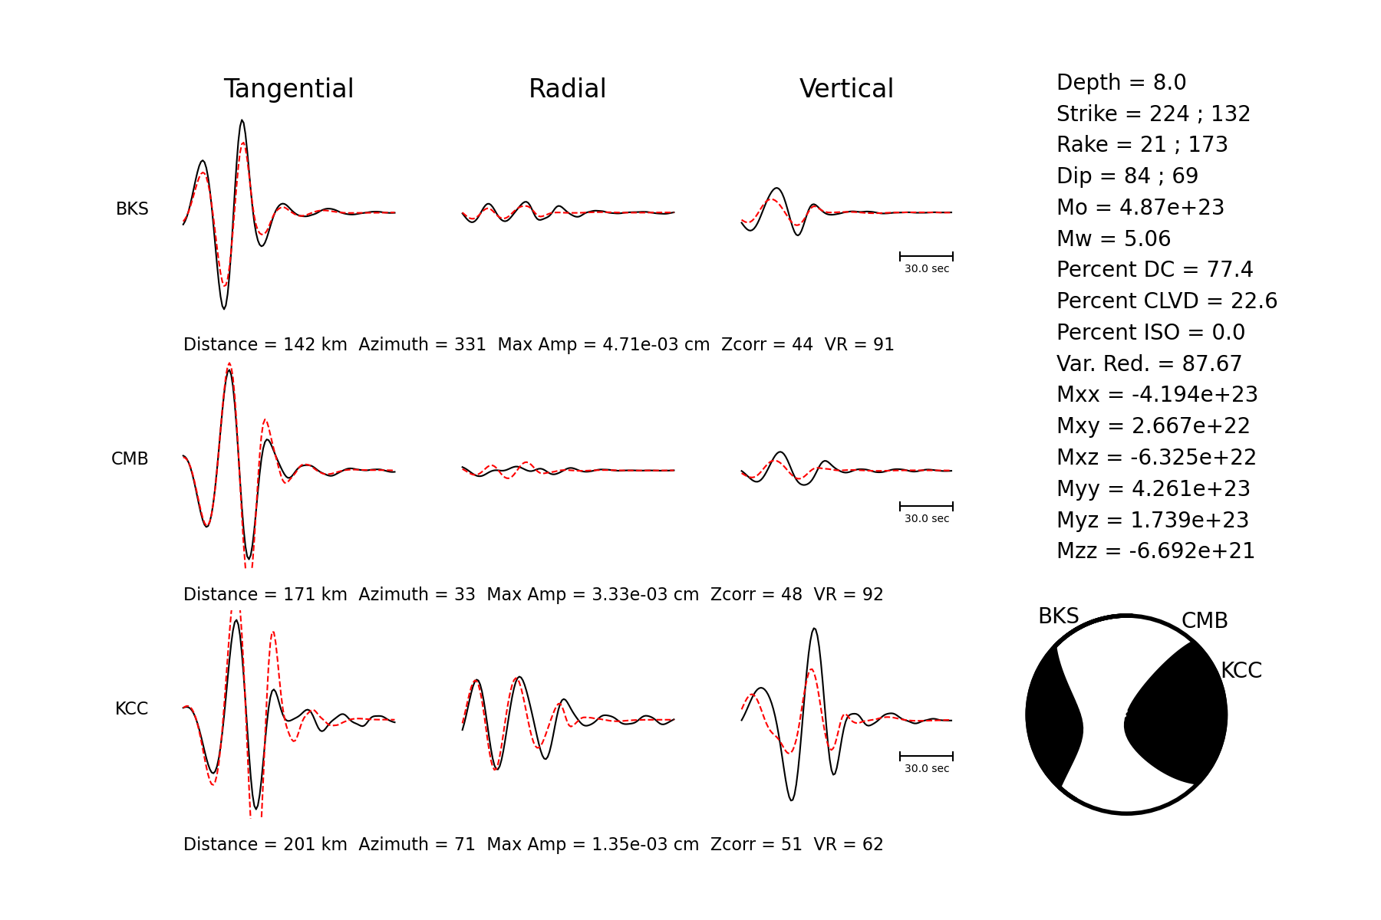

Figure 4. Three station inversion for BKS, CMB and KCC assuming a source depth of 8 km.

**Step 4: Six Station Moment Tensor Inversion**

Next try adding the other stations. Examine combinations of two and three stations to examine the sensitivity of the solution to the station geometry (jackknife testing). Keep a record of the variance reduction, strike, rake, dip and moment for each permutation and then compute the mean and standard deviation of each parameter. For the 6 station case (BKS, CMB, JRSC, KCC, ORV, PKD) find the best depth considering both the VR and the VR*PDC measures.

Bring plots showing your moment tensor inversion results using six stations, and the source depth and station sensitivity tests to class for discussion.

**Week3 EXERCISE**

In this exercise you will model two events located near Long Valley California, a volcanic center located in eastern California (Figure 5). In the directory Week3_Exercise there are three subdirectories, GFS, EVT1, and EVT2. In GFS the filtered (0.02 to 0.05 Hz acausal Butterworth) Greens functions have already been computed, but there are also processing scripts (run*) showing how they were computed using the Herrmann (2013) CPS package. Let me know if you are interested in learning to compute the FKI Green's functions. EVT1 and EVT2 contain SAC datafiles and polezero response files for an event that has a large non-double-couple mechanism, and a nearby event that is a pure double-couple. You will generate Green’s functions for source depths of 5, 8, 11 and 14 km to find the best source depth for each event assuming a deviatoric moment tensor solution. Then for the best source depth you will invert the data for a full moment tensor solution to test for possible isotropic or volumetric source radiation.

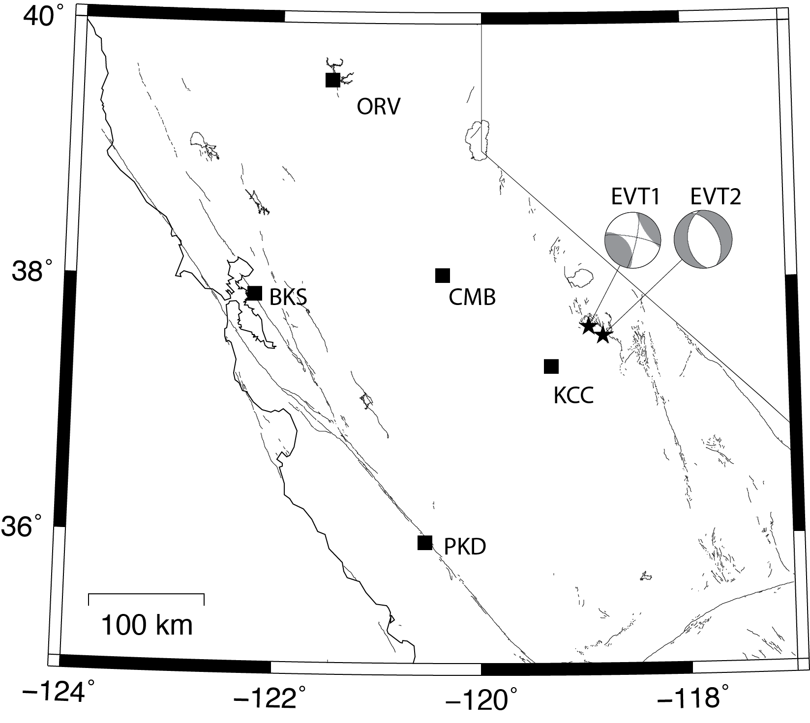

Figure 5. Map showing the locations of 5 BDSN stations and the two study events located near Long Valley, California. The deviatoric moment tensor solutions are plotted. One event has a large non-double-couple component, and the other is nearly a pure double-couple.

For each event in their respective directories use the **run_mkdatafiles** script to process the sac data files and create the filtered data ascii files used by the moment tensor code.

The azimuth and distance are obtained from the SAC header, and have already been included in the moment tensor input file, mt_inv.in.

Find the best fitting moment tensor solution for each event considering source depths of 5, 8 and 11 km. Note that for each source depth the zcor should be manually adjusted to be sure that the optimal time alignment shifts are used.

For each event compare the deviatoric and full moment tensor solutions and the variance reduction goodness of fit parameter. Recall that on the first line of the input file (mt_inv.in) the 4th number (5 or 6) refers to deviatoric (5) and full (6) moment tensor inversions. The deviatoric solution is found with the constraint that mzz=-1*(mxx + myy).

#### **Concluding Remarks**

We hope that this brief introduction to moment tensors and the practical exercises helps prepare you for participating in the BSL Alarm Response. Seismic moment tensors are an important product and contribution of the Berkeley Seismological Laboratory to the shared seismic monitoring effort for northern California, and it impacts assessments of earthquakes in near-realtime helping to identify causative faults, determining focal/centroid depth, estimating the scalar moment and moment magnitude, and contributes to generating ShakeMap. Through the effort of our alarm response team a moment tensor catalog is developed and made generally available for use in a variety of research applications including studying tectonics and faulting, estimating spatio-temporal stress, characterizing seismic hazard (PSHA), and evaluating seismicity under unusual circumstances such as volcanic and geothermal activity. The hard work of the students, postdocs and staff involved in the alarm response is greatly appreciated by myself, the BSL, and by researchers around the world who have used the database in their own work.

Send comments, bug reports and other inquiries to ddreger@berkeley.edu

**Please add the following acknowledgement to any WWW or technical journal publications that use moment tensor results obtained using this software. “Moment tensors were computed using the tdmt_invc_iso package developed by Douglas Dreger and Sean Ford of the Berkeley Seismological Laboratory. Green’s functions were computed using CPS3.3 (Herrmann, 2013).”**

**References and Supplemental Reading**

**Papers illustrating velocity model calibration:**

Dreger, D. S., and D. V. Helmberger (1990). Broadband Modeling of Local Earthquakes, *Bull. Seism. Soc. Am*., 80 1162-1179.

Dreger, D. S., and D. V. Helmberger (1993), Determination of Source Parameters at Regional Distances with Single Station or Sparse Network Data, *Journ. Geophys. Res*., 98, 8107-8125.

Dreger, D. and B. Romanowicz (1994). Source Characteristics of Events in the San Francisco Bay Region, *USGS Open-file report*, 94-176, 301-309.

Helmberger, D. V., and G. Engen (1980). Modeling the long-period body waves from shallow earthquakes at regional distances, *Bull. Seism. Soc. Am*., 70, 1699-1714.

Rodgers, A., W. Walter, R. Mellors, A. Al-Amri, Y. Zhang (1999). Lithospheric structure of the Arabian Shield and Platform from complete regional waveform modelling and surface wave group Velocities, *Geophys. Journ. Int*., 138, 871-878.

Saikia, C. K. (1994). Modified frequency-wavenumber algorithm for regional seismograms using Filon’s quadrature; modeling of Lg waves in eastern North America, *Geophys. Journ. Int*., 118, 142-158.

Song, X., L. Zhao and D. V. Helmberger (1996). Broad-band modelling of regional seismograms; the Basin and Range crustal structure, *Geophys. Journ. Int*., 125, 15-29.

Zhao, L., and D. V. Helmberger (1991). Broadband modelling along a regional shield path, *Geophys. Journ. Int*., 105, 301-312.

**Papers describing various moment tensor applications:**

Dreger, D., and A. Kaverina (2000). Seismic remote sensing for the earthquake source process and near-source strong shaking: A case study of the October 16, 1999 Hector Mine earthquake, Geophys. Res. Lett., 27, 1941-1944.

Fukuyama, E., and D. Dreger (2000). Performance test of an automated moment tensor determination system for the future "Tokai" earthquake, Earth Planets Space, 52, 383-392.

Gee, L. S., D. S. Neuhauser, D. S. Dreger, M. Pasyanos, R. A. Uhrhammer, and B. Romanowicz (1996), Real-Time Seismology at UC Berkeley: The Rapid Earthquake Data Integration Project, *Bull. Seism. Soc. Am*., 86, 936-945.

Jost, M. L., R. Herrmann (1989). A student's guide to and review of moment tensors, *Seism. Res. Lett*., 60, 37-57.

Pasyanos, M. E., D. S. Dreger, and B. Romanowicz (1996), Towards Real-Time Determination of Regional Moment Tensors, *Bull. Seism. Soc. Am*., 86, 1255-1269.

Romanowicz, B. D. Dreger, M . Pasyanos, and R. Urhammer (1993). Monitoring of Strain Release in Central and Northern California Using Broadband Data, *Geophys. Res. Let*., 20, 1643-1646.