AI Product Passport
Components and how they fit together
Federated architecture · data model v2.7 · September 2026

1. Overview
The AI Product Passport records the provenance of an AI model (study, data, training, model and evaluations) and issues it as a digitally signed, versioned PDF. It is deployed once, centrally. Each participating hospital runs a local node that keeps patient data inside the hospital and sends only metadata and aggregates to the central Passport.
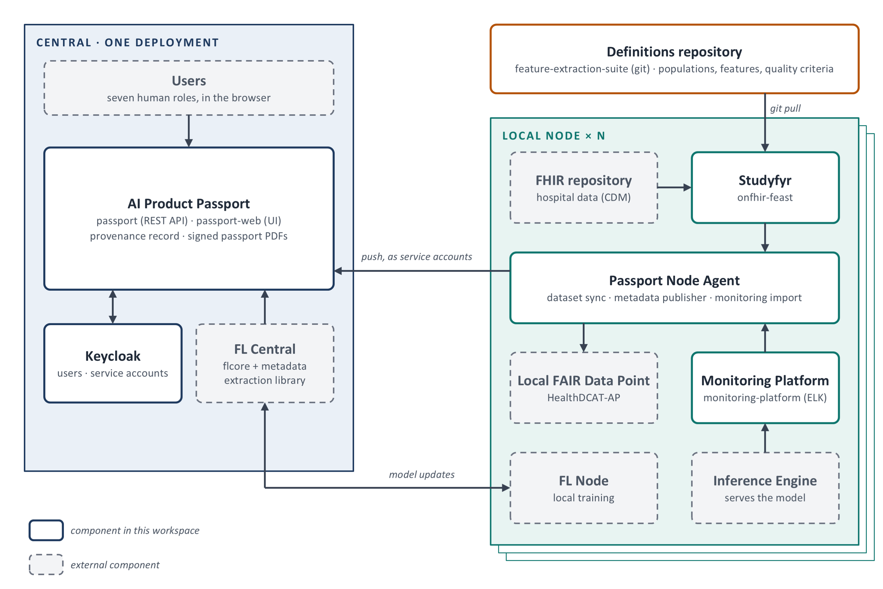
Figure 1. System overview: one central platform, one local node per hospital, one shared definitions repository.
Three rules hold the architecture together:
- Node to central only. Every integration starts at the node. The central platform never calls into a hospital and holds no hospital credentials.
- One identity per machine. Each machine client is its own Keycloak service account, so the audit log names the software agent behind every write.
- Shared definitions, local execution. Cohorts, features and quality criteria live in one git repository. Each node runs a tagged release, and the Passport records the (url, version) that was executed.

2. Central platform
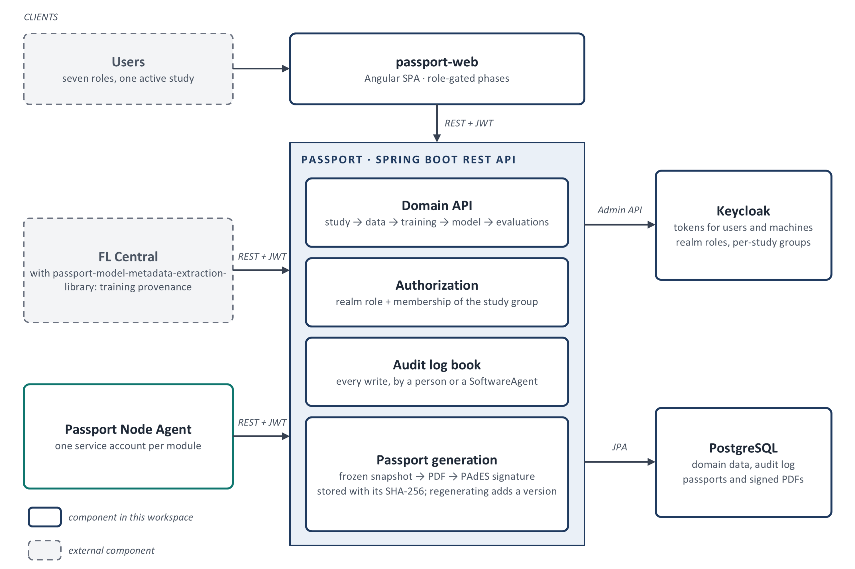
Figure 2. Central platform: clients, the Passport API and its supporting services.
- passport-web is the UI people work in: one role-gated phase per role, scoped to the active study.
- passport is the REST API. Every call is checked against the caller's role and study-group membership, and every write is recorded in the audit log book.
- Passport generation freezes a snapshot of the model's provenance, renders it to PDF from the passport-web export page, signs it (PAdES) and stores the bytes with their SHA-256. A passport is never rewritten; regenerating creates the next version.
- Keycloak issues tokens to people and machines and holds one group per study, with a subgroup per study role.
- PostgreSQL holds the domain data, the audit log and the stored passports.
- FL Central reports training provenance (algorithm, learning process, model, evaluation runs) through the metadata extraction library.

3. Local node
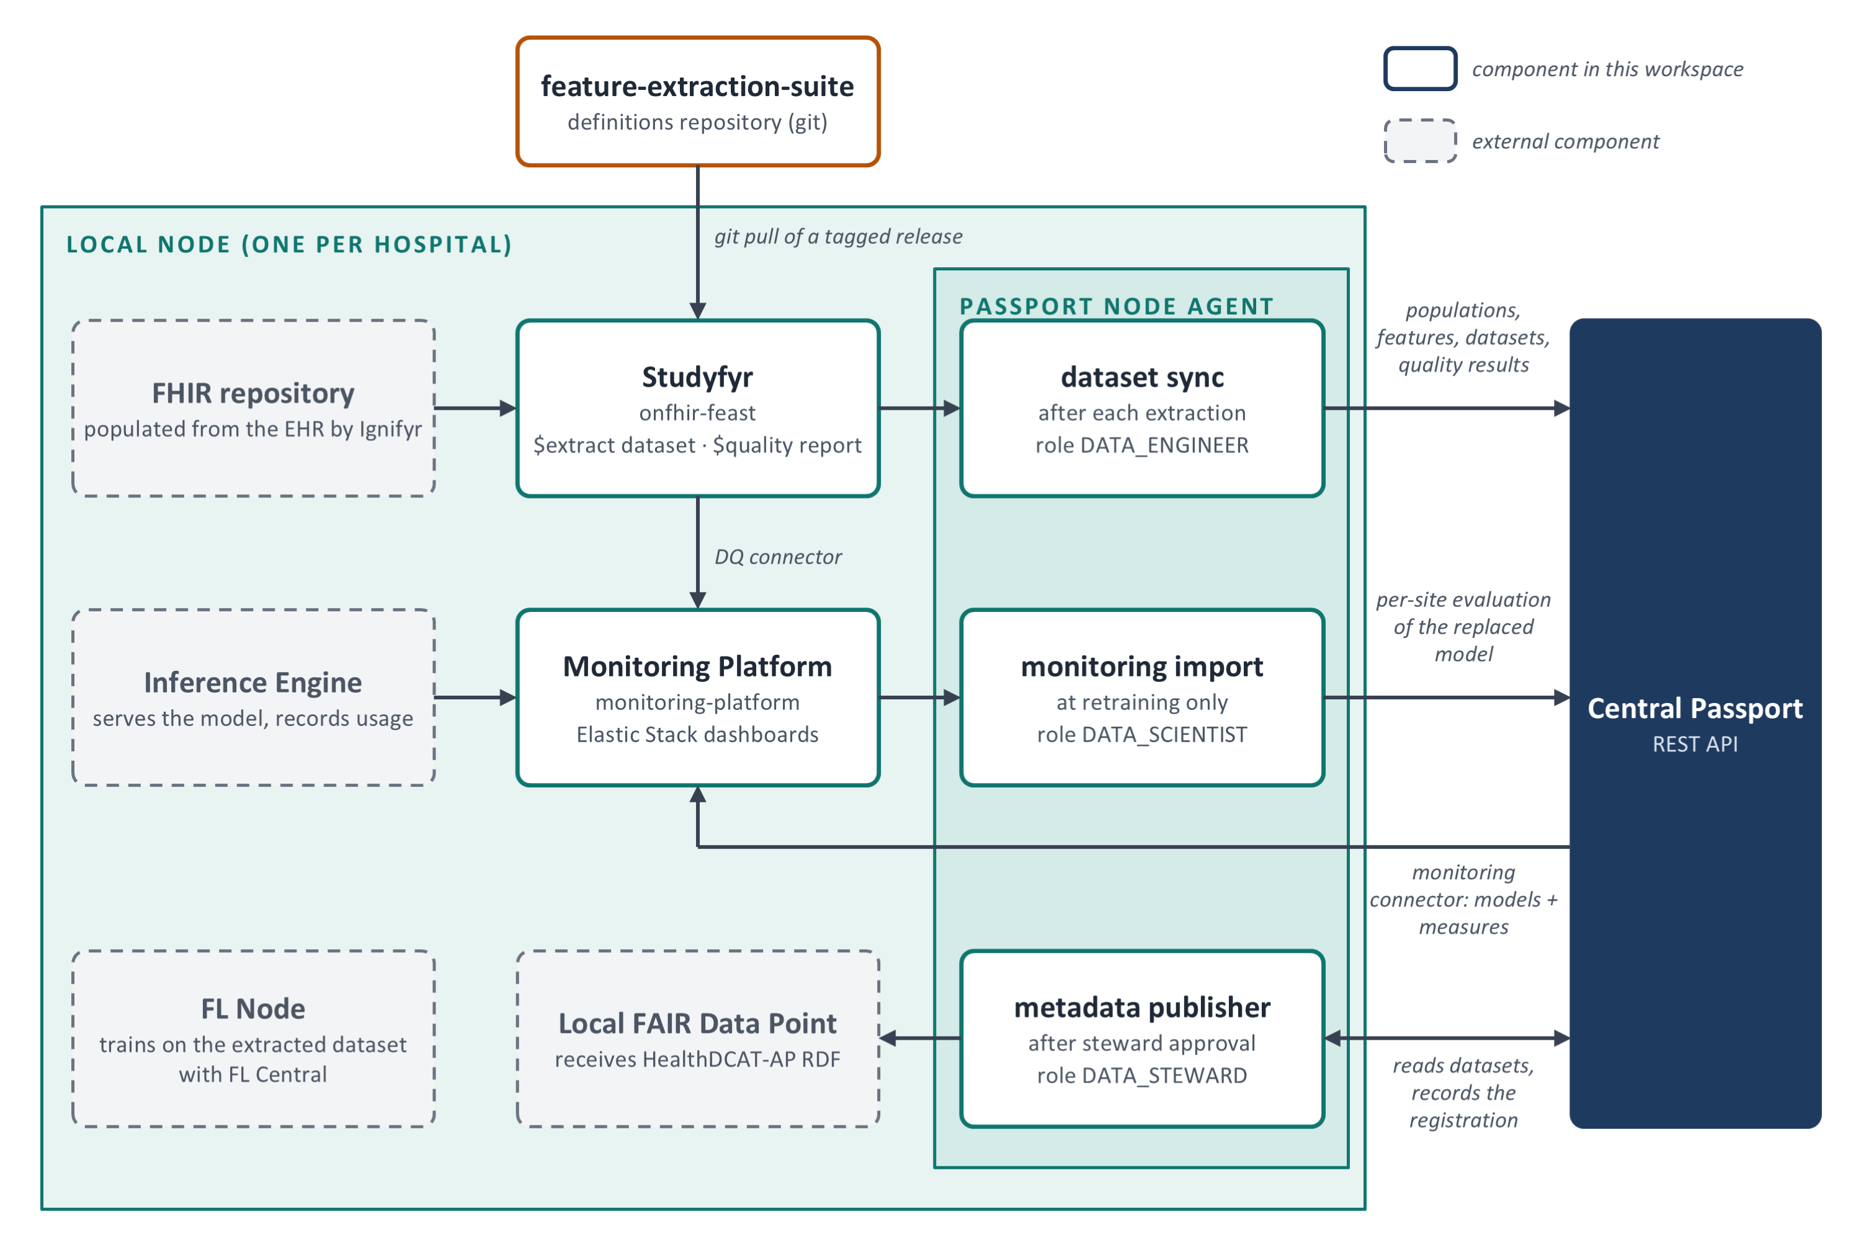
Figure 3. Local node: the four data flows and the Passport Node Agent modules that carry them to the central Passport.
- Extraction. Studyfyr (onfhir-feast) runs the definitions against the FHIR repository and produces a dataset and its quality report. Dataset sync writes the populations, features, dataset and quality results to the Passport.
- Training. The FL Node trains on the extracted dataset; FL Central aggregates and reports to the Passport.
- Monitoring. The Inference Engine feeds predictions and feedback to the Monitoring Platform. At retraining, monitoring import sends the per-site evaluation of the replaced model. The DQ connector and the monitoring connector only feed dashboards.
- Publication. After a Data Steward approves, the metadata publisher writes the dataset as HealthDCAT-AP RDF to the local FAIR Data Point and records the registration in the Passport.
Every node agent module can be re-run safely: each write is matched on its domain identity first, so a repeated run completes the work instead of duplicating it.

4. Component summary
Component | Repository | Runs at | Main duty
Passport backend | passport | Central | REST API, authorization, audit log book, passport generation and signing
Passport UI | passport-web | Central | Web UI for every role; also the export page the PDF is rendered from
Keycloak | passport (realm configuration) | Central | Identity for people and machines; per-study groups carry the study roles
Metadata extraction library | passport-model-metadata-extraction-library | Central, inside FL Central | Pushes training provenance from sklearn, Keras and PyTorch pipelines
Passport Node Agent | passport-node-agent | Node | Dataset sync, monitoring import, metadata publisher
Studyfyr | onfhir-feast | Node | Runs the definitions on FHIR data: dataset extraction, statistics, $quality
Definitions | feature-extraction-suite | Git, pulled by nodes | Populations, feature groups and their pipelines, feature sets, quality criteria
Monitoring Platform | monitoring-platform | Node | Elastic Stack: predictions, feedback, data quality and drift dashboards
Monitoring connector | passport-monitoring-platform-connector | Node, scheduled | Copies models and evaluation measures from the Passport to the dashboards
DQ connector | data-quality-monitoring-platform-connector | Node | Sends $quality results to the dashboards
Feast connector | passport-onfhir-feast-connector | Not deployed | Superseded prototype of dataset sync, kept for reference
External components, not developed in this workspace: the FHIR repository and Ignifyr (EHR to FHIR mapping), FL Central and FL Node (flcore, on Flower), the Inference Engine, the local FAIR Data Point, and the central metadata catalogue (integration not yet decided).

